Online supplementary material
Table S1 Treatment details (safety analysis set)
 | Thiotepa | Melphalan
Number of exposure days, n (%)
1 | 0 | 0
2 | 0 | 9 (22.0)
3 | 2 (4.9) | 32 (78.0)
4 | 39 (95.1) | -
Daily dose (mg/m²/day), median (min, max) | 200 (118, 200) | 70 (30, 70)
Cumulative dose (mg/m²), median (min, max) | 800 (472, 800) | 210 (90, 210)
Dose intensity (%), median (min, max) | 100.0 (59.0, 100.0) | 100.0 (42.9, 100.0)

Table S2. Neutrophil count by day post-HSCT in two patients who did not meet the criteria for successful engraftment
Neutrophil count  (/mm³) after HSCT | Day 7 | Day 10 | Day 14 | Day 15 | Day 21 | Day 28
Patient #1 | 5 | - | 2 813 | - | 748 | 940
Patient #2 | 0 | 1 250 | 6 050 | 5 650 | 1 220 | 1 160
HSCT hematopoietic stem cell transplantation

Fig. S1 Kaplan-Meier analysis of survival after autologous HSCT
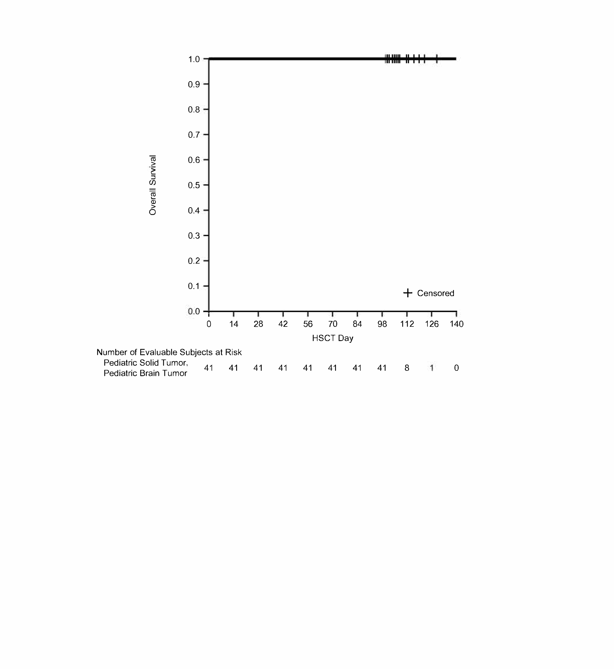
HSCT hematopoietic stem cell transplantation

