Supplemental Materials for

CD19-Targeting Chimeric Antigen Receptor T-Cell Therapy in Patients with a History of Rheumatic Autoimmune Diseases: A Retrospective Analysis

Supplemental Table 1: Characteristics of Patients Who Received Anti-CD19 CAR T-Cell Therapies with or without Rheumatic Autoimmune Diseases Before Matching

Characteristics | Autoimmune, n (%) | Non-autoimmune, n (%) | P value
N | 58 (100) | 1305 (100) | N/A
Age, mean (SD) | 60.0 (15.9) | 60.4 (13.7) | 0.83
Sex  Male  Female | 31 (53)  27 (47) | 897 (69)  400 (31) | 0.01
Ethnicity  Hispanic  Non-Hispanic | 52 (90)  6 (10) | 933 (72)  365 (28) | <0.01
Types of lymphoma  DLBCL  Others | 51 (88)  7 (12) | 1102 (84)  203 (16) | 0.47
CAR T-cell product  Axi-cel  Tisa-cel  Other | 32 (55)  15 (26)  13 (19) | 590 (45)  225 (17)  490 (38) | 0.03
Prior lines of therapy before CAR T  1  2  3  More than 3 | 12 (21)  13 (22)  11 (19)  22 (38) | 302 (23)  254 (19)  223 (17)  526 (40) | 0.90
ECOG PS  At least 2 | 10 (17) | 89 (7) | <0.01
LDH prior to CAR T, IU/L, mean (SD) | 304 (256) | 420 (279) | <0.01
Platelet count prior to CAR T, 10³/uL, mean (SD) | 128 (81) | 138 (90) | 0.41
CAR, chimeric antigen receptor. SD, standard deviation. DLBCL, diffuse large B-cell lymphoma. PS, performance status. LDH, lactate dehydrogenase.

Supplemental Table 2: Univariate Cox Regression of Variables Associated with Overall Survival

Variables | HR | 95% CI | P value
Age > 65 vs <=65 | 1.20 | 0.94 to 1.52 | 0.14
DLBCL vs Other lymphoma | 1.73 | 1.27 to 2.37 | <0.01
Axi-cel vs Other CAR T | 1.11 | 0.86 to 1.43 | 0.42
Prior lines of therapy >3 vs <=3 | 1.11 | 0.85 to 1.45 | 0.43
Autoimmune vs Non-autoimmune | 0.60 | 0.33 to 1.10 | 0.10
LDH elevated vs Normal | 2.29 | 1.90 to 2.76 | <0.01

HR, hazard ratio. CI, confidence interval. DLBCL, diffuse large B-cell lymphoma. Axi-cel, axicabtagene ciloleucel. CAR, chimeric antigen receptor.

Supplemental Table 3: Multivariable Cox Regression of Variables Associated with Overall Survival

Variables | HR | 95% CI | P value
Age > 65 vs <=65 | 1.25 | 0.96 to 1.62 | 0.09
DLBCL vs Other lymphoma | 1.57 | 1.07 to 2.33 | 0.02
Axi-cel vs Other CAR T | 0.92 | 0.66 to 1.28 | 0.61
Prior lines of therapy >3 vs <=3 | 0.96 | 0.72 to 1.30 | 0.81
Autoimmune vs Non-autoimmune | 0.85 | 0.76 to 1.16 | 0.78
LDH elevated vs Normal | 2.39 | 1.88 to 3.03 | <0.01

HR, hazard ratio. CI, confidence interval. DLBCL, diffuse large B-cell lymphoma. Axi-cel, axicabtagene ciloleucel. CAR, chimeric antigen receptor.

All patients received CD19 CAR T-cells (n=1,363)

1:1 PSM
Non-rheumatic autoimmune diseases (n=1,305)
Rheumatic autoimmune diseases (n=58)

Received CAR T after 1/2021 (n=30)
CRS analysis

Received CAR T after 2/2022 (n=17)
ICANS analysis

TNT-D and OS analysis, rheumatic disease outcome analysis
Rheumatic autoimmune diseases (n=58)

Supplemental Figure 1| Flowchart of patient selection and analysis population. CAR, chimeric antigen receptor. PSM, propensity score matching. CRS, cytokine release syndrome. ICANS, immune effector cells associated neurotoxicity. TNT-D, time-to-next-treatment, or death. OS, overall survival.
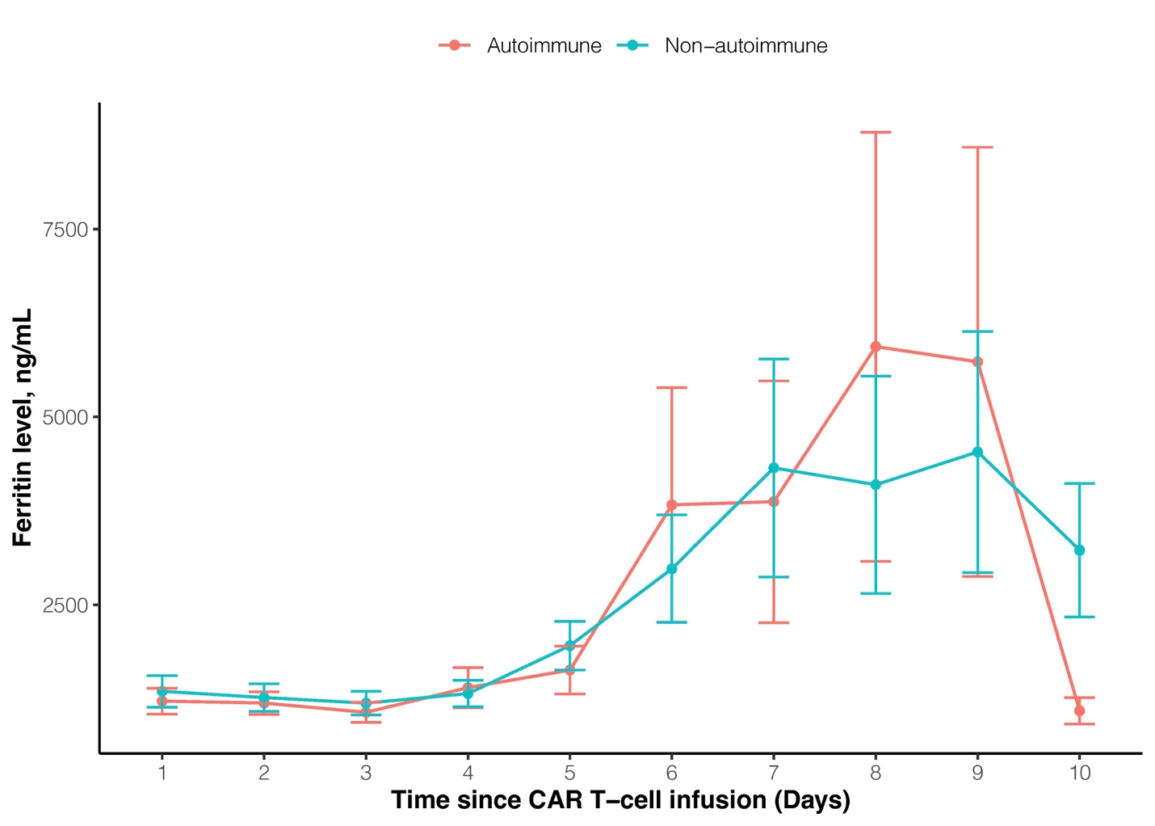
Supplemental Figure 2| Trend of Ferritin Level after CAR T-cell Infusion. The trend of ferritin level within the first 10 days after CAR T-cell infusion is shown for patients with rheumatic autoimmune diseases (red line) and non-autoimmune diseases (teal line). The dot represents the mean, and the error bar represents standard deviation.

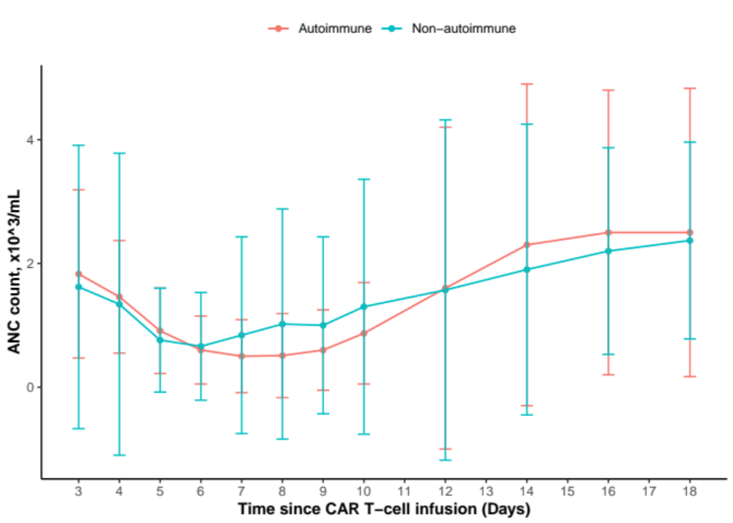
Supplemental Figure 3| Trend of ANC after CAR T-cell Infusion. The trend of ANC within the first 3 weeks after CAR T-cell infusion is shown for patients with rheumatic autoimmune diseases (red line) and non-autoimmune diseases (teal line). The dot represents the mean, and the error bar represents standard deviation. ANC, absolute neutrophil count.

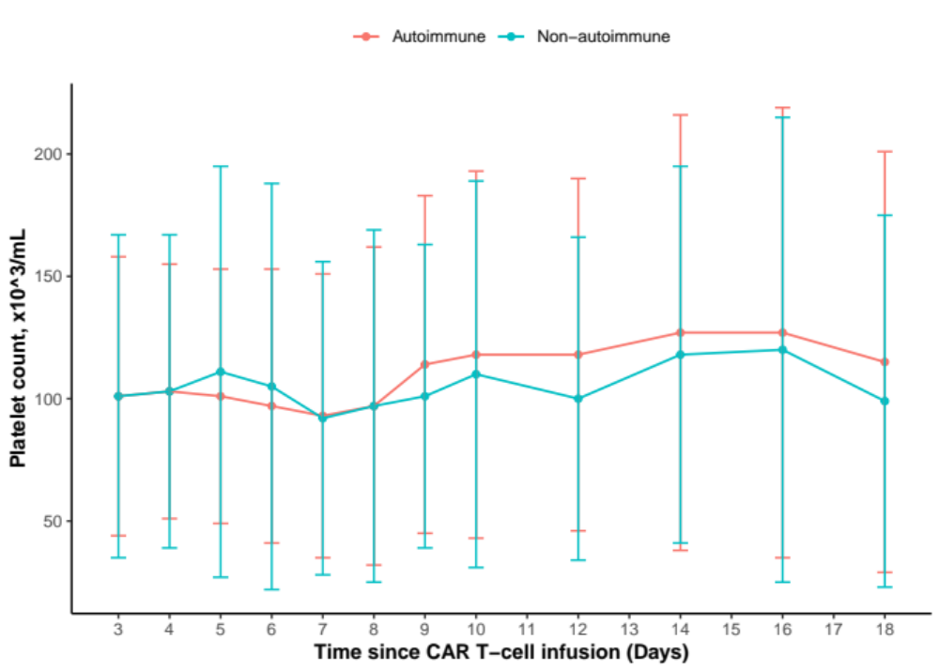
Supplemental Figure 4| Trend of platelet counts after CAR T-cell Infusion. The trend of platelet counts within the first 3 weeks after CAR T-cell infusion is shown for patients with rheumatic autoimmune diseases (red line) and non-autoimmune diseases (teal line). The dot represents the mean, and the error bar represents standard deviation.

