Supplementary Material
Figures:
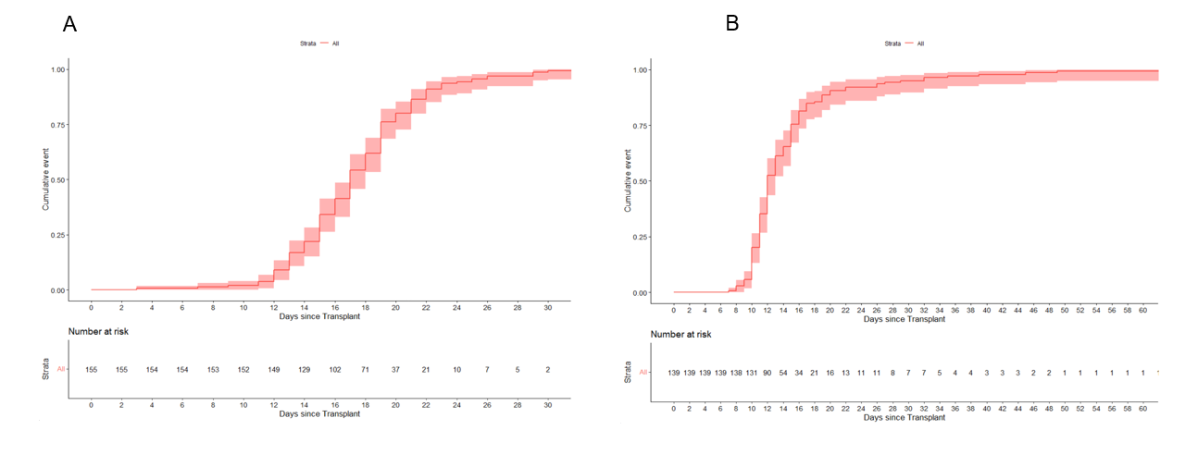

Supplementary Figure 1: Myeloid and platelet engraftment. (A) Myeloid engraftment, (B) Platelet engraftment
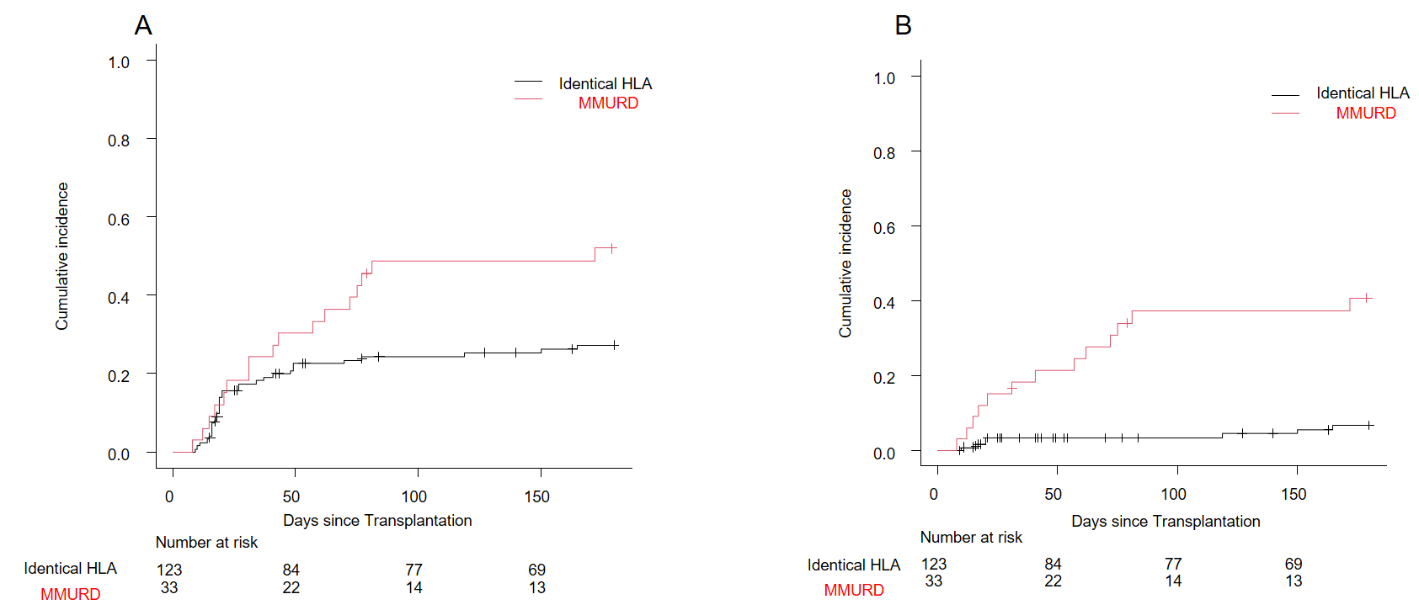

Supplementary Figure 2: aGvHD according to donor type. (A) aGvHD 2-4, (B) aGvHD 3-4
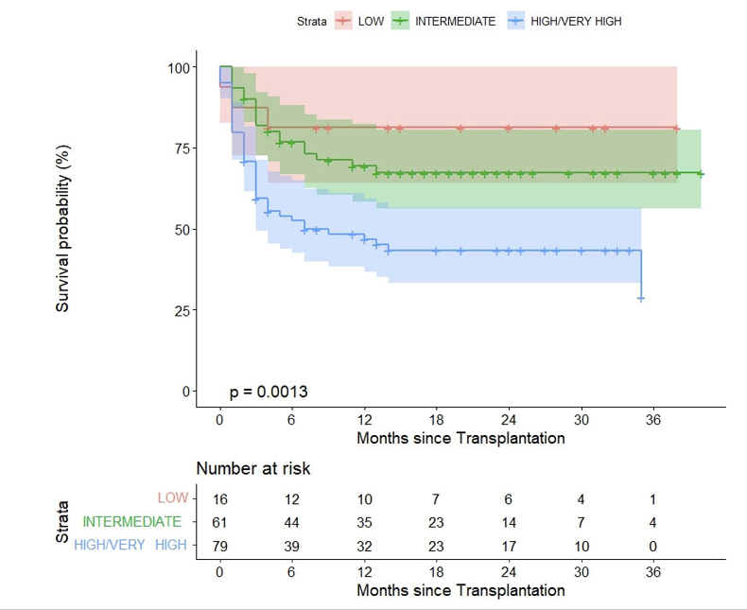
Supplementary Figure 3: Progression-free survival according to DRI
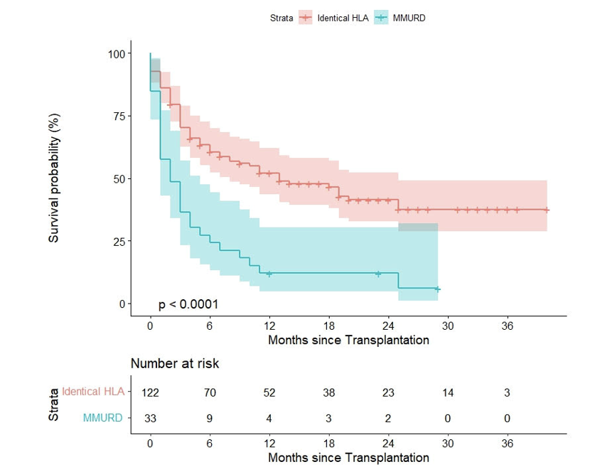
Supplementary Figure 4: Graft-free relapse-free survival according to donor type
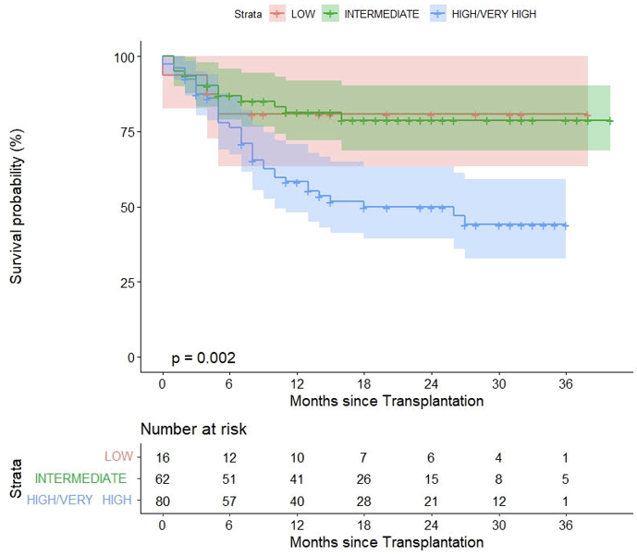
Supplementary Figure 5: Overall survival according to DRI
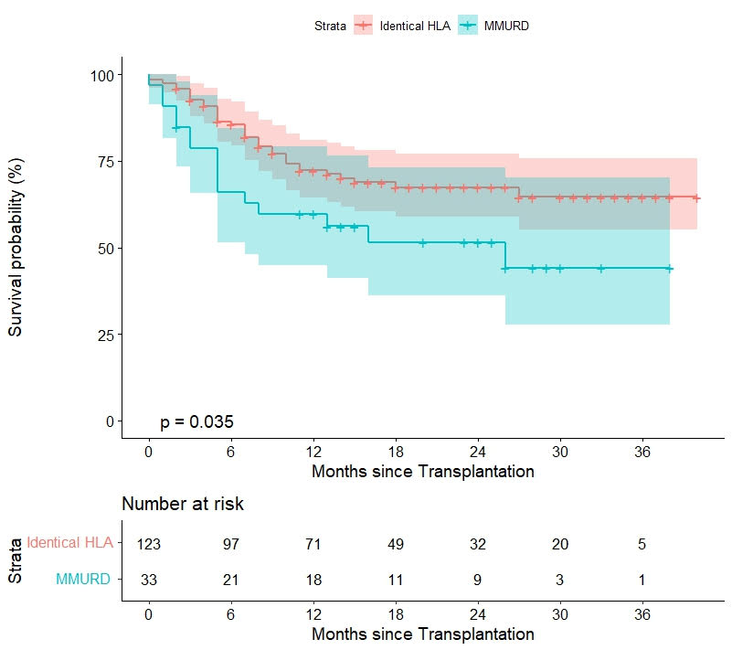
Supplementary Figure 6: Overall survival according to donor type

Tables:
Supplementary Table 1. Univariate and multivariate analysis for grades 2 to 4 acute GvHD
Risk factors | Univariate analysis |  |  | Multivariate analysis
 | P | HR | CI 95% | p | HR | CI 95%
Patient age > 55 | 0.463 | 1.284 | 0.659-2.503
Patient age > 60 | 0.400 | 1.271 | 0.727-2.220
Patient gender male | 0.354 | 1.317 | 0.736-2.358
Donor age >40 | 0.062 | 0.586 | 0.335-1.027
Diagnosis: myeloid vs lymphoid | 0.498 | 1.260 | 0.645-2.461
Diagnosis: acute vs chronic disease | 0.521 | 1.237 | 0.646-2.367
Previous allogeneic transplantation | 0.932 | 1.063 | 0.259-4.372
Unrelated donor (vs related donor) | 0.007 | 2.152 | 1.238-3.739
URD mismatched HLA (vs other) | 0.008 | 2.187 | 1.229-3.891 | <.001 | 6.99 | 2.99-16.29
HCT-CI ≥3 | 0.394 | 1.376 | 0.734-2.195
DRI high/very high vs intermediate vs low | 0.281 | 1
intermediate | 0.121 | 0.495 | 0.203-1.205
high/very high | 0.368 | 0.682 | 0.297-1.568
ECOG ≥2 | 0.782 | 1.326 | 0.181-9.727
CD34+ > 6 x 10⁶ /kg infused | 0.110 | 0.636 | 0.365-1.108
Female donor for male receptor (vs other) | 0.994 | 1.002 | 0.525-1.915
CMV: | 0.426 | 1
++ | 0.136 | 0.320 | 0.072-1.432
+- | 0.253 | 0.679 | 0.349-1.319
-- | 0.424 | 0.630 | 0.203-1.955
ABO mismatch: major. minor. bidireccional | 0.701 | 1
minor | 0.335 | 1.422 | 0.695-2.911
major | 0.355 | 1.372 | 0.702-2.681
bidireccional | 0.812 | 1.273 | 0.173-9.345
Conditioning FluBuThio (vs FluBu) | 0.690 | 1 | 0.382-1.890
TA-TMA | 0.014 | 2.922 | 1.241-6.881 | 0.023 | 4.33 | 1.23-15.23
SOS | 0.026 | 3.233 | 1.154-9.055
severe SOS | 0.050 | 1
mild / moderate | 0.068 | 6.444 | 0.872-47.633
severe | 0.089 | 2.777 | 0.856-8.983
CMV disease | 0.069 | 2.964 | 0.919-9.556
Fungal infection | 0.030 | 2.140 | 1.075-4.261

Supplementary Table 2. Univariate and multivariate analysis for grades 3-4 acute GvHD
Risk factors | Univariate analysis |  |  | Multivariate analysis
 | p | HR | CI 95% | p | HR | CI 95%
Patient age > 55 | 0.336 | 0.656 | 0.278-1.548
Patient age > 60 | 0.208 | 0.584 | 0.741-3.960
Patient gender male | 0.180 | 1.892 | 0.746-4.799
Donor age >40 | 0.003 | 0.255 | 0.105-0.620
Diagnosis: myeloid vs lymphoid | 0.973 | 1.016 | 0.400-2.578
Diagnosis: acute vs chronic disease | 0.793 | 0.888 | 0.365-2.159
Previous allogeneic transplantation | 0.534 | 0.047 | 0-725.166
Unrelated donor (vs related donor) | 0.001 | 4.276 | 1.755-10.415
URD mismatched HLA (vs other) | <0.001 | 6.814 | 2.934-15.824 | <0.001 | 6.664 | 2.699-16.452
HCT-CI ≥3 | 0.533 | 1.306 | 0.546-3.770
DRI high/very high vs intermediate vs low | 0.638 | 1
intermediate | 0.348 | 0.528 | 0.139-2.001
high/very high | 0.528 | 0.665 | 0.187-2.363
ECOG ≥2 | 0.125 | 0.437 | 0.152-1.258
CD34+ > 6 x 106/kg infused | 0.910 | 1.050 | 0.448-1.460
Female donor for male receptor (vs other) | 0.261 | 0.498 | 0.148-1.678
CMV: | 0.606 | 1
++ | 0.278 | 0.588 | 0.226-1.533
+- | 0.570 | 0.629 | 0.127-3.117
-- | 0.265 | 0.3 | 0.036-2.497
ABO mismatch: major. minor. bidireccional | 0.098 | 1
minor | 0.712 | 1.275 | 0.351-4.635
major | 0.014 | 3.107 | 1.262-7.651
bidireccional | 0.980 | not estimable | not estimable
Conditioning FluBuThio (vs FluBu) | 0.449 | 1.467 | 0.544-3.951
TA-TMA | 0.031 | 3.846 | 1.130-13.091 | 0.005 | 6.500 | 1.738-24.316
SOS | 0.444 | 2.208 | 0.291-16.753
severe SOS | 0.671 | 1
mild/moderate | 0.371 | 0.397 | 0.052-3.011
severe | 0.986 | not estimable | not estimable
CMV disease | 0.001 | 7.625 | 2.227-26.099
Fungal infection | 0.001 | 4.424 | 1.819-10.818 | 0.01 | 3.738 | 1.374-10.171

Supplementary Table 3. Univariate and multivariate analysis for chronic GvHD
Risk factors | Univariate analysis |  |  | Multivariate analysis
 | p | HR | CI 95% | p | HR | CI 95%
Patient age > 55 | 0.858 | 0.947 | 0.519-1.725
Patient age > 60 | 0.570 | 1.197 | 0.659-1.943
Patient gender male | 0.789 | 1.088 | 0.643-1.940
Donor age >40 | 0.917 | 1.035 | 0.537-1.997
Diagnosis: myeloid vs lymphoid | 0.567 | 1.224 | 0.643-2.192
Diagnosis: acute vs chronic disease | 0.213 | 1.581 | 0.755-2.663
Previous allogeneic transplantation | 0.794 | 1.305 | 0.231-12.681
Unrelated donor (vs related donor) | 0.755 | 1.107 | 0.507-1.613
URD mismatched HLA (vs other) | 0.864 | 1.070 | 0.522-2.081
HCT-CI ≥3 | 0.428 | 0.738 | 0.465-1.379
DRI high/very high vs intermediate vs low | 0.934 | 1
intermediate | 0.774 | 1.158 | 0.425-3.156
high/very high | 0.973 | 1.041 | 0.387-2.000
ECOG ≥2 | 0.415 | 1.326 | 0.608-2.027
CD34+ > 6 x 10⁶/kg infused | 0.231 | 0.684 | 0.368-1.274
Female donor for male receptor (vs other) | 0.002 | 2.774 | 1.454-5.291 | 0.006 | 2.458 | 1.294-4.670
CMV: | 0.582
-+ |  | 1
++ | 0.776 | 1.148 | 0.442-2.980
+- | 0.806 | 1.168 | 0.337-4.044
-- | 0.338 | 0.495 | 0.117-2.088
ABO mismatch: major. minor. bidireccional | 0.542
no mismatch |  | 1
minor | 0.301 | 0.632 | 0.265-1.508
major | 0.300 | 0.658 | 0.422-1.585
bidireccional | 0.878 | 0.855 | 0.110-5.917
Conditioning FluBuThio (vs FluBu) | 0.125 | 1.798 | 0.849-3.807
TA-TMA | 0.004 | 4.081 | 1.549-10.751 | 0.007 | 3.825 | 1.449-10.098
SOS (yes vs no) | 0.271 | 2.238 | 0.534-9.384
Severe SOS | <0.001
no |  | 1
mild/moderate | <0.001 | 33.612 | 6.409-176.278
severe | 0.972 | not estimable | not estimable
CMV disease | 0.364 | 0.045 | 0.000-35.510
Fungal infection | 0.147 | 0.349 | 0.000-5.500
aGvHD 2-4 | 0.442 | 0.762 | 0.382-1.523
aGvHD 3-4 | 0.115 | 0.388 | 0.120-1.259

Supplementary Table 4. Univariate and multivariate analysis for moderate to severe chronic GvHD
Risk factors | Univariate analysis |  |  | Multivariate analysis
 | p | HR | CI 95% | p | HR | CI 95%
Patient age > 55 | 0.754 | 1. 156 | 0.466-2.873
Patient age > 60 | 0.510 | 1.295 | 0.652-2.927
Patient gender male | 0.774 | 1.119 | 0.510-2.326
Donor age >40 | 0.445 | 1.403 | 0.581-3.387
Diagnosis: myeloid vs lymphoid | 0.601 | 0.808 | 0.321-1.505
Diagnosis: acute vs chronic disease | 0.802 | 0.902 | 0.355-1.669
Previous allogeneic transplantation | 0.440 | 2.221 | 0.348-19.979
Unrelated donor (vs related donor) | 0.520 | 0.762 | 0.344-1.774
URD mismatched HLA (vs other) | 0.541 | 0.718 | 0.244-2.031
HCT-CI ≥3 | 0.220 | 0.696 | 0.270-1.232
DRI high/very high vs intermediate vs low | 0.362
intermediate | 0.768 | 1.185 | 0.384-3.657
high/very high | 0.470 | 0.650 | 0.144-1.233
ECOG ≥2 | 0.538 | 1.299 | 0.406-2.405
CD34+ > 6 x 10⁶/kg infused | 0.805 | 0.908 | 0.391-1.751
female donor for male receptor (vs other) | 0.015 | 2.658 | 1.207-5.851 | 0.015 | 2.658 | 1.207-5.851
CMV: | 0.664
-+ |  | 1
++ | 0.247 | 2.365 | 0.580-10.723
+- | 0.511 | 1.823 | 0.307-10.929
-- | 0.581 | 1.656 | 0.385-13.819
ABO mismatch: major. minor. bidireccional | 0.126
no mismatch |  | 1
minor | 0.068 | 0.155 | 0.020-1.119
major | 0.090 | 0.397 | 0.150-1.263
bidireccional | 0.981 | not estimable | not estimable
Conditioning FluBuThio (vs FluBu) | 0.893 | 1.076 | 0.460-3.923
TMA | 0.064 | 3.233 | 0.935-11.175
SOS | 0.725 | 1.431 | 0.194-10.580
severe SOS | 0.277
mild/moderate | 0.109 | 5.210 | 0.692-39.264
severe | 0.979 | not estimable | not estimable
CMV disease | 0.485 | 0.046 | 0.000-260.266
Fungal infection | 0.561 | 0.652 | 0.000-25.994
aGvHD 2-4 | 0.103 | 0.446 | 0.169-1.179
aGvHD 3-4 | 0.110 | 0.196 | 0.027-1.444

Supplementary Table 5: Univariate and multivariate analysis for Non-Relapse Mortality
Risk factors | Univariate analysis |  |  | Multivariate analysis
 | p | HR | CI 95% | p | HR | CI 95%
Patient age > 55 | 0.951 | 0.965 | 0.307-3.031
Patient age > 60 | 0.214 | 2 | 0.675-5.805
Patient gender male | 0.262 | 1.925 | 0.613-6.051
Donor age >40 | 0.944 | 0.963 | 0.343-2.708
Diagnosis: myeloid vs lymphoid | 0.239 | 2.461 | 0.550-11.008
Diagnosis: acute vs chronic disease | 0.439 | 1.657 | 0.461-5.953
Previous allogeneic transplantation | 0.664 | 0.048 | 0-44.841
Unrelated donor (vs related donor) | 0.465 | 1.459 | 0.529-4.026
URD mismatched HLA (vs other) | 0.415 | 1.621 | 0.508-5.171
HCT-CI ≥3 | 0.735 | 1.196 | 0.571-4.889
DRI high/very high vs intermediate vs low | 0.839
intermediate | 0.559 | 1.867 | 0.230-15.181
high/very high | 0.576 | 1.820 | 0.223-14.837
ECOG ≥2 | 0.981 | not estimable | not estimable
CD34+ > 6 x 106 | 0.516 | 0.706 | 0.248-2.014
female donor for male receptor (vs other) | 0.851 | 1 | 0.355-3.508
CMV: | 0.847
-+ |  | 1
++ | 0.682 | 1.371 | 0.303-6.197
+- | 0.759 | 0.686 | 0.062-7.598
-- | 0.804 | 1 | 0.066-8.200
ABO mismatch: major. minor. bidireccional | 0.876
No mismatch |  | 1
minor | 0.777 | 0.804 | 0.178-3.363
major | 0.416 | 0.535 | 0.118-2.415
bidireccional | 0.984 | not estimable | not estimable
Conditioning FluBuThio (vs FluBu) | 0.795 | 1.183 | 0.333-4.196
TMA | 0.014 | 5.089 | 1.387-18.668
SOS | 0.011 | 6.698 | 1.444-31.067 | 0.032 | 6.103 | 1.169-31.871
Severe SOS | 0.016
mild/moderate | 0.989 | not estimable | not estimable
severe | 0.004 | 9.264 | 2.024-42.407
CMV disease | 0.705 | 0.048 | 0.000-322923
Fungal infection | 0.176 | 2.398 | 1.086-13.732
aGvHD 2-4 | 0.018 | 3.491 | 1.238-9.840 | 0.010 | 4.841 | 1.456-16.094
aGvHD 3-4 | 0.050 | 2.927 | 1.001-8.566

Supplementary Table 6: Univariate and multivariate analysis for relapse or progression
Risk factors | Univariate analysis |  |  | Multivariate analysis
 | p | HR | CI 95% | p | HR | CI 95%
Patient age > 55 | 0.260 | 1.486 | 0.745-2.963
Patient age > 60 | 0.017 | 2.032 | 1.137-3.633
Patient gender male | 0.444 | 1.244 | 0.707-2.189
Donor age >40 | 0.885 | 1.043 | 0.586-1.857
Diagnosis: myeloid vs lymphoid | 0.305 | 1.402 | 0.735-2.676
Diagnosis: acute vs chronic disease | 0.037 | 2.155 | 1.049-4.427
Previous allogeneic transplantation | 0.159 | 2.317 | 0.720-7.455
Unrelated donor (vs related donor) | 0.863 | 1.051 | 0.600-1.840
URD mismatched HLA (vs other) | 0.151 | 1.571 | 0.849-2.908
HCT-CI ≥3 | 0.059 | 1.762 | 0.978-3.177
DRI | 0.001 |  |  | 0.002
low |  | 1 |  |  | 1
intermediate | 0.546 | 1.586 | 0.355-7.088 | 0.897 | 1.105 | 0.243-5.035
high/very high | 0.033 | 4.699 | 1.132-19.499 | 0.104 | 3.301 | 0.782-13.929
ECOG ≥2 | not estimable | not estimable | not estimable
CD34+ > 6 x 10⁶/kg infused | 0.335 | 0.765 | 0.444-1.319
female donor for male receptor (vs other) | 0.462 | 1.253 | 0.687-2.285
CMV: | 0.023 |  |  | 0.028
-+ |  | 1 |  |  | 1
++ | 0.055 | 0.549 | 0.298-1.014 | 0.063 | 0.558 | 0.302-1.031
+- | 0.031 | 0.197 | 0.298-1.014 | 0.035 | 0.202 | 0.046-0.894
-- | 0.032 | 0.109 | 0.014-0.824 | 0.036 | 0.113 | 0.015-0.869
ABO mismatch: | 0.145
no mismatch |  | 1
minor | 0.334 | 1.402 | 0.706-2.2785
major | 0.176 | 0.548 | 0.229-1.311
bidireccional | 0.162 | 2.782 | 0.662-11.684
Conditioning FluBuThio (vs FluBu) | 0.201 | 0.547 | 0.217-1.379
TMA | 0.274 | 0.331 | 0.046-2.396
SOS | 0.221 | 2.080 | 0.644-6.719
severe SOS | 0.468
leve/moderado | 0.417 | 2.275 | 0.312-16.602
grave | 0.340 | 1.995 | 0.483-8.241
CMV disease | 0.961 | 0.952 | 0.131-6.902
fungal infection | 0.217 | 1.816 | 0.720-4.583
aGvHD 2-4 | 0.041 | 1.786 | 1.023-3.118
aGvHD 3-4 | 0.622 | 0.807 | 0.344-1.892
cGvHD | 0.011 | 0.429 | 0.224-0.822
severe to moderate cGvHD | 0.131 | 0.540 | 0.243-1.202

Supplementary Table 7: Univariate and multivariate analysis for Progression-free Survival
Risk factors | Univariate analysis |  |  | Multivariate analysis
 | p | HR | CI 95% | p | HR | CI 95%
Patient age > 55 | 0.173 | 1.545 | 0.826-2.889
Patient age > 60 | 0.003 | 2.225 | 1314-3.766
Patient gender male | 0.25 | 1.347 | 0.811-2.235
Donor age >40 | 0.954 | 1.015 | 0,607-1,621
Diagnosis: myeloid vs lymphoid | 0.098 | 1.670 | 0.910-3.066
Diagnosis: acute vs chronic disease | 0.034 | 1.971 | 1.053-3.687
Previous allogeneic transplantation | 0.364 | 1.712 | 0.537-5.461
Unrelated donor (vs related donor) | 0.579 | 1.149 | 0.703-1.879
URD mismatched HLA (vs other) | 0.114 | 1.551 | 0.901-1.672
HCT-CI ≥3 | 0.049 | 1.683 | 0.002-2.826
DRI | 0.003 |  |  | 0.015
low |  | 1
intermediate | 0.413 | 1.664 | 0.492-5.623 | 0.455 | 1.600 | 0.47-5.44
high/very high | 0.029 | 3.676 | 1.140-11.851 | 0.057 | 3.140 | 0.97-10.24
ECOG ≥2 | 0.573 | 1.773 | 0.242-13.009
CD34+ > 6 x 10⁶/kg infused | 0.316 | 0.778 | 0.476-1.271
Female donor for male receptor (vs other) | 0.578 | 1.166 | 0.678-2.006
CMV: | 0.025
-+ |  | 1
++ | 0.133 | 0.65 | 0.371-1.140
+- | 0.021 | 0.177 | 0.041-0.768
-- | 0.027 | 0.192 | 0.044-0.832
ABO mismatch: | 0.232
no mismatch |  | 1
minor | 0.581 | 1.197 | 0.631-2.272
major | 0.112 | 0.542 | 0.255-1.1153
bidireccional | 0.346 | 1.981 | 0.478-8.209
Conditioning FluBuThio (vs FluBu) | 0.477 | 0.775 | 0.383-1.566
TA-TMA | 0.766 | 1.167 | 0.424-3.213
SOS (yes vs no) | 0.030 | 2.758 | 1.101-6.909
severe SOS | 0.075
no |  | 1
mild / moderate | 0.550 | 1.829 | 0.252-13.278
severe | 0.027 | 3.155 | 1.142-8.715
CMV disease | 0.736 | 0.712 | 0.099-5.136
fungal infection | 0.086 | 1.804 | 0.919-3.542
aGVHD 2-4 | 0.003 | 2.098 | 1.287-3.419 | 0.006 | 1.990 | 1.22-3.26
aGHVD 3-4 | 0.593 | 1.194 | 0.624-2.283
cGVHD | 0.000 | 0.322 | 0.172-0.605 | <0.001 | 0.031 | 0.15-0.63
severe to moderate cGVHD | 0.055 | 0.484 | 0.231-1.017

Supplementary Table 8: Univariate and multivariate analysis for GvHD-free, Relapse-free Survival
Risk factors | Univariate analysis |  |  | Multivariate analysis
 | p | HR | CI 95% | p | HR | CI 95%
Patient age > 55 | 0.626 | 1.123 | 0.704-1.791
Patient age > 60 | 0.064 | 1.465 | 0.978-2.195
Patient gender male | 0.060 | 1.490 | 0.983-2.257
Donor age >40 | 0.322 | 0.812 | 0.537-1.226
Diagnosis: myeloid vs lymphoid | 0.33 | 1.262 | 0.790-2.014
Diagnosis: acute vs chronic disease | 0.278 | 1.291 | 0.814-2.047
Previous allogeneic transplantation | 0.375 | 1.575 | 0.577-4.296
Unrelated donor (vs related donor) | 0.029 | 1.563 | 1.047-2.333
URD mismatched HLA (vs other) | <0.001 | 2.843 | 1.830-4.417 | <0.001 | 2.850 | 1.83-4.43
HCT-CI ≥3 | 0.441 | 1.266 | 0.848-1.889
DRI | 0.138
low |  | 1
intermediate | 0.510 | 0.789 | 0.390-1.597
high/very high | 0.565 | 1.219 | 0.621-2.392
ECOG ≥2 | 0.801 | 0.773 | 0.104-5.734
CD34+ > 6 x 10⁶/kg infused | 0.278 | 0.801 | 0.537-1.195
female donor for male receptor (vs other) | 0.422 | 1.199 | 0.770-1866
CMV: | 0.191
-+ |  | 1
++ | 0.186 | 0.716 | 0.436-1.174
+- | 0.152 | 0.551 | 0.244-1.245
-- | 0.053 | 0.053 | 0.164-1.012
ABO mismatch: | 0.712
no mismatch |  | 1
minor | 0.526 | 1.194 | 0.690-2.066
major | 0.472 | 0.818 | 0.473-1.415
bidireccional | 0.636 | 1.406 | 0.343-5.768
Conditioning FluBuThio (vs FluBu) | 0.567 | 1.165 | 0.690-1.968
TA-TMA | 0.079 | 2.003 | 0.924-4.344 | 0.05 | 2.18 | 1.00-4.76
SOS | 0.101 | 2.130 | 0.862-5.266
severe SOS | 0.251
no |  | 1
mild/moderate | 0.341 | 2.625 | 0.361-19.109
severe | 0.165 | 2.036 | 0.746-5.558
CMV disease | 0.199 | 2.131 | 0.671-6.763
Fungal infection | 0.12 | 1.590 | 0.886-2.112
aGvHD 2-4 | <0.001 | 3.196 | 2.125-4.807
aGvHD 3-4 | <0.001 | 4.662 | 2.852-7.622
cGvHD | 0.769 | 0.941 | 0.625-1.415
severe to moderate cGvHD | 0.014 | 1.723 | 1.115-2.663

Supplementary Table 9: Univariate and multivariate analysis for Overall Survival
Risk factors | Univariate analysis |  |  | Multivariate analysis
 | p | HR | CI 95% | p | HR | CI 95%
Patient age > 55 | 0.229 | 1.44 | 0.723-2.867
Patient age > 60 | 0.018 | 2.014 | 1130-3.590
Patient gender male | 0.101 | 1.635 | 0.909-2.939
Donor age >40 | 0.676 | 0.891 | 0.515-1.538
Diagnosis: myeloid vs lymphoid | 0.046 | 2.158 | 1.015-4.585
Diagnosis: acute vs chronic disease | 0.054 | 2.029 | 0.988-4.165
Previous allogeneic transplantation | 0.165 | 2.294 | 0.711-7.400
Unrelated donor (vs related donor) | 0.229 | 1.395 | 8.100-2.403
URD mismatched HLA (vs other) | 0.041 | 1.851 | 1.027-3.336
HCT-CI ≥3 | 0.054 | 1.405 | 0.989-3.202
DRI | 0.004 |  |  | 0.020
low |  | 1
intermediate | 0.9722 | 1.023 | 0.288-3.627 | 0.081 | 1.17 | 0.32-4.33
high/very high | 0.084 | 2.82 | 0.870-9.1400 | 0.038 | 3.75 | 1.08-13.00
ECOG ≥2 | 0.301 | 1.336 | 0.772-2.312
CD34+ > 6 x 10⁶/kg infused | 0.374 | 0.779 | 0.450-1.351
female donor for male receptor (vs other) | 0.319 | 1.356 | 0.745-2.469
CMV: | 0.044
+- |  | 1
++ | 0.880 | 0.587 | 0.319-1.082
-+ | 0.034 | 0.202 | 0.046-0.885
-- | 0.047 | 0.223 | 0.051-0.979
ABO mismatch: | 0.328
no mismatch |  | 1
minor | 0.616 | 1.190 | 0.604-2.343
major | 0.094 | 0.449 | 0.176-1.147
bidireccional | 0.99 | 0.988 | 0.135-7.222
Conditioning FluBuThio (vs FluBu) | 0.933 | 1.033 | 0.486-2.197
TA-TMA | 0.299 | 1.724 | 0.617-4.813
SOS (yes vs no) | 0.007 | 4.100 | 1.464-11.485 | <0.001 | 12 | 3.89-44.70
SOS | 0.027
no |  | 1
mild/moderate | 0.169 | 4.068 | 0.550-30.060
severe | 0.018 | 4.111 | 1.272-13.288
CMV disease | 0.850 | 1.210 | 0.167-8.789
Fungal infection | 0.204 | 1.629 | 0.668-3.458
aGvHD 2-4 | 0.002 | 2.373 | 1.383-4.071 | 0.008 | 2.18 | 1.23-3.88
aGvHD 3-4 | 0.156 | 1.616 | 0.832-3.140
cGvHD | <0.001 | 0.24 | 0.108-0.532 | <0.001 | 0.21 | 0.09-0.50
severe to moderate cGvHD | 0.030 | 0.323 | 0.116-0.894

Supplementary Table 10: Pretransplantation demographics and transplant characteristics according to donor type
Characteristic | Total n= 159 | MRD (n=95) | MUD(n=28) | MMURD (n=33) | p
Age at transplant, years, median (range) | 61 (22-72) | 62 (25-72) | 61 (28-69) | 57 (20-71) | 0.06
Donor age, years, median (range) | 49 (19-74) | 57 (19-74) | 29 (19-49) | 26 (19-54) | <0.001
Male, n (%) | 98 (61.6) | 60 (63.2) | 14 (50.0) | 22 (66.7) | 0.36
HCT- CI, % |  |  |  |  | 0.08
0 | 3 (1.9) | 0 (0) | 2 (7.1) | 1 (3)
1,2 | 65 (40.9) | 39 (41.1) | 14 (50.0) | 11 (33.3)
≥3 | 91 (57.2) | 56 (58.9) | 12 (42.1) | 21 (63.6)
Diagnosis, n (%) |  |  |  |  | 0.06
Acute myeloid leukemia | 53 (33.3) | 34 (35.8) | 11 (39.8) | 8 (24.2)
Myelodysplastic syndrome | 39 (24.5) | 26 (27.4) | 6 (21.4) | 6 (18.2)
Hodgkin lymphoma | 9 (5.7) | 4 (4.2) | 3 (10.7) | 2 (6.1)
Non-Hodgkin Lymphoma | 22 (13.8) | 15 (15.8) | 1 (3.6) | 6 (18.2)
Acute lymphocytic leukemia | 3 (1.9) | 0 (0) | 2 (7.1) | 1 (3)
Chronic myelomonocytic leukemia | 8 (5.0) | 0 (0) | 2(7.1) | 6 (18.2)
MDS /MNP | 6 (3.8) | 5 (5.3) | 0(0) | 1 (3)
Primary myelofibrosis | 10 (6.3) | 8 (8.4) | 1(3.6) | 1 (3.0)
Multiple myeloma / Plasma cell leukemia | 2 (1.3) | 0 (0) | 1(3.6) | 0
Others* | 7 (4.4) | 3 (3.2) | 2(7.1) | 1 (3.0)
Previous transplantation, n (%)
Autologous transplantation | 28 (17.6) | 17 (17.9) | 5(17.9) | 5 (15.2) | 0.93
Allogeneic transplantation | 6 (3.8) | 2 (2.1) | 3(10.7) | 1 (3.0) | 0.11
Disease risk index, DRI, n (%) |  |  |  |  | 0.95
Very high/High | 80 (50.3) | 49(51.6) | 13(48.1) | 17 (51.5)
Intermediate | 62 (39.0) | 37(38.9) | 10(37.0) | 13 (39.4)
Low | 16 (10.1) | 9(9.5) | 4(14.8) | 3 (9.1)
Conditioning regimen, n (%) |  |  |  |  | 0.01
Flu-Bu | 129 (81.1) | 82(86.3) | 18(64.3) | 26 (78.7)
Flu-Bu-Thio | 26 (16.5) | 12(12.6) | 7(25.0) | 7 (21.2)
Others | 4 (2.5) | 1(1.1) | 3(10.7) | 0
GVHD prophylaxis, n (%)
Tacro + sirolimus + MMF | 159 (100) | 159 (100) | (100) | 159 (100)
Graft source, n (%) Peripheral blood | 159 (100) | 159 (100) | (100) | 159 (100)
CD34+ (x10⁶/kg) infused, median (range) | 6.21 (3.35-13.1) | 6.10 (3.50-9.70) | 6.90(3.80-11.40) | 6.00 (3.35-13.10) | 0.15
CMN (x10⁸/kg) infused, median (range) | 7.38 (0.40-63.0) | 7.25 (0.40-64.20) | 7.16(6.20-42.20) | 8.68 (2.80-63.00) | 0.35

* Others: blastic phase of chronic myeloid leukemia (n=1), T prolymphocytic leukemia (n=2), chronic lymphocytic leukamia LLC (n=2) and secondary aplastic anemia (n=1) and secondary haemofagocytic syndrome (n=1).
Supplementary Table 11: Outcomes according to donor type (MRD versus MUD)
Outcomes | MRD (n=95) | MUD(n=28) | P
aGVHD grades 2-4, CuIn at 100 and 180 days | 24.9% / 26.6% | 38.1%/38.1% | 0.193
aGVHD grades 3-4, CuIn at 100 and 180 days | 7.4% / 9.1% | 9.8%/9.8% | 0.842
Overall cGVHD, 1-year and 3-year CuIn | 20.1% / 44.0% | 24.5%/47.2% | 0.722
cGVHD moderate to severe 1-year and 3-year CuIn | 12.0%/30.6% | 14.3%/35.9% | 0.987
NRM at day +100, 1 year and 3 year | 3.2% / 6.8% / 8.3% | 3.6%/8.1%/13.4% | 0.524
PFS at 1 year and 3 year | 62.1% / 57.8% | 64.0%/64.0% | 0.650
GRFS at 1 year and 3 year | 49.7%/37.7% | 56.9%/56.9% | 0.422
OS at 1 year and 3 year | 70.5% / 63.6% | 74.0%/68.3% | 0.875

Supplementary Table 12: Outcomes according to donor type (HLA-matched versus MMURD)
Outcomes | HLA-matched (n=123) | MMURD (n=33) | p test log rank
aGVHD grades 2-4, CuIn at 100 and 180 days | 24.3% / 27.1% | 46.7% / 51.9% | 0.016
aGVHD grades 3-4, CuIn at 100 and 180 days | 3.4% / 6.7% | 37.3% / 40.7% | <0.001
Overall cGVHD, 1-year and 3-year CuIn | 21.2% / 44.6% | 32% / 32% | 0.856
cGVHD moderate to severe 1-year and 3-year CuIn | 12.6% / 30.6% | 16% / 16% | 0.445
NRM at day +100, 1 year and 3 year | 3.3% / 7.1% / 9.4% | 9.1% / 12.1% / 12.1% | 0.547
PFS at 1 year and 3 year | 62.6% / 59.2% | 48.5% / 24.2% | 0.098
GRFS at 1 year and 3 year | 51.2% / 37.7% | 9.1% / 9.1% | < 0.001
OS at 1 year and 3 year | 72.3% / 64.6% | 59.7% / 44.2% | 0.035

