Supplemental table 1. Primer and probe sequences

Primers and probes |  | Sequences
Alkaline phosphatase | FP | TTGTGCCAGAGAAAGAGAGAGA
 | RP | GTTTCAGGGCATTTTTCAAGGT
Runx2 | FP | ACGAAAAATTAACGCCAGTCG
 | RP | TCGGTCTGACGACGCTAAAG
OsteriX | FP | GAGGAAGAAGCTCACTATGGCTCCAG
 | RP | GCCTCCTTTCCCCAGGGTTGTTGA
Bmp2 | FP | CACACAGGGACACACCAACC
 | RP | CAAAGACCTGCTAATCCTCAC
Bmp6 | FP | AGCACAGAGACTCTGACCTATTTTTG
 | RP | CCACAGATTGCTAGTTGCTGTGA
Cathepsin K | FP | TAGCCACGCTTCCTATCCGA
 | RP | TCCTCCGGAGACAGAGCAAA
β-actin | FP | GCAGGAGTACGATGAGTCCG
 | RP | ACGCAGCTCAGTAACAGTCC
human EPO | FP | GGAGGCCGAGAATATCACGAC
 | RP | CCCTGCCAGACTTCTACGG
Cebp-α | FP | GCGGGAACGCAACAACATC
 | RP | GTCACTGGTCAACTCCAGCAC
Cebp-β | FP | GCAGCCACTTGAGTTCTCAGG
 | RP | GATGTAGGCGGAGAGGTCGAT
Ppar-γ | FP | GGAAGACCACTCGCATTCCTT
 | RP | GTAATCAGCAACCATTGGGTCA
Gata1 | FP | TGTCCTCACCATCAGATTCCA
 | RP | TCCCTCCATACTGTTGAGCAG
Gata2 | FP | CACCCCGCCGTATTGAATG
 | RP | CCTGCGAGTCGAGATGGTTG
Gata3 | FP | AAGCTCAGTATCCGCTGACG
 | RP | GTTTCCGTAGTAGGACGGGAC
Epor | FP | GCTCCGGGATGGACTTCA
 | RP | GAGCCTGGTGCAGGCTACAT
 | Probe | CATACCAGCTCGAGGGTGAGTCACGAAAG
S16 | FP | GATCGAGCCGCGCACG
 | RP | CAAATCGCTCCTTGCCCA
 | Probe | CTGCAGTACAAGTTACTGGAGCCTGTTTTGCT

SUPPLEMENTARY FIGURES

Supplementary Figure 1

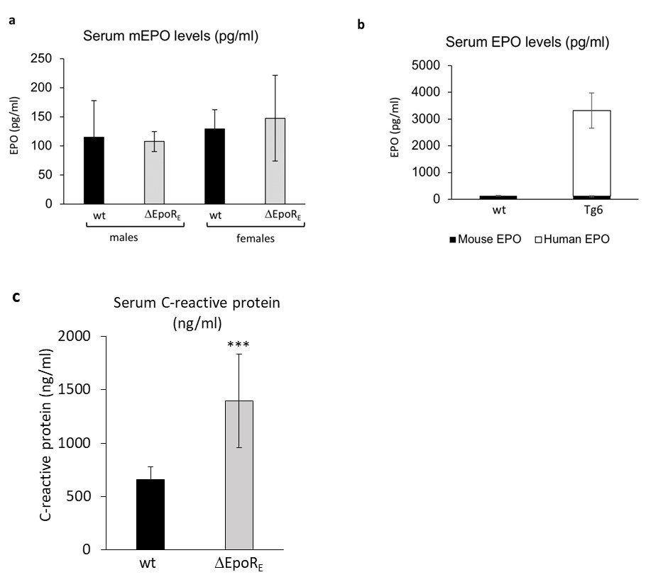

Suppl Figure 1: Serum EPO and C-reactive protein levels. (a) Endogenous circulating mouse EPO levels were determined from serum of wild type (wt) and ΔEpoR_{E} mice by ELISA assay. (n=5 for male-wt, female-wt and male-∆EpoR_{E}-mice; n=6 for female ∆EpoR_{E}-mice). (b) Endogenous circulating mouse EPO levels and transgenic circulating human EPO levels were determined from serum of wild type (wt) and Tg6 mice by ELISA assay specific for mouse and human EPO respectively. (n=5 for female-wt; n=4 for female Tg6-mice). No human EPO is detected in wt mice. (c) Levels of C-reactive protein in the serum of wild type (wt) and ΔEpoR_{E} mice quantitated by ELISA assay. (n=7 for wt, n=6 for ΔEpoR_{E} mice).

Supplementary Figure 2

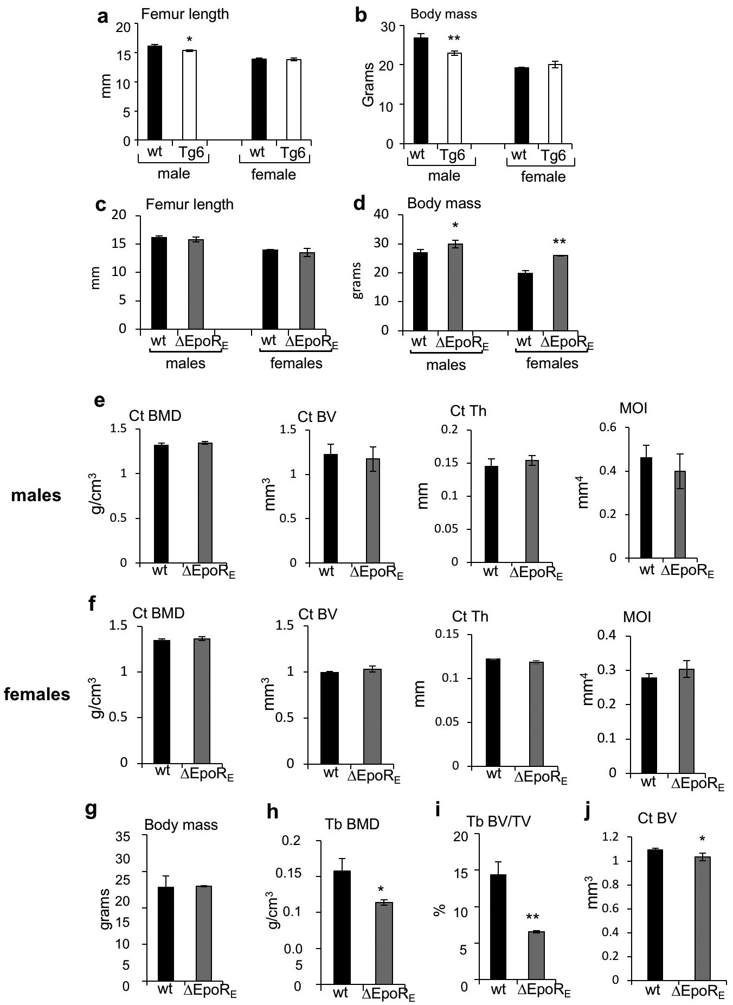

Suppl Figure 2: Bone characteristics and body mass of male and female Tg6 and ΔEpoR_{E} mice. (a) Length of the femurs of 11 week old male and female Tg6 mice and littermate controls determined by micro-Ct. (b): Corresponding body mass of male and female Tg6 mice and littermate controls. (c) Length of femurs of male and female ΔEpoR_{E} mice and wt control mice. (d) Body mass of male and female ΔEpoR_{E} mice and wt control mice (n=4/group). (e-f) Cortical bone morphometry measurements of 11 week old male (e) and female (f) ΔEpoR_{E} mice determined by micro-Ct (n=4/group, *p<0.05, **p<0.01, ***p<0.001). (g-j) Bone morphometry measurements of female age and weight-matched wild type C57BL6/J compared with 12-week-old ΔEpoR_{E} female mice including body mass (g), trabecular bone mineral density (h), trabecular bone volume (i) and cortical bone volume (j). (n=3/group, *p<0.05, **p<0.01, ***p<0.01)

Supplementary Figure 3

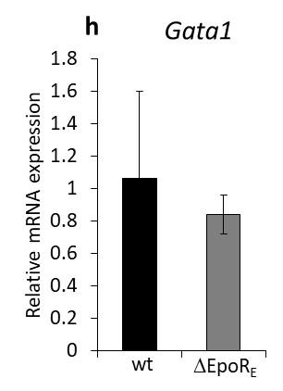
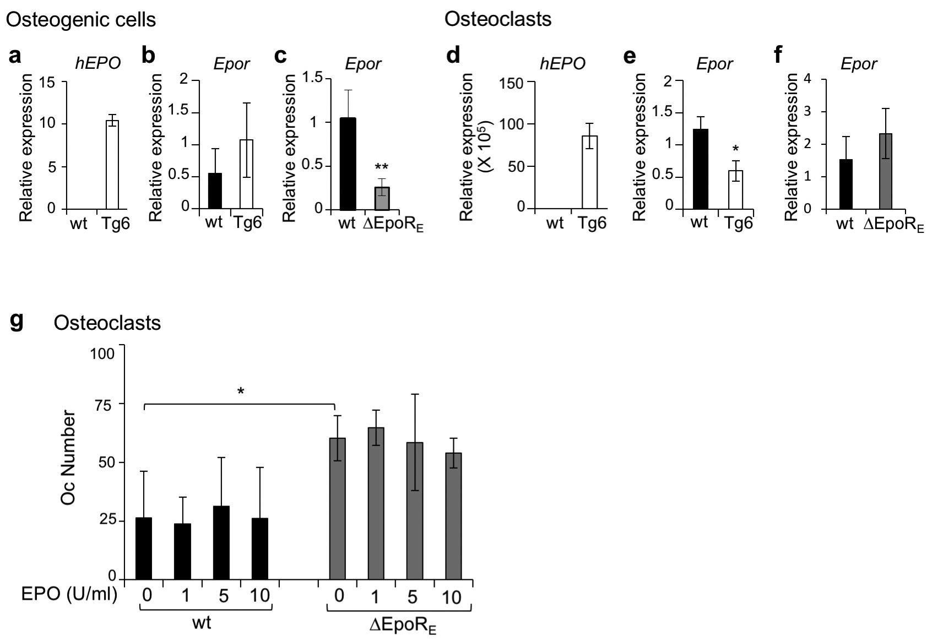

Suppl Figure 3: hEPO and Epor expression in osteogenic cells and osteoclasts, and osteoclast number in Tg6 and ΔEpoR_{E} mice. (a-c) Real-time PCR quantitation of hEPO (a) and Epor mRNA (b) in cultured wt and Tg6 osteogenic cells, and real time PCR quantification of Epor in wt and ΔEpoR_{E} osteogenic cells (c). (d-f) Real-time PCR quantitation of hEPO (d) and Epor mRNA (e) in cultured osteoclasts on day 4 of wt and Tg6 osteoclasts, and real time PCR quantification of EPOR in wt and ΔEpoR_{E} osteoclasts (f). (n=3-4/group, *p<0.05, **p<0.01). (g) Number of osteoclasts determined by TRAP staining in in vitro cultures of wild type and ΔEpoR_{E} osteoclast cultures treated with recombinant hEPO (1 U/ml, 5 U/ml and 10 U/ml EPO). (h) Real-time PCR quantitation of Gata1 mRNA in FACS sorted wt and ΔEpoR_{E} pre-osteoclasts.

Supplementary Figure 4

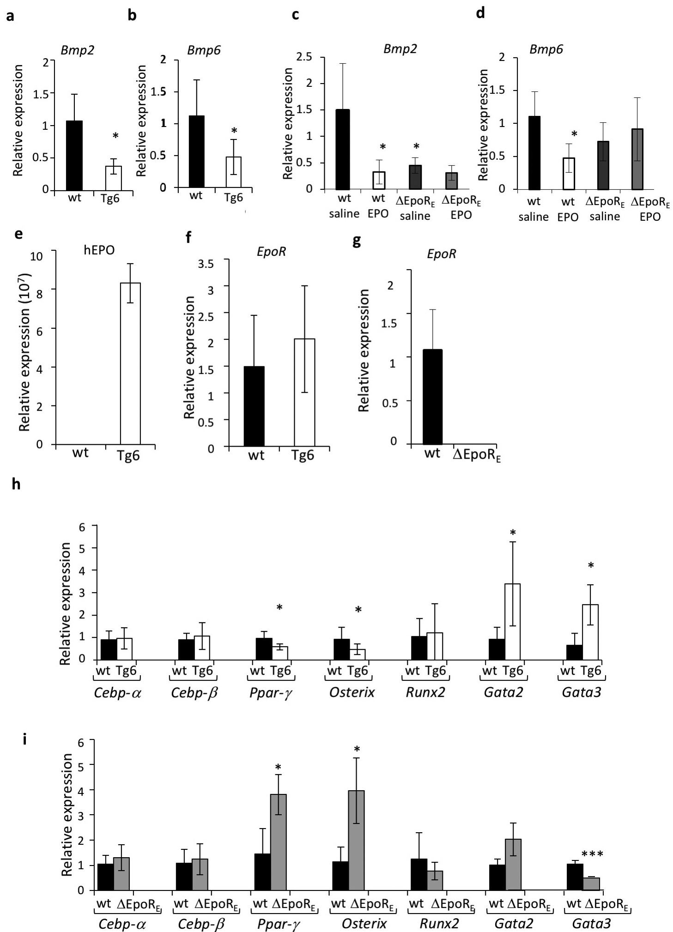

Suppl Figure 4: Bmp expression in bone marrow with EPO treatment and BMSC gene expression profile in Tg6 and ΔEpoR_{E} mice. (a-b) Real-time PCR quantitation of relative Bmp2 (a) and Bmp6 (b) mRNA in the whole bone marrow of wt and Tg6 mice. (c-d): Real-time PCR quantitation of expression of Bmp2 (c) and Bmp6 (d) levels in the whole bone marrow of wt and ΔEpoR_{E} mice treated with 1200U EPO/kg or saline for ten days. (e-f) Quantitation of hEPO (e) and Epor mRNA (f) levels by PCR in wt and Tg6 BMSCs. (g) Epor expression in wt and ΔEpoR_{E} BMSCs. (h-i): Quantification of transcription factors important in adipogenesis and osteogenesis in BMSCs isolated from wt littermate and Tg6 mice (h) and wt and ΔEpoR_{E} mice (i). (n=4-5/group, p<0.05).

Supplementary Figure 5
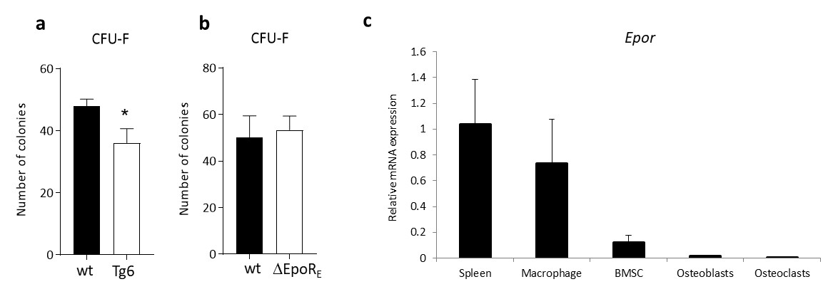

Suppl Figure 5: BMSC colony forming efficiency in Tg6 and ∆EpoR_{E} mice, and Epor expression in wt mice. (a-b) Colony forming efficiency of BMSCs was determined from the whole bone marrow using colony forming assay. (a) Number of colonies formed by wt and Tg6 mice (n=6/group) (b) Number of colonies formed by wt and ∆EpoR_{E} mice (n=5/group). (c) Real-time PCR quantitation of Epor mRNA expression in bone marrow macrophages, BMSCs, osteoblasts and osteoclasts relative to spleen.

