Supplementary Figure 3

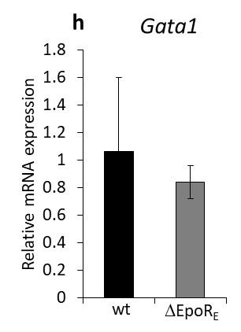
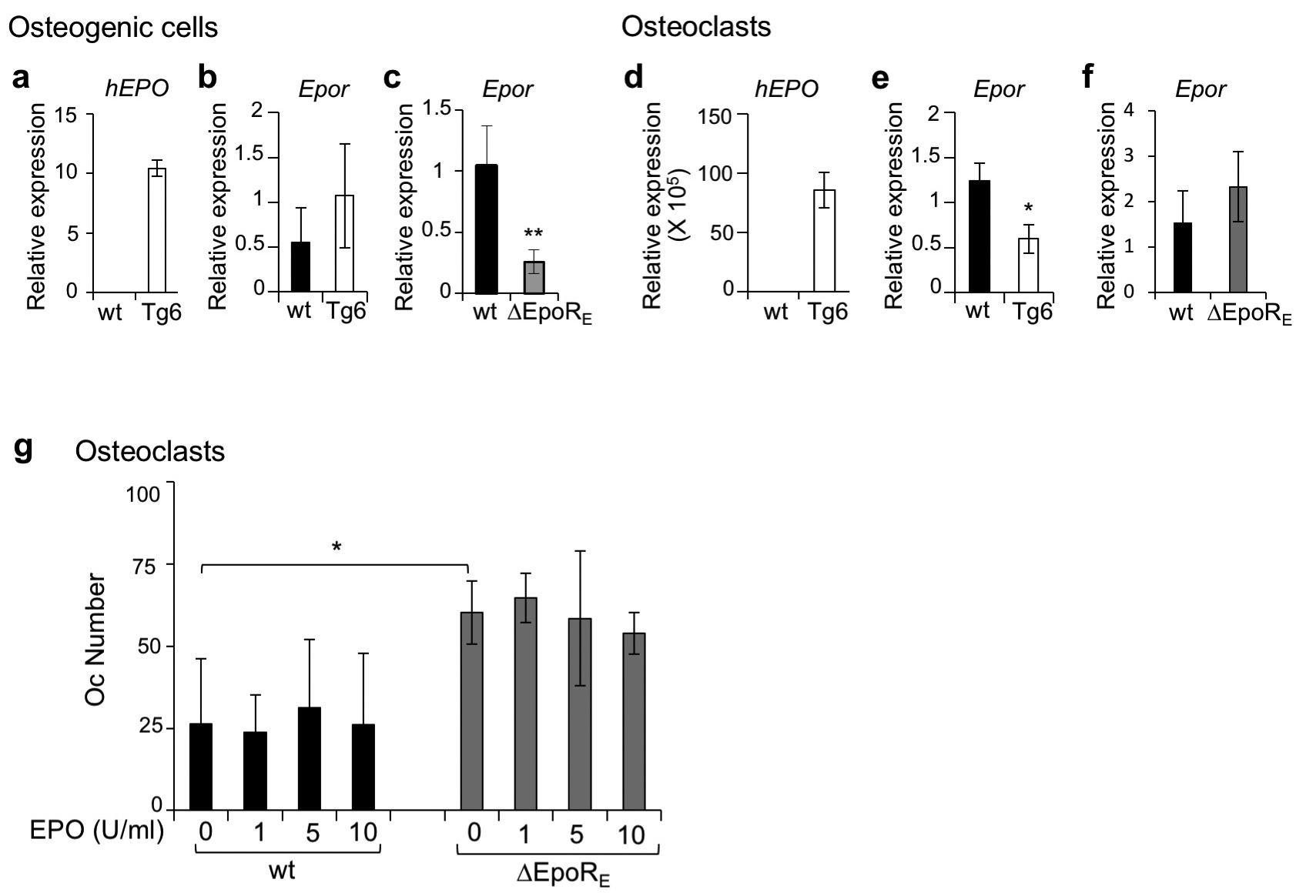

Suppl Figure 3: hEPO and Epor expression in osteogenic cells and osteoclasts, and osteoclast number in Tg6 and ΔEpoR_{E} mice. (a-c) Real-time PCR quantitation of hEPO (a) and Epor mRNA (b) in cultured wt and Tg6 osteogenic cells, and real time PCR quantification of Epor in wt and ΔEpoR_{E} osteogenic cells (c). (d-f) Real-time PCR quantitation of hEPO (d) and Epor mRNA (e) in cultured osteoclasts on day 4 of wt and Tg6 osteoclasts, and real time PCR quantification of EPOR in wt and ΔEpoR_{E} osteoclasts (f). (n=3-4/group, *p<0.05, **p<0.01). (g) Number of osteoclasts determined by TRAP staining in in vitro cultures of wild type and ΔEpoR_{E} osteoclast cultures treated with recombinant hEPO (1 U/ml, 5 U/ml and 10 U/ml EPO). (h) Real-time PCR quantitation of Gata1 mRNA in FACS sorted wt and ΔEpoR_{E} pre-osteoclasts.

