Supplementary Figure 4

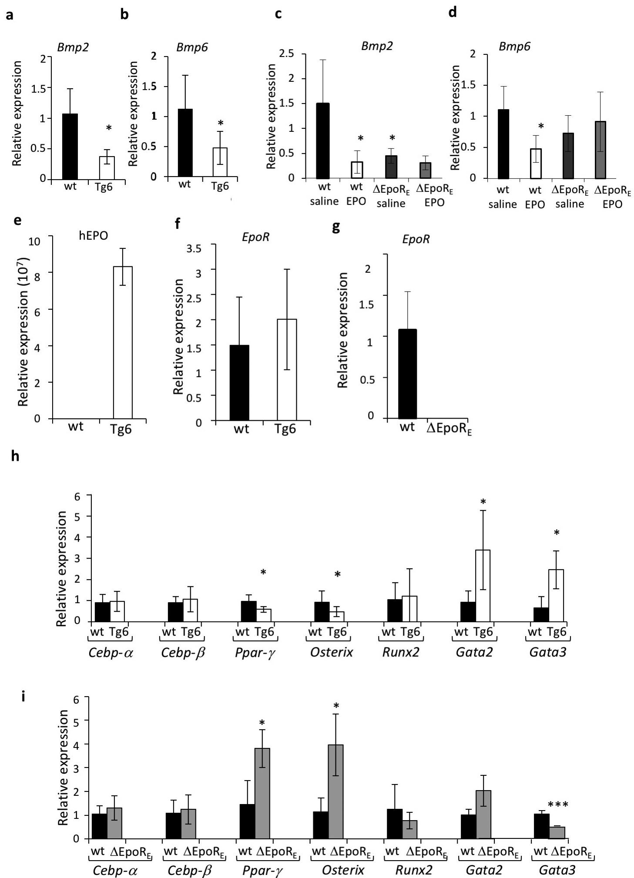

Suppl Figure 4: Bmp expression in bone marrow with EPO treatment and BMSC gene expression profile in Tg6 and ΔEpoR_{E} mice. (a-b) Real-time PCR quantitation of relative Bmp2 (a) and Bmp6 (b) mRNA in the whole bone marrow of wt and Tg6 mice. (c-d): Real-time PCR quantitation of expression of Bmp2 (c) and Bmp6 (d) levels in the whole bone marrow of wt and ΔEpoR_{E} mice treated with 1200U EPO/kg or saline for ten days. (e-f) Quantitation of hEPO (e) and Epor mRNA (f) levels by PCR in wt and Tg6 BMSCs. (g) Epor expression in wt and ΔEpoR_{E} BMSCs. (h-i): Quantification of transcription factors important in adipogenesis and osteogenesis in BMSCs isolated from wt littermate and Tg6 mice (h) and wt and ΔEpoR_{E} mice (i). (n=4-5/group, p<0.05).

