Supplementary Figure 5
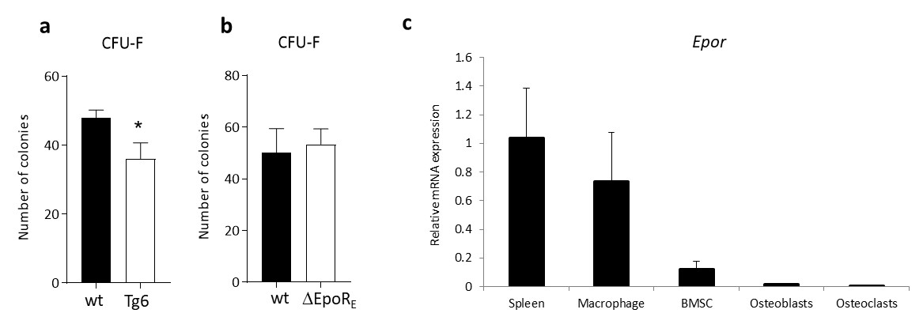

Suppl Figure 5: BMSC colony forming efficiency in Tg6 and ∆EpoR_{E} mice, and Epor expression in wt mice. (a-b) Colony forming efficiency of BMSCs was determined from the whole bone marrow using colony forming assay. (a) Number of colonies formed by wt and Tg6 mice (n=6/group) (b) Number of colonies formed by wt and ∆EpoR_{E} mice (n=5/group). (c) Real-time PCR quantitation of Epor mRNA expression in bone marrow macrophages, BMSCs, osteoblasts and osteoclasts relative to spleen.

