Supplementary Materials for

Sialylation of TLR2 Initiates Osteoclast Fusion
Ce Dou^{1,2}, Gehua Zhen¹, Yang Dan¹, Mei Wan¹, Nathachit Limjunyawong³, Yutong Wu ², Linda Liu⁴, Jianzhong Xu^{2*}, Shiwu Dong^{2*}, Xu Cao¹*
¹ Department of Orthopedic Surgery, Institute of Cell Engineering and Department of Biomedical Engineering, Johns Hopkins University School of Medicine, Baltimore, Maryland 21205, USA.
² Department of Orthopedics, Southwest Hospital, Third Military Medical University, Chongqing 400038, China.
³ The Solomon H. Snyder Department of Neuroscience, Johns Hopkins University School of Medicine, Baltimore, Maryland 21205, USA.
⁴ NextCure Inc, Beltsville, MD, USA.
*Correspondence to: Xu Cao: xcao11@jhmi.edu; Shiwu Dong: dongshiwu@tmmu.edu.cn; Jianzhong Xu: xujianzhong1962@163.com

This file includes:

Figures S1-S13
Supplementary texts
Figure S14-S20
References (58)

Supplementary Figures:

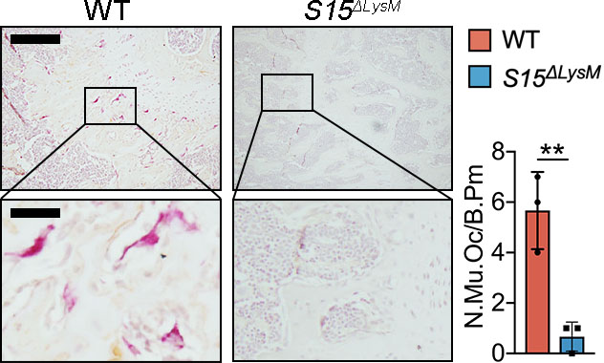
Supplementary Figure 1. TRAP stain of distal 11 wk-old Siglec15^{fl/fl} (WT) and Siglec15^{ΔLysM} mouse femur sections and quantification of multinuclear osteoclast number, n = 3. Bar represents 200 μm. Data represents Mean ± SD, statistically significant differences are indicated as ** (p < 0.01).

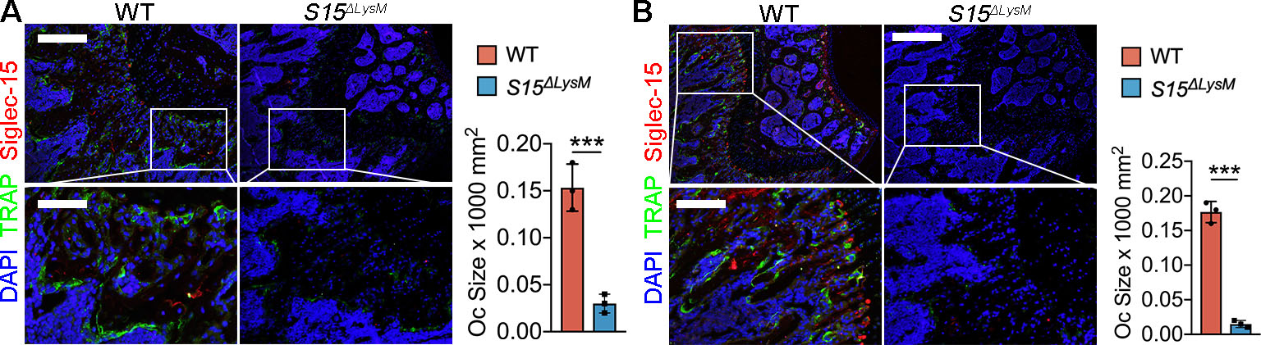
Supplementary Figure 2. Immunofluoresent stain of Siglec15 and TRAP of distal 4 wk-old (A) and 11 wk-old (B) Siglec15^{fl/fl} (WT) and Siglec15^{ΔLysM} mouse femur sections and quantification of osteoclast size, n = 3. Bar represents 200 μm. Data represents Mean ± SD, statistically significant differences are indicated as *** (p < 0.001).

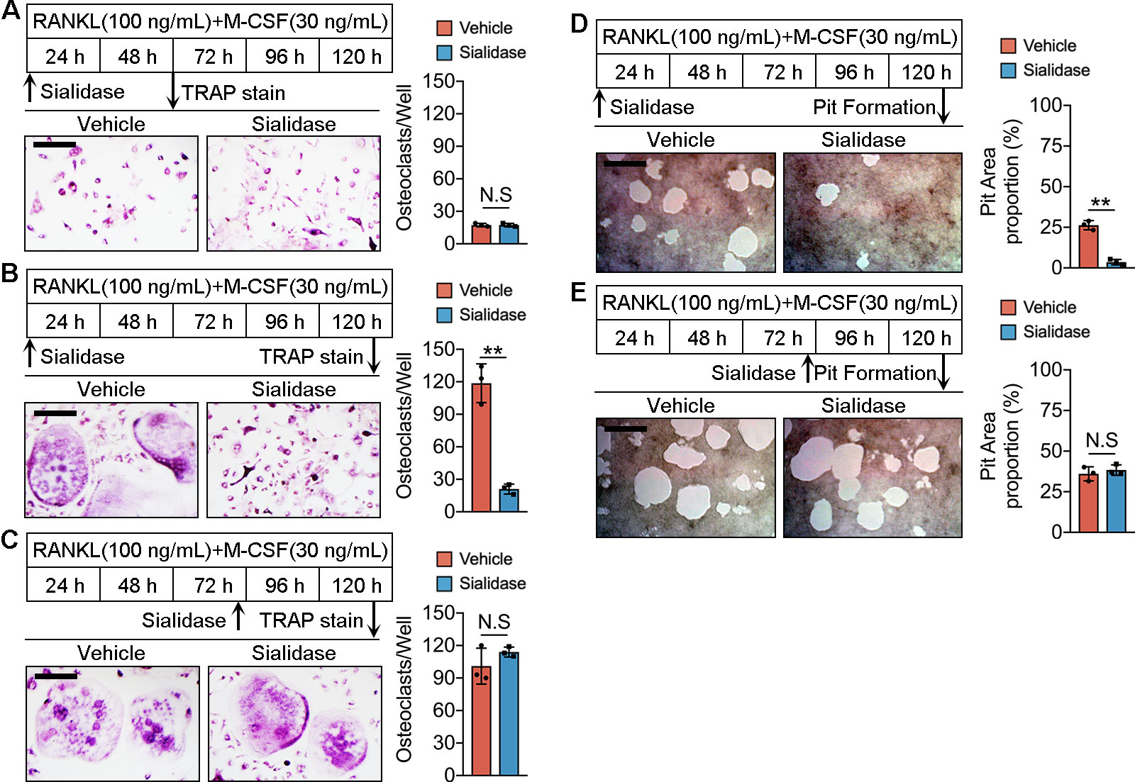
Supplementary Figure 3. WT BMMs were treated with vehicle or sialidase. Sialidase was treated at the beginning and TRAP stain was performed at 48 h (A) and 120 h (B). Sialidase was treated at 72 h and TRAP stain was performed at 120 h (C). Quantification of osteoclast number per well on the right. n = 3. Sialidase was treated at the beginning and pit formation was detected at 120 h (D), sialidase was treated at 72 h and pit formation was detected at 120 h (E). n = 3. Bar represents 100 μm. Data represents Mean ± SD, statistically significant differences are indicated as *** (p < 0.001).

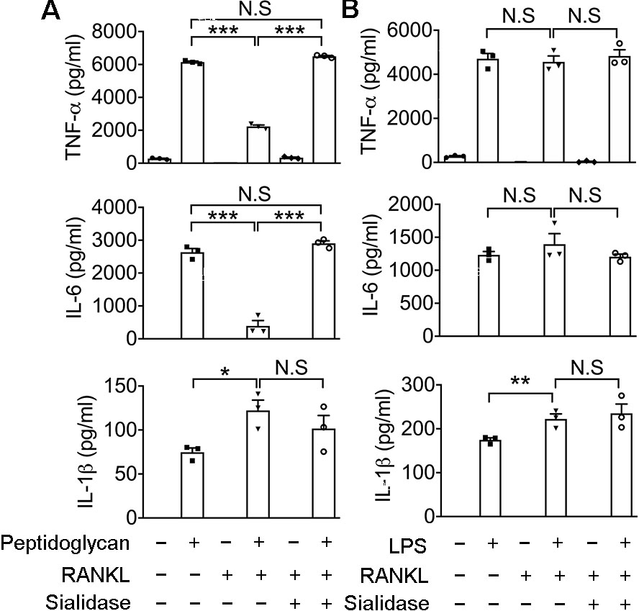
Supplementary Figure 4. ELISA detection of TNF-alpha, IL-6 and IL-1beta in WT BMMs treated with peptidoglycan (A) or LPS (B) as indicated. n = 3. Data represents Mean ± SD, statistically significant differences are indicated as *** (p < 0.001).

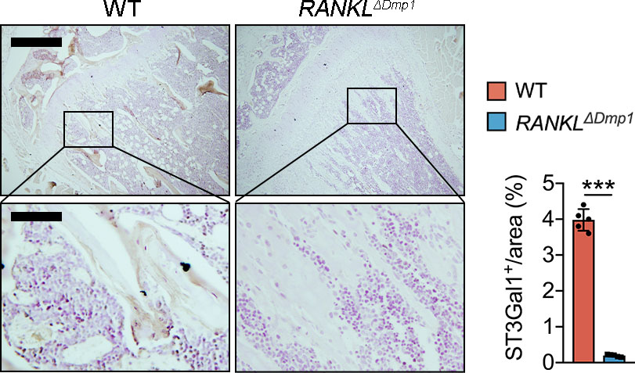
Supplementary Figure 5. Immunohistochemistry (IHC) staining of ST3Gal1 in RANKL^{fl/fl} and RANKL^{ΔDmp} mice distal femurs. Bar represents 200 μm. Quantification of ST3Gal1 positive area is shown on the right. n = 3. Data represents Mean ± SD, statistically significant differences are indicated as * (p < 0.05), *** (p < 0.001).

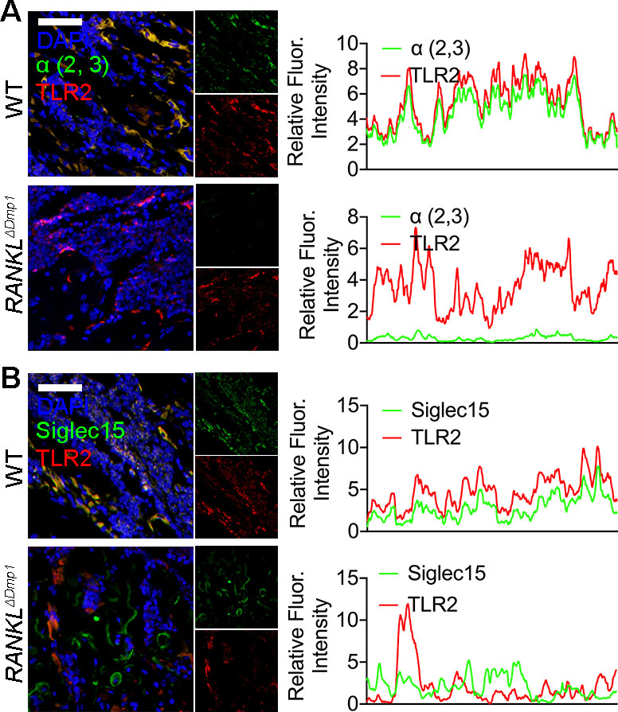
Supplementary Figure 6. (A) Immunostaining of α(2,3) and TLR2 of distal femur sections of RANKL^{fl/fl} and RANKL^{ΔDmp} mice and co-localization analysis of α(2,3) with TLR2. (B) Immunostaining of Siglec15 and TLR2 of distal femur sections of RANKL^{fl/fl} and RANKL^{ΔDmp} mice and co-localization analysis of Siglec15 with TLR2.

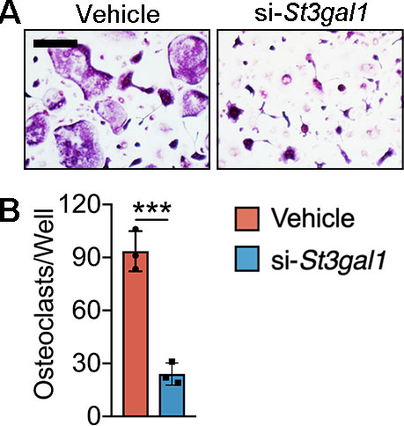
Supplementary Figure 7. (A) TRAP staining of RAW264.7 cells transfected with St3gal1 siRNA or vehicle before RANKL stimulation for 72 h. (B) Quantification of osteoclast number per well, n = 3. Data represents Mean ± SD, statistically significant differences are indicated as *** (p < 0.001).

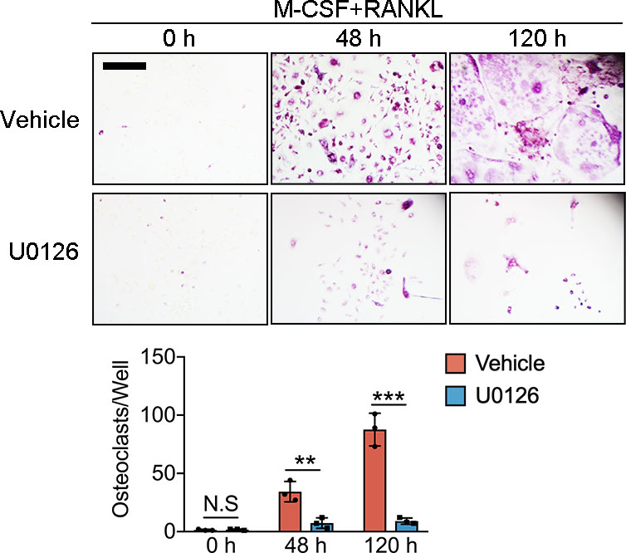
Supplementary Figure 8. TRAP stain of WT BMMs treated with vehicle or U0126 during osteoclastogenesis. Bar represents 100 μm. Quantification of osteoclast number per well. n = 3. Data represents Mean ± SD, statistically significant differences are indicated as *** (p < 0.001).

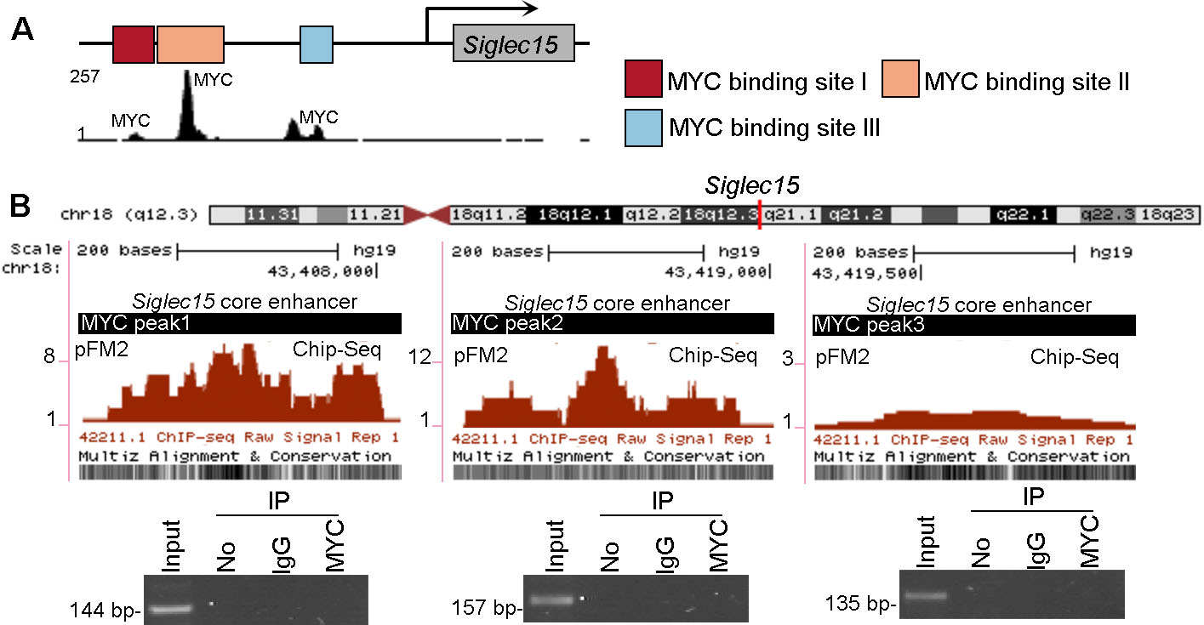
Supplementary Figure 9. (A) Three MYC recognition sites at the Siglec15 core enhancer. (B) chromatin immunoprecipitation (ChIP) assay validation of the direct MYC binding induced by GM-CSF.

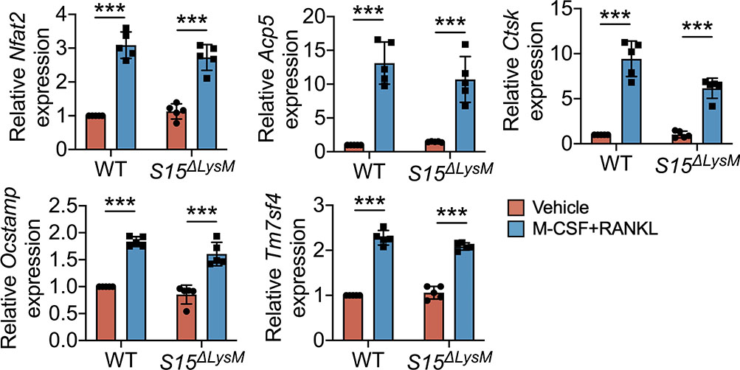
Supplementary Figure 10. Relative expression of Nfat2, Acp5, ctsk, oc-stamp and Tm7sf4 in WT and Siglec15^{ΔLysM} bone marrow macrophages treated with or without M-CSF+RANKL, n = 5. Data represents Mean ± SD, statistically significant differences are indicated as *** (p < 0.001).

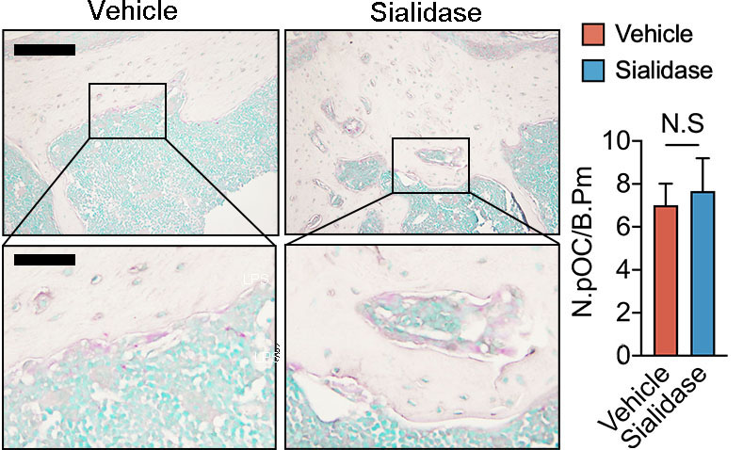
Supplementary Figure 11. TRAP staining of distal femur sections of Siglec15^{ΔLysM} mice intrafemorally injected with vehicle or sialidase and quantification of multinuclear osteoclast number, n = 3.

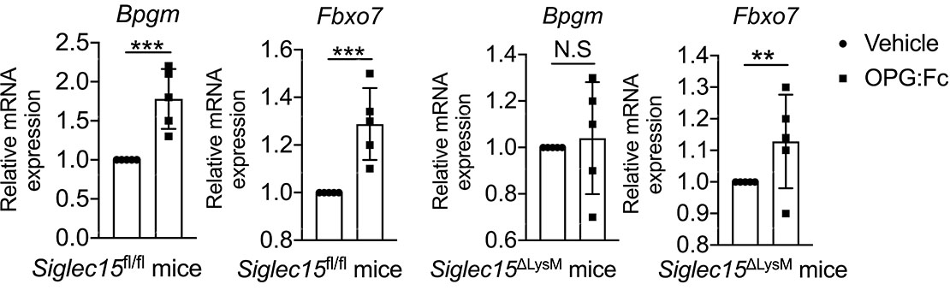
Supplementary Figure 12. Relative expression of osteomorph marker genes Bpgm and Fbxo7 in Siglec15^{fl/fl} and Siglec15^{ΔLysM} mice with or without OPG:Fc treatments, n = 5. Data represents Mean ± SD, statistically significant differences are indicated as ** (p < 0.01), *** (p < 0.001).

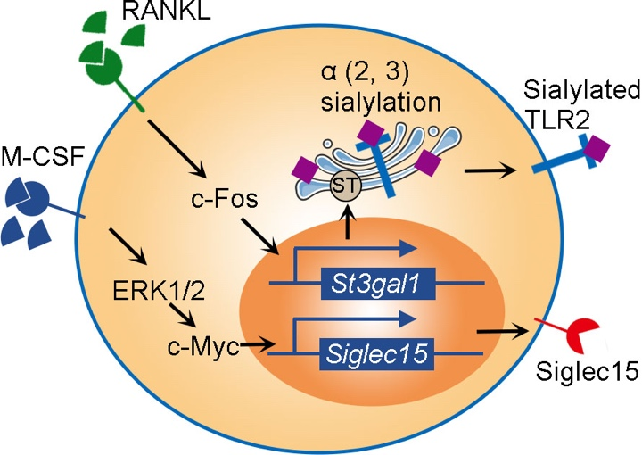
Supplementary Figure 13. Schematic diagram showing that Siglec15 is activated by M-CSF via ERK1/2-cMyc signaling and St3gal1 is activated by RANKL via c-Fos dependent pathway.

Supplementary Texts
To understand the detailed mechanism of Siglec15 regulating osteoclast formation, we incubated WT BMMs with biotinylated Siglec15 monoclonal antibody and manually separated Siglec15⁺ BMMs from Siglec15⁻ BMMs using anti-biotin microbeads and magnetic separators (Fig. S11A). Separated Siglec15⁺ and Siglec15⁻ BMMs were then stimulated with M-CSF and RANKL for osteoclastogenesis. Surprisingly, no significant difference was observed in osteoclast formation capacity between Siglec15⁺ and Siglec15⁻ BMMs (Fig. S12). One study reported that osteoclast fusion might be initiated by a small subset of progenitors ⁵⁸; therefore, we combined separated Siglec15⁺ BMMs with BMMs isolated from Siglec15^{ΔLysM} mice in different proportions (1%, 5%, and 10%). TRAP staining results showed that Siglec15⁺ BMMs failed to initiate osteoclast fusion in BMMs deficient of Siglec15 (Fig. S13). Furthermore, transwell culture showed that Siglec15⁺ BMMs also have no indirect effects on osteoclastogenesis of WT, Siglec15⁻, and Siglec15^{−/−} BMMs (Fig. S14). Immunofluorescent staining confirmed that Siglec15⁺ and Siglec15⁻ BMMs can form multinucleated osteoclasts with normal actin rings, and the expression of Siglec15 was restored in Siglec15⁻ BMMs during osteoclastogenesis (Fig. S15). Separated Siglec15⁻ BMMs were then cultured with M-CSF, and FCM analysis showed that Siglec15⁻ BMMs restored Siglec15 expression after 3 days of stimulation (Fig. S11B, C). BMMs cultured with RANKL alone, absent M-CSF, cannot survive during osteoclastogenesis (Fig. S11D, E). Immunofluorescent staining results showed that M-CSF stimulation significantly increased the proportion of Siglec15⁺ BMMs in Siglec15^{fl/fl} mice (Fig. S11F, G). We then tested the other CSF family member, granulocyte-macrophage CSF (GM-CSF, encoded by CSF2), and found that GM-CSF cannot induce osteoclastogenesis (Fig. S16) nor the expression of Siglec15 (Fig. S17).
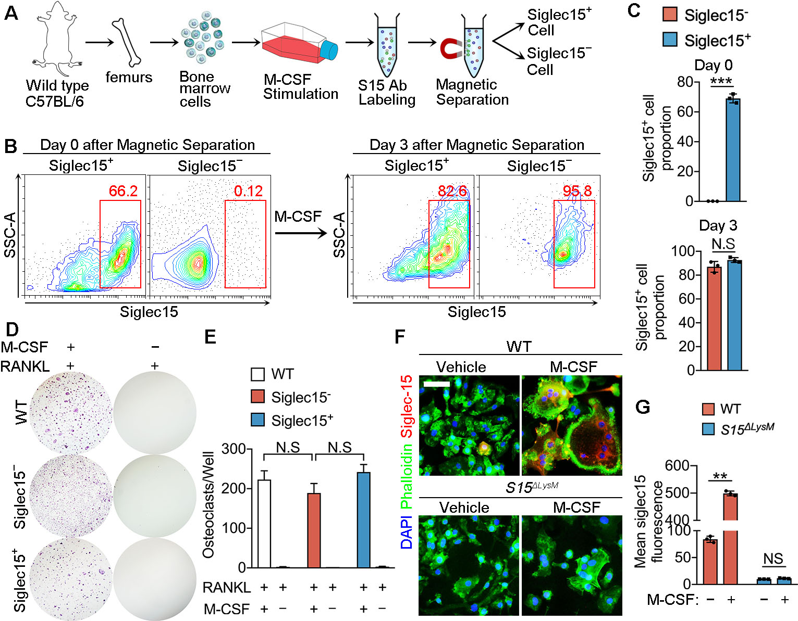
Supplementary Figure 14. Siglec15 expression is stimulated by M-CSF. (A) BMMs incubated with biotinylated Siglec15 monoclonal antibody were manually separated to Siglec15⁺ BMMs and Siglec15⁻ BMMs using anti-biotin microbeads and magnetic separators. (B) Flow cytometry analysis of WT and separated Siglec15− BMMs on day 0 and day 3 after treatment of M-CSF. (C) Quantification of Siglec15+ cell proportion. (D) TRAP stain of WT, Siglec15⁻ and Siglec15⁺ BMMs treated with M-CSF+RANKL or RANKL alone. (E) Site-directed mutagenesis of the MYC binding sites at Siglec15 core enhancer. (F) Quantification of osteoclast number per well. (G) Quantification of mean Siglec15 fluorescent intensity was shown on the right. n = 3. Data represents Mean ± SD, statistically significant differences are indicated as ** (p < 0.01), *** (p < 0.001).

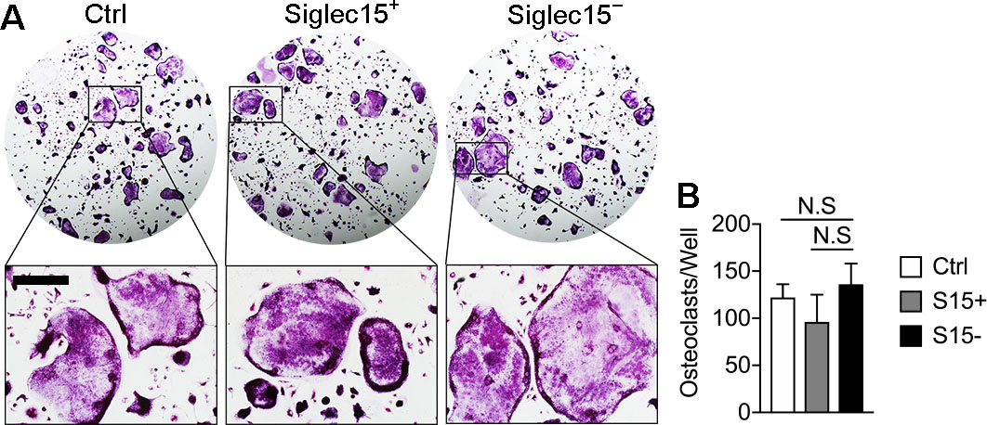
Supplementary Figure 15. (A) TRAP staining of Siglec15⁺ and Siglec15⁻ BMMs induced by RANKL and M-CSF. Bar represents 50 μm. (B) Quantification of osteoclast number per well, n = 3. Data represents Mean ± SD.

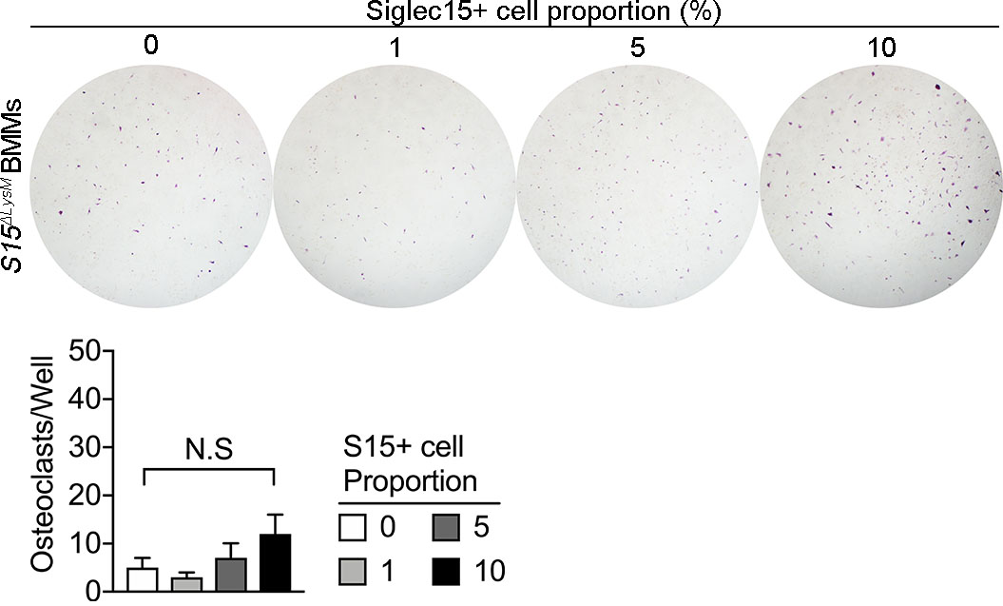
Supplementary Figure 16. TRAP stain of Siglec15^{ΔLysM} BMMs introduced with Siglec15⁺ BMMs of different proportion (0, 1%, 5%, 10%). Quantification of osteoclast number per well is shown below. n = 3. Data represents Mean ± SD.

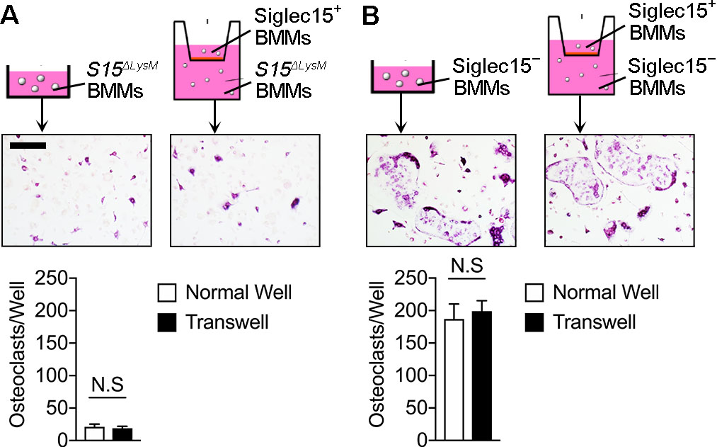
Supplementary Figure 17. (A) TRAP stain of Siglec15^{ΔLysM} BMMs in control wells or transwells co-incubated with Siglec15⁺ BMMs. Quantification of osteoclast number per well is shown below. Bar represents 50 μm. n = 3. Data represents Mean ± SD. (B) TRAP stain of Siglec15⁻ BMMs in control wells or transwells co-incubated with Siglec15⁺ BMMs. Quantification of osteoclast number per well is shown below. Bar represents 50 μm. n = 3. Data represents Mean ± SD.

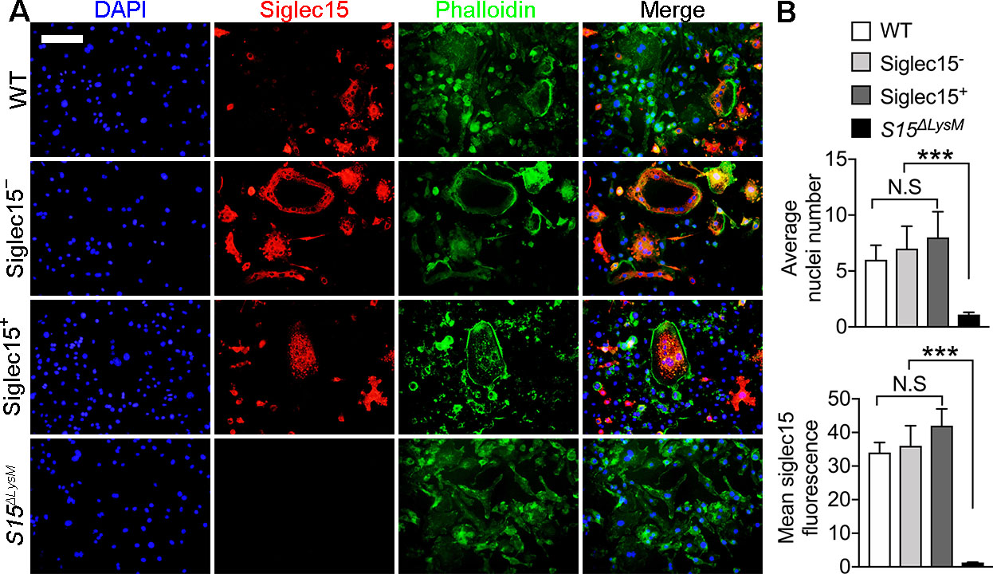
Supplementary Figure 18. (A) Immunostaining of Siglec15 and phalloidin in WT, Siglec15⁻, Siglec15⁺, and Siglec15^{ΔLysM} BMMs during osteoclastogenesis. Bar represents 50 μm. (B) Quantification of average nuclei number and mean siglec15 fluorescent intensity. Data represents Mean ± SD, statistically significant differences are indicated as *** (p < 0.001).

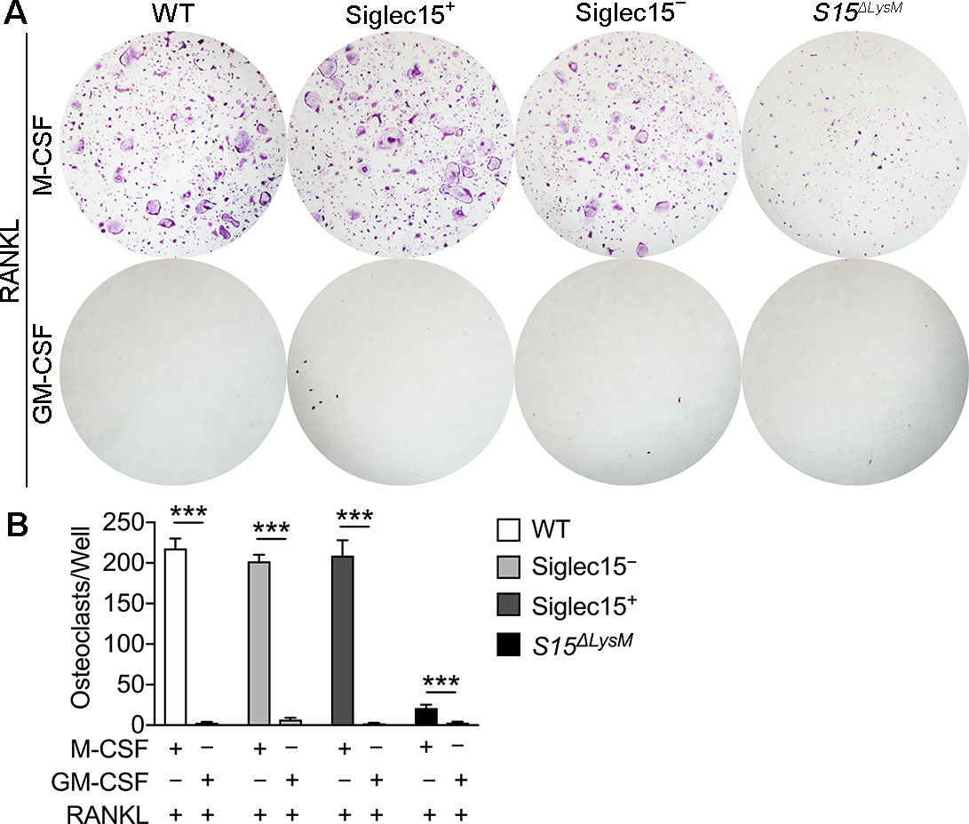
Supplementary Figure 19. (A) TRAP stain of WT, Siglec15⁻, Siglec15⁺, and Siglec15^{ΔLysM} BMMs induced with RANKL+M-CSF or RANKL+GM-CSF. (B) Quantification of osteoclast number per well on the right. n = 3. Data represents Mean ± SD, statistically significant differences are indicated as *** (p < 0.001).

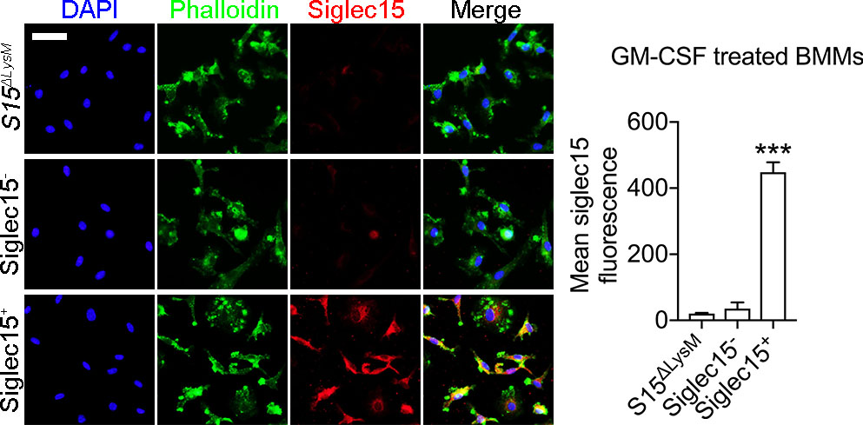
Supplementary Figure 20. Immunostaining of phalloidin and Siglec15 in Siglec15⁻, Siglec15⁺, and Siglec15^{ΔLysM} BMMs treated with GM-CSF. Quantification of mean Siglec15 fluorescence is shown on the right. Bar represents 50 μm. n = 3. Data represents Mean ± SD, statistically significant differences are indicated as *** (p < 0.001).

References
58. N. Levaot et al., Osteoclast fusion is initiated by a small subset of RANKL-stimulated monocyte progenitors, which can fuse to RANKL-unstimulated progenitors. Bone 79, 21-28 (2015).

