Supplementary Figure S1:
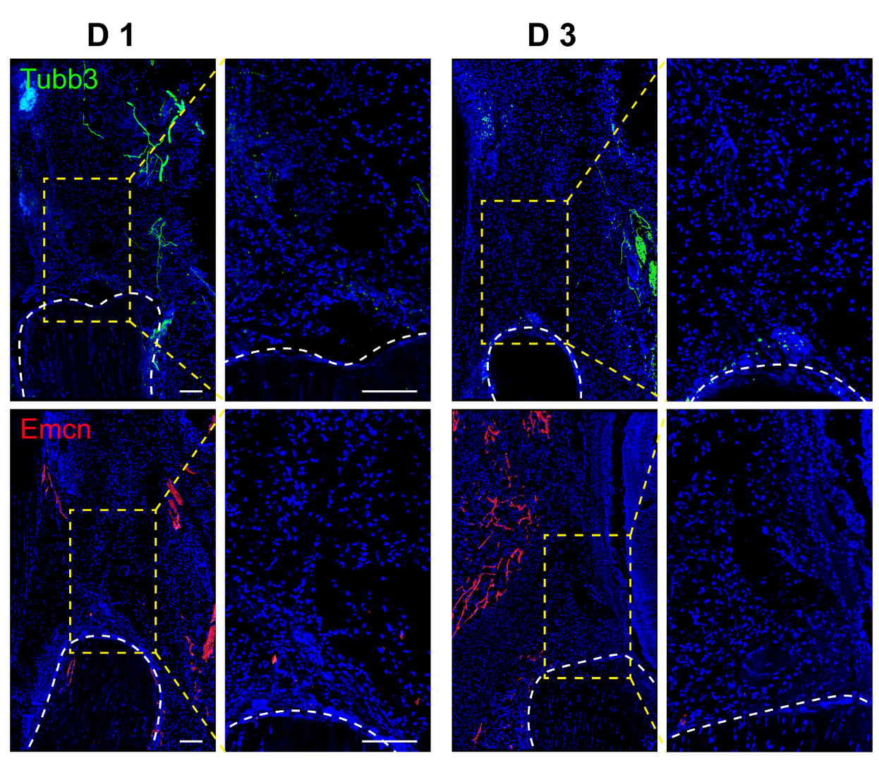
Supplementary Fig. 1. Tubb3 and Emcn immunostaining inset following injury site at D1 and D3. White dished line: tendon. Yellow box: high magnification inset. Scale bar: 100 μm.

Supplementary Figure S2:
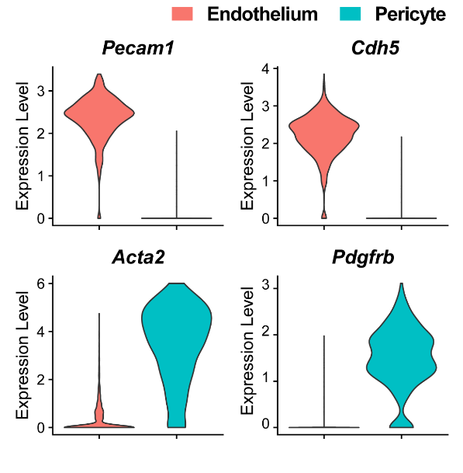
Supplementary Fig. 2. Violin plots of characteristic markers identifying endothelial cells and pericytes within the HO induction site. Shown in relation to data in Figure 1E. Cells pooled from the tendon injury site at D0, 7 and 21. N=3 animals per timepoint. Pecam1 (Platelet endothelial cell adhesion molecule 1), Cdh5 (Cadherin 5), Acta2 (Actin alpha 2), Pdgfrb (Platelet-derived growth factor receptor beta).

Supplementary Table S1: Primers used
Genes | Forward (5’-3’) | Reverse (5’-3’)
Anxa3 | ATGGCCTCTATCTGGGTTGGA | CAAGTCCTCTGATCGCTTTCC
Fgf1 | TTATACGGCTCGCAGACACC | TCTGGCCATAGTGAGTCCGA
Fgf18 | CTGCGCTTGTACCAGCTCTAT | GACTCCCGAAGGTATCTGTCT
Mmp9 | GGACCCGAAGCGGACATTG | CGTCGTCGAAATGGGCATCT
Pdgfa | TGGCTCGAAGTCAGATCCACA | TTCTCGGGCACATGGTTAATG
Pdgfb | CATCCGCTCCTTTGATGATCTT | GTGCTCGGGTCATGTTCAAGT
Pdgfc | GCCAAAGAACGGGGACTCG | AGTGACAACTCTCTCATGCCG
Pdgfd | ATGCAACGGCTCGTTTTAGTC | CGGAGTCGCAAAAGTGTCC
Pgf | AGTGGAAGTGGTGCCTTTCAA | GTGAGACACCTCATCAGGGTA
Sema5a | GACTTGCTAGGCCCGAGAC | TCTGAACTCCCGTAACCAGGG
Vegfa | CGGGCCTCGGTTCCA | GCAGCCTGGGACCACTTG
Vegfb | GCCAGACAGGGTTGCCATAC | GGAGTGGGATGGATGATGTCAG
Vegfc | GTGAGGTGTGTATAGATGTGGGG | ACGTCTTGCTGAGGTAACCTG
Vegfd | CCTGGGACAGAAGACCACTC | TGAGATCTCCCGGACATGGT
Wnt5a | CAACTGGCAGGACTTTCTCAA | CCTTCTCCAATGTACTGCATGTG
Gapdh | CTGGGCTACACTGAGCACC | AAGTGGTCGTTGAGGGCAATG

Supplementary Table S2: Antibodies used.
Antibody | Company | Catalog #
Rabbit anti-CD146 | Abcam | ab75769
Rabbit anti-CD31 | Abcam | ab28364
Rat anti-EMCN | Santa Cruz | sc-65495
Rabbit anti-FGF18 | Thermo Fisher | 11495-1-AP
Mouse anti-PDGFC | R&D Systems | AF1447
Rabbit anti-TUBB3 | Abcam | ab18207
Mouse anti-VEGFA | Abcam | ab1316
Rabbit anti-VEGFD | Abcam | ab155288
Goat anti-Mouse AF488 | Abcam | ab150117
Goat anti-Rabbit AF488 | Abcam | ab150077
Goat anti-Rabbit DyLight 594 | Vector Laboratories | DI-1594
Goat anti-Mouse AF647 | Abcam | ab150119
Goat anti-Rabbit AF647 | Abcam | ab150079
Goat anti-Rat AF594 | Abcam | ab150160

