Runx1 is a key regulator of articular cartilage homeostasis by orchestrating YAP, TGFβ, and Wnt signaling in articular cartilage formation and osteoarthritis
Running title: Function of Runx1 in articular cartilage formation and OA
Yan Zhang^{1,2,#}, Tao Zuo^{1, 3,#}, Abigail McVicar⁴, Hui-Lin Yang³, Yi-Ping Li^{1,4*}, Wei Chen^{1,4*}

Supplemental Figures

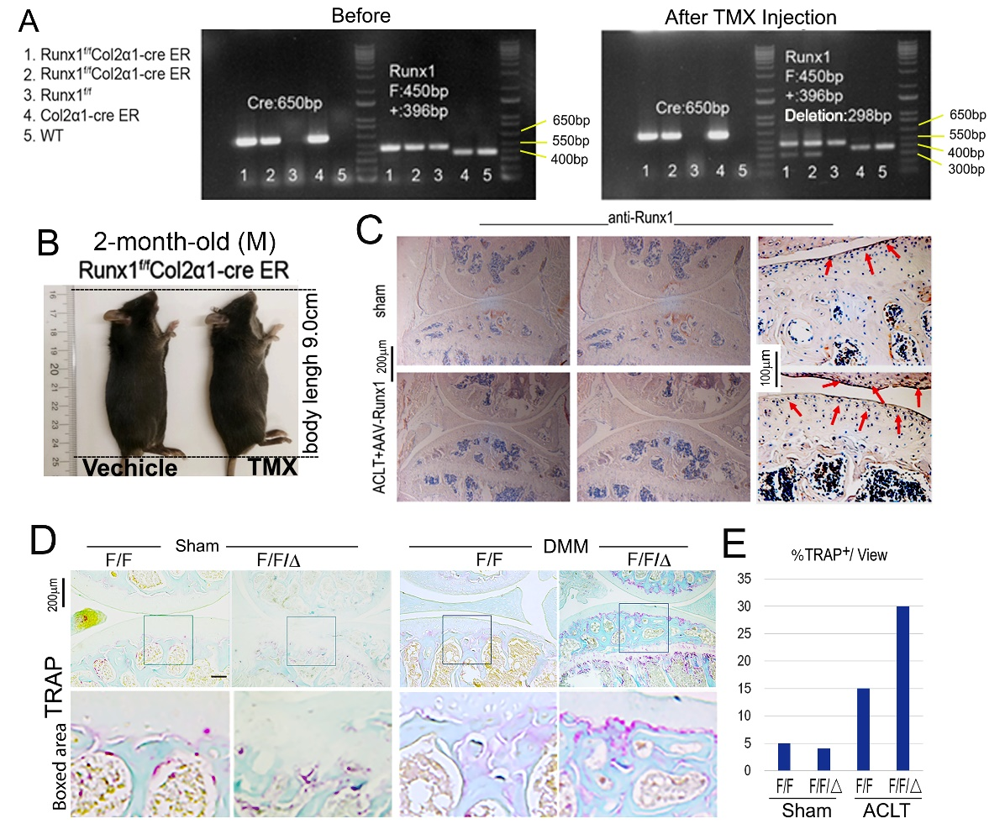
Supplemental Figure 1. Genotyping and Body lengths of Runx1^{f/f} Col2α1-Cre ER mice, TRAP staining for knee joint of Runx1^{f/f} Col2α1-Cre mice. (A) Gel images of PCR genotyping for Runx1^{f/f} Col2α1-Cre ER mice before and after tamoxifen (TMX) induction. (B) Body lengths from 2 month-old male Runx1^{f/f} Col2α1-Cre ER mice induced by vehicle (control) and TMX. (C) Anti-Runx1 immunohistochemistry staining. (D) TRAP staining for knee joint of 3-month-old mice after sham or DMM surgery in Runx1^{f/f} Col2α1-Cre mice. Bar: 200 μm and 100 μm. (E) Quantification of TRAP⁺ cells in D as % TRAP⁺ cells/view.

Supplemental Figure 2. Femur and tibia lengths of Runx1^{f/f} Col2α1-Cre ER mice. X-ray images of 8-month-old WT and Runx1^{f/f} Col2α1-Cre ER mice induced by vehicle (Oil) and TMX, and quantification of tibia and femur lengths. Results are presented as mean ± SD; ns, not significant.

Supplemental Figure 3. RNA-sequencing analysis showing differentially expressed genes in Runx1^{f/f} Col2α1-Cre ER mice knee joint, and chondrocyte genes expression in Runx1-deficiency cartilage. (A) Volcano plot illustrating differentially regulated gene expression in knee joints from RNA-seq analysis between control (WT) and Runx1^{f/f} Col2α1-Cre ER mice treated with TMX. (B) Pie chart for differentially regulated genes expression in knee joint of Runx1^{f/f} Col2α1-Cre ER mice treated with TMX. Percentage of genes upregulated and downregulated are shown in red and green, respectively. (C) Heatmap for chondrocyte related genes expression in (1) hip cartilage of Runx1^{f/f} mice and (2) hip cartilage of Runx1^{f/f} Col2α1-Cre mice.

