Figure 1 Supplemental, Panel A.
Kaplan-Meier display of progression free survival - PP population, Trabectedin Arm

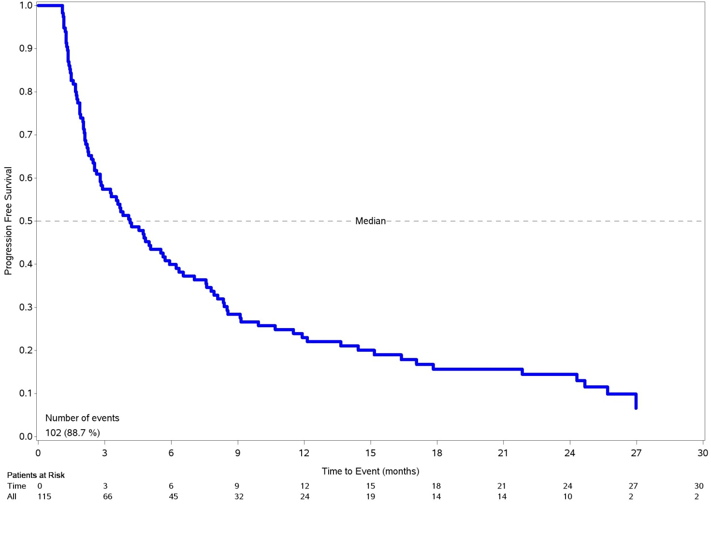

Figure 1 Supplemental, Panel B.
Kaplan-Meier display of overall survival - PP population, Trabectedin Arm

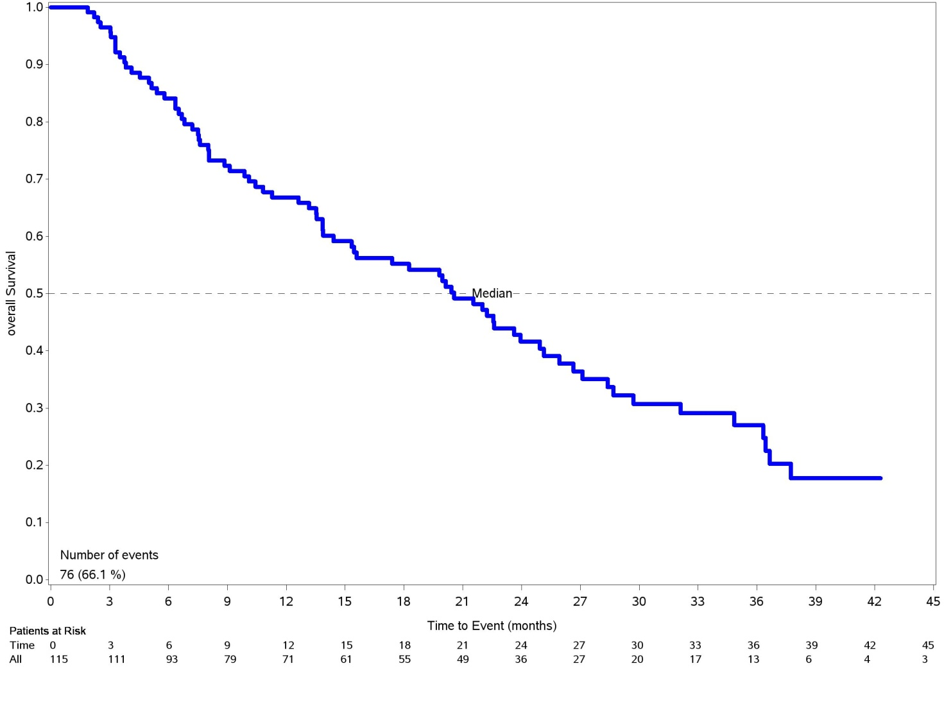

Supplementary Table 1 Tumor characteristics at first diagnosis and prior treatments - PP population
Gemcitabine+Docetaxel
N=38
Stage at first diagnosis - n (%)
IA | 7 (18.4)
IB | 14 (36.8)
IIA | 2 (5.3)
IIB | 4 (10.5)
IIIA | 2 (5.3)
IIIB | 1 (2.6)
IVA | 4 (10.5)
IVB | 4 (10.5)
Surgery for primary disease - n (%) | 38 (100)
Total abdominal hysterectomy+  bilateral salpingo oophorectomy | 29 (76.3)
Hysterectomy | 9 (23.7)
Lymphadenectomy - n (%) | 11 (28.9)
Adjuvant radiotherapy - n (%) | 8 (21.1)
Site of external beam radiotherapy - n (%)
Pelvic | 8 (100)
Chemotherapies - n (%)
Only adjuvant | 24 (63.2)
Only first line | 13 (34.2)
First and second line | 1 (2.6)
Adjuvant chemotherapy - n (%) | 24 (63.2)
Anthracyclines | 24 (100)
First line chemotherapy - n (%) | 14 (36.8)
Anthracyclines | 14 (100)
Second line chemotherapy - n (%) | 1 (2.6)
Anthracyclines | 1 (100)

Supplementary Table 2 Tumor characteristics at baseline - PP population
Gemcitabine+Docetaxel
N=38
Status of disease at study entry - n (%)
Progression | 21 (55.3)
Recurrence | 17 (44.7)
Persistent | 0 (0.0)
Site of disease at study entry - n (%)
Only pelvic | 4 (10.5)
Only distant metastasis | 18 (47.4)
1 site of metastasis | 12 (66.7)
2 sites of metastasis | 4 (22.2)
3 sites of metastasis | 1 (5.6)
>3 sites of metastasis | 1 (5.6)
Pelvic plus distant metastasis | 16 (42.1)
1 site of metastasis | 8 (50.0)
2 sites of metastasis | 3 (18.8)
3 sites of metastasis | 3 (18.8)
>3 sites of metastasis | 2 (12.5)
Peritoneum - n (%) | 15 (39.5)
Liver - n (%) | 7 (18.4)
Spleen - n (%) | 1 (2.6)
Lung - n (%) | 20 (52.6)
Bone - n (%) | 2 (5.3)
Intra-Abdominal Lymph nodes - n (%) | 5 (13.2)
Extra-Abdominal Lymph nodes - n (%) | 2 (5.3)
Abdominal wall - n (%) | 4 (10.5)
Other- n (%) | 3 (7.9)

