Supplementary Tables and/or Figures
Table S1. Primers and Universal Probe Library (UPL) hydrolysis probe number used for qPCR analysis.

Gene | 5' - 3' Sequence | UPL Probe
KLK4 | L: ATGGCCACAGCAGGAAAT | #45
 | R: CTACCAGAGACGAGCGATCC
KLK5 | L: AAGGCCCAACCAGCTCTACT | #4
 | R: CCGAGACGGACTCTGAAAAC
KLK6 | L: TGGTGCTGAGTCTGATTGCT | #82
 | R: CGCCATGCACCAACTTATT
KLK7 | L: CCTGCTCAGTGGCAATCA | #86
 | R: GGTGCACGGTGTACTCATTC
MSN | L: AAGTTGCTCCCGCAGAGA | #52
 | R: TGTTCCTCATGCCACACCT
KRT19 | L: GCCACTACTACACGACCATCC | #71
 | R: CAAACTTGGTTCGGAAGTCAT
COL5A2 | L: ACAGGGTTTACAAGGACAGCA | #79
 | R: GGTCCAGGATCACCAGGTT
COL1A2 | L: CTGGAGAGGCTGGTACTGCT | #79
 | R: AGCACCAAGAAGACCCTGAG
BMP5 | L: AATCCAGCTCTCATCAGGACTC | #47
 | R: CAGGCTTGTTTTTGCTCACTT
F10 | L: AGATTCAAGGTGAGGGTAGGG | #15
 | R: GACCACCTCCACCTCGTG
KRT7 | L: CAGGCTGAGATCGACAACATC | #24
 | R: CTTGGCACGAGCATCCTT
JUNB | L: ATACACAGCTACGGGATACGG | #49
 | R: GCTCGGTTTCAGGAGTTTGT
BMP4 | L: CTGCAACCGTTCAGAGGTC | #17
 | R: TGCTCGGGATGGCACTAC
MMP1 | L: GCTAACCTTTGATGCTATAACTACGA | #7
 | R: TTTGTGCGCATGTAGAATCTG
HPRT1 | L: TGACCTTGATTTATTTTGCATACC | #73
 | R: CGAGCAAGACGTTCAGTCCT

Table S2. Antibodies used for Western blot analyses (WB), immunofluorescence (IF) and immunohistochemistry (IHC).

Antibody name | Catalogue number, company,  stock concentration | Dilution
Antibody name | Catalogue number, company,  stock concentration | WB | IF | IHC
Rabbit anti-human moesin,  polyclonal | HPA011135, Sigma-Aldrich,  0.1 mg/ml | 1:1,000 | 1:50 | 1:200
Rabbit anti-human JUNB,  polyclonal | HPA019149, Sigma-Aldrich,  0.3 mg/ml | 1:1,000 | 1:200 | 1:50
Mouse anti-human keratin 19,  monoclonal | ab52625, Abcam,  1 mg/ml | 1:1,000 | 1:200 | 1:200
Rabbit anti-human keratin 7,  monoclonal | ab68459, Abcam,  1 mg/ml | 1:500 | 1:100 | 1:100
Mouse anti-human GAPDH,  monoclonal | MAB374, Chemicon,  1 mg/ml | 1:2,000
Rabbit anti-human KLK4,  polyclonal | pAb587ª |  |  | 1:200
ª Yang et al. 2017

Table S3. KLK4-7 gene expression in OV-KLK4-7 cells determined by qPCR and genome-wide RNA microarray analysis.

Gene | qPCR  mean ± SD | Genome-wide RNA microarray  fold-change (p-value)
KLK4 | 57.3 ± 6.1 | 2.2 (1.25E-05)
KLK5 | 603.3 ± 40.7 | 6.2 (3.78E-03)
KLK6 | 41.4 ± 4.6 | 2.9 (1.65E-04)
KLK7 | 339.4 ± 39.8 | 1.4 (7.25E-02)

Table S4. Genes displaying a greater than two-fold deregulation in OV-KLK4-7 compared to OV-VC cells using TGFβ, PAR and EMT PCR arrays. Red numbers indicate upregulation and blue numbers downregulation of the respective gene. The expression of the genes showing the highest deregulation, highlighted with grey background, were validated by qPCR (see Figure 1). Quality of gene expression is indicated as OKAY (the gene's threshold cycle is <30 in both OV-KLK4-7 and OV-VC cells), A (the gene's threshold cycle is 30-35 in either OV-KLK4-7 or OV-VC cells, and <30 in the other sample) and B (the gene's threshold cycle is 30-35 in both OV-KLK4-7 and OV-VC cells). Four endogenous control genes (HPRT1, RPL13A, GAPDH, ACTB), present on the PCR arrays, were used for normalization.

Gene | Name | Fold  change | Quality | PCR  array
BAMBI | BMP and activin membrane-bound inhibitor homolog | -4.2 | OKAY | TGFβ
BMP5 | Bone morphogenetic protein 5 | 20.3 | OKAY | TGFβ
EMP1 | Epithelial membrane protein 1 | -4.3 | OKAY | TGFβ
ID1 | Inhibitor of DNA binding 1 | -5.5 | OKAY | TGFβ
ID2 | Inhibitor of DNA binding 2 | -5.5 | OKAY | TGFβ
IL6 | Interleukin 6 (interferon, beta 2) | -5.5 | OKAY | TGFβ
TGFBI | Transforming growth factor, beta-induced, 68kDa | -6.6 | OKAY | TGFβ
TGFBR2 | Transforming growth factor, beta receptor II | -4.1 | OKAY | TGFβ
JUNB | Jun B proto-oncogene | -6.4 | OKAY | TGFβ
ACVRL1 | Activin A receptor type II-like 1 | 2.1 | OKAY | TGFβ
BMP6 | Bone morphogenetic protein 6 | -2.5 | OKAY | TGFβ
HERPUD1 | Homocysteine-inducible, endoplasmic reticulum stress-inducible, ubiquitin-like domain member 1 | -2.2 | OKAY | TGFβ
PLAU | Plasminogen activator, urokinase | -2.0 | OKAY | TGFβ
SMAD3 | SMAD family member 3 | -2.2 | OKAY | TGFβ
TGIF1 | TGFβ-induced factor homeobox 1 | -2.5 | OKAY | TGFβ
THBS1 | Thrombospondin 1 | -3.5 | OKAY | TGFβ
KLHL24 | Kelch-like 24 (Drosophila) | -2.7 | OKAY | TGFβ
NOV | Nephroblastoma overexpressed gene | -3.4 | OKAY | TGFβ
SMAD6 | SMAD family member 6 | -2.1 | OKAY | TGFβ
BMP4 | Bone morphogenetic protein 4 | -12.2 | A | TGFβ
CHRD | Chordin | -3.5 | A | TGFβ
COL1A2 | Collagen, type I, alpha 2 | 41.6 | A | TGFβ
EGR2 | Early growth response 2 | -26.4 | A | TGFβ
LTBP1 | Latent TGFβ binding protein 1 | -14.7 | A | TGFβ
PDGFB | Platelet-derived growth factor beta polypeptide | -5.8 | A | TGFβ
SMAD7 | SMAD family member 7 | -5.9 | A | TGFβ
SOX4 | SRY (sex determining region Y)-box 4 | -2.7 | A | TGFβ
BMP2 | Bone morphogenetic protein 2 | 4.6 | B | TGFβ
BMPER | BMP binding endothelial regulator | -5.2 | B | TGFβ
GDF5 | Growth differentiation factor 5 | -2.9 | B | TGFβ
GDF7 | Growth differentiation factor 7 | -2.3 | B | TGFβ
KANK4 | KN motif and ankyrin repeat domains 4 | -2.3 | B | TGFβ
EGR1 | Early growth response 1 | -6.1 | OKAY | PAR
ICAM1 | Intercellular adhesion molecule 1 | -6.1 | OKAY | PAR
JUNB | Jun B proto-oncogene | -12.1 | OKAY | PAR
THBS1 | Thrombospondin 1 | -6.1 | OKAY | PAR
CTGF | Connective tissue growth factor | -3.0 | OKAY | PAR
CYR61 | Cysteine-rich, angiogenic inducer, 61 | -3.0 | OKAY | PAR
F2R | Coagulation factor II (thrombin) receptor | -3.0 | OKAY | PAR
HBEGF | Heparin-binding EGF-like growth factor | 2.6 | OKAY | PAR
HMGCR | 3-hydroxy-3-methylglutaryl-CoA reductase | 2.6 | OKAY | PAR
IL6 | Interleukin 6 (interferon, beta 2) | -3.0 | OKAY | PAR
ITGB1 | Integrin, beta 1 | -3.0 | OKAY | PAR
PLAU | Plasminogen activator, urokinase | -3.0 | OKAY | PAR
PTPN11 | Protein tyrosine phosphatase, non-receptor type 11 | 2.6 | OKAY | PAR
SERPINB5 | Maspin | -3.0 | OKAY | PAR
TNF | Tumor necrosis factor | -3.0 | OKAY | PAR
TP53 | Tumor protein p53 | 2.6 | OKAY | PAR
CSF2 | Colony stimulating factor 2 | -12.1 | A | PAR
F10 | Coagulation factor X | 10.6 | A | PAR
MMP1 | Matrix metallopeptidase 1 | -12.1 | A | PAR
F2RL2 | Coagulation factor II (thrombin) receptor-like 2 | 5.3 | B | PAR
IL13 | Interleukin 13 | 2.6 | B | PAR
ITGAM | Integrin, alpha M | -3.0 | B | PAR
SERPINB2 | Plasminogen activator inhibitor-2 (PAI-2) | 2.6 | B | PAR
CAMK2N1 | Endogenous inhibitor of CAMKII | -7.3 | OKAY | EMT
COL5A2 | Collagen, type V, alpha 2 | 71.0 | OKAY | EMT
FN1 | Fibronectin 1 | -6.0 | OKAY | EMT
RGS2 | Regulator of G-protein signaling 2, 24kDa | -5.1 | OKAY | EMT
TSPAN13 | Tetraspanin 13 | -4.7 | OKAY | EMT
AHNAK | AHNAK nucleoprotein | 3.8 | OKAY | EMT
DSP | Desmoplakin | 2.6 | OKAY | EMT
FZD7 | Frizzled family receptor 7 | -2.1 | OKAY | EMT
IGFBP4 | Insulin-like growth factor binding protein 4 | -2.9 | OKAY | EMT
ITGAV | Integrin, alpha V | -3.4 | OKAY | EMT
ITGB1 | Integrin, beta 1 | -2.0 | OKAY | EMT
JAG1 | Jagged 1 | -2.2 | OKAY | EMT
PLEK2 | Pleckstrin 2 | 2.6 | OKAY | EMT
TIMP1 | TIMP metallopeptidase inhibitor 1 | -2.1 | OKAY | EMT
COL1A2 | Collagen, type I, alpha 2 | 69.6 | A | EMT
DSC2 | Desmocollin 2 | -3.3 | A | EMT
KRT19 | Keratin 19 | 347.3 | A | EMT
KRT7 | Keratin 7 | -1038.3 | A | EMT
MSN | Moesin | 396.2 | A | EMT
SNAI1 | Snail homolog 1 | -3.1 | A | EMT
STEAP1 | Six transmembrane epithelial antigen prostate 1 | -35.3 | A | EMT
WNT5B | Wnt-5b | -26.7 | A | EMT
MMP3 | Matrix metallopeptidase 3 (stromelysin 1) | 2.1 | B | EMT
MMP9 | Matrix metallopeptidase 9 | -2.2 | B | EMT
ZEB2 | Zinc finger E-box binding homeobox 2 | -19.7 | B | EMT

Table S5. Pathway and gene enrichment analyses. Different molecular and cell functions, canonical pathway and upstream regulators were identified in the microarray data as significantly regulated upon KLK4-7 expression.

Function and regulators | p-value
Cell movement | 2.76x10⁻¹⁷
Cell proliferation | 2.79x10⁻¹³
Cell organization | 2.92x10⁻¹¹
TGFβ1 | 1.90x10⁻⁹
Fibrosis | 1.53x10⁻⁶
EMT | 8.36x10⁻⁵
Gene enrichment | p-value
ECM proteins | 2.95x10⁻⁴
Cytoskeleton | 6.11x10⁻⁴
SMAD binding | 3.04x10⁻⁴

Figure S1. Visualization of differential gene expression in OV-KLK4-7 compared to OV-VC cells as analyzed by the TGFβ (A), PAR (B) and EMT (C) PCR arrays. Each dot represents at least one gene. Values on both axes reflect the ΔCt values of a given gene normalized to the housekeeping genes (HPRT1, RPL13A, GAPDH, ACTB) in OV-KLK4-7 and OV-VC cells, respectively (ΔCt values from bottom/left to top/right range from 18 to -4). Genes with Ct values >35 were excluded. Black dots represent genes showing less than two-fold regulation (less than a difference of 1.0 in ΔCt value) in OV-KLK4-7 versus OV-VC cells. Red and green dots represent genes being more than two-fold up- or down-regulated in OV-KLK4-7 compared to OV-VC cells. The distance of a dot from the central diagonal corresponds to the extent of differential gene expression.

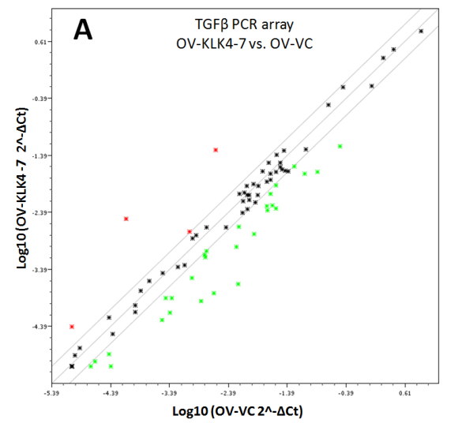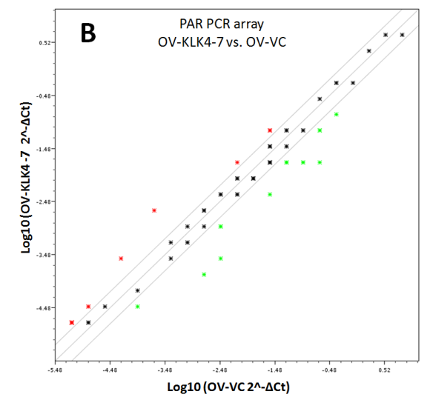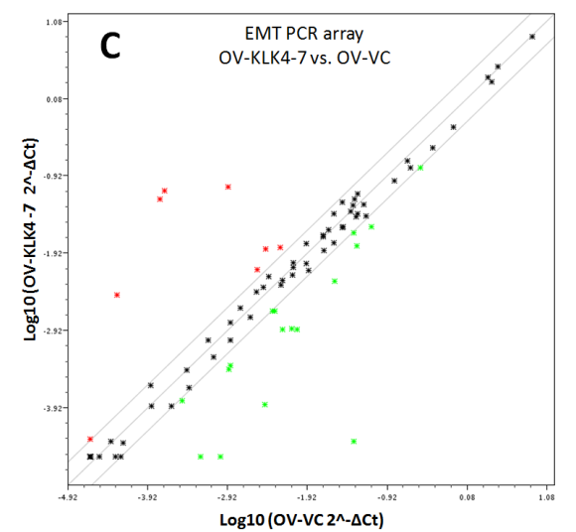

Figure S2. Volcano blot visualization of genome-wide RNA microarray data. Red dots indicate significantly up- and blue dots down-regulated genes with a fold change of ≥2/≤-2 and false discovery rate corrected P≤0.05 between both groups. The analyzed candidate genes are indicated in black. Two of the ten selected and analyzed candidate genes were not identified as differentially regulated genes in the RNA microarray (MMP1: 1.9; JUNB: -1.0; see Table 1).

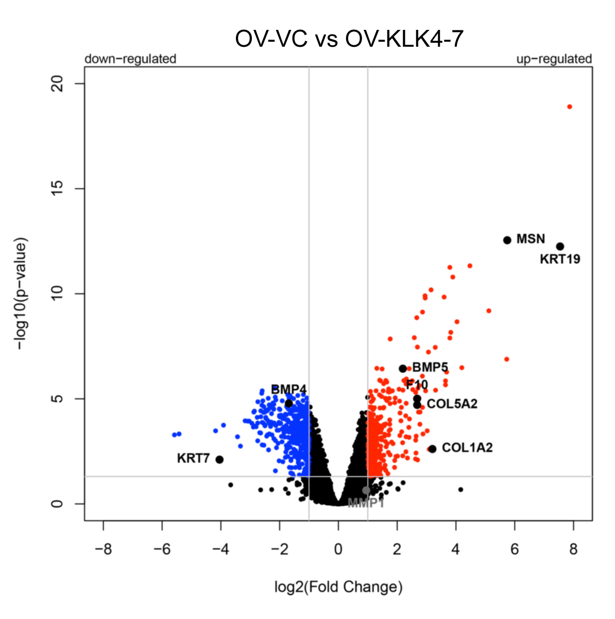

Figure S3. Immunohistochemical visualization of KLK4 protein expression in high-grade serous ovarian cancer tumor tissues. Tissue sections were stained with the in-house produced polyclonal rabbit antibody pAb587 directed to KLK4 as previously described (Yang et al. 2017). Micrographs illustrate representative core punches corresponding to low (left), moderate (middle), and high (right) KLK4 immuno-expression in tumor cells (scale bar, 100 µm).
