Supplementary Figures

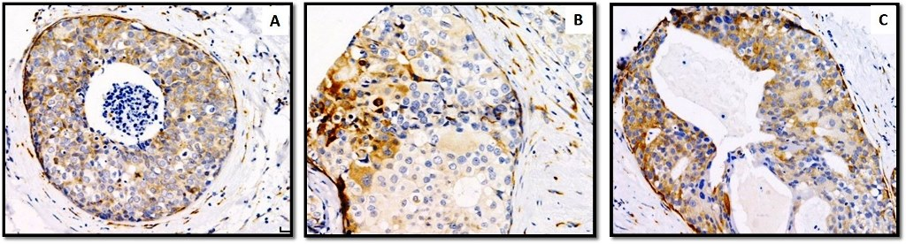

Supplementary Figure 1: Examples of H score around 40 for P4HA2 expression in DCIS tumour epithelial cells.

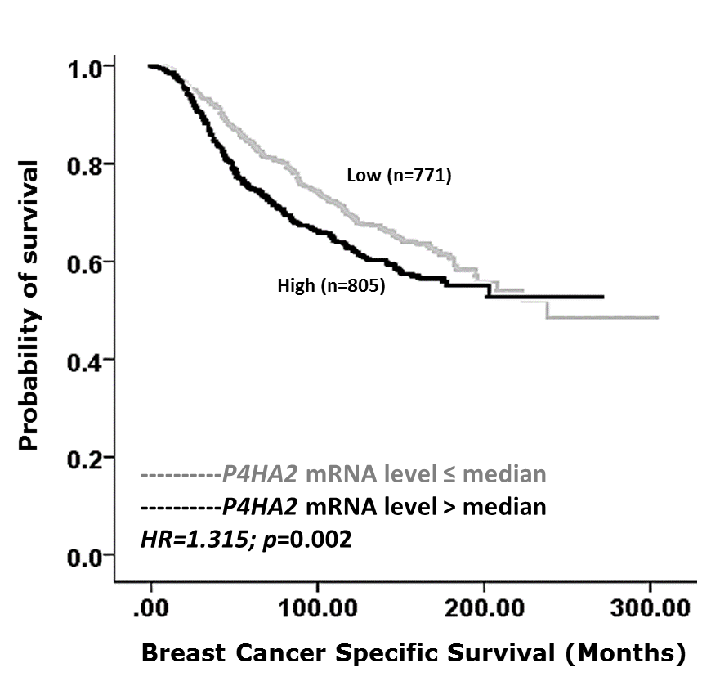

Supplementary Figure 2: Association between P4HA2 mRNA level and outcome in terms of breast cancer specific survival (BCSS) in the METABRIC series. The cohort was split into high and low mRNA expression based on the median (=8.28).

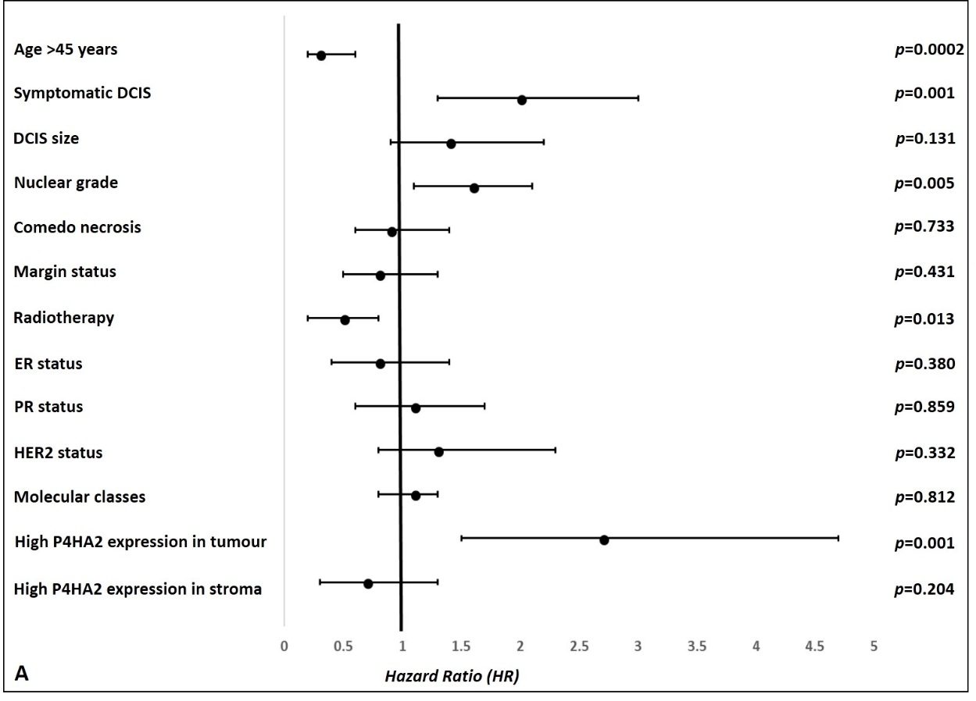
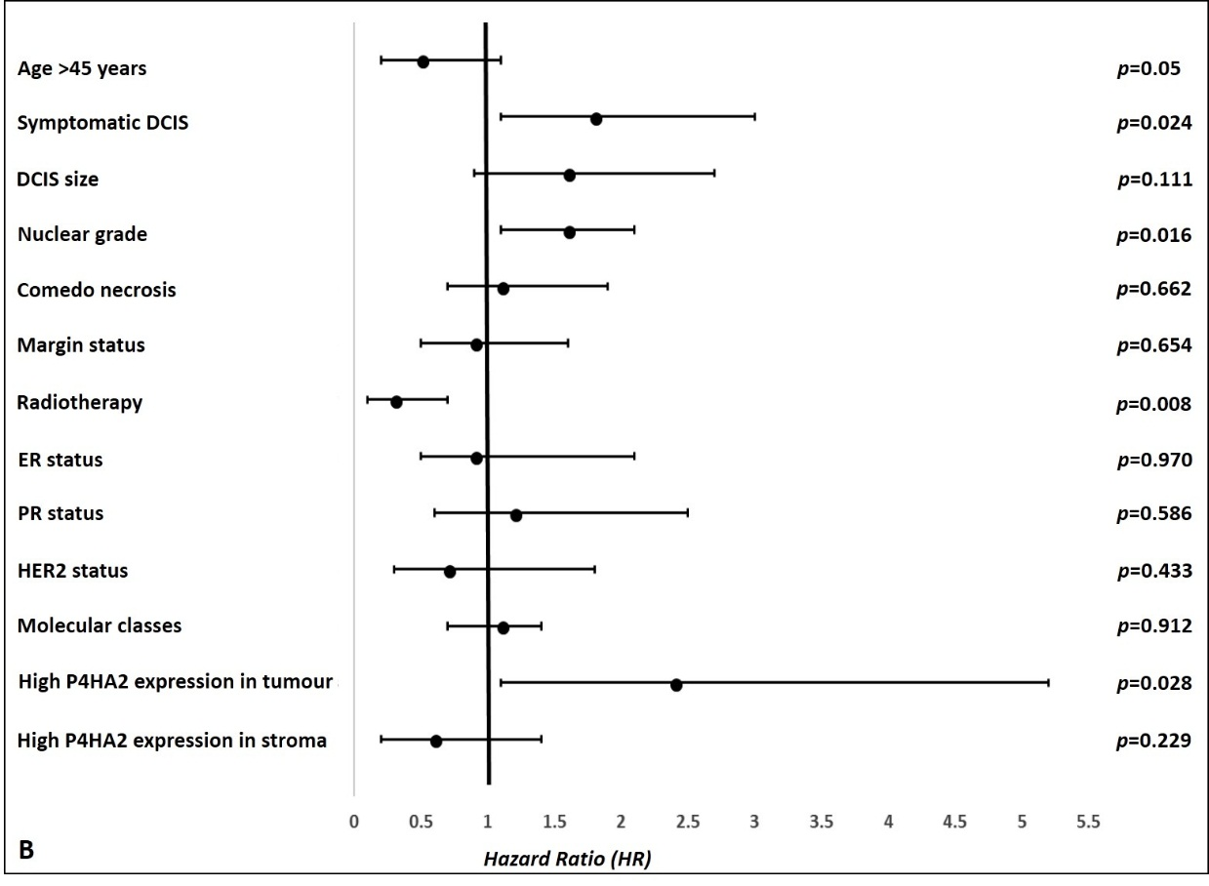
Supplementary Figure 3: Forest plots showing the univariate analysis results of association between different clinicopathological parameters and ipsilateral tumour recurrence for patients treated with breast conserving surgery in pure DCIS cohort; A) all recurrences whether DCIS or invasive and B) for invasive recurrences only. High expression of P4HA2 in tumour epithelial cells is associated with higher recurrence risk in both groups.

