Long-term risk of screen-detected and interval breast cancer after false-positive results at mammography screening: Joint analysis of three national cohorts
Marta Román, Solveig Hofvind, My von Euler-Chelpin, and Xavier Castells

Supplementary material
- Descriptive table of the characteristics of the study population by country.

- Sensitivity analyses to test the impact of the heterogeneity across countries
The sensitivity analysis showed very little impact of the heterogeneity across countries in the estimates. Compared with the estimates of the fully adjusted model (including country as a random effect) in Table 4, the estimates of the adjusted model excluding the country effect were HR_{False-positive} =2.01 (95%CI: 1.90-2.13) and HR_{2nd false-positive}= 4.48 (95% CI: 3.62-5.54) for screen-detected cancer and HR_{False-positive} =2.13 (95%CI: 1.98-2.29) and HR_{2nd false-positive} =3.91 (95%CI: 3.02-5.06) for interval breast cancer. In the adjusted model including country as a fixed effect, the estimates were HR_{False-positive} =2.04 (95%CI: 1.93-2.16) and HR_{2nd false-positive}=4.73 (95%CI: 3.82-5.85) for screen-detected cancer and HR_{False-positive} =2.18 (95%CI: 2.02-2.34) and HR_{2nd false-positive}=4.22 (95%CI: 3.26-5.46).

- Sensitivity analyses to test the impact of misclassification

- Effect of adjusting variables in the model estimates.

- Time to diagnosis of screen-detected cancers and interval breast cancers by screening mammogram result.
Additional figure 1, section 5: Time to diagnosis of screen-detected cancers by screening mammogram result.
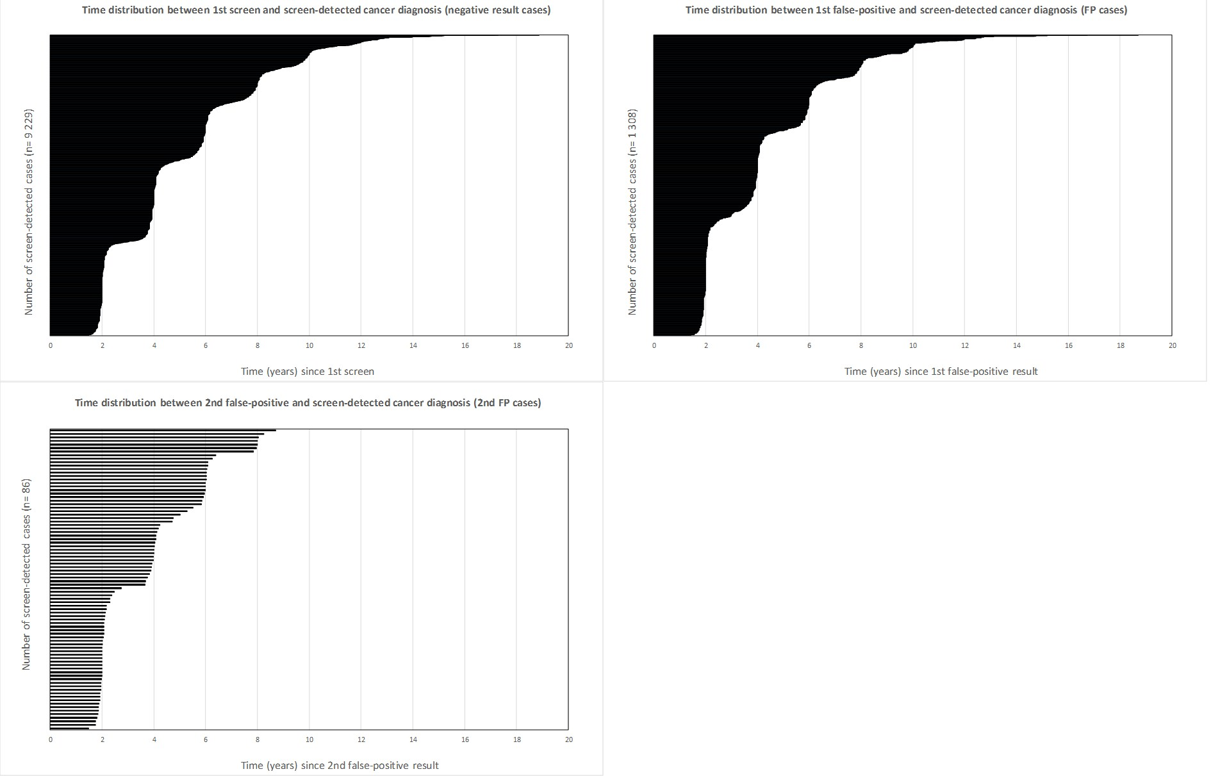

Additional figure 2, section 5: Time to diagnosis of interval breast cancers by screening mammogram result.
