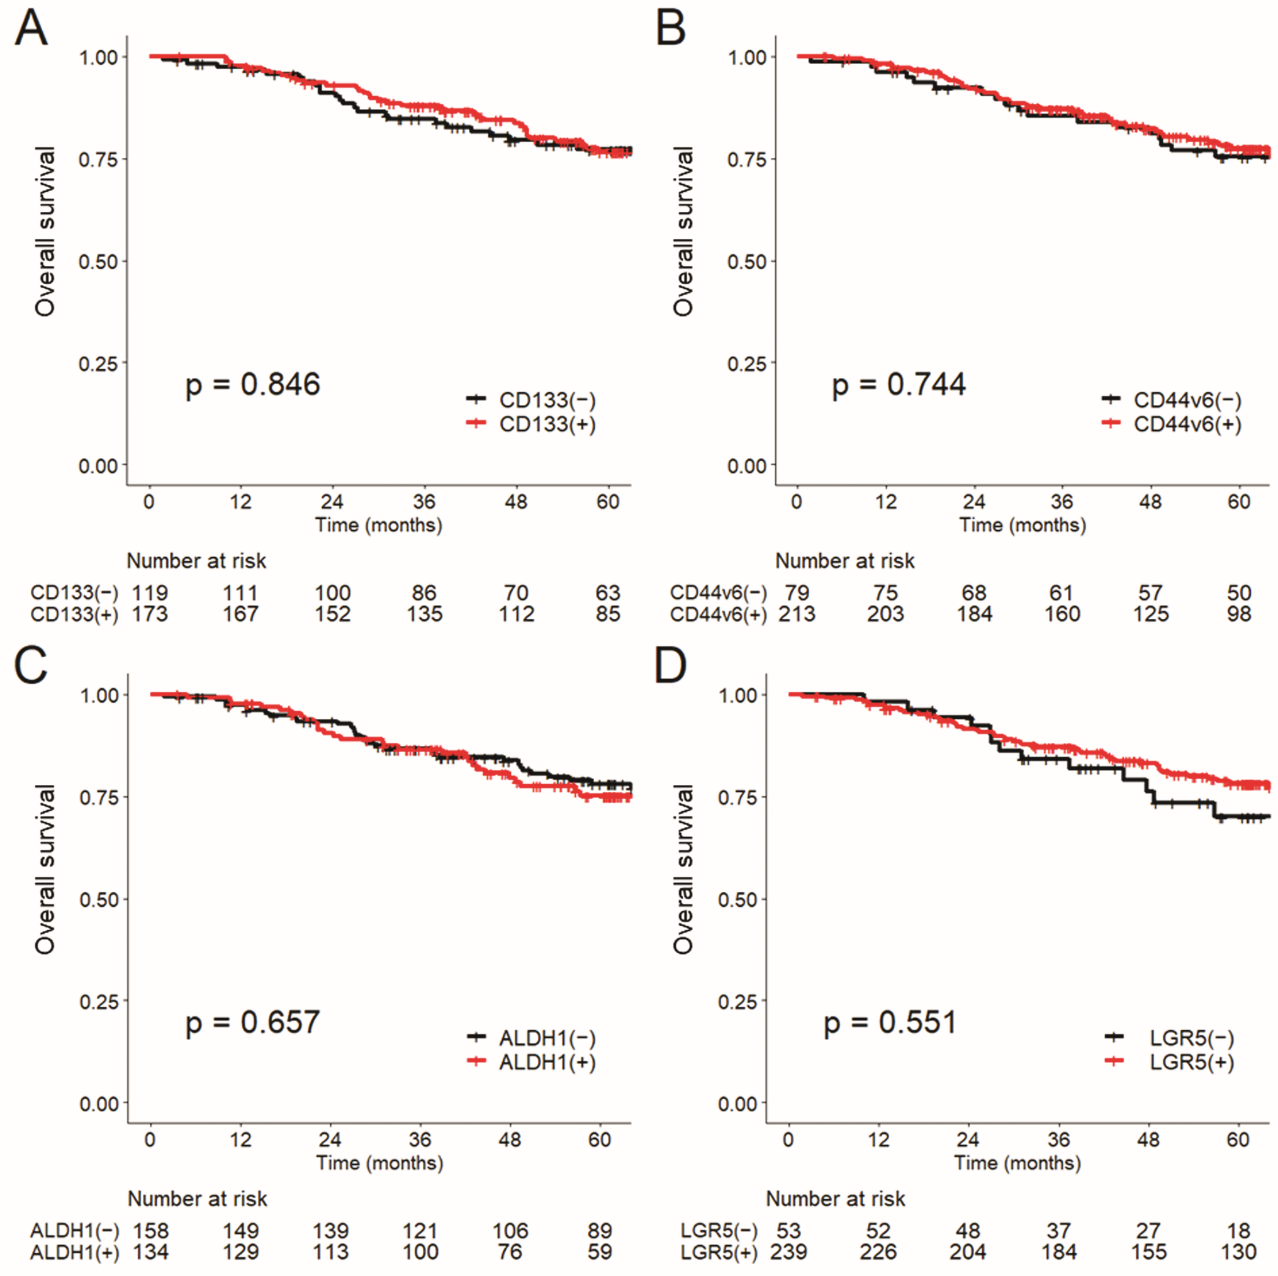

Supplementary Fig. 1: Stem cell marker expressions in primary tumor and overall survival.
CD133 (A), CD44v6 (B), ALDH1 (C), and LGR5 (D).
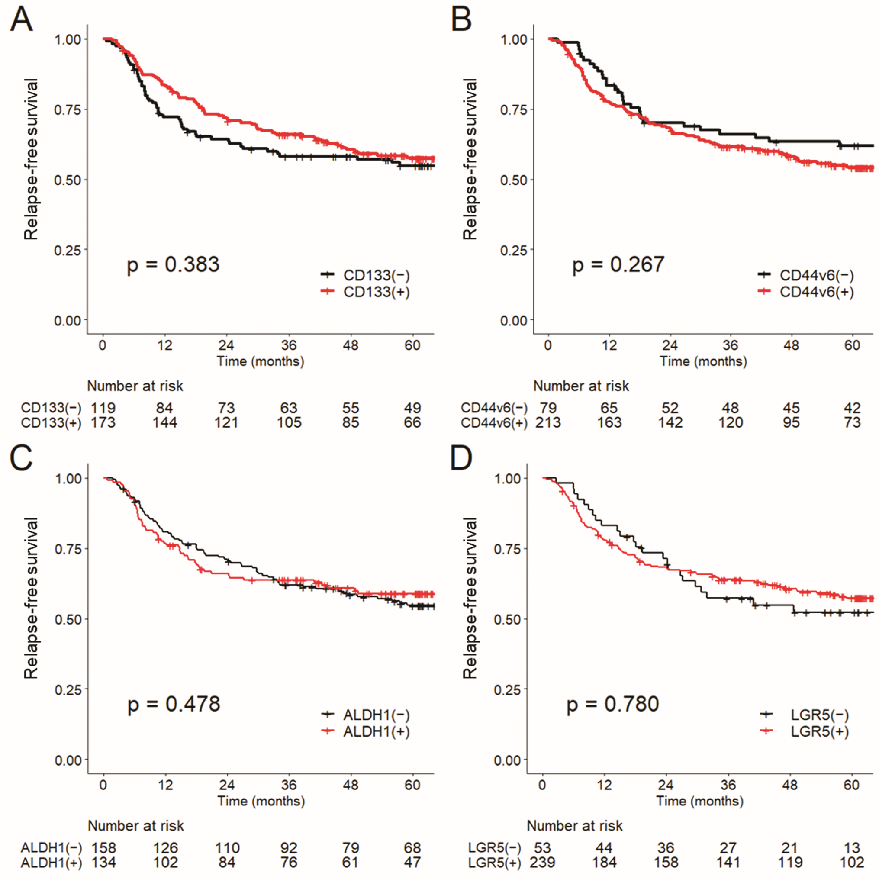

Supplementary Fig. 2: Stem cell marker expressions in primary tumor and relapse-free survival. CD133 (A), CD44v6 (B), ALDH1 (C), and LGR5 (D).

