Supplementary Figure 1. CONSORT diagram of original phase 3 study
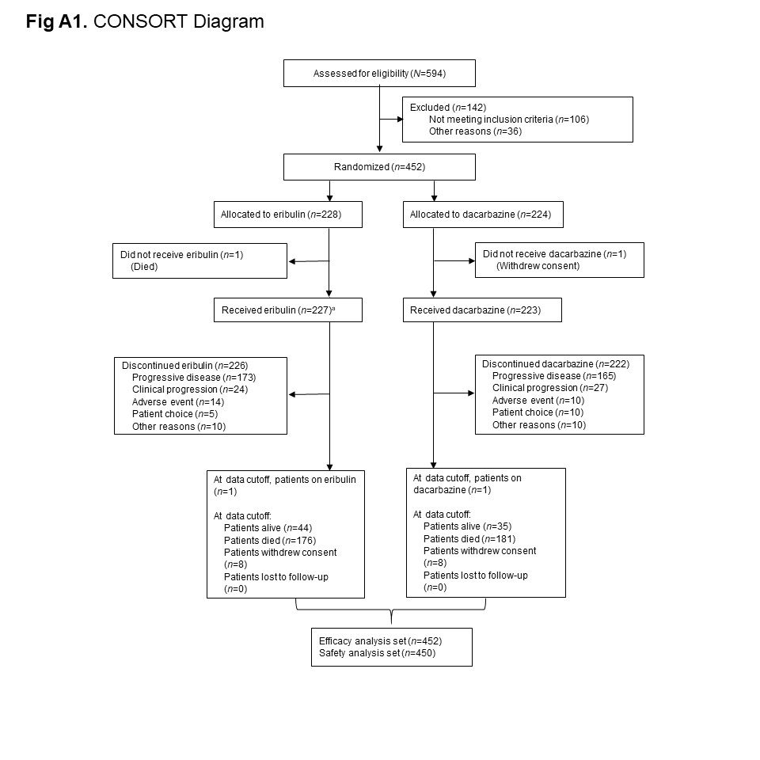
*Includes 1 patient who was assigned to eribulin but treated with dacarbazine.

Supplementary Figure 2: Overall survival (A) and progression-free survival (B) by uterine status
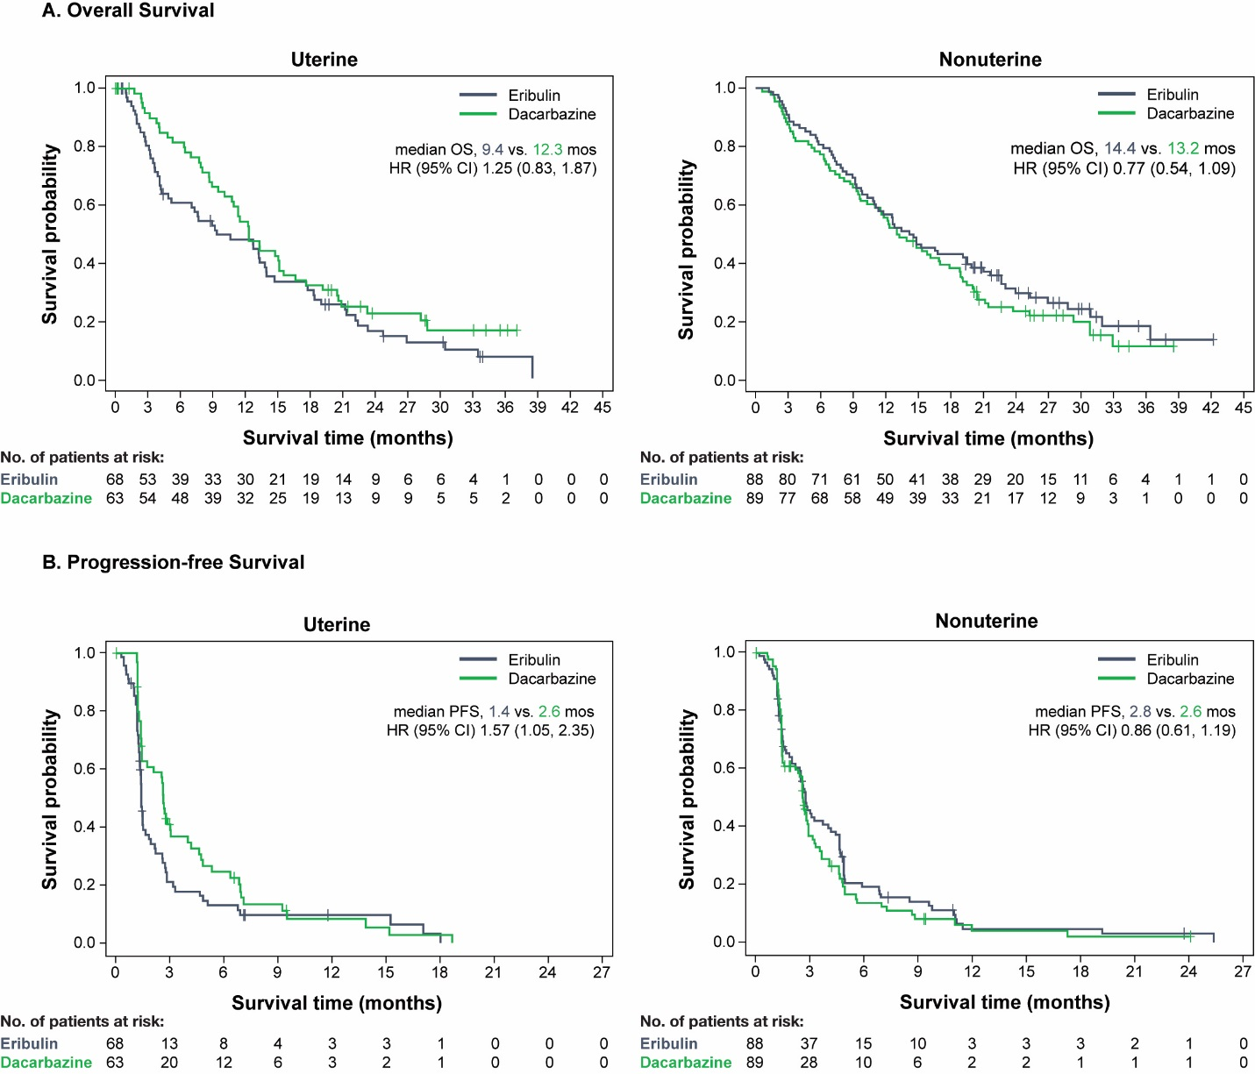

Supplementary Figure 3: Overall survival (A) and progression-free survival (B) by gender
