Table S1: Significantly enriched pathways in SCC tumors compared to NC lung and non-SCC lung cancer histotypes.

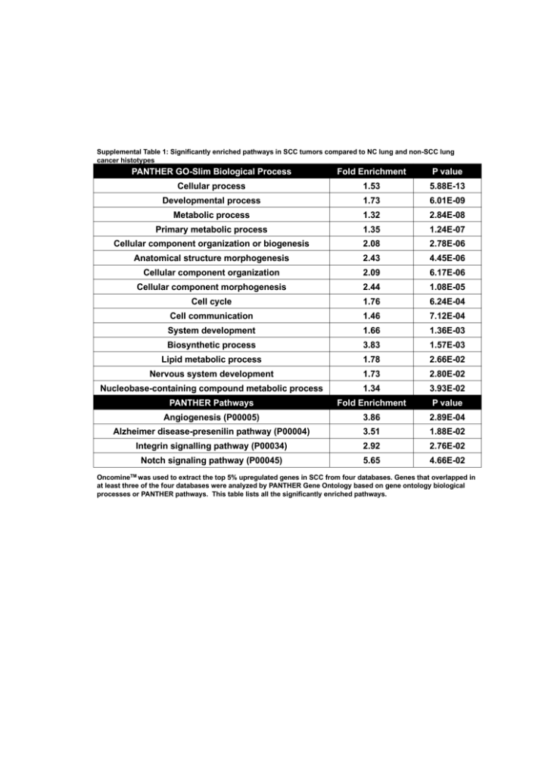

OncomineTM was used to extract the top 5% upregulated genes in SCC from four databases ¹⁸⁻²¹. Genes that overlapped in at least three of the four databases were analyzed by PANTHER Gene Ontology based on gene ontology biological processes or PANTHER pathways. This table lists all the significantly enriched pathways.

