Increased inflammatory lipid metabolism and anaplerotic mitochondrial activation follow acquired resistance to vemurafenib in BRAF-mutant melanoma cells.

SUPPLEMENTARY MATERIAL AND METHODS

NMR metabolic analysis of cells
Cells were extracted with a methanol-chloroform-water method and lyophilized samples of the aqueous fraction reconstituted in 540 µL of D2O containing 5% of 3-(trimethylsilyl) propionic-2,2,3,3-d4 acid (TSP, internal reference and quantification standard for ¹H NMR). Following ¹H NMR acquisition, EDTA and methylenediphosphonic acid (MDPA, internal standard) were added to a final concentration of 10 and 0.86 mM, respectively, at pH 8.2 for ³¹P NMR analysis. Media fractions were collected from control and treated cells, centrifuged to discard debris and 1ml of each freeze-dried and re-suspended in D2O-TSP.

NMR data acquisition and processing
For ¹H NMR, a 30° flip angle, a 2s relaxation delay (RD), a spectral width of 13 ppm and 64 k data points were used under conditions of water signal suppression for aqueous samples. ³¹P NMR spectra were acquired using power gated composite pulse ¹H decoupling, a 30° flip angle, a 1s RD, a spectral width of 100 ppm and 32 k data points. ¹³C NMR data were acquired using power gated composite pulse ¹H decoupling, 33 k data points, a 250 ppm spectral width, a repetition time of 6 s and a 30° flip angle. A line broadening of 0.2 Hz was applied for ¹H, 2Hz for ³¹P spectra and 5 Hz for ¹³C spectra.

Western blotting
The following primary antibodies were used: anti COX-1, anti COX-2 (R&D Systems; Minneapolis, US ), anti-prostaglandin E2 syntahse (mPGES-1)(Cayman chemical; Michigan, US), anti-ERK1/2 (total and phosphorylated), anti-pyruvate dehydrogenase (PDH, total and phosphorylated) (Cell Signaling Technology; Danvers, MA, USA), anti-GLUT-1, anti-glyceraldehyde-3-phosphate dehydrogenase (GAPDH) (Millipore, Nottingham, UK), anti-glutaminase (GLS)(Proteintech Europe; Manchester, UK) and anti-pyruvate carboxylase (abcam, Cambridge, UK). The secondary antibodies used were anti-rabbit (GE Healthcare Life Sciences; Buckinghamshire, UK), anti-goat (Santa Cruz Biotechnology; Santa Cruz, CA, USA) and anti-mouse Immunoglobulins/HRP (Dako A/S, Glostrup, Denmark).

Quantitative real-time PCR (qRT-PCR)
The Hs00377726_m1, Hs00153133_m1 and Hs00610420_m1 assays were used for the COX-1, COX-2 and mPGES-1 genes respectively (gene specific primers and FAM labelled probe) multiplexed with the endogenous control assay for β-ACTIN gene (β-ACTIN-specific primers and VIC/TAMARA-labelled probe; Applied Biosystems). mRNA levels of each gene were determined for each sample in the same well on the ABI 7900HT relative to those of β-ACTIN and data processed by expressing changes as the differences in the threshold cycle (2-∆∆Ct), inversely proportional to the amount of target mRNA per sample.

SUPPLEMENTARY FIGURES

FIGURE S1

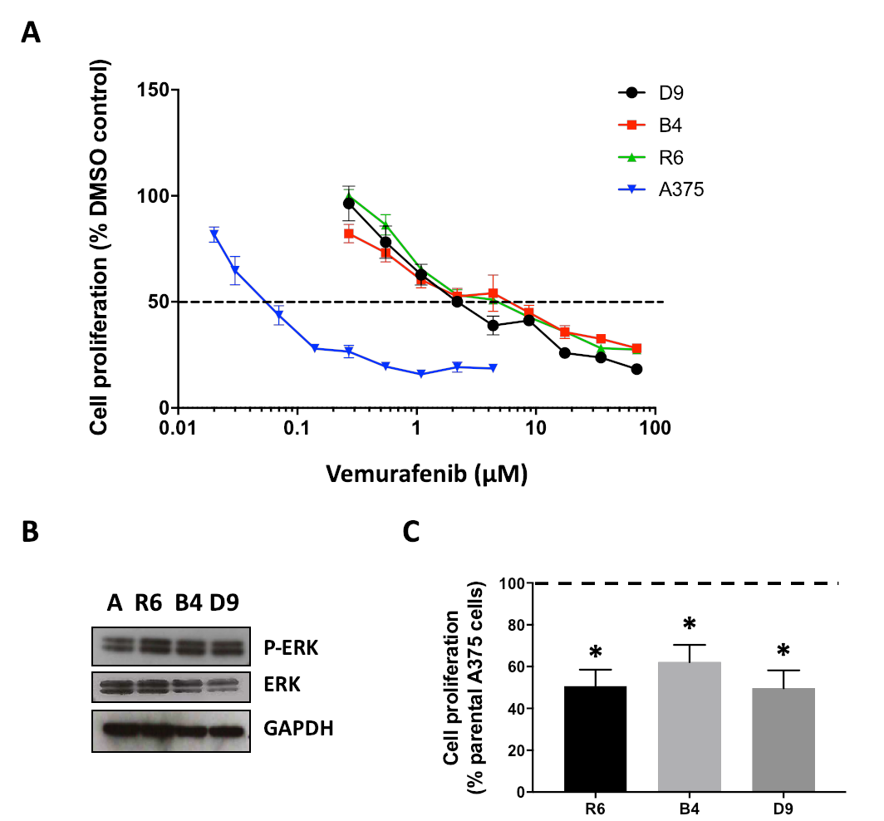
Figure 1: Generation and characterization of BRAF inhibitor-resistant A375 cell clones. A) GI₅₀ curves for vemurafenib sensitive (4.4 µM maximum dose) and resistant clones (70 µM maximum dose). B) Baseline P-ERK and ERK expression levels in sensitive and resistant cell lines. C) Changes in cell counts of the 3 vemurafenib-resistant clones compared to A375 cells after 72 h of seeding.

FIGURE S2

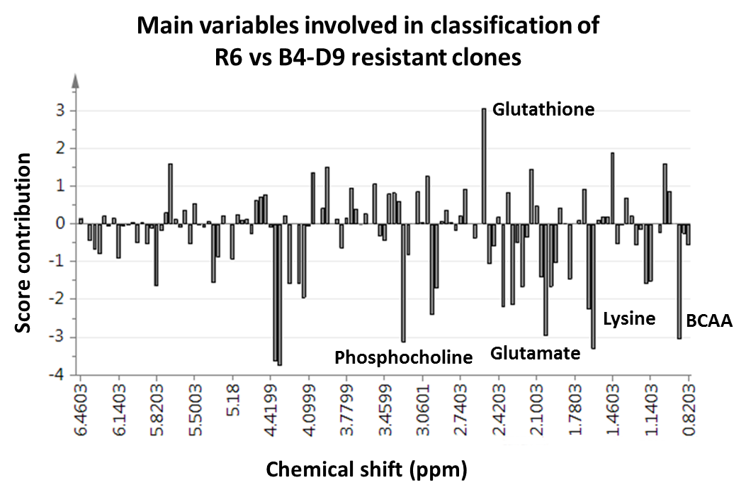

Figure S2: Multivariate analysis of NMR metabolic profiles from the three vemurafenib-resistant clones. Score contribution plot representing the main metabolic differences allowing the clustering or the R6 clone versus B4-D9 clones, as displayed in Figure 1B in the main manuscript.

FIGURE S3
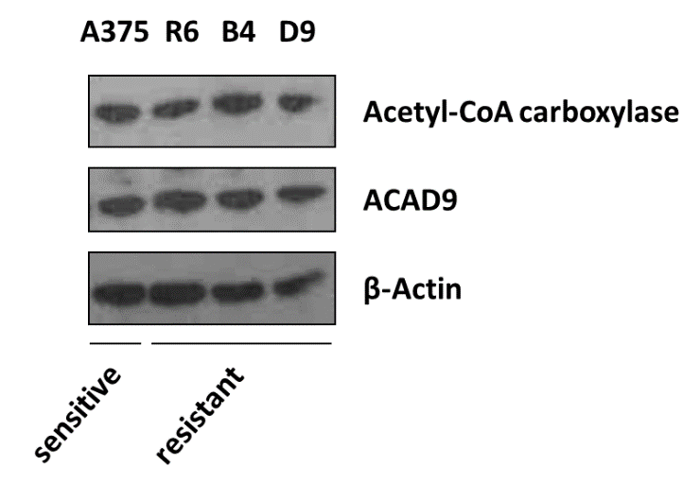
Figure S3: Lipid anabolism and catabolism assessment in sensitive and resistant clones. Protein expression of enzymes related to fatty acid synthesis (Acetyl-CoA carboxylase (ACC)) and lipid β-oxidation (ACAD9) in A375 (A) cells and three vemurafenib-resistant clones (R6, B4 and D9). Changes were confirmed in n=3 independent replicates.
FIGURE S4
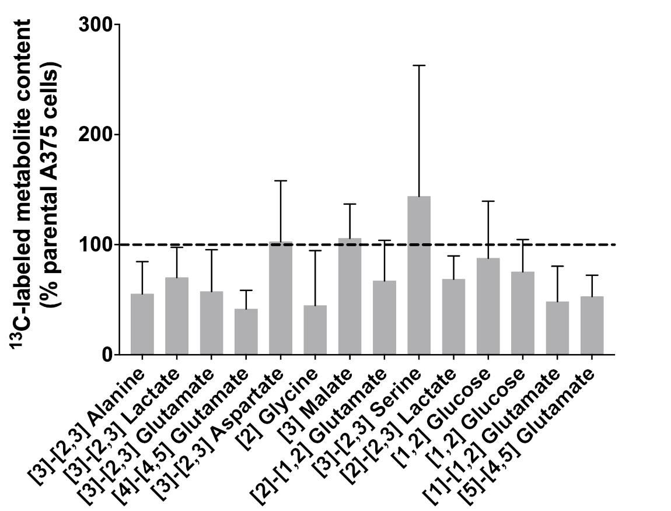
Figure A: ¹³C NMR analysis in R6 cells with respect to the parental clone. This graph is the equivalent to the one in Figure 4B of the main manuscript but showing the mean ± SD instead of the SE in order to better represent the data distribution.

FIGURE S5
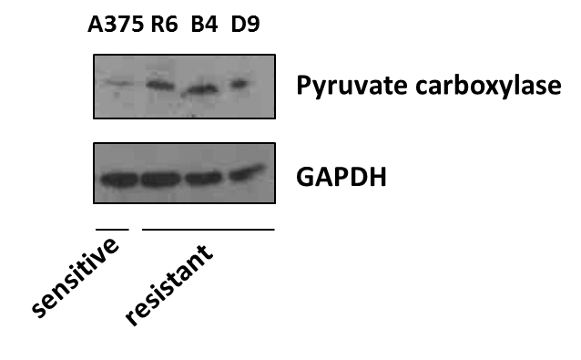
Figure S5: Pyruvate carboxylase expression in acquired resistance to vemurafenib. Protein expression of pyruvate carboxylase in A375 (A) cells and three vemurafenib-resistant clones (R6, B4 and D9). Changes were confirmed in n=3 independent replicates.

SUPPLEMENTARY TABLES
TABLE S1: ¹H and ³¹P NMR main metabolites analysed in the aqueous phase of sensitive and resistant cell extracts (au/ cell number). For comparison of metabolites, Student t-test with Sidak-Bonferroni correction for multiple comparisons (P≤0.05) was applied. Data represent the mean ± SE. * Significant results (P≤0.05) are marked in bold.
¹H NMR
Cell metabolites (ppm) | Sensitive |  | Resistant | P*
BCCA (0.88 ppm) | 5.90 ± 0.98 |  | 3.08 ± 0.57 | 0.228
Lactate (1.33 ppm) | 14.72 ± 3.85 |  | 7.84 ± 1.79 | 0.675
Acetate (1.90 ppm) | 0.65 ± 0.11 |  | 0.24 ± 0.03 | 0.007
Glutamate (2.32 ppm) | 5.06 ± 0.39 |  | 2.62 ± 0.26 | 0.002
Glutamine (2.45 ppm) | 2.81 ± 0.32 |  | 1.27 ± 0.19 | 0.008
Glutathione (2.48 ppm) | 1.76 ± 0.17 |  | 0.83 ± 0.12 | 0.007
Aspartate (2.76 ppm) | 0.29 ± 0.17 |  | 0.05 ± 0.01 | 0.501
Creatine (3.03 ppm) | 2.11 ± 0.24 |  | 1.64 ± 0.25 | 0.981
Choline (3.21 ppm) | 0.24 ± 0.03 |  | 0.19 ± 0.02 | 0.935
Phosphocholine (3.22 ppm) | 8.53 ± 0.52 |  | 5.54 ± 0.58 | 0.075
GPCho (3.24 ppm) | 1.26 ± 0.10 |  | 0.86 ± 0.09 | 0.241
UDP-GlcNAC (5.49 ppm) | 0.09 ± 0.01 |  | 0.04 ± 0.01 | 0.008
Ribose (6.15 ppm) | 0.54 ± 0.05 |  | 0.10 ± 0.04 | 0.053
Fumarate (6.49 ppm) | 0.04 ± 0.004 |  | 0.02 ± 0.003 | 0.001
³¹P NMR
Cell metabolites (ppm) |  | Sensitive | Resistant | P*
Phosphocholine (3.39 ppm) |  | 6.82 ± 0.47 | 2.08 ± 0.61 | 0.0018
GPE (0.38 ppm) |  | 0.28 ± 0.02 | 0.07 ± 0.02 | 0.0003
GPCho (-0.14 ppm) |  | 0.79 ± 0.07 | 0.19 ± 0.04 | 0.00002
Phosphocreatine (-2.99 ppm) |  | 0.88 ± 0.09 | 0.56 ± 0.13 | 0.6577
γ-NTP (-5.30 ppm) |  | 5.65 ± 0.29 | 1.53 ± 0.41 | 0.0001
α-NTP (-10.83 ppm) |  | 6.04 ± 0.27 | 1.71 ± 0.46 | 0.0002
β-NTP (-21.01 ppm) |  | 6.22 ± 0.41 | 1.64 ± 0.45 | 0.0002

TABLE S2: ¹H NMR and ³¹P NMR main metabolites analysed in the aqueous phase of resistant cell extracts (au/ cell number). For comparison of metabolites, Student t-test with Sidak-Bonferroni correction for multiple comparisons (P≤0.05) was applied. Data represent the mean ± SE. * Significant results (P≤0.05) are marked in bold.
¹H NMR
Cell metabolites (ppm) | R6 |  | B4 + D9 | P*
BCCA (0.88 ppm) | 2.09 ± 0.19 |  | 3.51 ± 0.77 | 0.996
Lactate (1.33 ppm) | 5.28 ± 2.50 |  | 8.94 ± 2.30 | 0.999
Acetate (1.90 ppm) | 0.17 ± 0.06 |  | 0.27 ± 0.04 | 0.989
Glutamate (2.32 ppm) | 2.16 ± 0.37 |  | 2.82 ± 0.33 | 0.996
Glutamine (2.45 ppm) | 1.14 ± 0.20 |  | 1.33 ± 0.26 | 0.999
Glutathione (2.48 ppm) | 0.88 ± 0.12 |  | 0.80 ± 0.16 | 0.999
Aspartate (2.76 ppm) | 0.04 ± 0.02 |  | 0.05 ± 0.01 | >0.999
Creatine (3.03 ppm) | 1.09 ± 0.18 |  | 1.88 ± 0.31 | 0.948
Choline (3.21 ppm) | 0.17 ± 0.05 |  | 0.20 ± 0.02 | 0.999
Phosphocholine (3.22 ppm) | 5.56 ± 0.51 |  | 5.53 ± 0.83 | >0.999
GPCho (3.24 ppm) | 0.57 ± 0.11 |  | 0.98 ± 0.09 | 0.442
UDP-GlcNAC (5.49 ppm) | 0.02 ± 0.01 |  | 0.04 ± 0.01 | 0.992
Ribose (6.15 ppm) | 0.27 ± 0.07 |  | 0.34 ± 0.05 | 0.999
Fumarate (6.49 ppm) | 0.01 ± 0.01 |  | 0.02 ± 0.003 | >0.999
³¹P NMR
Cell metabolites (ppm) |  | R6 | B4 + D9 | P*
Phosphocholine (3.39 ppm) |  | 4.66 ± 0.81 | 0.98 ± 0.20 | 0.002
GPE (0.38 ppm) |  | 0.15 ± 0.05 | 0.04 ± 0.01 | 0.028
GPCho (-0.14 ppm) |  | 0.34 ± 0.07 | 0.13 ± 0.02 | 0.028
Phosphocreatine (-2.99 ppm) |  | 1.02 ± 0.22 | 0.37 ± 0.09 | 0.028
γ-NTP (-5.30 ppm) |  | 3.09 ± 0.77 | 0.86 ± 0.14 | 0.016
α-NTP (-10.83 ppm) |  | 3.45 ± 0.92 | 0.96 ± 0.17 | 0.021
β-NTP (-21.01 ppm) |  | 3.28 ± 0.97 | 0.94 ± 0.16 | 0.028

