Supplementary Tables

Supplementary Table 1

Overall response rate, 2nd progression-free survival and 2nd overall survival according to second-line treatments
Patients receiving second-line treatment, N=419
PR or CR to first-line, N=278
 | FOLFOXIRI ± bev,  N=123 | Doublets ± bev,  N=86 | HR/OR  (95% C.I.) | p value* | Other  treatments,  N=69 | HR/OR  (95% C.I.) | p value** | p value***
ORR (%) | 29 | 12 | 3.15  (1.46-6.76) | 0.003 | 22 | 1.49  (0.75-2.97) | 0.259 | 0.013
2nd PFS (months) | 6.9 | 4.3 | 0.68  (0.51-0.91) | 0.010 | 4.7 | 0.63  (0.46-0.87) | 0.004 | 0.005
2nd OS (months) | 17.4 | 13.9 | 0.90  (0.64-1.26) | 0.548 | 13.6 | 1.00  (0.63-1.29) | 0.568 | 0.745
SD or PD to first-line, N=141
 | FOLFOXIRI ± bev,  N=53 | Doublets ± bev,  N=37 | HR/OR  (95% C.I.) | p value* | Other  treatments,  N=51 | HR/OR  (95% C.I.) | p value** | p value***
ORR (%) | 8 | 11 | 0.67  (0.16-2.88) | 0.594 | 6 | 1.31  (0.28-6.15) | 0.735 | 0.699
2nd PFS (months) | 4.8 | 5.3 | 1.05  (0.68-1.62) | 0.840 | 3.2 | 0.91  (0.60-1.37) | 0.644 | 0.959
2nd OS (months) | 8.8 | 11.6 | 1.30  (0.81-2.08) | 0.278 | 8.6 | 0.94  (0.61-1.46) | 0.796 | 0.527

2ndPFS: progression-free survival during second-line; 2ndOS: overall survival during second-line; Bev: bevacizumab; CI: Confidence Interval; HR: Hazard Ratio; ORR: overall response rate; N=number; OR=odds ratio.
* FOLFOXIRI ± bevacizumab versus doublets ± bevacizumab
** FOLFOXIRI ± bevacizumab versus other treatments
*** FOLFOXIRI ± bevacizumab versus doublets ± bevacizumab versus other treatments
Supplementary Table 2
Overall response rate, 2nd progression-free survival and 2nd overall survival according to second-line treatments
Patients receiving second-line treatment, N=419
OIFI ≥ 4 months, N=286
 | FOLFOXIRI ± bev,  N=133 | Doublets ± bev,  N=86 | HR and OR (95% C.I.) | p value* | Other  treatments,  N=67 | HR and OR  (95% C.I.) | p value** | p value***
ORR (%) | 26 | 15 | 1.93  (0.95-3.91) | 0.066 | 20 | 1.43  (0.69-2.93) | 0.941 | 0.173
2nd PFS (months) | 7.2 | 5.6 | 0.77  (0.58-1.04) | 0.083 | 4.9 | 0.69  (0.50-0.95) | 0.022 | 0.045
2nd OS (months) | 17.4 | 16.3 | 1.09  (0.77-1.55) | 0.608 | 16.5 | 1.07  (0.73-1.56) | 0.742 | 0.916
OIFI < 4 months, N=153
 | FOLFOXIRI ± bev,  N=43 | Doublets ± bev,  N=37 | HR and OR  (95% C.I.) | p value* | Other  treatments,  N=53 | HR and OR  (95% C.I.) | p value** | p value***
ORR (%) | 14 | 3 | 5.83  (0.67-50.93) | 0.076 | 9 | 1.56  (0.44-5.50) | 0.489 | 0.270
2nd PFS (months) | 4.4 | 3.1 | 0.84  (0.54-1.32) | 0.460 | 3.3 | 0.99  (0.65-1.50) | 0.948 | 0.615
2nd OS (months) | 8.8 | 9.1 | 0.88  (0.56-1.39) | 0.585 | 6.8 | 0.88  (0.58-1.34) | 0.551 | 0.836

2ndPFS: progression-free survival during second-line; 2ndOS: overall survival during second-line; Bev: bevacizumab; CI: Confidence Interval; HR: Hazard Ratio; OIFI: oxaliplatin irinotecan free interval; N=number; OR=odds ratio.
* FOLFOXIRI ± bevacizumab versus doublets ± bevacizumab
** FOLFOXIRI ± bevacizumab versus other treatments
*** FOLFOXIRI ± bevacizumab versus doublets ± bevacizumab versus other treatments
Supplementary Figure 1

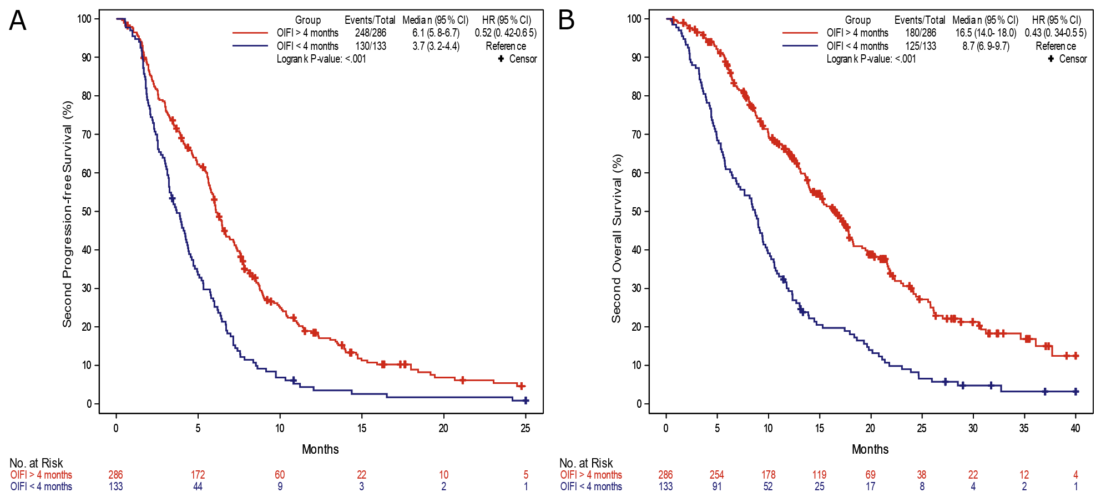

Supplementary Figure 1: 2nd PFS according to OIFI. CI: Confidence Interval; HR: Hazard Ratio; OIFI: oxaliplatin irinotecan free interval

