Supplementary Appendix. A
The statistical analysis plan and protocol for the FIRE-3 study are available online.

Table S.1. Reasons for exclusion of patients from the per-protocol analysis, by treatment group
Reason for exclusion | FOLFIRI plus  cetuximab  (N=30) | FOLFIRI plus  bevacizumab  (N=18)
Allergic reaction | 9
Clinical progression | 1
Deterioration of performance status | 1
Diarrhoea | 1 | 2
Early death | 1 | 4
Elevated liver enzymes | 1
Hypotension | 1
Ileus | 2 | 1
Ineligible (inclusion criteria violation) |  | 1
Infectious complication | 3
Patient wish / withdrawal of consent | 4 / 0 | 3 / 1
Radiation therapy | 1
Resectability |  | 1
Skin toxicity | 2
Thromboembolic event / bleeding | 1 / 0 | 3 / 1
Treatment pause >3 weeks | 2 | 1

Table S.2. Characteristics of the RAS wild-type (N=400) and per-protocol (N=352) populations
 | RAS wild-type population |  | Per-protocol population
 | FOLFIRI plus cetuximab  (N=199) | FOLFIRI plus bevacizumab  (N=201) | FOLFIRI plus cetuximab  (N=169) | FOLFIRI plus bevacizumab  (N=183)
Median age, years (range) | 64 (41–76) | 64 (31–76) | 65 (41–76) | 64 (31–76)
Age >65 years, n (%) | 95 (48) | 96 (48) | 83 (49) | 83 (45)
Female, n (%) | 52 (26) | 68 (34) | 41 (24) | 62 (34)
ECOG performance status:  0  1  2 | 108 (54)  88 (44)  3 (2) | 109 (54)  89 (44)  3 (2) | 94 (56)  73 (43)  2 (1) | 98 (54)  82 (45)  3 (2)
Site of primary tumour:  Colon  Rectum  Colon and rectum | 119 (60)  72 (36)  8 (4) | 126 (63)  68 (34)  7 (4) | 99 (59)  63 (37)  7 (4) | 116 (63)  61 (33)  6 (3)
Primary tumour side:  Left (hindgut)  Right (midgut)  Both or unknown | 158 (79)  38 (19)  3 (2) | 149 (74)  50 (25)  2 (1) | 137 (81)  30 (18)  3 (2) | 136 (74)  45 (25)  2 (1)
No. of metastatic sites:  1  2  ≥3  Unknown | 84 (42)  66 (33)  47 (24)  2 (1) | 82 (41)  69 (34)  49 (24)  2 (1) | 72 (43)  56 (33)  41 (24)  0 (0) | 76 (42)  65 (36)  42 (23)  0 (0)
Metastatic sites:  Liver only  Lung only | 71 (36)  5 (3) | 62 (31)  11 (6) | 62 (37)  4 (2) | 58 (32)  10 (6)
Prior therapy:  Primary tumour resection  Adjuvant chemotherapy | 168 (84)  37 (19) | 176 (88)  38 (19) | 142 (84)  34 (20) | 163 (89)  34 (19)
Percentages may not total 100 due to rounding.

Table S.3. Adverse events in the RAS wild-type population (N=400)
Adverse event | FOLFIRI + cetuximab  (N=199) |  |  |  | FOLFIRI + bevacizumab  (N=201)
 | Any grade |  | Grade ≥3 |  | Any grade |  | Grade ≥3
 | n | % | n | % | n | % | n | %
Haematotoxicity | 181 | 91.0 | 58 | 29.1 | 189 | 94.0 | 46 | 22.9
Leukopenia | 139 | 69.9 | 31 | 15.6 | 136 | 67.7 | 24 | 11.9
Anaemia | 174 | 87.4 | 6 | 3.0 | 188 | 93.5 | 3 | 1.5
Thrombocytopenia | 53 | 26.6 | 1 | 0.5 | 48 | 23.9 | 1 | 0.5
Neutropenia | 127 | 63.8 | 61 | 30.7 | 128 | 63.7 | 44 | 21.9
Febrile Neutropenia | 2 | 1.0 | 2 | 1.0 | 1 | 0.5 | 1 | 0.5
Non-haematological toxicity
Gastrointestinal disorders | 166 | 83.4 | 35 | 17.6 | 3 | 1.5
Nausea | 99 | 49.7 | 7 | 3.5 | 132 | 65.7 | 29 | 14.4
Vomiting | 48 | 24.1 | 5 | 2.5 | 69 | 34.3 | 8 | 4.0
Diarrhoea | 121 | 60.8 | 23 | 11.6 | 3 | 1.5
Mucositis/stomatitis | 85 | 42.7 | 9 | 4.5 | 181 | 90.0 | 47 | 23.4
Obstipation | 52 | 26.1 | 1 | 0.5 | 47 | 23.4 | 3 | 1.5
Bleeding (respiratory tract, GI, GU) | 45 | 22.6 | 2 | 1.0 | 60 | 29.9 | 1 | 0.5
Cardiac disorders | 15 | 7.5 | 2 | 1.0 | 189 | 94.0 | 46 | 22.9
Arrhythmias | 13 | 6.5 | 1 | 0.5 | 20 | 10.0 | 7 | 3.5
Other | 3 | 1.5 | 2 | 1.0 | 14 | 7.0 | 4 | 2.0
Endocrine disorders | 6 | 3.0 | 2 | 1.0 | 6 | 3.0 | 3 | 1.5
General disorders and administration-site conditions | 154 | 77.4 | 17 | 8.5 | 166 | 82.6 | 19 | 9.5
Fatigue (asthenia, lethargy) | 104 | 52.3 | 2 | 1.0 | 113 | 56.2 | 3 | 1.5
Fever, without neutropenia grade 3/4 | 35 | 17.6 | 1 | 0.5 | 32 | 15.9 | 1 | 0.5
Medical device complication | 3 | 1.5 | 1 | 0.5 | 2 | 1.0
Oedema | 31 | 15.6 | 2 | 1.0 | 21 | 10.4 | 1 | 0.5
Pain | 107 | 53.8 | 8 | 4.0 | 119 | 59.2 | 11 | 5.5
Wound healing problems | 4 | 2.0 |  |  | 1 | 0.5
Hepatobiliary disorders | 137 | 68.8 | 15 | 7.5 | 120 | 59.7 | 13 | 6.5
Liver toxicity | 137 | 68.8 | 15 | 7.5 | 120 | 59.7 | 13 | 6.5
Immune system disorders | 2 | 1.0 | 1 | 0.5 | 1 | 0.5
Allergic reaction | 2 | 1.0 | 1 | 0.5 | 1 | 0.5
Infections and infestations | 98 | 49.2 | 23 | 11.6 | 101 | 50.2 | 24 | 11.9
Abscess | 5 | 2.5 | 2 | 1.0 | 5 | 2.5
Infection, with neutropenia grade 3/4 | 6 | 3.0 | 4 | 2.0 | 13 | 6.5 | 6 | 3.0
Infection, without neutropenia grade 3/4 | 96 | 48.2 | 20 | 10.1 | 97 | 48.3 | 21 | 10.4
Injury | 2 | 1.0 | 1 | 0.5 | 3 | 1.5
Bone fracture | 2 | 1.0 | 1 | 0.5 | 3 | 1.5
Metabolism and nutrition disorders | 129 | 64.8 | 27 | 13.6 | 86 | 42.8 | 22 | 10.9
Electrolyte imbalance | 129 | 64.8 | 27 | 13.6 | 86 | 42.8 | 22 | 10.9
Musculoskeletal and connective tissue disorders | 2 | 1.0 | 1 | 0.5 | 2 | 1.0 | 1 | 0.5
Fistula/perforation | 2 | 1.0 | 1 | 0.5 | 2 | 1.0 | 1 | 0.5
Nervous system disorders | 47 | 23.6 |  |  | 49 | 24.4 | 3 | 1.5
Neurotoxicity, motor | 5 | 2.5 |  |  | 8 | 4.0 | 2 | 1.0
Neurotoxicity, sensory | 45 | 22.6 |  |  | 46 | 22.9 | 1 | 0.5
Nephrotoxicity | 29 | 14.6 | 1 | 0.5 | 51 | 25.4 | 4 | 2.0
Other | 140 | 70.4 | 31 | 15.6 | 136 | 67.7 | 22 | 10.9
Psychiatric disorder | 30 | 15.1 | 1 | 0.5 | 32 | 15.9 | 1 | 0.5
Skin and subcutaneous tissue disorders | 176 | 88.4 | 60 | 30.2 | 119 | 59.2 | 9 | 4.5
Alopecia | 57 | 28.6 | 1 | 0.5 | 81 | 40.3 | 3 | 1.5
Dry skin | 101 | 50.8 | 4 | 2.0 | 37 | 18.4 | 1 | 0.5
Hair disorder | 2 | 1.0
Hand-foot-syndrome | 54 | 27.1 | 9 | 4.5 | 30 | 14.9 | 2 | 1.0
Nail changes | 76 | 38.2 | 14 | 7.0 | 20 | 10.0
Pruritus/itching | 66 | 33.2 | 2 | 1.0 | 22 | 10.9 | 1 | 0.5
Rash/acne, acneiform | 156 | 78.4 | 36 | 18.1 | 19 | 9.5
Rash/desquamation | 74 | 37.2 | 15 | 7.5 | 24 | 11.9 | 2 | 1.0
Skin disorder, other | 35 | 17.6 | 4 | 2.0 | 14 | 7.0
Vascular disorders | 71 | 35.7 | 32 | 16.1 | 101 | 50.2 | 38 | 18.9
Hypertension | 49 | 24.6 | 14 | 7.0 | 75 | 37.3 | 14 | 7.0
Thromboembolic event | 31 | 15.6 | 22 | 11.1 | 36 | 17.9 | 25 | 12.4
Toxicities of special relevance to cetuximab
Acneiform exanthema | 156 | 78.4 | 36 | 18.1 | 19 | 9.5
Desquamation | 74 | 37.2 | 15 | 7.5 | 24 | 11.9 | 2 | 1.0
Paronychia | 76 | 38.2 | 14 | 7.0 | 20 | 10.0
Infusion-related allergic reaction | 2 | 1.0 | 1 | 0.5 | 1 | 0.5
Hypocalcaemia | 55 | 27.6 | 8 | 4.0 | 31 | 15.4 | 5 | 2.5
Hypomagnesaemia | 126 | 63.3 | 9 | 4.5 | 60 | 29.9 | 14 | 0.7
Toxicities of special relevance to bevacizumab
Hypertension | 49 | 24.6 | 14 | 7.0 | 75 | 37.3 | 14 | 7.0
Proteinuria | 5 | 2.5 |  |  | 4 | 2.0 | 1 | 0.5
Bleeding | 45 | 22.6 | 2 | 1.0 | 60 | 29.9 | 1 | 0.5
Fistulae / perforation | 2 | 1.0 | 1 | 0.5 | 2 | 1.0 | 1 | 0.5
Wound healing problems | 4 | 2.0 |  |  | 1 | 0.5
Thromboembolic event | 31 | 15.6 | 22 | 11.1 | 36 | 17.9 | 25 | 12.4
GI, gastrointestinal; GU, genitourinary.

Table S.4. Efficacy in the RAS wild-type population (N=400)
 | FOLFIRI plus  cetuximab  (N=199) | FOLFIRI plus bevacizumab  (N=201) | OR / HR  (95% CI) | P value
All patients
ORR, n (%)  [95% CI] | 131 (66)  [59–72] | 118 (59)  [52–66] | 1.36*  (0.90–2.03) | 0.15
Early tumour shrinkage, n (%) | 108/158 (68) | 85/174 (49) | 2.26*  (1.45–3.54) | 0.0004
Median depth of response, % (n=332) | 49 | 32 | NA | <0.0001
Median PFS, months  (95% CI) | 10  (9–12) | 10  (10–12) | 0.96†  (0.79–1.18) | 0.71
Median OS, months  (95% CI) | 31  (25–36) | 26  (23–29) | 0.76†  (0.62–0.94) | 0.012
Left-sided primary tumour | (N=158) | (N =149)
ORR, n (%)  [95% CI] | 109 (69)  (61–76) | 92 (62)  (53–70)
Early tumour shrinkage, n (%) | 89/126 (71) | 67/133 (50)
Median depth of response, % (n=259) | 50 | 33
Median PFS, months  (95% CI) | 11  (10–12) | 11  (10–12) | 0.90†  (0.71–1.14) | 0.38
Median OS, months  (95% CI) | 36  (30–41) | 28  (25–31) | 0.70†  (0.55–0.89) | 0.004
Right-sided primary tumour | (N=38) | (N=50)
ORR, n (%)  [95% CI] | 20 (53)  (36–69) | 25 (50)  (36–65) | 1.11*  (0.48–2.59) | 0.83
Early tumour shrinkage, n (%) | 17/30 (57) | 16/39 (41)
Median depth of response, % (n=69) | 38 | 29
Median PFS, months  (95% CI) | 8  (6–9) | 9  (7–12) | 1.41†  (0.91–2.19) | 0.13
Median OS, months  (95% CI) | 18  (12–25) | 23  (19–26) | 1.27†  (0.81–1.98) | 0.29
* Odds ratio; † Hazard ratio.
CI, confidence interval; FOLFIRI, fluorouracil, folinic acid, and irinotecan; HR, hazard ratio; NA, not applicable; OR, odds ratio; ORR, objective response rate; OS, overall survival; PFS, progression-free survival.

Table S.5. Best overall response to treatment in the RAS wild-type and per-protocol populations
Response, n (%) | FOLFIRI plus  cetuximab | FOLFIRI plus bevacizumab | P value
RAS wild-type population (N=400) | (N=199) | (N=201)
Objective response: | 131 (66) | 118 (59) | 0.150
Complete response | 8 (4) | 2 (1)
Partial response | 123 (62) | 116 (58)
Stable disease | 30 (15) | 56 (28)
Progressive disease | 9 (5) | 9 (5)
Not evaluable | 29 (15) | 18 (9)
Disease control rate* | 161 (81) | 174 (87) | 0.137
Per-protocol population (N=352) | (N=169) | (N=183)
Objective response: | 130 (77) | 118 (65) | 0.014
Complete response | 8 (5) | 2 (1)
Partial response | 122 (72) | 116 (63)
Stable disease | 30 (18) | 56 (31)
Progressive disease | 9 (5) | 9 (5)
Disease control rate* | 160 (95) | 174 (95) | >0.999
* Includes complete response, partial response and stable disease.
FOLFIRI, fluorouracil, folinic acid, and irinotecan.

Table S.6 Early tumour shrinkage - by CMS-type
Population: Safety set, RAS wild-type, patient in analysis of central CT-review, CMS-group known, N=258

Treatment arm / CMS-group |  | Early tumour shrinkage |  |  |  | Total
 |  | No (tumor shrinkage > -20%) |  | Yes (tumor shrinkage ≤ -20%) |  | Total
 |  | N | % | N | % | N
FOLFIRI + cetuximab | 1 | 8 | 47.1 | 9 | 52.9 | 17
FOLFIRI + cetuximab | 2 | 8 | 18.2 | 36 | 81.8 | 44
FOLFIRI + cetuximab | 3 | 8 | 47.1 | 9 | 52.9 | 17
FOLFIRI + cetuximab | 4 | 15 | 36.6 | 26 | 63.4 | 41
FOLFIRI + cetuximab | Total | 39 | 32.8 | 80 | 67.2 | 119
FOLFIRI + bevacizumab | 1 | 12 | 60.0 | 8 | 40.0 | 20
FOLFIRI + bevacizumab | 2 | 27 | 42.9 | 36 | 57.1 | 63
FOLFIRI + bevacizumab | 3 | 8 | 66.7 | 4 | 33.3 | 12
FOLFIRI + bevacizumab | 4 | 27 | 61.4 | 17 | 38.6 | 44
FOLFIRI + bevacizumab | Total | 74 | 53.2 | 65 | 46.8 | 139
Overall | 1 | 20 | 54.1 | 17 | 45.9 | 37
Overall | 2 | 35 | 32.7 | 72 | 67.3 | 107
Overall | 3 | 16 | 55.2 | 13 | 44.8 | 29
Overall | 4 | 42 | 49.4 | 43 | 50.6 | 85
Overall | Total | 113 | 43.8 | 145 | 56.2 | 258

Supplementary Table S7

Baseline characteristics of patients surviving 3, 4, and 5 years
Parameter | FOLFIRI + Cetuximab  3-y-OS  N=81 | FOLFIRI + Bev  3-y-OS  N=60 | FOLFIRI + Cetuximab  4-y-OS  N=48 | FOLFIRI + Bev  4-y-OS  N=31 | FOLFIRI + Cetuximab  5-y-OS  N=25 | FOLFIRI + Bev  5-y-OS  N=13
Age – median (years) | 63 | 63 | 60 | 63 | 60 | 65
Age - min (years) | 41 | 33 | 42 | 46 | 42 | 47
Age - max (years) | 76 | 75 | 76 | 75 | 76 | 69
Age > 65 years (%) | 45.7 | 40.0 | 35.4 | 45.2 | 28.0 | 46.2
Female (%) | 25.9 | 35.0 | 22.9 | 35.5 | 20.0 | 30.8
ECOG 0 (%) | 58.0 | 65.0 | 64.6 | 67.7 | 64.0 | 69.2
ECOG 1 (%) | 40.7 | 33.3 | 33.3 | 29.0 | 32.0 | 30.8
ECOG 2 (%) | 1.2 | 1.7 | 2.1 | 3.2 | 4.0 | -
Colon (%) | 53.1 | 65.0 | 47.9 | 67.7 | 48.0 | 69.2
Rectum (%) | 44.4 | 33.3 | 52.1 | 29.0 | 52.0 | 30.8
Colon and rectum (%) | 2.5 | 1.7 | - | 3.2 | - | -
Left-sided (%) | 91.4 | 81.7 | 95.8 | 80.6 | 92.0 | 92.3
Right-sided (%) | 7.4 | 18.3 | 4.2 | 19.4 | 8.0 | 7.7
Both-sided or unknown (%) | 1.2 | - | - | - | - | -
Metastatic sites: 1 (%) | 48.1 | 53.3 | 52.1 | 58.1 | 60.0 | 84.6
Metastatic sites: 2 (%) | 34.6 | 26.7 | 33.3 | 16.1 | 24.0 | -
Metastatic sites: ≥ 3 (%) | 16.0 | 18.3 | 14.6 | 22.6 | 16.0 | 7.7
Metastatic sites: unknown (%) | 1.2 | 1.7 | - | 3.2 | - | 7.7
Liver only (%) | 43.2 | 40.0 | 43.8 | 38.7 | 56.0 | 69.2
Lung only (%) | 2.5 | 10.0 | 4.2 | 16.1 | - | 15.4
Primary tumour resection (%) | 87.7 | 90.0 | 83.3 | 93.5 | 80.0 | 92.3
Adjuvant chemotherapy (%) | 19.8 | 23.3 | 29.2 | 32.3 | 20.0 | 15.4

Figure S.1. Distribution of patients included in the RAS wild-type (N=400, top) and per-protocol (N=352, bottom) analyses
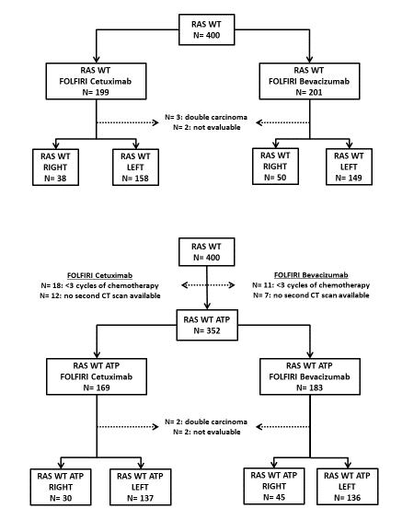
ATP, according to protocol; WT, wild-type.
Left and right refer to the location of the primary tumour.

Figure S.2. Primary tumour location and survival in the RAS wild-type population
Left-sided tumours (N=307): a. Progression-free survival, b. Overall survival; Right-sided tumours (N=88): c. Progression-free survival, d. Overall survival.
(a)
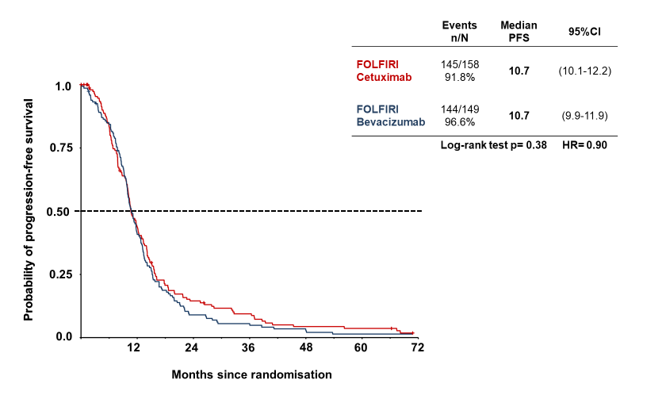
(b)
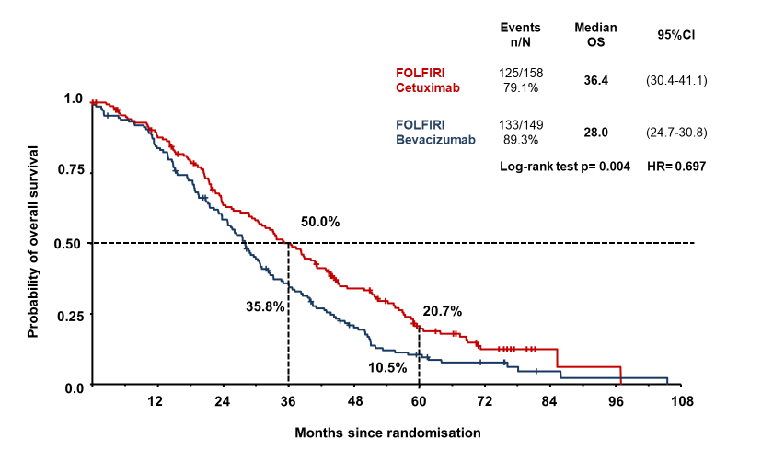

(c)
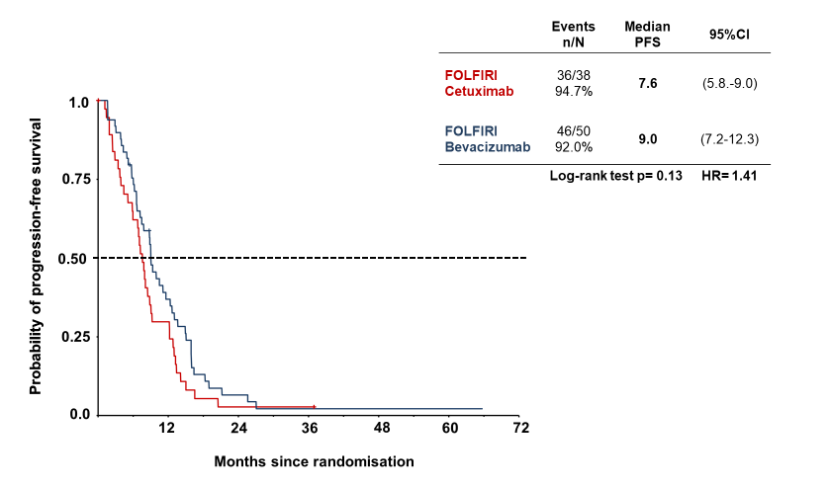
(d)
