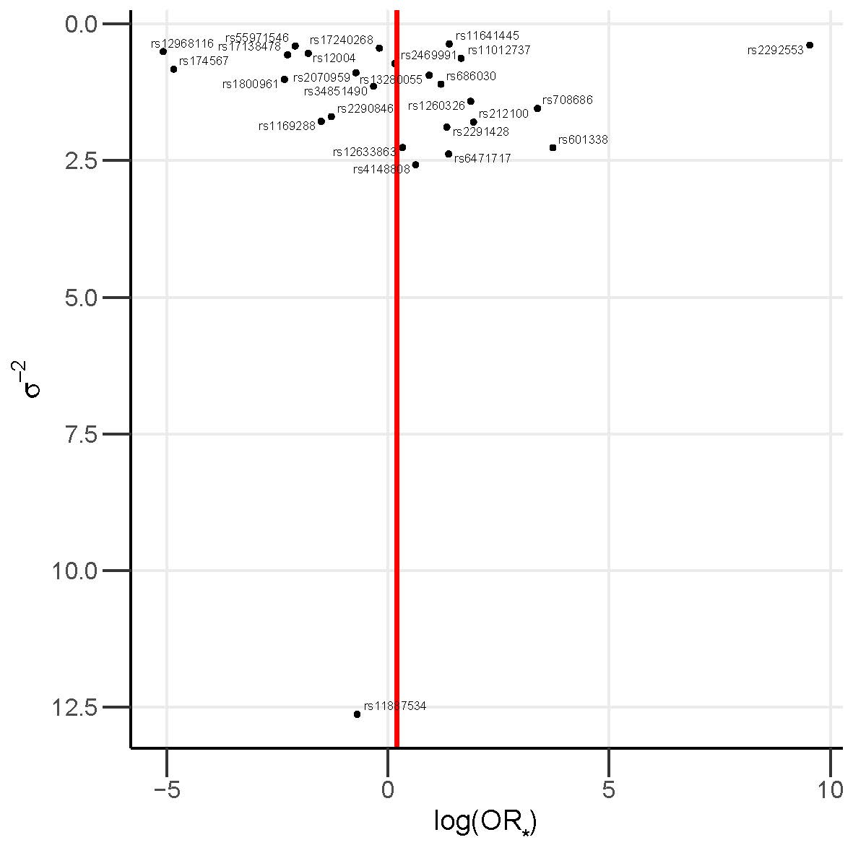
Supplementary Figure 1: Funnel plot of causal effect estimates for gallstone disease on colorectal cancer risk, with all 26 valid instrumental variables. Red line shows multiplicative random effects inverse variance weighted causal effect estimate. $\text{log}({\text{OR}}_{*})$, log odds ratio per genetically predicted standard deviation (of the log odds of gallstone disease) log unit increase of the risk of gallstone disease; $σ^{-2}$, Wald ratio estimate precision.

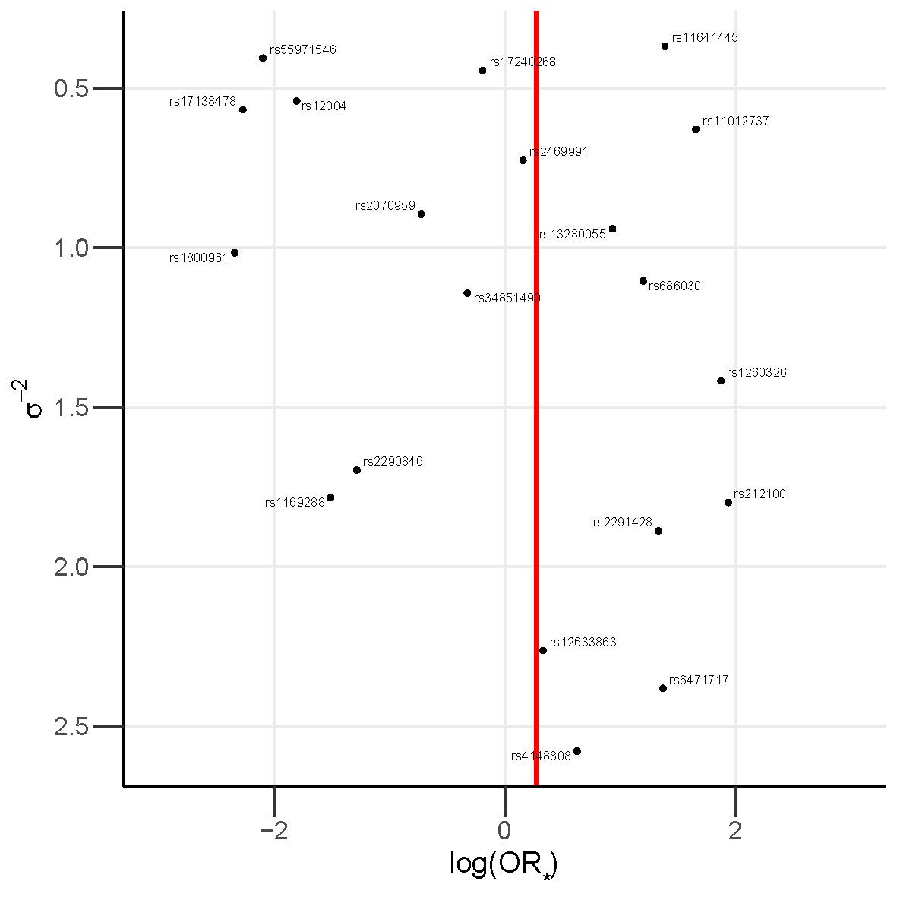
Supplementary Figure 2: Funnel plot of causal effect estimates for gallstone disease on colorectal cancer risk excluding six single nucleotide polymorphisms showing heterogeneity excluded. Red line shows multiplicative random effects inverse variance weighted causal effect estimate. $\text{log}({\text{OR}}_{*})$, log odds ratio per genetically predicted standard deviation (of the log odds of gallstone disease) log unit increase of the risk of gallstone disease; $σ^{-2}$, Wald ratio estimate precision.

Supplementary Tables Legends:

Supplementary Table 1: Gallstone disease GWAS demographic summary.

Supplementary Table 2: Circulating bilirubin levels GWAS demographic summary.

Supplementary Table 3: Summary of the 14 CRC GWAS in the meta-analysis.

Supplementary Table 4: Single nucleotide polymorphisms (SNPs) used as instrumental variables in the Mendelian randomisation analysis.

Supplementary Table 5: Assessing the suitability of IVs for each exposure for use in Mendelian randomisation analysis.

Supplementary Table 6: Causal estimates from each Mendelian randomisation method for each exposure and CRC risk.

Supplementary Figure Legends:

Supplementary Figure 1: Funnel plot of causal effect estimates for gallstone disease on colorectal cancer risk, with all 26 valid instrumental variables. Red line shows multiplicative random effects inverse variance weighted causal effect estimate. $\text{log}({\text{OR}}_{*})$, log odds ratio per genetically predicted standard deviation (of the log odds of gallstone disease) log unit increase of the risk of gallstone disease; $σ^{-2}$, Wald ratio estimate precision.

Supplementary Figure 2: Funnel plot of causal effect estimates for gallstone disease on colorectal cancer risk excluding six single nucleotide polymorphisms showing heterogeneity excluded. Red line shows multiplicative random effects inverse variance weighted causal effect estimate. $\text{log}({\text{OR}}_{*})$, log odds ratio per genetically predicted standard deviation (of the log odds of gallstone disease) log unit increase of the risk of gallstone disease; $σ^{-2}$, Wald ratio estimate precision.

