Supplemental Figure 1

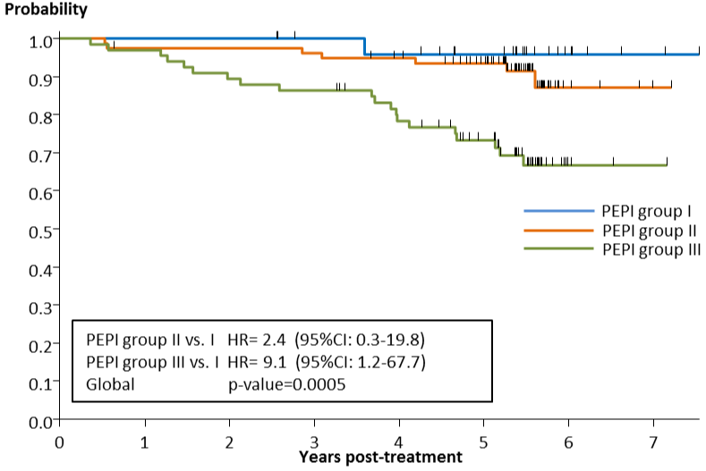

Supplemental table 1

 | Anastrozole |  | Fulvestrant
 | N | % | N | %
Sataloff’s classification T
. | 5 | 4.5 | 12 | 11.3
T A | 1 | 0.9 | 1 | 0.9
T B | 40 | 36.0 | 22 | 20.8
T C | 52 | 46.8 | 55 | 51.9
T D | 13 | 11.7 | 16 | 15.1
Sataloff’s classification N
. | 9 | 8.1 | 13 | 12.3
N A | 8 | 7.2 | 9 | 8.5
N B | 40 | 36.0 | 34 | 32.1
N C | 28 | 25.2 | 18 | 17.0
N D | 26 | 23.4 | 32 | 30.2
.: not available

Supplemental table 2

Pathology/Biomarker status | RFS points | Anastrozole | Fulvestrant
pT
. | . | 2 | 13
pT1/T2 | 0 | 100 | 77
pT3/T4 | 3 | 9 | 16
pN
. | . | 2 | 11
Negative | 0 | 54 | 42
Positive | 3 | 55 | 53
KI67 level
. | . | 17 | 21
0%-2.7% | 0 | 34 | 34
>2.7%-7.3% | 1 | 28 | 22
>7.3%-19.7% | 1 | 17 | 18
>19.7%-53.1% | 2 | 15 | 9
>53.1% | 3 | . | 2
ER-status Allred score
. | . | 8 | 17
0-2 | 3 | . | 1
3-8 | 0 | 103 | 88
PEPI score
. |  | 19 | 28
0 |  | 17 | 10
1 |  | 21 | 17
2 |  | 3 | 8
3 |  | 15 | 13
4 |  | 19 | 14
5 |  | 9 | 1
6 |  | 2 | 7
7 |  | 3 | 8
8 |  | 3 | .
PEPI group
Not calculated |  | 19 | 28
I |  | 17 | 10
II |  | 39 | 38
III (≥4) |  | 36 | 30

