Supplementary Online Material

Supplementary Figure 1. Time to first on-treatment plasma samples.….………..…………… ……….….….2
Supplementary Figure 2. Overview of changes between the baseline and on treatment plasma tumour (ptDNA) DNA fractions……………………………………………….………………………………………………..3
Supplementary Figure 3. Association of plasma tumour DNA (ptDNA) fraction before abiraterone with treatment outcome………………………………………………………………………..………………..………….4
Supplementary Figure 4. Previous response to ADT at hormone sensitive prostate cancer………………..5

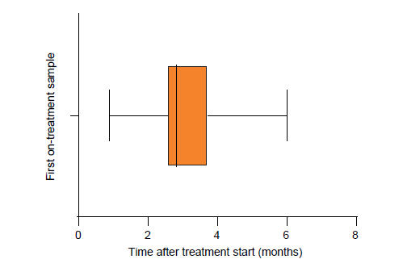

Supplementary Figure 1. Time to first on-treatment plasma samples.

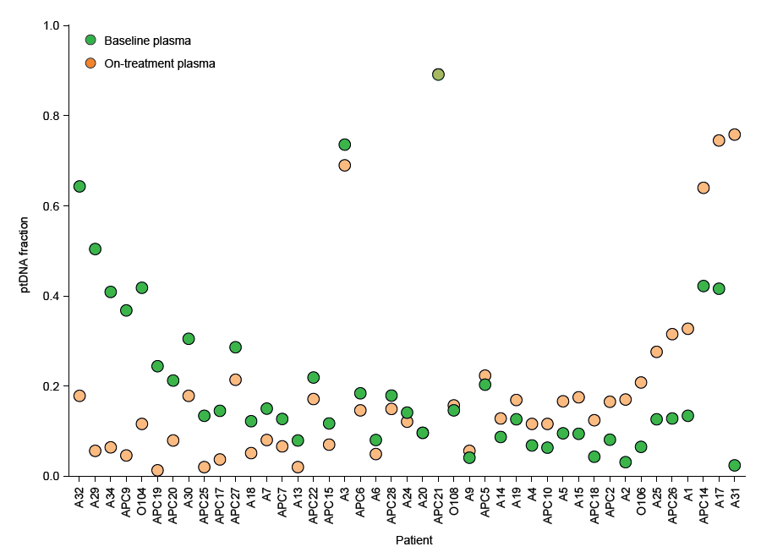

Supplementary Figure 2. Overview of changes between the baseline and on treatment ptDNA fractions.

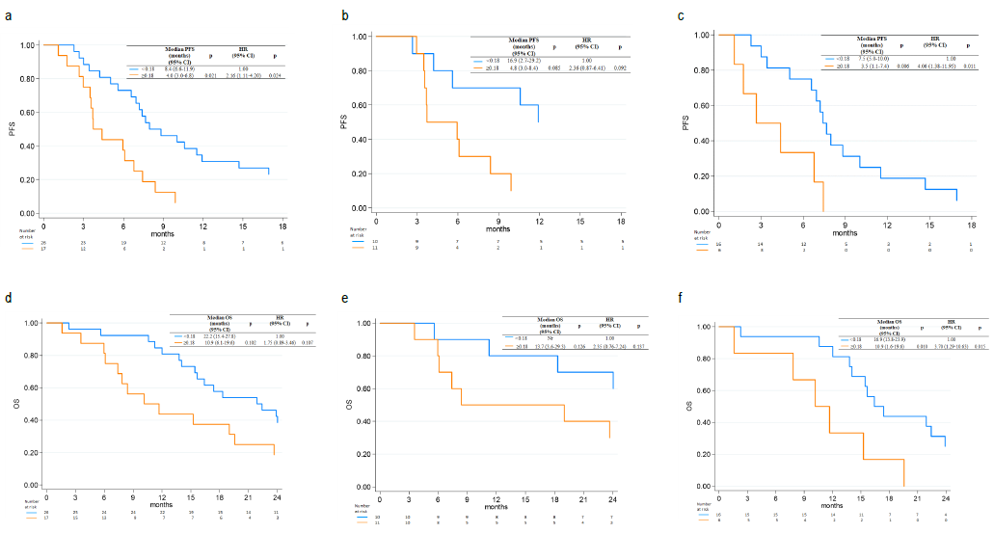

Supplementary Figure 3. Association of plasma tumour DNA (ptDNA) fraction before abiraterone with treatment outcome. Progression-free survival (PFS) in overall (a), chemotherapy-naive (b) and post-chemotherapy (c) patients according to median baseline ptDNA fraction. Overall survival (OS) in overall (d), chemotherapy-naive (e) and post-chemotherapy (f) patients according to median value of baseline ptDNA.

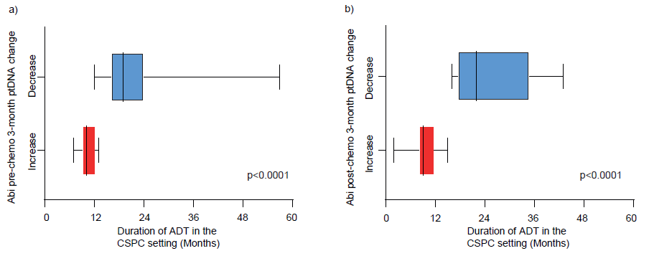

Supplementary Figure 4. (a) Previous response to ADT at hormone-sensitive prostate cancer (HSPC) in pre-chemotherapy and (b) in post-chemotherapy patients with ptDNA increase or decrease upon abiraterone treatment.

