Supplementary materials

Supplementary Table 1 - List of participating sites.
 | Site Name | Local PI
1 | Sheffield | Lynda Wyld and Matt Winter
2 | Barnsley | Julia Dicks
3 | Doncaster | Clare Rogers
4 | Milton Keynes | Amanda Taylor
5 | Scunthorpe and Grimsby | Rajesh Vijh (Scunthorpe), Jenny Smith (Grimsby)
6 | Leicester | Monika Kaushik
7 | Derby | Kwok Leung Cheung
8 | East Lancashire | Julie Iddon
9 | Harrogate | Matthew Adelekan
10 | St Helens and Knowsley | Riccardo Audisio
11 | York | Rana Nasr (York and Scarborough)
12 | Liverpool | Chris Holcombe
13 | Airedale | Claire Murphy
14 | Leeds | Kieran Horgan
15 | Bradford | Rick Linforth
16 | Cardiff | Helen Sweetland
17 | Aneurin Bevan Health Board | Simon Waters (Royal Gwent), Theresa Howe (Nevill Hall)
18 | Royal Lancaster | Rishi Parmeshwar
19 | Coventry | Abigail Tomlins
20 | Grantham | Anzors Gvaramadze
21 | Lincoln | Anzors Gvaramadze
22 | Pilgrim | Anzors Gvaramadze
23 | Hull | Peter Kneeshaw
24 | Nottingham | Lisa Whisker
25 | Southport | Anwar Haq
26 | Leighton | Vanessa Pope
27 | Royal Marsden | Jenny Rusby
28 | Cheltenham General | Sarah Vestey
29 | Guys and St Thomas | Michael Douek
30 | Dorset County | Caroline Osborne
31 | Mid Essex | Sascha Miles-Dua
32 | Mid Yorkshire | Jay Naik
33 | Bristol | Zoe Winters
34 | Chesterfield | Iman Azmy
35 | Rotherham | Inder Kumar
36 | Darent Valley | Seema Seetharam
37 | Kingston | Karyn Shenton
38 | Colchester | Mukesh Mukesh
39 | Yeovil | Caroline Osborne
40 | Croydon | Sanjay Joshi
41 | North Tees | Colm Hennessy
42 | South Tees | Imtiaz Cheema
43 | Luton and Dunstable | Mei-Lin Ah-See
44 | Weston General | Rachel Ainsworth
45 | Tameside | Stephanie Ridgway
46 | Macclesfield | Lisa Barraclough
47 | Wrightington, Wigan and Leigh | Angela Power
48 | Birmingham | Fiona Hoar
49 | Kings Mill | Rebecca Boulton
50 | Wythenshawe | Nigel Bundred
51 | Aintree | Peter Robson
52 | Brighton | Gargi Patel
53 | St Margaret’s | Ashraf Patel
54 | St Marys | Steve Parker
55 | Oxford | Asha Adwani
56 | Frimley and Wexham | Ruth Davis (Wexham), Raouf Daoud (Frimley)

Supplementary Table 2a - Definition of risk of breast cancer recurrence based on tumour characteristics on diagnostic biopsy or surgical specimen.
Tumour characteristics | Risk of recurrence
Tumour characteristics | High* | Low
ER | Negative | Positive
HER2 | Positive | Negative
Grade | 3 | 1-2
Nodal involvement | Yes | No
Oncotype DX Recurrence Score | ≥25 | <25
*high risk is defined by the presence of ≥1 of the features enlisted.

Supplementary Table 2b – Definition of fitness categories were determined. Overall scores were defined: Fit: 0-2. Vulnerable: 3-8. Frail: 9+.
Domain | Range | Score
Domain | Range | 0 | 1 | 2
ECOG PS | 0-4 | 0-1 | 2 | 3-4
ADL | 0-10 | 20 | 19 | ≤18
IADL | 0-8 | 8 | 7 | ≤6
Charlson comorbidity index | - | 0-1 | - | ≥2
Prescribed medications (excluding vitamins/minerals) | - | ≤3 | ≥4 | -
APSGA |  | 0-3 | 4-8 | ≥9
MMSE | 0-30 | ≥24 | 20-24 | <20

Supplementary Table 3 - Baseline patient characteristics by receipt of chemotherapy.
 |  | No Chemotherapy | Chemotherapy
 |  | N = 2414 | N = 397
Participation level | Full | 1789 (74.1%) | 322 (81.1%)
Participation level | Partial | 550 (22.8%) | 71 (17.9%)
Participation level | Consultee | 75 (3.1%) | 4 (1.0%)
Age | n | 2414 | 397
Age | Mean (SD) | 76.98 (5.25) | 73.62 (3.30)
Age | Median (IQR) | 76.00 (73.00, 80.00) | 73.00 (71.00, 76.00)
Age | Min, Max | 69, 95 | 69, 87
Charlson comorbidity index (no age) | n | 2322 | 385
Charlson comorbidity index (no age) | Mean (SD) | 1.07 (1.33) | 0.81 (1.10)
Charlson comorbidity index (no age) | Median (IQR) | 1.00 (0.00, 2.00) | 0.00 (0.00, 2.00)
Charlson comorbidity index (no age) | Min, Max | 0, 9 | 0, 6
Charlson calculated probability | n | 2322 | 385
Charlson calculated probability | Mean (SD) | 0.45 (0.30) | 0.56 (0.27)
Charlson calculated probability | Median (IQR) | 0.53 (0.21, 0.77) | 0.77 (0.21, 0.77)
Charlson calculated probability | Min, Max | 0, 0.77 | 0, 0.77
Number of concurrent medications | n | 2116 | 330
Number of concurrent medications | Mean (SD) | 4.13 (2.66) | 3.63 (2.49)
Number of concurrent medications | Median (IQR) | 4.00 (2.00, 6.00) | 3.00 (2.00, 5.00)
Number of concurrent medications | Min, Max | 0, 18 | 0, 14
ADL category | No dependency | 1683 (69.7%) | 321 (80.9%)
ADL category | Mild dependency | 274 (11.4%) | 34 (8.6%)
ADL category | Moderate/severe dependency | 262 (10.9%) | 16 (4.0%)
ADL category | Unknown | 195 (8.1%) | 26 (6.5%)
IADL category | No dependency | 1737 (72.0%) | 332 (83.6%)
IADL category | Mild dependency | 221 (9.2%) | 28 (7.1%)
IADL category | Moderate/severe dependency | 248 (10.3%) | 10 (2.5%)
IADL category | Unknown | 208 (8.6%) | 27 (6.8%)
MMSE category | Normal function | 2133 (88.4%) | 361 (90.9%)
MMSE category | Mild impairment | 220 (9.1%) | 28 (7.1%)
MMSE category | Moderate impairment | 30 (1.2%) | 6 (1.5%)
MMSE category | Severe | 31 (1.3%) | 2 (0.5%)
APG SGA category | Low | 1864 (77.2%) | 316 (79.6%)
APG SGA category | Moderate | 249 (10.3%) | 39 (9.8%)
APG SGA category | High | 36 (1.5%) | 4 (1.0%)
APG SGA category | Unknown | 265 (11.0%) | 38 (9.6%)
ECOG performance status | 0 | 1632 (67.6%) | 312 (78.6%)
ECOG performance status | 1 | 544 (22.5%) | 63 (15.9%)
ECOG performance status | 2 | 77 (3.2%) | 3 (0.8%)
ECOG performance status | 3 | 34 (1.4%) | 2 (0.5%)
ECOG performance status | 4 | 1 (0.0%) | 0 (0.0%)
ECOG performance status | Unknown | 126 (5.2%) | 17 (4.3%)
Supplementary Table 4 - Postoperative tumour characteristics by receipt of chemotherapy.
 |  | No Chemotherapy | Chemotherapy
 |  | N = 2414 | N = 397
Main side | Right | 1128 (46.7%) | 177 (44.6%)
Main side | Left | 1286 (53.3%) | 220 (55.4%)
Tumour size (mm) | n | 2365 | 387
Tumour size (mm) | Mean (SD) | 24.2 (15.8) | 32.8 (20.5)
Tumour size (mm) | Median (IQR) | 20.0 (14.0, 30.0) | 29.0 (21.0, 40.0)
Tumour size (mm) | Min, Max | 0, 155 | 0, 210
Tumour size (mm) | ≤ 20 | 1183 (49.0%) | 96 (24.2%)
Tumour size (mm) | 21-50 | 1043 (43.2%) | 242 (61.0%)
Tumour size (mm) | > 50 | 139 (5.8%) | 49 (12.3%)
Tumour size (mm) | Unknown | 49 (2.0%) | 10 (2.5%)
Nodal status | pN0-1mi | 1726 (71.5%) | 187 (47.1%)
Nodal status | pN1 | 495 (20.5%) | 117 (29.5%)
Nodal status | pN2 | 95 (3.9%) | 52 (13.1%)
Nodal status | pN3 | 46 (1.9%) | 32 (8.1%)
Nodal status | pNx | 52 (2.2%) | 9 (2.3%)
Grade | Grade 1 | 377 (15.6%) | 4 (1.0%)
Grade | Grade 2 | 1355 (56.1%) | 130 (32.7%)
Grade | Grade 3 | 618 (25.6%) | 247 (62.2%)
Grade | Unknown | 64 (2.7%) | 16 (4.0%)
Histology | Ductal NST | 1534 (63.5%) | 281 (70.8%)
Histology | Lobular carcinoma | 321 (13.3%) | 54 (13.6%)
Histology | Tubular carcinoma | 29 (1.2%) | 0 (0.0%)
Histology | Mucinous carcinoma | 70 (2.9%) | 1 (0.3%)
Histology | Other | 235 (9.7%) | 31 (7.8%)
Histology | Unknown | 225 (9.3%) | 30 (7.6%)
ER positive | Negative | 240 (9.9%) | 132 (33.2%)
ER positive | Positive | 2101 (87.0%) | 253 (63.7%)
ER positive | Unknown | 73 (3.0%) | 12 (3.0%)
HER2 status | Negative | 2050 (84.9%) | 222 (55.9%)
HER2 status | Inconclusive | 19 (0.8%) | 3 (0.8%)
HER2 status | Positive | 173 (7.2%) | 159 (40.1%)
HER2 status | Unknown | 172 (7.1%) | 13 (3.3%)
Oncotype Dx test performed | No | 428 (17.7%) | 36 (9.1%)
Oncotype Dx test performed | Yes | 35 (1.4%) | 6 (1.5%)
Oncotype Dx test performed | Not Applicable | 571 (23.7%) | 261 (65.7%)
Oncotype Dx test performed | Unknown | 1380 (57.2%) | 94 (23.7%)
Breast surgery | Wide local excision | 1433 (59.4%) | 165 (41.5%)
Breast surgery | Therapeutic mammoplasty / breast reshaping after WLE | 33 (1.4%) | 18 (4.5%)
Breast surgery | Mastectomy | 860 (35.6%) | 189 (47.6%)
Breast surgery | Mastectomy and reconstruction | 25 (1.0%) | 12 (3.0%)
Breast surgery | Other | 16 (0.7%) | 4 (1.0%)
Breast surgery | Unknown | 47 (1.9%) | 9 (2.3%)
Axillary surgery | Axillary sample | 76 (3.1%) | 12 (3.0%)
Axillary surgery | Axillary clearance | 274 (11.4%) | 140 (35.3%)
Axillary surgery | Sentinel lymph node biopsy | 1770 (73.3%) | 210 (52.9%)
Axillary surgery | Internal mammary node biopsy | 1 (0.0%) | 0 (0.0%)
Axillary surgery | No axillary surgery | 73 (3.0%) | 7 (1.8%)
Axillary surgery | Unknown | 220 (9.1%) | 28 (7.1%)

Supplementary Table 5 - Covariate balance in the final matched dataset: chemotherapy vs no chemotherapy.
 |  | Chemotherapy | No Chemotherapy
 |  | N = 200 | N = 350
Age | n | 200 | 350
Age | Mean (SD) | 73.48 (2.91) | 74.36 (3.06)
Age | Median (IQR) | 73.00 (71.00, 76.00) | 74.00 (72.00, 77.00)
Age | Min, Max | 70, 80 | 69, 80
aPG-SGA | Low | 173 (86.5%) | 302 (86.3%)
aPG-SGA | Moderate | 24 (12.0%) | 45 (12.9%)
aPG-SGA | High | 3 (1.5%) | 3 (0.9%)
ADL | No dependency | 162 (81.0%) | 273 (78.0%)
ADL | Mild dependency | 26 (13.0%) | 46 (13.1%)
ADL | Moderate/severe dependency | 12 (6.0%) | 31 (8.9%)
iADL | No dependency | 174 (87.0%) | 299 (85.4%)
iADL | Mild dependency | 19 (9.5%) | 31 (8.9%)
iADL | Moderate/severe dependency | 7 (3.5%) | 20 (5.7%)
MMSE | Normal function | 182 (91.0%) | 317 (90.6%)
MMSE | Mild impairment | 15 (7.5%) | 28 (8.0%)
MMSE | Moderate impairment | 3 (1.5%) | 5 (1.4%)
CCI | 0-1 | 176 (88.0%) | 301 (86.0%)
CCI | > 2 | 24 (12.0%) | 49 (14.0%)
Medications | 3 or fewer | 109 (54.5%) | 172 (49.1%)
Medications | 4 or more | 91 (45.5%) | 178 (50.9%)
ECOG | Low | 195 (97.5%) | 339 (96.9%)
ECOG | Moderate | 3 (1.5%) | 6 (1.7%)
ECOG | High | 2 (1.0%) | 5 (1.4%)
NPI | Moderate | 137 (68.5%) | 245 (70.0%)
NPI | Good | 10 (5.0%) | 17 (4.9%)
NPI | Poor | 53 (26.5%) | 88 (25.1%)
HER2 | Negative | 139 (69.5%) | 269 (76.9%)
HER2 | Positive | 61 (30.5%) | 81 (23.1%)

Supplementary Table 6 - Mortality status for HER2-positive patients and ER-negative patients by use of chemotherapy.

 |  | No Chemotherapy | Chemotherapy | Total
HER2+ | n | 170 | 156 | 326
HER2+ | Died | 45 (26.5%) | 19 (12.2%) | 64 (19.6%)
HER2+ | n | 169 | 156 | 325
HER2+ | Died of breast cancer | 24 (14.2%) | 12 (7.7%) | 36 (11.1%)
ER- | n | 237 | 132 | 369
ER- | Died | 92 (38.8%) | 20 (15.2%) | 112 (30.4%)
ER- | n | 234 | 131 | 365
ER- | Died of breast cancer | 56 (23.9%) | 13 (9.9%) | 69 (18.9%)

Supplementary Table 7 - Toxicity in patients receiving chemotherapy (n=397)
Supplementary Table 7a – Adverse event rates according in the overall chemotherapy population and according to level of participation.

 | Consultee | Full | Partial | Total
 | N = 4 | N = 322 | N = 71 | N = 397
Allergic reaction to chemotherapy agents | 0 (0%) | 21 (7%) | 5 (7%) | 26 (7%)
Anaemia | 2 (50%) | 69 (21%) | 14 (20%) | 85 (21%)
Fatigue | 3 (75%) | 231 (72%) | 49 (69%) | 283 (71%)
Hair thinning | 2 (50%) | 205 (64%) | 42 (59%) | 249 (63%)
Infection | 1 (25%) | 103 (32%) | 28 (39%) | 132 (33%)
Low white cell count | 2 (50%) | 76 (24%) | 19 (27%) | 97 (24%)
Nausea | 3 (75%) | 134 (42%) | 30 (42%) | 167 (42%)
Thrombocytopenia | 3 (75%) | 19 (6%) | 7 (10%) | 29 (7%)

Supplementary Table 7b - Adverse event rates according to CTCAE grading.
 | Worse CTCAE grading | Individuals
Allergic reactions | 1 | 7/26 (26.9%)
Allergic reactions | 2 | 9/26 (34.6%)
Allergic reactions | 3 | 2/26 (7.7%)
Allergic reactions | 4 | 1/26 (3.8%)
Allergic reactions | Missing | 7/26 (26.9%)
Anaemia | 1 | 29/85 (34.1%)
Anaemia | 2 | 25/85 (29.4%)
Anaemia | 3 | 2/85 (2.4%)
Anaemia | 4 | 1/85 (1.2%)
Anaemia | Missing | 28/85 (32.9%)
Fatigue | 1 | 95/283 (33.6%)
Fatigue | 2 | 75/283 (26.5%)
Fatigue | 3 | 26/283 (9.2%)
Fatigue | 4 | 1/283 (0.4%)
Fatigue | Missing | 86/283 (30.4%)
Alopecia | 1 | 60/249 (24.1%)
Alopecia | 2 | 114/249 (45.8%)
Alopecia | Missing | 75/249 (30.1%)
Infection | 2 | 49/132 (37.1%)
Infection | 3 | 44/132 (33.3%)
Infection | 4 | 6/132 (4.5%)
Infection | Missing | 33/132 (25.0%)
Low white cell count | 1 | 16/97 (16.5%)
Low white cell count | 2 | 24/97 (24.7%)
Low white cell count | 3 | 11/97 (11.3%)
Low white cell count | 4 | 11/97 (11.3%)
Low white cell count | Missing | 35/97 (36.1%)
Nausea | 1 | 84/167 (50%)
Nausea | 2 | 31/167 (19%)
Nausea | 3 | 3/167 (2%)
Nausea | Missing | 49/167 (29%)
Thrombocytopenia | 1 | 17/29 (59%)
Thrombocytopenia | 2 | 4/29 (14%)
Thrombocytopenia | Missing | 8/29 (28%)

Supplementary Table 8 - Mean scores and 95% confidence intervals (CIs) adjusted for baseline score for the EQ-5D-5L scale at each timepoint in chemotherapy versus no chemotherapy cohorts.
Domain | Time point |  | Chemotherapy | No Chemotherapy | Adjusted Mean Difference (95% CI) | P-value
Score | Baseline | n | 335 | 980 | - | -
Score | Baseline | Mean (SD) | 0.8769 (0.1327) | 0.8693 (0.1489) | - | -
Score | 6 weeks | n | 299 | 807 | 0.0130 (-0.0030, 0.0289)  -0.0028 (-0.0231, 0.0175) | 0.112
Score | 6 weeks | Mean (SD) | 0.8409 (0.1414) | 0.8242 (0.1572) | 0.0130 (-0.0030, 0.0289)  -0.0028 (-0.0231, 0.0175) | 0.112
Score | 6 months | n | 279 | 760 | -0.0013 (-0.0228, 0.0201)  0.0114 (-0.0143, 0.0372) | 0.789
Score | 6 months | Mean (SD) | 0.8247 (0.1767) | 0.8241 (0.1721) | -0.0013 (-0.0228, 0.0201)  0.0114 (-0.0143, 0.0372) | 0.789
Score | 12 months | n | 261 | 659 | 0.0001 (-0.0286, 0.0288)  0.0130 (-0.0030, 0.0289) | 0.903
Score | 12 months | Mean (SD) | 0.8274 (0.1639) | 0.8185 (0.1753) | 0.0001 (-0.0286, 0.0288)  0.0130 (-0.0030, 0.0289) | 0.903
Score | 18 months | n | 224 | 556 | -0.0028 (-0.0231, 0.0175)  -0.0013 (-0.0228, 0.0201) | 0.384
Score | 18 months | Mean (SD) | 0.8186 (0.1937) | 0.8088 (0.1910) | -0.0028 (-0.0231, 0.0175)  -0.0013 (-0.0228, 0.0201) | 0.384
Score | 24 months | n | 185 | 474 | 0.0114 (-0.0143, 0.0372) | 0.994
Score | 24 months | Mean (SD) | 0.8013 (0.1787) | 0.8020 (0.1968) | 0.0114 (-0.0143, 0.0372) | 0.994
VAS | Baseline | n | 324 | 951 | - | -
VAS | Baseline | Mean (SD) | 78.9 (16.3) | 76.9 (16.6) | - | -
VAS | 6 weeks | n | 296 | 793 | -1.44 (-3.52, 0.64) | 0.176
VAS | 6 weeks | Mean (SD) | 74.5 (17.4) | 74.9 (17.0) | -1.44 (-3.52, 0.64) | 0.176
VAS | 6 months | n | 280 | 757 | -6.57 (-8.74, -4.40) | <0.001
VAS | 6 months | Mean (SD) | 70.1 (18.0) | 75.3 (16.7) | -6.57 (-8.74, -4.40) | <0.001
VAS | 12 months | n | 256 | 656 | 0.72 (-1.60, 3.05) | 0.541
VAS | 12 months | Mean (SD) | 76.7 (15.8) | 74.8 (17.6) | 0.72 (-1.60, 3.05) | 0.541
VAS | 18 months | n | 230 | 549 | 0.92 (-1.78, 3.63) | 0.503
VAS | 18 months | Mean (SD) | 74.9 (17.6) | 73.6 (18.3) | 0.92 (-1.78, 3.63) | 0.503
VAS | 24 months | n | 185 | 479 | 1.48 (-1.41, 4.36) | 0.315
VAS | 24 months | Mean (SD) | 74.7 (16.3) | 72.7 (18.2) | 1.48 (-1.41, 4.36) | 0.315

Supplementary figures

Supplementary Figure 1
Logistic regression was used to calculate propensity scores for treatment allocation. The covariates included in the model were measures of functionality (ADL, IADL, MMSE, ECOG), nutritional status (nutrition (abridged PG-SGA), comorbidities (CCI, number of medications) and age. The models were built sequentially as follows:
- Using scores on their original scale and included patients in whom all scores were completed.
- Using the categorised versions of the functionality, nutrition and comorbidity again for patients with all scores; age was retained as a continuous term.
- As ii) including additional patients that could be classified but for whom the score itself was incomplete.
i) and ii) allowed a comparison of models based on categorised and uncategorised scores in order to establish how much information was lost by the categorisations; these were fitted the same participants. Models ii) and iii) differed in the number of individuals available for analysis, since completed inventories could be categorised for some participants. To illustrate taking the IADL, if seven of the eight questions were answered the total score is unknown, but the risk category could be assigned as “high risk” if the answers included two or more limitations. Models i) and ii) performed similarly as demonstrated by the AIC and c-statistics, meaning the simpler categorical model was adequate for creating the propensity scores.
The propensity scores were then used to match chemotherapy patients to patients who did not receive chemotherapy up to a 1:3 ratio. A calliper of 0.25 times the standard deviation of the propensity scores was used to ensure participants were closely matched. This ratio and calliper were chosen based on an examination of the propensity score overlaps for several combinations of ratios and callipers. The figure below shows the overlap in the propensity score for matched sets with different callipers and ratios. Supplementary Table 5 shows the balance achieved in the final matched dataset.
Propensity score overlap and number of observations for matched groups with differing ratios (y-axis) and callipers (x-axis): chemotherapy vs no chemotherapy.

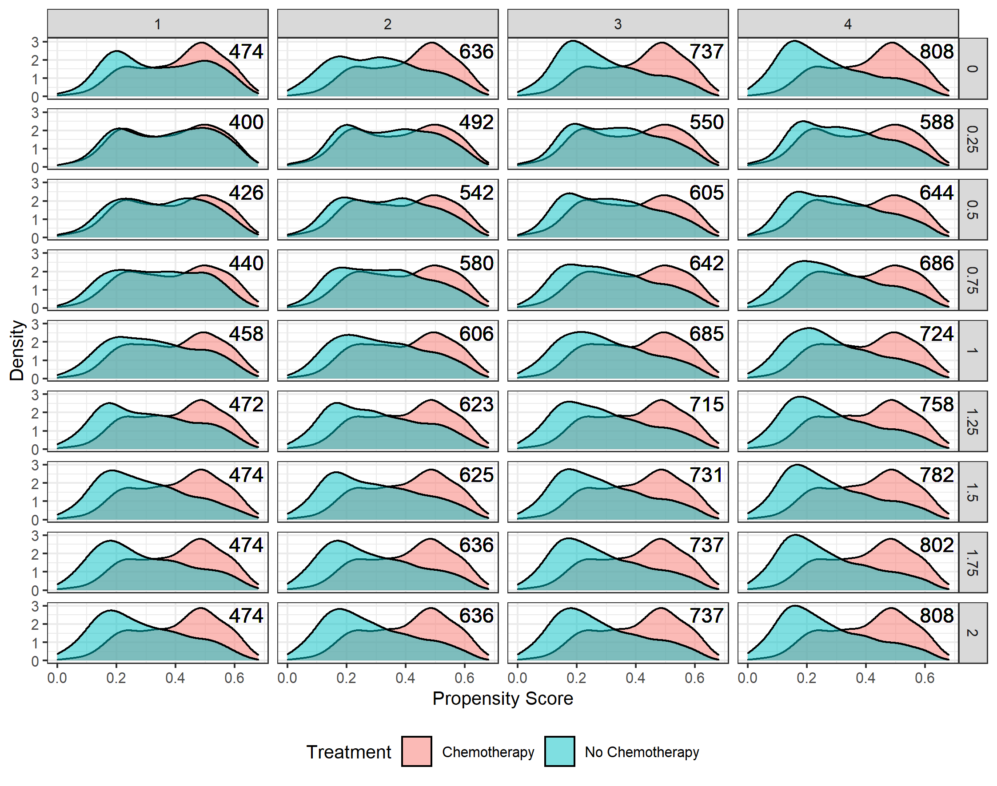
Supplementary Figure 2 - Kaplan-Meier plots for overall survival (8a) and breast cancer specific survival (8b) for HER2-positive and oestrogen receptor (ER)-negative patients by use of chemotherapy in unmatched population.
8a. 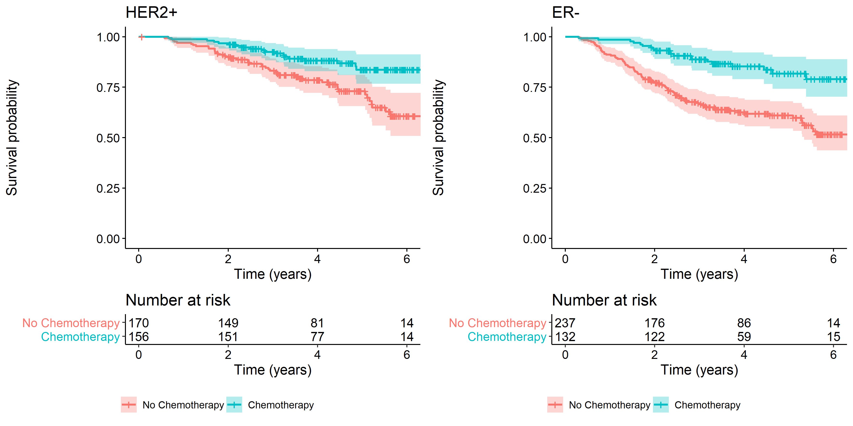
8b.
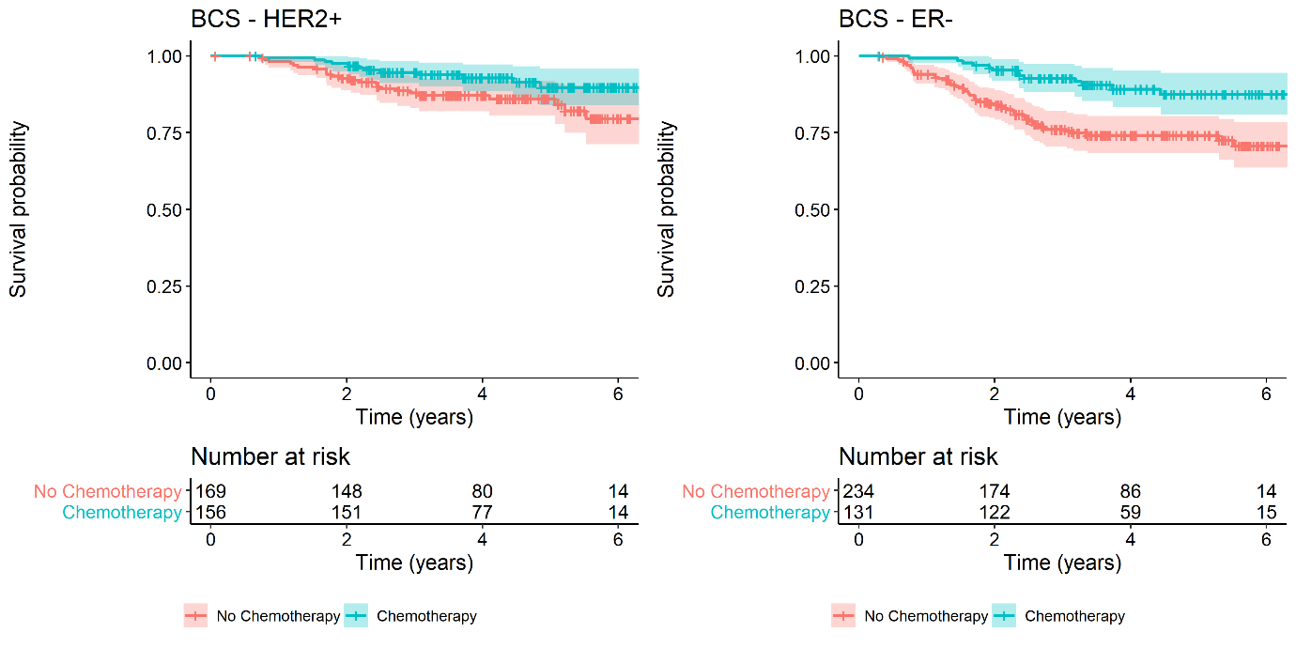

Supplementary Figure 3 – Mean (95% CI) scores over time points for the chemotherapy versus no chemotherapy population measured on the EQ-5D-5L scale.*
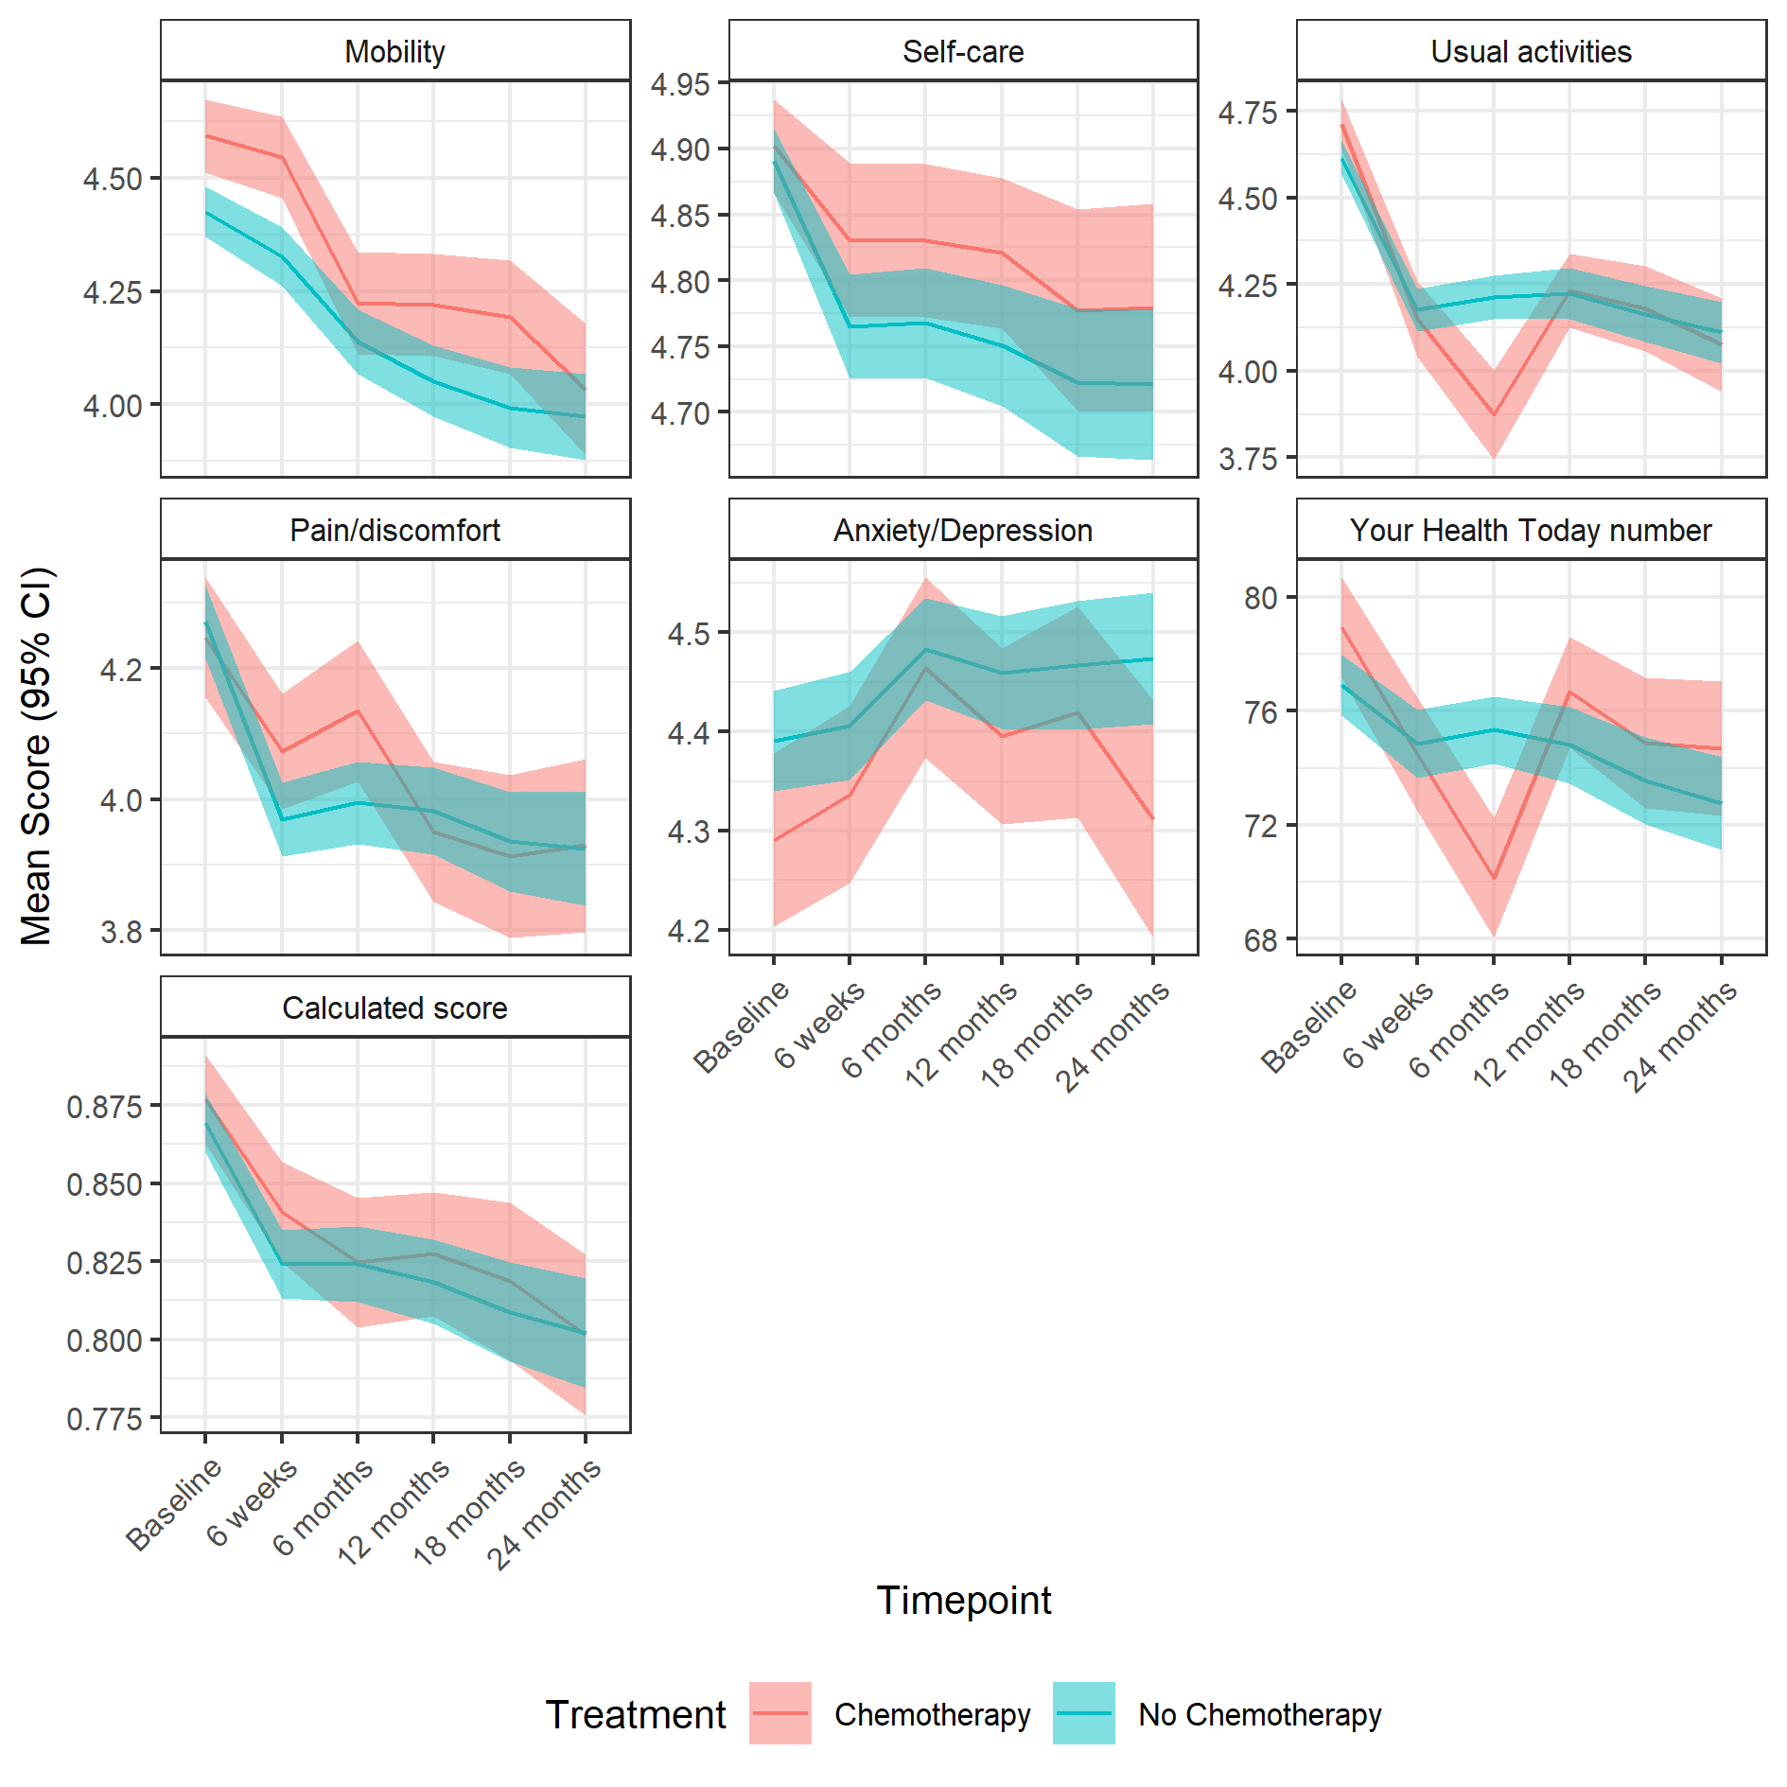
*the calculated score is a single summary number (index value) which reflects the health state in the context of the preferences of the general population of a country/region and is derived by applying a formula attaching weights to each of the levels in each dimension as per the EQ-5D-5L User Guide.

Supplementary Figure 4 – Mean (95% CI) EQ-5D-5L usual activities score over timepoints for the matched chemotherapy vs no chemotherapy population.

