Supplementary figure 1

Kaplan-Meier plot of local recurrence-free survival of those randomised to receive EBRT (red line) along with those randomised to receive TARGIT-IORT separated by those who received additional EBRT (purple line) and those who did not (blue line). No statistically significant difference was found between EBRT and the two latter groups.

Supplementary figure 2 – An illustration of the tool to assess which patient we recommend EBRT after TARGIT-IORT based on the data from the TARGIT-A trial. We urge the readers to please click on the link https://targit.org.uk/addrt – and input some numbers for a hypothetical patient to best illustrate the concept.
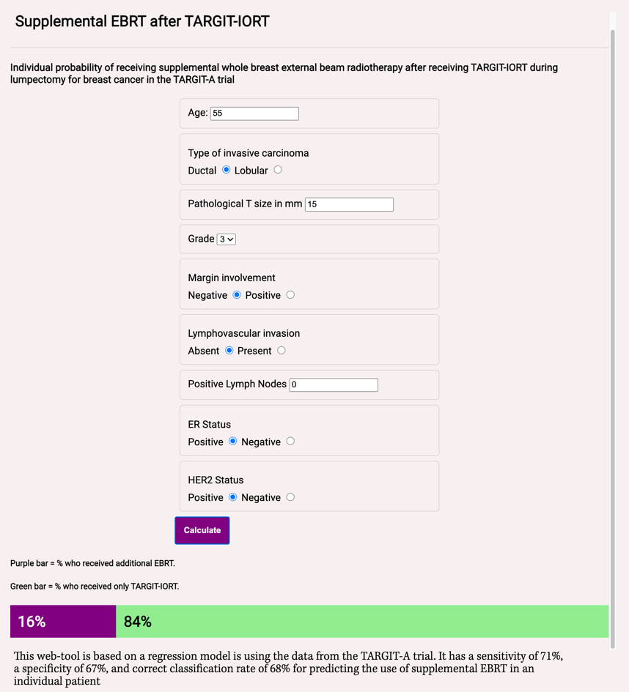

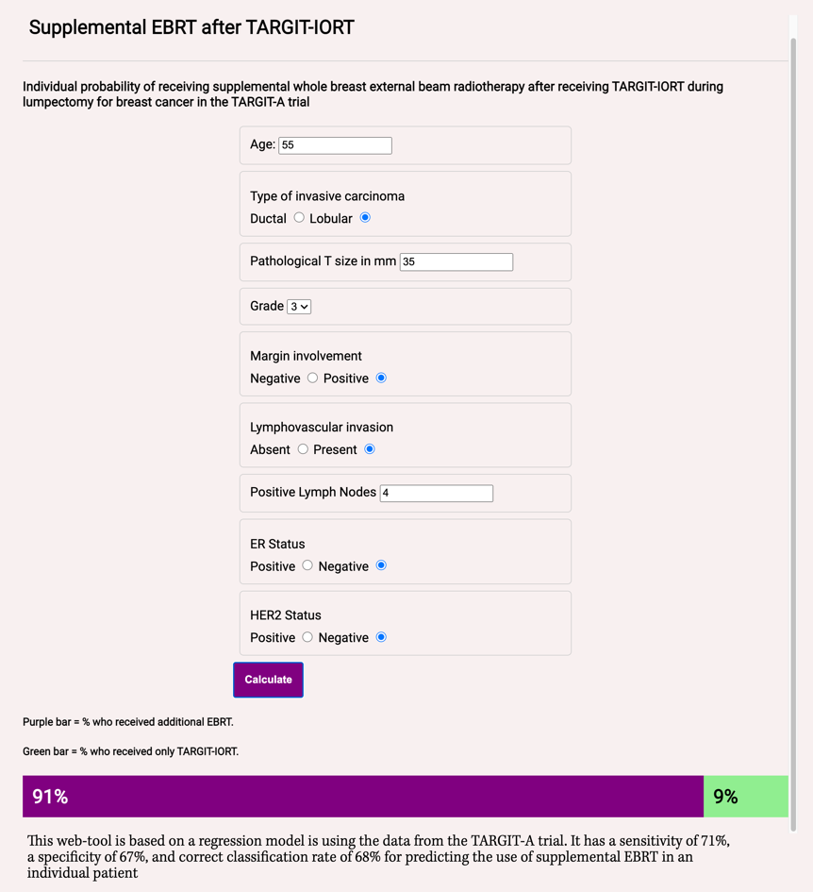
Supplementary table 1 – Patient and tumour characteristics

Characteristics | TARGIT-IORT (n=1140) | EBRT (n=1158)
Age (years)
≤50 | 117 (10.3) | 99 (8.6)
51-60 | 362 (31.8) | 375 (32.4)
61-70 | 481 (42.2) | 524 (45.3)
>70 | 180 (15.8) | 160 (13.8)
Body mass index
Normal (<25) | 408 (41.0) | 420 (42.2)
Overweight (25-29.9) | 375 (37.7) | 329 (33.1)
Obese (≥30) | 212 (21.3) | 246 (23.7)
Unknown | 145 (12.7) | 163 (14.1)
Specimen weight (g)
Median (interquartile range) | 40 (25-65) | 40 (24-70)
Pathological tumour size (mm; P=0.70)
≤10 | 369 (33.1) | 370 (33.1)
11-20 | 571 (51.2) | 557 (49.9)
>20 | 176 (15.8) | 190 (17.0)
Unknown | 24 (2.1) | 41 (3.5)
Grade
1 | 275 (24.5) | 286 (25.6)
2 | 621 (55.4) | 615 (55.0)
3 | 226 (20.1) | 217 (19.4)
Unknown | 18 (1.6) | 40 (3.5)
Margin
Free | 1007 (89.4) | 993 (88.2)
Ductal carcinoma in situ only | 54 (4.8) | 60 (5.3)
Invasive | 65 (5.8) | 73 (6.5)
Unknown | 14 (1.2) | 32 (2.8)
Re-excision | 76 (6.7) | 97 (8.4)
Lymphovascular invasion
Absent | 931 (83.4) | 946 (84.6)
Present | 185 (16.6) | 172 (15.4)
Unknown | 24 (2.1) | 40 (3.5)
Lymph nodes involved
0 | 872 (77.4) | 893 (79.2)
1-3 | 213 (18.9) | 205 (18.2)
>3 | 41 (3.6) | 29 (2.6)
Unknown | 14 (1.2) | 31 (2.7)
Estrogen receptor status
Positive | 1005 (89.8) | 1030 (91.7)
Negative | 114 (10.2) | 93 (8.3)
Unknown | 21 (1.8) | 35 (3.0)
Progesterone receptor status
Positive | 895 (80.3) | 921 (82.7)
Negative | 220 (19.7) | 193 (17.3)
Unknown | 25 (2.2) | 44 (3.8)
Human epidermal growth factor receptor 2 status
Positive | 156 (14.5) | 164 (15.1)
Negative | 920 (85.5) | 925 (84.9)
Unknown | 64 (5.6) | 69 (6.0)
Method of presentation
Screen detected | 739 (67.0) | 755 (68.0)
Symptomatic | 364 (33.0) | 355 (32.0)
Unknown | 37 (3.3) | 48 (4.2)
Endocrine therapy
Received | 897 (81.5) | 894 (81.1)
Did not receive | 204 (18.5) | 209 (18.9)
Unknown | 39 (3.4) | 55 (4.8)
Chemotherapy
Received | 239 (21.7) | 218 (19.7)
Did not receive | 863 (78.3) | 887 (80.3)
Unknown | 38 (3.3) | 53 (4.6)
EBRT=external beam radiotherapy; TARGIT-IORT=targeted intraoperative radiotherapy.
Data are numbers (percentages). For percentage calculation, the denominator for unknown percentages is the total number randomised (1140 and 1158) and the denominator for each category is the total number of known patients. No imbalance was found for any of these characteristics between the two randomised arms.

Supplementary table 2 Background risk factors for non-breast-cancer deaths

 | TARGIT-IORT (1140) |  | EBRT (1158)
Age (Median age is 63)
<63 years | 572 | 50.18% | 578 | 49.91%
>=63 years | 568 | 49.82% | 580 | 50.09%
Body Mass Index (BMI)
(Normal <25) | 408 | 41.01% | 420 | 42.21%
Overweight /Obese (>=25) | 587 | 58.99% | 575 | 57.79%

 | Patients at higher risk of breast cancer relapse and given TARGIT-IORT plus  supplemental EBRT (241) |  | EBRT (1158)
Age (Median age is 63)
<63 years | 120 | 49.79% | 578 | 49.91%
>=63 years | 121 | 50.21% | 580 | 50.09%
Body Mass Index (BMI)
Normal (<25) | 85 | 40.09% | 420 | 42.21%
Overweight /Obese (>=25) | 127 | 59.91% | 575 | 57.79%

