Legends of Supplementary materials.
Supplementary Table S1. ONCOVID-19 study Consortium: Full list of ONCOVID-19 investigators and affiliations, with inclusions per recruiting centers.
Supplementary Table S2. A) Symptoms at the time of COVID-19 diagnosis procedure in the global population and according to COVID-19 diagnosis. B) Hospitalisations, treatments and complications in the COVID-19 positive patients population.
Supplementary Table S3. Cause of death and seven-scale status at 1 month. *Missing date of testing (only chest CT-scan performed with negative result (N=3), no follow-up data (N=6), alive at last follow-up with missing date of follow-up (N=1), alive at last follow-up and date of last follow-up <28 days (N=12). **no follow-up data. Median follow-up: 2·07 (1·6—2·4) months.
Supplementary Table S4. Univariate analysis. Characteristics of the baseline characteristics of deceased patients at day 28 (A) in the global population, (B) in COVID-19 positive*,** patients.
Supplementary Figure S1. Overall survival according to (1) lymphocyte rate (≤0·7 G/L versus >0·7 G/L)) and (2) according to metastatic status in COVID-19 positive*,** and negative patients.
Supplementary Figure S2. Overall survival in patients with COVID-19 positive*,** and negative diagnosis, according to treatments· I- Immunotherapy; II- ChemoImmuno-therapy/Chemotherapy alone; III- Chemo-Immunotherapy/Immunotherapy alone).
Supplementary Figure S3. Overall survival in patients having received I- immunotherapy; II- anti-PD1, III- anti-CD20; IV- targeted therapy; V- anti-angiogenics, according to COVID-19 diagnosis results (positive*,** versus negative diagnosis).

Supplementary Table S1. ONCOVID-19 study Consortium: Full list of ONCOVID-19 investigators and affiliations, with inclusions per recruiting centers.
Souad Assaad^{1‡}, Philippe Zrounba¹, Claire Cropet², Charlotte Faucher⁴, Bertrand Gachot⁵, Anne-Laure Simonet Lamm⁶, Stéphane Lepretre⁷, Dominique Vanjak⁸, Fadila Chergui⁹, Simon Pernot¹⁰, Laetitia Stefani¹¹, Anne Parry¹¹, Elise Reignier¹¹, Jocelyne Provencal¹², Thibault Le Bourgeois¹³, Nicolas Martin¹³, Xavier Durando¹⁴, Maureen Bernadach¹⁴, Pascale Dubray-Longeras¹⁴, Hakim Mahammedi¹⁴, Morgane Masson¹⁴, Sophie Dubois¹⁴, Marie-Ange Mouret-Reynier¹⁴, Anda Sampetrean¹⁴, Julien Peron¹⁵, Roland Schott¹⁶, Guillaume Carbonnelle¹⁷, Magali Briere¹⁸, Blaha Belgadi¹⁹, Adeline Debreuve Theresette²⁰, Yacine Merrouche²⁰, Marianne Hamon²¹, Juliette Thariat²¹, Dominique Dramais²², Philippe Rochigneux²³, Clémence Brac de la Perrierre²⁴, Jean-Pierre Delord²⁴, Boris Campillo-Gimenez²⁵, Julien Gautier², Olivia Febvey-Combes², David Pérol² and Jean-Yves Blay^{1,3‡}.
Affiliations
¹Medical Oncology Department, Centre Léon Bérard, Lyon, France^{. 2}Department of Clinical Research and Innovation, Centre Léon Bérard, Lyon, France^{. 3}Université Claude Bernard, Lyon, France & Unicancer, Paris, France. ⁴Institut de Cancérologie de Montpellier, France.⁵Gustave Roussy, Villejuif, France. ⁶Centre Georges François Leclerc, Dijon, France. ⁷Centre Henri Becquerel, Rouen, France. ⁸Institut Curie, Paris, France. ⁹Institut de Cancérologie de Lorraine, Vandoeuvre-lès-Nancy, France. ¹⁰Institut Bergonié, Bordeaux, France. ¹¹Centre hospitalier Annecy-Genevois, Epagny Metz-Tessy, Saint-Julien-en-Genevois, France. ¹²Centre Hospitalier Métropole Savoie, France. ¹³Centre Antoine Lacassagne, Nice, France. ¹⁴Centre Jean Perrin, Clermont-Ferrand, France. ¹⁵Centre Hospitalier Lyon-Sud, Institut de Cancérologie des Hospices Civils de Lyon, Pierre Bénite, France. ¹⁶Institut de cancérologie Strasbourg Europe ICANS, Strasbourg, France. ¹⁷Centre Oscar Lambret, Lille, France. ¹⁸Institut de Cancérologie de l’Ouest, Angers, Saint Herblain, France. ¹⁹Groupement Hospitalier Porte de Provence, Montélimar, France. ²⁰Institut Jean Godinot, Reims, France. ²¹Centre François Baclesse, Caen, France. ²²Centre hospitalier de Valence, Valence, France. ²³Institut Paoli Calmettes, Marseille, France. ²⁴Institut Universitaire du Cancer de Toulouse- IUCT Oncopole, Toulouse, France. ²⁵Centre Eugène Marquis, Rennes, France.
‡Corresponding authors.

Investigation site | Principal investigator* and co-investigators | Number of inclusions
Centre Léon Bérard | SOUAD ASSAAD* | 293
Institut de Cancérologie de Montpellier | CHARLOTTE FAUCHER* | 151
Gustave Roussy | BERTRAND GACHOT* | 148
Centre Georges François Leclerc | ANNE LAURE SIMONET-LAMM* | 89
Centre Henri Becquerel | STÉPHANE LEPRETRE* | 65
Institut Curie | DOMINIQUE VANJAK* | 61
Institut de Cancérologie de Lorraine | FADILA CHERGUI* | 55
Institut Bergonié | SIMON PERNOT* | 51
CH Annecy-Genevois | LAETITIA STEFANI*, ANNE PARRY, ELISE REIGNIER | 44
Centre Hospitalier Métropole Savoie | JOCELYNE PROVENCAL* | 39
Centre Antoine Lacassagne | THIBAULT LE BOURGEOIS*, NICOLAS MARTIN | 35
Centre Jean Perrin | XAVIER DURANDO*, MAUREEN BERNADACH, MARIE-ANGE MOURET REYNIER, SOPHIE DUBOIS, MORGANE MASSON, ANDA SAMPETREAN, HAKIM MAHAMMEDI, PASCALE DUBRAY-LONGERAS | 31
Centre Hospitalier Lyon-Sud | JULIEN PERON* | 29
Institut de cancérologie Strasbourg Europe (ICANS) | ROLAND SCHOTT* | 26
Centre Oscar Lambret | GUILLAUME CARBONNELLE* | 21
Institut de Cancérologie de l’Ouest | MAGALI BRIERE* | 19
Groupement Hospitalier Porte de Provence | BLAHA BELGADI* | 14
Institut Jean Godinot | ADELINE DEBREUVE THERESETTE*, YACINE MERROUCHE 13
Centre François Baclesse | MARIANNE HAMON*, JULIETTE THARIAT | 11
CH Valence | DOMINIQUE DRAMAIS* | 11
Institut Paoli Calmettes | PHILIPPE ROCHIGNEUX* | 10
Institut Universitaire du Cancer de Toulouse-IUCT Oncopole | CLÉMENCE BRAC DE LA PERRIERE*, JEAN-PIERRE DELORD 8
Centre Eugène Marquis | BORIS CAMPILLO-GIMENEZ* | 7

Supplementary Table S2. S2A. Symptoms at the time of COVID-19 diagnosis in the global population and according to COVID-19 diagnosis; S2B. Hospitalisations, treatments and complications in COVID-19+ patients.
A)

 |  | COVID-19  Negative diagnosis |  | COVID-19  Positive diagnosis |  |  |  |  |  |  |  | Global population
 |  | N =737 |  | based on  RT-PCR  N =270 |  |  | based on  CT-scan  N =155 |  | Overall result  (RT-PCR or CT-scan  N=425 |  | N=1162
Fever |  | 470 | (64·1%) | 197 | (73·5%) | 79 |  | (51·6%) | 276 | (65·6%) | 746 |  | (64·6%)
Cough |  | 271 | (37·3%) | 151 | (57·2%) | 73 |  | (47·7%) | 224 | (53·7%) | 495 |  | (43·3%)
Body aches |  | 68 | (9·3%) | 36 | (14·0%) | 13 |  | (8·8%) | 49 | (12·1%) | 117 |  | (10·3%)
Diarrhea |  | 119 | (16·4%) | 58 | (22·8%) | 19 |  | (12·5%) | 77 | (19·0%) | 196 |  | (17·3%)
Other digestive disorders |  | 121 | (16·6%) | 43 | (17·1%) | 17 |  | (11·2%) | 60 | (14·9%) | 181 |  | (16·0%)
Dysgueusia |  | 32 | (4·6%) | 33 | (14·9%) | 5 |  | (3·6%) | 38 | (10·5%) | 70 |  | (6·6%)
Anosmia |  | 26 | (3·7%) | 29 | (13·1%) | 5 |  | (3·5%) | 34 | (9·4%) | 60 |  | (5·7%)
Respiratory infection |  | 67 | (9·2%) | 98 | (37·4%) | 44 |  | (29·7%) | 142 | (34·6%) | 209 |  | (18·4%)
Dyspnea |  | 272 | (37·2%) | 122 | (45·5%) | 79 |  | (52·0%) | 201 | (47·9%) | 473 |  | (41·1%)
Acute respiratory distress |  | 52 | (7·1%) | 31 | (11·6%) | 15 |  | (9·9%) | 46 | (11·0%) | 98 |  | (8·5%)
Pneumonia |  | 45 | (6·2%) | 53 | (20·2%) | 27 |  | (17·6%) | 80 | (19·2%) | 125 |  | (10·9%)
Oxygen saturation (SaO2) =94% |  | 155 | (23·8%) | 87 | (35·1%) | 52 |  | (36·1%) | 139 | (35·5%) | 294 |  | (28·2%)
(PaO2) / (Fio2) ≤300 mm Hg |  | 4 | (1·2%) | 11 | (10·1%) | 5 |  | (6·0%) | 16 | (8·3%) | 20 |  | (3·8%)
Acute renal insufficiency |  | 33 | (4·5%) | 14 | (5·3%) | 3 |  | (2·0%) | 17 | (4·1%) | 50 |  | (4·3%)
Multi-visceral deficiency |  | 3 | (0·4%) | 16 | (5·9%) | 7 |  | (4·5%) | 4 | (1·0%) | 7 |  | (0·6%)

B)
 | COVID-19 status
 | based on RT-PCR  N =270 |  | based on CT-scan  N =155 |  | Overall N=425
Hospitalisations | 262 | (97·0%) | 150 | (96·8%) | 412 | (96·9%)
Number of hospitalisations |  |  |  |  | 13 | (3·1%)
0 | 8 | (3·0%) | 5 | (3·2%) | 340 | (80·0%)
1 | 216 | (80·0%) | 124 | (80·0%) | 57 | (13·4%)
2 | 35 | (13·0%) | 22 | (14·2%) | 15 | (3·5%)
3 | 11 | (4·1%) | 4 | (2·6%) | 13 | (3·1%)
Total duration of hospitalisation (days)
Missing | 51 |  | 37 |  | 88
Median duration of hospitalisation |  | 10·0 (5·0—17·0) |  | 8·0 (5·0—16·0) |  | 9·0 (5·0—17·0)
Type of hospitalization 1
Missing | 49 |  | 35 |  | 84
Conventional hospitalization | 176 | (82·6%) | 95 | (82·6%) | 271 | (82·6%)
Intensive care unit | 25 | (11·7%) | 8 | (7·0%) | 33 | (10·1%)
Resuscitation | 2 | (0.9%) | 2 | (1.7%) | 4 | (1·2%)
Other | 10 | (4.7%) | 10 | (8.7%) | 20 | (6·1%)
Median duration of 1st hospitalisation (days) |  | 8.0 (4.0—13.0) |  | 6.0 (4.0—12.0) |  | 7.0 (4.0—12.5)
Type of hospitalization 2
Conventional hospitalization | 24 | (52.2%) | 12 | (46.2%) | 36 | (50·0%)
Intensive care unit | 13 | (28.3%) | 5 | (19.2%) | 18 | (25·0%)
Resuscitation | 7 | (15.2%) | 2 | (7.7%) | 9 | (12·5%)
Other | 2 | (4.3%) | 7 | (26.9%) | 9 | (12·5%)
Median duration of 2d hospitalisation (days) |  | 8.0 (3.0—11.0) |  | 7.5 (5.0—13.0) |  | 8·0 (4—13·0)
Type of hospitalization 3
Missing | 0 |  | 1 |  | 1
Conventional hospitalization | 9 | (81.8%) | 2 | (66.7%) | 11 | (78·6%)
Intensive care unit | 1 | (9.1%) | 0 | (0.0%) | 1 | (7·1%)
Other | 1 | (9.1%) | 1 | (33.3%) | 2 | (14·3%)
Median duration of 3rd hospitalisation (days) |  | 6.5 (5·0—13·0) |  | 7·0 (3·0—13·0) |  | 7·0 (5·0— 13·0)
Treatments
Supplemental oxygen | 115 | (53·0%) | 64 | (52·9%) | 179 | (53·0%)
Median duration (days) |  | 7·0 (4·0-13·0) |  | 5·0 (3·0—8·0) |  | 7·0 (4·0—12·0)
Non invasive ventilation | 32 | (14·7%) | 8 | (6·7%) | 40 | (11·9%)
Median duration (days) |  | 5·0 (3·0—8·5) |  | 7·0 (5·0—15·0) |  | 5·0 (3·0—9·0)
Invasive ventilation | 12 | (5·5%) | 4 | (3·3%) | 16 | (4·7%)
Median duration (days) |  | 13·0 (6·5—20·5) |  | 15·0 (5·0—16·0) |  | 13·0 (6·0—20·0)
Vasopressor support | 8 | (3·7%) | 4 | (3·3%) | 12 | (3·6%)
Median duration (days) |  | 8·5 (2·5—19·0) |  | 5·0 (2·0—5·0) |  | 13·0 (2·0—18·0)
Antiobiotic agent | 143 | (65·6%) | 78 | (65·0%) | 221 | (65·4%)
Median duration (days) |  | 8·0 (5·0—11·0) |  | 8·0 (6·0—11·0) |  | 8·0 (5·0—11·0)
Renal-replacement therapy | 1 | (0·5%) | 0 | (0·0%) | 1 | (0·3%)
Median duration (days) |  | 3·0 (3·0—3·0) |  | · (·— ·) |  | 10·0 (3·0—3·0)
Extracorporeal membrane oxygenation (ECMO) | 0 | (0·0%) | 1 | (0·8%) | 1 | (0·3%)
Median duration (days) |  | / |  | 10·0 (10·0—10·0) |  | 10·0 (10·0—10·0)
Glucocorticoid therapy | 28 | (12·8%) | 19 | (16·0%) | 47 | (13·9%)
Median duration (days) |  | 11·0 (1·0—31·0) |  | 13·0 (5·0-15·0) |  | 11·0 (7·0—16·0)
Complications during hospitalizations
Acute respiratory distress | 73 | (33·5%) | 30 | (25·0%) | 103 | (30·5%)
Pneumonia | 51 | (23·4%) | 18 | (15·1%) | 69 | (20·5%)
Acute renal insufficiency | 23 | (10·6%) | 11 | (9·2%) | 34 | (10·1%)
Acute liver failure | 3 | (1·4%) | 7 | (5·9%) | 10 | (3·0%)
Myocarditis | 5 | (2·3%) | 1 | (0·8%) | 6 | (1·8%)
Multi visceral deficiency | 10 | (4·6%) | 7 | (5·9%) | 17 | (5·0%)
Secondary infections | 25 | (11.5%) | 14 | (11.8%) | 39 | (11·6%)
Other | 39 | (17.9%) | 18 | (15.5%) | 57 | (17·1%)

 |  | COVID-19  Negative diagnosis |  |  | COVID-19  Positive diagnosis |  |  |  |  |  |  |  |  |  |  |  |  |  |  |  |  |  | Global  population
 |  | N =737 |  |  | based on  RT-PCR  N =270 |  |  |  |  |  |  | based on  CT-scan  N =155 |  |  |  |  |  |  | Overall result  (RT-PCR or  CT-scan)  N=425 |  |  |  | N=1162
Death at 28 days |  | 118 |  | (16·3%) | 71 |  |  |  |  |  | 45 |  |  |  |  |  |  | 116 |  |  |  | (27·8%) | 234 |  |  | (20·5%)
Not specified* |  | 11 |  |  | 2 |  |  |  |  |  | 6 |  |  |  |  |  |  | 8 |  |  |  |  | 19
Seven-scale status (28 days follow-up)
Not specified |  | 46 |  |  | 1 |  |  |  |  | 1 |  |  |  |  |  |  | 2 |  |  |  |  |  | 48
Not hospitalized with resumption of normal activities |  | 381 |  | (51·7%) | 132 |  |  | (48·9%) |  | 58 |  |  |  | (37·4%) |  |  | 190 |  |  |  | (44·7%) |  | 571 |  |  | (49·1%)
Not hospitalized but unable to resume normal activities |  | 74 |  | (10·0%) | 24 |  |  | (8·9%) |  | 19 |  |  |  | (12·3%) |  |  | 43 |  |  |  | (10·1%) |  | 117 |  |  | (10·1%)
Hospitalized, not requiring supplemental oxygen |  | 88 |  | (11·9%) | 27 |  |  | (10·0%) |  | 33 |  |  |  | (14·8%) |  |  | 50 |  |  |  | (11·8%) |  | 138 |  |  | (11·9%)
Hospitalized, requiring supplemental oxygen |  | 14 |  | (1·9%) | 7 |  |  | (2·6%) |  | 3 |  |  |  | (1·9%) |  |  | 10 |  |  |  | (2·4%) |  | 24 |  |  | (2·1%)
Hospitalized, requiring nasal high-flow oxygen therapy, noninvasive mechanical ventilation, or both |  | 2 |  | (0·3%) | 0 |  |  | (0%) |  | 0 |  |  |  | (0%) |  |  | 0 |  |  |  | (0·0%) |  | 2 |  |  | (0·2%)
Hospitalized, requiring ECMO, invasive mechanical ventilation, or both |  | 0 |  | (0·0%) | 1 |  |  | (0·4%) |  | 0 |  |  |  | (0%) |  |  | 1 |  |  |  | (0·2%) |  | 1 |  |  | (0·1%)
Death |  | 132 |  | (17·9%) | 78 |  |  |  |  | 51 |  |  |  | (32·9%) |  |  | 129 |  |  |  | (30·4%) |  | 261 |  |  | (22·5%)
Death at the time of analysis± |  | 167 |  | (22·7%) | 86 |  |  |  |  | 57 |  |  |  |  |  |  | 143 |  |  |  |  |  | 310 |  |  | (26·7%)
Not specified** |  | 2 |  |  | 2 |  |  |  |  | 2 |  |  |  |  |  |  | 4 |  |  |  |  |  | 6
Cause of death**
Toxic death |  | 3 |  |  | 0 |  |  |  |  | 0 |  |  |  |  |  |  | 0 |  |  |  |  |  | 3
Cancer-related |  | 138 |  |  | 20 |  |  |  |  | 30 |  |  |  |  |  |  | 50 |  |  |  |  |  | 188
COVID-19-related |  | 0 |  |  | 53 |  |  |  |  | 20 |  |  |  |  |  |  | 73 |  |  |  |  |  | 73
Other |  | 26 |  |  | 13 |  |  |  |  | 7 |  |  |  |  |  |  | 20 |  |  |  |  |  | 46
Patients having stopped anti-cancer treatment during the study |  | 290 |  |  |  | 135 |  |  | 78 |  |  |  |  |  |  | 213 |  |  |  |  |  |  | 503
Deaths in patients having stopped anti-cancer treatment during the study |  | 114 |  |  |  | 72 |  |  | 35 |  |  |  |  |  |  | 107 |  |  |  |  |  |  | 221
Cause of death**
Toxic death |  | 1 |  |  | 0 |  |  |  |  | 0 |  |  |  |  |  |  | 0 |  |  |  |  |  | 1
Cancer-related |  | 97 |  |  | 17 |  |  |  |  | 19 |  |  |  |  |  |  | 36 |  |  |  |  |  | 133
COVID-19-related |  | 0 |  |  | 49 |  |  |  |  | 12 |  |  |  |  |  |  | 61 |  |  |  |  |  | 61
Other |  | 16 |  |  | 6 |  |  |  |  | 4 |  |  |  |  |  |  | 10 |  |  |  |  |  | 26
Supplementary Table S3. Cause of death and seven-scale status (at 28 days) in the global population and according to the COVID-19 diagnosis.

Supplementary Table S4. Univariate analysis, compared characteristics of baseline characterisitics in deceased patients at day 28 in (A) the global population, (B) in the COVID-19 positive patient population.
- Global population
 | Death within 1 month |  |  |  |  |  | Included patients |  | Test
 | Missing |  | No |  | Yes |  |  |  | Test
 | N=19 |  | N=909 |  | N=234 |  | N=1162 |  | Test
Sex |  |  |  |  |  |  |  |  | Chi-2  P = <0·001
Male | 8 | (42·1%) | 405 | (44·6%) | 140 | (59·8%) | 553 | (47·6%) | Chi-2  P = <0·001
Female | 11 | (57·9%) | 504 | (55·4%) | 94 | (40·2%) | 609 | (52·4%) | Chi-2  P = <0·001
Age (years) |  |  |  |  |  |  |  |  | T-test  P = <0·001
N | 19 |  | 909 |  | 234 |  | 1162 |  | T-test  P = <0·001
Missing | 0 |  | 0 |  | 0 |  | 0 |  | T-test  P = <0·001
Mean (Std) | 56.8 (13.1) |  | 61.0 (15.1) |  | 65.2 (13.5) |  | 61.8 (14.9) |  | T-test  P = <0·001
Median (min; max) | 59.0 (33.0; 78.0) |  | 63.0 (1.0; 95.0) |  | 67.5 (22.0; 92.0) |  | 63.0 (1.0; 95.0) |  | T-test  P = <0·001
Q1-Q3 | 44.0-67.0 |  | 53.0-72.0 |  | 56.0-74.0 |  | 53.0-72.0 |  | T-test  P = <0·001
Age (years) |  |  |  |  |  |  |  |  | Chi-2  P = <0·001
<65 | 12 | (63.2%) | 502 | (55.2%) | 99 | (42.3%) | 613 | (52.8%) | Chi-2  P = <0·001
>=65 | 7 | (36.8%) | 407 | (44.8%) | 135 | (57.7%) | 549 | (47.2%) | Chi-2  P = <0·001
BMI |  |  |  |  |  |  |  |  | Chi-2  P = 0·273
Missing | 5 |  | 197 |  | 43 |  | 245 |  | Chi-2  P = 0·273
<18.5 | 1 | (7·1%) | 72 | (10.1%) | 29 | (15.2%) | 102 | (11·1%) | Chi-2  P = 0·273
[18.5-25[ | 4 | (28.6%) | 366 | (51·4%) | 100 | (52·4%) | 470 | (51·3%) | Chi-2  P = 0·273
[25-30[ | 5 | (35·7%) | 173 | (24·3%) | 39 | (20·4%) | 217 | (23·7%) | Chi-2  P = 0·273
[30-40[ | 4 | (28·6%) | 94 | (13·2%) | 22 | (11·5%) | 120 | (13·1%) | Chi-2  P = 0·273
>=40 | 0 | (0·0%) | 7 | (1·0%) | 1 | (0·5%) | 8 | (0·9%) | Chi-2  P = 0·273

 | Death within 1 month |  |  |  |  |  | Included patients |  | Test
 | Missing |  | No |  | Yes |  |  |  | Test
 | N=19 |  | N=909 |  | N=234 |  | N=1162 |  | Test
Cerebrovascular disease |  |  |  |  |  |  |  |  | Chi-2  P = 0·870
Unknown | 0 |  | 2 |  | 2 |  | 4 |  | Chi-2  P = 0·870
No | 18 | (94·7%) | 851 | (93·8%) | 217 | (93·5%) | 1086 | (93·8%) | Chi-2  P = 0·870
Yes | 1 | (5·3%) | 56 | (6·2%) | 15 | (6·5%) | 72 | (6·2%) | Chi-2  P = 0·870
Cardiovascular disease |  |  |  |  |  |  |  |  | Chi-2  P = 0·015
Unknown | 0 |  | 1 |  | 0 |  | 1 |  | Chi-2  P = 0·015
No | 9 | (47·4%) | 511 | (56·3%) | 111 | (47·4%) | 631 | (54·3%) | Chi-2  P = 0·015
Yes | 10 | (52·6%) | 397 | (43·7%) | 123 | (52·6%) | 530 | (45·7%) | Chi-2  P = 0·015
Respiratory disease |  |  |  |  |  |  |  |  | Chi-2  P = 0·977
Unknown | 0 |  | 1 |  | 2 |  | 3 |  | Chi-2  P = 0·977
No | 14 | (73·7%) | 760 | (83·7%) | 194 | (83·6%) | 968 | (83·5%) | Chi-2  P = 0·977
Yes | 5 | (26·3%) | 148 | (16·3%) | 38 | (16·4%) | 191 | (16·5%) | Chi-2  P = 0·977
Diabetes (Insulin-dependent type 1 diabetes and type 2 diabetes) |  |  |  |  |  |  |  |  | Chi-2  P = 0·008
Unknown | 0 |  | 4 |  | 1 |  | 5 |  | Chi-2  P = 0·008
No | 14 | (73·7%) | 782 | (86·4%) | 185 | (79·4%) | 981 | (84·8%) | Chi-2  P = 0·008
Yes | 5 | (26·3%) | 123 | (13·6%) | 48 | (20·6%) | 176 | (15·2%) | Chi-2  P = 0·008
Inflammatory and/or autoimmune diseases receiving immunosuppressive treatment |  |  |  |  |  |  |  |  | Chi-2  P = 0·004
Unknown | 0 |  | 3 |  | 4 |  | 7 |  | Chi-2  P = 0·004
No | 19 | (100·0%) | 887 | (97·9%) | 217 | (94·3%) | 1123 | (97·2%) | Chi-2  P = 0·004
Yes | 0 | (0·0%) | 19 | (2·1%) | 13 | (5·7%) | 32 | (2·8%) | Chi-2  P = 0·004
Immunodeficiency |  |  |  |  |  |  |  |  | Chi-2  P = 0·318
Unknown | 0 |  | 2 |  | 2 |  | 4 |  | Chi-2  P = 0·318
No | 17 | (89·5%) | 883 | (97·4%) | 223 | (96·1%) | 1123 | (97·0%) | Chi-2  P = 0·318
Yes | 2 | (10·5%) | 24 | (2·6%) | 9 | (3·9%) | 35 | (3·0%) | Chi-2  P = 0·318
Organ deficiency (hepatic, renal···) |  |  |  |  |  |  |  |  | Chi-2  P = 0·856
Unknown | 0 |  | 1 |  | 3 |  | 4 |  | Chi-2  P = 0·856
No | 16 | (84·2%) | 770 | (84·8%) | 197 | (85·3%) | 983 | (84·9%) | Chi-2  P = 0·856
Yes | 3 | (15·8%) | 138 | (15·2%) | 34 | (14·7%) | 175 | (15·1%) | Chi-2  P = 0·856
Organ and/or stem cell transplants |  |  |  |  |  |  |  |  | Chi-2  P = 0·439
Unknown | 0 |  | 1 |  | 4 |  | 5 |  | Chi-2  P = 0·439
No | 19 | (100·0%) | 894 | (98·5%) | 228 | (99·1%) | 1141 | (98·6%) | Chi-2  P = 0·439
Yes | 0 | (0·0%) | 14 | (1·5%) | 2 | (0·9%) | 16 | (1·4%) | Chi-2  P = 0·439
Smoker status |  |  |  |  |  |  |  |  | Chi-2  P = 0·632
Missing | 1 |  | 3 |  | 2 |  | 6 |  | Chi-2  P = 0·632
Unknown | 3 |  | 100 |  | 28 |  | 131 |  | Chi-2  P = 0·632
No smoker | 7 | (46·7%) | 428 | (53·1%) | 101 | (49·5%) | 536 | (52·3%) | Chi-2  P = 0·632
Current smoker | 5 | (33·3%) | 134 | (16·6%) | 38 | (18·6%) | 177 | (17·3%) | Chi-2  P = 0·632
Weaning | 3 | (20·0%) | 244 | (30·3%) | 65 | (31·9%) | 312 | (30·4%) | Chi-2  P = 0·632
Anti-hypertensive treatment (ARA2, IEC) |  |  |  |  |  |  |  |  | Chi-2  P = 0·122
Missing | 0 |  | 0 |  | 1 |  | 1 |  | Chi-2  P = 0·122
Unknown | 1 |  | 45 |  | 22 |  | 68 |  | Chi-2  P = 0·122
No | 12 | (66·7%) | 620 | (71·8%) | 140 | (66·4%) | 772 | (70·6%) | Chi-2  P = 0·122
Yes | 6 | (33·3%) | 244 | (28·2%) | 71 | (33·6%) | 321 | (29·4%) | Chi-2  P = 0·122

 | Death within 1 month |  |  |  |  |  | Included patients |  | Test
 | Missing |  | No |  | Yes |  |  |  | Test
 | N=19 |  | N=909 |  | N=234 |  | N=1162 |  | Test
Time from the date of diagnosis to the date of COVID test (months) |  |  |  |  |  |  |  |  | T-test  P = 0·082  Wilcoxon  P = 0·002
N | 19 |  | 907 |  | 233 |  | 1159 |  | T-test  P = 0·082  Wilcoxon  P = 0·002
Missing | 0 |  | 2 |  | 1 |  | 3 |  | T-test  P = 0·082  Wilcoxon  P = 0·002
Mean (Std) | 39·8 (55·7) |  | 32·9 (53·8) |  | 39·9 (55·2) |  | 34·5 (54·2) |  | T-test  P = 0·082  Wilcoxon  P = 0·002
Median (min; max) | 22·5 (1·45; 224·2) |  | 11·1 (0·03; 453·3) |  | 20·7 (0·03; 333·0) |  | 12·8 (0·03; 453·3) |  | T-test  P = 0·082  Wilcoxon  P = 0·002
Q1-Q3 | 4·8-40·2 |  | 4·1-39·3 |  | 6·0-46·5 |  | 4·4-41·8 |  | T-test  P = 0·082  Wilcoxon  P = 0·002
Type of tumor |  |  |  |  |  |  |  |  | Chi-2  P = 0·742
Hematologic malignancies | 3 | (15·8%) | 128 | (14·1%) | 31 | (13·2%) | 162 | (13·9%) | Chi-2  P = 0·742
Solid tumors | 16 | (84·2%) | 781 | (85·9%) | 203 | (86·8%) | 1000 | (86·1%) | Chi-2  P = 0·742
If Hematologic malignancies, specify |  |  |  |  |  |  |  |  | Chi-2  P = 0·704
Acute leukemia | 0 | (0·0%) | 1 | (0·1%) | 0 | (0·0%) | 1 | (0·1%) | Chi-2  P = 0·704
Acute lymphoblastic leukemia | 0 | (0·0%) | 7 | (0·8%) | 1 | (0·4%) | 8 | (0·7%) | Chi-2  P = 0·704
Acute myeloblastic leukemia | 0 | (0·0%) | 18 | (2·0%) | 3 | (1·3%) | 21 | (1·8%) | Chi-2  P = 0·704
Chronic myeloid leukemia | 0 | (0·0%) | 6 | (0·7%) | 2 | (0·9%) | 8 | (0·7%) | Chi-2  P = 0·704
Hodgkin Disease | 0 | (0·0%) | 11 | (1·2%) | 1 | (0·4%) | 12 | (1·0%) | Chi-2  P = 0·704
Non-Hodgkin lymphomas | 0 | (0·0%) | 38 | (4·2%) | 9 | (3·8%) | 47 | (4·0%) | Chi-2  P = 0·704
Chronic Lymphocytic Leukemia | 0 | (0·0%) | 4 | (0·4%) | 3 | (1·3%) | 7 | (0·6%) | Chi-2  P = 0·704
Multiple myelome | 2 | (10·5%) | 31 | (3·4%) | 7 | (3·0%) | 40 | (3·4%) | Chi-2  P = 0·704
Other | 1 | (5·3%) | 12 | (1·3%) | 5 | (2·1%) | 18 | (1·5%) | Chi-2  P = 0·704
If solid tumors, primary tumor site |  |  |  |  |  |  |  |  | Chi-2  P = 0·053
Malignant neoplasms of lip, oral cavity and pharynx | 1 | (5·3%) | 71 | (7·8%) | 27 | (11·5%) | 99 | (8·5%) | Chi-2  P = 0·053
Malignant neoplasms of digestive organs | 2 | (10·5%) | 111 | (12·2%) | 32 | (13·7%) | 145 | (12·5%) | Chi-2  P = 0·053
Malignant neoplasms of respiratory and intrathoracic organs | 1 | (5·3%) | 157 | (17·3%) | 48 | (20·5%) | 206 | (17·7%) | Chi-2  P = 0·053
Melanoma and other malignant neoplasms of skin | 0 | (0·0%) | 18 | (2·0%) | 2 | (0·9%) | 20 | (1·7%) | Chi-2  P = 0·053
Malignant neoplasm of breast | 6 | (31·6%) | 184 | (20·2%) | 28 | (12·0%) | 218 | (18·8%) | Chi-2  P = 0·053
Malignant neoplasms of genital organs or urinary tract | 4 | (21·1%) | 136 | (15·0%) | 42 | (17·9%) | 182 | (15·7%) | Chi-2  P = 0·053
Malignant neoplasms of eye, brain and other parts of central nervous system | 0 | (0·0%) | 33 | (3·6%) | 5 | (2·1%) | 38 | (3·3%) | Chi-2  P = 0·053
Malignant neoplasms of thyroid and other endocrine glands | 0 | (0·0%) | 12 | (1·3%) | 2 | (0·9%) | 14 | (1·2%) | Chi-2  P = 0·053
Other | 2 | (10·5%) | 59 | (6·5%) | 17 | (7·3%) | 78 | (6·7%) | Chi-2  P = 0·053
Type of tumor (recoded) |  |  |  |  |  |  |  |  | Chi-2  P = 0·087
Hematologic malignancies | 3 | (15·8%) | 128 | (14·1%) | 31 | (13·2%) | 162 | (13·9%) | Chi-2  P = 0·087
Malignant neoplasms of digestive organs | 2 | (10·5%) | 111 | (12·2%) | 32 | (13·7%) | 145 | (12·5%) | Chi-2  P = 0·087
Malignant neoplasms of respiratory and intrathoracic organs | 1 | (5·3%) | 157 | (17·3%) | 48 | (20·5%) | 206 | (17·7%) | Chi-2  P = 0·087
Malignant neoplasm of breast | 6 | (31·6%) | 184 | (20·2%) | 28 | (12·0%) | 218 | (18·8%) | Chi-2  P = 0·087
Malignant neoplasms of genital organs or urinary tract | 4 | (21·1%) | 136 | (15·0%) | 42 | (17·9%) | 182 | (15·7%) | Chi-2  P = 0·087
Other | 3 | (15·8%) | 193 | (21·2%) | 53 | (22·6%) | 249 | (21·4%) | Chi-2  P = 0·087
Metastatic disease |  |  |  |  |  |  |  |  | Chi-2  P = <0·001
No | 10 | (52·6%) | 415 | (45·7%) | 61 | (26·1%) | 486 | (41·8%) | Chi-2  P = <0·001
Yes | 9 | (47·4%) | 494 | (54·3%) | 173 | (73·9%) | 676 | (58·2%) | Chi-2  P = <0·001
Presence of pulmonary metastasis |  |  |  |  |  |  |  |  | Chi-2  P = <0·001
No | 16 | (84·2%) | 700 | (77·0%) | 152 | (65·0%) | 868 | (74·7%) | Chi-2  P = <0·001
Yes | 3 | (15·8%) | 209 | (23·0%) | 82 | (35·0%) | 294 | (25·3%) | Chi-2  P = <0·001
Time from diagnosis to metastatic disease (months) |  |  |  |  |  |  |  |  | T-test  P = 0·804  Wilcoxon  P = 0·424
N | 9 |  | 493 |  | 172 |  | 674 |  | T-test  P = 0·804  Wilcoxon  P = 0·424
Missing | 0 |  | 1 |  | 1 |  | 2 |  | T-test  P = 0·804  Wilcoxon  P = 0·424
Mean (Std) | 28·1 (26·8) |  | 22·3 (46·2) |  | 21·2 (47·9) |  | 22·1 (46·4) |  | T-test  P = 0·804  Wilcoxon  P = 0·424
Median (min— max) | 30·6 (0·0— 84·8) |  | 1·6 (-2·3— 398·9) |  | 1·5 (-0·9— 310·2) |  | 1·6 (-2·3— 398·9) |  | T-test  P = 0·804  Wilcoxon  P = 0·424
Q1-Q3 | 10·5-40·1 |  | 0·0-23·4 |  | 0·0-20·1 |  | 0·0-22·5 |  | T-test  P = 0·804  Wilcoxon  P = 0·424

 | Death within 1 month |  |  |  |  |  | Included patients |  | Test
 | Missing |  | No |  | Yes |  |  |  | Test
 | N=19 |  | N=909 |  | N=234 |  | N=1162 |  | Test
Performance Status (ECOG)
Missing | 0 |  | 1 |  | 0 |  | 1
Not done | 8 |  | 299 |  | 55 |  | 362
0 | 1 | (9.1%) | 94 | (15·4%) | 1 | (0·6%) | 96 | (12·0%)
1 | 5 | (45·5%) | 192 | (31·5%) | 22 | (12·3%) | 219 | (27·4%)
2 | 2 | (18·2%) | 203 | (33·3%) | 58 | (32·4%) | 263 | (32·9%)
3 | 3 | (27·3%) | 110 | (18·1%) | 73 | (40·8%) | 186 | (23·3%)
4 | 0 | (0·0%) | 10 | (1·6%) | 25 | (14·0%) | 35 | (4·4%)
Seven category scale (baseline)
Missing | 0 |  | 2 |  | 3 |  | 5
Not hospitalized with resumption of normal activities | 6 | (31·6%) | 209 | (23·0%) | 9 | (3·9%) | 224 | (19·4%)
Not hospitalized but unable to resume normal activities | 0 | (0·0%) | 94 | (10·4%) | 8 | (3·5%) | 102 | (8·8%)
Hospitalized, not requiring supplemental oxygen | 11 | (57·9%) | 445 | (49·1%) | 84 | (36·4%) | 540 | (46·7%)
Hospitalized, requiring supplemental oxygen | 1 | (5·3%) | 145 | (16·0%) | 99 | (42·9%) | 245 | (21·2%)
Hospitalized, requiring nasal high-flow oxygen therapy, noninvasive mechanical ventilation, or both | 1 | (5·3%) | 12 | (1·3%) | 18 | (7·8%) | 31 | (2·7%)
Hospitalized, requiring ECMO, invasive mechanical ventilation, or both | 0 | (0·0%) | 2 | (0·2%) | 8 | (3·5%) | 10 | (0·9%)
Death | 0 | (0·0%) | 0 | (0·0%) | 5 | (2·2%) | 5 | (0·4%)
Seven category scale (baseline) |  |  |  |  |  |  |  |  | Chi-2  P = <0·001
Missing | 0 |  | 2 |  | 3 |  | 5 |  | Chi-2  P = <0·001
Not hospitalized with resumption of normal activities/Not hospitalized but unable to resume normal activities/Hospitalized, not requiring supplemental oxygen | 17 | (89·5%) | 748 | (82·5%) | 101 | (43·7%) | 866 | (74·8%) | Chi-2  P = <0·001
Hospitalized, requiring supplemental oxygen, or nasal high-flow oxygen therapy or noninvasive mechanical ventilation or both, or ECMO or invasive mechanical ventilation or both, or death | 2 | (10·5%) | 159 | (17·5%) | 130 | (56·3%) | 291 | (25·2%) | Chi-2  P = <0·001

 | Death within 1 month |  |  |  |  |  | Included patients |  | Test
 | Missing |  | No |  | Yes |  |  |  | Test
 | N=19 |  | N=909 |  | N=234 |  | N=1162 |  | Test
Hemoglobin (g/dL) [- -·-] |  |  |  |  |  |  |  |  | T-test  P = 0·062  Wilcoxon  P = <0·001
N | 16 |  | 826 |  | 230 |  | 1072 |  | T-test  P = 0·062  Wilcoxon  P = <0·001
Missing | 3 |  | 83 |  | 4 |  | 90 |  | T-test  P = 0·062  Wilcoxon  P = <0·001
Mean (Std) | 11·2 (2·4) |  | 10·9 (2·1) |  | 10·4 (5·6) |  | 10·8 (3·2) |  | T-test  P = 0·062  Wilcoxon  P = <0·001
Median (min— max) | 11·1 (8·2— 18·3) |  | 10·8 (5·5— 16·3) |  | 9·8 (5·4— 89·0) |  | 10·6 (5·4— 89·0) |  | T-test  P = 0·062  Wilcoxon  P = <0·001
Q1-Q3 | 9·4-12·1 |  | 9·3-12·3 |  | 8·7-11·3 |  | 9·2-12·2 |  | T-test  P = 0·062  Wilcoxon  P = <0·001
Platelets (G/L) [- - - -] |  |  |  |  |  |  |  |  | T-test  P = 0·083  Wilcoxon  P = 0·022
N | 16 |  | 816 |  | 229 |  | 1061 |  | T-test  P = 0·083  Wilcoxon  P = 0·022
Missing | 3 |  | 93 |  | 5 |  | 101 |  | T-test  P = 0·083  Wilcoxon  P = 0·022
Mean (Std) | 242·9 (151·8) |  | 237·0 (133·1) |  | 219·2 (151·2) |  | 233·3 (137·5) |  | T-test  P = 0·083  Wilcoxon  P = 0·022
Median (min—max) | 216·0 (32·0— 636·0) |  | 215·0 (4·0— 754·0) |  | 189·0 (5·0— 861·0) |  | 213·0 (4·0— 861·0) |  | T-test  P = 0·083  Wilcoxon  P = 0·022
Q1— Q3 | 146·0-305·0 |  | 147·5-300·0 |  | 99·0-316·0 |  | 137·0-305·0 |  | T-test  P = 0·083  Wilcoxon  P = 0·022
Neutrophils (G/L) [- -·- -] |  |  |  |  |  |  |  |  | T-test  P = <0·001  Wilcoxon  P = <0·001
N | 14 |  | 793 |  | 217 |  | 1024 |  | T-test  P = <0·001  Wilcoxon  P = <0·001
Missing | 5 |  | 116 |  | 17 |  | 138 |  | T-test  P = <0·001  Wilcoxon  P = <0·001
Mean (Std) | 4·1 (2·7) |  | 6·0 (6·4) |  | 9·4 (9·9) |  | 6·7 (7·4) |  | T-test  P = <0·001  Wilcoxon  P = <0·001
Median (minmax) | 4·0 (0·1— 10·5) |  | 4·5 (0·0— 72·4) |  | 6·9 (0·0— 76·6) |  | 5·0 (0·0— 76·6) |  | T-test  P = <0·001  Wilcoxon  P = <0·001
Q1— Q3 | 2·3-4·8 |  | 2·5-7·3 |  | 3·6-12·1 |  | 2·6-8·2 |  | T-test  P = <0·001  Wilcoxon  P = <0·001
Lymphocytes (G/L) [- -·- -] |  |  |  |  |  |  |  |  | T-test  P = 0·196  Wilcoxon  P = <0·001
N | 14 |  | 791 |  | 215 |  | 1020 |  | T-test  P = 0·196  Wilcoxon  P = <0·001
Missing | 5 |  | 118 |  | 19 |  | 142 |  | T-test  P = 0·196  Wilcoxon  P = <0·001
Mean (Std) | 1·1 (0·6) |  | 1·2 (1·7) |  | 1·4 (3·6) |  | 1·2 (2·2) |  | T-test  P = 0·196  Wilcoxon  P = <0·001
Median (min— max) | 1·1 (0·2— 2·1) |  | 0·9 (0·0— 37·7) |  | 0·7 (0·0— 46·9) |  | 0·9 (0·0— 46·9) |  | T-test  P = 0·196  Wilcoxon  P = <0·001
Q1— Q3 | 0·7-1·5 |  | 0·5-1·4 |  | 0·4-1·2 |  | 0·5-1·4 |  | T-test  P = 0·196  Wilcoxon  P = <0·001
Lymphocytes (G/L) |  |  |  |  |  |  |  |  | Chi-2  P = <0·001
Missing | 5 |  | 118 |  | 19 |  | 142 |  | Chi-2  P = <0·001
<=0·7 | 3 | (21·4%) | 299 | (37·8%) | 109 | (50·7%) | 411 | (40·3%) | Chi-2  P = <0·001
>0·7 | 11 | (78·6%) | 492 | (62·2%) | 106 | (49·3%) | 609 | (59·7%) | Chi-2  P = <0·001
Creatinine (µmol/L) [- - -] |  |  |  |  |  |  |  |  | T-test  P = 0·004  Wilcoxon  P = 0·995
N | 15 |  | 787 |  | 222 |  | 1024 |  | T-test  P = 0·004  Wilcoxon  P = 0·995
Missing | 4 |  | 122 |  | 12 |  | 138 |  | T-test  P = 0·004  Wilcoxon  P = 0·995
Mean (Std) | 81·5 (31·7) |  | 77·1 (47·5) |  | 89·0 (71·2) |  | 79·8 (53·6) |  | T-test  P = 0·004  Wilcoxon  P = 0·995
Median (min— max) | 76·0 (41·0— 140·0) |  | 66·0 (19·0— 657·0) |  | 66·0 (19·0— 524·0) |  | 66·0 (19·0— 657·0) |  | T-test  P = 0·004  Wilcoxon  P = 0·995
Q1-Q3 | 57·0-116·0 |  | 54·0-87·0 |  | 48·0-100·0 |  | 53·0-88·0 |  | T-test  P = 0·004  Wilcoxon  P = 0·995
Aspartate Aminotransferase (AST) (IU/L) [- - - -] |  |  |  |  |  |  |  |  | T-test  P = <0·001  Wilcoxon  P = <0·001
N | 11 |  | 653 |  | 183 |  | 847 |  | T-test  P = <0·001  Wilcoxon  P = <0·001
Missing | 8 |  | 256 |  | 51 |  | 315 |  | T-test  P = <0·001  Wilcoxon  P = <0·001
Mean (Std) | 33·3 (19·2) |  | 42·3 (77·3) |  | 89·8 (220·1) |  | 52·4 (124·2) |  | T-test  P = <0·001  Wilcoxon  P = <0·001
Median (min— max) | 27·0 (19·0— 88·0) |  | 27·0 (5·0— 1578·0) |  | 39·0 (9·0— 2359·0) |  | 29·0 (5·0— 2359·0) |  | T-test  P = <0·001  Wilcoxon  P = <0·001
Q1-Q3 | 23·0-33·0 |  | 19·0-42·0 |  | 25·0-75·0 |  | 20·0-47·0 |  | T-test  P = <0·001  Wilcoxon  P = <0·001
Alanine Aminotransferase (ALT) (IU/L) [- - - -] |  |  |  |  |  |  |  |  | T-test  P = 0·012  Wilcoxon  P = 0·011
N | 11 |  | 654 |  | 184 |  | 849 |  | T-test  P = 0·012  Wilcoxon  P = 0·011
Missing | 8 |  | 255 |  | 50 |  | 313 |  | T-test  P = 0·012  Wilcoxon  P = 0·011
Mean (Std) | 26·5 (12·3) |  | 41·1 (100·4) |  | 68·2 (201·3) |  | 46·8 (129·0) |  | T-test  P = 0·012  Wilcoxon  P = 0·011
Median (min— max) | 24·0 (12·0— 47·0) |  | 24·0 (5·0— 1971·0) |  | 28·5 (5·0— 2438·0) |  | 24·0 (5·0— 2438·0) |  | T-test  P = 0·012  Wilcoxon  P = 0·011
Q1— Q3 | 13·0-41·0 |  | 15·0-40·0 |  | 16·0-62·0 |  | 15·0-42·0 |  | T-test  P = 0·012  Wilcoxon  P = 0·011
LDH (IU/L) [- - - - -] |  |  |  |  |  |  |  |  | T-test  P = 0·037  Wilcoxon  P = <0·001
N | 6 |  | 354 |  | 84 |  | 444 |  | T-test  P = 0·037  Wilcoxon  P = <0·001
Missing | 13 |  | 555 |  | 150 |  | 718 |  | T-test  P = 0·037  Wilcoxon  P = <0·001
Mean (Std) | 224·8 (39·3) |  | 376·9 (1012·4) |  | 628·6 (899·0) |  | 422·4 (989·2) |  | T-test  P = 0·037  Wilcoxon  P = <0·001
Median (min— max) | 232·0 (165·0— 279·0) |  | 247·0 (94·0— 18647·0) |  | 378·0 (87·0— 6915·0) |  | 259·5 (87·0— 18647·0) |  | T-test  P = 0·037  Wilcoxon  P = <0·001
Q1— Q3 | 198·0-243·0 |  | 193·0-364·0 |  | 220·5-591·0 |  | 200·5-398·0 |  | T-test  P = 0·037  Wilcoxon  P = <0·001
CRP (mg/L) [- - -·-] |  |  |  |  |  |  |  |  | T-test  P = <0·001  Wilcoxon  P = <0·001
N | 10 |  | 683 |  | 200 |  | 893 |  | T-test  P = <0·001  Wilcoxon  P = <0·001
Missing | 9 |  | 226 |  | 34 |  | 269 |  | T-test  P = <0·001  Wilcoxon  P = <0·001
Mean (Std) | 51·4 (62·8) |  | 84·3 (87·3) |  | 153·3 (109·1) |  | 99·4 (96·8) |  | T-test  P = <0·001  Wilcoxon  P = <0·001
Median (min— max) | 27·3 (0·9— 203·8) |  | 57·3 (0·3— 654·4) |  | 135·3 (1·9— 552·0) |  | 70·1 (0·3— 654·4) |  | T-test  P = <0·001  Wilcoxon  P = <0·001
Q1— Q3 | 9·3-70·0 |  | 20·0-121·6 |  | 70·9-219·0 |  | 24·9-144·5 |  | T-test  P = <0·001  Wilcoxon  P = <0·001
CRP (mg/L) |  |  |  |  |  |  |  |  | Chi-2  P = <0·001
Missing | 9 |  | 226 |  | 34 |  | 269 |  | Chi-2  P = <0·001
≤25 | 4 | (40·0%) | 204 | (29·9%) | 18 | (9·0%) | 226 | (25·3%) | Chi-2  P = <0·001
]25-72] | 4 | (40·0%) | 188 | (27·5%) | 33 | (16·5%) | 225 | (25·2%) | Chi-2  P = <0·001
]72-133] | 1 | (10·0%) | 148 | (21·7%) | 47 | (23·5%) | 196 | (21·9%) | Chi-2  P = <0·001
>133 | 1 | (10·0%) | 143 | (20·9%) | 102 | (51·0%) | 246 | (27·5%) | Chi-2  P = <0·001

 | Death within 1 month |  |  |  |  |  | Included patients |  | Test
 | Missing |  | No |  | Yes |  |  |  | Test
 | N=19 |  | N=909 |  | N=234 |  | N=1162 |  | Test
Chemotherapy |  |  |  |  |  |  |  |  | Chi-2  P = 0·661
No | 13 | (68·4%) | 360 | (39·6%) | 89 | (38·0%) | 462 | (39·8%) | Chi-2  P = 0·661
Yes | 6 | (31·6%) | 549 | (60·4%) | 145 | (62·0%) | 700 | (60·2%) | Chi-2  P = 0·661
Class of chemotherapy
Alkylating agents | 0 | (0·0%) | 58 | (6·4%) | 19 | (8·1%) | 77 | (6·6%)
Antimetabolites | 0 | (0·0%) | 62 | (6·8%) | 23 | (9·8%) | 85 | (7·3%)
Anthracyclines | 0 | (0·0%) | 20 | (2·2%) | 5 | (2·1%) | 25 | (2·2%)
Topoisomerases I/II inhibitors | 0 | (0·0%) | 7 | (0·8%) | 4 | (1·7%) | 11 | (0·9%)
Taxanes | 1 | (5·3%) | 55 | (6·1%) | 19 | (8·1%) | 75 | (6·5%)
Mitotic inhibitors | 1 | (5·3%) | 23 | (2·5%) | 3 | (1·3%) | 27 | (2·3%)
Combination | 3 | (15·8%) | 268 | (29·5%) | 52 | (22·2%) | 323 | (27·8%)
Other | 1 | (5·3%) | 56 | (6·2%) | 20 | (8·5%) | 77 | (6·6%)
Targeted therapy |  |  |  |  |  |  |  |  | Chi-2  P = 0·249
No | 14 | (73·7%) | 748 | (82·3%) | 200 | (85·5%) | 962 | (82·8%) | Chi-2  P = 0·249
Yes | 5 | (26·3%) | 161 | (17·7%) | 34 | (14·5%) | 200 | (17·2%) | Chi-2  P = 0·249
Class of targeted therapy
Anti HER/ERBB | 2 | (10·5%) | 35 | (3·9%) | 3 | (1·3%) | 40 | (3·4%)
Anti-angiogenic | 1 | (5·3%) | 32 | (3·5%) | 14 | (6·0%) | 47 | (4·0%)
PI3K-AKT-mTOR Inhibitors | 0 | (0·0%) | 9 | (1·0%) | 1 | (0·4%) | 10 | (0·9%)
RAS-RAF-MEK-ERK Inhibitors | 0 | (0·0%) | 5 | (0·6%) | 2 | (0·9%) | 7 | (0·6%)
BCR-ABL, KIT Inhibitors | 0 | (0·0%) | 17 | (1·9%) | 3 | (1·3%) | 20 | (1·7%)
MET Inhibitors | 0 | (0·0%) | 2 | (0·2%) | 0 | (0·0%) | 2 | (0·2%)
Other | 2 | (10·5%) | 61 | (6·7%) | 11 | (4·7%) | 74 | (6·4%)
Immunotherapy |  |  |  |  |  |  |  |  | Chi-2  P = 0·280
No | 16 | (84·2%) | 772 | (84·9%) | 192 | (82·1%) | 980 | (84·3%) | Chi-2  P = 0·280
Yes | 3 | (15·8%) | 137 | (15·1%) | 42 | (17·9%) | 182 | (15·7%) | Chi-2  P = 0·280
Type of immunotherapy |  |  |  |  |  |  |  |  | Chi-2  P = 0·459
Anti CTLA4 | 0 | (0·0%) | 3 | (0·3%) | 0 | (0·0%) | 3 | (0·3%) | Chi-2  P = 0·459
Anti-PD1 | 1 | (5·3%) | 97 | (10·7%) | 34 | (14·5%) | 132 | (11·4%) | Chi-2  P = 0·459
Anti-CD20 | 0 | (0·0%) | 18 | (2·0%) | 5 | (2·1%) | 23 | (2·0%) | Chi-2  P = 0·459
Other | 2 | (10·5%) | 19 | (2·1%) | 3 | (1·3%) | 24 | (2·1%) | Chi-2  P = 0·459
Surgery |  |  |  |  |  |  |  |  | Chi-2  P = 0·023
Missing | 0 |  | 1 |  | 0 |  | 1 |  | Chi-2  P = 0·023
No surgery | 17 | (89·5%) | 823 | (90·6%) | 225 | (96·2%) | 1065 | (91·7%) | Chi-2  P = 0·023
Surgery performed within 1 month prior to the test | 2 | (10·5%) | 61 | (6·7%) | 6 | (2·6%) | 69 | (5·9%) | Chi-2  P = 0·023
Surgery performed more than 1 month prior to the test | 0 | (0·0%) | 24 | (2·6%) | 3 | (1·3%) | 27 | (2·3%) | Chi-2  P = 0·023
Radiotherapy |  |  |  |  |  |  |  |  | Chi-2  P = 0·920
Missing | 0 |  | 8 |  | 2 |  | 10 |  | Chi-2  P = 0·920
No radiotherapy | 15 | (78·9%) | 778 | (86·3%) | 198 | (85·3%) | 991 | (86·0%) | Chi-2  P = 0·920
Radiotherapy performed within 1 month prior to the test | 3 | (15·8%) | 82 | (9·1%) | 23 | (9·9%) | 108 | (9·4%) | Chi-2  P = 0·920
Radiotherapy performed more than 1 month prior to the test | 1 | (5·3%) | 41 | (4·6%) | 11 | (4·7%) | 53 | (4·6%) | Chi-2  P = 0·920
Continuation of anticancer treatment during the study |  |  |  |  |  |  |  |  | Chi-2  P = <0·001
Missing | 1 |  | 0 |  | 0 |  | 1 |  | Chi-2  P = <0·001
No | 9 | (50·0%) | 313 | (34·4%) | 181 | (77·4%) | 503 | (43·3%) | Chi-2  P = <0·001
Yes | 9 | (50·0%) | 596 | (65·6%) | 53 | (22·6%) | 658 | (56·7%) | Chi-2  P = <0·001
Corticotherapy |  |  |  |  |  |  |  |  | Chi-2  P = 0·352
No | 18 | (94·7%) | 717 | (78·9%) | 178 | (76·1%) | 913 | (78·6%) | Chi-2  P = 0·352
Yes | 1 | (5·3%) | 192 | (21·1%) | 56 | (23·9%) | 249 | (21·4%) | Chi-2  P = 0·352

 | Death within 1 month |  |  |  |  |  | Included patients |  | Test
 | Missing |  | No |  | Yes |  |  |  | Test
 | N=19 |  | N=909 |  | N=234 |  | N=1162 |  | Test
Overall test result (taking into account PCR and radiological evaluation) |  |  |  |  |  |  |  |  | Chi-2  P = <0·001
Negative | 11 | (57·9%) | 608 | (66·9%) | 118 | (50·4%) | 737 | (63·4%) | Chi-2  P = <0·001
Positive | 8 | (42·1%) | 301 | (33·1%) | 116 | (49·6%) | 425 | (36·6%) | Chi-2  P = <0·001
Overall test result (3 modalities) |  |  |  |  |  |  |  |  | Chi-2  P = <0·001
Negative | 11 | (57·9%) | 608 | (66·9%) | 118 | (50·4%) | 737 | (63·4%) | Chi-2  P = <0·001
Pos PCR result with or without radiological signs | 2 | (10·5%) | 197 | (21·7%) | 71 | (30·3%) | 270 | (23·2%) | Chi-2  P = <0·001
Neg/missing PCR results and radiological signs | 6 | (31·6%) | 104 | (11·4%) | 45 | (19·2%) | 155 | (13·3%) | Chi-2  P = <0·001

- COVID-19 positive patient population

 | Death within 1 month |  |  |  |  |  | COVID-19 positive |  | Test
 | Missing |  | No |  | Yes |  |  |  | Test
 | N=8 |  | N=301 |  | N=116 |  | N=425 |  | Test
Sex |  |  |  |  |  |  |  |  | χ² P <0·001
Male | 3 | (37·5%) | 112 | (37·2%) | 69 | (59·5%) | 184 | (43·3%) | χ² P <0·001
Female | 5 | (62·5%) | 189 | (62·8%) | 47 | (40·5%) | 241 | (56·7%) | χ² P <0·001
Age (years) |  |  |  |  |  |  |  |  | T-test  P = 0·008
N | 8 |  | 301 |  | 116 |  | 425 |  | T-test  P = 0·008
Median | 53·0 |  | 63·0 |  | 68·0 |  | 63·0 |  | T-test  P = 0·008
Q1-Q3 | 38·5-60·5 |  | 52·0-73·0 |  | 56·5-75·0 |  | 53·0-74·0 |  | T-test  P = 0·008
Age (years) |  |  |  |  |  |  |  |  | Χ² P = 0·008
<65 | 7 | (87·5%) | 168 | (55·8%) | 48 | (41·4%) | 223 | (52·5%) | Χ² P = 0·008
≥65 | 1 | (12·5%) | 133 | (44·2%) | 68 | (58·6%) | 202 | (47·5%) | Χ² P = 0·008
BMI |  |  |  |  |  |  |  |  | Χ² P = 0·639
Missing | 3 |  | 72 |  | 22 |  | 97 |  | Χ² P = 0·639
<18·5 | 0 | (0·0%) | 19 | (8·3%) | 12 | (12·8%) | 31 | (9·5%) | Χ² P = 0·639
[18·5-25[ | 1 | (20·0%) | 116 | (50·7%) | 47 | (50·0%) | 164 | (50·0%) | Χ² P = 0·639
[25-30[ | 1 | (20·0%) | 53 | (23·1%) | 23 | (24·5%) | 77 | (23·5%) | Χ² P = 0·639
[30-40[ | 3 | (60·0%) | 37 | (16·2%) | 11 | (11·7%) | 51 | (15·5%) | Χ² P = 0·639
≥40 | 0 | (0·0%) | 4 | (1·7%) | 1 | (1·1%) | 5 | (1·5%) | Χ² P = 0·639

 | Death within 1 month |  |  |  |  |  |  | COVID-19 positive |  | Test
 | Missing |  | No |  | Yes
 | N=8 |  | N=301 |  | N=116 |  | N=425
Cerebrovascular disease |  |  |  |  |  |  |  |  |  | χ²  P = 0·950
Unknown | 0 |  | 0 |  | 1 |  | 1 |  |  | χ²  P = 0·950
No | 8 | (100·0%) | 278 | (92·4%) | 106 | (92·2%) | 392 |  | (92·5%) | χ²  P = 0·950
Yes | 0 | (0·0%) | 23 | (7·6%) | 9 | (7·8%) | 32 |  | (7·5%) | χ²  P = 0·950
Cardiovascular disease |  |  |  |  |  |  |  |  |  | χ²  P = 0·286
No | 5 | (62·5%) | 168 | (55·8%) | 58 | (50·0%) | 231 |  | (54·4%) | χ²  P = 0·286
Yes | 3 | (37·5%) | 133 | (44·2%) | 58 | (50·0%) | 194 |  | (45·6%) | χ²  P = 0·286
Respiratory disease |  |  |  |  |  |  |  |  |  | χ²  P = 0·449
No | 5 | (62·5%) | 256 | (85·0%) | 102 | (87·9%) | 363 |  | (85·4%) | χ²  P = 0·449
Yes | 3 | (37·5%) | 45 | (15·0%) | 14 | (12·1%) | 62 |  | (14·6%) | χ²  P = 0·449
Diabetes (Insulin-dependent type 1 diabetes and type 2 diabetes) |  |  |  |  |  |  |  |  |  | χ² P = 0·105
Unknown | 0 |  | 1 |  | 1 |  | 2 |  |  | χ² P = 0·105
No | 6 | (75·0%) | 257 | (85·7%) | 91 | (79·1%) | 354 |  | (83·7%) | χ² P = 0·105
Yes | 2 | (25·0%) | 43 | (14·3%) | 24 | (20·9%) | 69 |  | (16·3%) | χ² P = 0·105
Inflammatory and/or autoimmune diseases receiving immunosuppressive treatment |  |  |  |  |  |  |  |  |  | χ² P = 0·012
Unknown | 0 |  | 1 |  | 2 |  | 3 |  |  | χ² P = 0·012
No | 8 | (100·0%) | 294 | (98·0%) | 106 | (93·0%) | 408 |  | (96·7%) | χ² P = 0·012
Yes | 0 | (0·0%) | 6 | (2·0%) | 8 | (7·0%) | 14 |  | (3·3%) | χ² P = 0·012
Immunodeficiency |  |  |  |  |  |  |  |  |  | χ² P = 0·151
Unknown | 0 |  | 2 |  | 0 |  | 2 |  |  | χ² P = 0·151
No | 7 | (87·5%) | 290 | (97·0%) | 109 | (94·0%) | 406 |  | (96·0%) | χ² P = 0·151
Yes | 1 | (12·5%) | 9 | (3·0%) | 7 | (6·0%) | 17 |  | (4·0%) | χ² P = 0·151
Organ deficiency (hepatic, renal···) |  |  |  |  |  |  |  |  |  | χ² P = 0·696
Unknown | 0 |  | 1 |  | 3 |  | 4 |  |  | χ² P = 0·696
No | 7 | (87·5%) | 264 | (88·0%) | 101 | (89·4%) | 372 |  | (88·4%) | χ² P = 0·696
Yes | 1 | (12·5%) | 36 | (12·0%) | 12 | (10·6%) | 49 |  | (11·6%) | χ² P = 0·696
Organ and/or stem cell transplants |  |  |  |  |  |  |  |  |  | χ² P = 0·434
Unknown | 0 |  | 1 |  | 3 |  | 4 |  |  | χ² P = 0·434
No | 8 | (100·0%) | 294 | (98·0%) | 112 | (99·1%) | 414 |  | (98·3%) | χ² P = 0·434
Yes | 0 | (0·0%) | 6 | (2·0%) | 1 | (0·9%) | 7 |  | (1·7%) | χ² P = 0·434
Smoker status |  |  |  |  |  |  |  |  |  | χ² P = 0·043
Missing | 1 |  | 2 |  | 1 |  | 4 |  |  | χ² P = 0·043
Unknown | 1 |  | 37 |  | 14 |  | 52 |  |  | χ² P = 0·043
No smoker | 4 | (66·7%) | 163 | (62·2%) | 49 | (48·5%) | 216 |  | (58·5%) | χ² P = 0·043
Current smoker | 1 | (16·7%) | 32 | (12·2%) | 20 | (19·8%) | 53 |  | (14·4%) | χ² P = 0·043
Weaning | 1 | (16·7%) | 67 | (25·6%) | 32 | (31·7%) | 100 |  | (27·1%) | χ² P = 0·043
Anti-hypertensive treatment (ARA2, IEC) |  |  |  |  |  |  |  |  |  | χ² P = 0·627
Missing | 0 |  | 0 |  | 1 |  | 1 |  |  | χ² P = 0·627
Unknown | 1 |  | 17 |  | 10 |  | 28 |  |  | χ² P = 0·627
No | 5 | (71·4%) | 194 | (68·3%) | 69 | (65·7%) | 268 |  | (67·7%) | χ² P = 0·627
Yes | 2 | (28·6%) | 90 | (31·7%) | 36 | (34·3%) | 128 |  | (32·3%) | χ² P = 0·627

 | Death within 1 month |  |  |  |  |  | COVID+ patients |  | Test
 | Missing |  | No |  | Yes |  |  |  | Test
 | N=8 |  | N=301 |  | N=116 |  | N=425 |  | Test
Time from the date of diagnosis to the date of COVID-19 test (months) |  |  |  |  |  |  |  |  | T-test  P = 0·096  Wilcoxon  P = 0·016
N | 8 |  | 300 |  | 115 |  | 423 |  | T-test  P = 0·096  Wilcoxon  P = 0·016
Missing | 0 |  | 1 |  | 1 |  | 2 |  | T-test  P = 0·096  Wilcoxon  P = 0·016
Median | 20·8 |  | 11·4 |  | 21·1 |  | 13·4 ) |  | T-test  P = 0·096  Wilcoxon  P = 0·016
Q1-Q3 | 10·2-35·5 |  | 4·1-33·9 |  | 5·9-46·1 |  | 4·3-40·9
Type of tumor |  |  |  |  |  |  |  |  | χ² P = 0·530
Hematologic malignancies | 0 | (0·0%) | 42 | (14·0%) | 19 | (16·4%) | 61 | (14·4%) | χ² P = 0·530
Solid tumors | 8 | (100·0%) | 259 | (86·0%) | 97 | (83·6%) | 364 | (85·6%) | χ² P = 0·530
If Hematologic malignancies, specify |  |  |  |  |  |  |  |  | χ² P = 0·598
Acute leukemia | 0 | (0·0%) | 1 | (0·3%) | 0 | (0·0%) | 1 | (0·2%) | χ² P = 0·598
Acute lymphoblastic leukemia | 0 | (0·0%) | 1 | (0·3%) | 0 | (0·0%) | 1 | (0·2%) | χ² P = 0·598
Acute myeloblastic leukemia | 0 | (0·0%) | 6 | (2·0%) | 1 | (0·9%) | 7 | (1·6%) | χ² P = 0·598
Chronic myeloid leukemia | 0 | (0·0%) | 2 | (0·7%) | 1 | (0·9%) | 3 | (0·7%) | χ² P = 0·598
Hodgkin Disease | 0 | (0·0%) | 4 | (1·3%) | 1 | (0·9%) | 5 | (1·2%) | χ² P = 0·598
Non-Hodgkin lymphomas | 0 | (0·0%) | 14 | (4·7%) | 4 | (3·4%) | 18 | (4·2%) | χ² P = 0·598
Chronic Lymphocytic Leukemia | 0 | (0·0%) | 1 | (0·3%) | 2 | (1·7%) | 3 | (0·7%) | χ² P = 0·598
Multiple myelome | 0 | (0·0%) | 9 | (3·0%) | 6 | (5·2%) | 15 | (3·5%) | χ² P = 0·598
Other | 0 | (0·0%) | 4 | (1·3%) | 4 | (3·4%) | 8 | (1·9%) | χ² P = 0·598
If solid tumors, primary tumor site |  |  |  |  |  |  |  |  | χ² P = 0·063
Malignant neoplasms of lip, oral cavity and pharynx | 1 | (12·5%) | 24 | (8·0%) | 10 | (8·6%) | 35 | (8·2%) | χ² P = 0·063
Malignant neoplasms of digestive organs | 2 | (25·0%) | 30 | (10·0%) | 16 | (13·8%) | 48 | (11·3%) | χ² P = 0·063
Malignant neoplasms of respiratory and intrathoracic organs | 0 | (0·0%) | 47 | (15·6%) | 25 | (21·6%) | 72 | (16·9%) | χ² P = 0·063
Melanoma and other malignant neoplasms of skin | 0 | (0·0%) | 11 | (3·7%) | 0 | (0·0%) | 11 | (2·6%) | χ² P = 0·063
Malignant neoplasm of breast | 3 | (37·5%) | 69 | (22·9%) | 13 | (11·2%) | 85 | (20·0%) | χ² P = 0·063
Malignant neoplasms of genital organs or urinary tract | 2 | (25·0%) | 50 | (16·6%) | 24 | (20·7%) | 76 | (17·9%) | χ² P = 0·063
Malignant neoplasms of eye, brain and other parts of central nervous system | 0 | (0·0%) | 12 | (4·0%) | 3 | (2·6%) | 15 | (3·5%) | χ² P = 0·063
Malignant neoplasms of thyroid and other endocrine glands | 0 | (0·0%) | 5 | (1·7%) | 1 | (0·9%) | 6 | (1·4%) | χ² P = 0·063
Other | 0 | (0·0%) | 11 | (3·7%) | 5 | (4·3%) | 16 | (3·8%) | χ² P = 0·063
Type of tumor (recoded) |  |  |  |  |  |  |  |  | χ² P = 0·058
Hematologic malignancies | 0 | (0·0%) | 42 | (14·0%) | 19 | (16·4%) | 61 | (14·4%) | χ² P = 0·058
Malignant neoplasms of digestive organs | 2 | (25·0%) | 30 | (10·0%) | 16 | (13·8%) | 48 | (11·3%) | χ² P = 0·058
Malignant neoplasms of respiratory and intrathoracic organs | 0 | (0·0%) | 47 | (15·6%) | 25 | (21·6%) | 72 | (16·9%) | χ² P = 0·058
Malignant neoplasm of breast | 3 | (37·5%) | 69 | (22·9%) | 13 | (11·2%) | 85 | (20·0%) | χ² P = 0·058
Malignant neoplasms of genital organs or urinary tract | 2 | (25·0%) | 50 | (16·6%) | 24 | (20·7%) | 76 | (17·9%) | χ² P = 0·058
Other | 1 | (12·5%) | 63 | (20·9%) | 19 | (16·4%) | 83 | (19·5%) | χ² P = 0·058
Metastatic disease |  |  |  |  |  |  |  |  | χ² P <0·001
No | 5 | (62·5%) | 151 | (50·2%) | 34 | (29·3%) | 190 | (44·7%) | χ² P <0·001
Yes | 3 | (37·5%) | 150 | (49·8%) | 82 | (70·7%) | 235 | (55·3%) | χ² P <0·001
Presence of pulmonary metastasis |  |  |  |  |  |  |  |  | χ²  P = 0·027
No | 7 | (87·5%) | 243 | (80·7%) | 82 | (70·7%) | 332 | (78·1%) | χ²  P = 0·027
Yes | 1 | (12·5%) | 58 | (19·3%) | 34 | (29·3%) | 93 | (21·9%) | χ²  P = 0·027
Time from diagnosis to metastatic disease (months) |  |  |  |  |  |  |  |  | T-test  P = 0·512  Wilcoxon  P = 0·508
N | 3 |  | 150 |  | 82 |  | 235 |  | T-test  P = 0·512  Wilcoxon  P = 0·508
Missing | 0 |  | 0 |  | 0 |  | 0 |  | T-test  P = 0·512  Wilcoxon  P = 0·508
Median | 30·6 |  | 0·6 |  | 1·5 |  | 1·0 |  | T-test  P = 0·512  Wilcoxon  P = 0·508
Q1— Q3 | 10·5— 42·3 |  | 0·0— 17·4 |  | 0·0— 18·0 |  | 0·0— 18·0

 | Death within 1 month |  |  |  |  |  | COVID-19 positive |  | Test
 | Missing |  | No |  | Yes
 | N=8 |  | N=301 |  | N=116 |  | N=425
Performance Status (ECOG)
Not done | 2 |  | 95 |  | 27 |  | 124
0 | 1 | (16·7%) | 43 | (20·9%) | 1 | (1·1%) | 45 | (15·0%)
1 | 2 | (33·3%) | 67 | (32·5%) | 12 | (13·5%) | 81 | (26·9%)
2 | 1 | (16·7%) | 57 | (27·7%) | 27 | (30·3%) | 85 | (28·2%)
3 | 2 | (33·3%) | 33 | (16·0%) | 37 | (41·6%) | 72 | (23·9%)
4 | 0 | (0·0%) | 6 | (2·9%) | 12 | (13·5%) | 18 | (6·0%)
Seven category scale (baseline)
Missing | 0 |  | 0 |  | 1 |  | 1
Not hospitalized with resumption of normal activities | 2 | (25·0%) | 70 | (23·3%) | 4 | (3·5%) | 76 | (17·9%)
Not hospitalized but unable to resume normal activities | 0 | (0·0%) | 22 | (7·3%) | 3 | (2·6%) | 25 | (5·9%)
Hospitalized, not requiring supplemental oxygen | 5 | (62·5%) | 132 | (43·9%) | 30 | (26·1%) | 167 | (39·4%)
Hospitalized, requiring supplemental oxygen | 0 | (0·0%) | 70 | (23·3%) | 56 | (48·7%) | 126 | (29·7%)
Hospitalized, requiring nasal high-flow oxygen therapy, noninvasive mechanical ventilation, or both | 1 | (12·5%) | 5 | (1·7%) | 10 | (8·7%) | 16 | (3·8%)
Hospitalized, requiring ECMO, invasive mechanical ventilation, or both | 0 | (0·0%) | 2 | (0·7%) | 7 | (6·1%) | 9 | (2·1%)
Death | 0 | (0·0%) | 0 | (0·0%) | 5 | (4·3%) | 5 | (1·2%)
Seven category scale (baseline) |  |  |  |  |  |  |  |  | χ²P <0·001
Missing | 0 |  | 0 |  | 1 |  | 1 |  | χ²P <0·001
Not hospitalized with resumption of normal activities/Not hospitalized but unable to resume normal activities/Hospitalized, not requiring supplemental oxygen | 7 | (87·5%) | 224 | (74·4%) | 37 | (32·2%) | 268 | (63·2%) | χ²P <0·001
Hospitalized, requiring supplemental oxygen, or nasal high-flow oxygen therapy or noninvasive mechanical ventilation or both, or ECMO or invasive mechanical ventilation or both, or death | 1 | (12·5%) | 77 | (25·6%) | 78 | (67·8%) | 156 | (36·8%) | χ²P <0·001

 | Death within 1 month |  |  |  |  |  | COVID-19 positive |  | Test
 | Missing |  | No |  | Yes |  |  |  | Test
 | N=8 |  | N=301 |  | N=116 |  | N=425 |  | Test
Hemoglobin (g/dL) [- -·-] |  |  |  |  |  |  |  |  | T-test  P <0·001  Wilcoxon  P <0·001
N | 8 |  | 269 |  | 113 |  | 390 |  | T-test  P <0·001  Wilcoxon  P <0·001
Missing | 0 |  | 32 |  | 3 |  | 35 |  | T-test  P <0·001  Wilcoxon  P <0·001
Median | 11·4 |  | 10·9 |  | 9·9 |  | 10·6 |  | T-test  P <0·001  Wilcoxon  P <0·001
Q1-Q3 | 9·90-12·10 |  | 9·40-12·30 |  | 8·70-11·40 |  | 9·20-12·10 |  | T-test  P <0·001  Wilcoxon  P <0·001
Platelets (G/L) [- - - -] |  |  |  |  |  |  |  |  | T-test  P = 0·075  Wilcoxon  P = 0·008
N | 8 |  | 263 |  | 113 |  | 384 |  | T-test  P = 0·075  Wilcoxon  P = 0·008
Missing | 0 |  | 38 |  | 3 |  | 41 |  | T-test  P = 0·075  Wilcoxon  P = 0·008
Median | 238·0 |  | 199·0 |  | 169·0 |  | 192·5 |  | T-test  P = 0·075  Wilcoxon  P = 0·008
Q1-Q3 | 156·0 — 407·5 |  | 140·0 — 286·0 |  | 76·0 — 272·0 |  | 123·5 — 282·5 |  | T-test  P = 0·075  Wilcoxon  P = 0·008
Neutrophils (G/L) |  |  |  |  |  |  |  |  | T-test  P <0·001  Wilcoxon  P = 0·001
N | 8 |  | 260 |  | 108 |  | 376 |  | T-test  P <0·001  Wilcoxon  P = 0·001
Missing | 0 |  | 41 |  | 8 |  | 49 |  | T-test  P <0·001  Wilcoxon  P = 0·001
Median | 4·0 |  | 4·1 |  | 5·4 |  | 4·4 |  | T-test  P <0·001  Wilcoxon  P = 0·001
Q1—Q3 | 2·935 — 6·595 |  | 2·290 — 6·085 |  | 2·690 — 9·610 |  | 2·345 — 7·320 |  | T-test  P <0·001  Wilcoxon  P = 0·001
Lymphocytes (G/L) [- -·- -] |  |  |  |  |  |  |  |  | T-test  P = 0·009  Wilcoxon  P = 0·102
N | 8 |  | 261 |  | 106 |  | 375 |  | T-test  P = 0·009  Wilcoxon  P = 0·102
Missing | 0 |  | 40 |  | 10 |  | 50 |  | T-test  P = 0·009  Wilcoxon  P = 0·102
Median | 1·2 |  | 0·8 |  | 0·6 |  | 0·8 |  | T-test  P = 0·009  Wilcoxon  P = 0·102
Q1—Q3 | 1·100—1·600 |  | 0·500—1·250 |  | 0·360—1·220 |  | 0·450—1·240 |  | T-test  P = 0·009  Wilcoxon  P = 0·102
Lymphocytes (G/L) |  |  |  |  |  |  |  |  | χ²  P = 0·047
Missing | 0 |  | 40 |  | 10 |  | 50 |  | χ²  P = 0·047
≤0·7 | 1 | (12·5%) | 113 | (43·3%) | 58 | (54·7%) | 172 | (45·9%) | χ²  P = 0·047
>0·7 | 7 | (87·5%) | 148 | (56·7%) | 48 | (45·3%) | 203 | (54·1%) | χ²  P = 0·047
Creatinine (µmol/L) [- - -] |  |  |  |  |  |  |  |  | T-test  P = 0·008  Wilcoxon  P = 0·599
N | 8 |  | 253 |  | 108 |  | 369 |  | T-test  P = 0·008  Wilcoxon  P = 0·599
Missing | 0 |  | 48 |  | 8 |  | 56 |  | T-test  P = 0·008  Wilcoxon  P = 0·599
Median | 68·5 |  | 65·0 |  | 70·5 |  | 66·0 |  | T-test  P = 0·008  Wilcoxon  P = 0·599
Q1 — Q3 | 54·5 — 79·5 |  | 53·0 — 85·0 |  | 48·0 — 98·0 |  | 52·0 — 88·0 |  | T-test  P = 0·008  Wilcoxon  P = 0·599
Aspartate Aminotransferase (AST) (IU/L) [- - - -] |  |  |  |  |  |  |  |  | T-test  P = 0·289  Wilcoxon  P <0·001
N | 7 |  | 225 |  | 86 |  | 318 |  | T-test  P = 0·289  Wilcoxon  P <0·001
Missing | 1 |  | 76 |  | 30 |  | 107 |  | T-test  P = 0·289  Wilcoxon  P <0·001
Median | 27·0 |  | 31·0 |  | 43·5 |  | 34·0 |  | T-test  P = 0·289  Wilcoxon  P <0·001
Q1 — Q3 | 24·0 — 31·0 |  | 22·0 — 47·0 |  | 27·0 — 70·0 |  | 23·0 — 53·0 |  | T-test  P = 0·289  Wilcoxon  P <0·001
Alanine Aminotransferase (ALT) (IU/L) [- - - -] |  |  |  |  |  |  |  |  | T-test  P = 0·185  Wilcoxon  P = 0·385
N | 7 |  | 225 |  | 87 |  | 319 |  | T-test  P = 0·185  Wilcoxon  P = 0·385
Missing | 1 |  | 76 |  | 29 |  | 106 |  | T-test  P = 0·185  Wilcoxon  P = 0·385
Median | 24·0 |  | 27·0 |  | 31·0 |  | 27·0 |  | T-test  P = 0·185  Wilcoxon  P = 0·385
Q1 — Q3 | 13·0 — 29·0 |  | 18·0 — 42·0 |  | 16·0 — 62·0 |  | 17·0 — 46·0 |  | T-test  P = 0·185  Wilcoxon  P = 0·385
LDH (IU/L) [- - - - -] |  |  |  |  |  |  |  |  | T-test  P <0·001  Wilcoxon  P <0·001
N | 4 |  | 123 |  | 40 |  | 167 |  | T-test  P <0·001  Wilcoxon  P <0·001
Missing | 4 |  | 178 |  | 76 |  | 258 |  | T-test  P <0·001  Wilcoxon  P <0·001
Median | 212·0 |  | 256·0 |  | 383·0 |  | 273·0 |  | T-test  P <0·001  Wilcoxon  P <0·001
Q1 — Q3 | 181·5 — 234·5 |  | 212·0 — 385·0 |  | 269·0 — 536·0 |  | 217·0 — 402·0 |  | T-test  P <0·001  Wilcoxon  P <0·001
CRP (mg/L) [- - -·-] |  |  |  |  |  |  |  |  | T-test  P <0·001  Wilcoxon  P <0·001
N | 3 |  | 222 |  | 100 |  | 325 |  | T-test  P <0·001  Wilcoxon  P <0·001
Missing | 5 |  | 79 |  | 16 |  | 100 |  | T-test  P <0·001  Wilcoxon  P <0·001
Median | 29·1 |  | 48·3 |  | 128·8 |  | 71·9 |  | T-test  P <0·001  Wilcoxon  P <0·001
Q1 — Q3 | 16·90 — 203·80 |  | 18·00 — 101·50 |  | 73·80 — 193·50 |  | 24·30 — 133·00 |  | T-test  P <0·001  Wilcoxon  P <0·001
CRP (mg/L) |  |  |  |  |  |  |  |  | χ²  P <0·001
Missing | 5 |  | 79 |  | 16 |  | 100 |  | χ²  P <0·001
<=25 | 1 | (33·3%) | 76 | (34·2%) | 7 | (7·0%) | 84 | (25·8%) | χ²  P <0·001
]25 — 72] | 1 | (33·3%) | 61 | (27·5%) | 18 | (18·0%) | 80 | (24·6%) | χ²  P <0·001
]72 — 133] | 0 | (0·0%) | 52 | (23·4%) | 28 | (28·0%) | 80 | (24·6%) | χ²  P <0·001
>133 | 1 | (33·3%) | 33 | (14·9%) | 47 | (47·0%) | 81 | (24·9%) | χ²  P <0·001

 | Death within 1 month |  |  |  |  |  | COVID-19 positive patients |  | Test
 | Missing |  | No |  | Yes |  |  |  | Test
 | N=8 |  | N=301 |  | N=116 |  | N=425 |  | Test
Chemotherapy |  |  |  |  |  |  |  |  | χ²  P = 0·340
No | 5 | (62·5%) | 127 | (42·2%) | 43 | (37·1%) | 175 | (41·2%) | χ²  P = 0·340
Yes | 3 | (37·5%) | 174 | (57·8%) | 73 | (62·9%) | 250 | (58·8%) | χ²  P = 0·340
Class of chemotherapy
Alkylating agents | 0 | (0·0%) | 26 | (8·6%) | 11 | (9·5%) | 37 | (8·7%)
Antimetabolites | 0 | (0·0%) | 24 | (8·0%) | 10 | (8·6%) | 34 | (8·0%)
Anthracyclines | 0 | (0·0%) | 4 | (1·3%) | 3 | (2·6%) | 7 | (1·6%)
Topoisomerases I/II inhibitors | 0 | (0·0%) | 2 | (0·7%) | 3 | (2·6%) | 5 | (1·2%)
Taxanes | 1 | (12·5%) | 24 | (8·0%) | 7 | (6·0%) | 32 | (7·5%)
Mitotic inhibitors | 0 | (0·0%) | 9 | (3·0%) | 2 | (1·7%) | 11 | (2·6%)
Combination | 2 | (25·0%) | 71 | (23·6%) | 30 | (25·9%) | 103 | (24·2%)
Other | 0 | (0·0%) | 14 | (4·7%) | 7 | (6·0%) | 21 | (4·9%)
Targeted therapy |  |  |  |  |  |  |  |  | χ²  P = 0·596
No | 7 | (87·5%) | 245 | (81·4%) | 97 | (83·6%) | 349 | (82·1%) | χ²  P = 0·596
Yes | 1 | (12·5%) | 56 | (18·6%) | 19 | (16·4%) | 76 | (17·9%) | χ²  P = 0·596
Class of targeted therapy
Anti HER/ERBB | 1 | (12·5%) | 12 | (4·0%) | 2 | (1·7%) | 15 | (3·5%)
Anti-angiogenic | 0 | (0·0%) | 14 | (4·7%) | 6 | (5·2%) | 20 | (4·7%)
PI3K-AKT-mTOR Inhibitors | 0 | (0·0%) | 4 | (1·3%) | 1 | (0·9%) | 5 | (1·2%)
RAS-RAF-MEK-ERK Inhibitors | 0 | (0·0%) | 1 | (0·3%) | 1 | (0·9%) | 2 | (0·5%)
BCR-ABL, KIT Inhibitors | 0 | (0·0%) | 6 | (2·0%) | 2 | (1·7%) | 8 | (1·9%)
Other | 0 | (0·0%) | 19 | (6·3%) | 7 | (6·0%) | 26 | (6·1%)
Immunotherapy |  |  |  |  |  |  |  |  | χ²  P = 0·848
No | 7 | (87·5%) | 254 | (84·4%) | 97 | (83·6%) | 358 | (84·2%) | χ²  P = 0·848
Yes | 1 | (12·5%) | 47 | (15·6%) | 19 | (16·4%) | 67 | (15·8%) | χ²  P = 0·848
Type of immunotherapy
Anti CTLA4 | 0 | (0·0%) | 1 | (0·3%) | 0 | (0·0%) | 1 | (0·2%)
Anti-PD1 | 0 | (0·0%) | 35 | (11·6%) | 14 | (12·1%) | 49 | (11·5%)
Anti-CD20 | 0 | (0·0%) | 7 | (2·3%) | 3 | (2·6%) | 10 | (2·4%)
Other | 1 | (12·5%) | 4 | (1·3%) | 2 | (1·7%) | 7 | (1·6%)
Surgery |  |  |  |  |  |  |  |  | χ²  P = 0·287
No surgery | 6 | (75·0%) | 276 | (91·7%) | 111 | (95·7%) | 393 | (92·5%) | χ²  P = 0·287
Surgery performed within 1 month prior to the test | 2 | (25·0%) | 15 | (5·0%) | 4 | (3·4%) | 21 | (4·9%) | χ²  P = 0·287
Surgery performed more than 1 month prior to the test | 0 | (0·0%) | 10 | (3·3%) | 1 | (0·9%) | 11 | (2·6%) | χ²  P = 0·287
Radiotherapy |  |  |  |  |  |  |  |  | χ²  P = 0·550
Missing | 0 |  | 3 |  | 2 |  | 5 |  | χ²  P = 0·550
No radiotherapy | 8 | (100·0%) | 261 | (87·6%) | 99 | (86·8%) | 368 | (87·6%) | χ²  P = 0·550
Radiotherapy performed within 1 month prior to the test | 0 | (0·0%) | 27 | (9·1%) | 13 | (11·4%) | 40 | (9·5%) | χ²  P = 0·550
Radiotherapy performed more than 1 month prior to the test | 0 | (0·0%) | 10 | (3·4%) | 2 | (1·8%) | 12 | (2·9%) | χ²  P = 0·550
Continuation of anticancer treatment during the study |  |  |  |  |  |  |  |  | χ²  P <0·001
No | 6 | (75·0%) | 119 | (39·5%) | 88 | (75·9%) | 213 | (50·1%) | χ²  P <0·001
Yes | 2 | (25·0%) | 182 | (60·5%) | 28 | (24·1%) | 212 | (49·9%) | χ²  P <0·001
Corticotherapy |  |  |  |  |  |  |  |  | χ² P = 0·048
No | 8 | (100·0%) | 249 | (82·7%) | 86 | (74·1%) | 343 | (80·7%) | χ² P = 0·048
Yes | 0 | (0·0%) | 52 | (17·3%) | 30 | (25·9%) | 82 | (19·3%) | χ² P = 0·048

Supplementary Figure S1. Overall survival (1) according to lymphocyte counts [≤0·7 G/L vs >0·7 G/L)]; (2) according to metastatic status in (A) COVID-19 positive*,** (*based on RT-PCR results with or without radiological signs, or **based on radiological signs with negative or missing RT-PCR results) and (B) in COVID-19 negative patients.
A) COVID-19 positive patients*,** | B) COVID-19 negative patients.
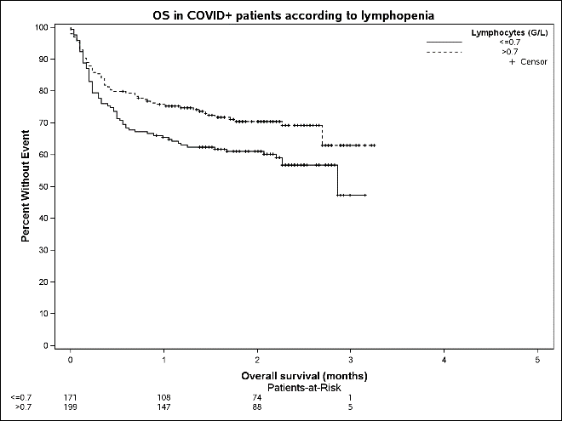 | 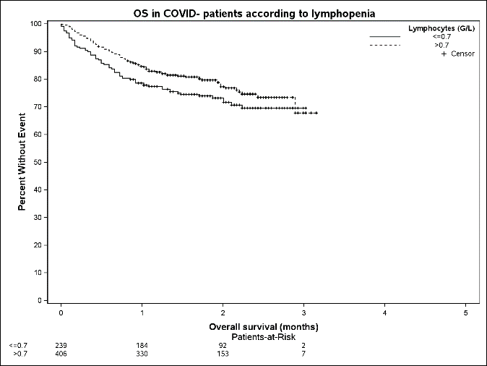
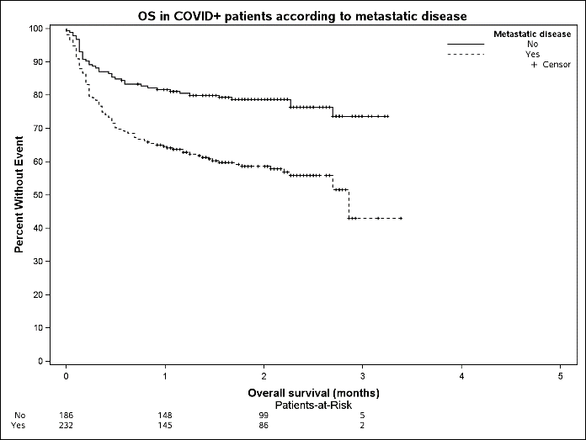 | 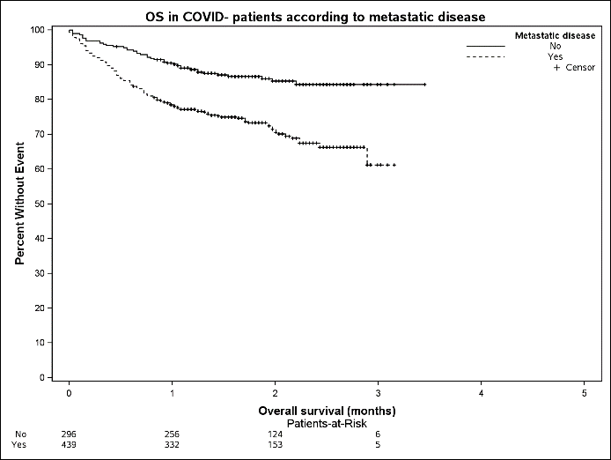

Supplementary Figures S2. Overall survival of COVID-19 positive patients (*based on RT-PCR results with or without radiological signs, or **based on radiological signs with negative or missing RT-PCR results) and COVID-19 negative patients.

I- Immunotherapy vs no immunotherapy.
- COVID-19 positive patients*,** | - COVID-19 negative patients
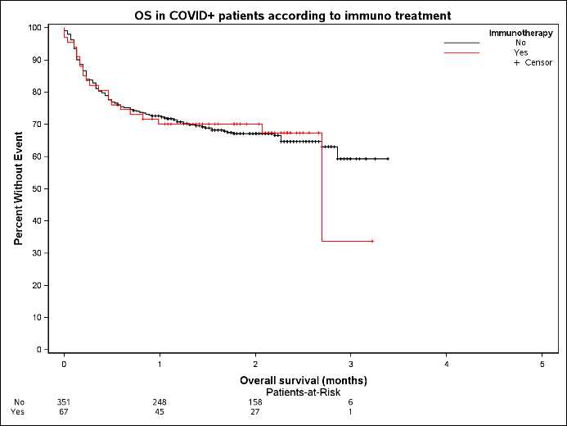 | 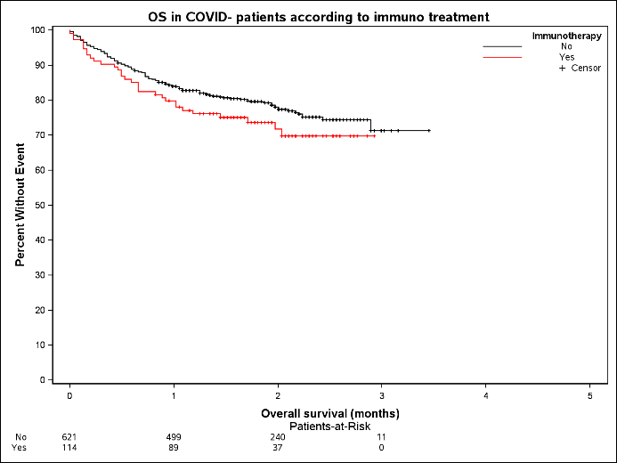
   | Event/Total | Survival Estimates  (95% CI)^{KM} | P-value
  Immunotherapy |  |  | 0·9902*
  No | 119/351 | 72·6 (68·1-77·4%)  67·1 (62·3-72·3%)
  Yes | 22/67 | 70·1 (59·9-82·0%)  70·1 (59·9-82·0%)
  ^{KM}Kaplan-Meier method— *Logrank test;
   | Event/Total | Survival Estimates  (95% CI)^{KM} | P-value
  Immunotherapy |  |  | 0·1773*
  No | 136/621 | 84·0 (81·2-87·0%)  78·0 (74·6-81·6%)
  Yes | 31/114 | 79·8 (72·8-87·5%)  71·7 (63·3-81·3%)
  ^{KM}Kaplan-Meier method; *Logrank test;
II- Chemotherapy +/- immunotherapy vs immunotherapy alone vs no treatment.
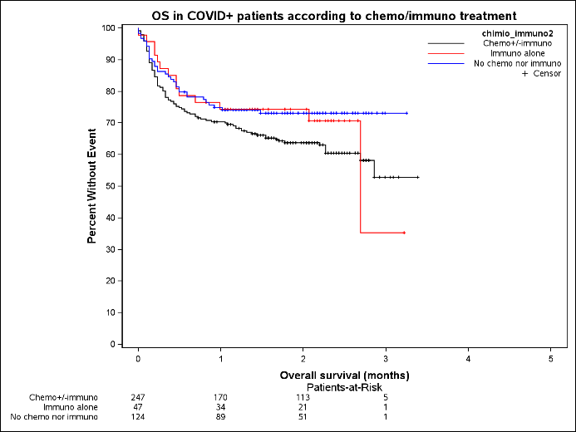 | 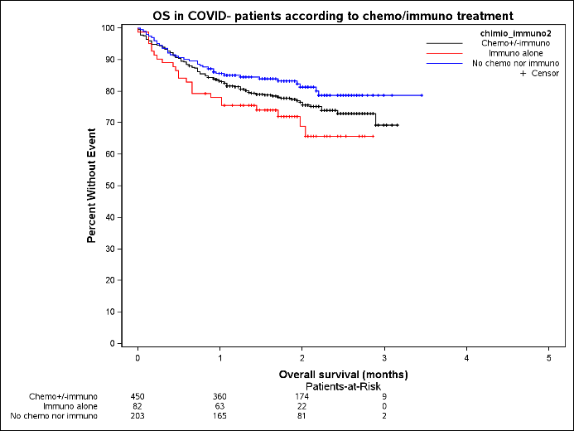
   | Event/Total | Survival Estimates  (95% CI)^{KM} | P-value
  chimio_immuno2 |  |  | 0·1295*
  Chemo+/-immuno | 94/247 | 70·4 (65·0-76·4%)  63·8 (58·0-70·2%)
  Immuno alone | 14/47 | 74·4 (62·9-88·0%)  74·4 (62·9-88·0%)
  No chemo nor immuno | 33/124 | 75·0 (67·7-83·0%):  73·1 (65·6-81·4%)
  ^{KM}Kaplan-Meier method; *Logrank test;
   | Event/Total | Survival Estimates  (95% CI)^{KM} | P-value
  chimio_immuno2 |  |  | 0·0891*
  Chemo+/-immuno | 106/450 | 83·3 (79·9-86·8%)  76·5 (72·5-80·8%)
  Immuno alone | 24/82 | 78·0 (69·6-87·5%)  68·9 (58·4-81·3%)
  No chemo nor immuno | 37/203 | 85·6 (80·9-90·6%):  81·3 (75·8-87·3%)
  ^{KM}Kaplan-Meier method; *Logrank test;
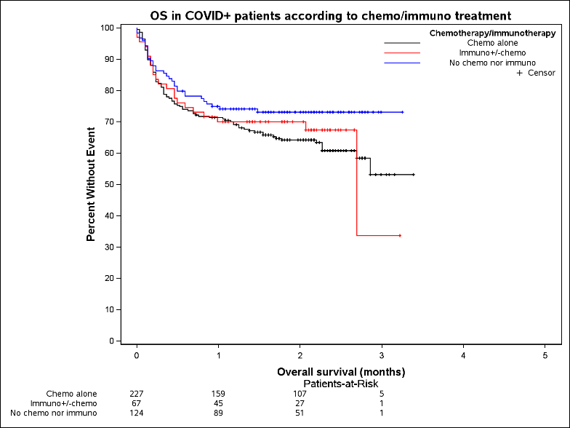 | 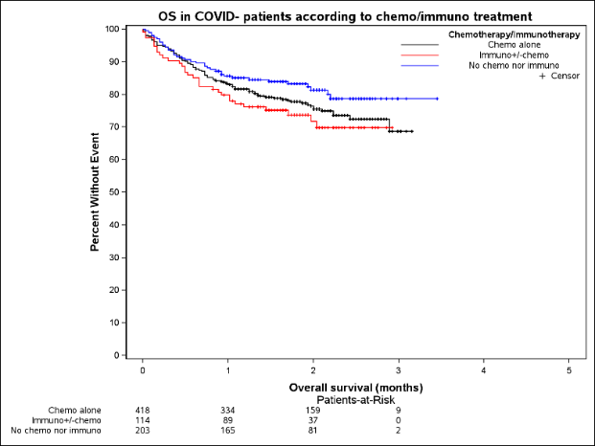
   | Event/Total | Survival Estimates  (95% CI)^{KM}
  Chemotherapy/immunotherapy
  Chemo alone | 86/227 | 71·4 (65·7-77·5%)  64·2 (58·2-70·8%)
  Immuno+/-chemo | 22/67 | 70·1 (59·9-82·0%)  70·1 (59·9-82·0%)
  No chemo nor immuno | 33/124 | 75·0 (67·7-83·0%)  73·1 (65·6-81·4%)
  ^{KM}Kaplan-Meier method;
   | Event/Total | Survival Estimates  (95% CI)^{KM}
  Chemotherapy/immunotherapy
  Chemo alone | 99/418 | 83·2 (79·7-86·9%)  76·4 (72·2-80·9%)
  Immuno+/-chemo | 31/114 | 79·8 (72·8-87·5%)  71·7 (63·3-81·3%)
  No chemo nor immuno | 37/203 | 85·6 (80·9-90·6%)  81·3 (75·8-87·3%)
  ^{KM}Kaplan-Meier method;
III- Chemotherapy alone vs immunotherapy +/- chemotherapy vs no treatment.

Supplementary Figures S3. Overall survival in COVID-19+ *,**vs COVID19 negative patients receiving
I- immunotherapy, II- anti-PD1, III anti-CD20, IV- targeted therapy, V- anti-angiogenics.

- Patients having received immunotherapy.
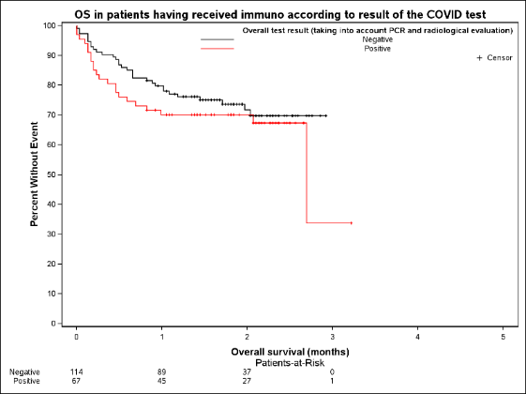
 | Event/Total | Survival Estimates (95% CI)^{KM}
COVID-19 diagnosis
Negative | 31/114 | 79·8 (72·8-87·5%)  71·7 (63·3-81·3%)
Positive*,** | 22/67 | 70·1 (59·9-82·0%)  70·1 (59·9-82·0%)

II- Patients having received anti-PD1.
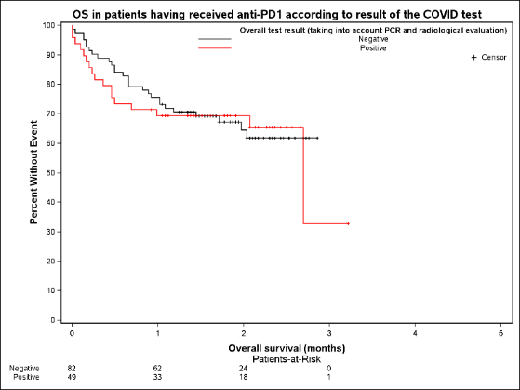
 | Event/Total | Survival Estimates (95% CI)^{KM}
COVID-19 diagnosis
Negative | 28/82 | 75·6 (66·9-85·5%)  64·6 (54·2-76·9%)
Positive*,** | 17/49 | 69·3 (57·5-83·5%)  69·3 (57·5-83·5%)

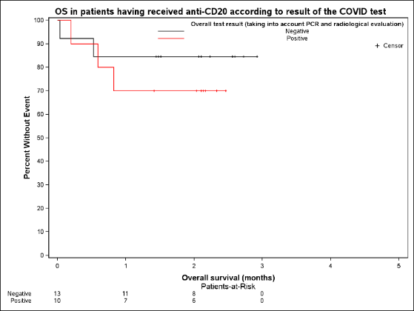
III- Patients having received anti-CD20.
 | Event/Total | Survival Estimates (95% CI)^{KM}
COVID-19 diagnosis
Negative | 2/13 | 84·6 (67·1-100·0%)  84·6 (67·1-100·0%)
Positive*,** | 3/10 | 70·0 (46·7-100·0%)  70·0 (46·7-100·0%)

IV- Patients having received targeted therapy.
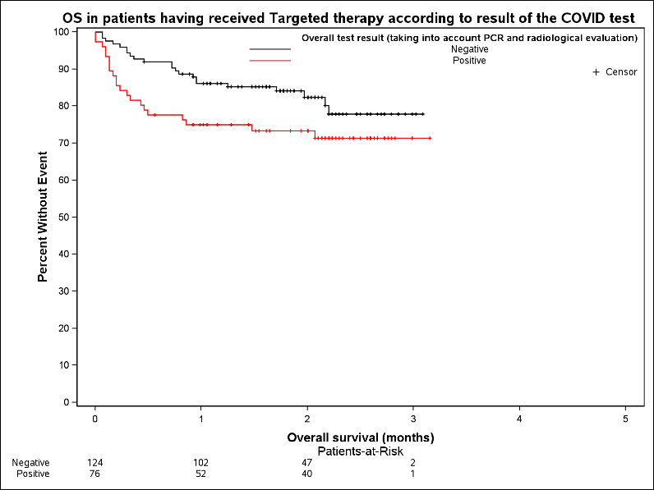
 | Event/Total | Survival Estimates (95% CI)^{KM}
COVID-19 diagnosis
Negative | 22/124 | 86·2 (80·3-92·5%)  82·4 (75·4-90·0%)
Positive*,** | 21/76 | 75·0 (65·8-85·4%)  73·4 (64·0-84·1%)

V- Patients having received anti-angiogenics.
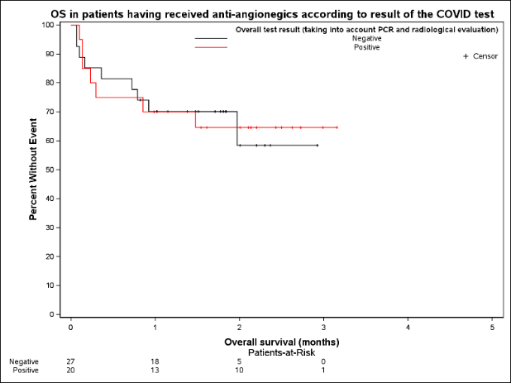
 | Event/Total | Survival Estimates (95% CI)^{KM}
COVID-19 diagnosis
Negative | 9/27 | 70·2 (54·8-89·8%)  58·5 (37·9-90·3%)
Positive*,** | 7/20 | 70·0 (52·5-93·3%)  64·6 (46·6-89·6%)

