Appendix

Supplementary Figure 1. Directed Acyclic Graph (DAG) for the association between demographic and clinical characteristics of COVID-19 positive cancer patients and severity/death of COVID-19 (www.dagitty.net).

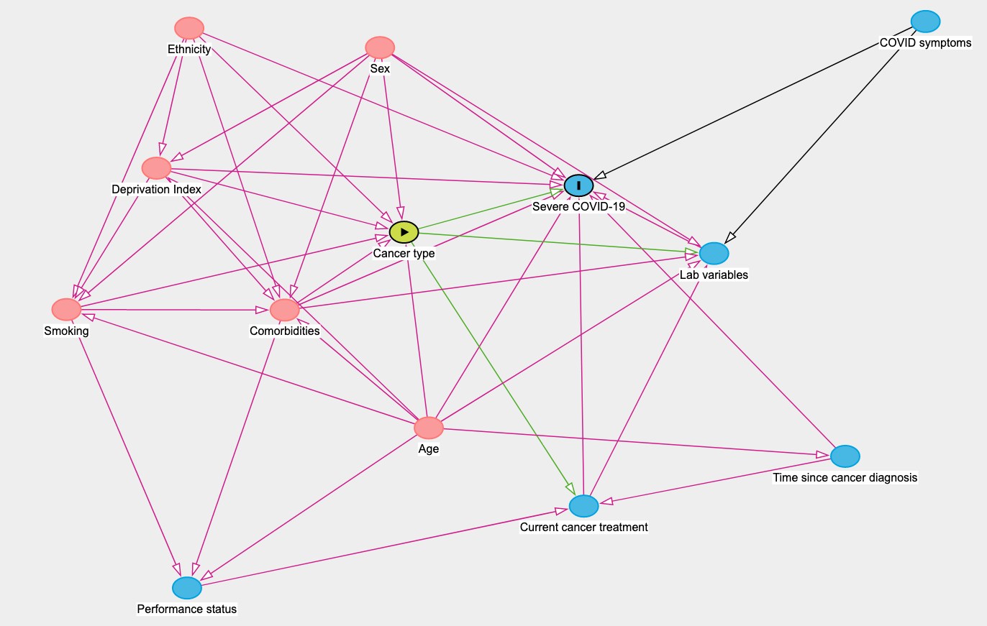

Supplementary Table 1. Overview of minimal adjustments for the associations between demographic and clinical characteristics of COVID-19 positive cancer patients and severity/death of COVID-19 (www.dagitty.net).

Main exposure variable | Minimal adjustments
Age | No adjustment is necessary to estimate the total effect of Age on severity/death of COVID-19
Sex | No adjustment is necessary to estimate the total effect of Sex on severity/death of COVID-19
Ethnicity | No adjustment is necessary to estimate the total effect of Ethnicity on severity/death of COVID-19
Deprivation Index | Age, Ethnicity, Sex
Comorbidities | Age, Deprivation Index, Ethnicity, Sex, Smoking
Smoking | Age, Deprivation Index, Ethnicity, Sex
Cancer type | - Age, Comorbidities, Deprivation Index, Ethnicity, Performance status, Sex  - Age, Comorbidities, Deprivation Index, Ethnicity, Sex, Smoking
Current cancer treatment | - Age, Cancer type, Comorbidities, Deprivation Index, Ethnicity, Sex, Time since cancer diagnosis  - Age, Cancer type, Comorbidities, Smoking, Time since cancer diagnosis  - Cancer type, Performance status, Time since cancer diagnosis
Time since cancer diagnosis | Age
Performance status | Age, Cancer type, Comorbidities, Deprivation Index, Ethnicity, Sex  Age, Comorbidities, Smoking
Laboratory variables | Age, COVID symptoms, Cancer type, Comorbidities, Current cancer treatment, Sex

Supplementary Table 2. Breakdown of haematological malignancies

Cancer Subgroup  (Total n=117) | N | %
Lymphoma | 39 | 33.30%
CLL | 13 | 11.10%
Symptomatic myeloma | 16 | 13.70%
Asymptomatic myeloma / MGUS | 17 | 14.50%
MDS / MDS-MPN / MPN | 15 | 12.80%
Acute leukaemia | 15 | 12.80%
Aplastic anaemia | 2 | 1.70%
MGUS - monoclonal gammopathy of unknown significance; MDS - Myelodysplastic syndromes; MPN - Myeloproliferative neoplasm

Supplementary Table 3. Breakdown of treatment types for haematological patients

Treatment group  (Total n=117) | N | %
“Active monitoring” (watch and wait) | 36 | 30.80%
Anti-CD20 mAb containing regimens | 24 | 20.50%
Intensive highly myelosuppressive regimens | 13 | 11.10%
Combination conventional chemotherapy | 7 | 6.00%
Imid based | 9 | 7.70%
Transplant - Allogeneic HSC | 4 | 3.40%
Velcade based | 7 | 6.00%
Other | 17 | 14.50%

