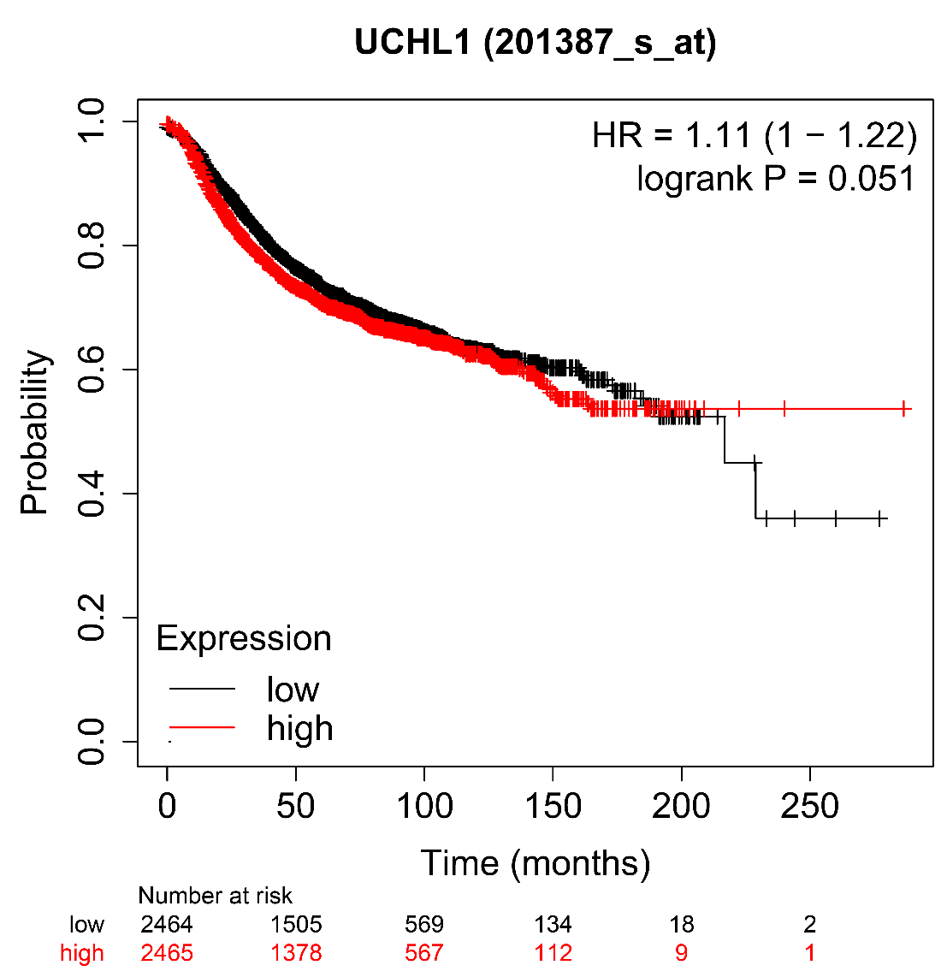
Figure S1: Kaplan-Meier Survival plot (KM-plotter) relationship between UCHL1 mRNA expression and overall survival in breast cancer patients (p = 0.051) using https://kmplot.com/analysis/. The p-value was calculated using a logrank test. The survival curve compares tumours with low (black) and high (red) expression of UCHL1.
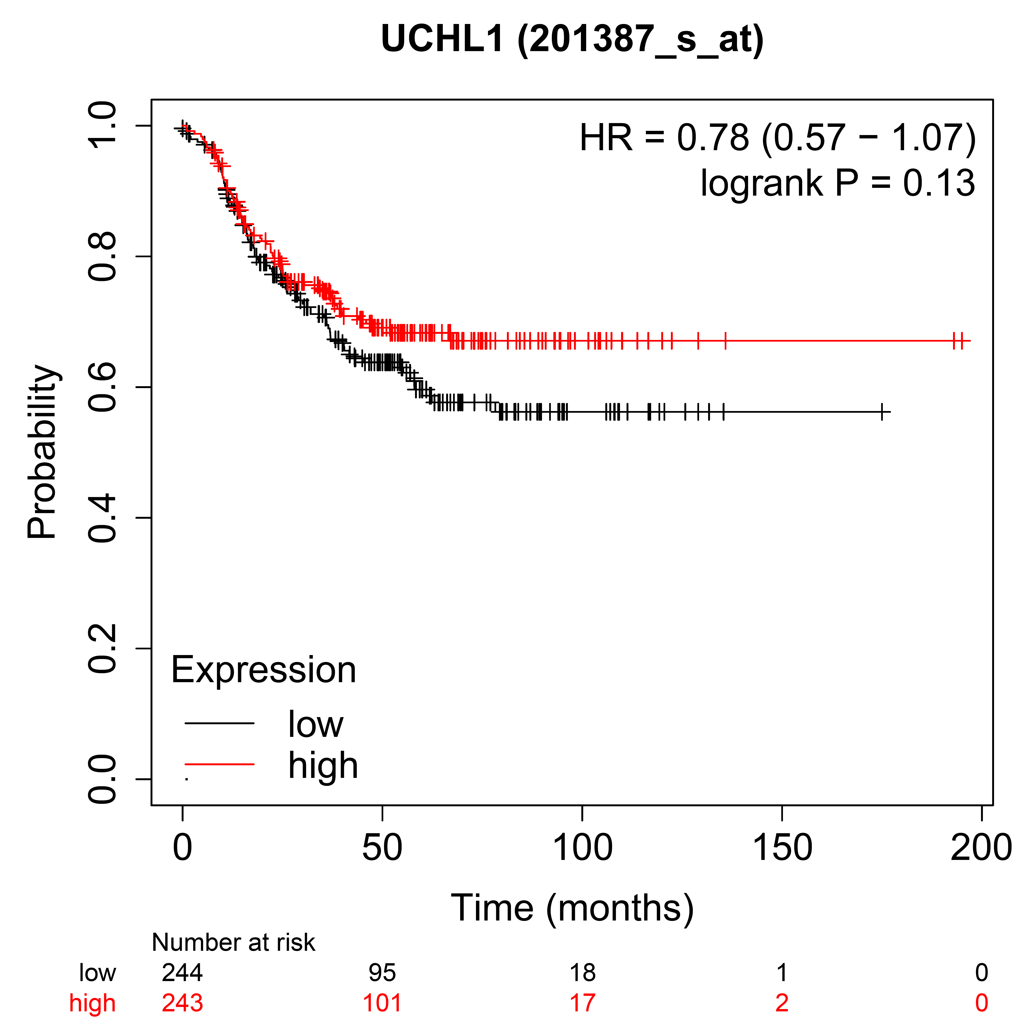
Figure S2: Kaplan-Meier Survival plot (KM-plotter) relationship between UCHL1 mRNA expression and overall survival in ER- and PR- breast cancer patients (p = 0.13) using https://kmplot.com/analysis/. The p-value was calculated using a logrank test. The survival curve compares tumours with low (black) and high (red) expression of UCHL1.

