Supplementary tables and figures

Supplementary Table 1. List of participating sites in the qFIT study.
Primary care sites | CCG
St Albans Surgery (formerly Dr Mohan and Associates) | Barking & Dagenham
Penshurst Gardens Surgery | Barnet
The Old Court House Surgery | Barnet
The Speedwell Practice | Barnet
Millway Medical Practice | Barnet
Oak Lodge Medical Centre | Barnet
PHGH Doctors | Barnet
Langdon Hills Medical Centre (Dr Salako & Partners) | Basildon and Brentwood
The Tile House Surgery | Basildon and Brentwood
Holborn Medical Centre | Camden
West Hampstead Medical Centre | Camden
Caversham Group Practice | Camden
Hampstead Group Practice | Camden
Keats Group Practice | Camden
Museum Practice | Camden
Parliament Hill Medical Centre | Camden
Prince of Wales Medical Centre | Camden
St Philips Medical Centre | Camden
Swiss Cottage Surgery | Camden
Elsdale Street Surgery | City & Hackney
The Well Street Surgery | City & Hackney
Woodberry Practice | Enfield
Brick Lane Surgery | Enfield
Eagle House Surgery | Enfield
East Enfield Medical Practice | Enfield
Morecambe Surgery | Enfield
Somerset Gardens Family Health Centre | Haringey
The Muswell Hill Practice | Haringey
Maylands Health Care | Havering
Petersfield Surgery | Havering
Bridgewater Surgeries | Herts Valley
Davenport House Surgery | Herts Valley
Harvey Group Practice | Herts Valley
Parkwood Surgery | Herts Valley
Fernville Surgery | Herts Valley
Manor View Practice | Herts Valley
City Road Medical Centre | Islington
The Miller Practice | Islington
Killick Street Health Centre | Islington
St Peter's Street Medical Practice | Islington
The Rise Group Practice | Islington
The Tufnell Surgery (now Junction Medical Practice) | Islington
Bute House Medical Centre | Luton
Beauchamp House Surgery | Mid Essex
Lord Lister Health Centre (Driver & Partners) | Newham
Wood Grange Medical Centre | Newham
Ilford Medical Centre | Redbridge
Wanstead Place Surgery | Redbridge
Glebelands Practice | Redbridge
Ilford Lane Surgery | Redbridge
The Willows Medical Practice | Redbridge
Chrisp Street Health Centre | Tower Hamlets
Limehouse Practice | Tower Hamlets
St Stephens Health Centre | Tower Hamlets
Ongar Health Centre | West Essex
Kings Medical Centre | West Essex
Lister Medical Centre | West Essex
Loughton Surgery | West Essex
Secondary care sites
Barnet Hospital
Burnley General Hospital
Bury General Hospital
Chase Farm Hospital
Homerton University Hospital
King George Hospital
Manchester UFT (Oxford Road Campus)
Newham Hospital
North Manchester General Hospital
North Middlesex University Hospital
Queen's Hospital
Rochdale Infirmary
Royal Blackburn Hospital
Royal Free Hospital
Stockport NHS foundation trust
Tameside & Glossop Hospital
The Princess Alexandra Hospital
The Royal London Hospital
The Royal Oldham Hospital
The Whittington Hospital
University College London Hospital
West Hertfordshire Hospital NHS Trust
Whipps Cross University Hospital
Wythenshawe Hospital

Supplementary Table 2. First type of exam by age group (in patients with a definitive diagnosis and a valid FIT) N=3585.
Type of exam | Age group | Number of patients that had exam (N; %) | Total N=3596
Colonoscopy | <30 | 17 (0.6) | 2794
Colonoscopy | 30-49 | 300 (10.7)
Colonoscopy | 50-79 | 2239 (80.1)
Colonoscopy | 80+ | 238 (8.5)
CT Colonography | <30 | 0 (0) | 511
CT Colonography | 30-49 | 11 (2.2) | 511
CT Colonography | 50-79 | 312 (61.1) | 511
CT Colonography | 80+ | 188 (36.8) | 511
Flexible Sigmoidoscopy | <30 | 4 (1.5) | 268
Flexible Sigmoidoscopy | 30-49 | 29 (10.8) | 268
Flexible Sigmoidoscopy | 50-79 | 168 (62.7) | 268
Flexible Sigmoidoscopy | 80+ | 67 (25.0) | 268
CT Scan | <30 | 0 (0) | 5
CT Scan | 30-49 | 0 (0) | 5
CT Scan | 50-79 | 3 (60.0) | 5
CT Scan | 80+ | 2 (40.0) | 5
Rigid Sigmoidoscopy | <30 | 0 (0) | 1
Rigid Sigmoidoscopy | 30-49 | 0 (0) | 1
Rigid Sigmoidoscopy | 50-79 | 1 (100) | 1
Rigid Sigmoidoscopy | 80+ | 0 (0) | 1
Other | <30 | 0 (0) | 4
Other | 30-49 | 1 (25.0) | 4
Other | 50-79 | 2 (50.0) | 4
Other | 80+ | 1 (25.0) | 4
Not Applicable | <30 | 0 (0) | 2
Not Applicable | 30-49 | 0 (0) | 2
Not Applicable | 50-79 | 1 (50.0) | 2
Not Applicable | 80+ | 1 (50.0) | 2
Missing Data | <30 | 0 (0) | 11
Missing Data | 30-49 | 0 (0) | 11
Missing Data | 50-79 | 8 (72.7) | 11
Missing Data | 80+ | 3 (27.3) | 11

Supplementary Table 3. Patients found to have cancers other than colorectal adenocarcinoma and their respective other diagnoses, symptoms and FIT concentrations (µg/g).
No | Sex | Age | Type of Cancer | Other diagnoses | Symptoms | f-Hb (µg/g)
1 | Male | 84 | Anal cancer | N/A | Rectal bleeding; Change in bowel habit | 6.8
2 | Male | 77 | Diffuse B-cell lymphoma | Diverticulosis | Abnormal imaging | 165
3 | Male | 52 | Lower rectal Gastrointestinal Stromal Tumour | N/A | N/A | <4
4 | Male | 79 | Lymphoma | N/A | Change in bowel habit; Abdominal mass | 8
5 | Male | 58 | Prostate cancer | Polyps; Diverticulosis | Rectal bleeding | >200
6 | Male | 75 | Neuroendocrine carcinoma | Polyps | Change in bowel habit | >200
7 | Male | 69 | Neuroendocrine carcinoma | Colitis; Diverticulosis; Haemorrhoids | Change in bowel habit; Weight loss | <4

Supplementary Table 4a. Comparison of the number of primary clinical features (i.e. those with anaemia, abdominal pain, rectal bleeding or change in bowel habit) in patients with and without colorectal cancer who had f-Hb <10µg/g. No patient had all 4 features.

Number of clinical features | With Colorectal cancer N=15 (%) | Without Colorectal cancer N=2803 (%)
0* | 1 (6.7) | 302 (10.8)
1 | 3 (20.0) | 1980 (70.6)
2 | 9 (60.0) | 489 (17.5)
3 | 2 (13.3) | 32 (1.1)
Fisher’s Exact test p<0.001
*these patients were referred on the urgent symptomatic pathway, but they did not have anaemia, abdominal pain, rectal bleeding or abdominal pain recorded

Supplementary Table 4b. Comparison of the number of clinical features (listed in Table 3 of the main paper) in patients with and without colorectal cancer who had f-Hb <10µg/g.

Number of clinical features | With Colorectal cancer N=15 (%) | Without Colorectal cancer N=2803 (%)
0* | 1 (6.7) | 108 (3.8)
1 | 3 (20.0) | 1818 (64.9)
2 | 5 (33.3) | 686 (24.5)
3 | 6 (40.0) | 191 (6.8)
Fisher’s Exact test p<0.001
*these patients were referred on the urgent symptomatic pathway, but they did not have any of the features listed in Table 3 recorded

Supplementary Table 5. Test performance of FIT for any cancer or Inflammatory Bowel Disease (IBD) at different f-Hb cut offs.

Individuals with negative test results, i.e. below the specified f-Hb cut-off
f-Hb cut off (µg/g) | Not Cancer or IBD (specificity)* (n=3286)  (TN) | Any Cancer or IBD*# (n=310)  (FN) | Negative Predictive Value (%)  (TN/TN+FN) | Risk of Cancer or IBD among test negatives,  (FN/TN+FN) | % of all patients beneath threshold (N=3596) | IBD only  (n=213)  (FN)
 | No. (%) | No. (%) | % | No. per 1000 | % | No. (%)
<4 | 2449 (74.5) | 120 (38.7) | 95.3 | 46.7 | 71.4 | 107 (50.2)
<6 | 2548 (77.5) | 128 (41.3) | 95.2 | 47.8 | 74.4 | 114 (53.5)
<10 | 2677 (81.5) | 145 (46.8) | 94.9 | 51.4 | 78.5 | 126 (59.1)
<20 | 2854 (86.9) | 160 (51.6) | 94.7 | 53.1 | 83.8 | 139 (65.3)
<50 | 3050 (92.8) | 182 (58.7) | 94.4 | 56.3 | 89.9 | 155 (72.8)
<80 | 3106 (94.5) | 192 (61.9) | 94.2 | 58.2 | 91.7 | 159 (74.7)
<100 | 3129 (95.2) | 201 (64.8) | 94.0 | 60.4 | 92.6 | 165 (78.9)
<120 | 3144 (95.7) | 210 (67.7) | 93.7 | 62.6 | 93.3 | 171 (80.3)
<150 | 3160 (96.2) | 213 (68.7) | 93.7 | 63.1 | 93.8 | 171 (80.3)
<200 | 3171 (96.5) | 222 (71.6) | 93.5 | 65.4 | 94.4 | 176 (82.6)

*excludes 7 patients with cancer other than CRC
#this is 100 minus sensitivity
Sensitivity at each threshold can be calculated by subtracting FN from column total divided by the column total
TN:true negatives FN:false negatives TP: true positives FP:false positives

Supplementary Table 6. Key Characteristics of studies assessing the diagnostic performance of FIT in detecting colorectal cancer (CRC) in a symptomatic population

Study first author [reference] | Country | Period of recruitment | Average Age  (Mean or Median) | Gender |  | f-HB
 |  |  |  | Male (%) | Female (%) | <10 μg/g (%)ª
Our study | UK | 2017-2019 | 65.7 | 46.6 | 53.1 | 78.4
Turvill 2021 [28] | UK | 2018-2019 | 67.4 | 44.7 | 55.3 | -
D’Souza 2020 [26] | UK | 2017-2019 | 64.0 | 45.1 | 54.9 | 81.0
McSorley s2020 [34] | UK | 2015-2019 | 60-66 | 43.2-47.3 | 52.7-56.4 | 44.7
Navarro 2020 [35] | Spain | 2016-2018 | 58.5 | 44.3 | 55.7 | 71.7
Mattar 2020 [36] | Brazil | 2015-2016 | 56.3 | 33.9 | 66.1 | 84.3
Hogberg - Diaquick FOB  2020 [37] | Sweden | 2015 | 65 | 40.6 | 59.4 | -
Hogberg - Actim faecal blood  2020 [37] | Sweden | 2015 | 62 | 39.3 | 60.7 | -
Hogberg - Chemtrue FOB  2020 [37] | Sweden | 2015 | 67 | 37.8 | 62.2 | -
Hogberg - Analyz FOB  2020 [37] | Sweden | 2015 | 66 | 38.4 | 61.6 | -
Nicholson 2020 [17] | UK | 2017-2020 | 60 | 41.4 | 58.6 | 90.5
Tsapournas 2020 [38] | Sweden | 2013-2017 | 65 | 42.1 | 57.9 | 73.6
D’Souza 2020 [15] | UK | 2016-2017 | 60.6 | 48.6 | 51.4 | 81.7
Chapman 2019 [8] | UK | 2016-2017 | 71.7 | 44.3 | 55.7 | 70.5
Nicholson 2019 [13] | UK | 2016 | 58 | 43.0 | 57.0 | 88.2
Khan 2020 [25] | UK | 2017-2018 | 72 | 40.5 | 59.5 | 79.6
Ayling 2020 [18] | UK | 2019 | 60 | 44.3 | 55.7 | 51.2
Widlak 2018 [39] | UK | - | 68 | 51.0 | 49.0 | -
Hogberg  2017 [42] | Sweden | 2013-2014 | 63 | 35.4 | 64.6 | -
Widlak 2017 [22] | UK | 2015-2016 | 67 | 49.0 | 51.0 | -
Mowat 2016 [20] | UK | 2013-2014 | 64 | 45.3 | 54.7 | 76.0
Godber 2016 [21] | UK | 2013 | 59 | 44.8 | 55.2 | 75.0
Rodriguez-Alonso 2015 [27]^{b} | Spain | 2011-2012 | - | 46.8 | 53.2 | 77.6
Terhaar sive Droste [41] | Netherlands | 2006-2009 | 61.8 | 46.2 | 53.8 | 82.8
ªThe percentage below f-Hb 10 μg/g was obtained from studies where this information was provided
^{b} Provided proportions for age groups: <40 years 7.1%; 41-50 years 13.0%; 51-60 years 22.4%; 61-70 years 29.1%; >70 years 28.4%

Supplementary Table 7. Summary of studies assessing the diagnostic performance of FIT in detecting colorectal cancer (CRC) in a symptomatic population
Study  First author [reference] | Total (N) | CRC  Prevalence % (cases) | f-Hb cut-off (µg/g )¹ | False Negatives (Missed cancers) | True Negatives | Sensitivity (%) | Specificity (%) | PPV (%) | NPV (%)
This study | 3596 | 2.5 (90) | 4 | 11 | 2556 | 87.8 | 73.0 | 7.7 | 99.6
This study | 3596 | 2.5 (90) | 10 | 15 | 2803 | 83.3 | 79.9 | 9.7 | 99.5
Turvill [28] | 5040 | 3.0 (151) | 19 | 22 | 4164 | 85.4 | 85.2 | 15.1 | 99.5
D’Souza [26] | 9822 | 3.3 (329) | 2 | 10 | 6161 | 97.0 | 64.9 | 8.7 | 99.8
D’Souza [26] | 9822 | 3.3 (329) | 10 | 30 | 7927 | 90.9 | 83.5 | 16.1 | 99.6
McSorley [34] | 4841 | 5.5 (266) | 10 | 14 | 2152 | 94.7 | 47.0 | 9.4 | 99.4
Navarro [35] | 727 | 5.0 (36) | 10 | 2 | 519 | 94.4 | 75.1 | 16.5 | 99.6
Navarro [35] | 727 | 5.0 (36) | 20 | 3 | 536 | 91.7 | 77.6 | 17.6 | 99.4
Mattar [36] | 172 | 3.5 (6) | 10 | 1 | 144 | 83.3 | 86.7 | 17.8 | 82.2
Hogberg - Diaquick FOB  [37] | 1751 | 2.2 (38) | 5 | 7 | 1361 | 81.6 | 79.5 | 8.1 | 99.5
Hogberg :Actim faecal blood [37] | 4232 | 1.9 (79) | 25-50 | 2 | 2923 | 97.5 | 70.4 | 5.9 | 99.9
Hogberg: Chemtrue FOB  (2020) [37] | 1756 | 1.7 (29) | 40 ng/ml | 0 | 1134 | 100.0 | 65.7 | 4.7 | 100.0
Hogberg: Analyz FOB [37] | 7889 | 2 (158) | 2 | 18 | 5641 | 88.6 | 73.0 | 6.3 | 99.7
Nicholson [17] | 9896 | 1.1 (105) | 7 | 9 | 8792 | 91.4 | 89.8 | 8.7 | 99.9
Nicholson [17] | 9896 | 1.1 (105) | 10 | 10 | 8943 | 90.5 | 91.3 | 10.1 | 99.9
Tsapournas  [38] | 242 | 5 (13) | 10 | 1 | 177 | 92.3 | 77.3 | 18.8 | 99.4
D’Souza  [15] | 218 | 3.7 (8) | 2 | 0 | 210 | 100.0 | 100.0 | 100.0 | 100.0
D’Souza  [15] | 218 | 3.7 (8) | 10 | 1 | 177 | 87.5 | 84.3 | 14.6 | 99.4
Chapman  [8] | 810 | 4.9 (40) | 4 | 1 | 497 | 97.5 | 64.5 | 12.5 | 99.8
Chapman  [8] | 810 | 4.9 (40) | 10 | 5 | 566 | 87.5 | 73.5 | 14.6 | 99.1
Nicholson  [10] | 238 | 2.9 (7) | 7 | 1 | 206 | 85.7 | 89.2 | 19.4 | 99.5
Nicholson  [10] | 238 | 2.9 (7) | 10 | 1 | 209 | 85.7 | 90.5 | 21.4 | 99.5
Khan [25] | 928 | 5.1 (47) | 10 | 7 | 732 | 85.1 | 83.5 | 22.6 | 99.0
Ayling [18] | 217 | 3.7 (8) | 10 | 1 | 110 | 87.5 | 52.6 | 6.6 | 99.1
Widlak [39] | 562 | 6.2 (35) | 3 | 7 | 490 | 80.0 | 93.0 | 44.0 | 99.0
Hogberg [42] | 373 | 2.1 (8) | 20 | 0 | 188 | 100.0 | 51.5 | 4.3 | 100.0
Widlak [22] | 430 | 5.8 (25) | 7 | 4 | 377 | 84.0 | 93.0 | 44.0 | 99.0
Mowat [20] | 755 | 3.7 (28) | 10 | 3 | 571 | 89.3 | 79.1 | 14.1 | 99.5
Godber [21] | 507 | 2.2 (11) | 10 | 0 | 380 | 100.0 | 76.6 | 8.7 | 100
Rodriguez-Alonso [27] | 1003 | 3.0 (30) | 10 | 1 | 777 | 96.7 | 79.9 | 12.9 | 99.9
Terhaar sive Droste [41] | 2058 | 5.4 (112) | 10 | 10 | 1693 | 91.1 | 87.0 | 28.7 | 99.4
¹Cut-offs: less than the cut-off value was used for determining false negatives, true negatives, specificity, Negative predictive value (NPV); those more than the cut-off value was used for determining sensitivity and PPV

Supplementary Table 8. Quality assessment of the 9 UK studies in the meta-analysis using the QUADAS-2 instrument

Bias |  |  |  |  | Applicability
 | PATIENT SELECTION | INDEX TEST | REFERENCE STANDARD | FLOW AND TIMING | PATIENT SELECTION | INDEX TEST | REFERENCE STANDARD
Our study | Low | Low | Low | Low¹ | Low | Low | Low
Chapman et al. [8] | Low | Low | Low | Low | High | Low | Low
D'Souza et al. [26] | Low | Low | Low | Low | Low | Low | Low
McSorley et al. [34] | Low | Low | Low | Low | Low | Low | Low
Nicholson et al. [17] | Low | Low | Low | Low | Low | Low | Low
Turvill et al. [28] | Low | Low | Low | Low | Low | Low | Low
Khan et al. [25] | Low | Low | Low | Low | Low | Low | Low
Widlak et al. [22] | Low | Low | Low | Low | Low | Low | Low
Widlak et al. [39] | Low | Low | Low | Low | Low | Low | Low

¹There are 3 attributes under ‘flow and timing’ and our study had low bias for two of these (i.e. short time interval between the index text and the reference standard test; and all patients received the same reference standard). However, our study did not meet the third feature (all patients should be included in the analysis), because 696 patients did not have a recorded cancer diagnosis reported to the study group. Nevertheless, these 696 seemed to be a random subset of all patients because there were no systematic differences between those with a missing cancer diagnosis and those with a cancer diagnosis; so there is likely to be no bias.

Urgent referral for suspected CRC
FIT pack offered by participating GP
Patient booked into hospital clinic (outpatient or telephone triage (straight-to-test))
Diagnostic tests according to patient suitability
Patient visits GP with abdominal symptoms
Sample & paperwork sent back by patient to lab
Hospital records diagnostic outcome
FIT pack offered by participating hospital
Results sent to qFIT study team
Consultant Clinic/Clinical nurse specialists telephone clinic
Endoscopist triage and book
FIT analysed in lab
Patient collects sample at home
Patient continues diagnosis-appropriate pathway
Data extraction
Data quality check

Supplementary Figure 1. Flow diagram for the study processes.

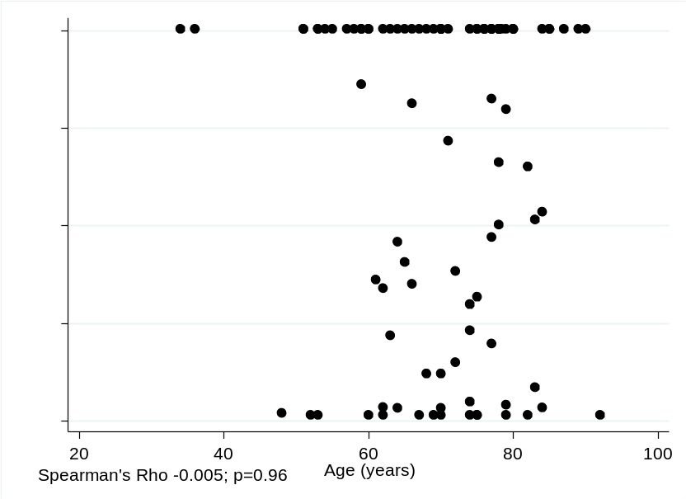
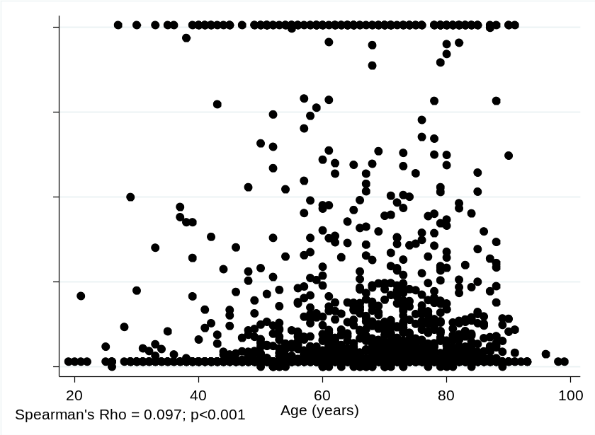

Supplementary Figure 2. Association between the f-Hb concentration and age among 3499 patients without cancer (upper figure) and 97 with cancer (lower figure). Due to the large sample size of non-cancers, the clinically insignificant correlation of 0.097 is statistically significant.

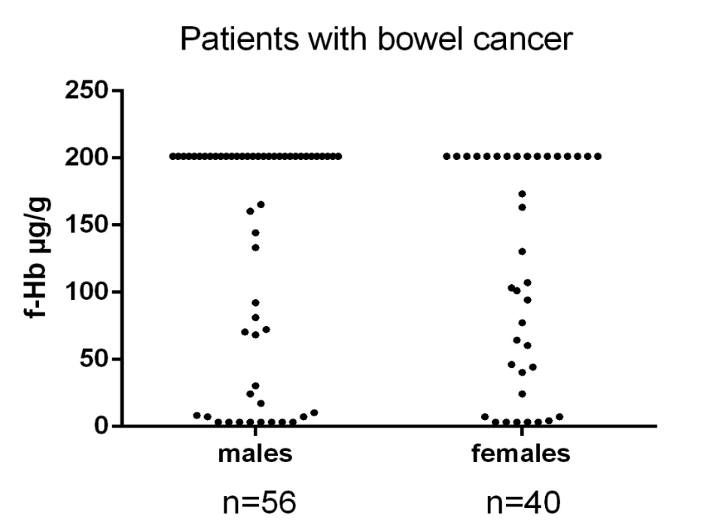
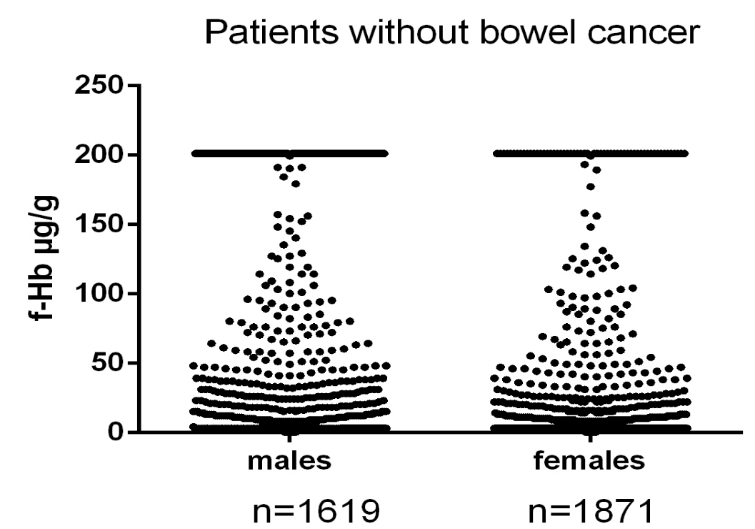
Kruskal Wallis test p=0.45
Kruskal Wallis test p<0.001

Supplementary Figure 3. Association between the f-Hb concentration and sex among 3490 patients without cancer (upper figure) and 97 with cancer (lower figure). In those without cancer the median f-Hb is <4 ug/g (males) and <4 ug/g (females), of which 76% (females) and 70% (males) had f-Hb <4 ug/g; this clinically insignificant difference is statistically significant due to the very large sample size.

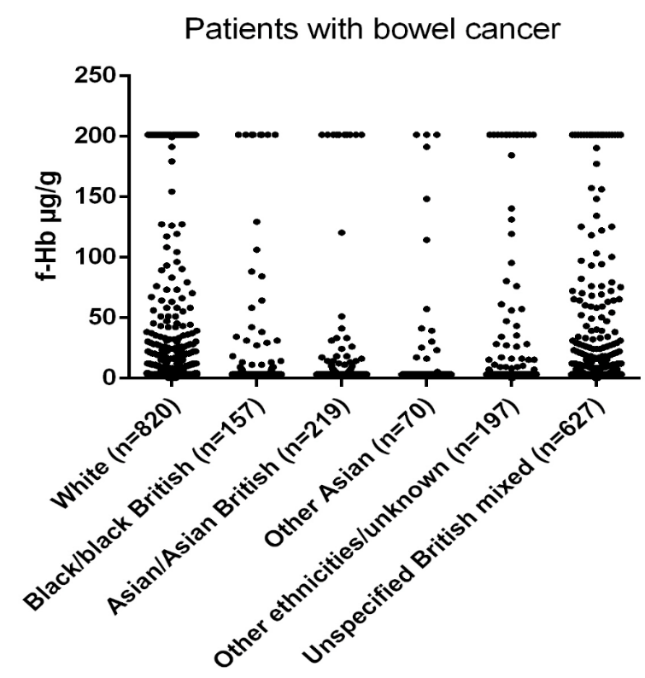
Kruskal Wallis test p=0.87

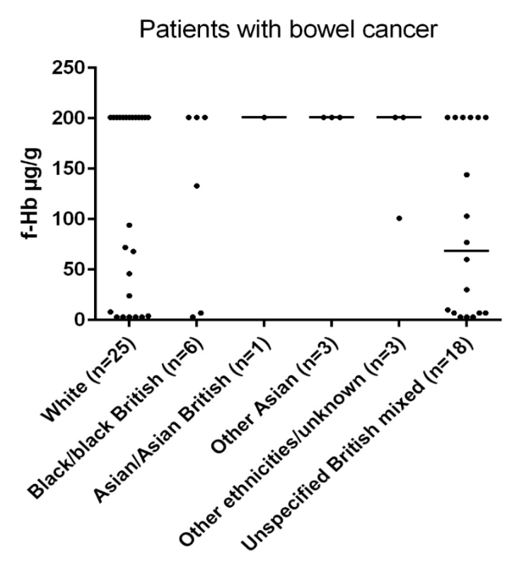
Kruskal Wallis test p=0.43

Supplementary Figure 4. Association between the f-Hb concentration and ethnicity among 2090 patients without cancer (upper figure) and 56 with cancer (lower figure).

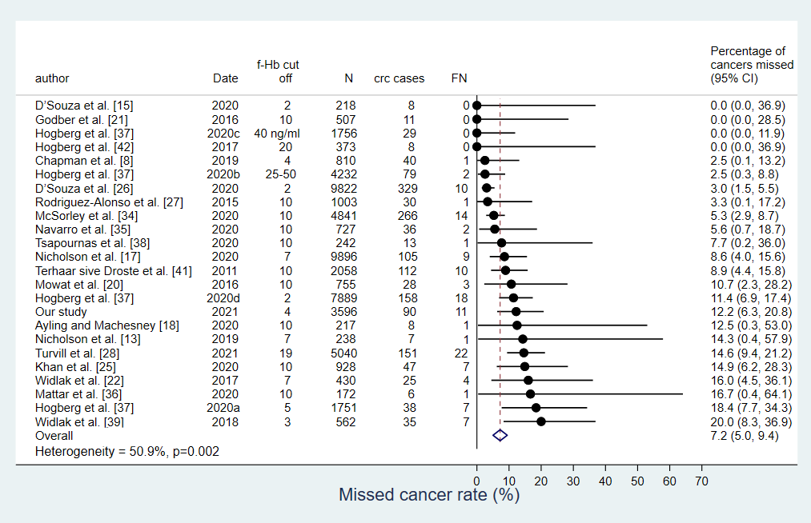
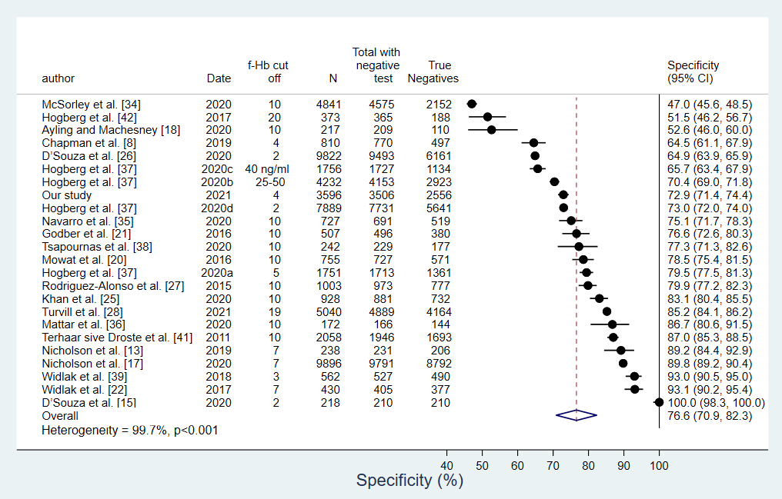
Supplementary Figure 5. Forest Plots of the CRC miss rate and specificity at the lowest cut-off of f-HB used in each study: 24 Studies; 1659 CRC cases (N=total; FN = false negatives, ie missed cancers)
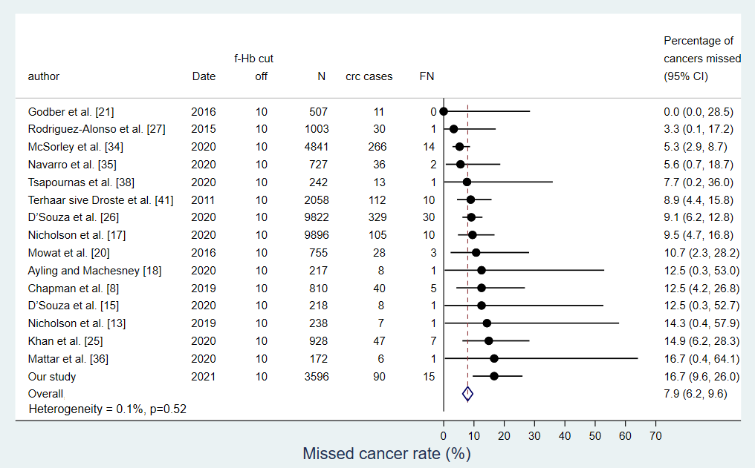
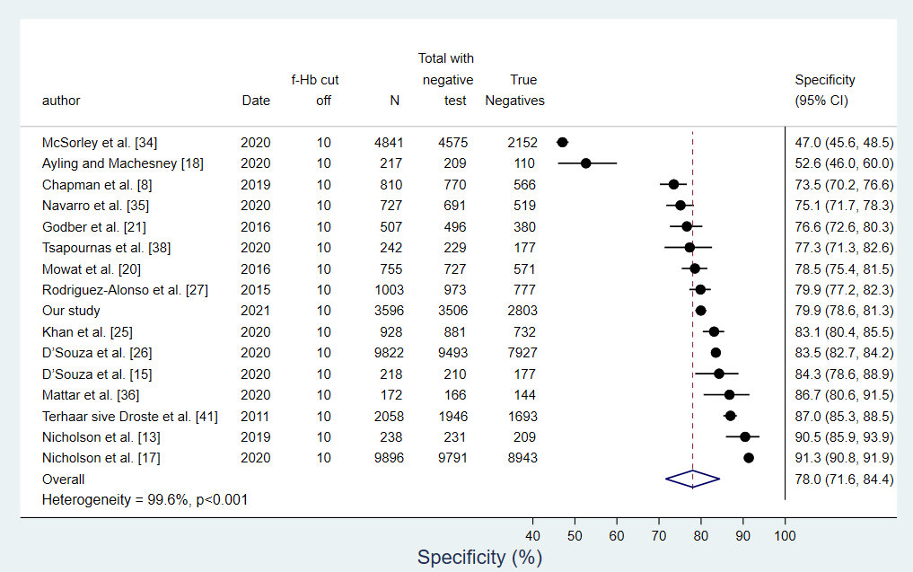
Supplementary Figure 6. Forest Plots of the CRC miss rate and specificity at a f-Hb cut-off of <10ug/g for all studies. 16 Studies; 1136 CRC cases (N=total; FN = false negatives, ie missed cancers). Excluding McSorley et al (low specificity), the pooled specificity is 80.4% (95% CI 77.0-83.7%)

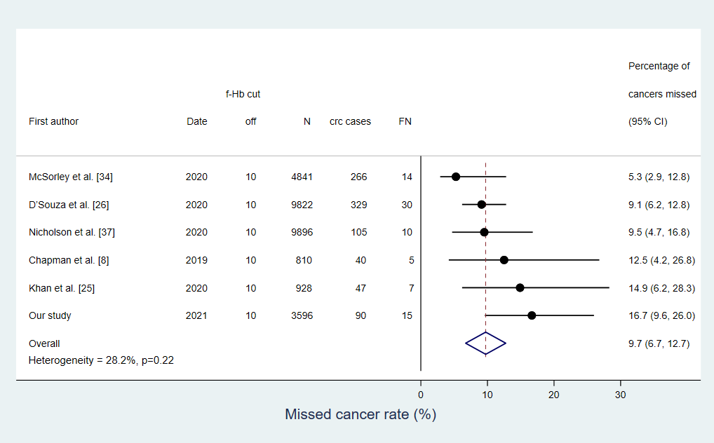
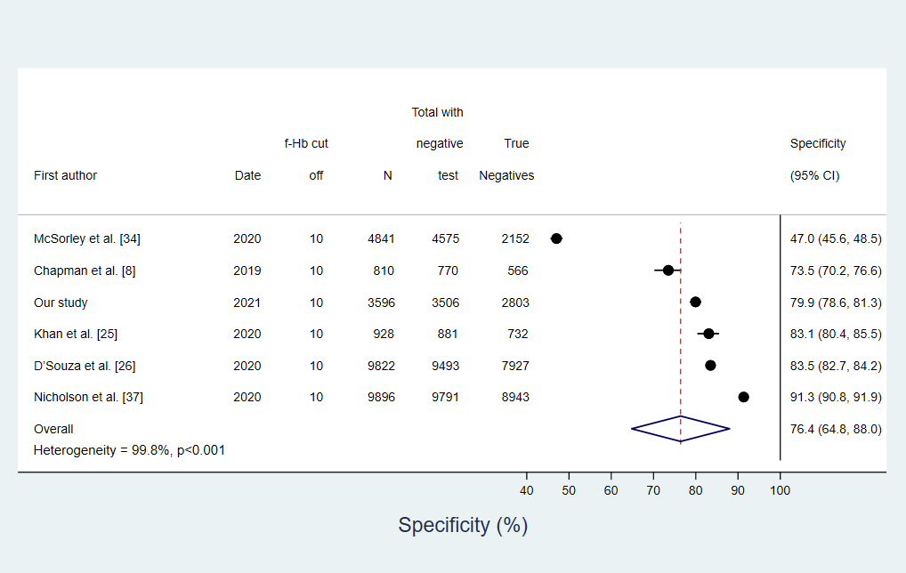
Supplementary Figure 7. Meta-analyses of 6 recent studies conducted in the UK, providing the combined CRC miss rate and specificity using a cut-off of 10 f-Hb for all studies. Excluding McSorley et al (low specificity), the pooled specificity is 82.4 (95% CI 76.9-87.8). The OC Sensor for the FIT assay was used in Chapman et al⁸ and our own study, and all others used HM-JACKarc. 877 CRC cases (N=total; FN = missed cancers/ false negatives).

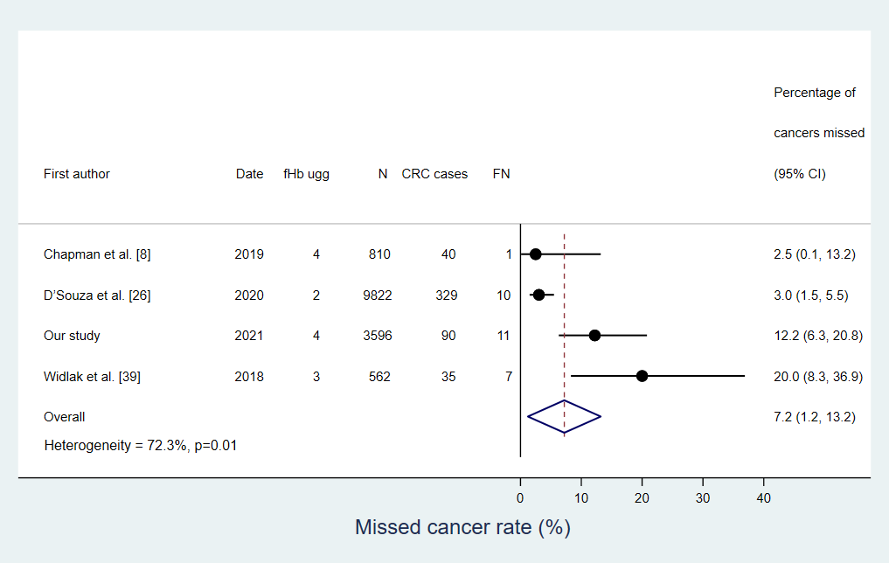
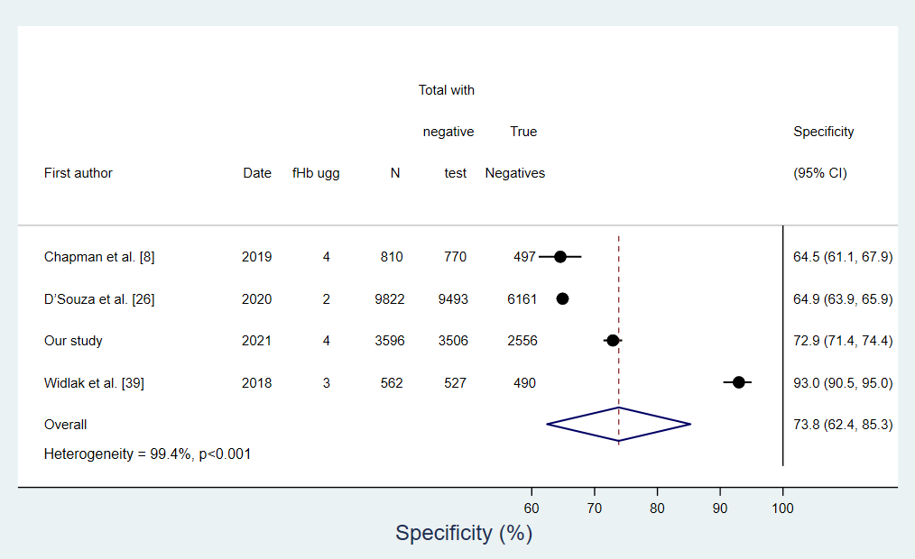
Supplementary Figure 8. Meta-analyses of 4 recent studies conducted in the UK, providing the combined CRC miss rate and specificity using a cut-off of f-Hb <4 for all studies. The OC Sensor for the FIT assay was used in Chapman et al⁸ and our own study, and all others used HM-JACKarc. 494 CRC cases (N=total; FN = false negatives, ie missed cancers).

