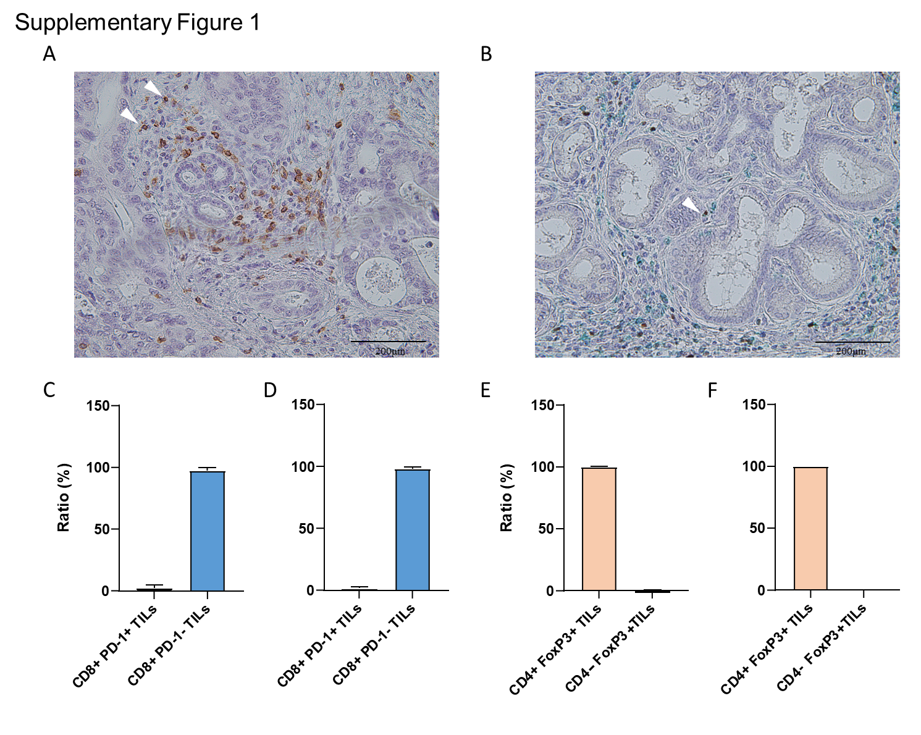
Supplementary Figure 1: Enzymatic double staining immunohistochemistry to analyze the phenotypes of TILs in ICCs. (A) White arrowhead shows CD8+ PD-1+ TILs in ICCs. CD8 and PD-1 on cell membrane of lymphocytes is stained with brawn and green, respectively. (B) White arrowhead shows CD4+ FoxP3+ TILs in ICCs. CD4 on cell membrane of lymphocytes and FoxP3 within nuclear is stained with green and brawn, respectively. Lower left bar graphs show the distribution of (C) intratumoral and (D) stromal CD8+ PD-1+ TIL counts of nine ICC patients. Lower right bar graphs show the distribution of (E) intratumoral and (F) stromal CD8+ PD-1+ TIL counts of nine ICC patients.
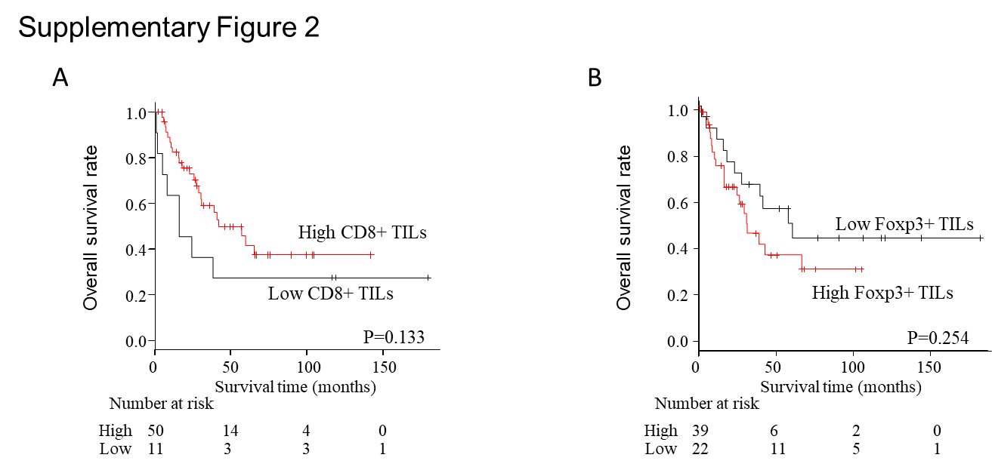

Supplementary Figure 2: Prognostic analysis with tumor infiltrating lymphocytes (TILs) in stroma of ICCs
Overall survival analysis were conducted based on (A) CD8+ TILs and (B) Foxp3+ TILs in stroma of ICCs.
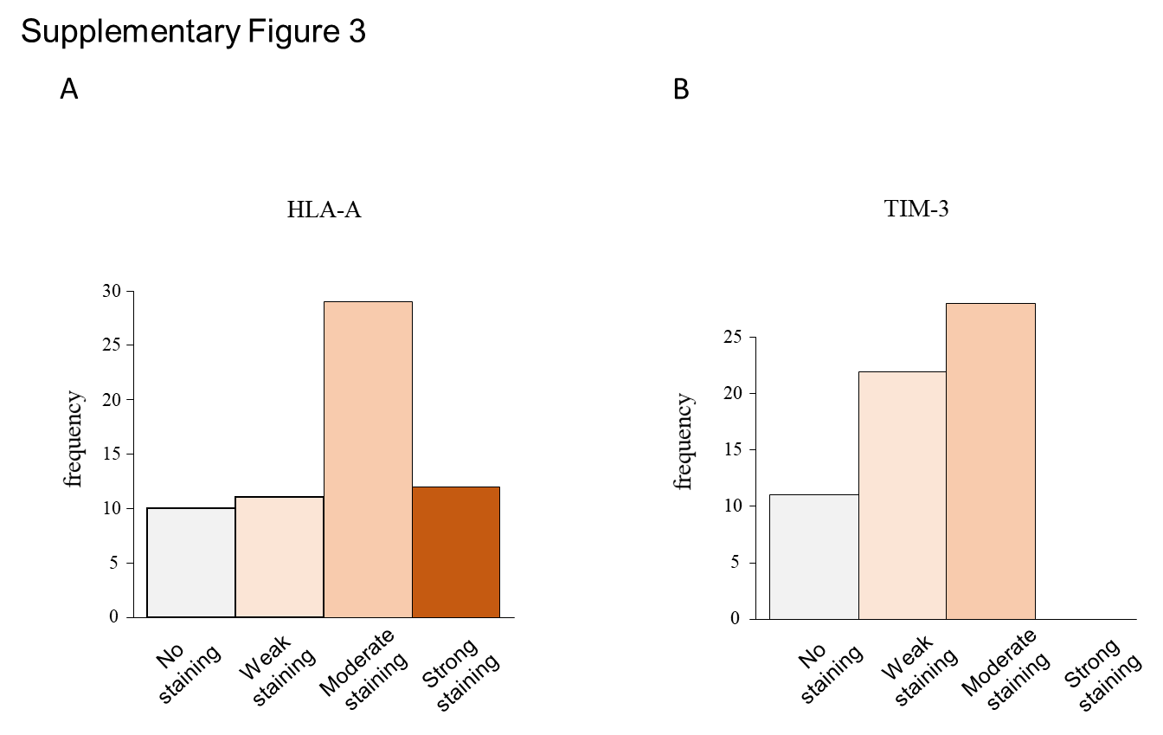
Supplementary Figure 3: Distribution of protein expression according to Immunoreactive score (IRS)
(A) HLA-A and (B) TIM-3 protein expression was evaluated in the tumor cell and lymphocytes, respectively. Protein expression was categorized into four subsets by IRS score as follows: 0–1 = no staining, 2–3 = weak staining, 4–8 = moderate staining, and 9–12 = strong staining.

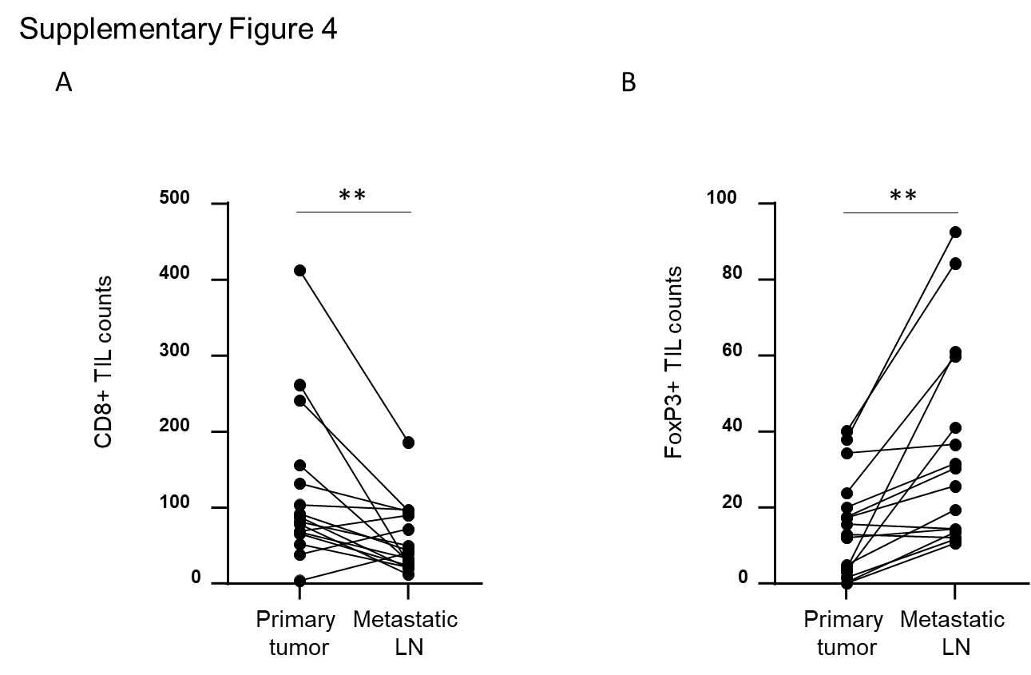
Supplementary Figure 4: CD8⁺ and FoxP3 TILs in primary lesions and metastatic lymph nodes. (A) Dot plot shows that the CD8⁺ TILs are less observed in metastatic lymph node than in the corresponding primary. LN; lymph node, ** P < 0.01. (B) Dot plot shows that the FoxP3+ TILs are more accumulated in metastatic lymph node than in corresponding primary lesion. LN; lymph node, ** P < 0.01.
Supplementary Table 1 The information of primary antibody for IHC analysis
mouse anti-CD8 monoclonal antibody (GTX72053, GeneTex, CA, USA; dilution 1;200)
Anti-PD1 antibody [CAL20] (ab237728, abcam, Cambridge, UK; dilution 1:200)
mouse anti-FOXP3 monoclonal antibody (ab20034, abcam, Cambridge, UK; dilution 1:100),
Anti-CD4 antibody [RM1013] (ab288724, abcam, Cambridge, UK; dilution 1:500)
human TIM3-antibody (AF2365, R&D systems, MN, USA; dilution 1:500)
Anti-HLA A Antibody (ab52922, abcam, Cambridge, UK; dilution 1:500)

Supplementary Table 2: Correlation between CD8+ TILs and other three variables
Variables |  | Total | Low CD8+ TIls | High CD8+ TILs | P value
 |  | N=61 | (N=44) | (N=17)
FoxP3+ TILs
 | Low | 40 | 16 (40.0%) | 24 (60.0%) | 0.046
 | High | 21 | 3 (14.3%) | 18 (85.7%)
HLA-A
 | No | 9 | 5 (55.6%) | 4 (44.4%) | 0.075
 | Weak | 11 | 2 (18.2%) | 9 (81.8%)
 | Moderate | 29 | 11 (37.9%) | 18 (62.1%)
 | Strong | 12 | 1 (8.3%) | 11 (91.7%)
TIM-3
 | No | 11 | 5 (45.5%) | 6 (54.5%) | 0.356
 | Weak | 22 | 5 (22.7%) | 17 (77.3%)
 | Moderate | 28 | 9 (32.1%) | 19 (67.9%)
 | Strong | 0 | 0 (0.0%) | 0 (0.0%)
Categorical variables were compared by Fisher’s exact test.

