Supplementary Material

Genomic landscape of pleural and peritoneal mesothelioma tumors

A  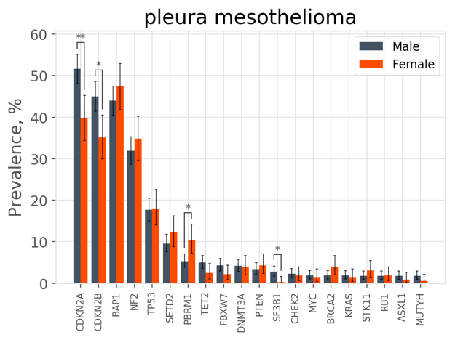 | B  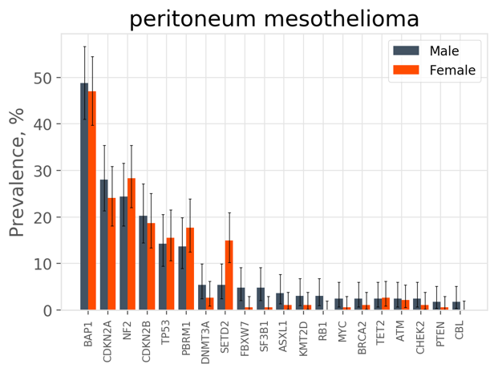
Supplementary Figure 1. Sex differences in genetic alterations in A) pleural mesothelioma and B) peritoneal mesothelioma. Error bars indicate 95% confidence interval (binomial) and statistical significance was tested by fisher’s exact and is indicated as * p < 0.05, ** p < 0.01.

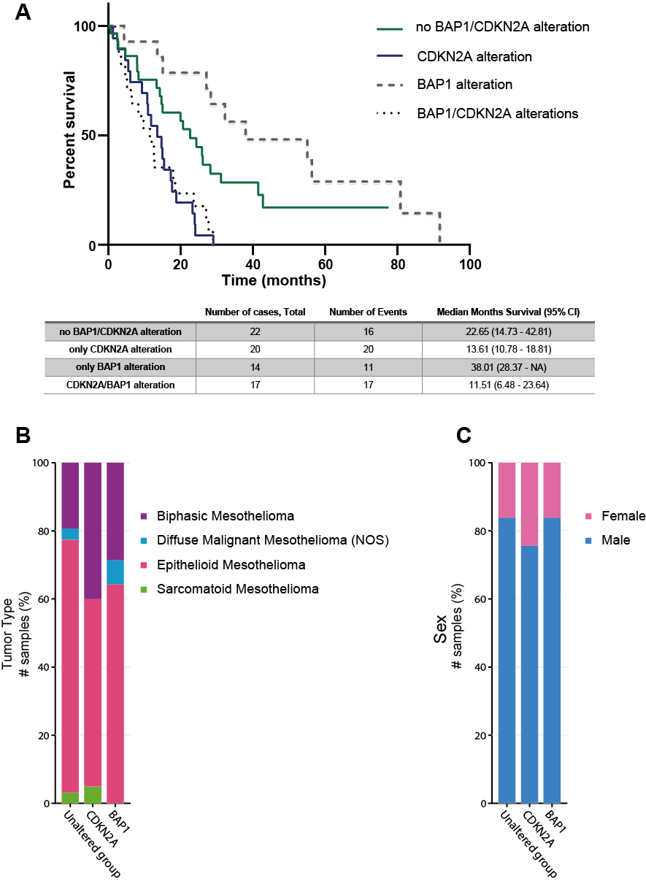
Supplementary Figure 2. Clinical data from the TCGA mesothelioma cohort (n = 82). A) Kaplan-Meier estimates of overall survival of the patient group without any BAP1 or CDKN2A alteration (green solid line), with CDKN2A alteration only (blue solid line), with BAP1 alteration only (grey dotted line), and with BAP1 and CDKN2A alteration (black dotted line), Logrank test p-value = 8.601 *10⁻⁶, B) distribution of the histological subtypes in the unaltered patient group, in the CDKN2A altered patient group and in the BAP1 altered patient group, C) sex distribution in the unaltered patient group, in the CDKN2A altered patient group and in the BAP1 altered patient group.

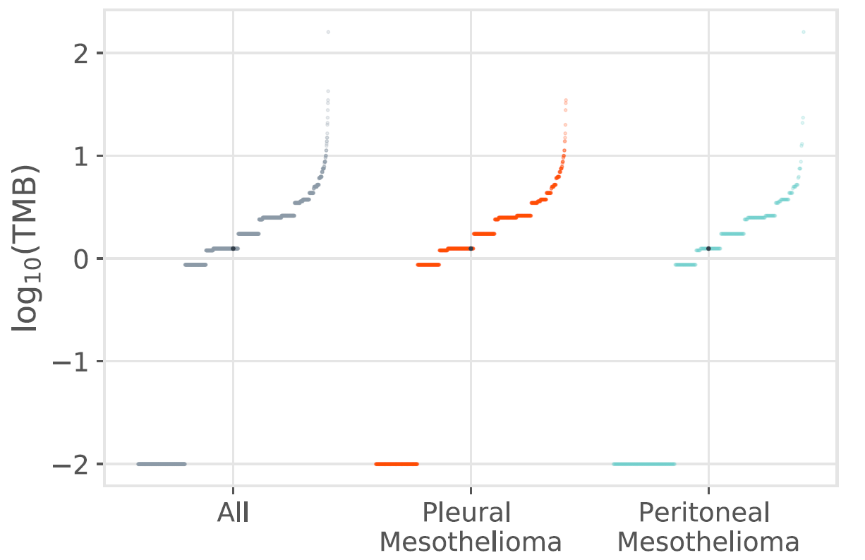
Supplementary Figure 3. Overview on tumor mutational burden of pleural and peritoneal mesothelioma patients

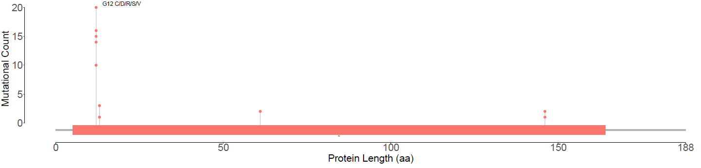
Supplementary Figure 4. Graphical overview on detected KRAS alterations in both groups.

Supplementary Table 1. Prevalence of genetic alterations in all mesothelioma cases

 | # Assessable  Samples | # Variant Samples | Prevalence  (% variant samples) | Prevalence  (Lower 95% CI) | Prevalence  (Upper 95% CI) | Short Variant | Rearrangement | Amplification (CN) | Deletion (CN) | Multiple
BAP1 | 1536 | 693 | 45.12% | 42.61% | 47.65% | 27.47% | 3.97% | 0.00% | 13.09% | 0.59%
CDKN2A | 1536 | 648 | 42.19% | 39.70% | 44.70% | 1.69% | 1.63% | 0.00% | 38.67% | 0.20%
CDKN2B | 1536 | 553 | 36.00% | 33.60% | 38.46% | 0.00% | 0.52% | 0.00% | 35.48% | 0.00%
NF2 | 1536 | 481 | 31.32% | 29.00% | 33.70% | 25.39% | 1.37% | 0.00% | 4.30% | 0.26%
MTAP | 679 | 185 | 27.25% | 23.93% | 30.76% | 0.00% | 0.29% | 0.00% | 26.95% | 0.00%
TP53 | 1536 | 265 | 17.25% | 15.39% | 19.24% | 16.15% | 0.33% | 0.00% | 0.65% | 0.13%
SETD2 | 1536 | 157 | 10.22% | 8.75% | 11.85% | 7.81% | 0.91% | 0.00% | 1.43% | 0.07%
PBRM1 | 1536 | 139 | 9.05% | 7.66% | 10.60% | 2.34% | 0.85% | 0.00% | 5.73% | 0.13%
TERT | 1365 | 95 | 6.96% | 5.67% | 8.44% | 6.96% | 0.00% | 0.00% | 0.00% | 0.00%
DNMT3A | 1536 | 66 | 4.30% | 3.34% | 5.43% | 3.97% | 0.26% | 0.00% | 0.07% | 0.00%
TET2 | 1536 | 58 | 3.78% | 2.88% | 4.85% | 3.78% | 0.00% | 0.00% | 0.00% | 0.00%
FBXW7 | 1536 | 52 | 3.39% | 2.54% | 4.42% | 2.21% | 0.33% | 0.00% | 0.85% | 0.00%
PTEN | 1536 | 46 | 2.99% | 2.20% | 3.97% | 1.69% | 0.00% | 0.00% | 1.30% | 0.00%
BRCA2 | 1536 | 36 | 2.34% | 1.65% | 3.23% | 1.95% | 0.13% | 0.00% | 0.26% | 0.00%
STK11 | 1536 | 36 | 2.34% | 1.65% | 3.23% | 1.11% | 0.33% | 0.00% | 0.85% | 0.07%
RAD21 | 679 | 15 | 2.21% | 1.24% | 3.62% | 0.00% | 0.00% | 2.21% | 0.00% | 0.00%
SF3B1 | 1536 | 32 | 2.08% | 1.43% | 2.93% | 2.08% | 0.00% | 0.00% | 0.00% | 0.00%
KMT2C | 686 | 14 | 2.04% | 1.12% | 3.40% | 1.75% | 0.15% | 0.00% | 0.00% | 0.15%
CHEK2 | 1536 | 31 | 2.02% | 1.38% | 2.85% | 1.76% | 0.07% | 0.00% | 0.20% | 0.00%
RB1 | 1536 | 29 | 1.89% | 1.27% | 2.70% | 0.98% | 0.07% | 0.00% | 0.85% | 0.00%
ARID2 | 857 | 16 | 1.87% | 1.07% | 3.01% | 1.05% | 0.35% | 0.00% | 0.47% | 0.00%
MYC | 1536 | 27 | 1.76% | 1.16% | 2.55% | 0.07% | 0.13% | 1.56% | 0.00% | 0.00%
KRAS | 1536 | 27 | 1.76% | 1.16% | 2.55% | 1.30% | 0.00% | 0.00% | 0.00% | 0.46%
ASXL1 | 1536 | 26 | 1.69% | 1.11% | 2.47% | 1.56% | 0.13% | 0.00% | 0.00% | 0.00%
MUTYH | 1536 | 23 | 1.50% | 0.95% | 2.24% | 1.50% | 0.00% | 0.00% | 0.00% | 0.00%
CTNNB1 | 1536 | 22 | 1.43% | 0.90% | 2.16% | 1.11% | 0.13% | 0.00% | 0.20% | 0.00%
ATM | 1536 | 21 | 1.37% | 0.85% | 2.08% | 1.17% | 0.20% | 0.00% | 0.00% | 0.00%
RICTOR | 1536 | 20 | 1.30% | 0.80% | 2.00% | 0.00% | 0.00% | 1.30% | 0.00% | 0.00%
CREBBP | 1536 | 19 | 1.24% | 0.75% | 1.92% | 0.91% | 0.33% | 0.00% | 0.00% | 0.00%
KMT2D | 1536 | 19 | 1.24% | 0.75% | 1.92% | 1.11% | 0.13% | 0.00% | 0.00% | 0.00%
PTCH1 | 1536 | 18 | 1.17% | 0.70% | 1.85% | 0.78% | 0.26% | 0.00% | 0.13% | 0.00%
LRP1B | 857 | 10 | 1.17% | 0.56% | 2.14% | 0.70% | 0.35% | 0.00% | 0.12% | 0.00%
SPTA1 | 686 | 8 | 1.17% | 0.50% | 2.28% | 1.17% | 0.00% | 0.00% | 0.00% | 0.00%
ARID1A | 1536 | 17 | 1.11% | 0.65% | 1.77% | 1.04% | 0.00% | 0.00% | 0.07% | 0.00%
EPHA3 | 1536 | 16 | 1.04% | 0.60% | 1.69% | 0.13% | 0.00% | 0.91% | 0.00% | 0.00%
LZTR1 | 686 | 7 | 1.02% | 0.41% | 2.09% | 0.87% | 0.15% | 0.00% | 0.00% | 0.00%
SUFU | 1536 | 12 | 0.78% | 0.40% | 1.36% | 0.39% | 0.00% | 0.00% | 0.39% | 0.00%
ALK | 1536 | 9 | 0.59% | 0.27% | 1.11% | 0.33% | 0.26% | 0.00% | 0.00% | 0.00%
EGFR | 1536 | 5 | 0.33% | 0.11% | 0.76% | 0.20% | 0.00% | 0.13% | 0.00% | 0.00%
PDGFRA | 1536 | 4 | 0.26% | 0.07% | 0.67% | 0.07% | 0.00% | 0.20% | 0.00% | 0.00%
ERBB2 | 1536 | 4 | 0.26% | 0.07% | 0.67% | 0.13% | 0.00% | 0.13% | 0.00% | 0.00%
PDGFRB | 1536 | 1 | 0.07% | 0.00% | 0.36% | 0.07% | 0.00% | 0.00% | 0.00% | 0.00%
FGFR3 | 1536 | 1 | 0.07% | 0.00% | 0.36% | 0.00% | 0.07% | 0.00% | 0.00% | 0.00%
PTCH2 | 686 | 0 | 0.00% | 0.00% | 0.54% | 0.00% | 0.00% | 0.00% | 0.00% | 0.00%
SOX2 | 1536 | 0 | 0.00% | 0.00% | 0.24% | 0.00% | 0.00% | 0.00% | 0.00% | 0.00%
CSF1R | 1536 | 0 | 0.00% | 0.00% | 0.24% | 0.00% | 0.00% | 0.00% | 0.00% | 0.00%
GLI1 | 686 | 0 | 0.00% | 0.00% | 0.54% | 0.00% | 0.00% | 0.00% | 0.00% | 0.00%

Table 2: Prevalence of genetic alterations in pleural mesothelioma cases

 | # Assessable Samples | # Variant Samples | Prevalence (% variant samples) | Prevalence (Lower 95% CI) | Prevalence (Upper 95% CI) | Short Variant | Rearrangement | Amplification (CN) | Deletion (CN) | Multiple
CDKN2A | 1113 | 536 | 48.16% | 45.19% | 51.14% | 1.26% | 1.62% | 0.00% | 45.01% | 0.27%
BAP1 | 1113 | 501 | 45.01% | 42.06% | 47.99% | 28.39% | 4.22% | 0.00% | 11.86% | 0.54%
CDKN2B | 1113 | 469 | 42.14% | 39.22% | 45.10% | 0.00% | 0.63% | 0.00% | 41.51% | 0.00%
NF2 | 1113 | 365 | 32.79% | 30.04% | 35.64% | 25.97% | 1.53% | 0.00% | 4.94% | 0.36%
MTAP | 461 | 149 | 32.32% | 28.07% | 36.80% | 0.00% | 0.00% | 0.00% | 32.32% | 0.00%
TP53 | 1113 | 198 | 17.79% | 15.59% | 20.17% | 16.53% | 0.45% | 0.00% | 0.63% | 0.18%
SETD2 | 1113 | 115 | 10.33% | 8.61% | 12.27% | 8.09% | 0.81% | 0.00% | 1.35% | 0.09%
TERT | 984 | 75 | 7.62% | 6.04% | 9.46% | 7.62% | 0.00% | 0.00% | 0.00% | 0.00%
PBRM1 | 1113 | 76 | 6.83% | 5.42% | 8.47% | 2.34% | 0.72% | 0.00% | 3.68% | 0.09%
TET2 | 1113 | 47 | 4.22% | 3.12% | 5.58% | 4.22% | 0.00% | 0.00% | 0.00% | 0.00%
DNMT3A | 1113 | 46 | 4.13% | 3.04% | 5.47% | 3.86% | 0.27% | 0.00% | 0.00% | 0.00%
FBXW7 | 1113 | 41 | 3.68% | 2.66% | 4.96% | 2.43% | 0.36% | 0.00% | 0.90% | 0.00%
PTEN | 1113 | 41 | 3.68% | 2.66% | 4.96% | 1.98% | 0.00% | 0.00% | 1.71% | 0.00%
BRCA2 | 1113 | 28 | 2.52% | 1.68% | 3.62% | 1.98% | 0.18% | 0.00% | 0.36% | 0.00%
ARID2 | 652 | 16 | 2.45% | 1.41% | 3.95% | 1.38% | 0.46% | 0.00% | 0.61% | 0.00%
RAD21 | 461 | 10 | 2.17% | 1.04% | 3.95% | 0.00% | 0.00% | 2.17% | 0.00% | 0.00%
STK11 | 1113 | 24 | 2.16% | 1.39% | 3.19% | 1.17% | 0.36% | 0.00% | 0.54% | 0.09%
CHEK2 | 1113 | 24 | 2.16% | 1.39% | 3.19% | 1.89% | 0.09% | 0.00% | 0.18% | 0.00%
SF3B1 | 1113 | 23 | 2.07% | 1.31% | 3.08% | 2.07% | 0.00% | 0.00% | 0.00% | 0.00%
KMT2C | 523 | 10 | 1.91% | 0.92% | 3.49% | 1.53% | 0.19% | 0.00% | 0.00% | 0.19%
KRAS | 1113 | 20 | 1.80% | 1.10% | 2.76% | 1.35% | 0.00% | 0.00% | 0.00% | 0.45%
MYC | 1113 | 20 | 1.80% | 1.10% | 2.76% | 0.00% | 0.09% | 1.71% | 0.00% | 0.00%
RB1 | 1113 | 20 | 1.80% | 1.10% | 2.76% | 1.08% | 0.00% | 0.00% | 0.72% | 0.00%
ASXL1 | 1113 | 17 | 1.53% | 0.89% | 2.43% | 1.35% | 0.18% | 0.00% | 0.00% | 0.00%
RICTOR | 1113 | 17 | 1.53% | 0.89% | 2.43% | 0.00% | 0.00% | 1.53% | 0.00% | 0.00%
MUTYH | 1113 | 16 | 1.44% | 0.82% | 2.32% | 1.44% | 0.00% | 0.00% | 0.00% | 0.00%
PTCH1 | 1113 | 15 | 1.35% | 0.76% | 2.21% | 0.90% | 0.27% | 0.00% | 0.18% | 0.00%
LRP1B | 652 | 8 | 1.23% | 0.53% | 2.40% | 0.77% | 0.31% | 0.00% | 0.15% | 0.00%
CREBBP | 1113 | 13 | 1.17% | 0.62% | 1.99% | 0.99% | 0.18% | 0.00% | 0.00% | 0.00%
CTNNB1 | 1113 | 13 | 1.17% | 0.62% | 1.99% | 0.81% | 0.18% | 0.00% | 0.18% | 0.00%
NSD3 | 461 | 5 | 1.08% | 0.35% | 2.51% | 0.00% | 0.00% | 1.08% | 0.00% | 0.00%
EPHA3 | 1113 | 12 | 1.08% | 0.56% | 1.88% | 0.18% | 0.00% | 0.90% | 0.00% | 0.00%
ATM | 1113 | 12 | 1.08% | 0.56% | 1.88% | 0.81% | 0.27% | 0.00% | 0.00% | 0.00%
SUFU | 1113 | 8 | 0.72% | 0.31% | 1.41% | 0.45% | 0.00% | 0.00% | 0.27% | 0.00%
ERBB2 | 1113 | 4 | 0.36% | 0.10% | 0.92% | 0.18% | 0.00% | 0.18% | 0.00% | 0.00%
EGFR | 1113 | 4 | 0.36% | 0.10% | 0.92% | 0.18% | 0.00% | 0.18% | 0.00% | 0.00%
PDGFRA | 1113 | 4 | 0.36% | 0.10% | 0.92% | 0.09% | 0.00% | 0.27% | 0.00% | 0.00%
ALK | 1113 | 4 | 0.36% | 0.10% | 0.92% | 0.36% | 0.00% | 0.00% | 0.00% | 0.00%
FGFR3 | 1113 | 1 | 0.09% | 0.00% | 0.50% | 0.00% | 0.09% | 0.00% | 0.00% | 0.00%
SOX2 | 1113 | 0 | 0.00% | 0.00% | 0.33% | 0.00% | 0.00% | 0.00% | 0.00% | 0.00%
PTCH2 | 523 | 0 | 0.00% | 0.00% | 0.70% | 0.00% | 0.00% | 0.00% | 0.00% | 0.00%
CSF1R | 1113 | 0 | 0.00% | 0.00% | 0.33% | 0.00% | 0.00% | 0.00% | 0.00% | 0.00%
PDGFRB | 1113 | 0 | 0.00% | 0.00% | 0.33% | 0.00% | 0.00% | 0.00% | 0.00% | 0.00%
GLI1 | 523 | 0 | 0.00% | 0.00% | 0.70% | 0.00% | 0.00% | 0.00% | 0.00% | 0.00%

Supplementary Table 3: Prevalence of genetic alterations in peritoneal mesothelioma cases

 | # Assessable Samples | # Variant Samples | Prevalence (% variant samples) | Prevalence (Lower 95% CI) | Prevalence (Upper 95% CI) | Short Variant | Rearrangement | Amplification (CN) | Deletion (CN) | Multiple
BAP1 | 355 | 170 | 47.89% | 42.59% | 53.22% | 26.76% | 3.38% | 0.00% | 17.18% | 0.56%
NF2 | 355 | 94 | 26.48% | 21.96% | 31.39% | 22.82% | 1.13% | 0.00% | 2.54% | 0.00%
CDKN2A | 355 | 92 | 25.92% | 21.43% | 30.80% | 2.82% | 1.69% | 0.00% | 21.41% | 0.00%
CDKN2B | 355 | 69 | 19.44% | 15.45% | 23.94% | 0.00% | 0.28% | 0.00% | 19.15% | 0.00%
PBRM1 | 355 | 56 | 15.77% | 12.14% | 19.99% | 1.97% | 1.13% | 0.00% | 12.39% | 0.28%
MTAP | 162 | 25 | 15.43% | 10.24% | 21.93% | 0.00% | 1.23% | 0.00% | 14.20% | 0.00%
TP53 | 355 | 53 | 14.93% | 11.39% | 19.07% | 14.08% | 0.00% | 0.00% | 0.85% | 0.00%
SETD2 | 355 | 37 | 10.42% | 7.45% | 14.08% | 7.61% | 1.13% | 0.00% | 1.69% | 0.00%
TERT | 317 | 15 | 4.73% | 2.67% | 7.68% | 4.73% | 0.00% | 0.00% | 0.00% | 0.00%
DNMT3A | 355 | 14 | 3.94% | 2.17% | 6.53% | 3.38% | 0.28% | 0.00% | 0.28% | 0.00%
KMT2C | 155 | 4 | 2.58% | 0.71% | 6.48% | 2.58% | 0.00% | 0.00% | 0.00% | 0.00%
SF3B1 | 355 | 9 | 2.54% | 1.17% | 4.76% | 2.54% | 0.00% | 0.00% | 0.00% | 0.00%
FBXW7 | 355 | 9 | 2.54% | 1.17% | 4.76% | 1.41% | 0.28% | 0.00% | 0.85% | 0.00%
TET2 | 355 | 9 | 2.54% | 1.17% | 4.76% | 2.54% | 0.00% | 0.00% | 0.00% | 0.00%
STK11 | 355 | 9 | 2.54% | 1.17% | 4.76% | 0.85% | 0.28% | 0.00% | 1.41% | 0.00%
ASXL1 | 355 | 8 | 2.25% | 0.98% | 4.39% | 2.25% | 0.00% | 0.00% | 0.00% | 0.00%
ATM | 355 | 8 | 2.25% | 0.98% | 4.39% | 2.25% | 0.00% | 0.00% | 0.00% | 0.00%
CTNNB1 | 355 | 7 | 1.97% | 0.80% | 4.02% | 1.69% | 0.00% | 0.00% | 0.28% | 0.00%
KMT2D | 355 | 7 | 1.97% | 0.80% | 4.02% | 1.97% | 0.00% | 0.00% | 0.00% | 0.00%
MUTYH | 355 | 7 | 1.97% | 0.80% | 4.02% | 1.97% | 0.00% | 0.00% | 0.00% | 0.00%
LZTR1 | 155 | 3 | 1.94% | 0.40% | 5.55% | 1.94% | 0.00% | 0.00% | 0.00% | 0.00%
SPTA1 | 155 | 3 | 1.94% | 0.40% | 5.55% | 1.94% | 0.00% | 0.00% | 0.00% | 0.00%
CHEK2 | 355 | 6 | 1.69% | 0.62% | 3.64% | 1.41% | 0.00% | 0.00% | 0.28% | 0.00%
ARID1A | 355 | 6 | 1.69% | 0.62% | 3.64% | 1.41% | 0.00% | 0.00% | 0.28% | 0.00%
BRCA2 | 355 | 6 | 1.69% | 0.62% | 3.64% | 1.69% | 0.00% | 0.00% | 0.00% | 0.00%
CREBBP | 355 | 6 | 1.69% | 0.62% | 3.64% | 0.85% | 0.85% | 0.00% | 0.00% | 0.00%
MYC | 355 | 5 | 1.41% | 0.46% | 3.26% | 0.00% | 0.28% | 1.13% | 0.00% | 0.00%
RB1 | 355 | 5 | 1.41% | 0.46% | 3.26% | 0.85% | 0.28% | 0.00% | 0.28% | 0.00%
KRAS | 355 | 5 | 1.41% | 0.46% | 3.26% | 1.13% | 0.00% | 0.00% | 0.00% | 0.28%
FAT1 | 155 | 2 | 1.29% | 0.16% | 4.58% | 0.65% | 0.00% | 0.00% | 0.00% | 0.65%
FOXP1 | 155 | 2 | 1.29% | 0.16% | 4.58% | 0.65% | 0.00% | 0.00% | 0.65% | 0.00%
CSF3R | 162 | 2 | 1.23% | 0.15% | 4.39% | 1.23% | 0.00% | 0.00% | 0.00% | 0.00%
RAD21 | 162 | 2 | 1.23% | 0.15% | 4.39% | 0.00% | 0.00% | 1.23% | 0.00% | 0.00%
PTEN | 355 | 4 | 1.13% | 0.31% | 2.86% | 1.13% | 0.00% | 0.00% | 0.00% | 0.00%
PIK3CA | 355 | 4 | 1.13% | 0.31% | 2.86% | 1.13% | 0.00% | 0.00% | 0.00% | 0.00%
CIC | 355 | 4 | 1.13% | 0.31% | 2.86% | 0.56% | 0.00% | 0.00% | 0.56% | 0.00%
ALK | 355 | 4 | 1.13% | 0.31% | 2.86% | 0.28% | 0.85% | 0.00% | 0.00% | 0.00%
GRIN2A | 193 | 2 | 1.04% | 0.13% | 3.69% | 1.04% | 0.00% | 0.00% | 0.00% | 0.00%
NOTCH4 | 193 | 2 | 1.04% | 0.13% | 3.69% | 1.04% | 0.00% | 0.00% | 0.00% | 0.00%
LRP1B | 193 | 2 | 1.04% | 0.13% | 3.69% | 0.52% | 0.52% | 0.00% | 0.00% | 0.00%
SUFU | 355 | 3 | 0.85% | 0.17% | 2.45% | 0.28% | 0.00% | 0.00% | 0.56% | 0.00%
PTCH1 | 355 | 1 | 0.28% | 0.01% | 1.56% | 0.28% | 0.00% | 0.00% | 0.00% | 0.00%
PDGFRB | 355 | 1 | 0.28% | 0.01% | 1.56% | 0.28% | 0.00% | 0.00% | 0.00% | 0.00%
EGFR | 355 | 1 | 0.28% | 0.01% | 1.56% | 0.28% | 0.00% | 0.00% | 0.00% | 0.00%
PDGFRA | 355 | 0 | 0.00% | 0.00% | 1.03% | 0.00% | 0.00% | 0.00% | 0.00% | 0.00%
SOX2 | 355 | 0 | 0.00% | 0.00% | 1.03% | 0.00% | 0.00% | 0.00% | 0.00% | 0.00%
PTCH2 | 155 | 0 | 0.00% | 0.00% | 2.35% | 0.00% | 0.00% | 0.00% | 0.00% | 0.00%
CSF1R | 355 | 0 | 0.00% | 0.00% | 1.03% | 0.00% | 0.00% | 0.00% | 0.00% | 0.00%
ERBB2 | 355 | 0 | 0.00% | 0.00% | 1.03% | 0.00% | 0.00% | 0.00% | 0.00% | 0.00%
FGFR3 | 355 | 0 | 0.00% | 0.00% | 1.03% | 0.00% | 0.00% | 0.00% | 0.00% | 0.00%
GLI1 | 155 | 0 | 0.00% | 0.00% | 2.35% | 0.00% | 0.00% | 0.00% | 0.00% | 0.00%

Supplementary Table 4: Co-occuring genetic alterations in all mesothelioma cases

Gene1 | Gene2 | OR | pval | pval_corrected
CDKN2A | CDKN2B | 2516.42268 | 0 | 0
CDKN2A | MTAP | 159.8279817 | 6.13694E-81 | 1.18238E-78
MYC | RAD21 | 95.95833333 | 8.10061E-10 | 5.85269E-08
CDKN2B | MTAP | 78.07467532 | 2.39729E-83 | 6.92815E-81
EPHA3 | SETD2 | 9.201342282 | 6.31823E-05 | 0.001922071
BAP1 | PBRM1 | 6.789576125 | 2.2463E-21 | 3.24591E-19
MYC | TP53 | 5.397486975 | 3.55122E-05 | 0.001207415
RB1 | TP53 | 5.387142857 | 1.90837E-05 | 0.000689399
BAP1 | SETD2 | 2.895938567 | 1.05996E-09 | 6.28053E-08
TERT | TP53 | 2.403682512 | 0.000266567 | 0.007336945
CDKN2A | NF2 | 2.099487668 | 2.8979E-11 | 2.79164E-09
CDKN2B | NF2 | 1.998490411 | 1.0866E-09 | 6.28053E-08
MTAP | NF2 | 1.869834711 | 0.000719667 | 0.017331982
BAP1 | NF2 | 0.648004765 | 0.000108547 | 0.003136995
CDKN2B | TP53 | 0.599082431 | 0.000554651 | 0.013938612
BAP1 | TP53 | 0.4544762 | 3.16706E-08 | 1.66415E-06
CDKN2A | PBRM1 | 0.362866919 | 3.41854E-07 | 1.41137E-05
CDKN2B | PBRM1 | 0.360928363 | 1.74467E-06 | 6.72279E-05
CDKN2B | SETD2 | 0.274950718 | 7.0697E-10 | 5.83755E-08
BAP1 | TERT | 0.26942549 | 8.65509E-08 | 4.16887E-06
CDKN2A | SETD2 | 0.229826353 | 2.12741E-13 | 2.45928E-11
BAP1 | RB1 | 0.189956459 | 0.000488219 | 0.012826836
MTAP | SETD2 | 0.103264383 | 3.40255E-07 | 1.41137E-05
BAP1 | KRAS | 0.094703329 | 3.86957E-05 | 0.001242562

Supplementary Table 5: Co-occuring genetic alterations in pleural mesothelioma cases

Gene1 | Gene2 | OR | pval | pval_corrected
CDKN2A | CDKN2B | 3964.235294 | 3.8988E-238 | 1.8617E-235
CDKN2A | MTAP | 429.2 | 6.90131E-60 | 1.64769E-57
MYC | RAD21 | 74.16666667 | 6.48864E-07 | 3.09833E-05
CDKN2B | MTAP | 66.70433145 | 7.79594E-58 | 1.24085E-55
EPHA3 | SETD2 | 12.87222222 | 5.39332E-05 | 0.001609568
MYC | TP53 | 11.52717391 | 3.0156E-07 | 1.59995E-05
BAP1 | PBRM1 | 6.03254149 | 1.66856E-11 | 1.99185E-09
RB1 | TP53 | 5.921568627 | 0.000164637 | 0.004367442
TERT | TP53 | 2.966965286 | 6.33646E-05 | 0.001779801
BAP1 | SETD2 | 2.627330317 | 2.45094E-06 | 9.00249E-05
CDKN2A | NF2 | 1.843836565 | 2.18129E-06 | 8.67972E-05
CDKN2B | NF2 | 1.736034744 | 1.96174E-05 | 0.000669095
CDKN2A | TP53 | 0.555418719 | 0.000294441 | 0.006695021
CDKN2B | TP53 | 0.537897311 | 0.000185339 | 0.004657854
BAP1 | TP53 | 0.416521602 | 1.60993E-07 | 1.0982E-05
CDKN2B | PBRM1 | 0.372918854 | 0.000263002 | 0.006279165
CDKN2A | PBRM1 | 0.335267569 | 2.45018E-05 | 0.000779973
CDKN2B | SETD2 | 0.30941704 | 2.36362E-07 | 1.41079E-05
CDKN2A | SETD2 | 0.264731463 | 9.11696E-10 | 8.7067E-08
BAP1 | TERT | 0.17520362 | 4.328E-09 | 3.44437E-07
BAP1 | KRAS | 0.132264529 | 0.001096437 | 0.023797673
MTAP | SETD2 | 0.078674948 | 1.02538E-06 | 4.4511E-05

Supplementary Table 6: Co-occuring genetic alterations in peritoneal mesothelioma cases

Gene1 | Gene2 | OR | pval | pval_corrected
CDKN2A | CDKN2B | 742.3333333 | 4.68243E-51 | 8.75614E-49
CDKN2B | MTAP | 109.6923077 | 1.16067E-16 | 1.08523E-14
CDKN2A | MTAP | 67.275 | 4.32507E-14 | 2.69596E-12
BAP1 | PBRM1 | 12.43055556 | 3.43704E-12 | 1.60682E-10
MTAP | NF2 | 4.954545455 | 0.000736866 | 0.012526719
BAP1 | SETD2 | 3.856025039 | 0.000403637 | 0.007548012
CDKN2A | NF2 | 3.185349612 | 1.52888E-05 | 0.00040843
CDKN2B | NF2 | 2.887635756 | 0.000222648 | 0.005204402
BAP1 | NF2 | 0.332533139 | 1.35311E-05 | 0.00040843
CDKN2A | SETD2 | 0 | 1.22125E-05 | 0.00040843
SETD2 | CDKN2A | 0 | 1.22125E-05 | 0.00040843

Supplementary Table 7: Mutually exclusive genetic alterations in all mesothelioma cases

Gene1 | Gene2 | OR | pval | pval_corrected
CDKN2A | SETD2 | 0.25629291 | 3.71009E-15 | 9.8495E-12
BAP1 | TP53 | 0.39703852 | 7.03155E-12 | 1.2000E-08
CDKN2B | SETD2 | 0.28761081 | 9.26102E-12 | 1.4752E-08
BAP1 | TERT | 0.24665328 | 1.61139E-09 | 1.9473E-06
ATM | BAP1 | 0.20859319 | 1.91197E-06 | 1.4736E-03
MTAP | SETD2 | 0.19724582 | 2.42258E-06 | 1.7278E-03
CDKN2B | PBRM1 | 0.41450382 | 1.16626E-05 | 6.7964E-03
BAP1 | KRAS | 0.11946234 | 1.64585E-05 | 9.1452E-03
CDKN2A | PBRM1 | 0.45775492 | 2.33682E-05 | 1.1880E-02
BAP1 | RB1 | 0.17213473 | 2.44349E-05 | 1.2163E-02
CDKN2B | TP53 | 0.57423547 | 0.000106062 | 4.0224E-02

Supplementary Table 8: Mutually exclusive genetic alterations in pleural mesothelioma cases

Gene1 | Gene2 | OR | pval | pval_corrected
CDKN2A | SETD2 | 0.279 | 2.4438E-11 | 3.3307E-08
BAP1 | TERT | 0.170 | 1.6370E-10 | 1.8592E-07
BAP1 | TP53 | 0.387 | 1.7624E-09 | 1.5013E-06
CDKN2B | SETD2 | 0.314 | 5.2150E-09 | 4.1809E-06
MTAP | SETD2 | 0.160 | 6.2572E-06 | 3.0457E-03
ATM | BAP1 | 0.185 | 2.3820E-05 | 1.0145E-02
CDKN2B | TP53 | 0.531 | 8.6145E-05 | 3.0105E-02
CDKN2A | PBRM1 | 0.405 | 1.8327E-04 | 4.9404E-02

Supplementary Table 9: Mutually exclusive genetic alterations in peritoneal mesothelioma cases

Gene1 | Gene2 | OR | pval | pval_corrected
BAP1 | NF2 | 0.3042 | 2.3770E-06 | 1.2780E-04
CDKN2A | SETD2 | 0.0000 | 2.1138E-07 | 1.2880E-05
CDKN2B | SETD2 | 0.0775 | 5.2639E-04 | 1.9245E-02

Supplementary Table 10: Alterations of KRAS in the entire cohort

Alteration | Count
G12C | 10
G12V | 4
G12D | 4
Q61H | 2
G13D | 2
A146T | 1
A146S | 1
G12R | 1
G12S | 1
G13C | 1

