Supplementary Information

Supplementary Table 1. Summary of safety.
Safety endpoint | Rucaparib (N=54)
Treatment duration, median (range), months | 7.7 (0.1–51.6)ª
Patients with at least one TEAE, n (%) | 54 (100)
Patients with at least one grade ≥3 TEAE, n (%) | 41 (75.9)
Treatment interruption and/or dose reduction due to TEAEs, n (%) | 45 (83.3)
Treatment interruption due to TEAEs, n (%) | 36 (66.7)
Dose reduction due to TEAEs, n (%) | 34 (63.0)
Discontinued due to TEAEs, n (%)^{b} | 8 (14.8)
Deaths due to TEAEs, n (%)^{b} | 1 (1.9)^{c}
Deaths due to disease progression, n (%) | 4 (7.4)
Most common (≥20%) TEAEs, n (%) | Any grade | Grade ≥3
Nausea | 46 (85.2) | 4 (7.4)
Asthenia/fatigue | 42 (77.8) | 11 (20.4)
Anaemia/decreased haemoglobin | 38 (70.4) | 19 (35.2)
Vomiting | 33 (61.1) | 3 (5.6)
Constipation | 29 (53.7) | 0
ALT/AST increased | 26 (48.1) | 8 (14.8)
Abdominal pain | 25 (46.3) | 3 (5.6)
Headache | 22 (40.7) | 1 (1.9)
Blood creatinine increased | 21 (38.9) | 0
Diarrhoea | 20 (37.0) | 0
Dysgeusia | 19 (35.2) | 0
Thrombocytopenia/decreased platelet count | 19 (35.2) | 1 (1.9)
Decreased appetite | 15 (27.8) | 1 (1.9)
Neutropenia/decreased neutrophil count | 14 (25.9) | 8 (14.8)
Upper respiratory tract infection | 14 (25.9) | 0
Arthralgia | 12 (22.2) | 0
Cough | 12 (22.2) | 1 (1.9)
Dyspnoea | 12 (22.2) | 1 (1.9)
Abdominal distension | 11 (20.4) | 0
Blood ALP increased | 11 (20.4) | 0
Urinary tract infection | 11 (20.4) | 1 (1.9)
ALP alkaline phosphatase, ALT alanine aminotransferase, AST aspartate aminotransferase, TEAE treatment-emergent adverse event.
ªThe patient with the longest treatment duration was transferred to compassionate use so the study could be closed.
^{b}Excluding disease progression.
^{c}B-cell type acute leukaemia (n=1).

Supplementary Fig. 1. Duration of response to rucaparib according to RECIST (N=32). Patients without PD were censored at their last postbaseline scan. BID twice daily, CI confidence interval, PD progressive disease, RECIST Response Evaluation Criteria in Solid Tumors version 1.1.
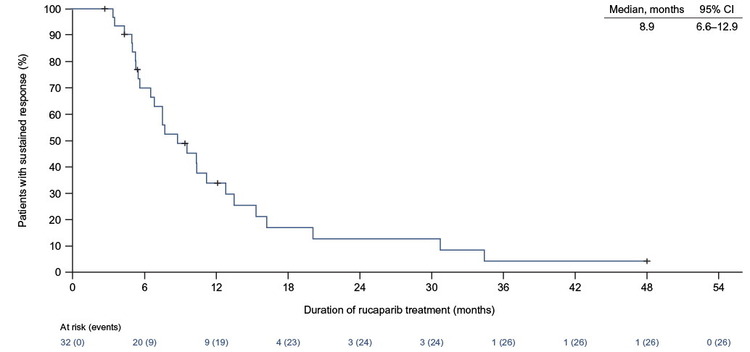

Supplementary Fig. 2. Kaplan–Meier analysis of progression-free survival with rucaparib (N=54). CI confidence interval.
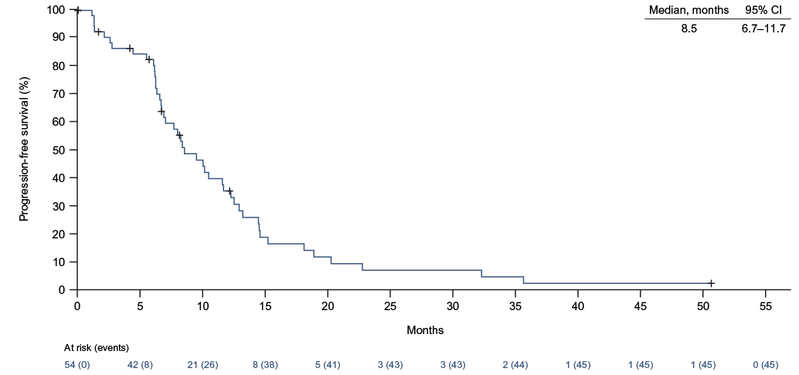

Supplementary Fig. 3. Mean serum laboratory values over time. a ALT. b AST. c Creatinine. Dashed lines indicate the upper and lower limits of normal for ALT (7–45 U/L), AST (7–40 U/L), and creatinine (53.04–79.56 μmol/L). Cycle 1 data are reported for day 15; all other data are reported for the first day of the cycle. ALT alanine aminotransferase, AST aspartate aminotransferase, SE standard error.
