SUPPLEMENTARY TABLES AND FIGURES

Supplementary Table 1. Tea and coffee drinking characteristicsª by preferred temperature and daily intake of hot beverages (tea and coffee) in a subset of 192,249 individuals who completed at least one 24-hour dietary recall questionnaires
 | All participants | Tea or coffee drinking
 | All participants | Non-drinkers or warm temperature^{b} | Hot temperature |  | Very hot temperature
 | All participants | Non-drinkers or warm temperature^{b} | ≤ 6 cups/d^{c} | > 6 cups/d | ≤ 6 cups/d | > 6 cups/d
N (row %) | 192,249 (100) | 31,937 (16.6) | 73,311 (38.1) | 55,195 (28.7) | 16,121 (8.4) | 15,685 (8.2)
Tea drinking
No, n (%) | 37,734 (19.6) | 8,957 (28.1) | 17,386 (23.7) | 6,047 (11.0) | 3,591 (22.3) | 1,753 (11.2)
Yes, n (%) | 154,515 (80.4) | 22,980 (71.9) | 55,925 (76.3) | 49,148 (89.0) | 12,530 (77.7) | 13,932 (88.8)
Black, n (%)^{d} | 136,822 (88.5) | 19,380 (84.3) | 48,318 (86.4) | 45,436 (92.5) | 10,808 (86.3) | 12,880 (92.5)
Green, n (%) | 12,326 (8.0) | 2,268 (9.9) | 4,782 (8.6) | 3,388 (6.9) | 1,023 (8.2) | 865 (6.2)
Herbal, n (%) | 18,521 (12.0) | 3,225 (14.0) | 8,095 (14.5) | 4,291 (8.7) | 1,748 (14.0) | 1,162 (8.3)
Rooibos, n (%) | 7,685 (5.0) | 1,261 (5.5) | 2,961 (5.3) | 2,242 (4.6) | 603 (4.8) | 618 (4.4)
Other, n(%) | 6,268 (4.1) | 1,109 (4.8) | 2,290 (4.1) | 1,760 (3.6) | 551 (4.4) | 558 (4.0)
Milk additive use
Black, n (%)^{e} | 123,563 (90.3) | 17,119 (88.3) | 43,766 (90.6) | 41,478 (91.3) | 9,623 (89.0) | 11,577 (89.9)
Rooibos, n (%) | 3,827 (49.8) | 574 (45.5) | 1,436 (48.5) | 1,203 (53.7) | 290 (48.1) | 324 (52.4)
Coffee drinking
No | 54,334 (28.3) | 10,586 (33.2) | 21,338 (29.1) | 13,103 (23.7) | 5,136 (31.9) | 4,171 (26.6)
Yes | 137,925 (71.7) | 21,351 (66.8) | 51,973 (70.9) | 42,995 (76.3) | 9,985 (68.1) | 11,514 (73.4)
Filtered, n (%)^{f} | 42,239 (30.6) | 6,305 (19.7) | 17,250 (23.5) | 12,200 (22.1) | 3,366 (20.9) | 3,118 (19.9)
Instant, n (%) | 94,161 (68.3) | 14,723 (46.1) | 32,955 (45.0) | 30,874 (55.9) | 7,102 (44.1) | 8,507 (54.2)
Espresso, n (%) | 4,620 (3.4) | 821 (2.6) | 2,040 (2.8) | 1,132 (2.1) | 378 (2.3) | 249 (1.6)
Capuccino, n (%) | 10,822 (7.9) | 1,598 (5.0) | 4,497 (6.1) | 2,925 (5.3) | 939 (5.8) | 863 (5.5)
Latte, n (%) | 10,124 (7.3) | 1,498 (4.7) | 3,856 (5.3) | 2,931 (5.3) | 929 (5.8) | 910 (5.8)
Other, n (%) | 1,919 (1.4) | 337 (1.1) | 719 (1.0) | 552 (1.0) | 153 (1.0) | 158 (1.0)
Milk additive use
Filtered, n (%)^{g} | 28,562 (67.6) | 4,170 (66.1) | 11,586 (67.2) | 8,610 (70.6) | 2,110 (62.7) | 2,086 (66.9)
Instant, n (%) | 78,073 (82.9) | 11,856 (80.5) | 27,278 (82.8) | 26,209 (84.9) | 5,685 (80.1) | 7,045 (82.8)
Espresso, n (%) | 1,228 (26.6) | 209 (25.5) | 558 (27.4) | 287 (25.4) | 111 (29.4) | 63 (25.3)
Other^{h}, n (%) | 1,132 (59.0) | 191 (56.7) | 417 (58.0) | 346 (62.7) | 79 (51.6) | 99 (62.7)
ª Shown as n (%)
^{b} Participants who reported not drinking tea or coffee and those who reported drinking warm beverages were combined.
^{c} Median intake of total hot beverages (tea and coffee)
^{d} Percentage of drinkers of respective tea type among all tea drinkers. Percentages are not exclusive across tea types.
^{e} Percentage of individuals who reported adding milk among respective type of tea drinkers
^{f} Percentage of drinkers of respective coffee type among all tea drinkers. Percentages are not exclusive across coffee types.
^{g} Percentage of individuals who reported adding milk among respective type of coffee drinkers
^{h} Other type of coffee not including latte and cappuccino

Supplementary Table 2. Risk of adenocarcinoma by preferred temperature and daily intake level of hot beverages (tea and coffee) without adjustment for GERD and Barrett’s Esophagus
 | Esophageal adenocarcinoma
 | N | Case N | HR (95% CI)ª | P-trend^{b}
All participants | 454,796 | 710
Participant N
Non-drinkers or warm temperature^{c} | 74,547 | 127 | 1.00 (reference)
Hot
≤ 4 cups/d | 110,344 | 120 | 0.69 (0.54 - 0.89) | 0.02
> 4 – 6 cups/d | 106,088 | 165 | 0.90 (0.71 - 1.14)
> 6 – 8 cups/d | 54,514 | 104 | 1.05 (0.80 - 1.36)
> 8 cups/d | 31,696 | 87 | 1.31 (0.99 - 1.73)
Very hot
≤ 4 cups/d | 24,226 | 21 | 0.68 (0.43 - 1.08) | 0.97
> 4 – 6 cups/d | 26,132 | 45 | 1.20 (0.85 - 1.68)
> 6 – 8 cups/d | 15,777 | 23 | 0.96 (0.61 - 1.49)
> 8 cups/d | 11,472 | 18 | 0.90 (0.55 - 1.48)
ª Hazard ratio (HR) and 95% confidence interval (CI) adjusted for age, sex, race (white or other), Townsend Deprivation Index, general health status (excellent, good, fair, or poor), body mass index (<18, 18 to <25, 25 to <30, ≥30 kg/m²), tobacco smoking (25-levels including current smoking status, smoking intensity [current and former smokers], time since quitting [former smokers], and cigar and pipe use [current and former smokers]); physical activity (>10 minutes of moderate or vigorous activity; days per week), and dietary intake including vegetables (tablespoons per day), fruits (pieces per day), red meat (beef, lamb, and pork; times/week), and processed meat (0, <1, 1, 2 to 4, 5 to 6, and ≥7 times/week). The baseline risk was stratified by the UK National Health Service assessment center region (England, Scotland, and Wales).
^{b} Tests for trend across intake categories in hot or very hot temperature group including the reference group (non-drinkers and warm temperature drinkers). A value zero was assigned for the reference group.
^{c} Participants who reported not drinking tea or coffee (n=4,746) and those who reported drinking warm beverages (n=69,801) served as the referent group.

Supplementary Figure 1. Directed Acyclic Graph (DAG) of proposed causal pathway between hot beverage temperature and EAC (panel A) and ESCC (panel B)

A
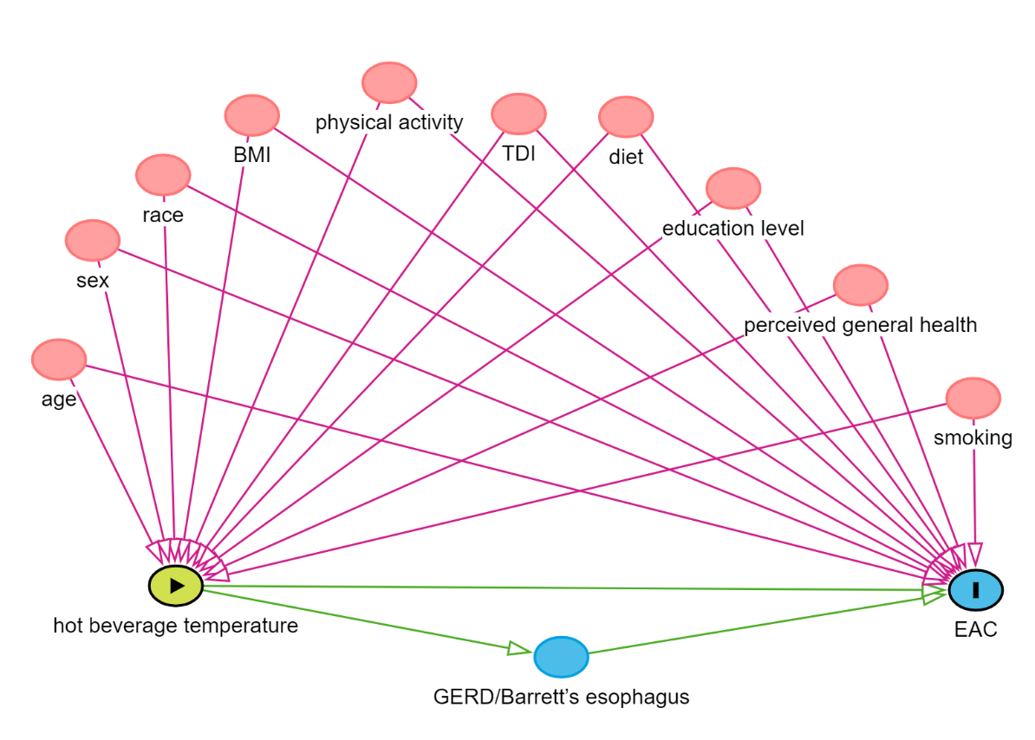

B
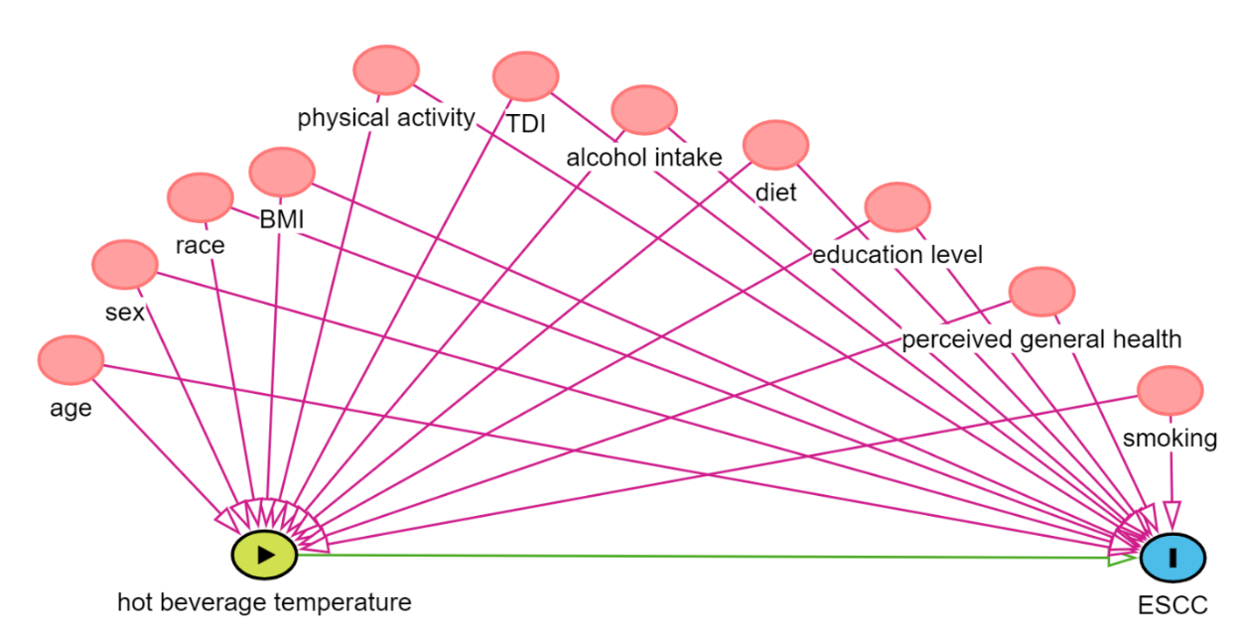
Abbreviations: BMI – Body mass index; TDI – Townsend Deprivation Index; GERD - gastroesophageal reflux disease ; EAC – Esophageal adenocarcinoma; ESCC – Esophageal squamous cell carcinoma

