Supplementary material

Supplementary Table S1. Detailed summary of the included studies assessing mucin expression in precursor lesions of the lower GIT
reference +  Newcastle-Ottawa score | Sample  (number and type) | Mucin | Detection method | Relevant findings | Location | Country
Krishn S.R. et al.¹²  Score: 6 | HP (n = 10); adenomas (n = 30); no normal colonic mucosae | MUC1, MUC2, MUC4, MUC5AC, MUC5B, MUC6, MUC17 | IHC | There was a downregulation of MUC2 and MUC4 expression (p < 0.0001) while MUC1 and MUC5AC expressions were upregulated (p = 0.01) during adenoma-adenocarcinoma progression. Expression of MUC17 was downregulated in inflamed tissues compared to normal tissues, but its increased expression differentiated adenomas (p = 0.0028) and adenocarcinomas (p = 0.025) from inflammation. Glycan epitope-Tn/STn on MUC1 showed higher expression in hyperplastic polyps (p = 0.023), adenomas (p = 0.042) and adenocarcinomas (p = 0.0096) compared to normal tissues. Multivariate regression analyses indicated that a combination of MUC2, MUC5AC, and MUC17 could effectively discriminate adenoma-adenocarcinoma from hyperplastic polyps. | Colorectum | USA
Khaidakov M. et al.¹³  Score: 5 | HP (n = 47); SSA (n = 37); normal colonic mucosae (n = 30) | MUC5AC | IHC | HP and SSA exhibited an 11.3- and 1.6-fold increase in MUC5AC expression, respectively. | Colon | USA
Mochizuka A. et al.¹⁴  Score: 6 | HP (n = 15); SSA (n = 29); TSA (n = 12); CA (n = 16); normal colonic mucosae (n = 10) | MUC5AC, MUC6 | IHC | MUC5AC was expressed in the normal colonic mucosa (40%) and in all the serrated polyps examined. MUC5AC was expressed in the mucous granules of goblet cells present in the normal mucosa and the crypt lining cells of serrated polyps. The staining scores for MUC5AC were higher in the HPs, SSAs, and TSAs than in the normal colonic mucosa. | Colorectum | Japan
Higuchi T. et al.¹⁵  Score: 8 | HP (n = 61); SSA (n = 24); MP (n = 9); TA (n = 57); TVA (n = 29); no normal colonic mucosae | MUC2, MUC5AC | IHC | MUC2 staining was increased in the serrated polyps. MUC5AC staining was similar to that of MUC2, but with additional staining of goblet cell thecae. AD showed less MUC2 expression than either HP or ASP. HP, SSA and MP showed more expression of MUC5AC than that observed in AD. Additionally, SSA had more expression of MUC5AC than either HP or SA, but not MP. | Colorectum | Canada
Hiromoto T. et al.¹⁶  Score: 8 | TSA (n = 131); no normal colonic mucosae | MUC2, MUC5AC, MUC6 | IHC | All cases were positive for MUC2 but negative for MUC6. MUC5AC positivity was found significantly more frequently in mucin rich TSA (MR-TSAs) (53%) than in conventional TSA (C-TSAs) (26%; P = 0.026). | Colorectum | Japan
Renaud F. et al. (2016)¹⁷  Score: 5 | Serrated polyps (n = 218); microvesicular HP (n = 68); SSA (n = 100); TSA (n = 8); CA (n = 112); no normal colonic mucosae | MUC2, MUC5AC | Promotor methylation status, IHC | MUC2 and MUC5AC expressions were more frequent in SA than in CA (95 vs. 63%, p < 0.0001 and 96 vs. 59%, p < 0.0001, respectively).  MUC2 hypomethylation was more frequent in serrated polyps than in CA (37 vs. 19%, p < 0.0001). MUC2 hypomethylation was associated with proximal location in both microvesicular HPs (MVHP) and SSA (p < 0.0001 and p < 0.0001, respectively). In MVHP, MUC2 hypomethylation was associated with proximal location (p = 0.001) and CIMP (p = 0.002). In SSA, MUC2 hypomethylation was associated with proximal location (p < 0.0001), BRAF mutation (p < 0.0001), MSI (p < 0.0001) and CIMP (p < 0.0001).  MUC5AC hypomethylation was detected in 19% of serrated polyps and none of the CA, indicating that MUC5AC hypomethylation is specific for the serrated pathway (p < 0.0001). MUC5AC hypomethylation was associated with proximal location in both MVHP and SSA (p < 0.011 and p < 0.0001, respectively), with a gradual increase of MUC5AC hypomethylation frequency from rectosigmoid through cecum. In MVHP, MUC5AC hypomethylation was also associated with BRAF mutation (p = 0.017), MSI (p < 0.0001), MLH1 methylation (p < 0.0001) and CIMP-H (p < 0.0001). In SSA (with or without dysplasia), MUC5AC hypomethylation was associated with BRAF mutation (p < 0.0001), MSI (p < 0.0001), MLH1 methylation (p < 0.0001) and CIMP (p < 0.0001).  MUC5AC hypomethylation was detected in 53% (39/74) of serrated polyps harbouring BRAF mutation, CIMP-H or MSI and in none (0/144) of the other serrated polyps, which corresponds to a positive predictive value of 100% and a negative predictive value of 81.4% for the identification of serrated lesions with malignant potential. By comparison, MUC2 hypomethylation was detected in 53% (39/74) of serrated polyps harbouring BRAF mutation, CIMP-H or MSI, but also in 28% (40/144) of the others, which corresponds to a positive predictive value of 49.4% and a negative predictive value of 76% for the identification of serrated lesions with malignant potential. | Colorectum | France
Molaei M. et al.¹⁸  Score: 7 | HP (n = 36); SA (n = 14), TA (n = 258), TVA (n = 114); VA (n = 31) ; no normal colonic mucosae | MUC1, MUC2, MUC5AC, MUC6 | IHC | The expression of MUC1 was significantly higher in TA than SSA/HP (23.5% vs. 7.8%, P = 0.005). The main difference between the MUC1 positive and negative polyps was in the level of neoplastic transformation.  The majority of colorectal polyps showed no expression of MUC5AC, with the exception of SSA (66% were MUC5AC positive). Certain patterns of MUC expression were significantly associated with invasion of polyps into the mucosa or muscularis mucosae, including the upregulation of MUC1, absence of MUC2, and positive MUC6 staining. Regression analysis, with covariates of gender, age, polyp site, and MUC status included, indicated that negative staining for MUC2 and positive staining for MUC6, would increase the risk of mucosal or muscularis mucosae invasion in colorectal polyps significantly. | Colorectum | Iran
Bartley A.N. et al.¹⁹  Score: 6 | Serrated polyps (n = 146); conventional tubular adenomas (n = 87); no normal colonic mucosae | MUC6 | IHC | SSA (53%), HP (17%) and TSA (18%) expressed MUC6. MUC6 expression was absent in TA | Colorectum | USA
Owens S.R. et al.²⁰  Score: 5 | Polyps (n = 94); no normal colonic mucosae | MUC6 | IHC | MUC6 was found to have 100% specificity in distinguishing SSA (n = 26; positive staining) from HP (n = 48; negative staining). TSA were also negative for MUC6. SSA with cytological dysplasia were found to lose expression of MLH-1 in dysplastic areas, while retaining MUC6 expression. | Colon | USA
Walsh M.D. et al. ²¹ | HP (n = 2); residual contiguous adenoma (n = 5); normal colonic mucosae (n = 7; adjacent non-tumoral tissue) | MUC13 | IHC | In all residual contiguous adenoma, MUC13 staining showed intense apical membrane reactivity with variable cytoplasmic reactivity and staining of some goblet cell thecae. incidental hyperplastic polyps that were close to, but not contiguous with, the carcinoma were noted. Staining in these lesions was apical, cytoplasmic and goblet cell theca with slight intensification of the staining toward the surface epithelium recapitulating the pattern of staining seen in normal epithelium. | Colorectum | Australia
Cansiz Ersöz C. et al.²²  Score: 7 | TSA (n = 25); TVA (n = 25); no normal colonic mucosae | MUC2, MUC5AC, MUC6 | IHC | Goblet MUC2 and MUC5AC expression was significantly higher in TSA compared to TVA. | Colorectum | Turkey
Myerscough N. et al.²³  Score: 6 | TA (n = 16);  TVA (n = 9);  VA (n = 14); no normal colonic mucosae | MUC2, MUC5AC, MUC5B, MUC6 | IHC | Changes in MUC2 synthesis and the new appearance of MUC5AC are significant events in the progression from adenoma to carcinoma in colorectal cancer development. | Rectum | United Kingdom
Li A. et al²⁴  Score: 7 | Adenomas (n = 200); no normal colonic mucosae | MUC1, MUC2 | IHC | MUC1 was expressed in adenomas with severe dysplasia (4%), but not in adenomas with mild or moderate dysplasia. MUC2 was expressed in a significantly greater number of adenomas with mild dysplasia (72%) than in adenomas with moderate dysplasia (45%) or severe dysplasia (47%, P < 0.0001). | Colorectum | Japan
Baldus S.E. et al. (2002)²⁵  Score: 7 | Adenomas (n = 42); no normal colonic mucosae | MUC1, MUC2, MUC5AC | IHC | There was a statistically significant positive correlation between the development of high-grade dysplasia in adenomas and the immunoreactivity of MUC1 epitopes, whereas MUC2 exhibited a significant negative correlation. | Colorectum | Germany
Kim D.H. et al.²⁷  Score: 4 | HP (n = 21); SA (n = 20); TA (n =25); TVA (n = 13); VA (n = 7); normal colonic mucosae (n = 10) | MUC2, MUC5AC | IHC | A higher frequency of MUC5AC and MUC2 expression was observed in HP (100%, 100%), SA (85%, 85%), TVA (85%, 85%), and VA (100%, 100%), compared to TA (32%, p<0.002; 36%, p<0.01). | Colorectum | USA
Renaud F. et al. (2015) ²⁸  Score: 7 | First cohort CRC (n = 36), second cohort CRC (n = 34); no normal colonic mucosae | MUC2, MUC4, MUC5AC | Pyrosequencing to determine promotor methylation status; IHC | MUC2 and MUC5AC hypomethylation was associated with MUC2 and MUC5AC protein expression (p = 0.004 and p < 0.001, respectively), poor differentiation (p = 0.001 and p = 0.007, respectively) and MSI status (p < 0.01 and p < 0.001, respectively). Interestingly, MUC5AC hypomethylation was specific to MSI cancers. Moreover, it was significantly associated with BRAF mutation and CpG island methylator phenotype (p < 0.001 and p < 0.001, respectively). | Colorectum | France
El-Sayed I.H. et al.³⁷  Score: 7 | Adenoma (n = 25); normal colonic mucosae (n = 10) | MUC2 | IHC | The results showed that in normal colonic specimens, MUC2 expression was detected in 20%. MUC2 positivity ranged from 60-96% was altered in 60-96% in the investigated adenoma cases. | Colorectum | Egypt
IHC = immunohistochemistry; SSA = sessile serrated adenoma; HP = hyperplastic polyp; TSA = traditional serrated adenoma; TA = tubular adenoma; TVA = tubulovillous; adenoma; VA = villous adenoma; MP = mixed polyps; CA = conventional adenoma; SA = serrated adenoma

Supplementary Table S2: Detailed summary of the included studies assessing mucin expression small intestinal and colorectal adenocarcinomas
Reference +  Newcastle-Ottawa score | Sample  (number and type) | Mucin | Detection method | Relevant findings | Location | Country
Krishn S.R. et al. ¹²  Score: 6 | CRC (n = 16); no normal colonic mucosae | MUC1, MUC2, MUC4, MUC5AC, MUC5B, MUC6, MUC17 | IHC | There was a downregulation of MUC2 and MUC4 expression (p < 0.0001) while MUC1 and MUC5AC expressions were upregulated (p = 0.01) during adenoma-adenocarcinoma progression. Expression of MUC17 was downregulated in inflamed tissues compared to normal tissues, but its increased expression differentiated adenocarcinomas (p = 0.025) from inflammation. Glycan epitope-Tn/STn on MUC1 showed higher expression in adenocarcinomas (p = 0.0096) compared to normal tissues. Multivariate regression analyses indicated that a combination of MUC2, MUC5AC, and MUC17 could effectively discriminate adenoma-adenocarcinoma from hyperplastic polyps. | Colorectum | USA
Walsh M.D. et al. ²¹  Score: 8 | CRC (n = 99); normal colonic mucosae (n = 65; adjacent non-tumoral tissue) | MUC13 | IHC | In normal colon, intense apical membrane and variable cytoplasmic MUC13 staining was present in both goblet and columnar cells, with strongest reactivity in the upper crypts and surface epithelium. All cancers showed staining of most tumour cells, being most conspicuous in the apical membranes of gland spaces. Left-sided tumours had a higher overall proportion of MUC13-positive tumour cells than right-sided tumours (P < .05), and high staining intensity was more frequent in adenocarcinomas (81%) than mucinous tumours (50%) (P < .05). Poorly differentiated and late-stage tumours were more likely to have high-intensity cytoplasmic staining (P < or = .025). Basolateral cell membranes were stained in 24% of cases, being more common in poorly differentiated tumours (55%) than well or moderately differentiated tumours (16%) (P < or = .001). Partial or full circumferential MUC13 staining was frequently observed in areas of tumour budding. Although MUC13 immunoreactivity was not predictive of patient outcome, there was a trend toward poorer outcome in patients with tumours showing basolateral MUC13. | Colorectum | Australia
Li A. et al. ²⁴  Score: 7 | CRC (n = 58); no normal colonic mucosae | MUC1, MUC2 | IHC | MUC1 was expressed in carcinomas (24%). MUC2 was also expressed in the carcinomas (38%). | Colorectum | Japan
Baldus S.E. et al. (2002) ²⁵  Score: 7 | CRC (n = 44); no normal colonic mucosae | MUC1, MUC2, MUC5AC | IHC | A significantly stronger MUC2 reactivity of mucinous vs. tubular adenocarcinomas was shown. | Colorectum | Germany
Park S.Y. et al. ²⁶  Score: 5 | Mucinous CRC (n = 69); no normal colonic mucosae | MUC1, MUC2, MUC5AC | IHC | Right-sided mucinous and non-mucinous colorectal adenocarcinomas, by comparison with those on the left side, were characterized by higher MUC2 and MUC5AC expression. The results indicate that MA is a distinctive form of colorectal cancer and has different phenotypes depending on tumour location. | Colorectum | South Korea
Kim D.H. et al. ²⁷  Score: 4 | non-mucinous CRC (n = 42); mucinous CRC cancers (n = 19); no normal colonic mucosae | MUC2, MUC5AC | IHC | MC (68%, 100%) showed a higher frequency of MUC5AC and MUC2 expression compared to NMC (31%, p=0.001; 38%, p<0.001). | Colorectum | USA
Renaud F. et al. ²⁸ | CRC (n = 36); no normal colonic tissue | MUC2, MUC4, MUC5AC | IHC and qPCR | MUC2 and MUC5AC hypomethylation was associated with MUC2 and MUC5AC protein expression (p = 0.004 and p < 0.001, respectively), poor differentiation (p = 0.001 and p = 0.007, respectively) and MSI status (p < 0.01 and p < 0.001, respectively). Interestingly, MUC5AC hypomethylation was specific to MSI cancers. Moreover, it was significantly associated with BRAF mutation and CpG island methylator phenotype (p < 0.001 and p < 0.001, respectively). All these results were confirmed in the control cohort. In the multivariate analysis, MUC5AC hypomethylation was a highly predictive biomarker for MSI cancers. | Colorectum | France
Losi L. et al. ²⁹  Score: 6 | Mucinous CRC (n = 76); non-mucinous CRC (n = 60); no normal colonic mucosae | MUC2, MUC5AC | IHC | MUC2 was noted in all mucinous carcinomas, whereas MUC5AC was present in 41 cases only (54%). In non-mucinous carcinomas, MUC2 was expressed in 61.7% of the tumours; by contrast, MUC5AC was present in 20% of the cases. The expression level of apomucins was significantly different in mucinous and non-mucinous lesions (p<0.001). The lack of MLH1 expression was considerably more frequent in carcinomas with secretion of MUC5AC (p<0.005). | Colorectum | Italy
You J.F. et al. ³⁰  Score: 6 | CRC (n = 147), HNPCC (n = 56); no normal colonic mucosae | MUC1, MUC2, MUC4, MUC5AC | IHC | A higher expression score of MUC1 in CRC was associated with a poorer survival (Ptrend = 0.043). If further stratified by mucin production, high MUC1 expression seemed to be a marker of worse long-term survival in mucinous tumours though not in non-mucinous tumours (P = 0.004). The detrimental effect of dual expression of mucin and MUC1 on the long-term outcome remained significant after stratification by TNM stages in Cox regression model (P = 0.039). | Colorectum | Taiwan
Al-Maghrabi J. et al. ³¹  Score: 6 | CRC (n = 128); local nodal metastases (n = 50); normal colonic mucosae (n = 42) | MUC2 | IHC | Low MUC2 immunostaining was higher in primary CRC (P = 0.003) and nodal metastasis (80%) (P < 0.001). There was significant association of low MUC2 immunostaining in CRC with age group below 60 years (P = 0.05) and occurrence of lymphovascular invasion (P = 0.034). Regression analysis revealed that low MUC2 immunostaining was an independent predictor of lymphovascular invasion (P = 0.041). In the Kaplan-Meier survival analysis, there was a significant longer disease-free survival in patients with low MUC2 immunostaining (P = 0.045). | Colorectum | Saudi Arabia
Lugli A. et al. ³²  Score: 6 | CRC (n = 1420); no normal colonic mucosae | MUC1, MUC2 | IHC | In MMR-proficient CRC, MUC1 expression was more frequently found in tumours with higher tumour stage (p=0.004) and higher tumour grade (p=0.041) and loss of MUC2 was associated with higher tumour stage (p=0.028), node stage (p=0.001), presence of vascular invasion (p=0.028) and worse survival (p=0.034). In MLH1-negative CRC, MUC2 loss was associated with the presence of lymph node metastasis (p=0.028) and worse survival (p=0.015), but there was no association between MUC1 expression and clinicopathological features | Colorectum | Canada
Nishida T. et al. ³³  Score: 7 | T1 CRC (n = 265); normal colonic mucosae (n = 265; adjacent non-tumoral tissues) | MUC2, MUC5AC | IHC | MUC2 and MUC5AC expression was significantly associated with tumour location, growth pattern, histologic type, invasive potential, and metastatic potential. The incidence of lymph node metastasis was significantly associated with MUC2 expression (p = 0.006). | Colorectum | Japan
Betge J. et al. ³⁴  Score: 7 | CRC (n = 381); no normal colonic mucosae | MUC1, MUC2, MUC5AC, MUC6 | IHC | Expression of MUC2 was lost in 85 (23 %) CRCs, and patients with MUC6-negative tumours showed shorter progression-free survival (PFS, p = 0.043). Gastric mucins MUC5AC and MUC6 showed high (>50 %) aberrant expression in 28 (8 %) and 9 (2 %) cases, respectively. High expression of MUC5AC was associated with longer PFS (p = 0.055). High expression of MUC6 was associated with 100 % PFS (p = 0.024) and longer cancer-specific survival (CSS, p = 0.043). MUC1 was expressed in 238 (64 %) tumours. When analysis was restricted to stages II and III, loss of MUC2 was associated with adverse outcome. Overexpression of both MUC5AC and MUC6 significantly predicted favourable PFS and CSS. | Colorectum | Germany
Walsh M.D. et al. ³⁵  Score: 7 | CRC (n = 976); no normal colonic mucosae | MUC2, MUC5AC, MUC5B, MUC6 | IHC | MUC2 overexpression was observed in 33% colorectal cancers, MUC5B expression in 53%, and de novo MUC5AC and MUC6 expression in 50%and 39%, respectively. Co-expression of two or more of the mucins was commonly observed. Expression of MUC2, MUC5AC and MUC6 was strongly associated with features associated with tumorigenesis via the serrated neoplasia pathway, including methylator positivity, somatic BRAF p.V600E mutation, and mismatch repair deficiency, as well as proximal location, poor differentiation, lymphocytic response, and increased T stage (all Po0.001). | Colorectum | Australia
Yao T. et al. (2001) ³⁶  Score: 4 | CRC (n = 83); no normal colonic mucosae | MUC2 | IHC | The small-intestinal type (CD10– and HGM-)showed a relatively lower incidence of lymphatic permeation and higher venous invasion. The large-intestinal type (CD10-, HGM- and MUC2+) showed a low incidence of venous invasion and lymph node metastasis. The mixed type (CD10+, GHM+, MUC2+) revealed female and right-side-dominant distribution, large tumour size, high incidence of mucinous carcinoma, and low incidence of venous invasion. Gastric type (CD10-, HGM+, MUC2-) was seen in only two cases (2%), which exhibited high histologic grade, lymphatic permeation and lymph node metastasis with no venous invasion. | Colorectum and small intestine | Japan
El-Sayed I.H. et al. ³⁷  Score: 7 | CRC (n = 25); normal colonic mucosae (n = 10) | MUC2 | IHC | The results showed that in normal colonic specimens, MUC2 expression was detected in 20%. Expression of MUC2, as detected by GOS and was positive in 92% of adenocarcinoma. | Colorectum | Egypt
Yao T. et al. (2002) ³⁸  Score: 8 | Advanced CRC with liver metastases (n = 31), CRC without liver metastases (n = ???); no normal colonic mucosae | MUC2 | IHC | The incidence of MUC2 (45.2%) and HGM (16.1%) expression in CRCs with liver metastasis did not differ from non-metastatic CRCs. In contrast, the incidence of CD10 expression was significantly higher in CRCs with liver metastasis (58.1%) than in control CRCs (21.7%). | Colorectum | Japan
Elzagheid A. et al. ³⁹  Score: 6 | Primary early CRC (n = 141); no normal colonic mucosae | MUC2 | IHC | Loss of MUC2 expression was significantly associated with disease recurrence (P < 0.031) and tumour localization (P < 0.048) in CRC. In univariate survival analysis, positive MUC2 significantly predicted longer DFS and DSS as well. | Colorectum | Libya
Hirano K. et al. ⁴⁰  Score: 7 | Early CRC (n = 170) (polypoid, 98; non-polypoid, 72); no normal colonic mucosae | MUC2, MUC5AC | IHC | MUC2 expression was significantly higher in polypoid carcinomas than in non-polypoid carcinomas. MUC5AC expression was also higher in polypoid carcinomas than in non-polypoid carcinomas. MUC2 expression was higher in carcinomas with low grade atypia than in those with high grade atypia. MUC5AC expression was also higher in carcinomas with low-grade atypia than in those with high-grade atypia. | Colorectum | Japan
Kang H. et al. ⁴¹  Score: 7 | CRC (n = 301); no normal colonic mucosae | MUC2 | IHC | Immunohistochemically, loss of expression of MUC-2 was significantly correlated with poor overall 5-year survival rate in stage II CRC using multivariate regression analysis (p = 0.047). | Colorectum | Korea
Perez R.O. et al. ⁴²  Score: 6 | Mucinous CRC (n = 35); no normal colonic mucosae | MUC1, MUC2, MUC5AC | IHC | MUC1 expression was significantly associated with decreased disease-free survival (p = 0.03). There was a significant association between MUC2+ expression and proximal tumour location and serosal involvement (p = 0.04 and 0.02, respectively; overall 3-year cancer-specific survival for patients with MUC2+ tumours was 60% and 100% for MUC2− tumours (p = 0.04). There was a significant association between MUC5+ expression and proximal tumour location (p = 0.001), but no significant association with other clinicopathological characteristics. Multiple-type MUC expression tumours were more frequently of proximal location as opposed to single-type MUC expression (75% versus 31%; p = 0.03). | Colorectum | Brazil
Hazgui M. et al. ⁴³  Score: 7 | CRC (n = 202); no normal colonic mucosae | MUC1, MUC5AC | IHC + RT-PCR | The expression of MUC1 and MUC5AC was abnormally high in the tumour tissues for both mRNA and protein. MUC1 expression was correlated with advanced cancer stages and lymph node metastases for both the mRNA (P < 0.016 and P < 0.002, respectively) and protein level (P < 0.006 and P < 0.001, respectively). However, MUC5AC expression did not pinpoint any significant association between the clinicopathological criteria, but patients who expressed MUC5AC showed an increase in overall survival (P < 0.009). | Colorectum | Tunisia
Sylvester P.A. et al. ⁴⁴  Score: 5 | Cancer in left hemicolon or rectum (n = 37); normal colonic mucosae (n = 10 | MUC2, MUC5AC, MUC5B, MUC6 | IHC | Low levels of MUC2mRNA were detected in non-mucinous adenocarcinomas (5/27) while a higher proportion of mucinous carcinomas (4/9) was positive. MUC2 protein product was detected immunohistochemically in 34/36 carcinoma specimens, with no change from normal controls. There was de novo expression of MUC5AC in 23/36 carcinomas. No MUC5B or MUC6 protein was detected. No difference in MUC2 and MUC5AC protein was found between mucinous and non-mucinous carcinomas. The level of MUC2 was increased in moderately differentiated cancers compared with normal controls and decreased in the poorly differentiated group. Decreased MUC2 was found in poorly differentiated compared with moderately differentiated tumours. More MUC5AC protein was detected in well and moderately differentiated tumours than in poorly differentiated tumours and in all tumours relative to controls. | Left hemicolon and rectum | United Kingdom
Rico S.D. et al. ⁴⁵  Score: 7 | CRC (n = 1812); no normal colonic mucosae | MUC5AC | IHC | MUC5AC expression was found in 261 (15.7%) of 1,667 analysable colorectal cancers. MUC5AC expression strongly depended on the tumour location and gradually decreased from proximal (27.4% of cecum cancers) to distal (10.6% of rectal cancers; p < 0.0001). | Colorectum | Germany
Katano T. et al. ⁴⁶  Score: 7 | LST (n = 105; 60 granular and 45 non-granular); no normal colonic mucosae | MUC5AC, MUC6 | IHC | MUC5AC positivity was significantly higher in G-LSTs compared to NG-LSTs (P = 0.002), and MUC5AC positivity in HA lesions was significantly higher than in LA lesions (P = 0.01). MUC6 and SOX2 positivity in SM G-LSTs, and chromogranin A positivity in SM NG-LSTs were significantly higher than in HAs (P =0.01, 0.01, and 0.03, respectively). | Colorectum | Japan
Kocer B. et al. ⁴⁷  Score: 6 | CRC (n = 41); normal colonic mucosae (n = 41 | MUC5AC | IHC | The MUC5AC glycoprotein was expressed in 34.1% of tumour tissues, 24.4% of normal colonic tissues and 19% of meta static tumours in the regional lymph nodes. The number of tumours that expressed MUC5AC was lower in patients older than 60years, in rectum-localized tumours and in patients who had evidence of recurrence and/or metastasis in the postoperative period. The patients with MUC5AC-negative tumours had a lower incidence of being disease free and of overall survival. | Colorectum | Turkey
Zhang W. et al. ⁴⁸  Score: 7 | CRC (n = 77); no normal colonic mucosae | MUC1 | IHC | Positive KL-6 mucin expression was correlated with decreased membranous beta-catenin expression (P=0.022), while no correlation was found between positive KL-6 expression and nuclear beta-catenin expression (P=0.142). Preservation of membranous beta-catenin expression was detected in 35 cases (45.5%) and decreased membranous beta-catenin expression was found in 42 cases (54.5%). Negative KL-6 expression was detected in 31 cases (41.3%) and positive expression was seen in 46 cases (59.7%). Combined positive KL-6 expression and decreased membranous beta-catenin expression was found in 30 patients (39.0%), whose survival was significantly worse than that of patients with other expression patterns for these two molecules (53.3 vs. 84.4%, P=0.005). Multivariate analysis showed that this combination was as an independent predictor of survival. | Colorectum | China
Kesari M.V. et al. ⁴⁹  Score: 7 | CRC (n = 50); no normal colonic mucosae | MUC1, MUC2, MUC5AC | IHC | MUC1 positivity was not observed in normal mucosa. It stained the cytoplasm and cell membrane of the tumour cells. Positive MUC1 staining was seen in 39 % of the CRC. MUC2 positivity was observed in normal mucosa. MUC2 stained the cytoplasm of the tumour cells. Positive MUC2 staining was observed in 43 % of the CRC. MUC5AC positivity was luminal or cytoplasmic. 24% of CRC were positive for MUC5AC. | Colorectum | India
Suzuki H. ⁵⁰  Score: 6 | CRC (n = 123); no normal colonic mucosae | MUC1 | IHC | MUC1 was recognized in the cancerous epithelia of pT1 carcinoma in 61%, pT2 in 78%, pT3 in 98% and pT4 in 90%of the cases at the deepest invading sites. | Colon | Japan
Baldus S.E. et al. (2002) ⁵¹  Score: 6 | CRC (n = 243); no normal colonic mucosae | MUC1, MUC2 | IHC | According to univariate and multivariate analysis (P < 0.0001) only MUC1 reactivity represented a marker of worse survival probability. | Colorectum | Germany
Zhang M.Q. et al. ⁵²  Score: 5 | SIA (n = 30); no normal colonic mucosae | MUC1, MUC2, MUC5AC | IHC | Specifically, positive staining for MUC1, MUC2, MUC5AC, SIMA, villin, and CDX2 was observed in 16 (53%), 17 (57%), 12 (40%), 15 (50%), 20 (67%), and 18 (60%) of SIAs and 25 (52%), 43 (90%), 39 (81%), 45 (94%), 47 (98%), and 47 (98%) of CRCs, respectively. | Small intestine and colorectum | USA
Guo Q. ⁵³  Score: 6 | CRC (n = 82); normal colonic mucosae (n = 82; adjacent non-tumoral tissue) | MUC1 | IHC | KL-6 localization in the circumferential membrane and/or cytoplasm was significantly associated with the presence of venous invasion (P = 0.0003), lymphatic invasion (P < 0.0001), lymph node metastasis (P < 0.0001), liver metastasis (P = 0.058), and advanced histological stage (P < 0.0001). Positive staining was observed in all metastatic lesions tested as well as in the primary colorectal carcinoma tissues, but not in non-cancerous epithelial cells. | Colorectum, lymph nodes and liver meta's | Japan
Tozawa E. et al. ⁵⁴  Score: 7 | CRC (n = 152; 30 mucinous, 122 non-mucinous); no normal colonic mucosae | MUC1, MUC2, MUC5AC | IHC | Carcinomas with mucus component (MC) commonly possessed the MUC2+ phenotype (90.9-100%), and 76.6-83.3% possessed either the MUC2+/MUC5AC+/MUC1+ or the MUC2+/MUC5AC-/MUC1+ phenotype. Carcinoma without MC was typically the MUC2- phenotype (89.5%). | Colorectum | Japan
Baldus S.E. et al. (2004) ⁵⁵  Score: 7 | CRC (n = 205); no normal colonic mucosae | MUC1 | IHC | MUC1 in the tumour centre was significantly associated with the histological grading (more strongly in carcinomas with low differentiation; P < 0.05). Expression of MUC1 at the tumour centre and at the invasion front correlated with a worse survival probability (p = 0.0071 and 0.0039 respectively). | Colorectum | Germany
Duncan T.J. et al. ⁵⁶  Score: 7 | Primary CRC (n = 462); no normal colonic mucosae | MUC1, MUC3 | IHC | No correlation was seen with either MUC1 or MUC3 and any of the clinicopathological variables including tumour grade and stage, vascular invasion and tumour type. Kaplan-Meier analysis demonstrated a significant reduction in disease specific survival with MUC1 positive tumours (p = 0.038), this was not seen with MUC3 (p = 0.552). On multivariate analysis, using Cox proportional hazards model, MUC1 expression was shown to be an independent marker of prognosis (HR 1.339, 95%CI 1.002-1.790, p = 0.048). | Colorectum | United Kingdom
Matsuyama T. et al. ⁵⁷  Score: 7 | CRC (n = 100); no normal colonic mucosae | MUC12 | RT-qPCR | MUC12 expression was significantly lower in cancer tissues than in adjacent normal tissues (p < 0.001). In Stages II and III CRC, patients with low expression showed worse disease-free survival (p = 0.020). Multivariate analysis disclosed that MUC12 expression status was an independent prognostic factor in Stages II and III CRC (relative risk, 8.236; 95% confidence interval, 1.702-39.849 p = 0.009) | Colorectum | Japan
Oh H.R. et al. ⁵⁸  Score: 5 | CRC (n = 141); normal colonic mucosae (n = 141; adjacent non-tumoural tissue) | MUC4, MUC7 and MUC15 | Single-strand conformation polymorphism analysis; DNA sequencing; IHC | MUC15 frameshift mutations (14.7% of GC and 15.2% of CRC with MSI-H), MUC 7 frameshift mutations (2.9% of GC with MSI-H) and MUC4 frameshift mutations (8.8% of GC and 3.8% of CRC with MSI-H). These mutations were not found in in MSS/MSI-L (0/118). Negative MUC15 expression was identified in 15–41% of the GC and CRC irrespective of MSI status. Of note, the negative expression was more common in those with MUC15 mutations. | Stomach and colorectum | Korea
Xiao X. et al. ⁵⁹  Score: 7 | CRC (n= 150); normal colonic tissues (n = 150; adjacent non-cancerous tissues) | MUC20 | IHC; RT-qPCR; micro-array | MUC20 was up-regulated in CRC patients with poor prognosis by microarray. MUC20 expression was significantly higher in CRC tissues than in ANCT (P < 0.05). We further showed that MUC20 overexpression was correlated with recurrence and poor outcome (P < 0.05). The Kaplan-Meier survival curves indicated that disease-free survival (DFS) and overall survival (OS) were significantly worse in CRC patients with MUC20 overexpression. The Cox multivariate analysis revealed that MUC20 overexpression and TNM stage were independent prognostic factors. | Colorectum | China
Shibahara H. et al. ⁶⁰  Score: 5 | SIA (n = 60); normal colonic mucosae (n = 60) | MUC1, MUC2, MUC3, MUC4, MUC5AC, MUC6, MUC16 | IHC | MUC1, MUC5AC and MUC16 expression was increased in SBC lesions compared to the normal epithelium, and expression of these mucins was related to clinicopathologic factors, as follows: MUC1 [tumour location (p = 0.019), depth (p = 0.017) and curability (p = 0.007)], MUC5AC [tumour location (p = 0.063) and lymph node metastasis (p = 0.059)], and MUC16 [venous invasion (p = 0.016) and curability (p = 0.016)].  There were five factors associated with a poor prognosis: poorly-differentiated or neuroendocrine histological type (p<0.001), lymph node metastasis (p<0.001), lymphatic invasion (p = 0.026), venous invasion (p<0.001) and curative resection (p<0.001), in addition to expression of MUC1 (p = 0.042), MUC5AC (p = 0.007) and MUC16 (p<0.001). In subsequent multivariate analysis with curability as the covariate, lymph node metastasis, venous invasion, and MUC5AC and/or MUC16 expression were significantly related to the prognosis. Multivariate analysis in curative cases (n = 45) showed that SBC with MUC5AC and/or MUC16 expression had a significantly independent high hazard risk after adjusting for the effects of venous invasion (hazard ratio: 5.6, 95% confidence interval: 1.8-17). | Small intestine | Japan
Jun S.Y. et al. ⁶¹  Score: 6 | SIA (n = 189); no normal colonic mucosae | MUC1, MUC5AC, MUC6 | IHC | Patients expressing MUC1 tended to demonstrate high-grade (P=0.021) and nodular or infiltrative (P=0.020) tumours.  Intestinal-type SIA (CDX2+, MUC1-) demonstrated more frequent distal (jejunal or ileal; P=0.033), tubular (P=0.039), and low-grade tumours (P=0.004) and significantly better survival according to univariate (P<0.0001) and multivariate (P=0.001) analyses. | Small intestine | Republic of Korea
Kumagai R. et al. ⁶²  Score: 7 | SIA (n = 47); no normal colonic mucosae | MUC2, MUC5AC, MUC6 | IHC | The tumour sizes of the MUC2(+) tumours were significantly larger than those of the MUC2(-) tumours (mean, 5.7 ± 1.4 cm vs 4.7 ± 2.1 cm, P < 0.05). All three tumours with adenomatous component were positive for MUC2 (P < 0.05). | Small intestine | Japan
Ishikawa R. et al ⁶³  Score: 6 | 52 cases of JIAC, 182 cases of CRC, no normal mucosae | MUC1, MUC2, MUC5AC, MUC6 | Immunohistochemical staining using primary antibodies as mentioned in the study | High expression of MUC1 was found in 26.9% of JIAC and 28.6% of CRC (p-value= 0.815). High expression of MUC2 was found in 50% of JIAC and 43.2% of CRC (p-value = 0.379). High expression of MUC5AC was found in 21.2% of JIAC and 13.2% of CRC (p-value = 0.151). High expression of MUC6 was found in 3.8% of JIAC and 1.6% of CRC (p-value = 0.295). Kaplan–Meier analysis showed that the overall survival of patients with JIAC with high MUC1 protein expression was significantly shorter than that of patients with JIAC with low MUC1 expression. Cox’s univariate and multivariate analyses for overall survival showed that the expression of MUC1 was associated with significantly increased risk of poor overall survival, hazard ratio (HR) of univariate analysis, 3.4 [95 % confidence interval (CI), 1.3–9; P = 0.016] HR of multivariate analysis, 5.88 (95 % CI, 1.75–19.7; P = 0.004). | Jejunum, ileum and colorectum | Japan

CRC = colorectal cancer; SIA = small intestinal adenocarcinoma; IHC = immunohistochemistry; MC = mucinous carcinoma; NMC = non-mucinous carcinoma; HNPCC = hereditary non-polyposis colorectal cancer; MSI = microsatellite instability: MMR = mismatch repair; HGM = human gastric mucin; PFS = progression free survival; CSS = cancer specific survival; ANCT = adjacent non-cancerous tissue; SBC = small bowel cancer; G-LST = granular type laterally spreading tumour; NG-LST = non-granular type laterally spreading tumour; DFS = disease free survival; DSS = disease specific survival; JIAC = jejunoileal adenocarcinoma

Supplementary Table S3: Detailed summary of the included studies assessing mucin expression rare tumours
Reference +  Newcastle-Ottawa score | Sample  (number and type) | Mucin | Detection method | Relevant findings | Location | Country
Terada, T. et al. ⁶⁴  Score: 8 | Colonic SRCC (n = 12); normal colonic mucosae (n = 12; from adjacent non-cancerous tissue) | MUC1, MUC2, MUC5AC, MUC6 | IHC | Significant differences in the expression of MUC1 (stomach SRCC 10% vs colorectal SRCC 42%), MUC2 (13% vs 92%), MUC5AC (67% vs 33%), and MUC6 (70% vs 0%). | Stomach and colorectum | Japan
Winn B. et al. ⁶⁵  Score: 5 | Medullary carcinoma (n = 16); no normal colonic mucosae | MUC1, MUC2 | IHC | Evidence of intestinal differentiation by MUC-1, MUC-2 staining was seen in 67 and 60% of the medullary carcinomas respectively. Medullary carcinoma of the colon retains a significant degree of intestinal differentiation as evidenced by its high percentage of staining for MUC-1, MUC-2. | Colon | USA
Kurosawa T. et al. ⁶⁶  Score: 7 | CAED (n = 42), no normal colonic mucosae | MUC2, MUC5AC, MUC6 | IHC | MUC5AC positive CAED tend to have larger tumour masses (p < 0.05) and originate from right side of the colon (p = 0.032). Small-intestinal type and unclassified type were dominant in our CAED cases, and there were more gastric type and less large-intestinal type than “usual” CRCs (p = 0.015). CAED with gastric type tended to have larger tumour masses (p = 0.039) and originate from right side of the colon (p = 0.007). There were more cases with small-intestinal and unclassified types in which some liver metastases and stage IV diseases were found though they were not statistically significant. Unclassified type showed fewer cases with lymph node metastases than other types (6 cases, 40.0%, p = 0.047). | Colorectum | Japan
Chang M.S. et al. ⁶⁷  Score: 5 | Appendiceal mucinous adenoma (n = 22); NUMP (n = 20); appendiceal mucinous adenocarcinoma (n = 14); no normal colonic mucosae | MUC2, MUC5AC | Fluorescence in situ hybridization; IHC | MUC2 was immunopositive in 64% of mucinous adenocarcinomas versus 9% of cases with mucinous adenoma and no cases of mucinous neoplasm of uncertain malignant potential. MUC5AC was immunopositive in 43% of mucinous adenocarcinomas, whereas it was immunonegative in all cases of mucinous adenoma and mucinous neoplasm of  uncertain malignant potential. | Appendix | Korea
Yoon S.O. et al. ⁶⁸  Score: 5 | Appendiceal mucinous adenoma (n = 32); appendiceal mucinous NUMP (n = 23); appendiceal mucinous adenocarcinoma (n = 15); no normal colonic mucosae | MUC1, MUC2, MUC5AC, MUC6 | IHC | MUC2 and MUC5AC were more frequently positive in the mucinous adenocarcinoma group than in the mucinous adenoma group (P<0.05). | Appendix | Korea
Yajima N. et al. ⁶⁹  Score: 4 | appendiceal mucinous adenocarcinoma (n = 27); appendiceal mucinous adenoma (n = 13), appendiceal non-mucinous adenoma (n = 3), appendiceal non-mucinous carcinoma (n = 3); no normal colonic mucosae | MUC1, MUC2, MUC5AC, MUC6 | IHC | In normal appendix, among all MUCs examined, only MUC2 was positive in mucosal mucous cells. Similarly, in appendiceal tumours, MUC2 was unequivocal and constantly positive in all the cases. By contrast, MUC1 was negative in adenoma cases but positive in 2 (14%) cases of MA and all 3 cases of NMA. MUC5AC was positive in approximately half of MA and MC cases and in one third of NMA and NMAC cases. MUC6 was expressed only in limited cases of MAC (14%) and NMC (33%). | Appendix | Japan
Elsayed B. ⁷⁰  Score: 8 | Appendiceal mucinous neoplasms, no normal mucosae (systematic review and meta-analysis) | MUC2 | Immunohistochemical staining using primary antibodies as mentioned in the primary studies | The analysis of IHC markers in studies comparing appendiceal neoplasms revealed MUC2 as markers of AMNs. | Appendix | Qatar
SRCC = Signet ring cell carcinoma; CAED = colonic adenocarcinoma with enteroblastic differentiation; NUMP = neoplasm of unknown potential; MA = mucinous adenoma; NMA = non-mucinous adenoma; MC = mucinous carcinoma; NMC = non-mucinous carcinoma

Supplementary figures
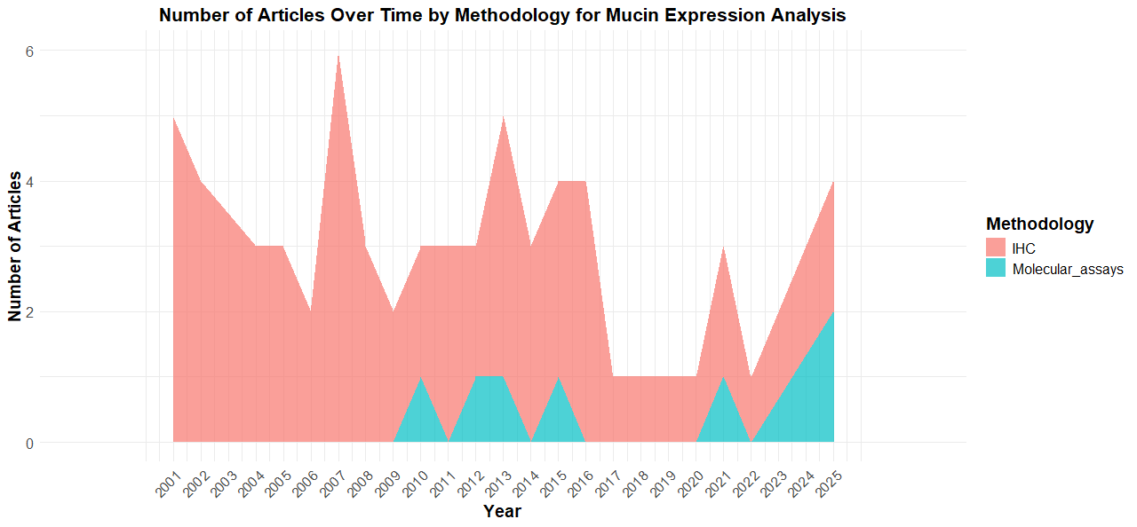
Supplementary figure S1. Area chart showing the number of published articles over time stratified by methodology used for mucin expression analysis. Different colours correspond to the methodologies applied: immunohistochemistry (IHC) and molecular assays (e.g., RT-PCR, microarray, FISH).

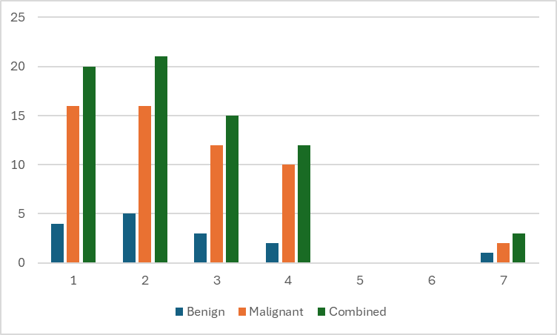
Supplementary figure S2. Number of mucins (x-axis) investigated per study. Blue = number of studies investigating a certain number of mucins in benign lesions (serrated and adenomatous polyps); orange = number of studies investigating a certain number of mucins in malignant lesions (CRC, small intestinal adenocarcinoma, rare tumours); green = sum of benign and malignant lesions.
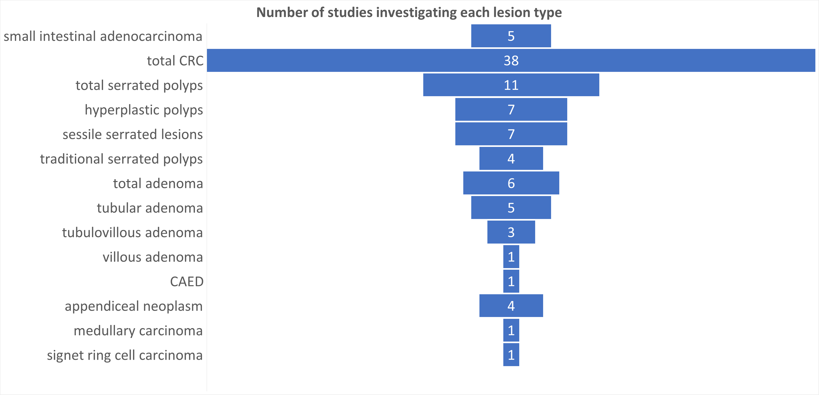
Supplementary figure S3. Total number of studies investigating a certain lesion type. CAED = colonic adenocarcinoma with enteroblastic differentiation

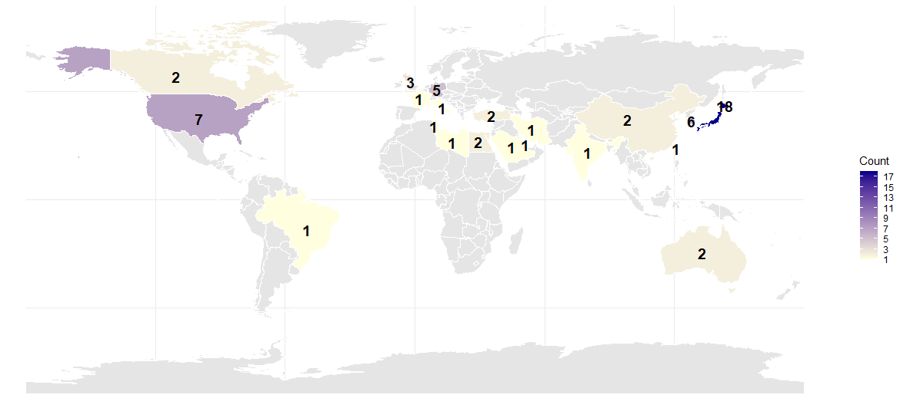
Supplementary figure S4. World map showing the frequency distribution of countries where all included studies were conducted. Colours represent the number of occurrences per country, with the legend indicating specific counts

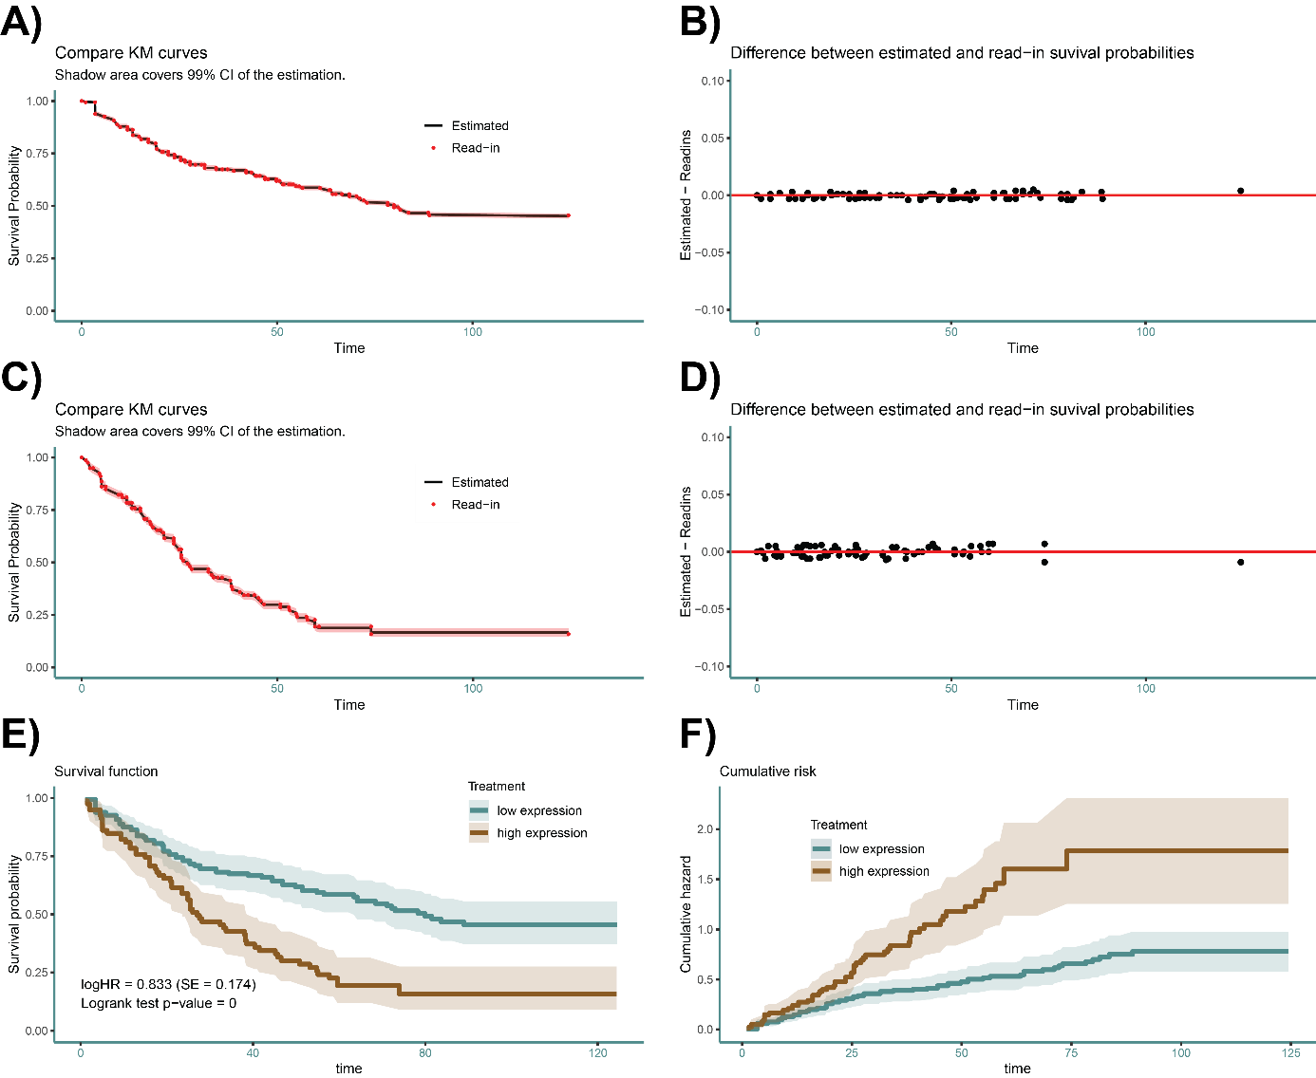
Supplementary figure S5. Visualisation of reconstructed Kaplan-Meijer curves (E) of Baldus et al. 2002 for overall survival of high (C,D) MUC1 expression compared to low (A, B), based on estimated individual patient data (IPD) using IPDfromKM. For each arm, the data points (red dots) from the original Kaplan-Meijer curve are shown (A,C) together with the new fitted curve (black line) and it’s 95% confidence interval (red). Accuracy can be evaluated using the difference between the original data points and the reconstructed Kaplan-Meijer curves (B,D). Finally, the univariate analysis is redone using the IPD reporting the estimated logHR, SE(logHR) and the p-value of the log-rank test for comparison to the original publication (E,F).

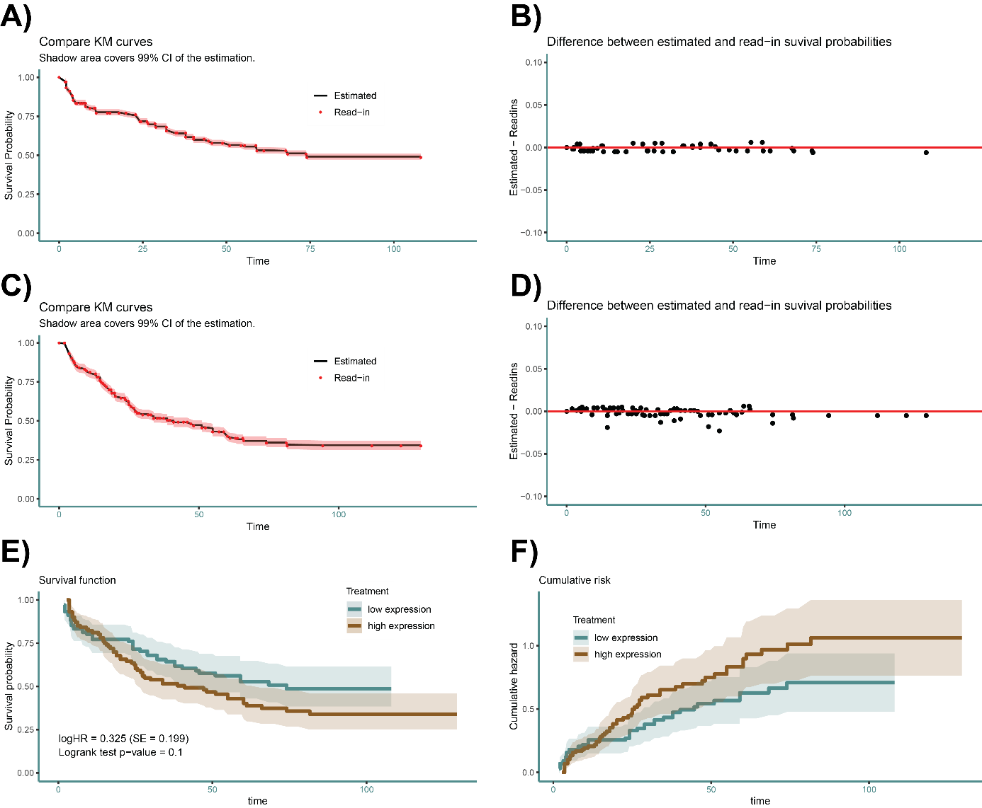
Supplementary figure S6. Visualisation of reconstructed Kaplan-Meijer curves (E) of Baldus et al. 2004 for overall survival of high (C,D) MUC1 expression compared to low (A, B), based on estimated individual patient data (IPD) using IPDfromKM. For each arm, the data points (red dots) from the original Kaplan-Meijer curve are shown (A,C) together with the new fitted curve (black line) and it’s 95% confidence interval (red). Accuracy can be evaluated using the difference between the original data points and the reconstructed Kaplan-Meijer curves (B,D). Finally, the univariate analysis is redone using the IPD reporting the estimated logHR, SE(logHR) and the p-value of the log-rank test for comparison to the original publication (E,F).

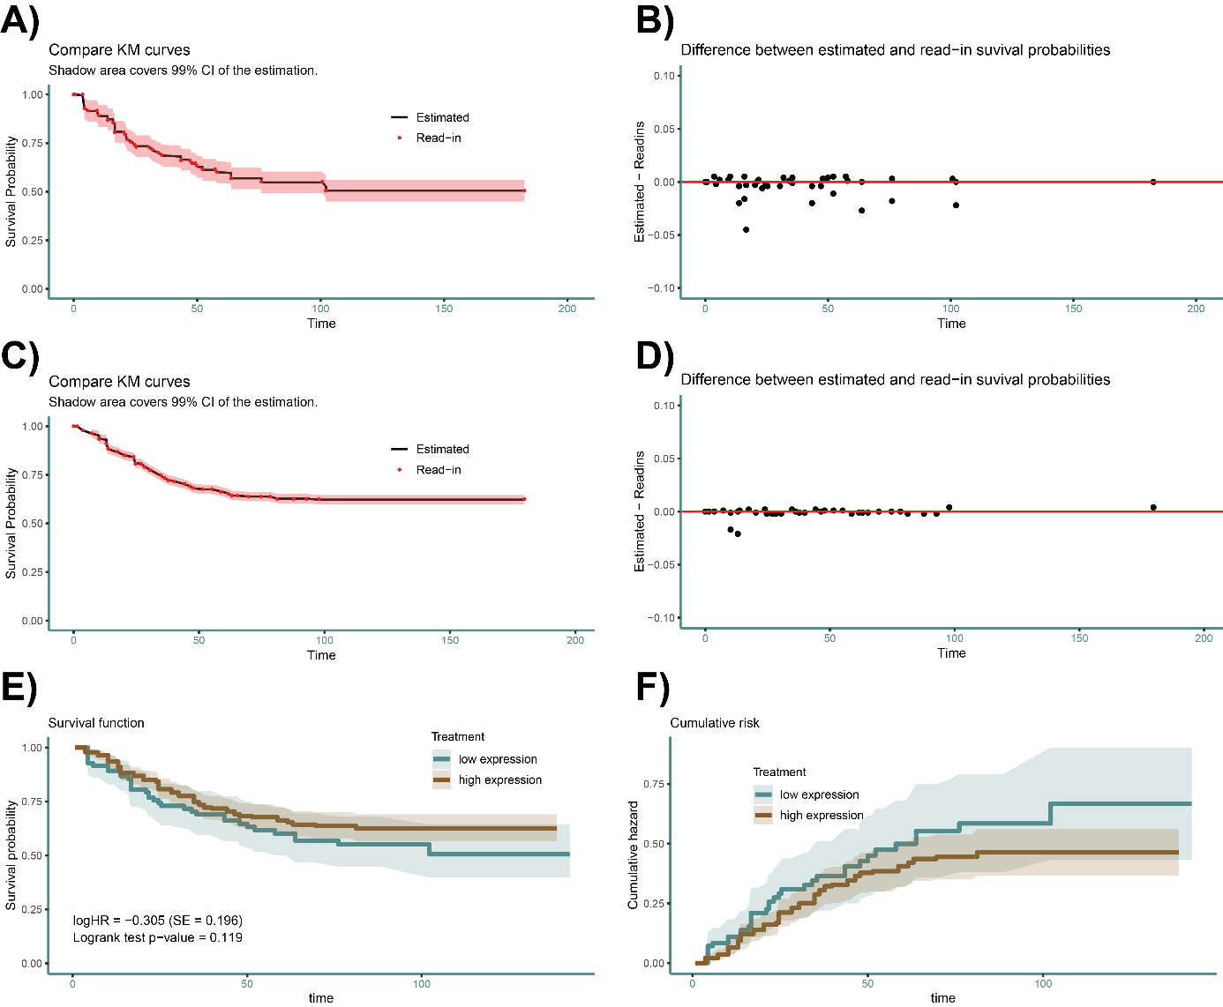
Supplementary figure S7. Visualisation of reconstructed Kaplan-Meijer curves (E) of Betge et al. 2016 for cancer specific survival of high (C,D) MUC2 expression compared to low (A, B), based on estimated individual patient data (IPD) using IPDfromKM. For each arm, the data points (red dots) from the original Kaplan-Meijer curve are shown (A,C) together with the new fitted curve (black line) and it’s 95% confidence interval (red). Accuracy can be evaluated using the difference between the original data points and the reconstructed Kaplan-Meijer curves (B,D). Finally, the univariate analysis is redone using the IPD reporting the estimated logHR, SE(logHR) and the p-value of the log-rank test for comparison to the original publication (E,F).

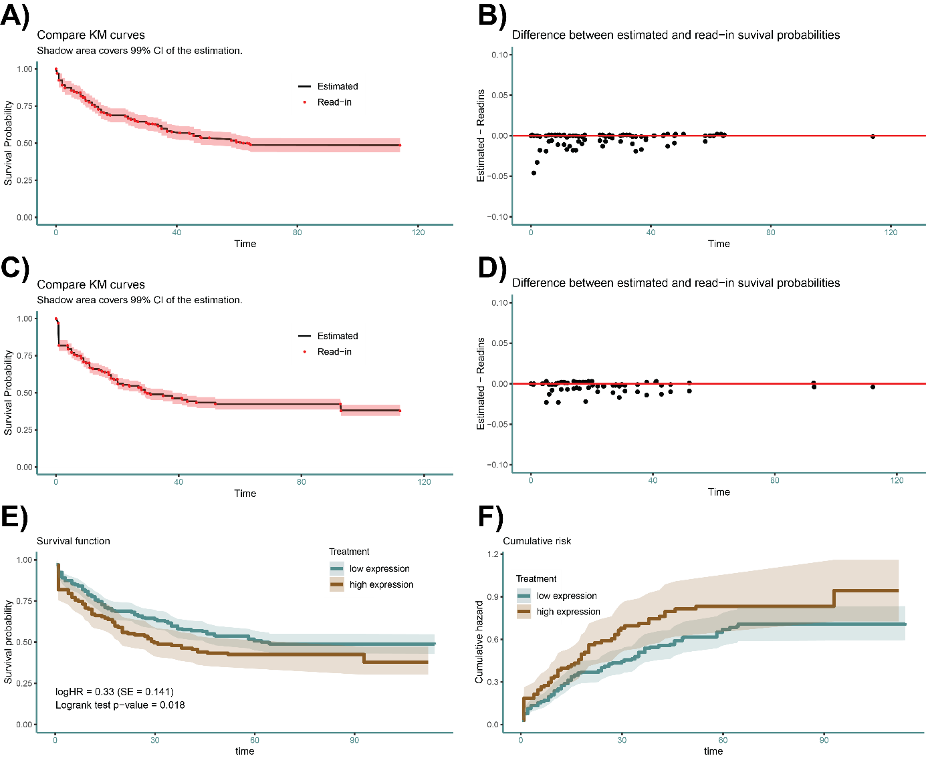
Supplementary figure S8. Visualisation of reconstructed Kaplan-Meijer curves (E) of Duncan et al. 2007 for cancer specific survival of high (C,D) MUC1 expression compared to low (A, B), based on estimated individual patient data (IPD) using IPDfromKM. For each arm, the data points (red dots) from the original Kaplan-Meijer curve are shown (A,C) together with the new fitted curve (black line) and it’s 95% confidence interval (red). Accuracy can be evaluated using the difference between the original data points and the reconstructed Kaplan-Meijer curves (B,D). Finally, the univariate analysis is redone using the IPD reporting the estimated logHR, SE(logHR) and the p-value of the log-rank test for comparison to the original publication (E,F).

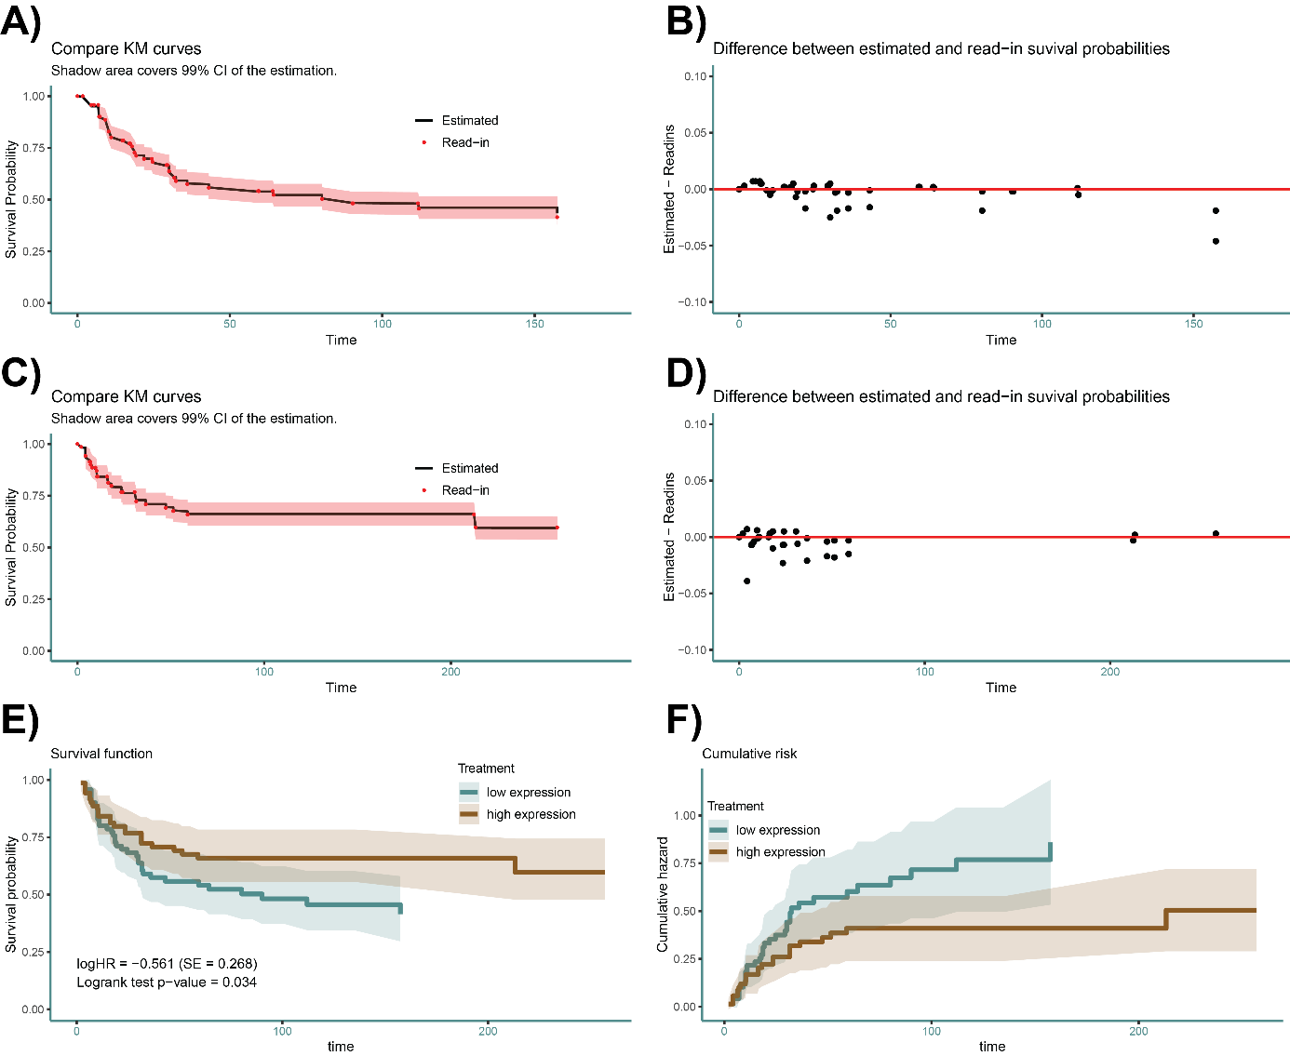
Supplementary figure S9. Visualisation of reconstructed Kaplan-Meijer curves (E) of Elzagheid et al. 2013 for cancer specific survival of high (C,D) MUC2 expression compared to low (A, B), based on estimated individual patient data (IPD) using IPDfromKM. For each arm, the data points (red dots) from the original Kaplan-Meijer curve are shown (A,C) together with the new fitted curve (black line) and it’s 95% confidence interval (red). Accuracy can be evaluated using the difference between the original data points and the reconstructed Kaplan-Meijer curves (B,D). Finally, the univariate analysis is redone using the IPD reporting the estimated logHR, SE(logHR) and the p-value of the log-rank test for comparison to the original publication (E,F).

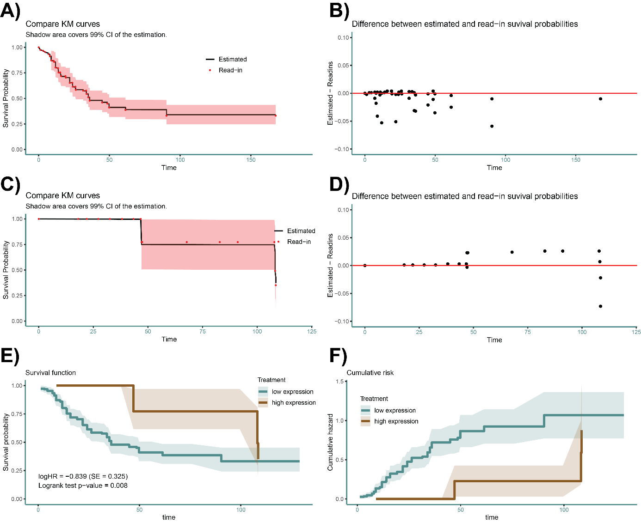
Supplementary figure S10. Visualisation of reconstructed Kaplan-Meijer curves (E) of Hazgui et al. 2002 for overall survival of high (C,D) MUC5AC expression compared to low (A, B), based on estimated individual patient data (IPD) using IPDfromKM. For each arm, the data points (red dots) from the original Kaplan-Meijer curve are shown (A,C) together with the new fitted curve (black line) and it’s 95% confidence interval (red). Accuracy can be evaluated using the difference between the original data points and the reconstructed Kaplan-Meijer curves (B,D). Finally, the univariate analysis is redone using the IPD reporting the estimated logHR, SE(logHR) and the p-value of the log-rank test for comparison to the original publication (E,F).

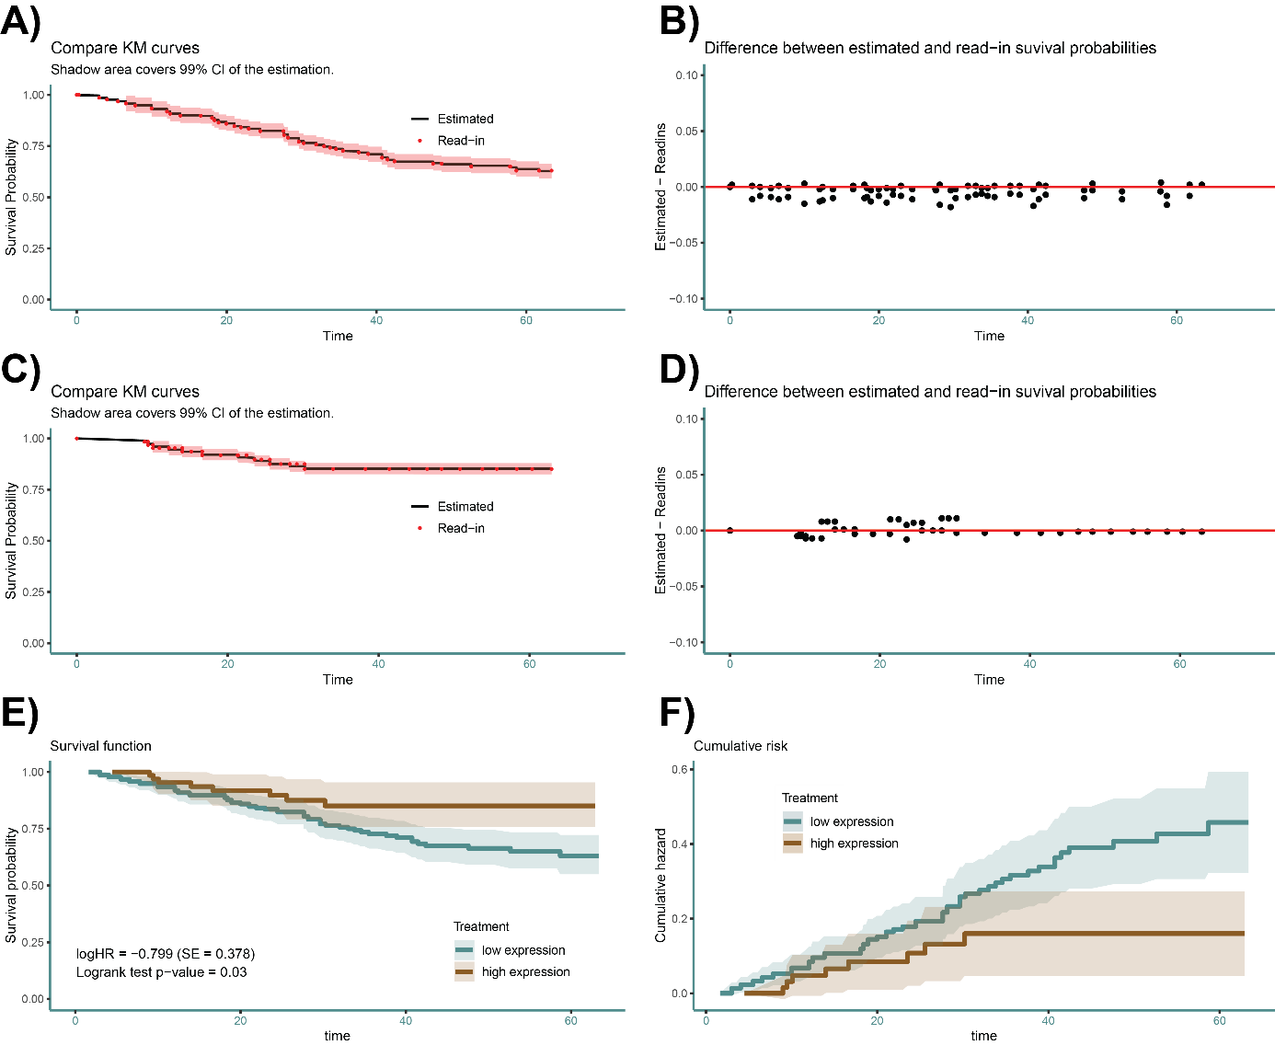
Supplementary figure S11. Visualisation of reconstructed Kaplan-Meijer curves (E) of Kang et al. 2011 for overall survival of high (C,D) MUC2 expression compared to low (A, B), based on estimated individual patient data (IPD) using IPDfromKM. For each arm, the data points (red dots) from the original Kaplan-Meijer curve are shown (A,C) together with the new fitted curve (black line) and it’s 95% confidence interval (red). Accuracy can be evaluated using the difference between the original data points and the reconstructed Kaplan-Meijer curves (B,D). Finally, the univariate analysis is redone using the IPD reporting the estimated logHR, SE(logHR) and the p-value of the log-rank test for comparison to the original publication (E,F).

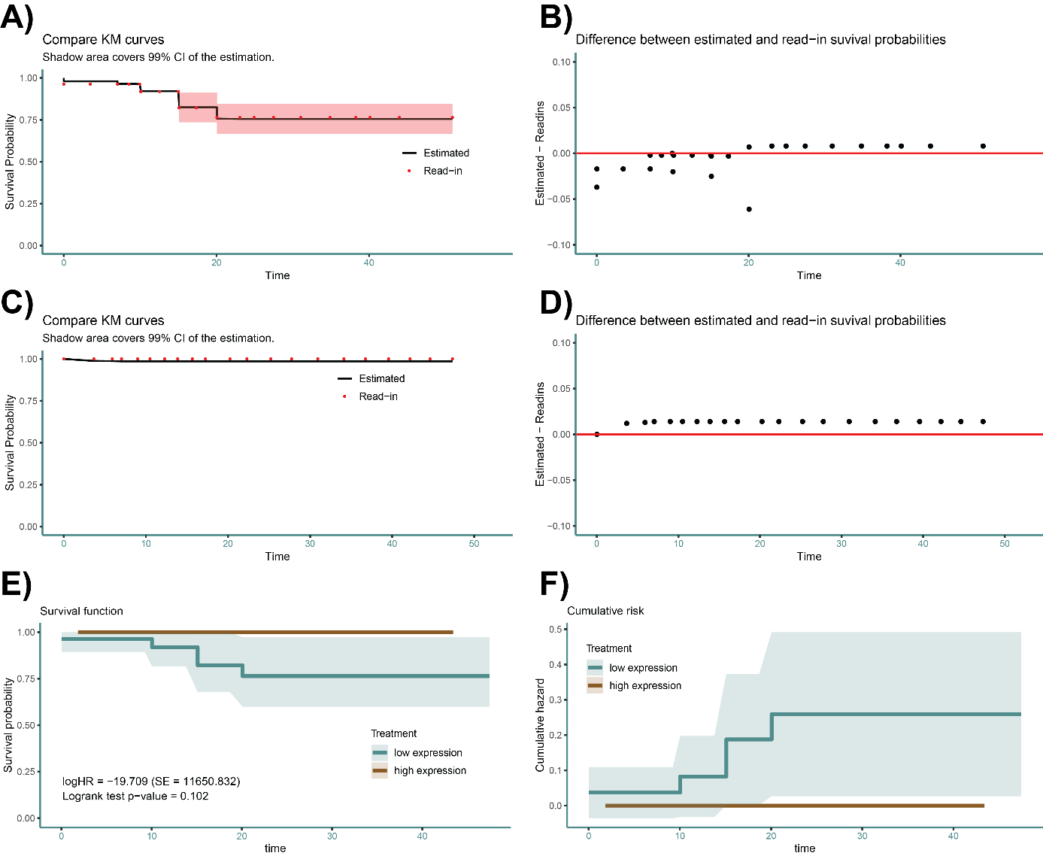
Supplementary figure S12. Visualisation of reconstructed Kaplan-Meijer curves (E) of Kocer et al. 2002 for overall survival of high (C,D) MUC5AC expression compared to low (A, B), based on estimated individual patient data (IPD) using IPDfromKM. For each arm, the data points (red dots) from the original Kaplan-Meijer curve are shown (A,C) together with the new fitted curve (black line) and it’s 95% confidence interval (red). Accuracy can be evaluated using the difference between the original data points and the reconstructed Kaplan-Meijer curves (B,D). Finally, the univariate analysis is redone using the IPD reporting the estimated logHR, SE(logHR) and the p-value of the log-rank test for comparison to the original publication (E,F).

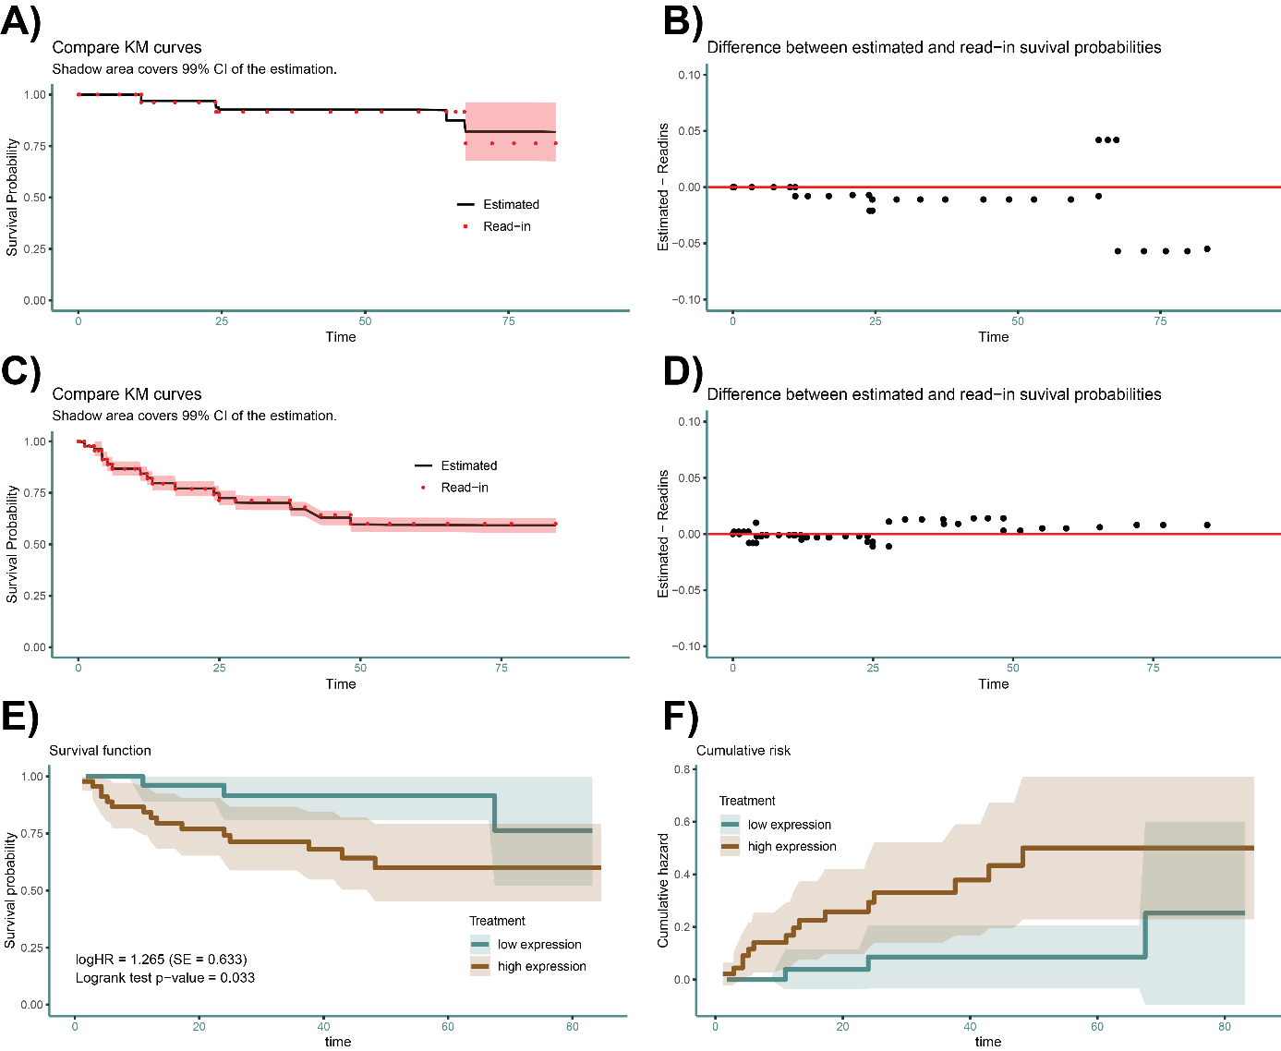
Supplementary figure S13. Visualisation of reconstructed Kaplan-Meijer curves (E) of Zhang et al. 2008 for cancer specific survival of high (C,D) MUC1 expression compared to low (A, B), based on estimated individual patient data (IPD) using IPDfromKM. For each arm, the data points (red dots) from the original Kaplan-Meijer curve are shown (A,C) together with the new fitted curve (black line) and it’s 95% confidence interval (red). Accuracy can be evaluated using the difference between the original data points and the reconstructed Kaplan-Meijer curves (B,D). Finally, the univariate analysis is redone using the IPD reporting the estimated logHR, SE(logHR) and the p-value of the log-rank test for comparison to the original publication (E,F).

