Supplementary Information

Senescence-related gene signature predicts prostate cancer progression and identifies PCNA as a therapeutic target via multi-omics machine learning integration
Renxuan Lin et al.

*Corresponding author: Zong-Ren Wang, wangzr27@mail.sysu.edu.cn; Ren Liu, liur227@mail.sysu.edu.cn.

Supplementary Table 1. Reagents and resources.
Reagent or Resource | Source | Identifier
Cell lines
RM-1 | iCell | iCell-m051
PC3 | iCell | iCell-h174
DU145 | iCell | iCell-h250
Antibodies
PCNA(PC10) Mouse mAb #2586 | CST | Cat# 2586T
Rabbit monoclonal [SP6] to Ki67 | Abcam | Cat# ab16667
Chemicals
AOH1996 | Abmole | Cat# M40519
Enzalutamide | MCE | Cat# HY-70002
Z-VAD-FMK | MCE | Cat# HY-16658B
Deposited data
TCGA-PRAD
Stockholm |  | GSE70769
Cambridge |  | GSE70768
CancerMap |  | GSE94767
GSE54460 |  | GSE54460
Taylor |  | GSE21034
GTEX |  | https://xenabrowser.net/
Bulk-RNAseq human prostate cancer | Bolis et al. | https://prostatecanceratlas.org
SU2C |  | cBioPortal
CTPC |  | https://pcatools.shinyapps.io/CTPC_V2/
CRPC scRNA-seq |  | GSE137829

Supplementary Table 2. List of primers
Gene | Forward primer (5’- 3’) | Reverse primer (5’- 3’)
PCNA | CCTGCTGGGATATTAGCTCCA | CAGCGGTAGGTGTCGAAGC
ACTB | CATGTACGTTGCTATCCAGGC | CTCCTTAATGTCACGCACGAT

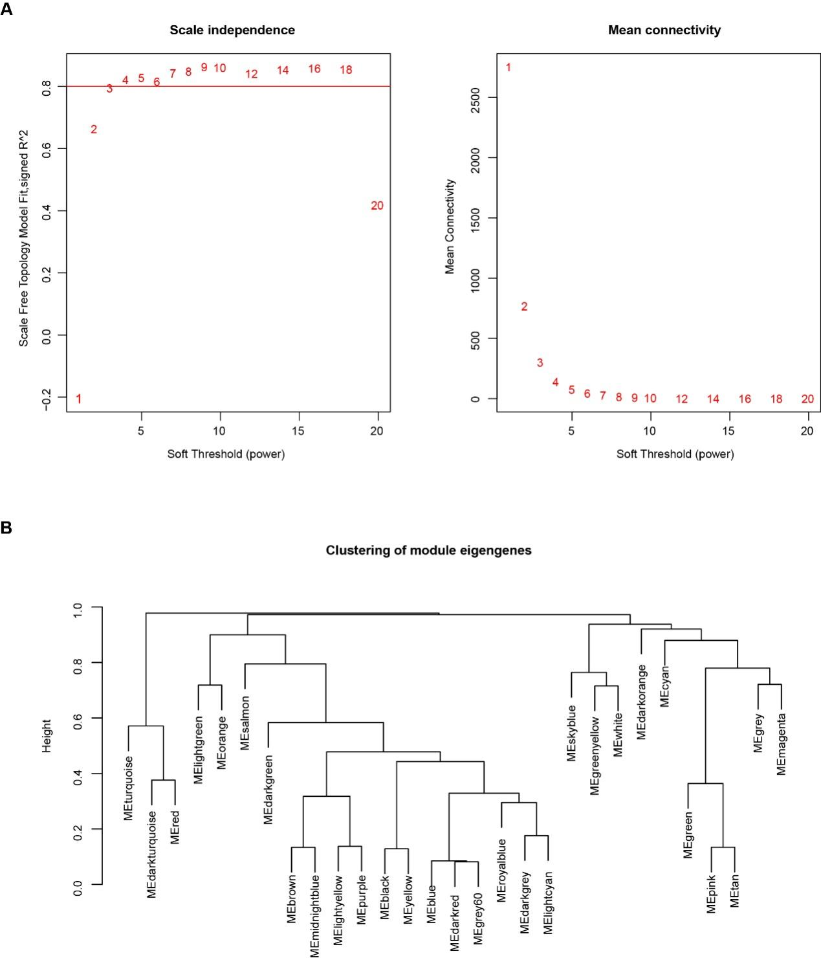
Figure S1. Construction of WGCNA in TCGA-PRAD
A. Network topology analysis for different soft-threshold powers. The effects of soft-threshold power on the topology-fit index (scale-free) are shown in the left-hand panel.
B. Clustering Dendrogram of Module Genes.
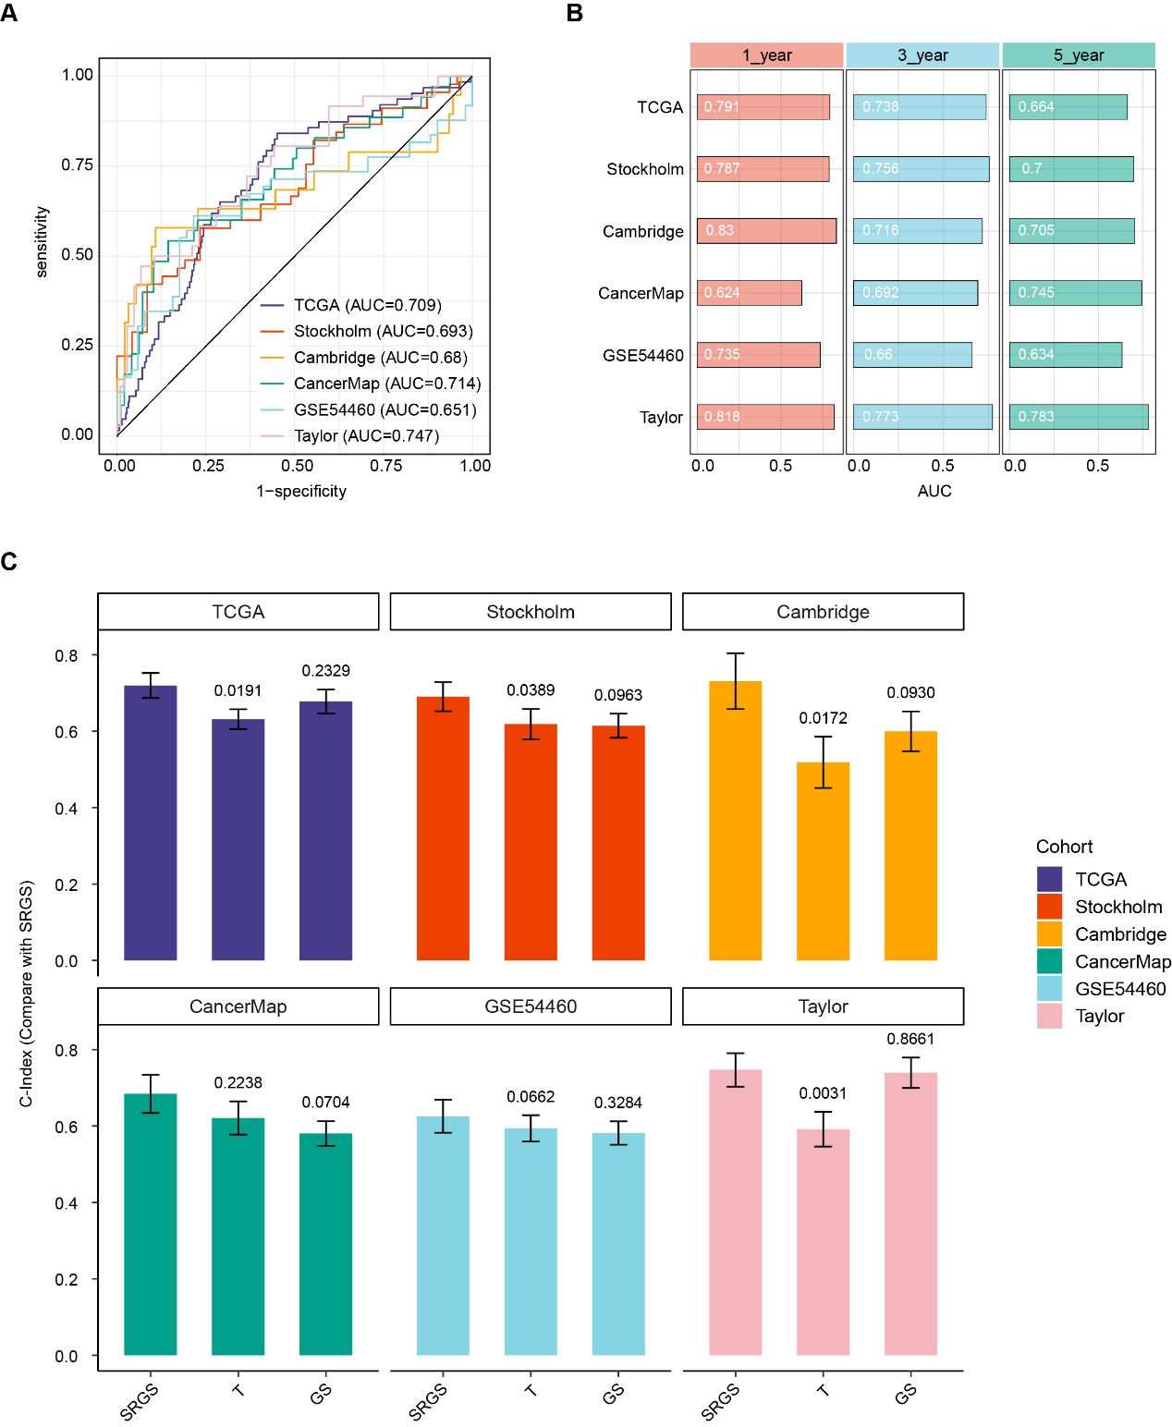
Figure S2. Assessment of the SRGS model
A. Receiver Operating Characteristic (ROC) curves for SRGS predicting biochemical recurrence (BCR) across all cohorts, with the corresponding area under the curve (AUC) values.
B. Time-dependent ROC analysis for predicting Biochemical Recurrence (BCR) at 1, 3, and 5 years across all cohorts.
C. Comparison of the performance of SRGS with those of other clinical factors in predicting prognosis. Statistical tests: two-sided z-score test. Data are shown as mean ± 95% CI.

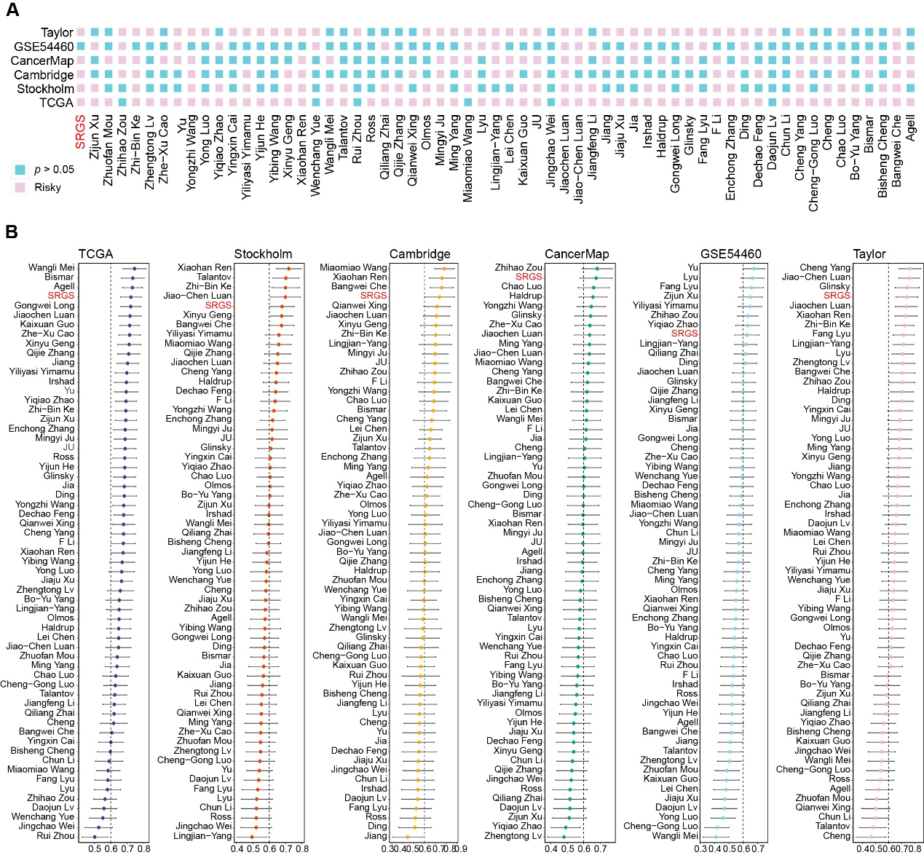
Figure S3. Comparison of prognostic models in prostate cancer cohorts
A. Univariate Cox regression analysis of SRGS and 60 published gene signatures in TCGA-PRAD, Stockholm, Cambridge, CancerMap, GSE54460, and Taylor.
B. C-index analysis comparing SRGS with 60 published gene signatures in TCGA-PRAD, Stockholm, Cambridge, CancerMap, GSE54460, Taylor. Data are presented as mean ± 95% CI.

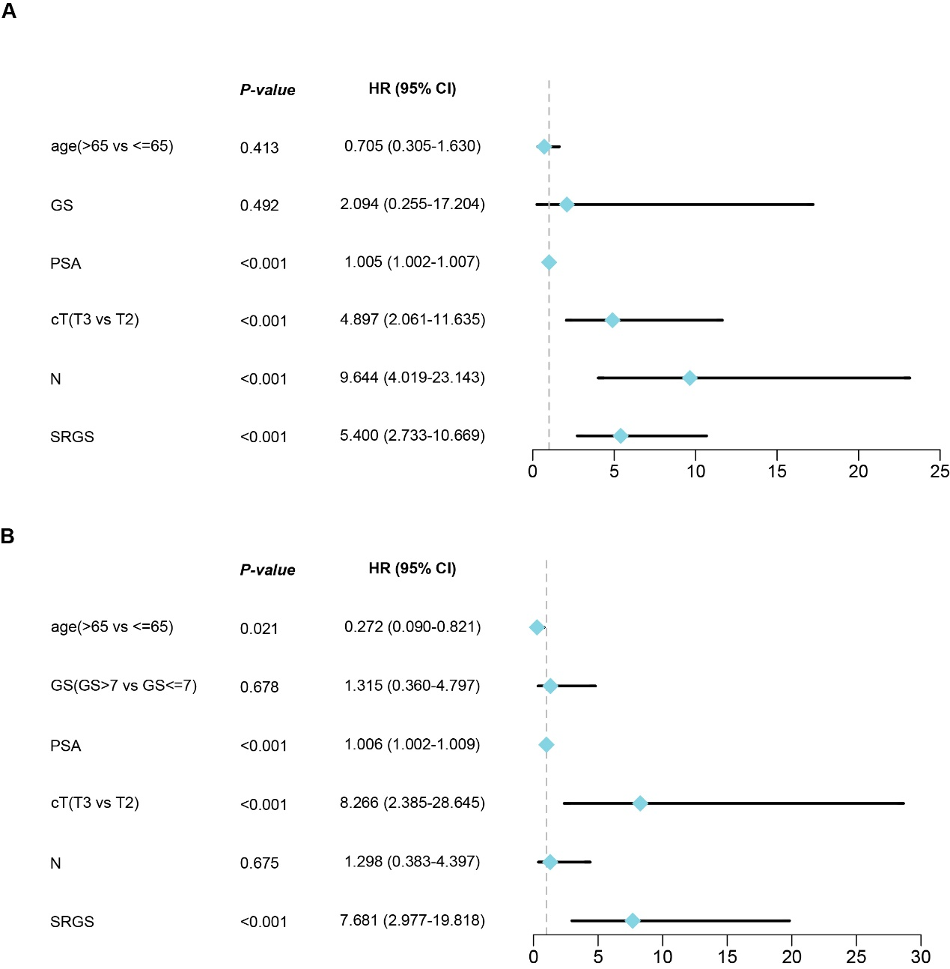
Figure S4. Validation of SRGS as an independent risk factor in SYSU-PRAD cohort
A. Results of the univariate Cox regression analysis in the SYSU-PRAD cohort (n = 90).
B. Results of the multivariate Cox regression analysis in the SYSU-PRAD cohort (n = 90).

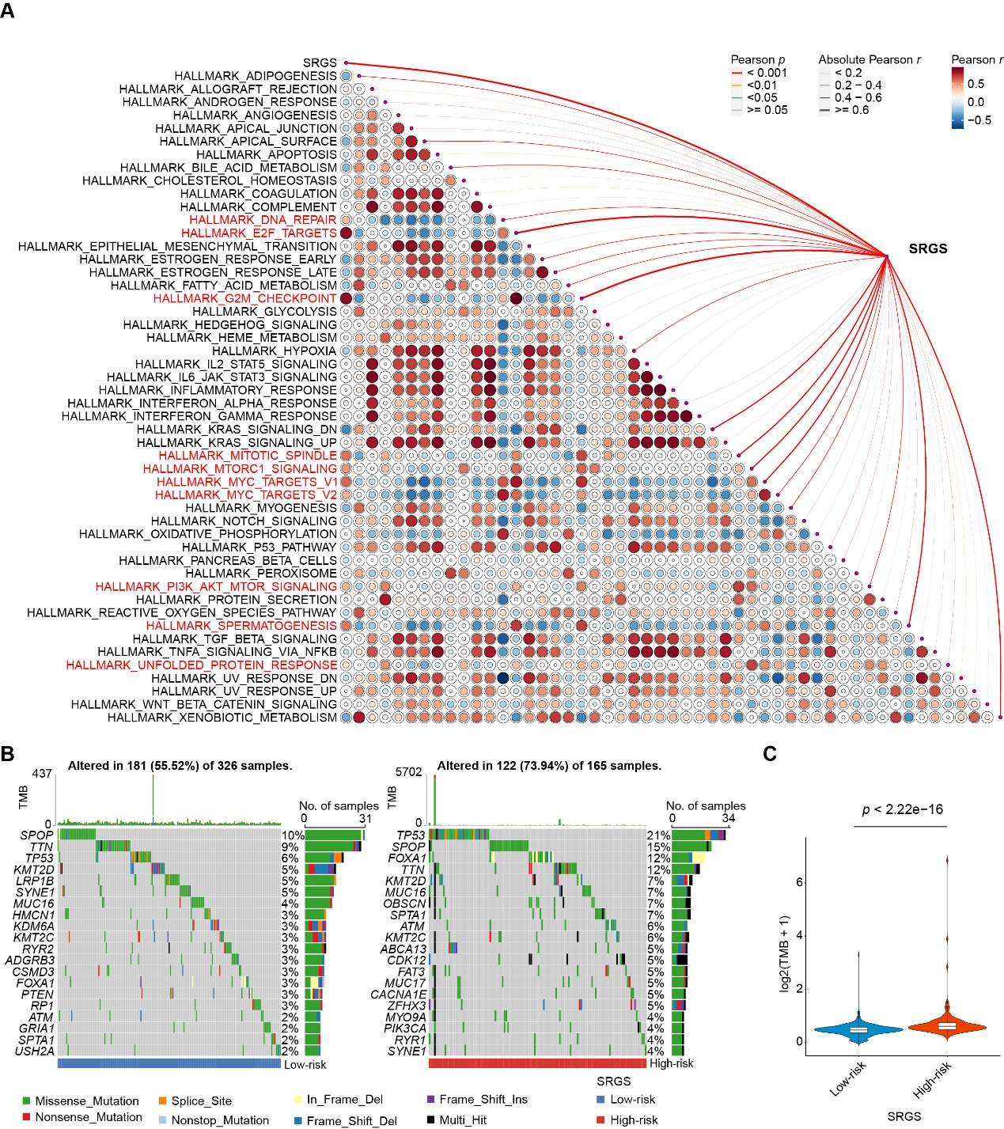
Figure S5. Exploration of potential mechanisms promoting tumor progression in TCGA-PRAD Cohort
A. Heatmap showing correlations between SRGS and 50 tumor-associated pathways in TCGA-PRAD cohort.
B. Genomic mutation profiles in TCGA-PRAD cohort based on SRGS group. Tumor mutational burden (TMB) in each tumor sample (top). Frequently mutated prostate cancer-associated genes and their occurrence in tumor samples (bottom). Mutation frequencies are represented by a bar plot.
C. Comparison of the overall TMB in TCGA-PRAD cohort based on SRGS group. Statistical test: two-sided unpaired Wilcoxon test.

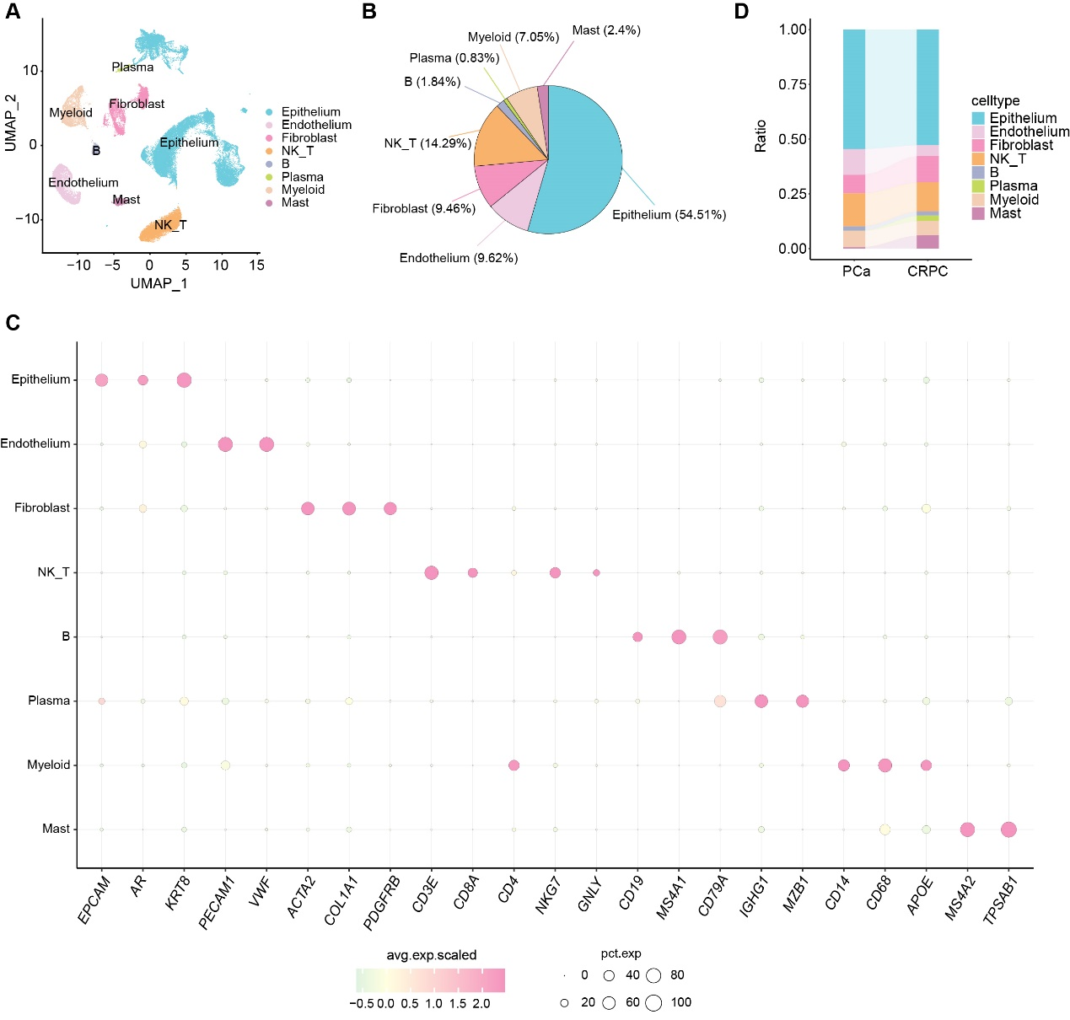
Figure S6. Single cell analysis of the prostate cancer tumor microenvironment
A. UMAP visualization of the prostate cancer tumor microenvironment, where each color represents a specific cell type.
B. Pie chart showing the proportions of different cellular types in prostate cancer.
C. Dot plot showing marker gene levels in various cell types in prostate cancer.
D. Stacked bar plots showing the composition of cell proportions in primary prostate cancer and CRPC.
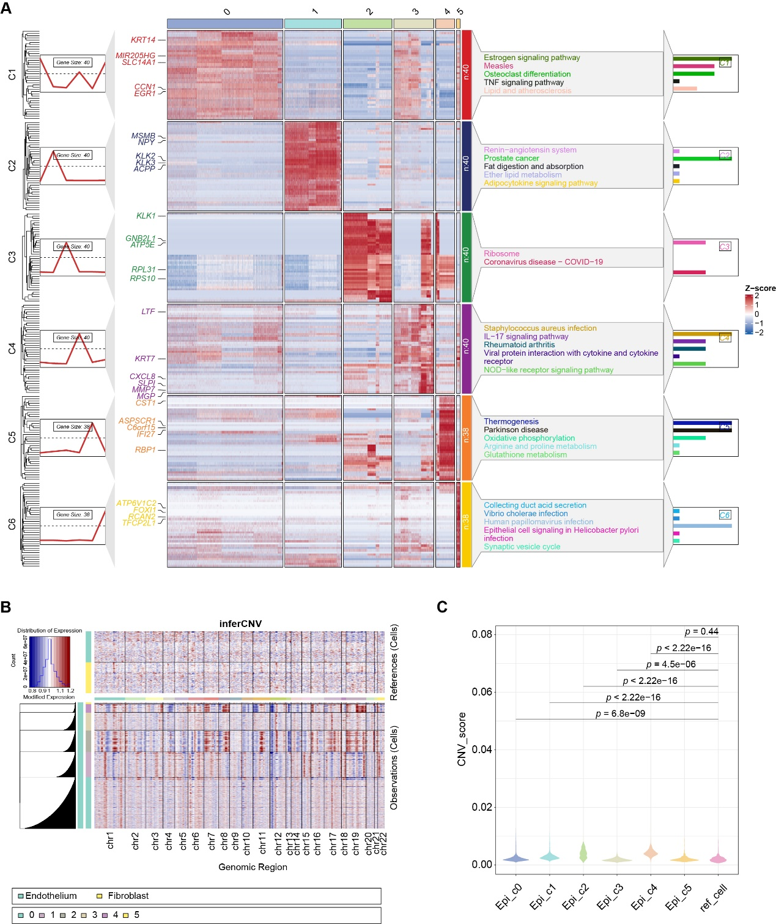
Figure S7. Analysis of epithelium subsets in prostate cancer
A. Heatmap showing the differential genes of various epithelial cell clusters in prostate cancer, with the top five enriched pathways for these differential genes.
B. CNV heatmap visualized using inferCNV analysis, highlighting the copy number variations across different epithelial cell clusters in prostate cancer.
C. CNV scores between epithelial cell subclusters and reference cells. Statistical test: two-sided unpaired Wilcoxon test.

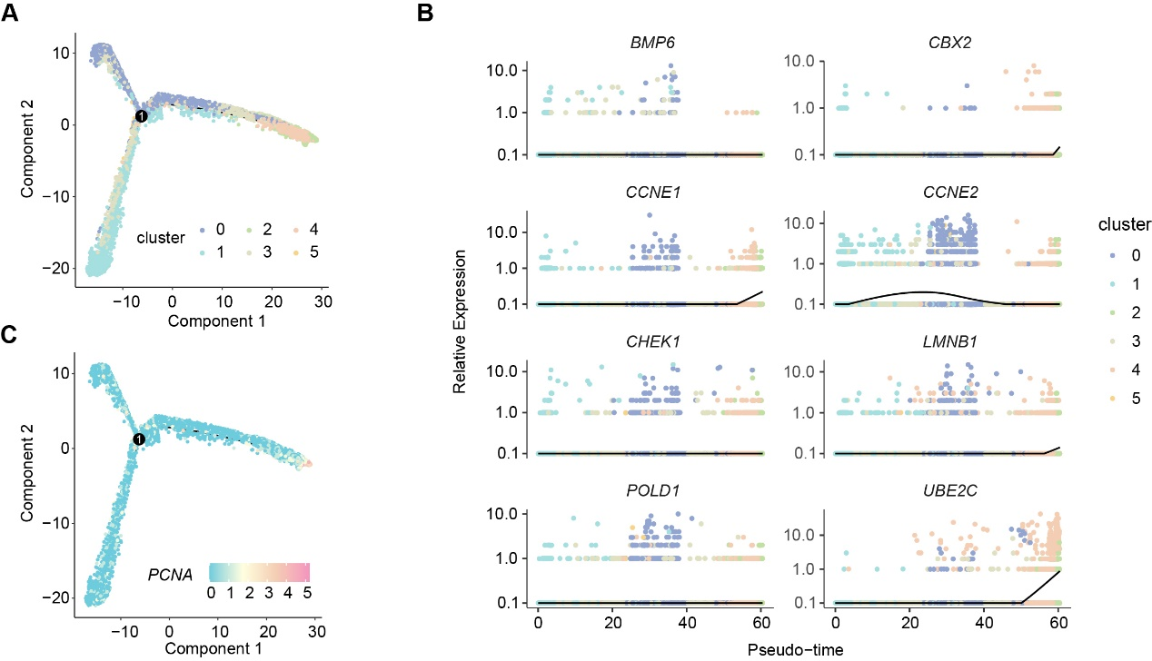
Figure S8. Pseudotime analysis of epithelium subsets in prostate cancer
A. Pseudotime cell trajectories analysis using Monocle 2, visualizing the dynamic changes within epithelial clusters during prostate cancer progression.
B. Expression changes of eight genes in SRGS during pseudotime progression.
C. The expression dynamics of PCNA along the pseudotime trajectory.

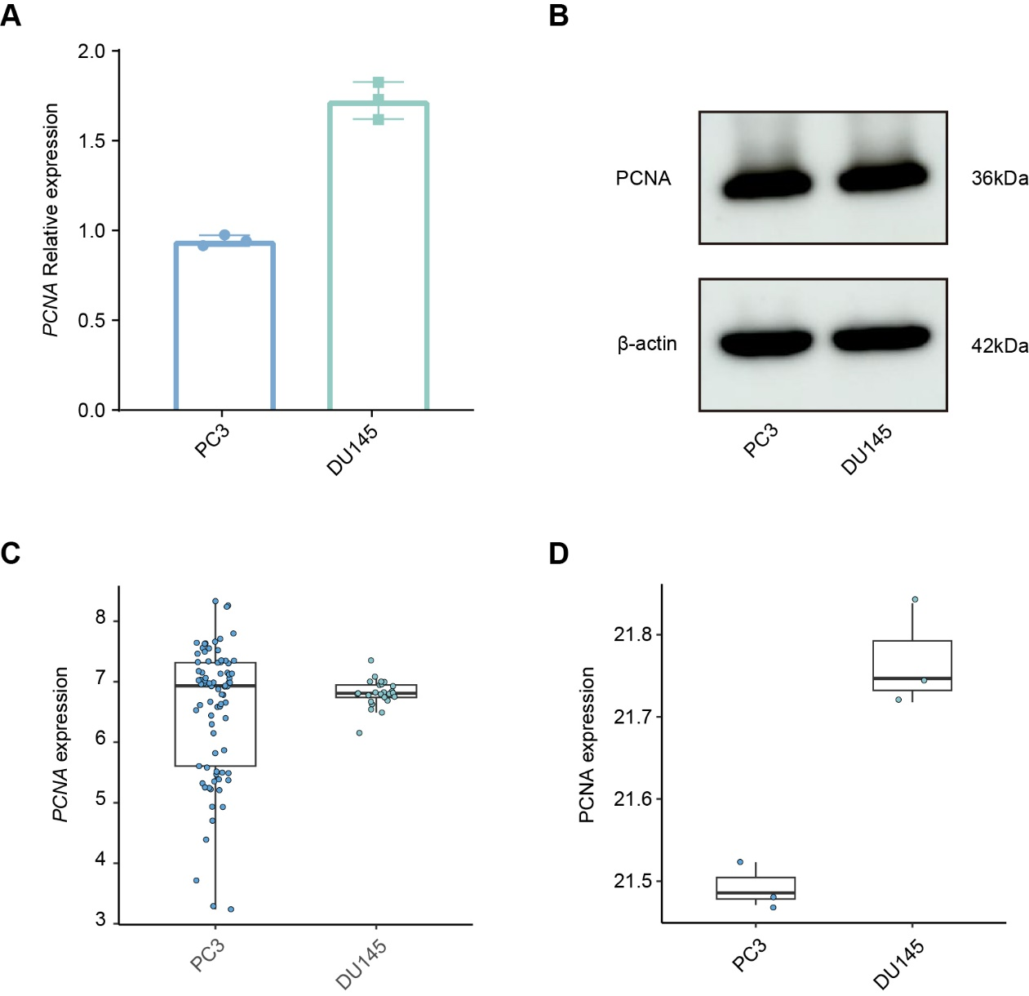
Figure S9. Expression levels of PCNA in PC3 and DU145 cells.
A. PCNA mRNA expression levels in PC3 and DU145 cells determined by RT–qPCR.
B. Protein expression levels of PCNA in PC3 and DU145 cells assessed by Western blot.
C. PCNA mRNA expression levels of PC3 and DU145 cells in the CTPC dataset.
D. PCNA protein expression levels in PC3 and DU145 cells based on the proteomic data reported by Ou et al.

