Supplementary Data

Table S1: Cross-table comparing patient demographic and primary tumour characteristics for patients at the time of diagnosis with an early (>90 days) or late (≤90 days) SNB for the post-2016 cohort (n=730)
Variable | N | Early SNB (≤90 days)  (N=384) |  | Late SNB (>90 days)  (N=346) |  | Test statistic
 |  |  |  |  |  |  | P-value
Age (yrs), median (IQR) | 730 | 63 | (53-71) | 65 | (55-72) | F_{1,728}=1.15 | 0.284¹
Breslow thickness (mm), median (IQR) | 729 | 1.9 | (1.3-3.0) | 2.1 | (1.2-3.6) | F_{1,727}=1.07 | 0.300¹
Reporting interval (days), median (IQR) | 730 | 13.0 | (8.0-17.6) | 12.0 | (9.0-17.0) | F_{1,728}=0.33 | 0.567¹
Sex : Male | 730 | 212 | (55.2) | 178 | (51.4) | X²₁=1.04 | 0.309²
Referral location : Peripheral hospital | 730 | 163 | (42.4) | 223 | (64.5) | X²₁=35.36 | <0.001²
Site  Head and neck  Lower extremity  Torso  Upper extremity | 730 | 60  86  155  83 | (15.6)  (22.4)  (40.4)  (21.6) | 48  86  134  78 | (13.9)  (24.9)  (38.7)  (22.5) | X²₃=1.04 | 0.792²
Subtype  Superficial spreading  Nodular  Lentigo  Acral lentiginous  Other | 730 | 274  63  15  9  23 | (71.4)  (16.4)  (3.9)  (2.3)  (6.0) | 245  65  12  3  21 | (70.8)  (18.8)  (3.5)  (0.9)  (6.1) | X²₄=3.11 | 0.540²
Lymphovascular invasion : Yes | 721 | 27 | (7.1) | 14 | (4.1) | X²₁=3.08 | 0.079²
Ulceration : Yes | 728 | 111 | (29.0) | 93 | (27.0) | X²₁=0.37 | 0.544²
T-stage²  IA  IB  IIA  IIB  IIC | 728 | 7  177  95  74  30 | (1.8)  (46.2)  (24.8)  (19.3)  (7.8) | 3  150  93  59  40 | (0.9)  (43.5)  (27.0)  (17.1)  (11.6) | X²₄=5.00 | 0.287²
SNB Performed : Yes | 730 | 341 | (88.8) | 303 | (87.6) | X²₁=0.26 | 0.607²
Values are n (%) unless otherwise indicated; N; number of non-missing values; SNB, sentinel lymph node biopsy; IQR, interquartile range.
1 Kruskal-Wallis 2 Pearson
2 American Joint Committee on Cancer (AJCC) Classification

Table S2: Cross-table comparing patient demographic and primary tumour characteristics for patients at the time of diagnosis with an early (>68 days) or late (≤68 days) SNB for the entire cohort (n=1625)
Variable | N | Early SNB (≤68 days)  (N=824) |  | Late SNB (>68 days)  (N=801) |  | Test statistic
 |  |  |  |  |  |  | P-value
Age (yrs), median (IQR) | 1625 | 63 | (52-71) | 65 | (54-72) | F_{1,1623}=3.58 | 0.059¹
Breslow thickness (mm), median (IQR) | 1622 | 1.8 | (1.2-2.9) | 1.8 | (1.2-3.2) | F_{1,1620}=1.82 | 0.178¹
Reporting interval (days), median (IQR) | 1625 | 8.0 | (5.4-14.0) | 11.0 | (7.0-15.0) | F_{1,1623}=45.20 | <0.001¹
Sex : Male | 1625 | 443 | (53.8) | 400 | (49.9) | X²₁=2.38 | 0.123²
Referral location : Peripheral hospital | 1625 | 358 | (43.4) | 515 | (64.3) | X²₁=71.01 | <0.001²
Year : Post-2016 | 1625 | 222 | (26.9) | 508 | (63.4) | X²₁=218.45 | <0.001
Site  Head and neck  Lower extremity  Torso  Upper extremity | 1625 | 119  201  330  174 | (14.4)  (24.4)  (40.0)  (21.1) | 127  202  299  173 | (15.9)  (25.2)  (37.3)  (21.6) | X²₃=1.47 | 0.690²
Subtype  Superficial spreading  Nodular  Lentigo  Acral lentiginous  Other | 1625 | 581  143  41  22  37 | (70.5)  (17.4)  (5.0)  (2.7)  (4.5) | 562  149  31  9  50 | (70.2)  (18.6)  (3.9)  (1.1)  (6.2) | X²₄=8.90 | 0.064²
Lymphovascular invasion : Yes | 1598 | 61 | (7.5) | 36 | (4.6) | X²₁=6.02 | 0.014²
Ulceration : Yes | 1621 | 210 | (25.5) | 209 | (26.2) | X²₁=0.10 | 0.757²
T-stage²  IA  IB  IIA  IIB  IIC | 1620 | 22  416  186  131  67 | (2.7)  (50.6)  (22.6)  (15.9)  (8.2) | 23  372  194  128  81 | (2.9)  (46.6)  (24.3)  (16.0)  (10.2) | X²₄=3.65 | 0.455²
SNB Performed : Yes | 1625 | 781 | (94.8) | 729 | (91.0) | X²₁=8.78 | 0.003²
Values are n (%) unless otherwise indicated; N; number of non-missing values; SNB, sentinel lymph node biopsy; IQR, interquartile range.
1 Kruskal-Wallis 2 Pearson
2 American Joint Committee on Cancer (AJCC) Classification

Table S3: Cross-table comparing patient demographic and primary tumour characteristics for patients at the time of diagnosis with an early (>68 days) or late (≤68 days) SNB for the post-2016 cohort (n=730)
Variable | N | Early SNB (≤68 days)  (N=222) |  | Late SNB (>68 days)  (N=508) |  | Test statistic
 |  |  |  |  |  |  | P-value
Age (yrs), median (IQR) | 730 | 62.5 | (51.9-71.0) | 64 | (54.0-72.0) | F_{1,728}=1.52 | 0.218¹
Breslow thickness (mm), median (IQR) | 729 | 1.9 | (1.3-2.8) | 2.1 | (1.2-3.5) | F_{1,727}=1.22 | 0.269¹
Reporting interval (days), median (IQR) | 730 | 12.0 | (8.0-17.1) | 13.0 | (9.0-17.0) | F_{1,728}=1.12 | 0.289¹
Sex : Male | 730 | 131 | (59.0) | 259 | (51.0) | X²₁=4.00 | 0.046²
Referral location : Peripheral hospital | 730 | 71 | (32.0) | 315 | (62.0) | X²₁=55.90 | <0.001²
Site  Head and neck  Lower extremity  Torso  Upper extremity | 730 | 36  44  92  50 | (16.2)  (19.8)  (41.4)  (22.5) | 72  128  197  111 | (14.2)  (25.2)  (38.8)  (21.9) | X²₃=2.64 | 0.451²
Subtype  Superficial spreading  Nodular  Lentigo  Acral lentiginous  Other | 730 | 152  39  12  7  12 | (68.5)  (17.6)  (5.4)  (3.2)  (5.4) | 367  89  15  5  32 | (72.2)  (17.5)  (3.0)  (1.0)  (6.3) | X²₄=7.45 | 0.114²
Lymphovascular invasion : Yes | 721 | 17 | (7.8) | 24 | (4.8) | X²₁=2.60 | 0.107²
Ulceration : Yes | 728 | 64 | (28.8) | 140 | (27.7) | X²₁=0.10 | 0.748²
T-stage  IA  IB  IIA  IIB  IIC | 728 | 2  107  58  40  15 | (0.9)  (48.2)  (26.1)  (18.0)  (6.8) | 8  220  130  93  55 | (1.6)  (43.5)  (25.7)  (18.4)  (10.9) | X²₄=4.02 | 0.403²
SNB Performed : Yes | 730 | 195 | (87.8) | 449 | (88.4) | X²₁=0.04 | 0.833²
Values are n (%) unless otherwise indicated; N; number of non-missing values; SNB, sentinel lymph node biopsy; IQR, interquartile range.
1 Kruskal-Wallis 2 Pearson

Table S4: Table summarising patients who did not receive SNB (n=115)
Variable | Early SNB (≤90 days)  (N=67) |  | Late SNB (>90 days)  (N=48) |  | Total  (N=115)
Reason for not performing SNB, N (%)  Technical¹  Patient factors²  Progression³  Unknown | 48  15  4  0 | (71.6%)  (22.4%)  (6.0%)  (0.0%) | 29  11  7  1 | (60.4%)  (22.9%)  (14.6%)  (2.1%) | 77  26  11  1 | (60.9%)  (22.6%)  (9.6%)  (0.9%)
Total | 67 | (58.3%) | 48 | (41.7%) | 115 | (100.0%)
SNB, sentinel lymph node biopsy; IQR, interquartile range.
1 Failure of mapping e.g., failure to migrate or too many nodes were identified.
2 Failed attendance to appointment or allergic reaction to tracer agent.
3 Clinical and/or radiological metastatic disease after primary diagnosis and prior to or at the time of lymphoscintigraphy.

Figures
Figure S1: Odds ratio plot for early (≤90 days) and late (>90 days) SNB adjusted for age, Breslow thickness, sex, ulceration and progression for the entire cohort (N=1625)
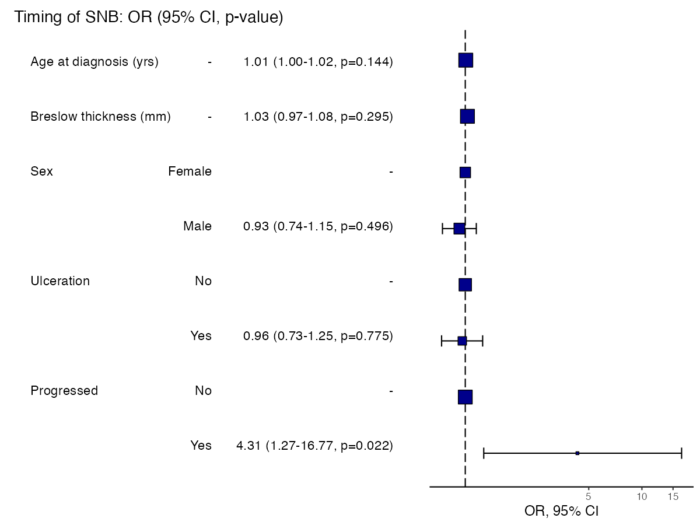
SNB, sentinel lymph node biopsy; OR, odds ratio; 95% CI, 95% confidence interval
Figure S2: Odds ratio plot for melanoma progression before or at SNB adjusted for age, Breslow thickness, sex, ulceration and diagnosis-to-SNB (N=1625)
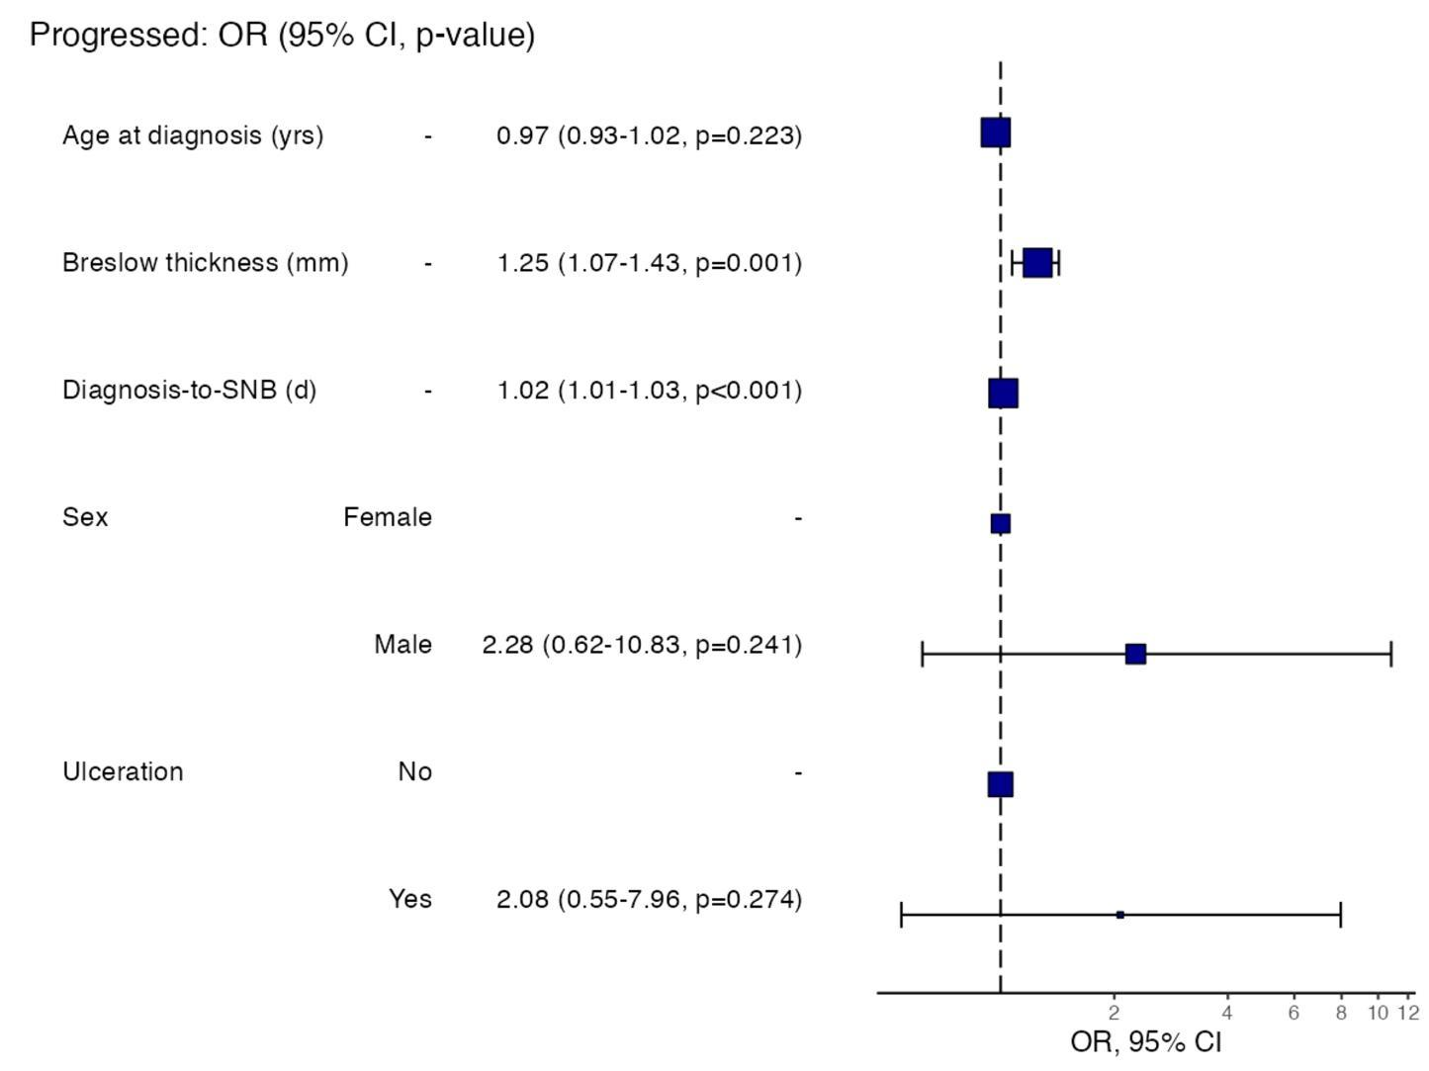
SNB, sentinel lymph node biopsy; OR, odds ratio; 95% CI, 95% confidence interval

Figure S3: Odds ratio plot for early (≤90 days) and late (>90 days) SNB adjusted for age, Breslow thickness, SNB deposit size, sex and ulceration (N=286)
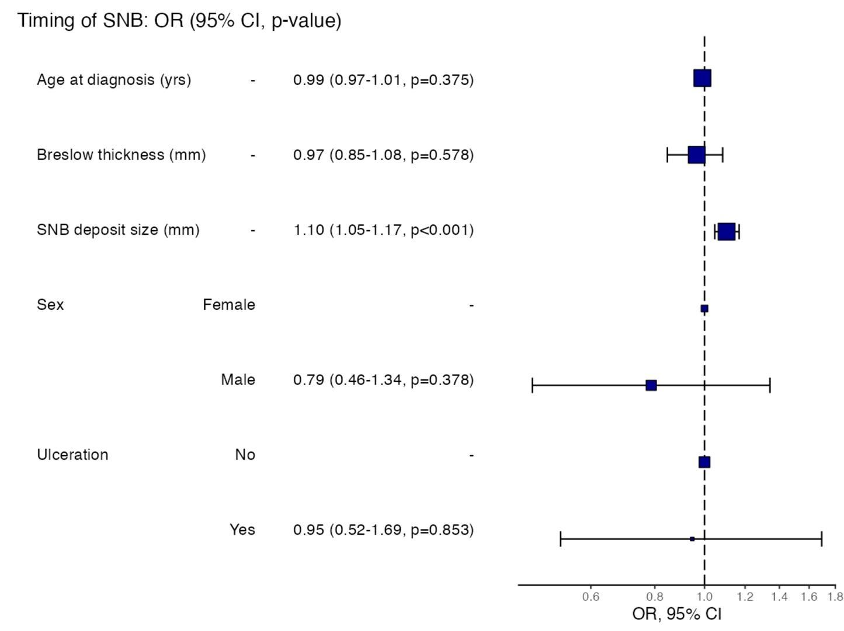
SNB, sentinel lymph node biopsy; OR, odds ratio; 95% CI, 95% confidence interval

Figure S4: Odds ratio plot for early (≤90 days) and late (>90 days) SNB adjusted for age, Breslow thickness, sex, ulceration and high (>1mm) and low (≤1mm) risk deposit (N=286)
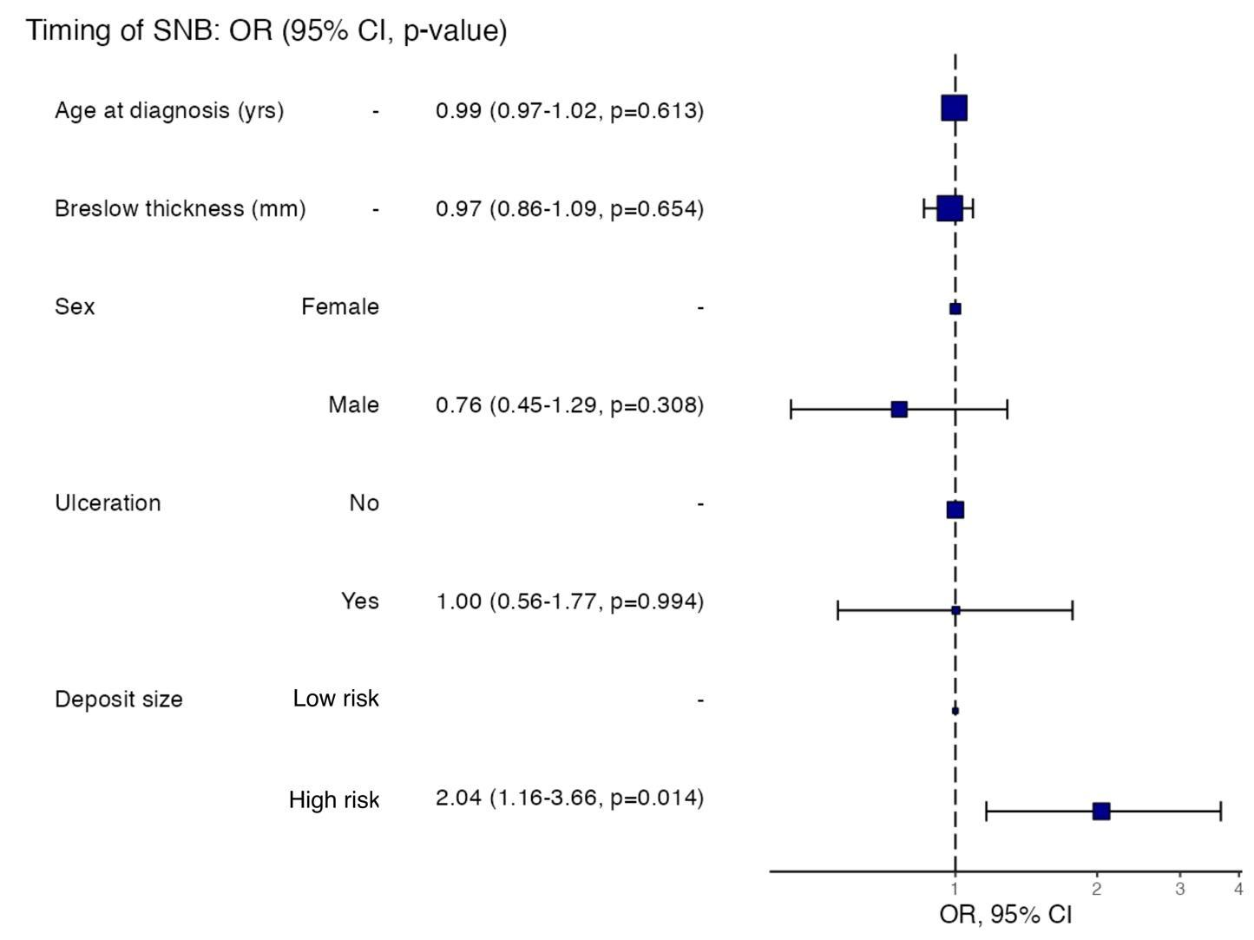
SNB, sentinel lymph node biopsy; OR, odds ratio; 95% CI, 95% confidence interval

Figure S5: Odds ratio plot for early (≤68 days) and late (>68 days) SNB adjusted for age at diagnosis, Breslow thickness, SNB deposit size, sex and ulceration (N=286).
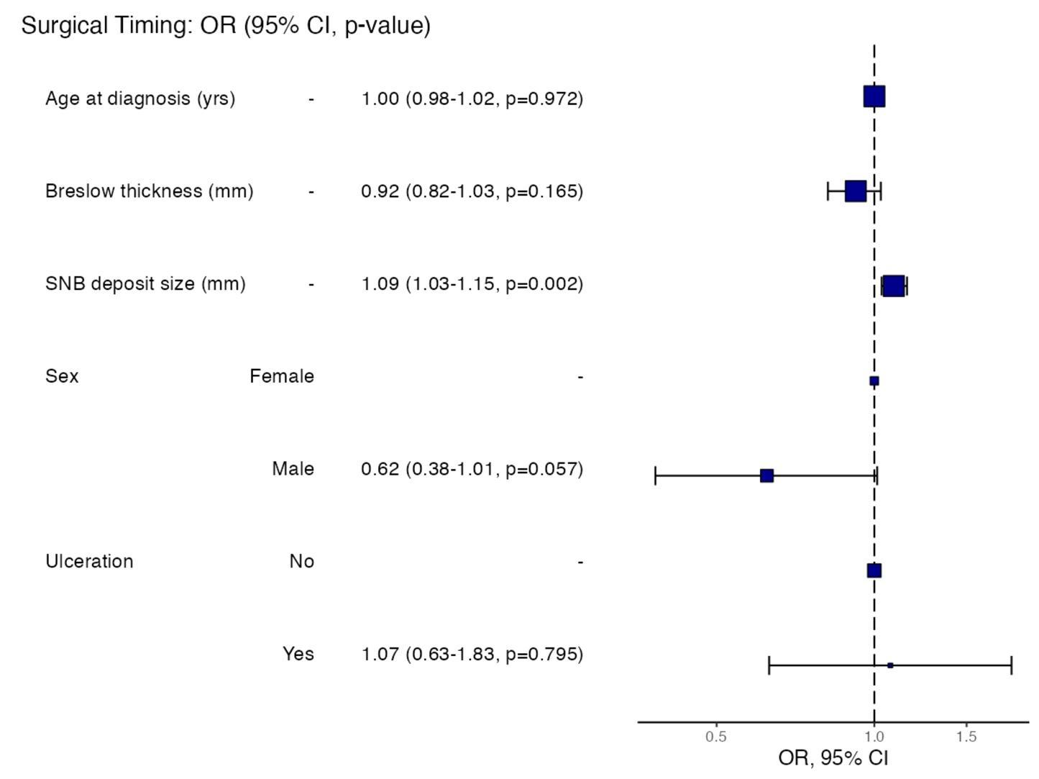
SNB, sentinel lymph node biopsy; OR, odds ratio; 95% CI, 95% confidence interval

Figure S6: Odds ratio plot for early (≤68 days) and late (>68 days) SNB adjusted for age at diagnosis, Breslow thickness, sex, ulceration and high (>1mm) and low (≤1mm)-risk deposit (N=286).
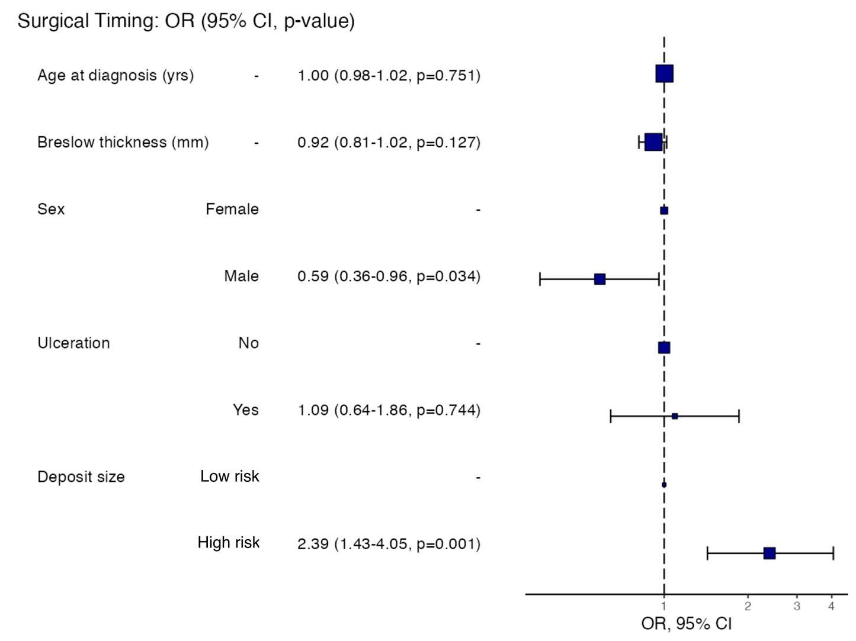
SNB, sentinel lymph node biopsy; OR, odds ratio; 95% CI, 95% confidence interval

