Appendices
Appendix 1
Further participant demographics
 | All participants | GPs | Patients | Public
Participant group
Patients |  |  | 425
History of skin cancer |  |  | 86 (20%)
Seen HCP about a skin lesion in last 5 years |  |  | 339 (80%)
Members of the public |  |  |  | 1577
GPs |  | 300
GP partner |  | 90 (30%)
Salaried GP |  | 121 (40%)
Locum GP |  | 33 (11%)
GP with an extended role in dermatology |  | 20 (7%)
GP trainee |  | 36 (12%)
Geographical location
England | 1954 (85%) | 270 (90%) | 366 (86%) | 1318 (84%)
East Midlands | 178 | 26 | 33 | 119
East of England | 217 | 24 | 53 | 140
London | 308 | 41 | 49 | 218
Northeast England | 90 | 15 | 22 | 53
Northwest England | 248 | 45 | 35 | 168
Southeast England | 323 | 36 | 64 | 223
Southwest England | 206 | 20 | 48 | 138
West Midlands | 198 | 38 | 32 | 128
Yorkshire & the Humber | 186 | 25 | 30 | 131
Northern Ireland | 47 (2%) | 6 (2%) | 10 (2%) | 31 (2%)
Scotland | 197 (9%) | 16 (5%) | 34 (8%) | 147 (9%)
Wales | 104 (5%) | 8 (3%) | 15 (4%) | 81 (5%)
Ethnicity
African | 59 (3%) | 17 (6%) | 8 (2%) | 34 (2%)
Any other Asian background | 33 (1%) | 8 (3%) | 2 (0.5%) | 23 (2%)
Any other Black / African / Caribbean background | 11 (0.5%) | 7 (2%) | 1 (0.2%) | 3 (0.2%)
Any other Mixed / Multiple ethnic background | 27 (1%) | 8 (3%) | 5 (1%) | 14 (0.9%)
Any other White background | 107 (5%) | 14 (5%) | 26 (6%) | 67 (4%)
Any other ethnic group | 19 (0.8%) | 3 (1%) | 3 (0.7%) | 13 (0.8%)
Arab | 10 (0.4%) | 8 (3%) | 0 | 2 (0.1%)
Bangladeshi | 13 (0.6%) | 3 (1%) | 0 | 10 (0.6%)
Caribbean | 11 (0.5%) | 2 (0.7%) | 2 (0.5%) | 7 (0.4%)
Chinese | 39 (2%) | 11 (4%) | 2 (0.5%) | 26 (2%)
White English / Welsh / Scottish / Northern Irish / British | 1721 (75%) | 121 (40%) | 354 (83%) | 1246 (79%)
Gypsy or Irish Traveller | 2 (0.1%) | 0 | 1 (0.2%) | 1 (0.1%)
Indian | 74 (3%) | 35 (12%) | 5 (1%) | 34 (2%)
Irish | 29 (1%) | 6 (2%) | 5 (1%) | 18 (1%)
Pakistani | 38 (2%) | 18 (6%) | 2 (0.5%) | 18 (1%)
Prefer not to say | 28 (1%) | 28 (9%) | 0 | 0
White and Asian | 30 (1%) | 6 (2%) | 3 (0.7%) | 21 (1%)
White and Black African | 33 (1%) | 4 (1%) | 3 (0.7%) | 26 (2%)
White and Black Caribbean | 18 (0.8%) | 1 (0.3%) | 3 (0.7%) | 14 (0.9%)

Experience of skin cancer, self-assessed risk of developing skin cancer, and attitude to the use of AI technologies
 | All participants | GPs | Patients | Public
Perceived risk of developing skin cancer in the next 10 years, compared to other people of your age
Much lower | 148 (7%) |  | 18 (4%) | 130 (8%)
A bit lower | 281 (14%) |  | 49 (12%) | 232 (15%)
About the same | 1048 (52%) |  | 184 (43%) | 864 (55%)
A bit higher | 290 (15%) |  | 116 (27%) | 174 (11%)
Much higher | 69 (3%) |  | 36 (9%) | 33 (2%)
Prefer not to say | 111 (6%) |  | 19 (5%) | 92 (6%)
No response | 55 (3%) |  | 3 (0.7%) | 52 (3%)
How supportive are you of using AI technologies to help assess skin lesions and diagnose skin cancer where the AI technology is used by a healthcare professional in a GP surgery
Strongly disapprove | 68 (3%) | 1 (0.3%) | 21 (5%) | 46 (3%)
Disapprove | 128 (6%) | 7 (2%) | 35 (8%) | 86 (6%)
Neutral | 435 (19%) | 56 (19%) | 73 (17%) | 306 (19%)
Approve | 990 (43%) | 166 (55%) | 175 (41%) | 649 (41%)
Strongly Approve | 681 (30%) | 70 (23%) | 121 (29%) | 490 (31%)
How supportive are you of using AI technologies to help assess skin lesions and diagnose skin cancer where the AI technology is used by patients on a smartphone, and if the AI thinks it might be a skin cancer then patients will be advised to see a GP
Strongly disapprove | 131 (6%) | 9 (3%) | 37 (9%) | 85 (5%)
Disapprove | 305 (13%) | 39 (13%) | 64 (15%) | 202 (13%)
Neutral | 551 (24%) | 55 (18%) | 103 (24%) | 393 (25%)
Approve | 877 (38%) | 151 (50%) | 139 (33%) | 587 (37%)
Strongly Approve | 438 (19%) | 46 (15%) | 82 (19%) | 310 (20%)
Skin cancer diagnosis in a family member or close friend
Yes | 516 (26%) |  | 157 (37%) | 359 (23%)
No | 1408 (70%) |  | 251 (59%) | 1157 (73%)
"Don't know" | 78 (4%) |  | 17 (4%) | 61 (4%)

Patient reported experience of routes to diagnosis
 | All patients | Melanoma diagnosis | NMSC diagnosis | Any skin cancer diagnosis | Benign skin lesion diagnosis
What was the diagnosis of your skin lesion? (multiple responses possible)
Melanoma | 22 | 22 |  | 22
Squamous Cell Carcinoma | 15 |  | 15 | 15
Basal Cell Carcinoma | 33 |  | 33 | 33
Pre-cancerous lesion | 34 |  | 34 | 34
Benign mole | 218 |  |  |  | 218
Don't know | 49
Prefer not to say | 13
Other (multiple responses, all n<4) | 76 |  |  |  | 76
Roughly how long did it take from the first time you noticed the skin lesion to seeing a HCP?
Straight away | 16 (4%) | 2 | 3 | 4 | 11
Within a week | 70 (16%) | 3 | 8 | 10 | 50
1 week to 1 month | 117 (28%) | 7 | 25 | 27 | 75
2 to 3 months | 71 (17%) | 2 | 12 | 13 | 48
4 to 6 months | 37 (9%) | 2 | 9 | 10 | 19
7 to 12 months | 20 (5%) | 1 | 4 | 4 | 15
Over 12 months | 48 (11%) | 2 | 7 | 9 | 35
Can't remember | 46 (11%) | 3 | 8 | 9 | 24
Did you do any of the following before deciding to see a HCP? (multiple responses possible)
Search the internet | 193 | 8 | 25 | 26 | 137
Speak to family of friends | 178 | 9 | 23 | 29 | 131
Use a mobile phone app to look at the skin lesion | 43 | 3 | 9 | 11 | 26
Use another piece of technology to look at the skin lesion | 12 | 1 | 5 | 5 | 7
Can't remember | 26 | 1 | 5 | 5 | 15
None of the above | 123 | 7 | 29 | 32 | 70
Other (multiple responses, all n=1) | 71 | 4 | 17 | 19 | 52
How many times did you see a healthcare professional in total (in the GP surgery and in hospital) before a diagnosis was made?
1 appointment | 240 (56%) | 3 | 24 | 26 | 185
2-3 appointments | 154 (36%) | 13 | 40 | 46 | 83
4-5 appointments | 14 (3%) | 3 | 9 | 9 | 3
6 or more appointments | 3 (1%) | 1 | 2 | 3 | 0
Can't remember | 14 (3%) | 2 | 1 | 2 | 6
How long did it take from first seeing a HCP to getting a diagnosis (either from the GP or the hospital doctor)?
Straight away | 181 (43%) | 6 | 14 | 17 | 142
Within a week | 52 (12%) | 1 | 9 | 10 | 35
1 week to 1 month | 97 (23%) | 7 | 34 | 37 | 47
2 to 3 months | 37 (9%) | 2 | 12 | 12 | 21
4 to 6 months | 13 (3%) | 2 | 1 | 3 | 9
7 to 12 months | 7 (2%) | 1 | 1 | 1 | 4
Over 12 months | 6 (1%) | 1 | 3 | 3 | 2
Can't remember | 32 (8%) | 2 | 2 | 3 | 17

GP specific questions
 | Number
Confidence in the diagnosis and management of suspicious skin lesions
1 (least confident) | 0
2 | 13 (4%)
3 | 117 (39%)
4 | 136 (45%)
5 (most confident) | 34 (11%)
Postgraduate dermatological courses or qualifications
Yes | 77 (26%)
No | 223 (74%)
Work as a GP with extended role in dermatology (GPwER or GPwSI)
Yes | 55 (18%)
No | 245 (82%)

Appendix 2: Simple ranking exercise - full results including the attributes selected as 2nd to 6th most important by participants
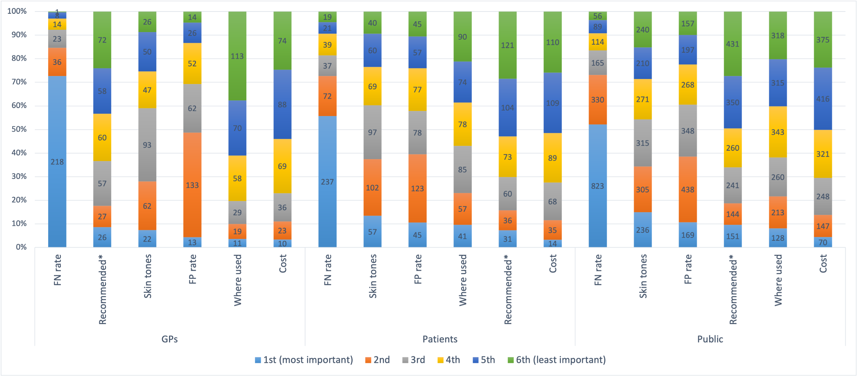
Simple ranking exercise results for GPs (n = 300), patients (n = 425), and public (n = 1577)
FN rate = False Negative rate
* = recommended for use with patients in local/national guidelines
FP rate = False Positive rate

Appendix 3a: Regression analysis by participant group
GP participants (N=300)
Choice | Attribute notes | Coefficient | std. err. | z | P>|z| | [95% conf. interval] |  | MRS | Relative importance
False negatives | Continuous | -0.062 | 0.0038 | -16.12 | 0 | -0.069 | -0.054 | -7.2 | -2.2
False positives | Continuous | -0.016 | 0.0024 | -6.86 | 0 | -0.021 | -0.012 | -1.9 | -0.59
Cost | Continuous | -0.0086 | 0.0013 | -6.69 | 0 | -0.011 | -0.0061 | -1 | -0.52
Where used | At home = 1, GP surgery = 2 | 0.13 | 0.055 | 2.36 | 0.018 | 0.022 | 0.24 | 15 | 0.13
Skin colour | All skin colours = 1, white skin only =2 | -0.68 | 0.054 | -12.65 | 0 | -0.78 | -0.57 | -79 | -0.68
Recommended in guidelines | recommended = 2, not recommended = 1 | 0.45 | 0.061 | 7.32 | 0 | 0.33 | 0.56 | 52 | 0.45
Patient participants (N=425)
Choice | Attribute notes | Coefficient | std. err. | z | P>|z| | [95% conf. interval] |  | MRS | Relative importance
False negatives | Continuous | -0.047 | 0.0026 | -18 | 0 | -0.052 | -0.042 | -7.4 | -1.7
False positives | Continuous | -0.014 | 0.0021 | -6.6 | 0 | -0.018 | -0.0096 | -2.2 | -0.49
Cost | Continuous | -0.0063 | 0.001 | -6.2 | 0 | -0.0083 | -0.0043 | -1 | -0.38
Where used | At home = 1, GP surgery = 2 | 0.26 | 0.045 | 5.8 | 0 | 0.17 | 0.35 | 41 | 0.26
Skin colour | All skin colours = 1, white skin only =2 | -0.74 | 0.053 | -14 | 0 | -0.84 | -0.63 | -116 | -0.74
Recommended in guidelines | recommended = 2, not recommended = 1 | 0.29 | 0.044 | 6.6 | 0 | 0.2 | 0.38 | 46 | 0.29
Public participants (N=1577)
Choice | Attribute notes | Coefficient | std. err. | z | P>|z| | [95% conf. interval] |  | MRS | Relative importance
False negatives | Continuous | -0.037 | 0.0013 | -29 | 0 | -0.04 | -0.035 | -6.3 | -1.3
False positives | Continuous | -0.015 | 0.001 | -15 | 0 | -0.017 | -0.013 | -2.6 | -0.55
Cost | Continuous | -0.0058 | 0.00049 | -12 | 0 | -0.0068 | -0.0049 | -1 | -0.35
Where used | At home = 1, GP surgery = 2 | 0.17 | 0.023 | 7.4 | 0 | 0.13 | 0.22 | 29 | 0.17
Skin colour | All skin colours = 1, white skin only =2 | -0.7 | 0.026 | -27 | 0 | -0.75 | -0.65 | -120 | -0.7
Recommended in guidelines | recommended = 2, not recommended = 1 | 0.35 | 0.023 | 15 | 0 | 0.3 | 0.39 | 59 | 0.35

Appendix 3b: Regression analysis for further subgroup analysis by age, skin tone, patients split by diagnosis, public split by whether they reported a history of skin cancer in a family member or close friend, and supportiveness for GPs and patients using AI technologies
GPs under 55 years (N=271)
Choice | Attribute notes | Coefficient | std. err. | z | P>|z| | [95% confidence interval]
False negatives¹ | Continuous | -0.0632191 | 0.0041427 | -15.26 | <0.0001 | -0.0713387 | -0.0550996
False positives² | Continuous | -0.0166899 | 0.002533 | -6.59 | <0.0001 | -0.0216544 | -0.0117254
Cost³ | Continuous | -0.0087485 | 0.0013813 | -6.33 | <0.0001 | -0.0114558 | -0.0060413
Where used⁴ | At home = 1  GP surgery = 2 | 0.1103357 | 0.0576885 | 1.91 | 0.056 | -0.0027317 | 0.2234032
Skin tones⁵ | All skin tones = 1  White skin only = 2 | -0.6953462 | 0.0576892 | -12.05 | <0.0001 | -0.8084149 | -0.5822776
Recommended in guidelines⁶ | Recommended = 2  Not recommended = 1 | 0.4505559 | 0.0632172 | 7.13 | <0.0001 | 0.3266525 | 0.5744592
GPs 55 years and over (N=29)
Choice | Attribute notes | Coefficient | std. err. | z | P>|z| | [95% confidence interval]
False negatives¹ | Continuous | -0.0499736 | 0.0100934 | -4.95 | <0.0001 | -0.0697563 | -0.0301909
False positives² | Continuous | -0.0139661 | 0.0073597 | -1.9 | 0.058 | -0.0283909 | 0.0004587
Cost³ | Continuous | -0.0076516 | 0.0037295 | -2.05 | 0.04 | -0.0149613 | -0.0003419
Where used⁴ | At home = 1  GP surgery = 2 | 0.2826525 | 0.1821729 | 1.55 | 0.121 | -0.0743999 | 0.6397049
Skin tones⁵ | All skin tones = 1  White skin only = 2 | -0.5540786 | 0.1517209 | -3.65 | <0.0001 | -0.8514461 | -0.2567111
Recommended in guidelines⁶ | Recommended = 2  Not recommended = 1 | 0.4097415 | 0.2144262 | 1.91 | 0.056 | -0.0105261 | 0.8300092
Patients under 55 years (N=214)
Choice | Attribute notes | Coefficient | std. err. | z | P>|z| | [95% confidence interval]
False negatives¹ | Continuous | -0.0484832 | 0.0037642 | -12.88 | <0.0001 | -0.0558608 | -0.0411056
False positives² | Continuous | -0.0117413 | 0.003058 | -3.84 | <0.0001 | -0.0177348 | -0.0057477
Cost³ | Continuous | -0.0071482 | 0.0014698 | -4.86 | <0.0001 | -0.010029 | -0.0042675
Where used⁴ | At home = 1  GP surgery = 2 | 0.1818425 | 0.062205 | 2.92 | 0.003 | 0.059923 | 0.303762
Skin tones⁵ | All skin tones = 1  White skin only = 2 | -0.750542 | 0.0738597 | -10.16 | <0.0001 | -0.8953043 | -0.6057797
Recommended in guidelines⁶ | Recommended = 2  Not recommended = 1 | 0.3058938 | 0.0621449 | 4.92 | <0.0001 | 0.184092 | 0.4276956
Patients 55 years and over (N=212)
Choice | Attribute notes | Coefficient | std. err. | z | P>|z| | [95% confidence interval]
False negatives¹ | Continuous | -0.044865 | 0.003556 | -12.62 | <0.0001 | -0.0518347 | -0.0378953
False positives² | Continuous | -0.0157449 | 0.0028809 | -5.47 | <0.0001 | -0.0213914 | -0.0100985
Cost³ | Continuous | -0.0055931 | 0.0014216 | -3.93 | <0.0001 | -0.0083793 | -0.0028068
Where used⁴ | At home = 1  GP surgery = 2 | 0.3399525 | 0.065738 | 5.17 | <0.0001 | 0.2111085 | 0.4687966
Skin tones⁵ | All skin tones = 1  White skin only = 2 | -0.7266 | 0.0756561 | -9.6 | <0.0001 | -0.8748832 | -0.5783169
Recommended in guidelines⁶ | Recommended = 2  Not recommended = 1 | 0.2763862 | 0.0623481 | 4.43 | <0.0001 | 0.1541862 | 0.3985863
Public under 55 years (N=977)
Choice | Attribute notes | Coefficient | std. err. | z | P>|z| | [95% confidence interval]
False negatives¹ | Continuous | -0.0345599 | 0.0016343 | -21.15 | <0.0001 | -0.037763 | -0.0313567
False positives² | Continuous | -0.0157253 | 0.0012693 | -12.39 | <0.0001 | -0.018213 | -0.0132376
Cost³ | Continuous | -0.005898 | 0.0005938 | -9.93 | <0.0001 | -0.0070618 | -0.0047342
Where used⁴ | At home = 1  GP surgery = 2 | 0.0947606 | 0.0286932 | 3.3 | 0.001 | 0.038523 | 0.1509983
Skin tones⁵ | All skin tones = 1  White skin only = 2 | -0.727047 | 0.0338917 | -21.45 | <0.0001 | -0.7934736 | -0.6606204
Recommended in guidelines⁶ | Recommended = 2  Not recommended = 1 | 0.3091757 | 0.0291259 | 10.62 | <0.0001 | 0.25209 | 0.3662614
Public 55 years and over (N=599)
Choice | Attribute notes | Coefficient | std. err. | z | P>|z| | [95% confidence interval]
False negatives¹ | Continuous | -0.0415587 | 0.0020198 | -20.58 | <0.0001 | -0.0455174 | -0.0376
False positives² | Continuous | -0.0149755 | 0.0017866 | -8.38 | <0.0001 | -0.0184772 | -0.0114738
Cost³ | Continuous | -0.0058725 | 0.0008462 | -6.94 | <0.0001 | -0.007531 | -0.004214
Where used⁴ | At home = 1  GP surgery = 2 | 0.2996323 | 0.0383947 | 7.8 | <0.0001 | 0.2243801 | 0.3748845
Skin tones⁵ | All skin tones = 1  White skin only = 2 | -0.6660753 | 0.0413588 | -16.1 | <0.0001 | -0.7471371 | -0.5850135
Recommended in guidelines⁶ | Recommended = 2  Not recommended = 1 | 0.4153396 | 0.0372653 | 11.15 | <0.0001 | 0.342301 | 0.4883781
GPs with white skin tones (N=141)
Choice | Attribute notes | Coefficient | std. err. | z | P>|z| | [95% confidence interval]
False negatives¹ | Continuous | -0.0781945 | 0.0062997 | -12.41 | <0.0001 | -0.0905416 | -0.0658474
False positives² | Continuous | -0.0158799 | 0.003916 | -4.06 | <0.0001 | -0.0235552 | -0.0082046
Cost³ | Continuous | -0.0115675 | 0.0021462 | -5.39 | <0.0001 | -0.0157738 | -0.0073611
Where used⁴ | At home = 1  GP surgery = 2 | 0.252388 | 0.0925875 | 2.73 | 0.006 | 0.07092 | 0.4338561
Skin tones⁵ | All skin tones = 1  White skin only = 2 | -0.6973651 | 0.0829662 | -8.41 | <0.0001 | -0.859976 | -0.5347543
Recommended in guidelines⁶ | Recommended = 2  Not recommended = 1 | 0.6344401 | 0.1034671 | 6.13 | <0.0001 | 0.4316483 | 0.8372319
GPs with non-white skin tones (N=131)
Choice | Attribute notes | Coefficient | std. err. | z | P>|z| | [95% confidence interval]
False negatives¹ | Continuous | -0.0542912 | 0.0057784 | -9.4 | <0.0001 | -0.0656165 | -0.0429658
False positives² | Continuous | -0.0166488 | 0.0034223 | -4.86 | <0.0001 | -0.0233565 | -0.0099411
Cost³ | Continuous | -0.0087269 | 0.0018915 | -4.61 | <0.0001 | -0.0124342 | -0.0050196
Where used⁴ | At home = 1  GP surgery = 2 | 0.1177446 | 0.077904 | 1.51 | 0.131 | -0.0349444 | 0.2704336
Skin tones⁵ | All skin tones = 1  White skin only = 2 | -0.6273366 | 0.0774415 | -8.1 | <0.0001 | -0.7791192 | -0.475554
Recommended in guidelines⁶ | Recommended = 2  Not recommended = 1 | 0.3797739 | 0.0841016 | 4.52 | <0.0001 | 0.2149378 | 0.54461
Patients with white skin tones (N=387)
Choice | Attribute notes | Coefficient | std. err. | z | P>|z| | [95% confidence interval]
False negatives¹ | Continuous | -0.0488568 | 0.0027367 | -17.85 | <0.0001 | -0.0542206 | -0.0434929
False positives² | Continuous | -0.0149473 | 0.0022033 | -6.78 | <0.0001 | -0.0192658 | -0.0106289
Cost³ | Continuous | -0.0060277 | 0.0010754 | -5.6 | <0.0001 | -0.0081355 | -0.0039199
Where used⁴ | At home = 1  GP surgery = 2 | 0.2725351 | 0.048205 | 5.65 | <0.0001 | 0.178055 | 0.3670152
Skin tones⁵ | All skin tones = 1  White skin only = 2 | -0.7533853 | 0.0553974 | -13.6 | <0.0001 | -0.8619623 | -0.6448084
Recommended in guidelines⁶ | Recommended = 2  Not recommended = 1 | 0.2963008 | 0.0467179 | 6.34 | <0.0001 | 0.2047355 | 0.3878662
Patients with non-white skin tones (N=39)
Choice | Attribute notes | Coefficient | std. err. | z | P>|z| | [95% confidence interval]
False negatives¹ | Continuous | -0.0269314 | 0.0074444 | -3.62 | <0.0001 | -0.0415222 | -0.0123406
False positives² | Continuous | -0.0024057 | 0.006603 | -0.36 | 0.716 | -0.0153474 | 0.0105359
Cost³ | Continuous | -0.0098738 | 0.0032697 | -3.02 | 0.003 | -0.0162822 | -0.0034653
Where used⁴ | At home = 1  GP surgery = 2 | 0.1508473 | 0.1366056 | 1.1 | 0.269 | -0.1168947 | 0.4185893
Skin tones⁵ | All skin tones = 1  White skin only = 2 | -0.6202588 | 0.1788464 | -3.47 | 0.001 | -0.9707913 | -0.2697263
Recommended in guidelines⁶ | Recommended = 2  Not recommended = 1 | 0.2421473 | 0.1362481 | 1.78 | 0.076 | -0.024894 | 0.5091886
Public with white skin tones (N=1859)
Choice | Attribute notes | Coefficient | std. err. | z | P>|z| | [95% confidence interval]
False negatives¹ | Continuous | -0.0408689 | 0.0014214 | -28.75 | <0.0001 | -0.0436548 | -0.038083
False positives² | Continuous | -0.0155545 | 0.0011265 | -13.81 | <0.0001 | -0.0177623 | -0.0133466
Cost³ | Continuous | -0.0064035 | 0.000535 | -11.97 | <0.0001 | -0.0074521 | -0.0053549
Where used⁴ | At home = 1  GP surgery = 2 | 0.1890753 | 0.025716 | 7.35 | <0.0001 | 0.1386728 | 0.2394778
Skin tones⁵ | All skin tones = 1  White skin only = 2 | -0.6829772 | 0.0285358 | -23.93 | <0.0001 | -0.7389063 | -0.6270481
Recommended in guidelines⁶ | Recommended = 2  Not recommended = 1 | 0.3690966 | 0.0255086 | 14.47 | <0.0001 | 0.3191007 | 0.4190926
Public with non-white skin tones (N=245)
Choice | Attribute notes | Coefficient | std. err. | z | P>|z| | [95% confidence interval]
False negatives¹ | Continuous | -0.0187441 | 0.0027839 | -6.73 | <0.0001 | -0.0242005 | -0.0132877
False positives² | Continuous | -0.0155048 | 0.0026796 | -5.79 | <0.0001 | -0.0207568 | -0.0102528
Cost³ | Continuous | -0.0037912 | 0.0012363 | -3.07 | 0.002 | -0.0062143 | -0.0013681
Where used⁴ | At home = 1  GP surgery = 2 | 0.0994615 | 0.0529813 | 1.88 | 0.06 | -0.00438 | 0.203303
Skin tones⁵ | All skin tones = 1  White skin only = 2 | -0.8051419 | 0.0685014 | -11.75 | <0.0001 | -0.9394021 | -0.6708817
Recommended in guidelines⁶ | Recommended = 2  Not recommended = 1 | 0.2667464 | 0.054379 | 4.91 | <0.0001 | 0.1601654 | 0.3733273
Patient participant with a history of melanoma (N=22)
Choice | Attribute notes | Coefficient | std. err. | z | P>|z| | [95% confidence interval]
False negatives¹ | Continuous | -0.0291442 | 0.008019 | -3.63 | <0.0001 | -0.0448611 | -0.0134273
False positives² | Continuous | -0.0088808 | 0.0094379 | -0.94 | 0.347 | -0.0273788 | 0.0096172
Cost³ | Continuous | -0.0004478 | 0.004317 | 0.1 | 0.917 | -0.0080134 | 0.008909
Where used⁴ | At home = 1  GP surgery = 2 | 0.4816262 | 0.2460842 | 1.96 | 0.05 | 0.00069 | 0.9639425
Skin tones⁵ | All skin tones = 1  White skin only = 2 | -0.7709829 | 0.2322271 | -3.32 | 0.001 | -1.22614 | -0.3158261
Recommended in guidelines⁶ | Recommended = 2  Not recommended = 1 | -0.1116817 | 0.1614145 | -0.69 | 0.489 | -0.4280484 | 0.204685
Patient participant with a history of KCs (BCC, SCC, or pre-cancerous skin lesion) (N=76)
Choice | Attribute notes | Coefficient | std. err. | z | P>|z| | [95% confidence interval]
False negatives¹ | Continuous | -0.041966 | 0.0061573 | -6.82 | <0.0001 | -0.0540341 | -0.0298979
False positives² | Continuous | -0.01636 | 0.0045625 | -3.59 | <0.0001 | -0.0253024 | -0.0074176
Cost³ | Continuous | -0.0073951 | 0.0024643 | -3 | 0.003 | -0.012225 | -0.0025653
Where used⁴ | At home = 1  GP surgery = 2 | 0.3383183 | 0.1010194 | 3.35 | 0.001 | 0.1403239 | 0.5363127
Skin tones⁵ | All skin tones = 1  White skin only = 2 | -0.4553746 | 0.1152311 | -3.95 | <0.0001 | -0.6812234 | -0.2295257
Recommended in guidelines⁶ | Recommended = 2  Not recommended = 1 | 0.2551348 | 0.1032278 | 2.47 | 0.013 | 0.0528121 | 0.4574576
Patient participant with a history of any skin cancer (Melanoma, BCC, SCC, or pre-cancerous lesion) (N=86)
Choice | Attribute notes | Coefficient | std. err. | z | P>|z| | [95% confidence interval]
False negatives¹ | Continuous | -0.0400814 | 0.0054269 | -7.39 | <0.0001 | -0.0507179 | -0.0294449
False positives² | Continuous | -0.0134579 | 0.0045176 | -2.98 | 0.003 | -0.0223122 | -0.0046036
Cost³ | Continuous | -0.0065032 | 0.002286 | -2.84 | 0.004 | -0.0109836 | -0.0020227
Where used⁴ | At home = 1  GP surgery = 2 | 0.3600538 | 0.0983727 | 3.66 | <0.0001 | 0.1672467 | 0.5528608
Skin tones⁵ | All skin tones = 1  White skin only = 2 | -0.5433289 | 0.1107821 | -4.9 | <0.0001 | -0.7604579 | -0.3261999
Recommended in guidelines⁶ | Recommended = 2  Not recommended = 1 | 0.2189912 | 0.0940281 | 2.33 | 0.02 | 0.0346995 | 0.403283
Patient participant with a history of a benign skin lesion (N=277)
Choice | Attribute notes | Coefficient | std. err. | z | P>|z| | [95% confidence interval]
False negatives¹ | Continuous | -0.053346 | 0.0034034 | -15.67 | <0.0001 | -0.0600166 | -0.0466754
False positives² | Continuous | -0.0139782 | 0.0027186 | -5.14 | <0.0001 | -0.0193065 | -0.0086498
Cost³ | Continuous | -0.0068699 | 0.0012759 | -5.38 | <0.0001 | -0.0093706 | -0.0043692
Where used⁴ | At home = 1  GP surgery = 2 | 0.2133857 | 0.0586002 | 3.64 | <0.0001 | 0.0985315 | 0.3282399
Skin tones⁵ | All skin tones = 1  White skin only = 2 | -0.8401366 | 0.0676416 | -12.42 | <0.0001 | -0.9727117 | -0.7075614
Recommended in guidelines⁶ | Recommended = 2  Not recommended = 1 | 0.3111071 | 0.0592354 | 5.25 | <0.0001 | 0.1950078 | 0.4272065
Public participant reporting a history of skin cancer in a family member or close friend (N=359)
Choice | Attribute notes | Coefficient | std. err. | z | P>|z| | [95% confidence interval]
False negatives¹ | Continuous | -0.0459332 | 0.0027365 | -16.79 | <0.0001 | -0.0512966 | -0.0405697
False positives² | Continuous | -0.0132841 | 0.002328 | -5.71 | <0.0001 | -0.0178469 | -0.0087214
Cost³ | Continuous | -0.0057515 | 0.0011033 | -5.21 | <0.0001 | -0.0079139 | -0.003589
Where used⁴ | At home = 1  GP surgery = 2 | 0.2140643 | 0.0520236 | 4.11 | <0.0001 | 0.1120999 | 0.3160288
Skin tones⁵ | All skin tones = 1  White skin only = 2 | -0.7796547 | 0.057932 | -13.46 | <0.0001 | -0.8931993 | -0.6661101
Recommended in guidelines⁶ | Recommended = 2  Not recommended = 1 | 0.348707 | 0.0467263 | 7.46 | <0.0001 | 0.2571252 | 0.4402888
Public participant reporting no history of skin cancer family members or close friends (N=1157)
Choice | Attribute notes | Coefficient | std. err. | z | P>|z| | [95% confidence interval]
False negatives¹ | Continuous | -0.0347671 | 0.0014724 | -23.61 | <0.0001 | -0.037653 | -0.0318812
False positives² | Continuous | -0.0150508 | 0.0011849 | -12.7 | <0.0001 | -0.0173732 | -0.0127283
Cost³ | Continuous | -0.005744 | 0.0005545 | -10.36 | <0.0001 | -0.0068309 | -0.0046572
Where used⁴ | At home = 1  GP surgery = 2 | 0.1538128 | 0.0264429 | 5.82 | <0.0001 | 0.1019855 | 0.20564
Skin tones⁵ | All skin tones = 1  White skin only = 2 | -0.6828 | 0.0304065 | -22.46 | <0.0001 | -0.7423957 | -0.6232044
Recommended in guidelines⁶ | Recommended = 2  Not recommended = 1 | 0.3461508 | 0.0268908 | 12.87 | <0.0001 | 0.2934457 | 0.3988559
GPs that are supportive of GPs using AI (N=236)
Choice | Attribute notes | Coefficient | std. err. | z | P>|z| | [95% confidence interval]
False negatives¹ | Continuous | -0.0647064 | 0.0044626 | -14.5 | <0.0001 | -0.073453 | -0.0559598
False positives² | Continuous | -0.0170447 | 0.0028194 | -6.05 | <0.0001 | -0.0225706 | -0.0115187
Cost³ | Continuous | -0.0107482 | 0.0014737 | -7.29 | <0.0001 | -0.0136365 | -0.0078598
Where used⁴ | At home = 1  GP surgery = 2 | 0.1650344 | 0.0627451 | 2.63 | 0.009 | 0.0420562 | 0.2880126
Skin tones⁵ | All skin tones = 1  White skin only = 2 | -0.6941732 | 0.0636165 | -10.91 | <0.0001 | -0.8188592 | -0.5694872
Recommended in guidelines⁶ | Recommended = 2  Not recommended = 1 | 0.4367325 | 0.0688615 | 6.34 | <0.0001 | 0.3017664 | 0.5716985
GPs that are unsupportive of GPs using AI (N=8)
Choice | Attribute notes | Coefficient | std. err. | z | P>|z| | [95% confidence interval]
False negatives¹ | Continuous | -0.0617648 | 0.0265262 | -2.33 | 0.02 | -0.1137552 | -0.0097744
False positives² | Continuous | -0.0220277 | 0.0133483 | -1.65 | 0.099 | -0.0481899 | 0.0041346
Cost³ | Continuous | -0.0100913 | 0.0105336 | -0.96 | 0.338 | -0.0307368 | 0.0105542
Where used⁴ | At home = 1  GP surgery = 2 | 0.1186386 | 0.3239499 | 0.37 | 0.714 | -0.5162916 | 0.7535688
Skin tones⁵ | All skin tones = 1  White skin only = 2 | -0.7414714 | 0.3259867 | -2.27 | 0.023 | -1.380394 | -0.1025493
Recommended in guidelines⁶ | Recommended = 2  Not recommended = 1 | 0.8993077 | 0.4239007 | 2.12 | 0.034 | 0.0684775 | 1.730138
Patients that are supportive of GPs using AI (N=297)
Choice | Attribute notes | Coefficient | std. err. | z | P>|z| | [95% confidence interval]
False negatives¹ | Continuous | -0.0515706 | 0.0032144 | -16.04 | <0.0001 | -0.0578707 | -0.0452704
False positives² | Continuous | -0.014173 | 0.0024821 | -5.71 | <0.0001 | -0.0190377 | -0.0093082
Cost³ | Continuous | -0.0064694 | 0.0012376 | -5.23 | <0.0001 | -0.0088951 | -0.0040437
Where used⁴ | At home = 1  GP surgery = 2 | 0.2161168 | 0.0555161 | 3.89 | <0.0001 | 0.1073072 | 0.3249264
Skin tones⁵ | All skin tones = 1  White skin only = 2 | -0.8076581 | 0.066177 | -12.2 | <0.0001 | -0.9373625 | -0.6779536
Recommended in guidelines⁶ | Recommended = 2  Not recommended = 1 | 0.3158489 | 0.0560163 | 5.64 | <0.0001 | 0.2060591 | 0.4256388
Patients that are unsupportive of GPs using AI (N=56)
Choice | Attribute notes | Coefficient | std. err. | z | P>|z| | [95% confidence interval]
False negatives¹ | Continuous | -0.035541 | 0.0070183 | -5.06 | <0.0001 | -0.0492967 | -0.0217853
False positives² | Continuous | -0.0063986 | 0.005434 | -1.18 | 0.239 | -0.017049 | 0.0042518
Cost³ | Continuous | -0.0050685 | 0.0026007 | -1.95 | 0.051 | -0.0101657 | 0.0000288
Where used⁴ | At home = 1  GP surgery = 2 | 0.3768039 | 0.120396 | 3.13 | 0.002 | 0.140832 | 0.6127758
Skin tones⁵ | All skin tones = 1  White skin only = 2 | -0.3759922 | 0.1263033 | -2.98 | 0.003 | -0.6235421 | -0.1284422
Recommended in guidelines⁶ | Recommended = 2  Not recommended = 1 | 0.26018 | 0.1031114 | 2.52 | 0.012 | 0.0580854 | 0.4622746
Public that are supportive of GPs using AI (N=1138)
Choice | Attribute notes | Coefficient | std. err. | z | P>|z| | [95% confidence interval]
False negatives¹ | Continuous | -0.0418418 | 0.0015383 | -27.2 | <0.0001 | -0.0448567 | -0.0388268
False positives² | Continuous | -0.0174368 | 0.0012431 | -14.03 | <0.0001 | -0.0198732 | -0.0150003
Cost³ | Continuous | -0.0063312 | 0.000592 | -10.7 | <0.0001 | -0.0074914 | -0.0051709
Where used⁴ | At home = 1  GP surgery = 2 | 0.1573245 | 0.0274363 | 5.73 | <0.0001 | 0.1035503 | 0.2110986
Skin tones⁵ | All skin tones = 1  White skin only = 2 | -0.7511666 | 0.0320521 | -23.44 | <0.0001 | -0.8139875 | -0.6883457
Recommended in guidelines⁶ | Recommended = 2  Not recommended = 1 | 0.3751345 | 0.0283905 | 13.21 | <0.0001 | 0.3194901 | 0.430779
Public that are unsupportive of GPs using AI (N=132)
Choice | Attribute notes | Coefficient | std. err. | z | P>|z| | [95% confidence interval]
False negatives¹ | Continuous | -0.0197155 | 0.0037899 | -5.2 | <0.0001 | -0.0271436 | -0.0122873
False positives² | Continuous | -0.0106025 | 0.0033465 | -3.17 | 0.002 | -0.0171615 | -0.0040436
Cost³ | Continuous | -0.006312 | 0.0017156 | -3.68 | <0.0001 | -0.0096745 | -0.0029494
Where used⁴ | At home = 1  GP surgery = 2 | 0.2534741 | 0.0801601 | 3.16 | 0.002 | 0.0963633 | 0.410585
Skin tones⁵ | All skin tones = 1  White skin only = 2 | -0.5410409 | 0.07944 | -6.81 | <0.0001 | -0.6967403 | -0.3853414
Recommended in guidelines⁶ | Recommended = 2  Not recommended = 1 | 0.2488242 | 0.0735025 | 3.39 | 0.001 | 0.1047618 | 0.3928865
GPs that are supportive of patients using AI (N=197)
Choice | Attribute notes | Coefficient | std. err. | z | P>|z| | [95% confidence interval]
False negatives¹ | Continuous | -0.0583881 | 0.004514 | -12.93 | <0.0001 | -0.0672355 | -0.0495408
False positives² | Continuous | -0.0171334 | 0.0030974 | -5.53 | <0.0001 | -0.0232042 | -0.0110627
Cost³ | Continuous | -0.0093689 | 0.0015952 | -5.87 | <0.0001 | -0.0124953 | -0.0062424
Where used⁴ | At home = 1  GP surgery = 2 | 0.0860329 | 0.063269 | 1.36 | 0.174 | -0.0379721 | 0.2100379
Skin tones⁵ | All skin tones = 1  White skin only = 2 | -0.701315 | 0.0671243 | -10.45 | <0.0001 | -0.8328761 | -0.5697538
Recommended in guidelines⁶ | Recommended = 2  Not recommended = 1 | 0.3689075 | 0.0711301 | 5.19 | <0.0001 | 0.229495 | 0.5083199
GPs that are unsupportive of patients using AI (N=48)
Choice | Attribute notes | Coefficient | std. err. | z | P>|z| | [95% confidence interval]
False negatives¹ | Continuous | -0.0779301 | 0.011805 | -6.6 | <0.0001 | -0.1010674 | -0.0547927
False positives² | Continuous | -0.0096031 | 0.0052475 | -1.83 | 0.067 | -0.019888 | 0.0006818
Cost³ | Continuous | -0.009169 | 0.0035897 | -2.55 | 0.011 | -0.0162046 | -0.0021333
Where used⁴ | At home = 1  GP surgery = 2 | 0.210196 | 0.1596143 | 1.32 | 0.188 | -0.1026423 | 0.5230343
Skin tones⁵ | All skin tones = 1  White skin only = 2 | -0.6579212 | 0.1359263 | -4.84 | <0.0001 | -0.9243318 | -0.3915106
Recommended in guidelines⁶ | Recommended = 2  Not recommended = 1 | 0.6513605 | 0.1791986 | 3.63 | <0.0001 | 0.3001376 | 1.002583
Patients that are supportive of patients using AI (N=222)
Choice | Attribute notes | Coefficient | std. err. | z | P>|z| | [95% confidence interval]
False negatives¹ | Continuous | -0.0529558 | 0.003671 | -14.43 | <0.0001 | -0.0601508 | -0.0457608
False positives² | Continuous | -0.0151793 | 0.0029494 | -5.15 | <0.0001 | -0.0209601 | -0.0093984
Cost³ | Continuous | -0.0066161 | 0.001525 | -4.34 | <0.0001 | -0.0096051 | -0.0036271
Where used⁴ | At home = 1  GP surgery = 2 | 0.1508138 | 0.0643035 | 2.35 | 0.019 | 0.0247812 | 0.2768464
Skin tones⁵ | All skin tones = 1  White skin only = 2 | -0.8240467 | 0.0734555 | -11.22 | <0.0001 | -0.9680169 | -0.6800766
Recommended in guidelines⁶ | Recommended = 2  Not recommended = 1 | 0.2930406 | 0.0645043 | 4.54 | <0.0001 | 0.1666144 | 0.4194668
Patients that are unsupportive of patients using AI (N=101)
Choice | Attribute notes | Coefficient | std. err. | z | P>|z| | [95% confidence interval]
False negatives¹ | Continuous | -0.0409656 | 0.0051572 | -7.94 | <0.0001 | -0.0510736 | -0.0308577
False positives² | Continuous | -0.0075118 | 0.0040193 | -1.87 | 0.062 | -0.0153895 | 0.0003659
Cost³ | Continuous | -0.0048128 | 0.0019489 | -2.47 | 0.014 | -0.0086326 | -0.000993
Where used⁴ | At home = 1  GP surgery = 2 | 0.5210313 | 0.0947747 | 5.5 | <0.0001 | 0.3352762 | 0.7067863
Skin tones⁵ | All skin tones = 1  White skin only = 2 | -0.6021736 | 0.1014993 | -5.93 | <0.0001 | -0.8011085 | -0.4032387
Recommended in guidelines⁶ | Recommended = 2  Not recommended = 1 | 0.3297061 | 0.0845188 | 3.9 | <0.0001 | 0.1640524 | 0.4953598
Public that are supportive of patients using AI (N=896)
Choice | Attribute notes | Coefficient | std. err. | z | P>|z| | [95% confidence interval]
False negatives¹ | Continuous | -0.0444875 | 0.0017988 | -24.73 | <0.0001 | -0.0480131 | -0.0409619
False positives² | Continuous | -0.0170082 | 0.0014045 | -12.11 | <0.0001 | -0.0197609 | -0.0142556
Cost³ | Continuous | -0.0073369 | 0.0006733 | -10.9 | <0.0001 | -0.0086565 | -0.0060173
Where used⁴ | At home = 1  GP surgery = 2 | 0.0693471 | 0.0290463 | 2.39 | 0.017 | 0.0124174 | 0.1262769
Skin tones⁵ | All skin tones = 1  White skin only = 2 | -0.7568647 | 0.0368055 | -20.56 | <0.0001 | -0.8290022 | -0.6847273
Recommended in guidelines⁶ | Recommended = 2  Not recommended = 1 | 0.3518203 | 0.0331724 | 10.61 | <0.0001 | 0.2868035 | 0.416837
Public that are unsupportive of patients using AI (N=287)
Choice | Attribute notes | Coefficient | std. err. | z | P>|z| | [95% confidence interval]
False negatives¹ | Continuous | -0.0250194 | 0.0027771 | -9.01 | <0.0001 | -0.0304624 | -0.0195764
False positives² | Continuous | -0.0121871 | 0.0023855 | -5.11 | <0.0001 | -0.0168625 | -0.0075117
Cost³ | Continuous | -0.0042937 | 0.0011094 | -3.87 | <0.0001 | -0.0064681 | -0.0021194
Where used⁴ | At home = 1  GP surgery = 2 | 0.3929198 | 0.0591823 | 6.64 | <0.0001 | 0.2769246 | 0.5089151
Skin tones⁵ | All skin tones = 1  White skin only = 2 | -0.6616472 | 0.0605401 | -10.93 | <0.0001 | -0.7803036 | -0.5429907
Recommended in guidelines⁶ | Recommended = 2  Not recommended = 1 | 0.2875032 | 0.04744 | 6.06 | <0.0001 | 0.1945225 | 0.380484
Key:
1 = the false negative rate
2= the false positive rate
3= the cost to the NHS each time the AI technology is used
4= whether the AI technology is used by an healthcare professional in the GP surgery or at home by patients on a smartphone
5= whether the AI technology has been developed and tested on all skin tones
6= whether the AI technology is recommended for use with patients in guidelines

Std. err. = standard error

Appendix 4 – Tests for linearity of False Negatives, False Positives, and Cost attributes
Logistic regression including quadratic terms to assess whether the continuous variables (cost, false positives, false negatives) are linear. Terms for FP^3 added as evidence that false positive attribute is not linear.
Choice | Coefficient | std. err. | z | P>|z| | Lower 95% CI | Upper 95% CI
False_negatives | -0.0415931 | 0.0030089 | -13.82 | 0 | -0.0474903 | -0.0356958
FN^2 | -2.89E-07 | 0.0000712 | 0 | 0.997 | -0.0001399 | 0.0001393
False_positives | 0.0239566 | 0.009475 | 2.53 | 0.011 | 0.005386 | 0.0425272
FP^2 | -0.0016871 | 0.0005708 | -2.96 | 0.003 | -0.0028058 | -0.0005684
FP^3 | 0.0000187 | 9.02E-06 | 2.07 | 0.039 | 9.85E-07 | 0.0000363
Cost | -0.0050646 | 0.0023522 | -2.15 | 0.031 | -0.0096748 | -0.0004544
Cost^2 | -0.000015 | 0.0000213 | -0.7 | 0.482 | -0.0000567 | 0.0000267
Where_used | 0.1934229 | 0.0202785 | 9.54 | 0 | 0.1536779 | 0.233168
Skin_tone | -0.6869181 | 0.0219971 | -31.23 | 0 | -0.7300315 | -0.6438046
Recommended | 0.3706086 | 0.0193885 | 19.11 | 0 | 0.3326078 | 0.4086095
False negative^2 and Cost^2 are not significant, indicating these variables are linear. False positive^2 and ^3 are significant indicating that this variable is not linear

Linearity test for false positives
Choice | Coefficient | std. err. | z | P>|z| | Lower 95% CI | Upper 95% CI
False_positives | 0.006112 | 0.0030673 | 1.99 | 0.046 | 0.0001002 | 0.0121237
c.False_positives#c.False_positives | -0.0005361 | 0.0000747 | -7.17 | 0 | -0.0006825 | -0.0003896
False_negatives | -0.0416005 | 0.0010909 | -38.13 | 0 | -0.0437386 | -0.0394624
Cost | -0.0065868 | 0.0004337 | -15.19 | 0 | -0.0074369 | -0.0057367
Where_used | 0.1896817 | 0.0197485 | 9.6 | 0 | 0.1509755 | 0.228388
Skin_tone | -0.6906984 | 0.0218382 | -31.63 | 0 | -0.7335005 | -0.6478963
Recommended | 0.3685492 | 0.0191843 | 19.21 | 0 | 0.3309486 | 0.4061498
Expression: Pr(Choice|fixed effect is 0), predict(pu0)
dy/dx wrt: False_positives
Delta-method
False_positives at: | dy/dx | std. err. | z | P>|z| | Lower 95% CI | Upper 95% CI
False_positives at = 2 | 0.000674 | 0.0004735 | 1.42 | 0.155 | -0.0002541 | 0.0016022
False_positives at = 14 | -0.0014921 | 0.0001872 | -7.97 | 0 | -0.0018591 | -0.0011251
False_positives = 26 | -0.0033466 | 0.0002141 | -15.63 | 0 | -0.0037663 | -0.002927
False_positives = 38 | -0.004425 | 0.0003659 | -12.09 | 0 | -0.0051421 | -0.0037079
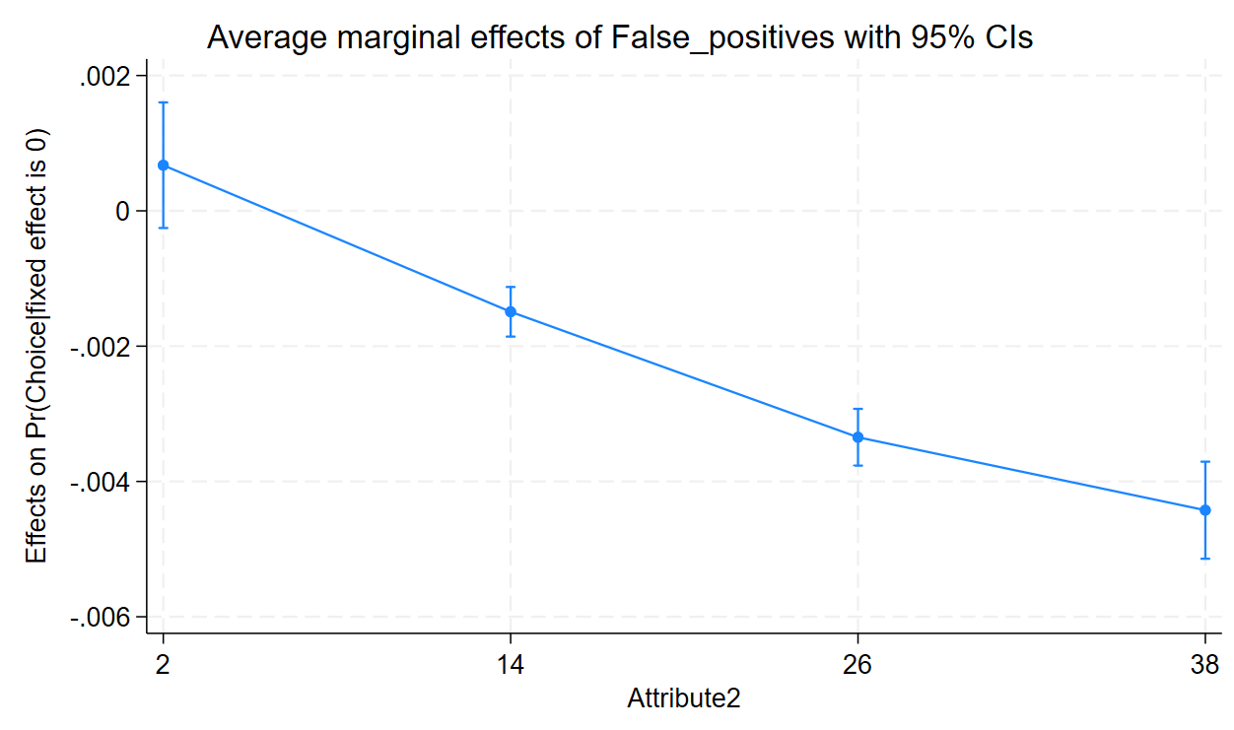
Linearity test for false negative attribute
Choice | Coefficient | std. err. | z | P>|z| | lower 95% CI | Upper 95% CI
False_negatives | -0.0422435 | 0.002906 | -14.54 | 0 | -0.0479392 | -0.0365477
c.False_negatives#c.False_negatives | 0.000017 | 0.000069 | 0.25 | 0.805 | -0.0001182 | 0.0001523
False_positives | -0.0150238 | 0.0008665 | -17.34 | 0 | -0.0167222 | -0.0133255
Cost | -0.0061398 | 0.0004094 | -15 | 0 | -0.0069422 | -0.0053374
Where_used | 0.1798036 | 0.0195204 | 9.21 | 0 | 0.1415443 | 0.218063
Skin_tone | -0.7045732 | 0.0216667 | -32.52 | 0 | -0.7470391 | -0.6621073
Recommended | 0.3448867 | 0.0195055 | 17.68 | 0 | 0.3066566 | 0.3831168
Expression: Pr(Choice|fixed effect is 0), predict(pu0)
dy/dx wrt: False_negatives
Delta-method
False_negatives at: | dy/dx | std. err. | z | P>|z| | Lower 95% CI | Upper 95% CI
False_negatives = 2 | 87384 | 0.000543 | -16.09 | 0 | -0.0098027 | 0.0076741
False_negatives = 14 | -0.0069841 | 0.0001561 | -44.73 | 0 | -0.0072902 | -0.0066781
False_negatives = 26 | -0.0051524 | 0.0002027 | -25.42 | 0 | -0.0055497 | -0.0047551
False_negatives = 38 | -0.0035769 | 0.0002358 | -15.17 | 0 | -0.0040391 | -0.0031147
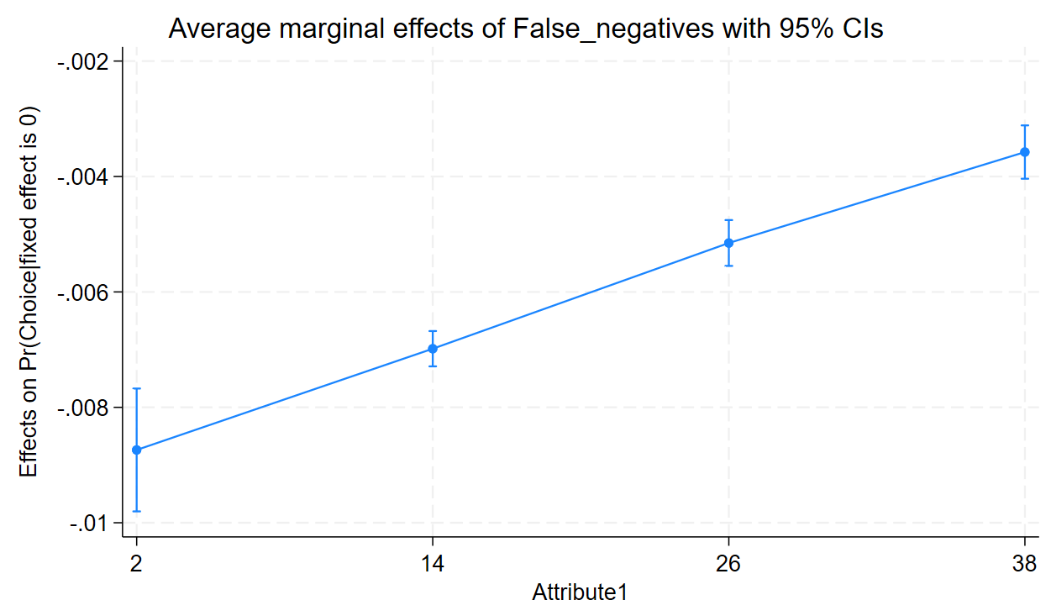
Linearity test for cost
Choice | Coefficient | std. err. | z | P>|z| | lower 95% CI | Upper 95% CI
Cost | -0.0078165 | 0.0023977 | -3.26 | 0.001 | -0.012516 | -0.0031171
c.Cost#c.Cost | 0.0000153 | 0.0000218 | 0.7 | 0.484 | -0.0000275 | 0.000058
False_positives | -0.0150034 | 0.0008595 | -17.46 | 0 | -0.0166879 | -0.0133188
False_negatives | -0.0415929 | 0.0011011 | -37.77 | 0 | -0.043751 | -0.0394347
Where_used | 0.1796284 | 0.019112 | 9.4 | 0 | 0.1421696 | 0.2170872
Skin_tone | -0.7057503 | 0.0216461 | -32.6 | 0 | -0.7481759 | -0.6633248
Recommended | 0.3440695 | 0.0192529 | 17.87 | 0 | 0.3063345 | 0.3818045
Expression: Pr(Choice|fixed effect is 0), predict(pu0)
dy/dx wrt: Cost
Delta-method
Cost at: | dy/dx | std. err. | z | P>|z| | Lower 95% CI | Upper 95% CI
Cost = 25 | -0.0011173 | 0.0001842 | -6.07 | 0 | -0.0014783 | -0.0007562
Cost = 55 | -0.0008779 | 0.0000616 | -14.25 | 0 | -0.0009987 | -0.0007572
Cost = 85 | -0.0006778 | 0.000198 | -3.42 | 0.001 | -0.0010659 | -0.0002897
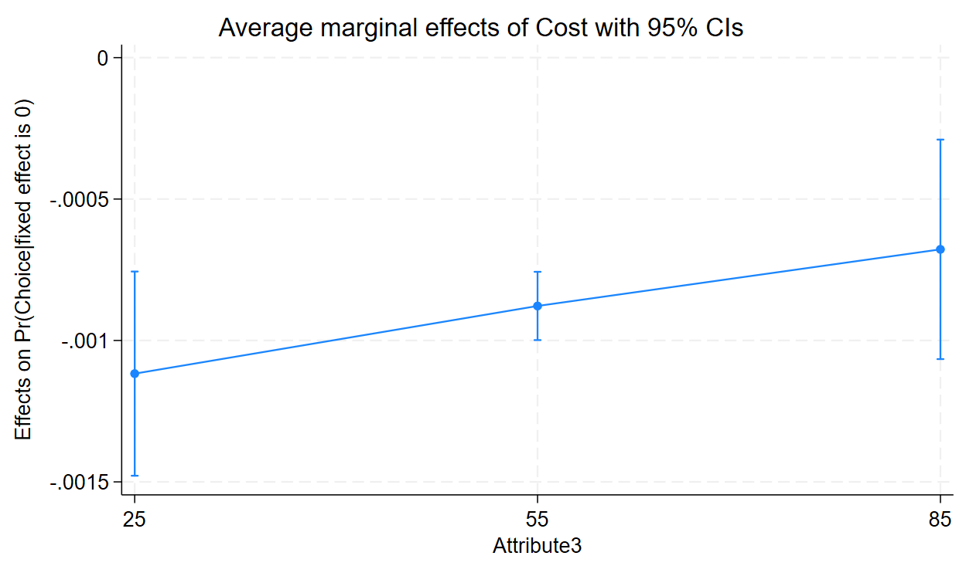
The graphs demonstrate the linearity of the false positives, false negative, and cost attributes between the levels used in this study. Hence, although there is evidence that the false positive attribute is non-linear, it appears to be linear between the levels tested in this DCE.

Appendix 5 – interactions between variables
5.1 Interaction between false negative variable and false positive variable
Choice Coefficient Std. err. z P>|z| [95% conf. interval]
False_negatives -0.0385 0.00145 -26.5 0 -0.0413, -0.0356
False_positives -0.0117 0.00151 -7.79 0 -0.0147, -0.00879
c.False_negatives#c.False_positives -0.000161 0.000063 -2.56 0.01 -0.000284, -0.0000377
Cost -0.00631 0.000432 -14.6 0 -0.00716, -0.005467
Where_used 0.187 0.0183 10.2 0 0.151, 0.222
Skin_tone -0.711 0.0179 -39.7 0 -0.746, -0.676
Recommended 0.346 0.0177 19.6 0 0.311, 0.381

( 1) [Choice]c.False_negatives#c.False_positives = 0
chi2( 1) = 6.56
Prob > chi2 = 0.0104

Expression: Pr(Choice|fixed effect is 0), predict(pu0)
dy/dx wrt: False_positives
Delta-method
False_positives at: dy/dx std. err. z P>|z| [95% conf. interval]
2 -0.00255 0.000274 -9.32 0 -0.00309, -0.00201
14 -0.00241 0.000126 -19.2 0 -0.00266, -0.00217
26 -0.00206 0.000115 -18 0 -0.00229, -0.00184
38 -0.00163 0.000146 -11.2 0 -0.00192, -0.00135

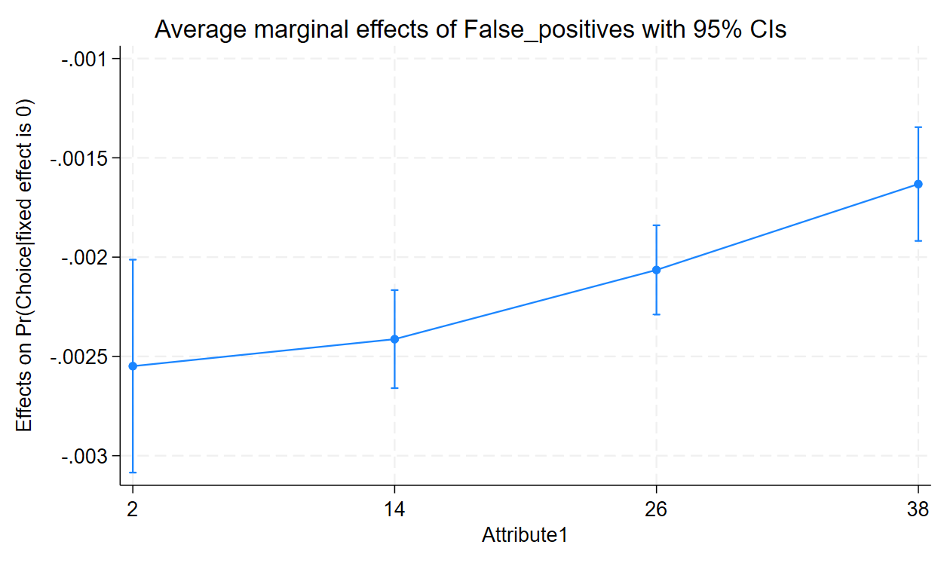
Variables that uniquely identify margins: False_negatives

5.2 Interaction between false negative variable and skin tone
Choice Coefficient Std. err. z P>|z| [95% conf. interval]
False_negatives -0.0447 0.00151 -29.7 0 -0.0477, -0.0418
Skin_tone -0.831 0.0535 -15.6 0 -0.936, -0.726
Skin_tone#c.False_negatives 0.00636 0.00253 2.51 0.012 0.0014, 0.0113
Cost -0.00623 0.000429 -14.5 0 -0.00707, -0.00539
False_positives -0.0149 0.000786 -18.9 0 -0.0164, -0.0133
Where_used 0.184 0.0181 10.2 0 0.149, 0.22
Recommended 0.351 0.0178 19.6 0 0.316, 0.386

( 1) [Choice]2.Skin_tone#c.False_negatives = 0
chi2( 1) = 6.31
Prob > chi2 = 0.012

Expression: Pr(Choice|fixed effect is 0), predict(pu0)
dy/dx wrt: False_negatives
Delta-method
Skin_tone dy/dx std. err. z P>|z| [95% conf. interval]
All skin tones -0.00761 0.00017 -44.9 0 -0.00794, -0.00728
White skin only -0.00435 0.000245 -17.8 0 -0.00483, -0.00387

Variables that uniquely identify margins: Skin_tone
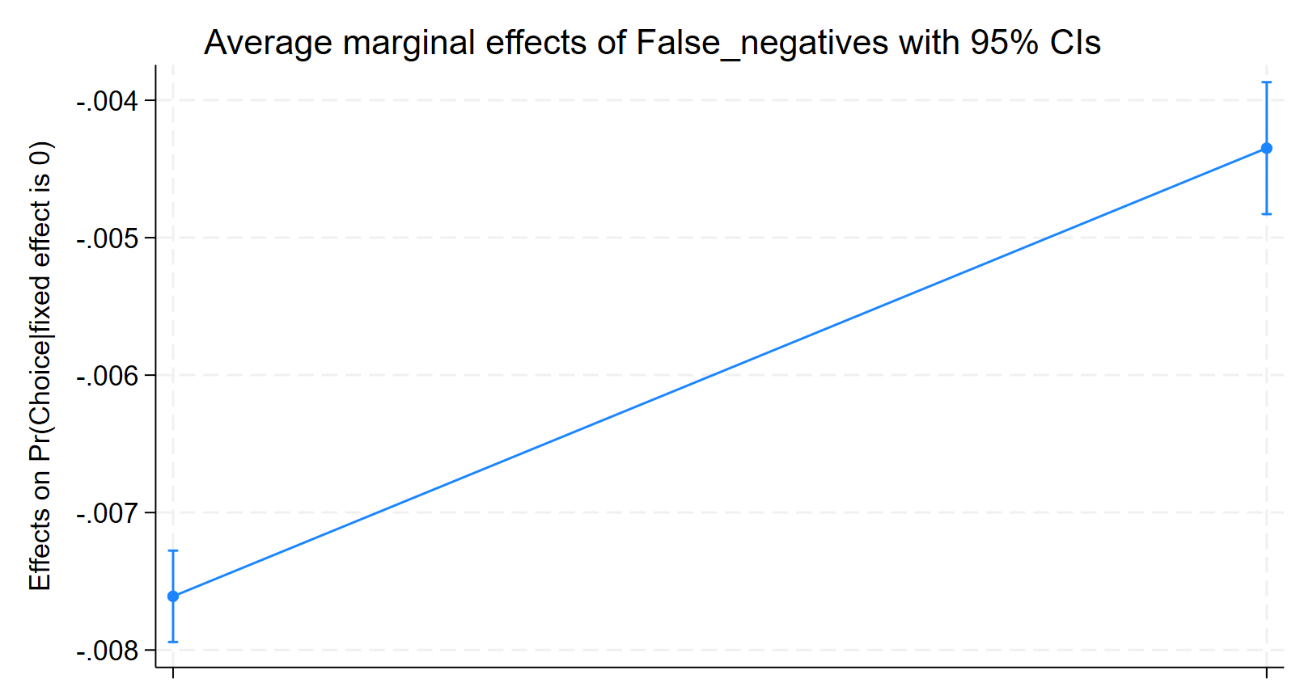
All skin tones White skin only

5.3 Interaction between false positive variable and skin tone
Choice Coefficient Std. err. z P>|z| [95% conf. interval]
False_positives -0.0145 0.00141 -10.3 0 -0.0172, -0.0117
Skin_tone -0.682 0.0496 -13.7 0 -0.779, -0.585
Skin_tone#c.False_positives -0.00111 0.00226 -0.49 0.622 -0.00554, 0.00331
Cost -0.00608 0.000449 -13.6 0 -0.00696, -0.0052
False_negatives -0.0416 0.000815 -51 0 -0.0432, -0.04
Where_used 0.18 0.0181 9.94 0 0.144, 0.215
Recommended 0.346 0.0179 19.3 0 0.311, 0.381

. testparm i.Skin_tone#c.False_positives
( 1) [Choice]2.Skin_tone#c.False_positives = 0
chi2( 1) = 0.24
Prob > chi2 = 0.6217

Expression: Pr(Choice|fixed effect is 0), predict(pu0)
dy/dx wrt: False_positives
Delta-method
Skin_tone dy/dx std. err. z P>|z| [95% conf. interval]
All skin tones -0.00255 0.000209 -12.2 0 -0.00296, -0.00214
White skin only -0.00186 0.000189 -9.85 0 -0.00223, -0.00149
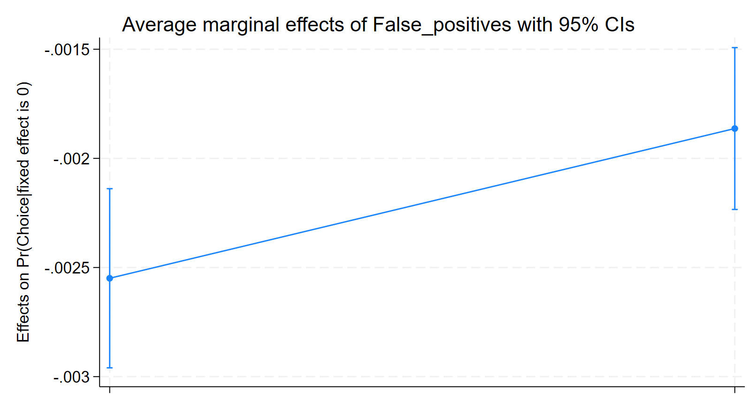
All skin tones White skin only

Variables that uniquely identify margins: Skin_tone

Appendix 6 – Regression model including quadratic terms for false positive rate, to account for non-linearity demonstrated in appendix 4
6.1 Results of regression analysis for regression model including quadratic terms, broken down by participant group
Attribute | Attribute notes | Coefficient | SE | z | P>|z| | 95% Confidence Interval
All participants
False Positives | Continuous | 0.0240498 | 0.0093148 | 2.58 | 0.01 | 0.0057931 | 0.0423065
False Negatives | Continuous | -0.0416222 | 0.0010907 | -38.16 | 0 | -0.0437598 | -0.0394845
Cost | Continuous | -0.0066914 | 0.0004324 | -15.48 | 0 | -0.0075388 | -0.005844
FP2 | Continuous | -0.0017061 | 0.0005562 | -3.07 | 0.002 | -0.0027963 | -0.0006159
FP3 | Continuous | 0.0000191 | 8.76E-06 | 2.18 | 0.029 | 1.97E-06 | 0.0000363
Where use | At home = 1, GP surgery = 2 | 0.192922 | 0.0200873 | 9.6 | 0 | 0.1535517 | 0.2322924
Skin tone | All skin tones = 1, white skin only. =2 | -0.6875292 | 0.022066 | -31.16 | 0 | -0.7307778 | -0.6442806
Recommended | recommended = 2, not recommended = 1 | 0.3698413 | 0.0192492 | 19.21 | 0 | 0.3321136 | 0.4075691
GPs
False Positives | Continuous | 0.0756037 | 0.0338809 | 2.23 | 0.026 | 0.0091982 | 0.1420091
FP2 | Continuous | -0.0047094 | 0.002016 | -2.34 | 0.019 | -0.0086607 | -0.0007581
FP3 | Continuous | 0.0000634 | 0.0000313 | 2.03 | 0.043 | 2.06E-06 | 0.0001248
False Negatives | Continuous | -0.0618775 | 0.0038096 | -16.24 | 0 | -0.0693443 | -0.0544108
Cost | Continuous | -0.0095911 | 1.40E-03 | -6.85 | 0 | -1.23E-02 | -6.85E-03
Where use | At home = 1, GP surgery = 2 | 0.1654886 | 0.061799 | 2.68 | 0.007 | 0.0443648 | 0.2866124
Skin tone | All skin tones = 1, white skin only. =2 | -0.6491625 | 0.0551909 | -11.76 | 0 | -0.7573346 | -0.5409904
Recommended | recommended = 2, not recommended = 1 | 0.4844089 | 0.0604844 | 8.01 | 0 | 0.3658615 | 0.6029562
Patients
False Positives | Continuous | -0.0047728 | 0.0227733 | -0.21 | 0.834 | -0.0494076 | 0.039862
FP2 | Continuous | 0.0002224 | 0.0013617 | 0.16 | 0.87 | -0.0024465 | 0.0028914
FP3 | Continuous | -0.0000119 | 0.0000215 | -0.55 | 0.58 | -0.000054 | 0.0000302
False Negatives | Continuous | -0.0467019 | 0.0025875 | -18.05 | 0 | -0.0517732 | -0.0416306
Cost | Continuous | -0.0067777 | 0.0010835 | -6.26 | 0 | -0.0089013 | -0.004654
Where use | At home = 1, GP surgery = 2 | 0.2677585 | 0.0471818 | 5.68 | 0 | 0.1752839 | 0.3602332
Skin tone | All skin tones = 1, white skin only. =2 | -0.7260027 | 0.0537036 | -13.52 | 0 | -0.8312598 | -0.6207456
Recommended | recommended = 2, not recommended = 1 | 0.3103604 | 0.0440653 | 7.04 | 0 | 0.223994 | 0.3967267
Public
False Positives | Continuous | 0.0234823 | 0.0107404 | 2.19 | 0.029 | 0.0024315 | 0.0445331
FP2 | Continuous | -0.0017467 | 0.0006423 | -2.72 | 0.007 | -0.0030057 | -0.0004878
FP3 | Continuous | 0.0000204 | 0.0000101 | 2.01 | 0.045 | 4.87E-07 | 0.0000402
False Negatives | Continuous | -0.0371234 | 0.0012647 | -29.35 | 0 | -0.0396021 | -0.0346447
Cost | Continuous | -0.0063532 | 0.0005073 | -12.52 | 0 | -0.0073475 | -0.0053589
Where use | At home = 1, GP surgery = 2 | 0.1822077 | 0.023948 | 7.61 | 0 | 0.1352704 | 0.2291449
Skin tone | All skin tones = 1, white skin only. =2 | -0.6861546 | 0.0267522 | -25.65 | 0 | -0.738588 | -0.6337212
Recommended | recommended = 2, not recommended = 1 | 0.3724004 | 0.023115 | 16.11 | 0 | 0.3270958 | 0.4177049

6.2 Predicted probabilities of selecting the technologies over the gold standard pathway, separated by participant group
 | XB (utility score of the test) | exp(XB) | Pr(Alt i is chosen) [exp(XB)/sum(exp(XB))] | Pr(Alt i not chosen) | Ranking
GPs
Gold standard pathway | -1.4348459 | 0.23815206 | NA - Gold standard pathway |  | 6
Technology A | -1.1873359 | 0.30503282 | 0.561563532 | 0.438436468 | 5
Technology Bi | -0.3075046 | 0.735279485 | 0.755347912 | 0.244652088 | 2
Technology Bii | -0.9566671 | 0.384171159 | 0.617317733 | 0.382682267 | 4
Technology C | -2.3944738 | 0.091220667 | 0.276952702 | 0.723047298 | 8
Technology D | -3.151258 | 0.042798253 | 0.152333885 | 0.847666115 | 9
Technology Ei | -0.0652548 | 0.936828729 | 0.797314082 | 0.202685918 | 1
Technology Eii | -0.8160709 | 0.442165559 | 0.64993989 | 0.35006011 | 3
Technology F | -2.1038107 | 0.121990672 | 0.338728678 | 0.661271322 | 7
Patients
Gold standard pathway | -1.2365431 | 0.290386321 | NA - Gold standard pathway |  | 5
Technology A | -1.0497355 | 0.35003032 | 0.546566559 | 0.453433441 | 4
Technology Bi | -0.6397479 | 0.527425371 | 0.644922757 | 0.355077243 | 2
Technology Bii | -1.3657506 | 0.255189059 | 0.467742989 | 0.532257011 | 6
Technology C | -2.3299136 | 0.097304154 | 0.250984123 | 0.749015877 | 8
Technology D | -2.8373285 | 0.058581959 | 0.167871873 | 0.832128127 | 9
Technology Ei | -0.4536823 | 0.635284531 | 0.686296354 | 0.313703646 | 1
Technology Eii | -0.7695241 | 0.463233469 | 0.614677951 | 0.385322049 | 3
Technology F | -1.9835156 | 0.137584693 | 0.321481335 | 0.678518665 | 7
Public
Gold standard pathway | -0.9932558 | 0.370368879 | NA - Gold standard pathway |  | 5
Technology A | -0.8447622 | 0.429659519 | 0.537055335 | 0.462944665 | 4
Technology Bi | -0.3818311 | 0.682610336 | 0.648265727 | 0.351734273 | 2
Technology Bii | -1.0679857 | 0.343700136 | 0.481326215 | 0.518673785 | 6
Technology C | -1.863242 | 0.155168757 | 0.295257174 | 0.704742826 | 8
Technology D | -2.1024899 | 0.122151903 | 0.248013704 | 0.751986296 | 9
Technology Ei | -0.2406865 | 0.786088026 | 0.679738279 | 0.320261721 | 1
Technology Eii | -0.6220218 | 0.53685792 | 0.591757123 | 0.408242877 | 3
Technology F | -1.4750993 | 0.22875601 | 0.381816904 | 0.618183096 | 7
NB: not shown in the table but there is no change to the ranking of the technologies compared to the original model

For ease of reference the tables below (6.3 and 6.4) display:
6.3: The co-efficients of the attributes under the original regression mode versus the co-efficients of the attributes in the new regression model which includes quadratic terms for the false positive rate attribute, broken down by participant group
6.4: The predicted probability participants would choose to use one of the proposed AI technologies to help detect skin cancer over the gold standard pathway of the patient seeing a primary care clinician. Broken down by participant group and demonstrating the predicted probability of selection under the original regression model and the new regression model including quadratic terms for the false positive attribute.
These results demonstrate that including quadratic terms for the false positive attribute within the regression model makes little difference to the co-efficients or the probability of the 8 AI technologies modelled here being selected over the gold standard pathway.
6.3 Co-efficients for attributes - original regression model versus model including quadratic terms for false positives (FP^2 and FP^3), broken down by participant group
 | Co-efficients with original model | Co-efficients for model including quadratic terms for false positives
GPs
False Positive | -0.0163717 | 0.0756037
FP2 | NA | -0.0047094
FP3 | NA | 0.0000634
False Negatives | -0.0617401 | -0.0618775
Cost | -0.0086028 | -0.0095911
Where use | 0.1294513 | 0.1654886
Skin tone | -0.6791493 | -0.6491625
Recommended | 0.445339 | 0.4844089
Patients
False Positive | -0.0136901 | -0.0047728
FP2 | NA | 0.0002224
FP3 | NA | -0.0000119
False Negatives | -0.0466398 | -0.0467019
Cost | -0.0063419 | -0.0067777
Where use | 0.2604181 | 0.2677585
Skin tone | -0.7375066 | -0.7260027
Recommended | 0.2899783 | 0.3103604
Public
False Positive | -0.0153738 | 0.0234823
FP2 | NA | -0.0017467
FP3 | NA | 0.0000204
False Negatives | -0.0370702 | -0.0371234
Cost | -0.0058439 | -0.0063532
Where use | 0.170207 | 0.1822077
Skin tone | -0.7027782 | -0.6861546
Recommended | 0.3476038 | 0.3724004
6.4 Predicted probabilities of selecting the technologies over the gold standard pathway - original regression model versus model including quadratic terms for false positives, separated by participant group
GPs
Technology A | 0.561428211 | 0.561563532
Technology Bi | 0.73008877 | 0.755347912
Technology Bii | 0.578330507 | 0.617317733
Technology C | 0.237655447 | 0.276952702
Technology D | 0.132425932 | 0.152333885
Technology Ei | 0.776182016 | 0.797314082
Technology Eii | 0.649627216 | 0.64993989
Technology F | 0.316024512 | 0.338728678
Patients
Technology A | 0.546504997 | 0.546566559
Technology Bi | 0.644036981 | 0.644922757
Technology Bii | 0.463918503 | 0.467742989
Technology C | 0.250793679 | 0.250984123
Technology D | 0.172308946 | 0.167871873
Technology Ei | 0.686053926 | 0.686296354
Technology Eii | 0.614530858 | 0.614677951
Technology F | 0.323451469 | 0.321481335
Public
Technology A | 0.537002427 | 0.537055335
Technology Bi | 0.635500987 | 0.648265727
Technology Bii | 0.463343785 | 0.481326215
Technology C | 0.27878633 | 0.295257174
Technology D | 0.237643037 | 0.248013704
Technology Ei | 0.668261709 | 0.679738279
Technology Eii | 0.591628595 | 0.591757123
Technology F | 0.372196191 | 0.381816904

Appendix 7 – Latent class analysis
Table 6: Latent class analysis
6a: Latent class model with 3 latent classes
Attribute |  | Co-efficient | Standard error | z | P>|z| | [95% conf. interval]
Class 1
FNs |  | -0.51 | 0.0049 | -10 | 0 | -0.06 | -0.041
FPs |  | -0.044 | 0.0071 | -6.3 | 0 | -0.058 | -0.031
Cost |  | 0.0095 | 0.0028 | 3.4 | 0.001 | 0.0041 | 0.015
Where used |  | 0.36 | 0.083 | 4.3 | 0 | 0.2 | 0.52
Skin tone |  | -2.2 | 0.17 | -13 | 0 | -2.6 | -1.9
Recommended |  | 0.87 | 0.064 | 14 | 0 | 0.75 | 1
Class 2
FNs |  | -0.15 | 0.0086 | -17 | 0 | -0.16 | -0.13
FPs |  | -0.025 | 0.0036 | -7 | 0 | -0.032 | -0.018
Cost |  | -0.21 | 0.0031 | -6.9 | 0 | -0.027 | -0.015
Where used |  | 0.03 | 0.09 | 0.33 | 0.74 | -0.15 | 0.21
Skin tone |  | -1.1 | 0.12 | -8.9 | 0 | -1.3 | -0.83
Recommended |  | 0.41 | 0.1 | 4 | 0 | 0.21 | 0.61
Class 3
FNs |  | -0.009 | 0.0017 | -5.2 | 0 | -0.012 | -0.0056
FPs |  | -0.016 | 0.0014 | -12 | 0 | -0.019 | -0.013
Cost |  | -0.01 | 0.00078 | -13 | 0 | -0.012 | -0.0088
Where used |  | 0.3 | 0.032 | 9.3 | 0 | 0.24 | 0.36
Skin tone |  | -0.12 | 0.038 | -3.1 | 0.002 | -0.19 | -0.043
Recommended |  | 0.29 | 0.032 | 9.1 | 0 | 0.23 | 0.35
6b: Demographic share of classes 1 and 2 in comparison to class 3
Demographic group | Co-efficient |  | Standard error | z | P>|z| | [95% conf. interval]
Class 1
Patient participant | 0.078 |  | 0.31 | 0.26 | 0.8 | -0.52 | 0.68
Public participant | -0.12 |  | 0.26 | -0.47 | 0.64 | -0.64 | 0.39
History of skin cancer | -0.6 |  | 0.36 | -1.7 | 0.095 | -1.3 | 0.11
Female Sex | 0.36 |  | 0.13 | 2.8 | 0.005 | 0.11 | 0.6
White skin | 0.075 |  | 0.17 | 0.44 | 0.66 | -0.26 | 0.41
Age under 55 years | 0.007 |  | 0.14 | 0.05 | 0.96 | -0.27 | 0.28
Class 2
Patient participant | -1.1 |  | 0.26 | -4.3 | 0 | -1.6 | -0.6
Public participant | 1.6 |  | 0.22 | -7.4 | 0 | -2 | -1.2
History of skin cancer | -0.59 |  | 0.33 | -1.8 | 0.077 | -1.3 | 0.065
Female Sex | -0.004 |  | 0.12 | -0.03 | 0.97 | -0.25 | 0.24
White skin | 1.1 |  | 0.19 | 5.7 | 0 | 0.704 | 1.45
Age under 55 years | 0.26 |  | 0.13 | 1.9 | 0.056 | -0.00683 | 0.519

