Supplementary Tables and Figures
Table of Contents
Supplementary Figure 1. Flow chart of study population selection 2
Supplementary Table 1. STROBE checklist 3
Supplementary Table 2. Scoring system of the healthy diet score 6
Supplementary Table 3. ICD-10 diagnosis codes for overall and site-specific cancers 7
Supplementary Table 4. The number and percentage of missing values 8
Supplementary Methods 1 9
Supplementary Table 5. Additional adjusted covariates for site-specific cancers 10
Supplementary Methods 2 11
Supplementary Table 6. Association between HLS and overall and site-specific cancers in model 1 12
Supplementary Figure 2. Association between individual healthy lifestyle factors and overall and site-specific cancers in model 2 13
Supplementary Table 7. Association between individual healthy lifestyle factors and overall and site-specific cancers in model 1 14
Supplementary Table 8. Association between individual healthy lifestyle factors and overall and site-specific cancers in model 2 16
Supplementary Figure 3. Multivariable-adjusted PAF estimates of smoking for site-specific cancers 18
Supplementary Figure 4. Multivariable-adjusted PAF estimates of alcohol intake for site-specific cancers 19
Supplementary Figure 5. Multivariable-adjusted PAF estimates of unhealthy diet for site-specific cancers 20
Supplementary Figure 6. Multivariable-adjusted PAF estimates of physical inactivity for site-specific cancers 21
Supplementary Figure 7. Multivariable-adjusted PAF estimates of overweight for site-specific cancers 22
Supplementary Table 9. Association between HLS groups and site-specific cancers stratified by age and sex 23
Supplementary Reference 25

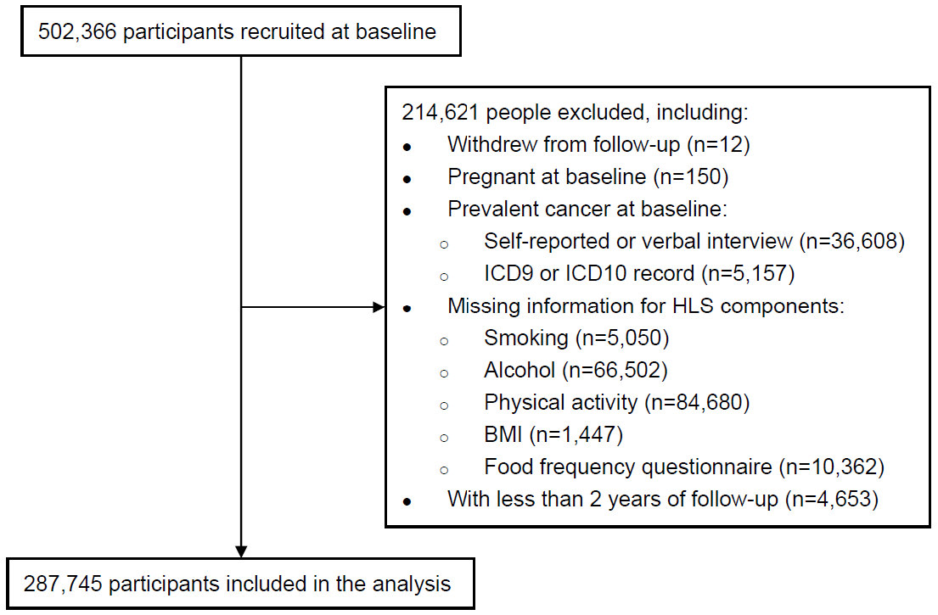

Supplementary Figure 1. Flow chart of study population selection

Supplementary Table 1. STROBE checklist
 | Item No | Recommendation | Page No
Title and abstract | 1 | (a) Indicate the study’s design with a commonly used term in the title or the abstract | 1
Title and abstract | 1 | (b) Provide in the abstract an informative and balanced summary of what was done and what was found | 2
Introduction
Background/rationale | 2 | Explain the scientific background and rationale for the investigation being reported | 3
Objectives | 3 | State specific objectives, including any prespecified hypotheses | 3
Methods
Study design | 4 | Present key elements of study design early in the paper | 4-5
Setting | 5 | Describe the setting, locations, and relevant dates, including periods of recruitment, exposure, follow-up, and data collection | 4-5
Participants | 6 | (a) Give the eligibility criteria, and the sources and methods of selection of participants. Describe methods of follow-up | 4
Participants | 6 | (b) For matched studies, give matching criteria and number of exposed and unexposed | N/A
Variables | 7 | Clearly define all outcomes, exposures, predictors, potential confounders, and effect modifiers. Give diagnostic criteria, if applicable | 4-5, Supplementary Table 2-3, and 5
Data sources/ measurement | 8* | For each variable of interest, give sources of data and details of methods of assessment (measurement). Describe comparability of assessment methods if there is more than one group | 4-5, Supplementary Table 2
Bias | 9 | Describe any efforts to address potential sources of bias | 5-6
Study size | 10 | Explain how the study size was arrived at | 4
Quantitative variables | 11 | Explain how quantitative variables were handled in the analyses. If applicable, describe which groupings were chosen and why | 4
Statistical methods | 12 | (a) Describe all statistical methods, including those used to control for confounding | 5-6
Statistical methods | 12 | (b) Describe any methods used to examine subgroups and interactions | 6
Statistical methods | 12 | (c) Explain how missing data were addressed | 5
Statistical methods | 12 | (d) If applicable, explain how loss to follow-up was addressed | N/A
Statistical methods | 12 | (e) Describe any sensitivity analyses | N/A
Results
Participants | 13* | (a) Report numbers of individuals at each stage of study—eg numbers potentially eligible, examined for eligibility, confirmed eligible, included in the study, completing follow-up, and analysed | 7
Participants | 13* | (b) Give reasons for non-participation at each stage | 7
Participants | 13* | (c) Consider use of a flow diagram | Supplementary Figure 1
Descriptive data | 14* | (a) Give characteristics of study participants (eg demographic, clinical, social) and information on exposures and potential confounders | 7, Table 1
Descriptive data | 14* | (b) Indicate number of participants with missing data for each variable of interest | Supplementary Table 4
Descriptive data | 14* | (c) Summarise follow-up time (eg, average and total amount) | 7
Outcome data | 15* | Report numbers of outcome events or summary measures over time | 7
Main results | 16 | (a) Give unadjusted estimates and, if applicable, confounder-adjusted estimates and their precision (eg, 95% confidence interval). Make clear which confounders were adjusted for and why they were included | 7-8
Main results | 16 | (b) Report category boundaries when continuous variables were categorized | 7-8
Main results | 16 | (c) If relevant, consider translating estimates of relative risk into absolute risk for a meaningful time period | N/A
Other analyses | 17 | Report other analyses done—eg analyses of subgroups and interactions, and sensitivity analyses | 8
Discussion
Key results | 18 | Summarise key results with reference to study objectives | 9
Limitations | 19 | Discuss limitations of the study, taking into account sources of potential bias or imprecision. Discuss both direction and magnitude of any potential bias | 12
Interpretation | 20 | Give a cautious overall interpretation of results considering objectives, limitations, multiplicity of analyses, results from similar studies, and other relevant evidence | 9-12
Generalisability | 21 | Discuss the generalisability (external validity) of the study results | 12
Other information
Funding | 22 | Give the source of funding and the role of the funders for the present study and, if applicable, for the original study on which the present article is based | 14
*Give information separately for exposed and unexposed groups.
Note: An Explanation and Elaboration article discusses each checklist item and gives methodological background and published examples of transparent reporting. The STROBE checklist is best used in conjunction with this article (freely available on the Web sites of PLoS Medicine at http://www.plosmedicine.org/, Annals of Internal Medicine at http://www.annals.org/, and Epidemiology at http://www.epidem.com/). Information on the STROBE Initiative is available at http://www.strobe-statement.org.

Supplementary Table 2. Scoring system of the healthy diet score
Food Group | Frequency/Servings | Score
Red and processed meat | Multiple times per day | 0.5
Red and processed meat | Multiple times per week | 2
Red and processed meat | Once per week | 3
Red and processed meat | Less than once per week | 4
Red and processed meat | Never | 5
Fish | Multiple times per day | 4.5
Fish | Multiple times per week | 3
Fish | Once per week | 2
Fish | Less than once per week | 1
Fish | Never | 0
Cheese | Multiple times per day | 9
Cheese | Multiple times per week | 6
Cheese | Once per week | 4
Cheese | Less than once per week | 2
Cheese | Never | 0
Wholegrains | >7 servings per week | 10
Wholegrains | 7 servings per week | 8
Wholegrains | >1 and <7 servings per week | 6
Wholegrains | 1 serving per week | 4
Wholegrains | <1 serving per week | 2
Wholegrains | 0 serving per week | 0
Fruits  Vegetables | Multiple times per day | 10
Fruits  Vegetables | Once per day | 8
Fruits  Vegetables | 0 time per day | 0

Supplementary Table 3. ICD-10 diagnosis codes for overall and site-specific cancers
Cancer site | ICD-10
Overall cancer | C00-C97
Oral | C01-06
Pharynx | C09-C13
Larynx | C32
Esophagus | C15
Stomach | C16
Small intestine | C17
Colorectum | C18-C20
Anus | C21
Liver | C22
Gallbladder and biliary tract | C23-24
Pancreas | C25
Lung | C33-34
Melanoma | C43
Mesothelioma | C45
Soft tissue | C46-49
Kidney | C64-65
Bladder | C67
Central nervous system | C70-72
Thyroid | C73
Non-Hodgkin lymphoma | C82-86, C96
Multiple myeloma | C90
Leukemia | C91-95
Breast | C50
Uterus | C54-55
Ovary | C56
Prostate | C61
ICD-10, International Classification of Diseases, Tenth Revision.

Supplementary Table 4. The number and percentage of missing values
Variable | N | Percentage
Family history | 28155 | 9.78
Screening | 1105 | 0.38
Index of multiple deprivation | 46 | 0.02
Ethnicity | 800 | 0.28
Household income | 29111 | 10.12
Qualifications | 20 | 0.01
Time spend outdoors in summer | 5975 | 2.08
Use of sun/UV protection | 235 | 0.08
Skin colour | 2395 | 0.83
Sunburn during childhood | 61296 | 21.30
Frequency of solarium/sunlamp use | 1340 | 0.47
Ease of skin tanning | 20 | 0.01
Hormone replacement therapy (female) | 334 | 0.24
Ever taken oral contraceptive pill (female) | 254 | 0.18
Parity (female) | 91 | 0.06
Age when periods started (female) | 6 | 0.00

Supplementary Methods 1
Covariates included age at recruitment (years) and gender (male or female), ethnicity (White, Asian or Asian British, Black or Black British, Mixed, and other ethnic group), region (London, North West England, North-Eastern England, Yorkshire & the Humber, West Midlands, East Midlands, South-East England, South-West England, Wales & Scotland), Townsend Deprivation Index (quintiles), household income (<£18,000, £18,000-£30,999, £31,000-£51,999, £52,000-£100,000, >£100,000), education (college or university degree, A levels/AS levels or equivalent, O levels/GCSEs or equivalent, CSEs or equivalent, NVQ or HND or HNC or equivalent, other professional qualifications), history of cancer screening (screening of bowel cancer, breast cancer, prostate cancer, cervical cancer), family history of cancer (prostate cancer, breast cancer, bowel cancer, lung cancer), hypertension, diabetes, and height.

Supplementary Table 5. Additional adjusted covariates for site-specific cancers
Cancer site | Covariate
Colorectum | history of inflammatory bowel disease, Crohn’s disease, or ulcerative colitis (yes/no), NSAID: aspirin or ibuprofen use (yes/no)
Stomach | history of gastric ulcer
Esophagus | history of gastro-esophageal reflux disease
Breast, uterus, ovary | ever hormone replacement therapy (HRT) use (yes/no), ever oral contraceptive pill use (yes/no), parity (0, 1-2, ≥3 live births), age at onset of menopause, menopause (pre-menopausal, post-menopausal)
Melanoma | skin color, hair color, time spent outdoors in summer (hours/day), use of sun/UV protection (never/rarely, sometimes, most of the time, always, do not go out in sunshine), solarium use (yes/no), sunburn during childhood, ease of skin tanning

Supplementary Methods 2
The population attributable fractions (PAFs) (95% CI) of site-specific cancers attributable to low-medium HLS and each unhealthy behavior were estimated using multivariable Cox proportional hazards models and the R package graphPAF¹, where the formula is as follows:
$$PAF(t)=\frac{P\left(T≤t\right)-P(T_{0}≤t)}{P(T≤t)}$$
T: time-to-event; P (T ≤ t): factual probability of event at or before time t; P (T₀ ≤ t): counterfactual probability of event at or before time t had the exposure been eliminated for everyone at baseline. PAFs were estimated in the models in the main analysis.

Supplementary Table 6. Association between HLS and overall and site-specific cancers in model 1
Cancer site | Low HLS |  | Medium HLS |  | High HLS
Cancer site | N | HR (95% CI) | N | HR (95% CI) | N | HR (95% CI)
Overall cancers | 2460 | 1.00 (ref) | 16391 | 0.81 (0.78, 0.84) | 10051 | 0.69 (0.67, 0.72)
Oral | 42 | 1.00 (ref) | 181 | 0.65 (0.48, 0.88) | 103 | 0.53 (0.36, 0.76)
Pharynx | 35 | 1.00 (ref) | 156 | 0.53 (0.39, 0.73) | 64 | 0.36 (0.24, 0.54)
Larynx | 43 | 1.00 (ref) | 64 | 0.27 (0.18, 0.38) | 21 | 0.09 (0.05, 0.19)
Esophagus | 94 | 1.00 (ref) | 431 | 0.56 (0.46, 0.68) | 169 | 0.37 (0.29, 0.48)
Stomach | 56 | 1.00 (ref) | 275 | 0.63 (0.49, 0.81) | 123 | 0.42 (0.31, 0.58)
Small intestine | 10 | 1.00 (ref) | 97 | 0.98 (0.59, 1.64) | 64 | 0.90 (0.51, 1.58)
Colorectum | 296 | 1.00 (ref) | 2000 | 0.80 (0.72, 0.89) | 1136 | 0.65 (0.58, 0.74)
Anus | 9 | 1.00 (ref) | 53 | 0.64 (0.36, 1.15) | 42 | 0.56 (0.29, 1.08)
Liver | 70 | 1.00 (ref) | 255 | 0.48 (0.38, 0.60) | 139 | 0.35 (0.26, 0.48)
Gallbladder and biliary tract | 11 | 1.00 (ref) | 104 | 1.21 (0.71, 2.08) | 66 | 1.09 (0.61, 1.96)
Pancreas | 92 | 1.00 (ref) | 569 | 0.67 (0.56, 0.81) | 294 | 0.49 (0.39, 0.61)
Lung | 481 | 1.00 (ref) | 1397 | 0.33 (0.30, 0.37) | 432 | 0.15 (0.13, 0.17)
Melanoma | 100 | 1.00 (ref) | 947 | 1.14 (0.96, 1.36) | 687 | 1.09 (0.91, 1.31)
Mesothelioma | 34 | 1.00 (ref) | 147 | 0.86 (0.60, 1.23) | 72 | 0.66 (0.43, 1.03)
Soft tissue | 28 | 1.00 (ref) | 135 | 0.66 (0.46, 0.96) | 94 | 0.61 (0.40, 0.93)
Kidney | 79 | 1.00 (ref) | 542 | 0.87 (0.71, 1.07) | 266 | 0.63 (0.50, 0.80)
Bladder | 86 | 1.00 (ref) | 426 | 0.70 (0.57, 0.86) | 198 | 0.47 (0.37, 0.61)
Central nervous system | 40 | 1.00 (ref) | 287 | 1.07 (0.80, 1.43) | 186 | 0.86 (0.62, 1.20)
Thyroid | 16 | 1.00 (ref) | 104 | 0.70 (0.45, 1.09) | 93 | 0.76 (0.47, 1.23)
Non-Hodgkin lymphoma | 85 | 1.00 (ref) | 727 | 1.13 (0.93, 1.37) | 516 | 1.18 (0.96, 1.46)
Multiple myeloma | 41 | 1.00 (ref) | 306 | 1.06 (0.80, 1.41) | 217 | 1.08 (0.79, 1.48)
Leukemia | 65 | 1.00 (ref) | 482 | 0.88 (0.71, 1.08) | 279 | 0.76 (0.60, 0.98)
Pre-menopausal breast | 53 | 1.00 (ref) | 571 | 0.92 (0.73, 1.16) | 499 | 0.80 (0.63, 1.02)
Post-menopausal breast | 119 | 1.00 (ref) | 1465 | 0.94 (0.81, 1.09) | 1185 | 0.78 (0.67, 0.91)
Uterus | 39 | 1.00 (ref) | 397 | 0.96 (0.72, 1.28) | 312 | 0.80 (0.59, 1.08)
Ovary | 23 | 1.00 (ref) | 263 | 1.08 (0.75, 1.55) | 233 | 0.98 (0.67, 1.44)
Prostate | 507 | 1.00 (ref) | 4191 | 1.12 (1.04, 1.21) | 2497 | 1.16 (1.06, 1.26)
Model 1 was adjusted for age and sex.

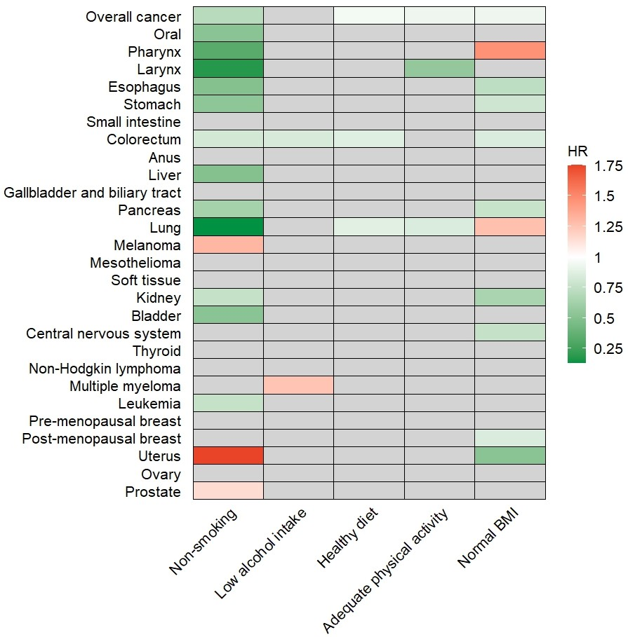

Supplementary Figure 2. Association between individual healthy lifestyle factors and overall and site-specific cancers in model 2
Model 2 was adjusted for age, sex, ethnicity, region, index of multiple deprivation, household income, education, history of cancer screening, family history of cancer, hypertension, diabetes, height, and additionally adjusted for all other individual lifestyle factors. For certain cancer types, we further adjusted for additional covariates (Supplementary Table 5). The heatmap is colored based on HR. Green indicates lower cancer risk (HR < 1) and red indicates higher risk (HR > 1). Grey indicates that the association was not significant after being corrected by the Benjamini–Hochberg method. Abbreviations: HR, hazard ratio.

Supplementary Table 7. Association between individual healthy lifestyle factors and overall and site-specific cancers in model 1
Cancer site | Non-smoking | Pª | Moderate alcohol intake | Pª | Healthy diet | Pª | Adequate physical activity | Pª | Normal BMI | Pª
Cancer site | HR (95% CI) | Pª | HR (95% CI) | Pª | HR (95% CI) | Pª | HR (95% CI) | Pª | HR (95% CI) | Pª
Overall cancer | 0.70 (0.68, 0.72) | <.001 | 0.97 (0.94, 0.99) | 0.013 | 0.96 (0.93, 0.98) | <.001 | 0.93 (0.90, 0.96) | <.001 | 0.92 (0.90, 0.95) | <.001
Oral | 0.48 (0.37, 0.61) | <.001 | 0.84 (0.67, 1.05) | 0.265 | 0.90 (0.70, 1.15) | 0.441 | 0.90 (0.67, 1.21) | 0.638 | 1.11 (0.88, 1.41) | 0.559
Pharynx | 0.28 (0.22, 0.37) | <.001 | 0.79 (0.61, 1.02) | 0.173 | 0.77 (0.58, 1.04) | 0.43 | 0.89 (0.64, 1.23) | 0.618 | 1.46 (1.12, 1.89) | 0.021
Larynx | 0.15 (0.10, 0.21) | <.001 | 0.71 (0.49, 1.03) | 0.171 | 0.53 (0.33, 0.86) | 0.281 | 0.56 (0.38, 0.83) | 0.014 | 1.34 (0.90, 1.97) | 0.33
Esophagus | 0.47 (0.40, 0.55) | <.001 | 0.93 (0.80, 1.09) | 0.558 | 0.83 (0.70, 0.98) | 0.032 | 0.83 (0.68, 1.01) | 0.178 | 0.69 (0.57, 0.83) | <.001
Stomach | 0.48 (0.39, 0.59) | <.001 | 0.98 (0.81, 1.18) | 0.925 | 0.86 (0.70, 1.06) | 0.173 | 0.89 (0.69, 1.14) | 0.558 | 0.75 (0.60, 0.94) | 0.036
Small intestine | 0.83 (0.55, 1.26) | 0.569 | 1.31 (0.97, 1.78) | 0.178 | 1.00 (0.72, 1.38) | 0.986 | 0.77 (0.52, 1.14) | 0.359 | 0.69 (0.48, 0.98) | 0.112
Colorectum | 0.81 (0.74, 0.89) | <.001 | 0.84 (0.78, 0.90) | <.001 | 0.89 (0.82, 0.96) | 0.011 | 0.93 (0.85, 1.02) | 0.301 | 0.86 (0.80, 0.93) | <.001
Anus | 0.77 (0.46, 1.32) | 0.524 | 0.87 (0.59, 1.29) | 0.638 | 0.79 (0.51, 1.22) | 0.644 | 0.80 (0.48, 1.33) | 0.558 | 1.09 (0.73, 1.65) | 0.829
Liver | 0.43 (0.35, 0.52) | <.001 | 1.08 (0.90, 1.30) | 0.583 | 0.84 (0.69, 1.04) | 0.423 | 0.77 (0.61, 0.98) | 0.097 | 0.74 (0.60, 0.93) | 0.025
Gallbladder and biliary tract | 0.88 (0.59, 1.32) | 0.756 | 1.38 (1.03, 1.85) | 0.098 | 0.99 (0.72, 1.35) | 0.36 | 0.96 (0.64, 1.45) | 0.986 | 0.56 (0.39, 0.81) | 0.01
Pancreas | 0.61 (0.52, 0.71) | <.001 | 0.94 (0.82, 1.07) | 0.48 | 0.87 (0.76, 1.01) | 0.407 | 0.88 (0.74, 1.05) | 0.293 | 0.75 (0.65, 0.87) | 0.001
Lung | 0.11 (0.10, 0.12) | <.001 | 1.01 (0.93, 1.10) | 0.946 | 0.81 (0.74, 0.89) | <.001 | 0.83 (0.75, 0.92) | 0.01 | 1.23 (1.12, 1.34) | <.001
Melanoma | 1.45 (1.24, 1.70) | <.001 | 0.88 (0.80, 0.97) | 0.033 | 1.04 (0.94, 1.15) | 0.212 | 1.02 (0.89, 1.17) | 0.976 | 0.97 (0.87, 1.07) | 0.659
Mesothelioma | 0.84 (0.62, 1.14) | 0.583 | 1.00 (0.78, 1.28) | 0.986 | 0.86 (0.65, 1.13) | 0.004 | 0.97 (0.68, 1.39) | 0.986 | 0.83 (0.62, 1.12) | 0.407
Soft tissue | 0.86 (0.61, 1.21) | 0.592 | 0.90 (0.70, 1.15) | 0.572 | 1.12 (0.86, 1.45) | 0.986 | 0.89 (0.64, 1.26) | 0.693 | 0.83 (0.63, 1.10) | 0.388
Kidney | 0.72 (0.61, 0.85) | 0.001 | 1.14 (0.99, 1.30) | 0.163 | 1.01 (0.87, 1.16) | 0.986 | 0.80 (0.67, 0.95) | 0.041 | 0.60 (0.51, 0.71) | <.001
Bladder | 0.49 (0.41, 0.57) | <.001 | 1.02 (0.88, 1.18) | 0.952 | 0.85 (0.72, 1.01) | 0.173 | 0.99 (0.80, 1.22) | 0.986 | 0.85 (0.71, 1.02) | 0.171
Central nervous system | 1.10 (0.86, 1.43) | 0.629 | 0.96 (0.80, 1.14) | 0.755 | 0.94 (0.77, 1.13) | 0.952 | 1.11 (0.86, 1.43) | 0.618 | 0.78 (0.64, 0.96) | 0.046
Thyroid | 0.91 (0.60, 1.38) | 0.742 | 1.32 (1.01, 1.73) | 0.116 | 1.15 (0.87, 1.53) | 0.412 | 0.89 (0.61, 1.28) | 0.638 | 0.76 (0.57, 1.03) | 0.178
Non-Hodgkin lymphoma | 0.97 (0.83, 1.13) | 0.955 | 1.07 (0.96, 1.19) | 0.397 | 1.09 (0.97, 1.22) | 0.476 | 0.99 (0.85, 1.16) | 0.986 | 1.01 (0.90, 1.14) | 0.884
Multiple myeloma | 1.05 (0.82, 1.33) | 0.693 | 1.28 (1.08, 1.51) | 0.014 | 1.13 (0.95, 1.35) | 0.441 | 0.85 (0.68, 1.07) | 0.407 | 0.93 (0.78, 1.12) | 0.675
Leukemia | 0.76 (0.64, 0.91) | 0.01 | 0.99 (0.86, 1.14) | 0.971 | 1.00 (0.86, 1.16) | 0.986 | 0.90 (0.74, 1.08) | 0.43 | 0.88 (0.75, 1.03) | 0.222
Pre-menopausal breast | 1.19 (0.93, 1.52) | 0.36 | 0.85 (0.75, 0.95) | 0.023 | 0.91 (0.80, 1.04) | 0.986 | 0.90 (0.77, 1.06) | 0.338 | 1.03 (0.92, 1.16) | 0.829
Post-menopausal breast | 0.89 (0.79, 1.01) | 0.178 | 0.88 (0.82, 0.95) | 0.005 | 0.97 (0.90, 1.05) | 0.441 | 0.92 (0.83, 1.03) | 0.301 | 0.87 (0.81, 0.94) | 0.003
Uterus | 1.76 (1.29, 2.40) | 0.001 | 1.19 (1.03, 1.38) | 0.059 | 1.06 (0.91, 1.24) | 0.43 | 0.83 (0.68, 1.01) | 0.178 | 0.52 (0.44, 0.61) | <.001
Ovary | 0.99 (0.74, 1.34) | 0.976 | 1.12 (0.94, 1.33) | 0.407 | 1.10 (0.92, 1.31) | 0.638 | 0.96 (0.75, 1.23) | 0.952 | 0.83 (0.69, 0.99) | 0.141
Prostate | 1.21 (1.13, 1.29) | <.001 | 0.98 (0.94, 1.03) | 0.583 | 0.98 (0.93, 1.03) | 0.084 | 1.01 (0.94, 1.08) | 0.986 | 1.02 (0.96, 1.07) | 0.747
Model 1 was adjusted for age and sex.
ª P-value corrected by the Benjamini-Hochberg method.

Supplementary Table 8. Association between individual healthy lifestyle factors and overall and site-specific cancers in model 2
Cancer site | Non-smoking | Pª | Moderate alcohol intake | Pª | Healthy diet | Pª | Adequate physical activity | Pª | Normal BMI | Pª
Cancer site | HR (95% CI) | Pª | HR (95% CI) | Pª | HR (95% CI) | Pª | HR (95% CI) | Pª | HR (95% CI) | Pª
Overall cancer | 0.71 (0.69, 0.73) | <.001 | 0.97 (0.95, 0.99) | 0.064 | 0.95 (0.92, 0.97) | <.001 | 0.93 (0.90, 0.96) | <.001 | 0.93 (0.90, 0.95) | <.001
Oral | 0.52 (0.40, 0.68) | <.001 | 0.78 (0.62, 0.99) | 0.121 | 0.95 (0.74, 1.22) | 0.829 | 0.90 (0.67, 1.21) | 0.675 | 1.14 (0.90, 1.45) | 0.496
Pharynx | 0.33 (0.25, 0.43) | <.001 | 0.75 (0.58, 0.98) | 0.117 | 0.84 (0.62, 1.13) | 0.455 | 0.87 (0.62, 1.21) | 0.628 | 1.46 (1.12, 1.90) | 0.023
Larynx | 0.18 (0.12, 0.26) | <.001 | 0.71 (0.49, 1.04) | 0.237 | 0.59 (0.36, 0.97) | 0.117 | 0.56 (0.37, 0.84) | 0.027 | 1.31 (0.88, 1.94) | 0.366
Esophagus | 0.50 (0.42, 0.60) | <.001 | 0.93 (0.80, 1.09) | 0.608 | 0.83(0.69, 0.98) | 0.112 | 0.83 (0.68, 1.02) | 0.182 | 0.73 (0.60, 0.88) | 0.005
Stomach | 0.54 (0.44, 0.67) | <.001 | 0.92 (0.76, 1.11) | 0.599 | 0.92 (0.75, 1.14) | 0.634 | 0.89 (0.69, 1.14) | 0.553 | 0.80 (0.64, 1.01) | 0.180
Small intestine | 0.89 (0.58, 1.35) | 0.728 | 1.28 (0.94, 1.74) | 0.262 | 1.02 (0.73, 1.41) | 0.960 | 0.77(0.52, 1.14) | 0.380 | 0.72 (0.50, 1.04) | 0.202
Colorectum | 0.82 (0.75, 0.89) | <.001 | 0.84 (0.79, 0.90) | <.001 | 0.87 (0.80, 0.93) | <.001 | 0.93 (0.85, 1.03) | 0.338 | 0.85 (0.79, 0.92) | <.001
Anus | 0.87 (0.50, 1.50) | 0.801 | 0.85 (0.57, 1.26) | 0.608 | 0.75(0.48, 1.16) | 0.377 | 0.80 (0.48, 1.34) | 0.608 | 1.00 (0.65, 1.52) | 0.986
Liver | 0.50 (0.41, 0.62) | <.001 | 0.99 (0.82, 1.20) | 0.971 | 0.86(0.70, 1.07) | 0.368 | 0.82 (0.65, 1.05) | 0.269 | 0.85 (0.68, 1.07) | 0.372
Gallbladder and biliary tract | 0.99 (0.66, 1.50) | 0.953 | 1.36 (1.00, 1.84) | 0.146 | 1.07 (0.78, 1.47) | 0.836 | 0.99 (0.66, 1.50) | 0.953 | 0.66 (0.45, 0.95) | 0.088
Pancreas | 0.63 (0.54, 0.74) | <.001 | 0.92 (0.81, 1.05) | 0.427 | 0.86 (0.75, 1.00) | 0.146 | 0.90 (0.75, 1.07) | 0.427 | 0.77 (0.66, 0.90) | 0.005
Lung | 0.13 (0.11, 0.14) | <.001 | 0.97 (0.90, 1.06) | 0.703 | 0.88 (0.79, 0.97) | 0.035 | 0.85 (0.77, 0.95) | 0.005 | 1.27 (1.16, 1.39) | <.001
Melanoma | 1.31 (1.12, 1.54) | 0.005 | 0.96 (0.87, 1.06) | 0.608 | 0.98 (0.89, 1.09) | 0.648 | 0.99 (0.86, 1.14) | 0.977 | 0.94 (0.85, 1.05) | 0.504
Mesothelioma | 1.02 (0.75, 1.39) | 0.971 | 1.03 (0.80, 1.33) | 0.925 | 0.97 (0.74, 1.29) | 0.925 | 0.96 (0.67, 1.38) | 0.847 | 0.94 (0.70, 1.28) | 0.847
Soft tissue | 0.91 (0.64, 1.30) | 0.728 | 0.89 (0.69, 1.15) | 0.599 | 1.10 (0.85, 1.43) | 0.648 | 0.90 (0.64, 1.27) | 0.675 | 0.83 (0.63, 1.10) | 0.372
Kidney | 0.76 (0.64, 0.90) | 0.010 | 1.17 (1.02, 1.33) | 0.097 | 1.02 (0.88, 1.18) | 0.871 | 0.81 (0.68, 0.97) | 0.074 | 0.65 (0.55, 0.78) | <.001
Bladder | 0.52 (0.44, 0.62) | <.001 | 1.01 (0.87, 1.18) | 0.925 | 0.87 (0.74, 1.03) | 0.254 | 1.00 (0.81, 1.24) | 0.986 | 0.88 (0.74, 1.05) | 0.368
Central nervous system | 1.11 (0.86, 1.44) | 0.612 | 0.96 (0.80, 1.14) | 0.782 | 0.92 (0.76, 1.12) | 0.608 | 1.09 (0.84, 1.41) | 0.675 | 0.76 (0.62, 0.93) | 0.042
Thyroid | 0.85 (0.56, 1.30) | 0.671 | 1.28 (0.97, 1.69) | 0.214 | 1.12 (0.84, 1.49) | 0.638 | 0.90 (0.62, 1.29) | 0.737 | 0.77 (0.57, 1.04) | 0.217
Non-Hodgkin lymphoma | 0.99 (0.85, 1.16) | 0.868 | 1.06 (0.95, 1.18) | 0.504 | 1.06 (0.94, 1.19) | 0.562 | 1.00 (0.85, 1.17) | 0.925 | 0.98 (0.87, 1.11) | 0.868
Multiple myeloma | 1.06 (0.83, 1.35) | 0.896 | 1.25 (1.05, 1.48) | 0.049 | 1.12 (0.94, 1.34) | 0.397 | 0.87 (0.69, 1.09) | 0.339 | 0.94 (0.78, 1.13) | 0.636
Leukemia | 0.76 (0.64, 0.92) | 0.019 | 1.00 (0.87, 1.15) | 0.977 | 0.97(0.84, 1.13) | 0.867 | 0.90 (0.75, 1.09) | 0.499 | 0.88 (0.75, 1.03) | 0.242
Pre-menopausal breast | 1.15 (0.88, 1.51) | 0.608 | 0.89 (0.79, 1.02) | 0.186 | 0.88 (0.77, 1.01) | 0.180 | 0.93 (0.78, 1.11) | 0.461 | 1.02 (0.90, 1.16) | 0.867
Post-menopausal breast | 0.90 (0.79, 1.03) | 0.193 | 0.90 (0.83, 0.98) | 0.076 | 0.95 (0.88, 1.03) | 0.380 | 0.94 (0.84, 1.05) | 0.372 | 0.85 (0.77, 0.92) | <.001
Uterus | 1.75 (1.27, 2.40) | 0.005 | 1.15 (0.99, 1.34) | 0.117 | 1.06 (0.91, 1.24) | 0.628 | 0.83 (0.69, 1.01) | 0.184 | 0.52 (0.44, 0.62) | <.001
Ovary | 1.06 (0.78, 1.44) | 0.896 | 1.07 (0.90, 1.29) | 0.617 | 1.10 (0.92, 1.32) | 0.501 | 0.98(0.77, 1.26) | 0.896 | 0.84 (0.70, 1.01) | 0.176
Prostate | 1.15 (1.08, 1.23) | <.001 | 0.99 (0.94, 1.04) | 0.826 | 0.96(0.91, 1.01) | 0.237 | 1.00 (0.94, 1.07) | 0.896 | 1.01 (0.96, 1.07) | 0.836
Model 2 was adjusted for age, sex, ethnicity, region, index of multiple deprivation, household income, education, history of cancer screening, family history of cancer, hypertension, diabetes, height, and additionally adjusted for all other individual lifestyle factors. For certain cancer types, we further adjusted for additional covariates (Supplementary Table 5).
ª P-value corrected by the Benjamini–Hochberg method.

Supplementary Figure 3. Multivariable-adjusted PAF estimates of smoking for site-specific cancers
The negative PAF was truncated at a lower limit of 0, as this is the lowest threshold to determine an association with increased risk.
Model 2 was adjusted for age, sex, alcohol intake, unhealthy diet, physical inactivity, overweight, ethnicity, region, index of multiple deprivation, household income, education, history of cancer screening, family history of cancer, hypertension, diabetes, and height. For certain cancer types, we further adjusted for additional covariates (Supplementary Table 5).

Supplementary Figure 4. Multivariable-adjusted PAF estimates of alcohol intake for site-specific cancers
The negative PAF was truncated at a lower limit of 0, as this is the lowest threshold to determine an association with increased risk.
Model 2 was adjusted for age, sex, smoking, unhealthy diet, physical inactivity, overweight, ethnicity, region, index of multiple deprivation, household income, education, history of cancer screening, family history of cancer, hypertension, diabetes, and height. For certain cancer types, we further adjusted for additional covariates (Supplementary Table 5).

Supplementary Figure 5. Multivariable-adjusted PAF estimates of unhealthy diet for site-specific cancers
The negative PAF was truncated at a lower limit of 0, as this is the lowest threshold to determine an association with increased risk.
Model 2 was adjusted for age, sex, smoking, alcohol intake, physical inactivity, overweight, ethnicity, region, index of multiple deprivation, household income, education, history of cancer screening, family history of cancer, hypertension, diabetes, and height. For certain cancer types, we further adjusted for additional covariates (Supplementary Table 5).

Supplementary Figure 6. Multivariable-adjusted PAF estimates of physical inactivity for site-specific cancers
The negative PAF was truncated at a lower limit of 0, as this is the lowest threshold to determine an association with increased risk.
Model 2 was adjusted for age, sex, smoking, alcohol intake, unhealthy diet, overweight, ethnicity, region, index of multiple deprivation, household income, education, history of cancer screening, family history of cancer, hypertension, diabetes, and height. For certain cancer types, we further adjusted for additional covariates (Supplementary Table 5).

Supplementary Figure 7. Multivariable-adjusted PAF estimates of overweight for site-specific cancers
The negative PAF was truncated at a lower limit of 0, as this is the lowest threshold to determine an association with increased risk.
Model 2 was adjusted for age, sex, smoking, alcohol intake, unhealthy diet, physical inactivity, ethnicity, region, index of multiple deprivation, household income, education, history of cancer screening, family history of cancer, hypertension, diabetes, and height. For certain cancer types, we further adjusted for additional covariates (Supplementary Table 5).

Supplementary Table 9. Association between HLS groups and site-specific cancers stratified by age and sex
Cancer site | HR (95% CI) |  | P_{interaction} | HR (95% CI) |  | P_{interaction}
Cancer site | Age<60 | Age≥60 | P_{interaction} | Women | Men | P_{interaction}
Overall |  |  | 0.981 |  |  | 0.214
Medium HLS | 0.81 (0.76, 0.85) | 0.84 (0.80, 0.88) |  | 0.80 (0.75, 0.85) | 0.84 (0.80, 0.88)
High HLS | 0.70 (0.65, 0.75) | 0.74 (0.70, 0.78) |  | 0.68 (0.64, 0.73) | 0.74 (0.70, 0.78)
Oral |  |  | 0.336 |  |  | 0.273
Medium HLS | 0.64 (0.42, 0.99) | 0.74 (0.47, 1.16) |  | 0.41 (0.23, 0.74) | 0.81 (0.56, 1.16)
High HLS | 0.52 (0.30, 0.89) | 0.66 (0.39, 1.11) |  | 0.50 (0.27, 0.93) | 0.52 (0.32, 0.85)
Pharynx |  |  | 0.290 |  |  | 0.148
Medium HLS | 0.61 (0.41, 0.93) | 0.55 (0.33, 0.93) |  | 0.33 (0.17, 0.64) | 0.67 (0.46, 0.96)
High HLS | 0.53 (0.31, 0.90) | 0.28 (0.14, 0.60) |  | 0.19 (0.09, 0.44) | 0.52 (0.32, 0.86)
Larynxª |  |  | 0.096 |  |  | 0.401
Medium HLS | 0.27 (0.15, 0.50) | 0.34 (0.21, 0.54) |  | 0.40 (0.10, 1.50) | 0.31 (0.21, 0.46)
High HLS | 0.04 (0.00, 0.28) | 0.18 (0.08, 0.40) |  | N/A | 0.15 (0.07, 0.31)
Esophagus |  |  | 0.377 |  |  | 0.047
Medium HLS | 0.60 (0.43, 0.84) | 0.60 (0.47, 0.76) |  | 1.16 (0.59, 2.31) | 0.55 (0.45, 0.68)
High HLS | 0.38 (0.24, 0.61) | 0.43 (0.32, 0.59) |  | 0.79 (0.38, 1.65) | 0.38 (0.29, 0.51)
Stomach |  |  | 0.484 |  |  | 0.355
Medium HLS | 0.73 (0.47, 1.14) | 0.64 (0.47, 0.88) |  | 0.44 (0.26, 0.74) | 0.76 (0.57, 1.01)
High HLS | 0.46 (0.25, 0.84) | 0.50 (0.34, 0.73) |  | 0.45 (0.25, 0.80) | 0.45 (0.30, 0.67)
Colorectum |  |  | 0.325 |  |  | 0.004
Medium HLS | 0.83 (0.70, 0.98) | 0.80 (0.70, 0.91) |  | 0.85 (0.69, 1.05) | 0.80 (0.71, 0.90)
High HLS | 0.64 (0.53, 0.78) | 0.67 (0.57, 0.78) |  | 0.78 (0.62, 0.97) | 0.58 (0.50, 0.68)
Liver |  |  | 0.675 |  |  | 0.139
Medium HLS | 0.48 (0.32, 0.71) | 0.59 (0.44, 0.79) |  | 0.50 (0.30, 0.83) | 0.56 (0.43, 0.73)
High HLS | 0.55 (0.33, 0.91) | 0.40 (0.27, 0.59) |  | 0.46 (0.26, 0.81) | 0.41 (0.28, 0.60)
Pancreas |  |  | 0.012 |  |  | 0.557
Medium HLS | 0.54 (0.40, 0.73) | 0.81 (0.64, 1.03) |  | 0.50 (0.37, 0.68) | 0.83 (0.66, 1.04)
High HLS | 0.36 (0.24, 0.53) | 0.63 (0.47, 0.83) |  | 0.43 (0.30, 0.60) | 0.54 (0.40, 0.73)
Lung |  |  | 0.842 |  |  | 0.438
Medium HLS | 0.39 (0.32, 0.46) | 0.38 (0.34, 0.43) |  | 0.36 (0.31, 0.43) | 0.39 (0.35, 0.44)
High HLS | 0.21 (0.16, 0.28) | 0.18 (0.15, 0.22) |  | 0.19 (0.16, 0.24) | 0.18 (0.14, 0.22)
Soft tissue |  |  | 0.129 |  |  | 0.276
Medium HLS | 0.69 (0.39, 1.21) | 0.65 (0.39, 1.06) |  | 0.75 (0.40, 1.41) | 0.63 (0.40, 0.99)
High HLS | 0.44 (0.22, 0.89) | 0.72 (0.42, 1.25) |  | 0.74 (0.38, 1.45) | 0.50 (0.27, 0.90)
Kidney |  |  | 0.015 |  |  | 0.154
Medium HLS | 0.96 (0.69, 1.33) | 0.92 (0.71, 1.19) |  | 1.03 (0.64, 1.68) | 0.91 (0.72, 1.13)
High HLS | 0.52 (0.33, 0.80) | 0.85 (0.63, 1.14) |  | 0.65 (0.38, 1.12) | 0.78 (0.59, 1.03)
Bladder |  |  | 0.339 |  |  | 0.656
Medium HLS | 0.59 (0.40, 0.87) | 0.81 (0.64, 1.04) |  | 0.83 (0.44, 1.56) | 0.73 (0.59, 0.90)
High HLS | 0.48 (0.29, 0.79) | 0.55 (0.40, 0.74) |  | 0.54 (0.27, 1.10) | 0.52 (0.39, 0.69)
Post-menopausal breast^{b} |  |  | 0.031 | N/A | N/A | N/A
Medium HLS | 0.95 (0.76, 1.20) | 0.96 (0.79, 1.17) |  | N/A | N/A | N/A
High HLS | 0.91 (0.71, 1.16) | 0.74 (0.60, 0.91) |  | N/A | N/A | N/A
ª No cases of laryngeal cancer were observed among women with high HLS, resulting in an undefined hazard ratio for this group.
^{b} Post-menopausal breast cancer was only for women.
Model 2 was adjusted for age, sex, ethnicity, region, index of multiple deprivation, household income, education, history of cancer screening, family history of cancer, hypertension, diabetes, and height. For certain cancer types, we further adjusted for additional covariates (Supplementary Table 4). The variable used to categorize the subgroups was not adjusted for in the stratified analysis. Abbreviations: HLS, Healthy Lifestyle Score; HR, hazard ratio; CI, confidence interval.

Supplementary Reference
1. Ferguson J, O’Connell M. graphPAF: An R package to estimate and display population attributable fractions2023.

