Supplementary figure 1

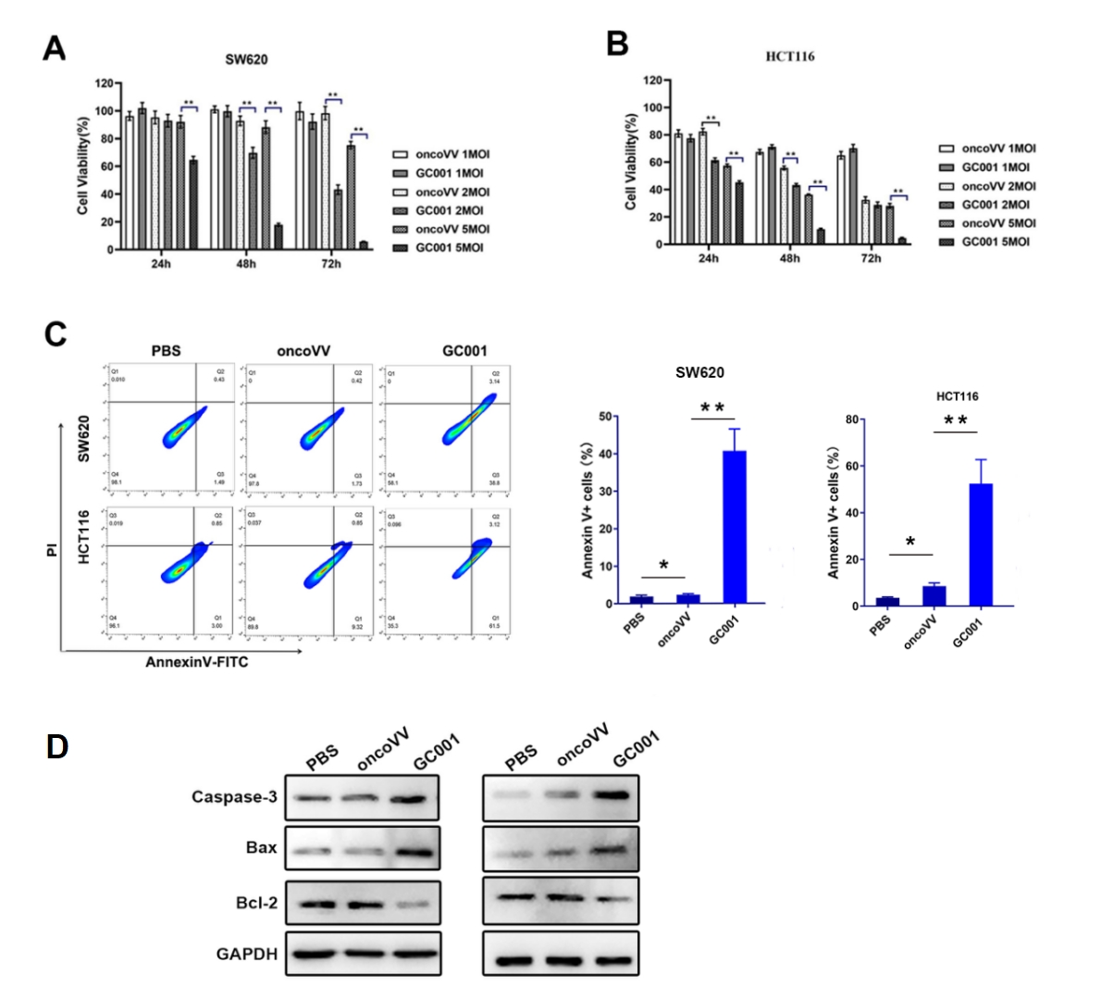

Supple Fig 1. The cytotoxicity of GC001 on colorectal cancer cells. GC001 potently inhibited cell proliferation in SW620 (A) and HCT116 (B) cells as determined by MTT assay. (C) GC001 enhanced the ratio of apoptotic cells as determined by flow cytometry. (D) The effect of GC001 on apoptotic pathway elements including caspase-3, Bax, and Bcl-2 as determined by Western blot. The presented data represent a result from at least 3 independent experiments (mean ± SEM, n = 3, *: p<0.05, **: p<0.01).

Supplementary figure 2

Supple Fig 2. MG132 inhibited NRF2 degradation. Western blot was used to investigate NRF2 protein levels in HCT116 cells treated with PBS, oncoVV, GC001, or oncoVV‑shSTRIP1#2, in combination with or without MG132 at 120 nM. Viruses were administrated at 1.5 MOI. GAPDH served as a loading control.

Supplementary figure 3

Supple Fig 3. GC001-induced ROS production was effectively attenuated by NADPH treatment, as determined by flow cytometry. The presented data are representative of at least three independent experiments. NADPH was used at 200 μM, while GC001 or oncoVV were administered at 2MOI.

Supplementary figure 4

Supple Fig 4. STRIP1 silencing did not alter ROS levels in HCT116 cells, as evaluated by flow cytometry. The presented data are representative of at least three independent experiments.

Supplementary figure 5

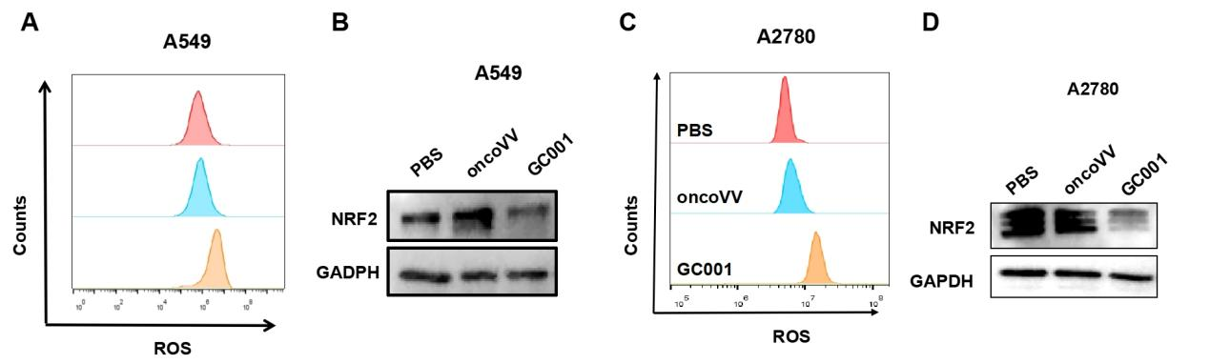
Supple Fig 5. GC001 elevated ROS in lung cancer and ovarian cancer cells. (A) GC001 elevated intracellular ROS in A549 lung cancer cells as determined by flow cytometry analysis. (B) Western blot analysis for NRF2 levels in A549 cells treated with GC001, oncoVV, or PBS. (C) GC001 elevated intracellular ROS in A2780 ovarian cancer cells as determined by flow cytometry analysis. (D) Western blot analysis for NRF2 levels in A2780 cells treated with GC001, oncoVV, or PBS.

Supplementary figure 6

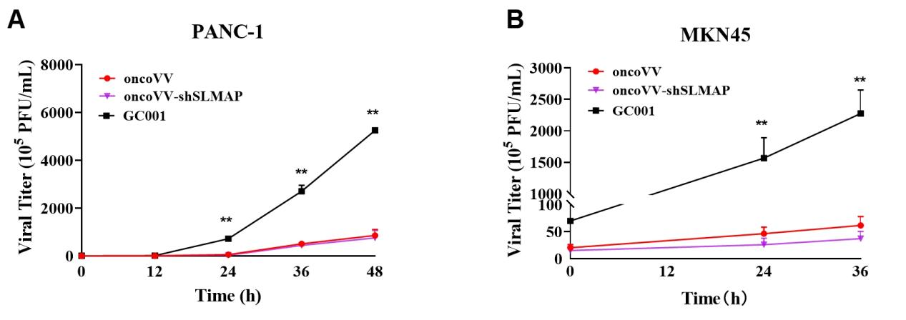
Supple Fig 6. The replication of oncoVV, oncoVV-shSLMAP and GC001 in PANC-1 (A) or MKN45 (B) cells was investigated by TCID₅₀ assay. **: p<0.01. Values are shown in Mean ± SEM from 3 independent biological samples.

Supplementary figure 7

Supple Fig 7. Densitometric quantification of Western blot bands (A-D for Fig. 2B, E, I, J respectively. E-G for Fig. 6B, E, H respectively) via ImageJ, with background-subtracted gray values measured for phosphorylated target, total target protein and GAPDH. Total target signals were normalized to GAPDH; phosphorylation levels were calculated as phosphorylation/total target gray ratios. All normalized values were calibrated to PBS vehicle control (baseline = 1) for intergroup comparison. Values are expressed as mean ± SD (*P<0.05, **P<0.01).

