Supplemental Materials
Figure 1 Mutation Matrix
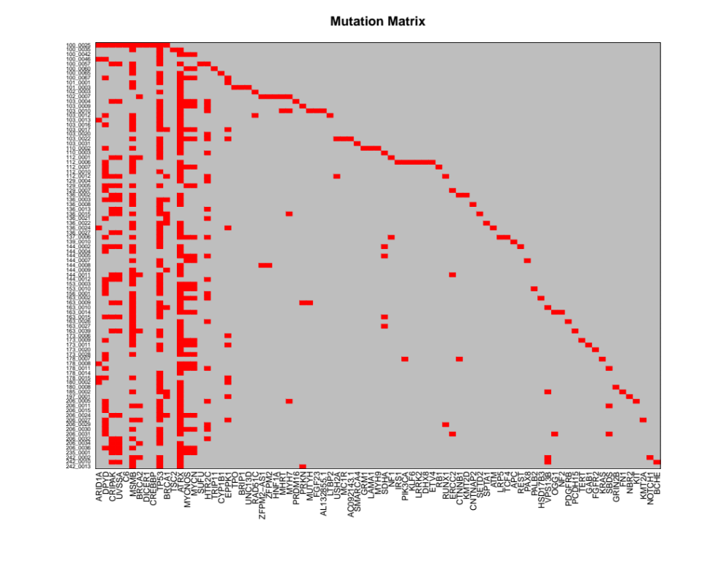

Table 1. RFS From Procurement – Hub Genes

Gene | VigilMedian | PlaceboMedian | Difference | nVigil | nPlacebo | PVAL
PIK3CAwt | 18.2998 | 15.8686 | 2.4312 | 46 | 43 | 0.0799
* PIK3CAm was unable to be performed due to small sample size

Gene | VigilMedian | PlaceboMedian | Difference | nVigil | nPlacebo | PVAL
NF1wt | 18.3326 | 16 | 2.3326 | 47 | 42 | 0.0742
* NF1m was unable to be performed due to small sample size

Gene | VigilMedian | PlaceboMedian | Difference | nVigil | nPlacebo | PVAL
BRCA2wt | 18.2998 | 14.9158 | 3.384 | 46 | 36 | 0.0304
* BRCA2m was unable to be performed due to small sample size

Gene | VigilMedian | PlaceboMedian | Difference | nVigil | nPlacebo | PVAL
ARID1Am | 17.9713 | 14.3573 | 3.614 | 3 | 4 | 0.0365
ARID1Awt | 18.3326 | 16 | 2.3326 | 44 | 40 | 0.1142

Gene | VigilMedian | PlaceboMedian | Difference | nVigil | nPlacebo | PVAL
MUTYHwt | 18.3326 | 16 | 2.3326 | 45 | 44 | 0.0879
* MUTYHm was unable to be performed due to small sample size

Table 2. RFS From Randomization – Small Distance Gene Pairs

Gene 1 | Gene 2 | VigilMedian | PlaceboMedian | Difference | nVigil | nPlacebo | PVAL
UVSSAm | ATRXm | NR | 11.7947 | NR | 9 | 6 | 0.2556
UVSSAwt | ATRXm | 11.4661 | 8.3778 | 3.0883 | 32 | 28 | 0.359
UVSSAwt | ATRXwt | NR | 8.4928 | NR | 4 | 4 | 0.0386
*UVSSAm – ATRXwt was unable to be performed due to small sample size
* NR indicates not reached

Gene 1 | Gene 2 | VigilMedian | PlaceboMedian | Difference | nVigil | nPlacebo | PVAL
BRCA2wt | BRCA1m | 4.731 | 11.4004 | -6.6694 | 5 | 6 | 0.4507
BRCA2wt | BRCA1wt | 11.4661 | 8.345 | 3.1211 | 41 | 30 | 0.0354
*BRCA2m-BRCA1m and BRCA2m-BRCA1wt were unable to be performed due to small sample size

Gene 1 | Gene 2 | VigilMedian | PlaceboMedian | Difference | nVigil | nPlacebo | PVAL
ERCC2wt | BRCA2wt | 11.4661 | 8.345 | 3.1211 | 46 | 34 | 0.0566
*ERCC2m – BRCA2m, ERCC2m – BRCA2wt, ERCC2wt – BRCA2m were unable to be performed due to small sample size

Gene 1 | Gene 2 | VigilMedian | PlaceboMedian | Difference | nVigil | nPlacebo | PVAL
MUTYHwt | BRCA2wt | 11.4661 | 8.345 | 3.1211 | 44 | 36 | 0.0458
*MUTYHm – BRCA2m, MUTYHm – BRCA2wt, MUTYHwt – BRCA2m were unable to be performed due to small sample size

Gene 1 | Gene 2 | VigilMedian | PlaceboMedian | Difference | nVigil | nPlacebo | PVAL
OGG1wt | BRCA2wt | 11.4661 | 8.345 | 3.1211 | 45 | 35 | 0.0552
* OGG1m – BRCA2m, OGG1m – BRCA2wt, OGG1wt – BRCA2m were unable to be performed due to small sample size

Gene 1 | Gene 2 | VigilMedian | PlaceboMedian | Difference | nVigil | nPlacebo | PVAL
PIK3CAwt | BRCA2wt | 10.6448 | 8.0493 | 2.5955 | 45 | 35 | 0.0351
* PIK3CAm – BRCA2m, PIK3CAm – BRCA2wt, PIK3CAwt – BRCA2m were unable to be performed due to small sample size

Gene 1 | Gene 2 | VigilMedian | PlaceboMedian | Difference | nVigil | nPlacebo | PVAL
PRKNwt | BRCA2wt | 11.4661 | 8.0493 | 3.4168 | 44 | 35 | 0.0357
* PRKNm – BRCA2m, PRKNm – BRCA2wt, PRKNwt – BRCA2m were unable to be performed due to small sample size

Gene 1 | Gene 2 | VigilMedian | PlaceboMedian | Difference | nVigil | nPlacebo | PVAL
RAD51Cwt | BRCA2wt | 11.4661 | 8.345 | 3.1211 | 45 | 35 | 0.0464
* RAD51m – BRCA2m, RAD51m – BRCA2wt, RAD51wt – BRCA2m were unable to be performed due to small sample size

Gene 1 | Gene 2 | VigilMedian | PlaceboMedian | Difference | nVigil | nPlacebo | PVAL
RUNX1wt | BRCA2wt | 11.4661 | 8.0493 | 3.4168 | 45 | 35 | 0.0379
* RUNX1m – BRCA2m, RUNX1m – BRCA2wt, RUNX1wt – BRCA2m were unable to be performed due to small sample size

Gene 1 | Gene 2 | VigilMedian | PlaceboMedian | Difference | nVigil | nPlacebo | PVAL
TP53m | ERCC2wt | 18.694 | 8.345 | 10.3491 | 33 | 30 | 0.0577
TP53wt | ERCC2wt | 10.4805 | 19.614 | -9.1335 | 14 | 11 | 0.432
* TP53m – ERCC2m and TP53wt – ERCC2m were unable to be performed due to small sample size

Gene 1 | Gene 2 | VigilMedian | PlaceboMedian | Difference | nVigil | nPlacebo | PVAL
TP53m | HTR2Cm | 12.7474 | 5.7823 | 6.9651 | 10 | 3 | 0.0395
TP53m | HTR2Cwt | 18.694 | 8.9692 | 9.7248 | 23 | 29 | 0.213
TP53wt | HTR2Cwt | 13.6674 | 8.1643 | 5.5031 | 7 | 10 | 0.3037
*TP53wt – HTR2Cm was unable to be performed due to small sample size

Gene 1 | Gene 2 | VigilMedian | PlaceboMedian | Difference | nVigil | nPlacebo | PVAL
TP53m | MYCNm | NR | 8.5092 | NR | 7 | 8 | 0.0592
TP53m | MYCNwt | 18.694 | 8.345 | 10.3491 | 26 | 24 | 0.3284
TP53wt | MYCNm | 5.7823 | 13.9959 | -8.2136 | 6 | 4 | 0.1119
TP53wt | MYCNwt | 13.6674 | 13.8973 | -0.23 | 8 | 8 | 0.2458
* NR indicates not reached

Table 3. RFS From Procurement – Small Distance Gene Pairs

Gene 1 | Gene 2 | VigilMedian | PlaceboMedian | Difference | nVigil | nPlacebo | PVAL
BRCA1m | ARID1Awt | 17.577 | 16 | 1.577 | 5 | 6 | 0.4216
BRCA1wt | ARID1Am | 17.9713 | 14.3573 | 3.614 | 3 | 3 | 0.0294
BRCA1wt | ARID1Awt | 19.3511 | 15.8686 | 3.4825 | 39 | 34 | 0.1117
*BRCA1m – ARID1Am was unable to be performed due to small sample size

Gene 1 | Gene 2 | VigilMedian | PlaceboMedian | Difference | nVigil | nPlacebo | PVAL
BRCA2wt | ARID1Am | 17.9713 | 14.3573 | 3.614 | 3 | 3 | 0.0294
BRCA2wt | ARID1Awt | 18.3326 | 15.8686 | 2.4641 | 43 | 33 | 0.0476
*BRCA2m-BARID1Am and BRCA2m-ARID1Awt were unable to be performed due to small sample size

Gene 1 | Gene 2 | VigilMedian | PlaceboMedian | Difference | nVigil | nPlacebo | PVAL
CTNNB1wt | ARID1Am | 17.9713 | 14.3573 | 3.614 | 3 | 4 | 0.0365
CTNNB1wt | ARID1Awt | 18.2998 | 16 | 2.2998 | 42 | 40 | 0.2056
* CTNNB1m-ARID1Am and CTNNB1m-ARID1Awt were unable to be performed due to small sample size

Gene 1 | Gene 2 | VigilMedian | PlaceboMedian | Difference | nVigil | nPlacebo | PVAL
ERCC2wt | ARID1Am | 17.9713 | 14.3573 | 3.614 | 3 | 4 | 0.0365
ERCC2wt | ARID1Awt | 18.3326 | 16 | 2.3326 | 44 | 37 | 0.0853
* ERCC2m-ARID1Am and ERCC2m-ARID1Awt were unable to be performed due to small sample size

Gene 1 | Gene 2 | VigilMedian | PlaceboMedian | Difference | nVigil | nPlacebo | PVAL
HTR2Cm | ARID1Awt | 18.2998 | 17.7741 | 0.5257 | 17 | 5 | 0.2549
HTR2Cwt | ARID1Am | 17.9713 | 14.3573 | 3.614 | 3 | 4 | 0.0365
HTR2Cwt | ARID1Awt | 25.4949 | 16 | 9.4949 | 27 | 35 | 0.1505
*HTR2Cm – ARID1Am was unable to be performed due to small sample size

Gene 1 | Gene 2 | VigilMedian | PlaceboMedian | Difference | nVigil | nPlacebo | PVAL
MUTYHwt | ARID1Am | 17.9713 | 14.3573 | 3.614 | 3 | 4 | 0.0365
MUTYHwt | ARID1Awt | 19.3511 | 16 | 3.3511 | 42 | 40 | 0.1117
* MUTYHm-ARID1Am and MUTYHm-ARID1Awt were unable to be performed due to small sample size

Gene 1 | Gene 2 | VigilMedian | PlaceboMedian | Difference | nVigil | nPlacebo | PVAL
NF1wt | ARID1Am | 17.9713 | 14.3573 | 3.614 | 3 | 4 | 0.0365
NF1wt | ARID1Awt | 18.3326 | 16 | 2.3326 | 44 | 38 | 0.0971
* NF1m-ARID1Am and NF1m-ARID1Awt were unable to be performed due to small sample size

Gene 1 | Gene 2 | VigilMedian | PlaceboMedian | Difference | nVigil | nPlacebo | PVAL
PIK3CAwt | ARID1Am | 17.9713 | 14.3573 | 3.614 | 3 | 4 | 0.0365
PIK3CAwt | ARID1Awt | 18.3326 | 16 | 2.3326 | 43 | 39 | 0.1043
* PIK3CAm-ARID1Am and PIK3CAm-ARID1Awt were unable to be performed due to small sample size

Gene 1 | Gene 2 | VigilMedian | PlaceboMedian | Difference | nVigil | nPlacebo | PVAL
PRKNwt | ARID1Am | 17.9713 | 14.3573 | 3.614 | 3 | 4 | 0.0365
PRKNwt | ARID1Awt | 18.3326 | 16 | 2.3326 | 42 | 39 | 0.1065
* PRKNm-ARID1Am and PRKNm-ARID1Awt were unable to be performed due to small sample size

Gene 1 | Gene 2 | VigilMedian | PlaceboMedian | Difference | nVigil | nPlacebo | PVAL
RAD51Cwt | ARID1Am | 17.9713 | 14.3573 | 3.614 | 3 | 4 | 0.0365
RAD51Cwt | ARID1Awt | 19.3511 | 17.7741 | 1.577 | 43 | 39 | 0.1094
* RAD51Cm-RARID1Am and RAD51Cm-ARID1Awt were unable to be performed due to small sample size

Gene 1 | Gene 2 | VigilMedian | PlaceboMedian | Difference | nVigil | nPlacebo | PVAL
RUNX1wt | ARID1Am | 17.9713 | 14.3573 | 3.614 | 3 | 4 | 0.0365
RUNX1wt | ARID1Awt | 19.3511 | 16 | 3.3511 | 43 | 39 | 0.0942
* RUNX1m-ARID1Am and RUNX1m-ARID1Awt were unable to be performed due to small sample size

Gene 1 | Gene 2 | VigilMedian | PlaceboMedian | Difference | nVigil | nPlacebo | PVAL
UVSSAm | ARID1Awt | 17.577 | 17.7741 | -0.1971 | 11 | 11 | 0.1999
UVSSAwt | ARID1Am | 17.9713 | 14.3573 | 3.614 | 3 | 3 | 0.0294
UVSSAwt | ARID1Awt | 19.3511 | 15.8686 | 3.4825 | 33 | 29 | 0.1786
* UVSSAm-ARID1Am was unable to be performed due to small sample size

Gene 1 | Gene 2 | VigilMedian | PlaceboMedian | Difference | nVigil | nPlacebo | PVAL
BRCA2wt | ATRXm | 18.3326 | 15.8686 | 2.4641 | 40 | 28 | 0.1386
BRCA2wt | ATRXwt | 17.9713 | 12.3532 | 5.6181 | 6 | 8 | 0.0373
* BRCA2m-ATRXm and BRCA2m-ATRXwt were unable to be performed due to small sample size

Gene 1 | Gene 2 | VigilMedian | PlaceboMedian | Difference | nVigil | nPlacebo | PVAL
NF1wt | ATRXm | 18.3326 | 16 | 2.3326 | 41 | 33 | 0.2374
NF1wt | ATRXwt | 17.9713 | 12.4846 | 5.4867 | 6 | 9 | 0.0505
* NF1m-ATRXm and NF1m-ATRXwt were unable to be performed due to small sample size

Gene 1 | Gene 2 | VigilMedian | PlaceboMedian | Difference | nVigil | nPlacebo | PVAL
UVSSAm | ATRXm | NR | 18.7269 | NR | 9 | 6 | 0.1777
UVSSAwt | ATRXm | 18.3326 | 14.9158 | 3.4168 | 32 | 28 | 0.3346
UVSSAwt | ATRXwt | NR | 15.1786 | NR | 4 | 4 | 0.0386
* UVSSAm-ATRXwt was unable to be performed due to small sample size

Gene 1 | Gene 2 | VigilMedian | PlaceboMedian | Difference | nVigil | nPlacebo | PVAL
BRCA2wt | BRCA1m | 17.577 | 16 | 1.577 | 5 | 6 | 0.4216
BRCA2wt | BRCA1wt | 18.3326 | 14.7844 | 3.5483 | 41 | 30 | 0.0274
*BRCA2m-BRCA1m and BRCA2m-BRCA1wt were unable to be performed due to small sample size

Gene 1 | Gene 2 | VigilMedian | PlaceboMedian | Difference | nVigil | nPlacebo | PVAL
ERCC2wt | BRCA1m | 17.577 | 16 | 1.577 | 5 | 7 | 0.4765
ERCC2wt | BRCA1wt | 18.3326 | 14.9158 | 3.4168 | 42 | 34 | 0.0595
* ERCC2m-BRCA1m and ERCC2m-BRCA1wt were unable to be performed due to small sample size

Gene 1 | Gene 2 | VigilMedian | PlaceboMedian | Difference | nVigil | nPlacebo | PVAL
ERCC2wt | BRCA2wt | 18.2998 | 14.9158 | 3.384 | 46 | 34 | 0.0334
*ERCC2m – BRCA2m, ERCC2m – BRCA2wt, ERCC2wt – BRCA2m were unable to be performed due to small sample size

Gene 1 | Gene 2 | VigilMedian | PlaceboMedian | Difference | nVigil | nPlacebo | PVAL
HTR2Cm | BRCA2wt | 18.2998 | 17.7741 | 0.5257 | 17 | 5 | 0.2549
HTR2Cwt | BRCA2wt | 19.6468 | 14.9158 | 4.731 | 29 | 31 | 0.0466
*HTR2Cm-BRCA2m and HTR2Cwt-BRCA2m were unable to be performed due to small sample size

Gene 1 | Gene 2 | VigilMedian | PlaceboMedian | Difference | nVigil | nPlacebo | PVAL
MUTYHwt | BRCA2wt | 18.3326 | 14.9158 | 3.4168 | 44 | 36 | 0.0302
*MUTYHm – BRCA2m, MUTYHm – BRCA2wt, MUTYHwt – BRCA2m were unable to be performed due to small sample size

Gene 1 | Gene 2 | VigilMedian | PlaceboMedian | Difference | nVigil | nPlacebo | PVAL
MYCNm | BRCA2wt | 17.347 | 15.9343 | 1.4127 | 13 | 12 | 0.185
MYCNwt | BRCA2wt | 18.2998 | 14.7844 | 3.5154 | 33 | 24 | 0.0591
*MYCNm – BRCA2m and MYCN– BRCA2m were unable to be performed due to small sample size

Gene 1 | Gene 2 | VigilMedian | PlaceboMedian | Difference | nVigil | nPlacebo | PVAL
NF1wt | BRCA2wt | 18.2998 | 14.9158 | 3.384 | 46 | 35 | 0.0396
* NF1m – BRCA2m, NF1m – BRCA2wt, NF1wt – BRCA2m were unable to be performed due to small sample size

Gene 1 | Gene 2 | VigilMedian | PlaceboMedian | Difference | nVigil | nPlacebo | PVAL
OGG1wt | BRCA2wt | 18.2998 | 14.9158 | 3.384 | 45 | 35 | 0.033
* OGG1m – BRCA2m, OGG1m – BRCA2wt, OGG1wt – BRCA2m were unable to be performed due to small sample size

Gene 1 | Gene 2 | VigilMedian | PlaceboMedian | Difference | nVigil | nPlacebo | PVAL
PIK3CAwt | BRCA2wt | 18.2998 | 14.9158 | 3.384 | 45 | 35 | 0.0213
* PIK3CAm – BRCA2m, PIK3CAm – BRCA2wt, PIK3CAwt – BRCA2m were unable to be performed due to small sample size

Gene 1 | Gene 2 | VigilMedian | PlaceboMedian | Difference | nVigil | nPlacebo | PVAL
PRKNwt | BRCA2wt | 18.2998 | 14.9158 | 3.384 | 44 | 35 | 0.0227
* PRKNm – BRCA2m, PRKNm – BRCA2wt, PRKNwt – BRCA2m were unable to be performed due to small sample size

Gene 1 | Gene 2 | VigilMedian | PlaceboMedian | Difference | nVigil | nPlacebo | PVAL
RAD51Cwt | BRCA2wt | 18.3326 | 15.8686 | 2.4641 | 45 | 35 | 0.029
* RAD51Cm – BRCA2m, RAD51Cm – BRCA2wt, RAD51Cwt – BRCA2m were unable to be performed due to small sample size

Gene 1 | Gene 2 | VigilMedian | PlaceboMedian | Difference | nVigil | nPlacebo | PVAL
RUNX1wt | BRCA2wt | 18.3326 | 14.9158 | 3.4168 | 45 | 35 | 0.0241
* RUNX1m – BRCA2m, RUNX1m – BRCA2wt, RUNX1wt – BRCA2m were unable to be performed due to small sample size

Gene 1 | Gene 2 | VigilMedian | PlaceboMedian | Difference | nVigil | nPlacebo | PVAL
NF1wt | ERCC2wt | 18.3326 | 15.8686 | 2.4641 | 47 | 39 | 0.0516
* NF1m – ERCC2m, NF1m – ERCC2wt, NF1wt – ERCC2m were unable to be performed due to small sample size

Gene 1 | Gene 2 | VigilMedian | PlaceboMedian | Difference | nVigil | nPlacebo | PVAL
PIK3CAwt | ERCC2wt | 18.2998 | 15.8686 | 2.4312 | 46 | 40 | 0.0555
* PIK3CAm – ERCC2m, PIK3CAm – ERCC2wt, PIK3CAwt – ERCC2m were unable to be performed due to small sample size

Gene 1 | Gene 2 | VigilMedian | PlaceboMedian | Difference | nVigil | nPlacebo | PVAL
PRKNwt | ERCC2wt | 18.3326 | 15.8686 | 2.4641 | 45 | 40 | 0.0573
* PRKNm – ERCC2m, PRKNm – ERCC2wt, PRKNwt – ERCC2m were unable to be performed due to small sample size

Gene 1 | Gene 2 | VigilMedian | PlaceboMedian | Difference | nVigil | nPlacebo | PVAL
RUNX1wt | ERCC2wt | 18.3326 | 15.8686 | 2.4641 | 46 | 40 | 0.0536
* RUNX1m – ERCC2m, RUNX1m – ERCC2wt, RUNX1wt – ERCC2m were unable to be performed due to small sample size

Gene 1 | Gene 2 | VigilMedian | PlaceboMedian | Difference | nVigil | nPlacebo | PVAL
TP53m | ERCC2wt | 19.3511 | 15.8686 | 3.4825 | 33 | 30 | 0.0408
TP53wt | ERCC2wt | 18.2998 | 25.5934 | -7.2936 | 14 | 11 | 0.4641
* TP53m – ERCC2m, TP53wt– ERCC2m were unable to be performed due to small sample size

Gene 1 | Gene 2 | VigilMedian | PlaceboMedian | Difference | nVigil | nPlacebo | PVAL
TP53m | MYCNm | NR | 15.9343 | NR | 7 | 8 | 0.0529
TP53m | MYCNwt | 17.9713 | 17.7741 | 0.1971 | 26 | 24 | 0.2649
TP53wt | MYCNm | 13.963 | 20.2218 | -6.2587 | 6 | 4 | 0.177
TP53wt | MYCNwt | 19.6468 | 14.9158 | 4.731 | 8 | 8 | 0.195
* NR indicates not reached

Gene 1 | Gene 2 | VigilMedian | PlaceboMedian | Difference | nVigil | nPlacebo | PVAL
TP53m | NF1wt | 19.3511 | 16 | 3.3511 | 33 | 30 | 0.0577
TP53wt | NF1wt | 18.2998 | 14.9158 | 3.384 | 14 | 12 | 0.4102
* TP53m – NF1m, TP53wt– NF1m were unable to be performed due to small sample size

