Supplemental information
Supplemental Table 1: List of antibodies used in the study
Supplemental Table 2: The clinical information of 253 TNBC patients

Supplemental Figure legends

Figure S1. A. The in vitro invasion selection system. The diagram shows the selection system. The un-invasive (MB231 1-0) and highly invasive (MB231 1-5) cells were selected from the parental MB231 cells. B. MDA-MB231 cell line was fat-pad injected into NOD-SCID mice. After 9 weeks, the organs were collected and detected through IVIS system ex vivo.

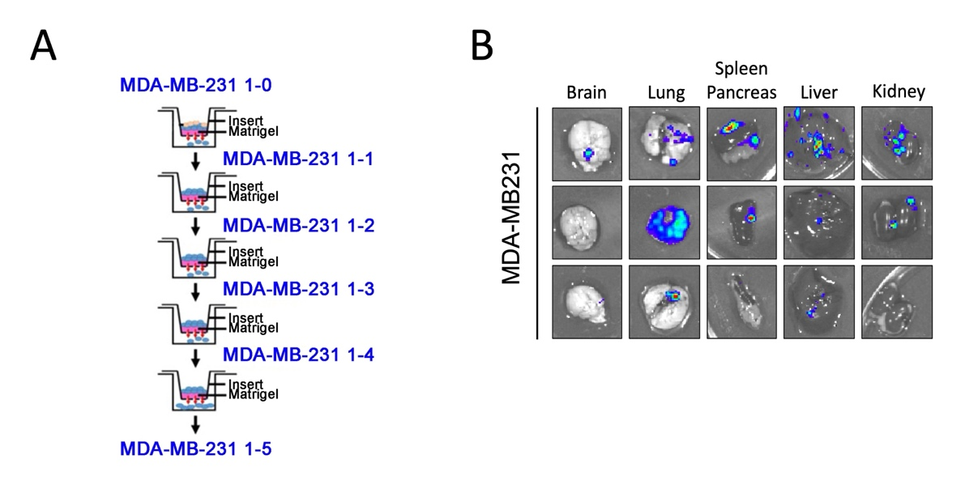

Figure S2. The RNA sequencing analysis to reveal the differential expression pathways in MB231-CTMP compared with the parental MB231 cells. The analysis of KEGG pathway, cellular component, biological process, and molecular function significantly enhanced in CTMP overexpression MB231 cells compared to the parental cells.

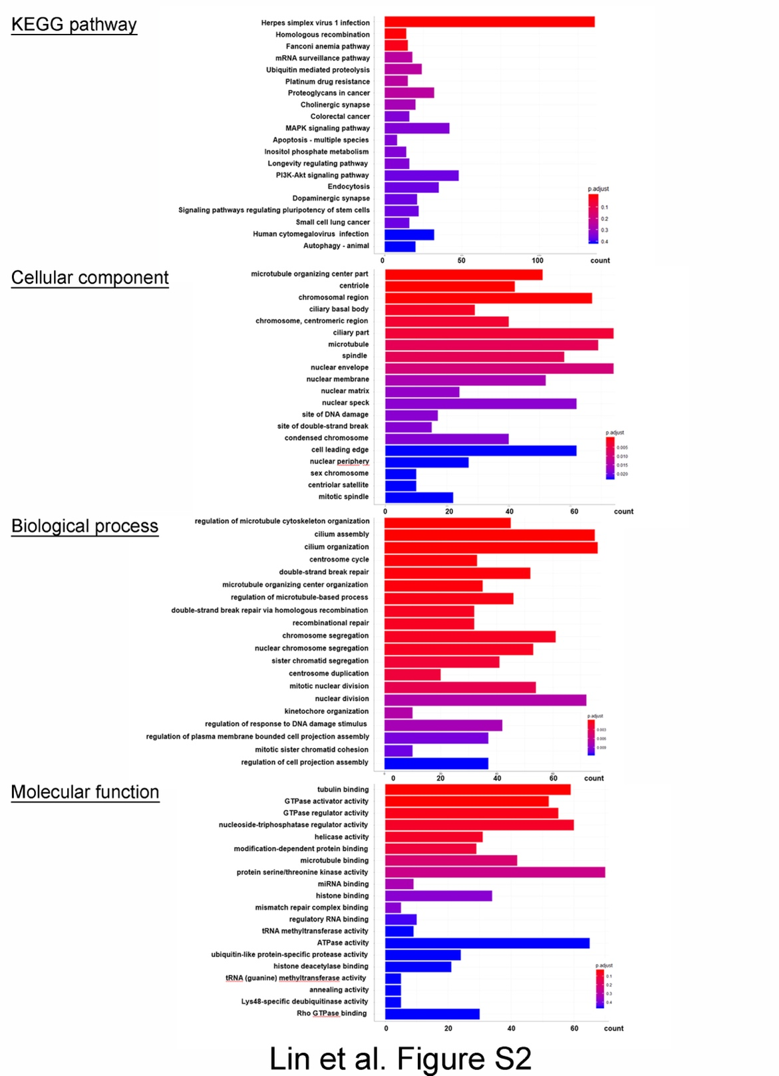
Supplementary Figure 3. RT-qPCR analysis of various TNBC cells, CTMP overexpression BT549 cells, and CTMP knockdown MDA-MB231 cells.
A. RT-qPCR analysis of CTMP mRNA in the indicated breast tumor cell lines and the RT-qPCR results were normalized to MDA-MB231. Error bars, SEM. n=3. B. RT-qPCR analysis of CTMP expression in control and CTMP overexpression cells (BT549), or (C) control and sh-CTMP cells (MDA231). Error bars, SEM. n=3. ****p＜0.0001 by Student’s t test.
