a
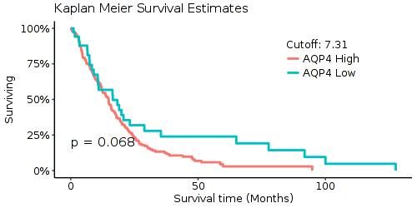
b
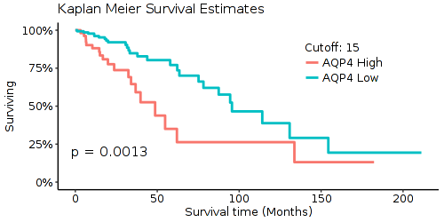
c
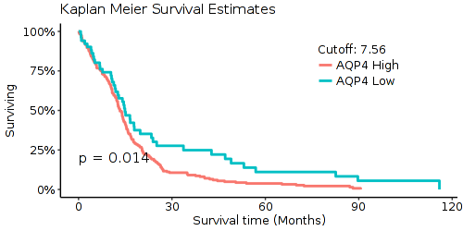
d
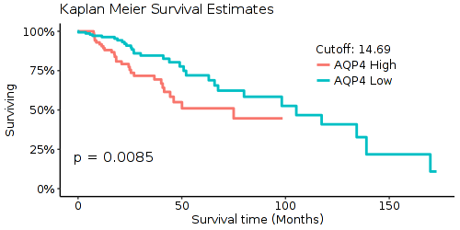

e
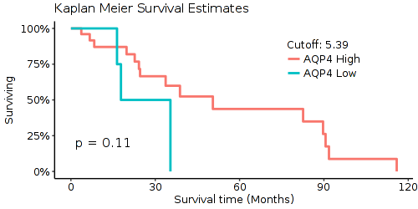
f
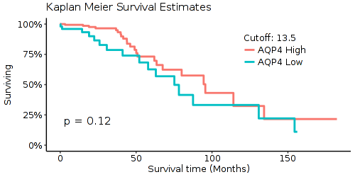
g
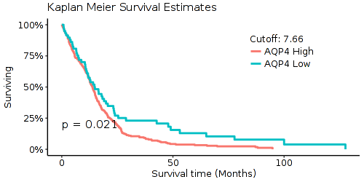
h
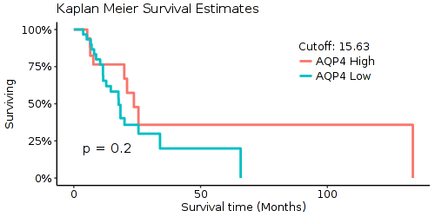
Supplementary Figure S1
a Survival curve of female patients with glioblastoma.
b Survival curve of female patients with lower grade glioma.
c Survival curve of male patients with glioblastoma.
d Survival curve of male patients with lower grade glioma.
e Survival curve of glioblastoma patients with IDH mutant type.
f Survival curve of lower grade glioma patients with IDH mutant type.
g Survival curve of glioblastoma patients with IDH wild type.
h Survival curve of lower grade glioma patients with IDH wild type.

