Supplementary Information for

PIK3CA Mutations Fortifies Molecular Determinants for Immune Signaling in Vascular Cancers

Authors: Donghee Lee, Emma Kozurek, Md Abdullah, Ethan J. Wong, Rong Li, Zhiyan Silvia Liu, Hai Dang Nguyen, Erin B. Dickerson, Jong Hyuk Kim*

*Corresponding author: Jong Hyuk Kim
E-mail address: jkim19@ufl.edu

This file includes:
Fig. S1 to S12

Fig. S1. Genetic alterations of key genes in PI3K-AKT pathway in human angiosarcomas and canine hemangiosarcomas. (A) Oncoplot image of human angiosarcoma samples (upper) was obtained from cBioPortal for Cancer Genomics (https://www.cbioportal.org/). The Angiosarcoma Project (Provisional, July 2020) with 83 samples was used for the analysis. Oncoplot (lower) visualizes data of canine hemangiosarcoma samples retrieved from Megquier et al. [16]. (B) Lollipop plots show mutations in the PIK3CA gene that change amino acids in human angiosarcomas (Upper) and canine hemangiosarcomas (Bottom).

Fig. S2. Confirmation of PIK3CA mutations edited in COSB cells. Sanger sequencing was performed following PCR amplification of the PIK3CA gene region corresponding to the 1047th amino acid from genomic DNA (gDNA) isolated from both PIK3CA wild-type (COSB-WT) and PIK3CA-mutant (COSB-H1047R) cells. Homogeneous PIK3CA H1047R mutation was confirmed with successful CAT to CGT gene editing in COSB-H1047R cells.

Fig. S3. Constitutive activation of PI3K-AKT pathways in PIK3CA-mutant hemangiosarcoma cells. The AKT Pathway Phosphorylation Array was performed in DHSA-1426 WT and PIK3CA-mutant (C8 and C35) cells (A) as well as in COSB-WT and PIK3CA-mutant (COSB-H1047R) cells (B). Green squares indicate positive controls, and red squares represent key proteins downstream of PI3K signaling.

Fig. S4. Gene expression analysis between PIK3CA WT and PIK3CA-mutant hemangiosarcoma. Plots show the Gene Ontology Biological Process (GOBP) analysis results using the differentially expressed genes (adjusted p-value < 0.05) between WT and PIK3CA mutant tumors in (A) hemangiosarcoma patients’ samples (WT, n=58; mutants, n=16) and (B) COSB-WT and COSB-H1047R cells. The results present the top 15 pathways ranked by gene ratio.

Fig. S5. Single-cell gene expression analysis in PIK3CA-mutant hemangiosarcoma cells. (A) UMAP plot visualizes distinct clusters between WT and C35 cells. (B) Dot plot depicts differentially expressed genes involved in angiogenesis (indicated in blue) and immune response (indicated in red). ‘Average expression’ represents the mean expression level of a gene within a single cell cluster. ‘Percent expressed’ indicates the proportion of cells in a cluster that expresses the gene.

Fig. S6. Effect of PI3K inhibition on cell proliferation of hemangiosarcoma cells with and without PIK3CA mutations. (A) WT and PIK3CA-mutant DHSA-1426 cells were treated with different concentrations of ZSTK474 for 72 hours. Cell viability was measured using the CellTiter 96™ AQueous One Solution Cell Proliferation Assay. Data were complied from two independent experiments. Error bars indicate mean ± SD. The IC50 was calculated using non-linear regression method (left). The boxplot shows the IC50 data from each individual experiment (black point) and their mean value (horizontal black line, right). (B) Graph shows cell viability curve of COSB-WT and PIK3CA-mutant COSB-H1047R cells in response to alpelisib. Data were complied from two independent experiments.

Fig. S7. Differential gene expression between PIK3CA-mutant C35 and C8 cells. (A) The volcano plot shows DEG (red dots) with absolute log fold change above 1.5 (indicated by vertical dot lines) and an adjusted p-value (q) below 0.01 (indicated by horizontal dot line). DEGs are denoted with their respective gene names. (B) Pre-ranked gene set enrichment analysis (GSEA) was performed using fgsea R package. A bar plot shows the pathways with the statistical significance (FDR-corrected adjusted p-value < 0.05). X-axis indicates normalized enrichment score (NES) of enriched pathways. (C-D) Bar plots showing the expression of indicated genes in C8 and C35 cells. Y-axes represent normalized counts from RNA-seq analysis. Horizontal black bars indicate the mean of duplicate data points (shown as dots).

Fig. S8. Synergistic effect of alpelisib with doxorubicin in hemangiosarcoma cells. Heatmaps show the highest single agent (A), Loewe additivity (B), and zero interaction potency (C) synergy scores for combinations of the drugs alpelisib and doxorubicin. Cell viability was measured using the CellTiter 96™ AQueous One Solution Cell Proliferation Assay. Synergy scores were determined using the SynergyFinder web application. (D) Table summarizes the synergy scores for 0.1 μM doxorubicin and 10 μM alpelisib combination.

Fig. S9. KEGG pathway analysis with marker genes in alpelisib-resistant single-cell clusters. Plots show KEGG pathways with statistical significance with q-value less than 0.05, analyzed by marker genes in (A) cluster 0 and (B) cluster 5.

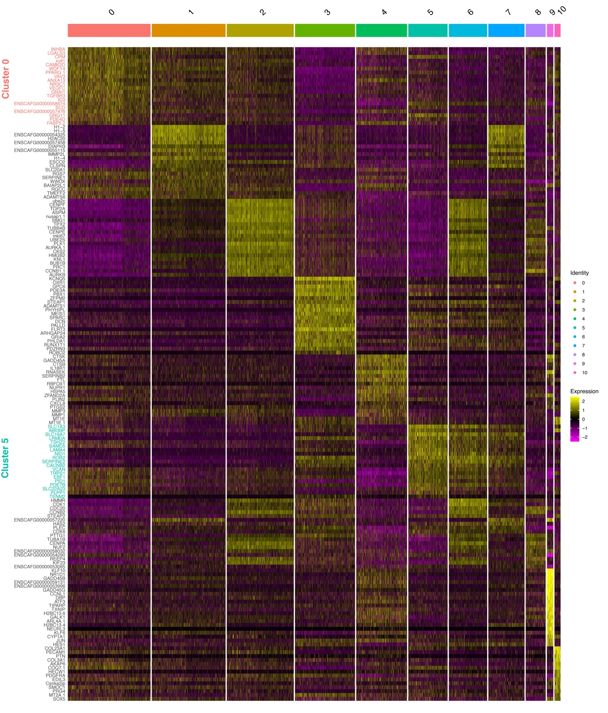
Fig. S10. Single-cell gene expression profiles of distinct cell clusters in mutant C35 cells treated with alpelisib. Heatmap displays the DEGs for each cluster. The colored bars and numbers at the top represent each cluster. Each column represents a single cell, and each row represents a gene. The turquoise vertical bar highlights the DEGS in cluster 5.

Fig. S11. Enrichment of MAPK/ERK pathway in response to alpelisib treatment. (A) Representative immunoblotting data show dose-dependent feedback activation of phosphorylated ERK upon ZSTK474, a pan-PI3K inhibitor, treatment for 24 hours in WT and C35 cells. (B) Enrichment plots from fgsea analysis performed with a pre-ranked gene list from the PIK3CA-mutant COSB-H1047R cells treated with alpelisib and DMSO. (C) Enrichment scores were estimated by fgsea analysis using a pre-ranked gene list from PIK3CA-H1047R transformed MCF10A human mammary gland cells treated with alpelisib and DMSO. RNA-seq gene expression data were downloaded from Gene Expression Omnibus (GEO) database with the accession number GSE157858. Gene rank for GSEA analysis was determined by Wald statistics using DESeq2 software. NES and adjusted p-value are calculated with 1,000 permutations.

Fig. S12. Heatmap shows pseudotime of each single-cell.

