Supplemental Information

Impact of rod-specific Vhl deletion in 3 and 6 weeks old mice
To verify that rod-specific deletion of Vhl resulted in a late onset degeneration in the adult retina, we investigated 3 weeks and 6 weeks old rod^{ΔVhl} and control (Vhl^{flox/flox}) mice. Although Opsin-Cre-mediated excision of floxed sequences starts at around PND7, it reaches its maximal extent around 6 weeks of age ¹. Nevertheless, levels of HIF1A were elevated already at 3 weeks of age (Fig, S1A). The increased presence of HIF1A, however, did not result in increased expression of HIF1 target genes at this time point. Adm and Vegf were not significantly different from controls and only showed increased expression levels at 6 weeks (Adm, Fig S1B) or 11 weeks (Vegf, Fig. 5) of age, respectively. The reason for the delayed activation of transcription by elevated HIF1A levels is currently unknown and will be elucidated in future experiments. At 3 and 6 weeks of age, ONL thickness and retinal morphology were not affected in rod^{ΔVhl} mice (Fig. S1C-F), and expression levels of rod and cone specific genes such as Gnat1 and Gnat2 were not different from control levels (Fig. S1B). This suggests that rod-specific deletion of Vhl did not affect survival of photoreceptors up to 6 weeks of age. This is further supported by normal expression levels of survival (Lif, Fgf2) and stress (glial fibrillary acidic protein; Gfap) related genes at 3 and 6 weeks of age (Fig. S1B). We conclude that retinal degeneration in rod^{ΔVhl} mice started in the adult retina and was not caused by developmental deficits.

Verification of mouse strains
To verify successful deletion of floxed sequences, genomic DNA was isolated from the retina and PCR-amplified using the three primers shown in Table S9. Since genomic DNA was isolated from all retinal cells and Opsin-Cre is specifically expressed in rods ^{1, 2}, the 2-loxP fragment indicating the presence of non-excised DNA was always detected. Nevertheless, the 1-loxP fragment indicating Cre-mediated deletion of floxed sequences was present in all Cre-positive mice (Figure S2A). Deletion of Vhl caused increased levels of HIF1A and HIF2A proteins already at 11 weeks of age (Figure S2B). Additional deletion of Hif1a reduced HIF1A but not HIF2A to basal levels. In contrast, additional deletion of Hif2a reduced levels of HIF2A but not of HIF1A to controls. Additional inactivation of both, Hif1a and Hif2a prevented accumulation of both proteins. Retinal samples of hypoxic and normoxic wild type mice served as controls. These data show that Cre-mediated deletion of floxed sequences was successful and resulted in the anticipated levels of HIF transcription factors.

Deletion of Vhl in rods may affect function in cones
Photopic ERG recordings of rod^{ΔVhl} mice at 6 months of age showed reduced b-wave amplitudes suggesting that cones were affected by the hypoxic response in rods. After the additional rod-specific deletion of Hif1a, of Hif2a or of both Hif1a and Hif2a photopic b-wave amplitudes of deletion strains were not distinguishable from their respective controls (Fig. S3). Importantly, photopic ERGs were recorded in the same mice and during the same experimental session used to determine the scotopic ERGs shown in Fig. 4. The reduced photopic response in rod^{ΔVhl} mice may not have been caused by a significant loss of cones since expression of cone specific transducin (Gnat2) was not affected at 6 months of age (Fig. 2C), the timepoint of the functional tests. Thus, the hypoxic response of rods between 10 weeks and 6 months of age may have induced a lasting effect on cone function by unknown mechanisms. These putative mechanisms may depend on both HIF1 and HIF2 transcription factors as additional deletion of either factor in rod^{ΔVhl} mice prevented the effect.

STAT3 is activated in absence of Vhl
Inactivation of Vhl in rod photoreceptors stabilized (Figs. S1A,S2B) and activated (Figure 5) HIF1A and HIF2A transcription factors. In addition, inactivation of Vhl resulted in the phosphorylation of STAT3 in an HIF1A dependent manner as the additional deletion of Hif1a resulted in basal pSTAT3 levels (Fig. S4). It has been reported that HIF1 can cooperate with STAT3 to regulate gene expression of target genes ³. Furthermore, it has been shown that HIF1 increases STAT3 activity through decreasing the levels of suppressor of cytokine signalling 3 (SOCS3) ⁴ and that constitutively active STAT3 directly interacts with the C-terminal domain of HIF1A ⁵. Thus, HIF1 and STAT3 may cooperate to regulate expression of specific target genes in rod photoreceptors.

Transcriptomic analysis
To detect genes that may be under transcriptional control of HIF1 and/or HIF2 in rods and that may contribute to the degenerative phenotype in rod^{ΔVhl} mice, we determined the retinal transcriptome of rod^{ΔVhl}, rod^{ΔVhl;Hif1a} and Vhl^{flox/flox};Hif1a^{flox/flox} control mice at 11 weeks of age. Tables S2 – S4 show the top 20 up- and down regulated genes of each individual comparison. The full lists of genes analysed can be found in Files S1 – S3. Inactivation of Vhl in rods had a strong impact on the retinal transcriptome with 657 and 245 genes that were more than 2-fold (P < 0.05) up- or down-regulated, respectively. In contrast, only 30 genes were more than 2-fold (P < 0.05) up- and 29 genes down-regulated in rod^{ΔVhl;Hif1a} mice when compared to controls. Whereas the differentially regulated genes in rod^{ΔVhl} mice may be mostly controlled by HIF1, HIF2 and/or STAT3, the genes found in rod^{ΔVhl;Hif1a} mice may be primarily regulated by HIF2. When we compared differentially regulated genes in rod^{ΔVhl} to those in rod^{ΔVhl;Hif1a} mice we identified 493 genes that were expressed at least 2-fold higher than in rod^{ΔVhl} mice and 246 genes that were down regulated. These genes may be primarily regulated by HIF1 and/or STAT3, but not by HIF2. Venn diagrams of up- and down-regulated genes showed that genes differentially regulated in rod^{ΔVhl} mice were largely overlapping with those regulated in rod^{ΔVhl} when compared to rod^{ΔVhl;Hif1a} mice. But both had only little overlap to the differentially regulated genes rod^{ΔVhl;Hif1a} mice (Fig. S5A). Rod^{ΔVhl;Hif1a} mice had overlaps only with rod^{ΔVhl} mice since both mice had HIF2 activated. This was not the case in the list of genes that resulted from the comparison of rod^{ΔVhl} mice with rod^{ΔVhl;Hif1a} mice as already stated above. The gene that was commonly downregulated in all three gene lists was Igh-VJ558, a gene that has been implicated in the immune response, leukocyte migration and apoptosis ^{6, 7}. The strongly different retinal transcriptome of rod^{ΔVhl} mice and the similarity of rod^{ΔVhl;Hif1a} to controls is also obvious from the cluster heat map (Fig. S5B). Thus, inactivating Hif1a in mice lacking Vhl results in only few transcriptomic changes that may be attributable to HIF2.
To evaluate the regulation of the genes in more detail, we cross-compared the top regulated genes of all three lists. Table S5 uses the top 20 up- and down regulated genes in rod^{ΔVhl} mice (see Table S2) as reference list. Fold-changes of these genes as detected in the other lists are shown for direct comparison. The same was done using the 20 top regulated genes in rod^{ΔVhl} when compared to rod^{ΔVhl;Hif1a} (see Table S3) as reference list (Table S6); and using the 20 top regulated in genes in rod^{ΔVhl;Hif1a} (see Table S4) as reference list (Table S7). It is apparent that the transcriptome of rod^{ΔVhl;Hif1a} mice differs strongly from rod^{ΔVhl} mice. Genes that were differentially regulated in rod^{ΔVhl;Hif1a} and rod^{ΔVhl} mice compared to their respective controls, but not in rod^{ΔVhl} mice when compared to rod^{ΔVhl;Hif1a} are good candidates to be regulated by HIF2 in rod photoreceptors. These genes included five (Prim2, Gadl1, Xlrb4, Slurp1, Mybph) up- and eight (Mns1, Lmod1, Lce1i, Lce1d, Lce1f, Cd27, Ak7, Calm4) down-regulated genes that were not defined as HIF2 targets so far. Clearly, however, HIF2-regulated expression of these genes needs to be verified by additional tests in future experiments.

References
1. Le YZ et al. Mouse opsin promoter-directed Cre recombinase expression in transgenic mice. Mol Vis 2006; 12: 389-398.
2. Lange C et al. Normoxic activation of hypoxia-inducible factors in photoreceptors provides transient protection against light-induced retinal degeneration. Invest Ophthalmol Vis Sci 2011; 52: 5872-5880.
3. Pawlus MR, Wang L, Murakami A, Dai G, Hu CJ. STAT3 or USF2 contributes to HIF target gene specificity. PLoS One 2013; 8: e72358.
4. Yokogami K, Yamashita S, Takeshima H. Hypoxia-induced decreases in SOCS3 increase STAT3 activation and upregulate VEGF gene expression. Brain Tumor Pathol 2013; 30: 135-143.
5. Jung JE et al. STAT3 inhibits the degradation of HIF-1alpha by pVHL-mediated ubiquitination. Exp Mol Med 2008; 40: 479-485.
6. Bong JJ, Kang YM, Shin SC, Choi SJ, Lee KM, Kim HS. Identification of radiation-sensitive expressed genes in the ICR and AKR/J mouse thymus. Cell Biol Int 2013; 37: 485-494.
7. Lin M et al. Impacts of hypoxia-inducible factor-1 knockout in the retinal pigment epithelium on choroidal neovascularization. Invest Ophthalmol Vis Sci 2012; 53: 6197-6206.

Figure S1

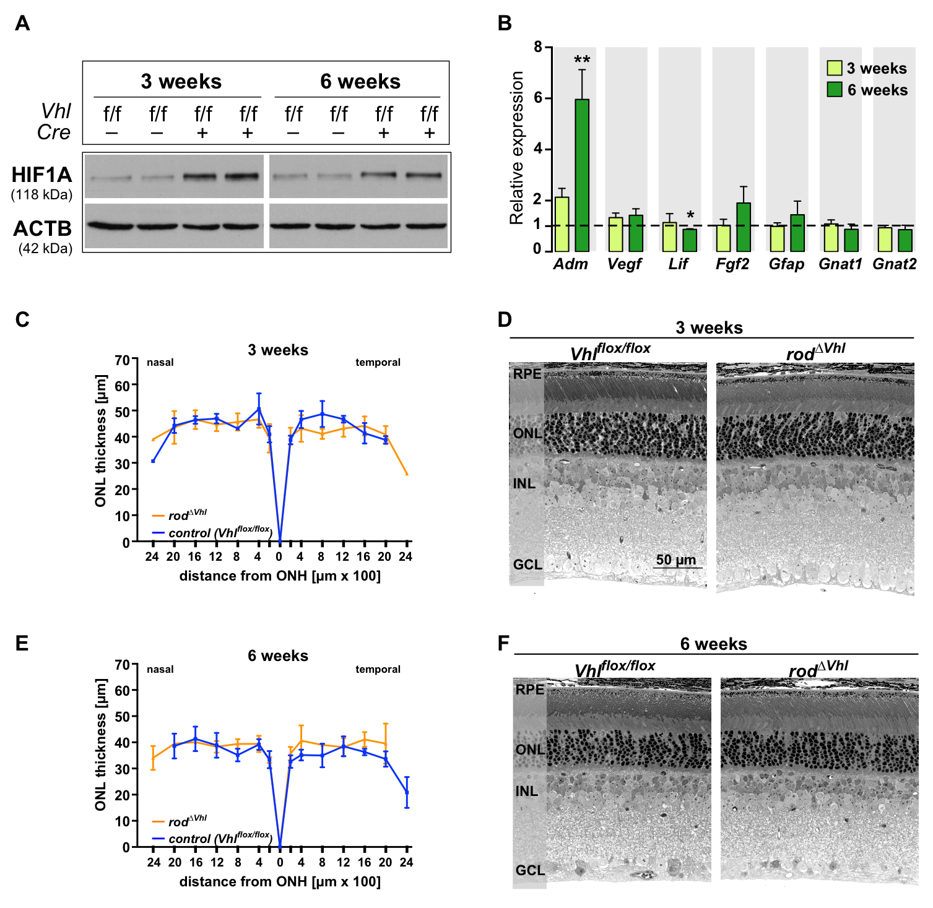

Fig S1. Impact of rod-specific Vhl deletion in 3 and 6 weeks old mice.
A) Western blots for HIF1A in retinal homogenates of 3 and 6 weeks old rod^{ΔVhl} and control mice. ACTB was used as loading control. B) Retinal expression of indicated genes was tested in retinas of rod^{ΔVhl} mice at 3 and 6 weeks of age. Expression levels were calculated relative to their respective Cre-negative controls (set to 1; dotted line). Shown are means ± SD of N = 3-5. *: P < 0.05; **: P < 0.01. Individual comparisons between Cre-positive and Cre-negative mice of each genotype were done using Student’s t-test. C, E) ONL thicknesses of rod^{ΔVhl} and control mice were determined at 3 and 6 weeks of age and are presented as spidergrams. Shown are means ± SD of N = 3-4, except for rod^{ΔVhl} mice at 6 months (N = 2). D, F) Retinal morphology of rod^{ΔVhl} and control mice at 3 and 6 weeks of age. Cre-negative Vhl^{flox/flox} mice served as controls. RPE: retinal pigment epithelium; ONL: outer nuclear layer; INL: inner nuclear layer. GCL: ganglion cell layer. Scale bar: 50 µm. N = 3-4, except for rod^{ΔVhl} mice at 6 months (N = 2).

Figure S2

Fig S2. Characterization of mouse strains.
A) Cre-positive (+) and Cre-negative (-) strains carrying floxed (f/f) alleles of Vhl, Hif1a and Hif2a were tested for excision of floxed sequences from genomic DNA of the retina by conventional PCR. 2-loxP: not excised; 1-loxP: excised; NA: not applicable. Note that genomic DNA was isolated from total retina that included cells without CRE expression. Thus, the 2-loxP band was expected in all samples. B) Western blots for HIF1A and HIF2A in retinal homogenates of strains with genotypes as indicated. ACTB was used as control. Mice were 10-11 weeks of age. Retinal homogenates of wild type mice exposed to 6 h of hypoxia (7% O₂) were used as positive controls. Homogenates of normoxic wild type mice served as negative controls. N = 3.

Figure S3
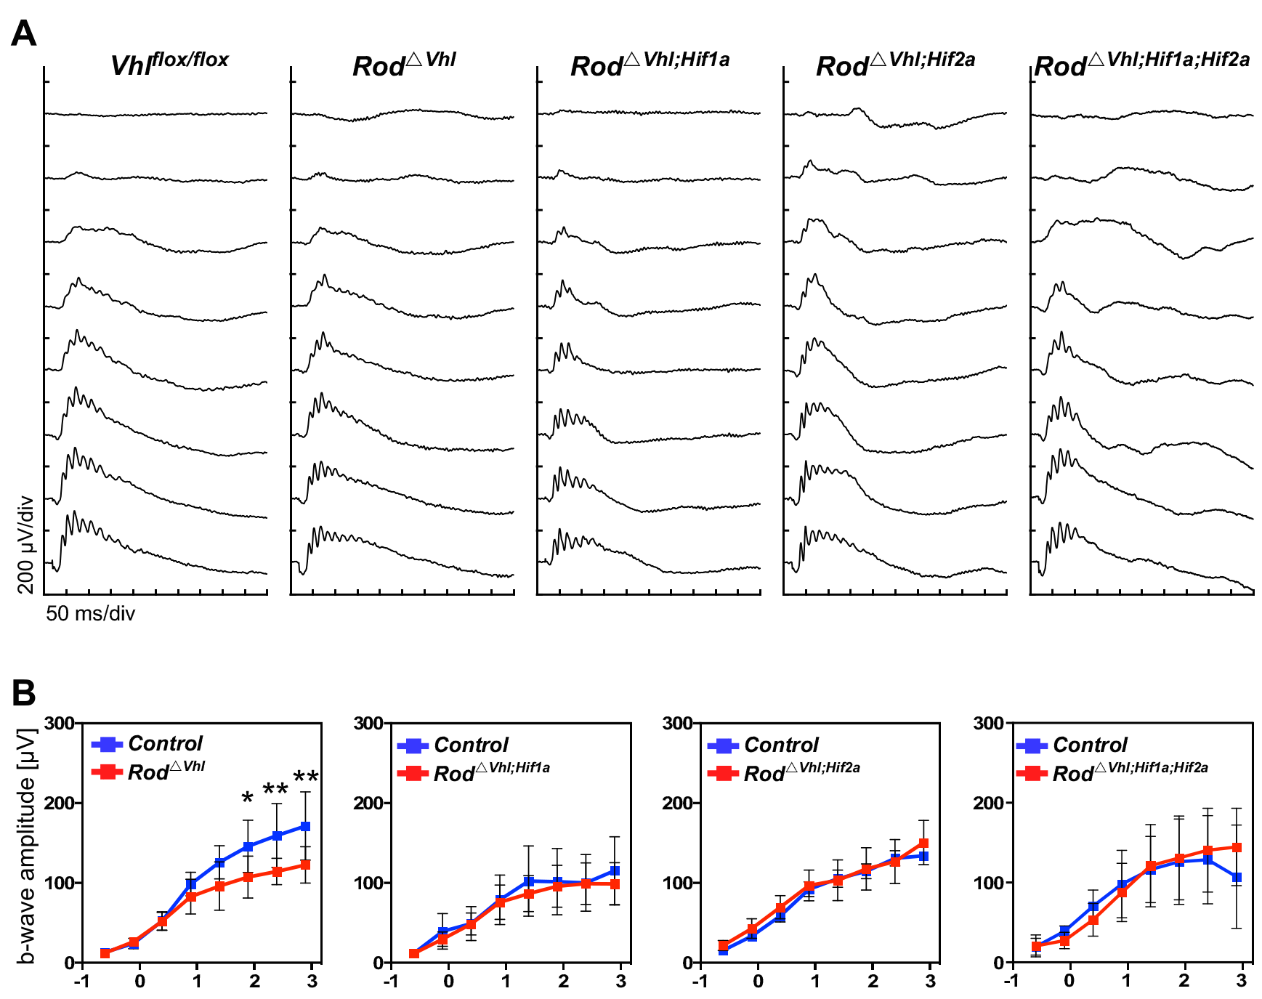
Fig S3. Retinal function. Photopic retinal function was tested in 6 months old rod^{ΔVhl}, rod^{ΔVhl;Hif1a}, rod^{ΔVhl;Hif2a}, and rod^{ΔVhl;Hif1a;Hif2a} mice. Cre-negative Vhl^{flos/flox} mice served as controls. A) Representative photopic ERG traces recorded after light stimuli of increasing light intensities. B) Photopic b-wave amplitudes plotted as a function of stimulus intensity. Control mice were Cre-negative littermates of the respective strains. Shown are averages ± SD. N = 6 eyes (3 mice), except for controls of rod^{ΔVhl;Hif2a} (N = 5), rod^{ΔVhl;Hif2a} (N = 7), controls of rod^{ΔVhl;Hif1a;Hif2a} (N = 5) and rod^{ΔVhl;Hif1a;Hif2a} (N = 4). *: P < 0.05; **: P < 0.01. 2-way ANOVA with Sidak’s multiple comparison test.

Figure S4

Fig S4. Protein levels in retinal homogenates.
Western blot for indicated proteins in mice at 10-11 weeks of age. Retinal homogenates of wild type mice exposed to 6 h of hypoxia (7% O₂) were used as positive controls. Homogenates of normoxic wild type mice served as negative controls. Note that homogenates were the same as those used for Fig. 2B and the same ACTB control is shown. N = 3.

Figure S5
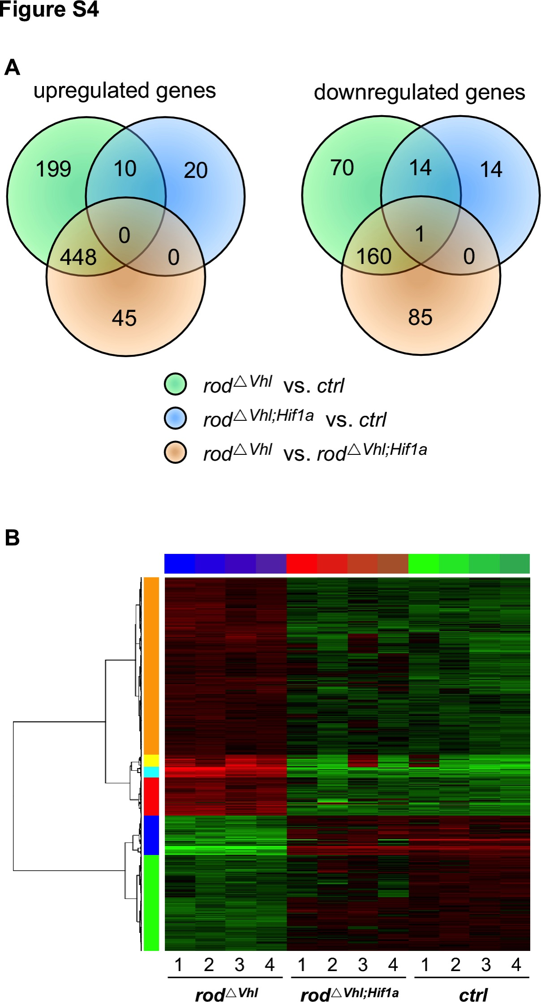
Fig S5. Differentially regulated genes. A) Venn diagrams of genes differentially regulated in rod^{ΔVhl} (compared to controls; green), rod^{ΔVhl;Hif1a} (compared to controls; blue) and rod^{ΔVhl} (compared to rod^{ΔVhl;Hif1a}; orange). Controls were Vhl^{flox/flox};Hif1a^{flox/flox} mice. Genes with a fold change of ≥ 2 and a P-value < 0.05 were included in the analysis. B) Cluster heat map of the transcriptomic data. Note the close relationship between rod^{ΔVhl;Hif1a} and control mice.

Figure S6
Fig S6. Schematic representation of viral construct. Expression of sh-Hif1a is controlled by the U6 promoter. Expression of EGFP is driven by the CMV enhancer and CMV promoter. A woodchuck hepatitis post-transcriptional regulatory element (WPRE) is added before the bovine growth hormone (bGH) poly(A) signal. ITR: inverted terminal repeat. The entire cassette is 3001 bp in length.

Table S1. Human retina samples used in the study
Nr | Age | Gender | Post mortem-time | Cause of death
HE19 | 17 | male | 30 h | Accident
HE4 | 24 | male | 21 h | Heart failure
HE25 | 31 | male | 29 h | Accident
HE27 | 34 | female | 24 h | Accident
HE26 | 53 | male | 20 h | Cerebrellar stroke
HE6 | 57 | male | 13 h | Multiorgan failure
HE11 | 58 | male | 31 h | Accident / brain trauma
HE1 | 72 | male | 13 h | Cardiogenic shock
HE16 | 74 | male | 35 h | Prostata adenocarcinoma
HE17 | 78 | male | 27 h | Heart failure
HE13 | 80 | female | 15 h | Cerebral ischemia
HE15 | 91 | female | 23 h | Aortic stenosis
HE3 | 92 | male | 36 h | Gastrointestinal bleeding

Table S2
Top regulated genes in retinas of rod^{ΔVhl} mice, relative to Vhl^{flox/flox};Hif1a^{flox/flox} ctrl mice
Top 20 genes upregulated in retinas of rod^{ΔVhl} mice relative to ctrl
Entrez  Gene ID | Gene Symbol | ratio | pValue | Description
71957 | Ints11 | 162.9 | 4.09E-07 | integrator complex subunit 11
76487 | Ppp1r3g | 79.7 | 8.93E-10 | protein phosphatase 1, regulatory (inhibitor) subunit 3G
223780 | Adm2 | 71.9 | 9.09E-08 | adrenomedullin 2
13615 | Edn2 | 62.7 | 4.30E-08 | endothelin 2
67573 | Loxl4 | 33.9 | 1.83E-05 | lysyl oxidase-like 4
240913 | Adamts4 | 31.9 | 1.61E-04 | a disintegrin-like and metallopeptidase (reprolysin type) with thrombospondin type 1 motif, 4
16763 | Lad1 | 30.3 | 6.58E-07 | ladinin
14663 | Glycam1 | 25.2 | 3.39E-05 | glycosylation dependent cell adhesion molecule 1
11535 | Adm | 23.7 | 1.12E-07 | adrenomedullin
17339 | Mip | 22.9 | 8.08E-03 | major intrinsic protein of eye lens fiber
214301 | Crygn | 22.3 | 6.26E-03 | crystallin, gamma N
192199 | Rspo1 | 21.7 | 7.82E-03 | R-spondin homolog (Xenopus laevis)
233187 | Lim2 | 21.6 | 4.19E-03 | lens intrinsic membrane protein 2
12954 | Cryaa | 20.9 | 7.34E-03 | crystallin, alpha A
20856 | Stc2 | 20.7 | 1.13E-06 | stanniocalcin 2
77998 | Grifin | 19.8 | 3.58E-03 | galectin-related inter-fiber protein
12051 | Bcl3 | 19.5 | 1.62E-06 | B-cell leukemia/lymphoma 3
276829 | Smtnl2 | 17.0 | 9.83E-08 | smoothelin-like 2
381359 | Prdm12 | 16.2 | 1.72E-05 | PR domain containing 12
100039660 | Ect2l | 15.5 | 1.72E-05 | epithelial cell transforming sequence 2 oncogene-like
Top 20 genes downregulated in retinas of rod^{ΔVhl} mice relative to ctrl
Entrez  Gene ID | Gene Symbol | ratio | pValue | Description
258198 | Olfr224 | 0.015 | 2.21E-06 | olfactory receptor 224
80509 | Med8 | 0.015 | 3.21E-07 | mediator of RNA polymerase II transcription, subunit 8 homolog (yeast)
76681 | Trim12a | 0.024 | 2.23E-08 | tripartite motif-containing 12A
30939 | Pttg1 | 0.026 | 1.03E-09 | pituitary tumor-transforming gene 1
54631 | Nphs1 | 0.032 | 1.02E-07 | nephrosis 1 homolog, nephrin (human)
14537 | Gcnt1 | 0.039 | 1.14E-09 | glucosaminyl (N-acetyl) transferase 1, core 2
75764 | Slx1b | 0.051 | 2.71E-09 | SLX1 structure-specific endonuclease subunit homolog B (S. cerevisiae)
72154 | Zfp157 | 0.058 | 4.90E-07 | zinc finger protein 157
269209 | Stk36 | 0.091 | 4.27E-06 | serine/threonine kinase 36 (fused homolog, Drosophila)
214523 | Tmprss4 | 0.095 | 2.39E-08 | transmembrane protease, serine 4
17427 | Mns1 | 0.100 | 1.01E-06 | meiosis-specific nuclear structural protein 1
72461 | Prcp | 0.115 | 1.35E-08 | prolylcarboxypeptidase (angiotensinase C)
16061 | Igh-VJ558 | 0.117 | 4.18E-04 | immunoglobulin heavy chain (J558 family)
140709 | Emid2 | 0.120 | 1.01E-06 | EMI domain containing 2
17921 | Myo7a | 0.124 | 1.77E-07 | myosin VIIA
94216 | Col4a6 | 0.129 | 3.29E-04 | collagen, type IV, alpha 6
69611 | Lce1d | 0.148 | 1.60E-02 | late cornified envelope 1D
71687 | Tmem25 | 0.154 | 6.43E-08 | transmembrane protein 25
12769 | Ccr9 | 0.163 | 5.52E-03 | chemokine (C-C motif) receptor 9
66442 | Spc25 | 0.168 | 7.49E-05 | SPC25, NDC80 kinetochore complex component, homolog (S. cerevisiae)

Genes with P > 0.05 were excluded from the analysis, as were ‘Rik’ sequences, ‘expressed sequences’, ‘predicted genes’ and ‘hypothetical proteins’. Also excluded was ‘Xist’ as this gene is X-linked and the number of females and males in the gene chip analyses were not balanced.

Table S3
Top regulated genes in retinas of rod^{ΔVhl} mice, relative to rod^{ΔVhl;Hif1a} mice
Top 20 genes upregulated in retinas of rod^{ΔVhl} mice relative to rod^{ΔVhl;Hif1a} mice
Entrez  Gene ID | Gene Symbol | ratio | pValue | Description
71957 | Ints11 | 282.8 | 5.20E-09 | integrator complex subunit 11
223780 | Adm2 | 70.9 | 1.19E-06 | adrenomedullin 2
13615 | Edn2 | 65.8 | 3.12E-08 | endothelin 2
76487 | Ppp1r3g | 59.2 | 5.15E-06 | protein phosphatase 1, regulatory (inhibitor) subunit 3G
240913 | Adamts4 | 24.7 | 2.89E-04 | a disintegrin-like and metallopeptidase (reprolysin type) with thrombospondin type 1 motif, 4
11535 | Adm | 23.5 | 6.34E-08 | adrenomedullin
16763 | Lad1 | 23.3 | 3.38E-05 | ladinin
67573 | Loxl4 | 22.4 | 2.51E-04 | lysyl oxidase-like 4
381359 | Prdm12 | 19.5 | 1.37E-05 | PR domain containing 12
12051 | Bcl3 | 18.7 | 4.52E-06 | B-cell leukemia/lymphoma 3
233187 | Lim2 | 17.0 | 2.37E-02 | lens intrinsic membrane protein 2
17339 | Mip | 16.3 | 2.49E-02 | major intrinsic protein of eye lens fiber
21818 | Tgm3 | 15.6 | 4.76E-04 | transglutaminase 3, E polypeptide
20856 | Stc2 | 13.8 | 5.69E-07 | stanniocalcin 2
276829 | Smtnl2 | 13.2 | 2.79E-07 | smoothelin-like 2
14663 | Glycam1 | 13.0 | 1.27E-03 | glycosylation dependent cell adhesion molecule 1
15006 | H2-Q1 | 12.2 | 9.49E-06 | histocompatibility 2, Q region locus 1
14173 | Fgf2 | 11.6 | 7.27E-06 | fibroblast growth factor 2
192199 | Rspo1 | 11.3 | 2.04E-02 | R-spondin homolog (Xenopus laevis)
12954 | Cryaa | 10.9 | 1.64E-02 | crystallin, alpha A
Top 20 genes downregulated in retinas of rod^{ΔVhl} mice relative to rod^{ΔVhl;Hif1a} mice
Entrez  Gene ID | Gene Symbol | ratio | pValue | Description
76681 | Trim12a | 0.014 | 8.54E-09 | tripartite motif-containing 12A
80509 | Med8 | 0.025 | 1.54E-06 | mediator of RNA polymerase II transcription, subunit 8 homolog (yeast)
30939 | Pttg1 | 0.026 | 1.81E-10 | pituitary tumor-transforming gene 1
258198 | Olfr224 | 0.027 | 2.80E-05 | olfactory receptor 224
54631 | Nphs1 | 0.028 | 4.80E-07 | nephrosis 1 homolog, nephrin (human)
75764 | Slx1b | 0.034 | 4.22E-09 | SLX1 structure-specific endonuclease subunit homolog B (S. cerevisiae)
14537 | Gcnt1 | 0.035 | 3.59E-11 | glucosaminyl (N-acetyl) transferase 1, core 2
109685 | Hyal3 | 0.052 | 3.57E-06 | hyaluronoglucosaminidase 3
72154 | Zfp157 | 0.053 | 2.11E-07 | zinc finger protein 157
17921 | Myo7a | 0.074 | 3.64E-08 | myosin VIIA
214523 | Tmprss4 | 0.084 | 2.07E-08 | transmembrane protease, serine 4
72461 | Prcp | 0.101 | 9.91E-09 | prolylcarboxypeptidase (angiotensinase C)
269209 | Stk36 | 0.103 | 4.68E-06 | serine/threonine kinase 36 (fused homolog, Drosophila)
94216 | Col4a6 | 0.112 | 3.70E-04 | collagen, type IV, alpha 6
140709 | Emid2 | 0.112 | 9.73E-07 | EMI domain containing 2
209760 | Tmc7 | 0.129 | 1.24E-05 | transmembrane channel-like gene family 7
68668 | Klk5 | 0.134 | 1.22E-02 | kallikrein related-peptidase 5
71687 | Tmem25 | 0.156 | 7.66E-08 | transmembrane protein 25
19223 | Ptgis | 0.167 | 2.71E-06 | prostaglandin I2 (prostacyclin) synthase
18261 | Ocm | 0.175 | 1.41E-05 | oncomodulin

Genes with P > 0.05 were excluded from the analysis, as were ‘Rik’ sequences, ‘expressed sequences’, ‘predicted genes’ and ‘hypothetical proteins’. Also excluded was ‘Xist’ as this gene is X-linked and the number of females and males in the gene chip analyses were not balanced.

Table S4
To Top regulated genes in retinas of rod^{ΔVhl;Hif1a} mice, relative to Vhl^{flox/flox};Hif1a^{flox/flox} control mice
Top 20 genes upregulated in retinas of rod^{ΔVhl;Hif1a} mice relative to ctrl
Entrez  Gene ID | Gene Symbol | ratio | pValue | Description
109685 | Hyal3 | 7.0 | 1.26E-02 | hyaluronoglucosaminidase 3
19076 | Prim2 | 5.3 | 7.60E-09 | DNA primase, p58 subunit
77044 | Arid2 | 4.8 | 3.88E-02 | AT rich interactive domain 2 (ARID, RFX-like)
434794 | Xlr4a | 4.5 | 8.59E-03 | X-linked lymphocyte-regulated 4A
628171 | Olfr936 | 3.4 | 5.31E-03 | olfactory receptor 936
73748 | Gadl1 | 3.3 | 1.48E-02 | glutamate decarboxylase-like 1
545548 | Lce3a | 2.9 | 3.65E-03 | late cornified envelope 3A
12534 | Cdk1 | 2.9 | 8.44E-03 | cyclin-dependent kinase 1
27083 | Xlr4b | 2.9 | 3.77E-02 | X-linked lymphocyte-regulated 4B
57277 | Slurp1 | 2.8 | 2.82E-02 | secreted Ly6/Plaur domain containing 1
17748 | Mt1 | 2.7 | 6.82E-08 | metallothionein 1
53311 | Mybph | 2.7 | 3.58E-02 | myosin binding protein H
67652 | Spaca1 | 2.7 | 8.29E-05 | sperm acrosome associated 1
194597 | Tmprss11a | 2.5 | 4.75E-03 | transmembrane protease, serine 11a
230678 | Tmem125 | 2.4 | 1.02E-03 | transmembrane protein 125
244332 | Defb14 | 2.3 | 5.00E-03 | defensin beta 14
14428 | Galr2 | 2.3 | 1.65E-02 | galanin receptor 2
238393 | Serpina3f | 2.3 | 2.42E-05 | serine (or cysteine) peptidase inhibitor, clade A, member 3F
22326 | Vax1 | 2.2 | 3.28E-02 | ventral anterior homeobox containing gene 1
69930 | Zfp715 | 2.2 | 2.04E-02 | zinc finger protein 715
Top 20 genes downregulated in retinas of rod^{ΔVhl;Hif1a} mice relative to ctrl
Entrez  Gene ID | Gene Symbol | ratio | pValue | Description
353371 | Oxct2b | 0.183 | 1.24E-02 | 3-oxoacid CoA transferase 2B
17427 | Mns1 | 0.254 | 1.58E-02 | meiosis-specific nuclear structural protein 1
51925 | D2Ertd640e | 0.260 | 2.78E-04 | DNA segment, Chr 2, ERATO Doi 640, expressed
93689 | Lmod1 | 0.324 | 3.44E-02 | leiomodin 1 (smooth muscle)
76585 | Lce1i | 0.335 | 5.87E-03 | late cornified envelope 1I
69611 | Lce1d | 0.338 | 2.88E-02 | late cornified envelope 1D
56057 | Btg4 | 0.356 | 4.73E-02 | B-cell translocation gene 4
16061 | Igh-VJ558 | 0.357 | 7.34E-03 | immunoglobulin heavy chain (J558 family)
236904 | Klhl15 | 0.375 | 1.83E-02 | kelch-like 15 (Drosophila)
67828 | Lce1f | 0.376 | 1.43E-02 | late cornified envelope 1F
20521 | Slc22a12 | 0.377 | 3.41E-04 | solute carrier family 22 (organic anion/cation transporter), member 12
21940 | Cd27 | 0.380 | 1.84E-02 | CD27 antigen
78801 | Ak7 | 0.385 | 4.67E-04 | adenylate kinase 7
68694 | Lce1e | 0.394 | 2.09E-02 | late cornified envelope 1E
258692 | Olfr1442 | 0.395 | 1.93E-02 | olfactory receptor 1442
76117 | Arhgap15 | 0.397 | 2.29E-03 | Rho GTPase activating protein 15
246746 | Cd300lf | 0.398 | 4.89E-02 | CD300 antigen like family member F
96875 | Prg4 | 0.400 | 1.36E-04 | proteoglycan 4 (megakaryocyte stimulating factor, articular superficial zone protein)
15130 | Hbb-b2 | 0.402 | 2.54E-02 | hemoglobin, beta adult minor chain
80796 | Calm4 | 0.402 | 2.60E-02 | calmodulin 4

Genes with P > 0.05 were excluded from the analysis, as were ‘Rik’ sequences, ‘expressed sequences’, ‘predicted genes’ and ‘hypothetical proteins’. Also excluded was ‘Xist’ as this gene is X-linked and the number of females and males in the gene chip analyses were not balanced.

Table S5
Comparison to top 20 genes that were differentially regulated in rod^{ΔVhl} mice relative to Vhl^{flox/flox};Hif1a^{flox/flox} control mice
Reference list: Table S2: rod^{ΔVhl} vs ctrl  Upregulated genes  Potential targets of: HIF1; HIF2; pSTAT3 |  |  |  |  |  |  |  | rod^{ΔVhl} vs rod^{ΔVhl;Hif1a} |  | rod^{ΔVhl;Hif1a} vs ctrl
 |  |  |  |  |  |  |  | potential targets of:  HIF1; pSTAT3 |  | potential targets of:  HIF2
Entrez  Gene ID |  | Gene Symbol |  | ratio |  | pValue |  | ratio | pValue | ratio | pValue
71957 |  | Ints11 |  | 162.9 |  | 4.09E-07 |  | 282.8 | 5.20E-09 | – | –
76487 |  | Ppp1r3g |  | 79.7 |  | 8.93E-10 |  | 59.2 | 5.15E-06 | – | –
223780 |  | Adm2 |  | 71.9 |  | 9.09E-08 |  | 70.9 | 1.19E-06 | – | –
13615 |  | Edn2 |  | 62.7 |  | 4.30E-08 |  | 65.8 | 3.12E-08 | – | –
67573 |  | Loxl4 |  | 33.9 |  | 1.83E-05 |  | 22.4 | 2.51E-04 | – | –
240913 |  | Adamts4 |  | 31.9 |  | 1.61E-04 |  | 24.7 | 2.89E-04 | – | –
16763 |  | Lad1 |  | 30.3 |  | 6.58E-07 |  | 23.3 | 3.38E-05 | – | –
14663 |  | Glycam1 |  | 25.2 |  | 3.39E-05 |  | 13.0 | 1.27E-03 | – | –
11535 |  | Adm |  | 23.7 |  | 1.12E-07 |  | 23.5 | 6.34E-08 | – | –
17339 |  | Mip |  | 22.9 |  | 8.08E-03 |  | 16.3 | 2.49E-02 | – | –
214301 |  | Crygn |  | 22.3 |  | 6.26E-03 |  | † 10.3 | † 1.19E-02 | – | –
192199 |  | Rspo1 |  | 21.7 |  | 7.82E-03 |  | 11.3 | 2.04E-02 | – | –
233187 |  | Lim2 |  | 21.6 |  | 4.19E-03 |  | 17.0 | 2.37E-02 | – | –
12954 |  | Cryaa |  | 20.9 |  | 7.34E-03 |  | 10.9 | 1.64E-02 | – | –
20856 |  | Stc2 |  | 20.7 |  | 1.13E-06 |  | 13.8 | 5.69E-07 | – | –
77998 |  | Grifin |  | 19.8 |  | 3.58E-03 |  | † 10.7 | † 1.75E-02 | – | –
12051 |  | Bcl3 |  | 19.5 |  | 1.62E-06 |  | 18.7 | 4.52E-06 | – | –
276829 |  | Smtnl2 |  | 17.0 |  | 9.83E-08 |  | 13.2 | 2.79E-07 | † 1.3 | † 1.34E-02
381359 |  | Prdm12 |  | 16.2 |  | 1.72E-05 |  | 19.5 | 1.37E-05 | – | –
100039660 |  | Ect2l |  | 15.5 |  | 1.72E-05 |  | † 10.8 | † 3.46E-05 | – | –
Reference list: Table S2: rod^{ΔVhl} vs ctrl  Downregulated genes  Potential targets of: HIF1; HIF2; pSTAT3 |  |  |  |  |  |  |  | rod^{ΔVhl} vs rod^{ΔVhl;Hif1a} |  | rod^{ΔVhl;Hif1a} vs ctrl
 |  |  |  |  |  |  |  | potential targets of:  HIF1; pSTAT3 |  | potential targets of:  HIF2
Entrez  Gene ID |  | Gene Symbol |  | ratio |  | pValue |  | ratio | pValue | ratio | pValue
258198 |  | Olfr224 |  | 0.015 |  | 2.21E-06 |  | 0.027 | 2.80E-05 | – | –
80509 |  | Med8 |  | 0.015 |  | 3.21E-07 |  | 0.025 | 1.54E-06 | – | –
76681 |  | Trim12a |  | 0.024 |  | 2.23E-08 |  | 0.014 | 8.54E-09 | † 1.68 | † 3.77E-03
30939 |  | Pttg1 |  | 0.026 |  | 1.03E-09 |  | 0.026 | 1.81E-10 | – | –
54631 |  | Nphs1 |  | 0.032 |  | 1.02E-07 |  | 0.028 | 4.80E-07 | – | –
14537 |  | Gcnt1 |  | 0.039 |  | 1.14E-09 |  | 0.035 | 3.59E-11 | – | –
75764 |  | Slx1b |  | 0.051 |  | 2.71E-09 |  | 0.034 | 4.22E-09 | † 1.49 | † 9.70E-03
72154 |  | Zfp157 |  | 0.058 |  | 4.90E-07 |  | 0.053 | 2.11E-07 | – | –
269209 |  | Stk36 |  | 0.091 |  | 4.27E-06 |  | 0.103 | 4.68E-06 | – | –
214523 |  | Tmprss4 |  | 0.095 |  | 2.39E-08 |  | 0.084 | 2.07E-08 | – | –
17427 |  | Mns1 |  | 0.100 |  | 1.01E-06 |  | – | – | † 0.25 | † 1.58E-02
72461 |  | Prcp |  | 0.115 |  | 1.35E-08 |  | 0.101 | 9.91E-09 | † 1.14 | † 2.83E-02
16061 |  | Igh-VJ558 |  | 0.117 |  | 4.18E-04 |  | † 0.313 | † 2.28E-02 | † 0.37 | † 1.28E-02
140709 |  | Emid2 |  | 0.120 |  | 1.01E-06 |  | 0.112 | 9.73E-07 | – | –
17921 |  | Myo7a |  | 0.124 |  | 1.77E-07 |  | 0.074 | 3.64E-08 | † 1.75 | † 1.24E-04
94216 |  | Col4a6 |  | 0.129 |  | 3.29E-04 |  | 0.112 | 3.70E-04 | – | –
69611 |  | Lce1d |  | 0.148 |  | 1.60E-02 |  | – | – | † 0.34 | † 2.88E-02
71687 |  | Tmem25 |  | 0.154 |  | 6.43E-08 |  | 0.156 | 7.66E-08 | – | –
12769 |  | Ccr9 |  | 0.163 |  | 5.52E-03 |  | – | – | – | –
66442 |  | Spc25 |  | 0.168 |  | 7.49E-05 |  | † 0.183 | † 1.35E-04 | – | –

Genes with P > 0.05 were excluded from the analysis, as were ‘Rik’ sequences, ‘expressed sequences’, ‘predicted genes’ and ‘hypothetical proteins’. Also excluded was ‘Xist’ as this gene is X-linked and the number of females and males in the gene chip analyses were not balanced.
† : not present in the top 20 regulated genes of the respective list
– : not present in the respective list of genes, or P > 0.05

Table S6
Comparison to top 20 genes that were differentially regulated in rod^{ΔVhl} relative to rod^{Δrod;Hif1a} mice
Reference list: Table S3: rod^{ΔVhl} vs rod^{ΔVhl;Hif1a}  Upregulated genes  Potential targets of: HIF1; pSTAT3 |  |  |  |  |  |  |  | rod^{ΔVhl;Hif1a} vs ctrl |  | rod^{ΔVhl} vs ctrl
 |  |  |  |  |  |  |  | potential targets of:  HIF2 |  | potential targets of:  HIF1; HIF2; pSTAT3
Entrez  Gene ID |  | Gene Symbol |  | ratio |  | pValue |  | ratio | pValue | ratio | pValue
71957 |  | Ints11 |  | 282.8 |  | 5.20E-09 |  | – | – | 162.9 | 4.09E-07
223780 |  | Adm2 |  | 70.9 |  | 1.19E-06 |  | – | – | 71.9 | 9.09E-08
13615 |  | Edn2 |  | 65.8 |  | 3.12E-08 |  | – | – | 62.7 | 4.30E-08
76487 |  | Ppp1r3g |  | 59.2 |  | 5.15E-06 |  | – | – | 79.7 | 8.93E-10
240913 |  | Adamts4 |  | 24.7 |  | 2.89E-04 |  | – | – | 31.9 | 1.61E-04
11535 |  | Adm |  | 23.5 |  | 6.34E-08 |  | – | – | 23.7 | 1.12E-07
16763 |  | Lad1 |  | 23.3 |  | 3.38E-05 |  | – | – | 30.3 | 6.58E-07
67573 |  | Loxl4 |  | 22.4 |  | 2.51E-04 |  | – | – | 33.9 | 1.83E-05
381359 |  | Prdm12 |  | 19.5 |  | 1.37E-05 |  | – | – | 16.2 | 1.72E-05
12051 |  | Bcl3 |  | 18.7 |  | 4.52E-06 |  | – | – | 19.5 | 1.62E-06
233187 |  | Lim2 |  | 17.0 |  | 2.37E-02 |  | – | – | 21.6 | 4.19E-03
17339 |  | Mip |  | 16.3 |  | 2.49E-02 |  | – | – | 22.9 | 8.08E-03
21818 |  | Tgm3 |  | 15.6 |  | 4.76E-04 |  | – | – | † 14.5 | † 2.99E-05
20856 |  | Stc2 |  | 13.8 |  | 5.69E-07 |  | – | – | 20.7 | 1.13E-06
276829 |  | Smtnl2 |  | 13.2 |  | 2.79E-07 |  | † 1.3 | † 1.34E-02 | 17.0 | 9.83E-08
14663 |  | Glycam1 |  | 13.0 |  | 1.27E-03 |  | – | – | 25.2 | 3.39E-05
15006 |  | H2-Q1 |  | 12.2 |  | 9.49E-06 |  | – | – | † 10.3 | † 2.26E-06
14173 |  | Fgf2 |  | 11.6 |  | 7.27E-06 |  | – | – | † 9.86 | † 1.01E-05
192199 |  | Rspo1 |  | 11.3 |  | 2.04E-02 |  | – | – | 21.7 | 7.82E-03
12954 |  | Cryaa |  | 10.9 |  | 1.64E-02 |  | – | – | 20.9 | 7.34E-03
Reference list: Table S3: rod^{ΔVhl} vs rod^{ΔVhl;Hif1a}  Downregulated genes  Potential targets of: HIF1; pSTAT3 |  |  |  |  |  |  |  | rod^{ΔVhl;Hif1a} vs ctrl |  | rod^{ΔVhl} vs ctrl
 |  |  |  |  |  |  |  | potential targets of:  HIF2 |  | potential targets of:  HIF1; HIF2; pSTAT3
Entrez  Gene ID |  | Gene Symbol |  | ratio |  | pValue |  | ratio | pValue | ratio | pValue
76681 |  | Trim12a |  | 0.014 |  | 8.54E-09 |  | † 1.68 | † 3.77E-03 | 0.024 | 2.23E-08
80509 |  | Med8 |  | 0.025 |  | 1.54E-06 |  | – | – | 0.015 | 3.21E-07
30939 |  | Pttg1 |  | 0.026 |  | 1.81E-10 |  | – | – | 0.026 | 1.03E-09
258198 |  | Olfr224 |  | 0.027 |  | 2.80E-05 |  | – | – | 0.015 | 2.21E-06
54631 |  | Nphs1 |  | 0.028 |  | 4.80E-07 |  | – | – | 0.032 | 1.02E-07
75764 |  | Slx1b |  | 0.034 |  | 4.22E-09 |  | † 1.49 | † 9.70E-03 | 0.051 | 2.71E-09
14537 |  | Gcnt1 |  | 0.035 |  | 3.59E-11 |  | – | – | 0.039 | 1.14E-09
109685 |  | Hyal3 |  | 0.052 |  | 3.57E-06 |  | 6.96 | 1.26E-02 | – | –
72154 |  | Zfp157 |  | 0.053 |  | 2.11E-07 |  | – | – | 0.058 | 4.90E-07
17921 |  | Myo7a |  | 0.074 |  | 3.64E-08 |  | † 1.75 | † 1.24E-04 | 0.124 | 1.77E-07
214523 |  | Tmprss4 |  | 0.084 |  | 2.07E-08 |  | – | – | 0.095 | 2.39E-08
72461 |  | Prcp |  | 0.101 |  | 9.91E-09 |  | † 1.14 | † 2.83E-02 | 0.115 | 1.35E-08
269209 |  | Stk36 |  | 0.103 |  | 4.68E-06 |  | – | – | 0.091 | 4.27E-06
94216 |  | Col4a6 |  | 0.112 |  | 3.70E-04 |  | – | – | 0.129 | 3.29E-04
140709 |  | Emid2 |  | 0.112 |  | 9.73E-07 |  | – | – | 0.120 | 1.01E-06
209760 |  | Tmc7 |  | 0.129 |  | 1.24E-05 |  | † 1.45 | † 2.99E-03 | † 0.187 | † 4.51E-05
68668 |  | Klk5 |  | 0.134 |  | 1.22E-02 |  | – | – | – | –
71687 |  | Tmem25 |  | 0.156 |  | 7.66E-08 |  | – | – | 0.154 | 6.43E-08
19223 |  | Ptgis |  | 0.167 |  | 2.71E-06 |  | † 1.49 | † 9.72E-03 | † 0.249 | † 1.39E-06
18261 |  | Ocm |  | 0.175 |  | 1.41E-05 |  | † 1.42 | † 3.63E-02 | † 0.403 | † 4.41E-06

Genes with P > 0.05 were excluded from the analysis, as were ‘Rik’ sequences, ‘expressed sequences’, ‘predicted genes’ and ‘hypothetical proteins’. Also excluded was ‘Xist’ as this gene is X-linked and the number of females and males in the gene chip analyses were not balanced.
† : not present in the top 20 regulated genes of the respective list
– : not present in the respective list of genes, or P > 0.05

Table S7
Comparison to top 20 genes that were differentially regulated in rod^{ΔVhl;Hif1a} relative to Vhl^{flox/flox};Hif1a^{flox/flox} control mice
Reference list: Table S4: rod^{ΔVhl;Hif1a} vs ctrl  Upregulated genes  Potential targets of: HIF2 |  |  |  |  |  |  |  | rod^{ΔVhl} vs rod^{ΔVhl;Hif1a} |  | rod^{ΔVhl} vs ctrl
 |  |  |  |  |  |  |  | potential targets of: HIF1; pSTAT3 |  | potential targets of:  HIF1; HIF2; pSTAT3
Entrez  Gene ID |  | Gene Symbol |  | ratio |  | pValue |  | ratio | pValue | ratio | pValue
109685 |  | Hyal3 |  | 7.0 |  | 1.26E-02 |  | 0.05 | 3.57E-06 | – | –
19076 |  | Prim2 |  | 5.3 |  | 7.60E-09 |  | – | – | † 4.7 | † 3.02E-05
77044 |  | Arid2 |  | 4.8 |  | 3.88E-02 |  | – | – | – | –
434794 |  | Xlr4a |  | 4.5 |  | 8.59E-03 |  | – | – | – | –
628171 |  | Olfr936 |  | 3.4 |  | 5.31E-03 |  | – | – | – | –
73748 |  | Gadl1 |  | 3.3 |  | 1.48E-02 |  | – | – | † 5.0 | † 9.08E-04
545548 |  | Lce3a |  | 2.9 |  | 3.65E-03 |  | † 0.2 | † 2.17E-03 | – | –
12534 |  | Cdk1 |  | 2.9 |  | 8.44E-03 |  | – | – | – | –
27083 |  | Xlr4b |  | 2.9 |  | 3.77E-02 |  | – | – | † 2.6 | † 5.27E-03
57277 |  | Slurp1 |  | 2.8 |  | 2.82E-02 |  | – | – | † 2.5 | † 8.05E-03
17748 |  | Mt1 |  | 2.7 |  | 6.82E-08 |  | † 0.8 | † 9.22E-03 | † 2.0 | † 4.22E-05
53311 |  | Mybph |  | 2.7 |  | 3.58E-02 |  | – | – | † 1.9 | † 3.72E-02
67652 |  | Spaca1 |  | 2.7 |  | 8.29E-05 |  | – | – | – | –
194597 |  | Tmprss11a |  | 2.5 |  | 4.75E-03 |  | – | – | – | –
230678 |  | Tmem125 |  | 2.4 |  | 1.02E-03 |  | – | – | – | –
244332 |  | Defb14 |  | 2.3 |  | 5.00E-03 |  | – | – | – | –
14428 |  | Galr2 |  | 2.3 |  | 1.65E-02 |  | † 0.3 | † 1.33E-02 | – | –
238393 |  | Serpina3f |  | 2.3 |  | 2.42E-05 |  | † 1.44 | † 2.38E-03 | † 3.3 | † 2.46E-07
22326 |  | Vax1 |  | 2.2 |  | 3.28E-02 |  | – | – | – | –
69930 |  | Zfp715 |  | 2.2 |  | 2.04E-02 |  | † 0.4 | † 1.87E-02 | † 0.8 | † 9.99E-03
Reference list: Table S4: rod^{ΔVhl;Hif1a} vs ctrl  Downregulated genes  Potential targets of: HIF2 |  |  |  |  |  |  |  | rod^{ΔVhl} vs rod^{ΔVhl;Hif1a} |  | rod^{ΔVhl} vs ctrl
 |  |  |  |  |  |  |  | potential targets of:  HIF1; pSTAT3 |  | potential targets of:  HIF1; HIF2; pSTAT3
Entrez  Gene ID |  | Gene Symbol |  | ratio |  | pValue |  | ratio | pValue | ratio | pValue
353371 |  | Oxct2b |  | 0.183 |  | 1.24E-02 |  | – | – | – | –
17427 |  | Mns1 |  | 0.254 |  | 1.58E-02 |  | – | – | 0.100 | 1.01E-06
51925 |  | D2Ertd640e |  | 0.260 |  | 2.78E-04 |  | – | – | – | –
93689 |  | Lmod1 |  | 0.324 |  | 3.44E-02 |  | – | – | † 0.322 | † 3.25E-02
76585 |  | Lce1i |  | 0.335 |  | 5.87E-03 |  | – | – | † 0.207 | † 1.09E-02
69611 |  | Lce1d |  | 0.338 |  | 2.88E-02 |  | – | – | 0.148 | 1.60E-02
56057 |  | Btg4 |  | 0.356 |  | 4.73E-02 |  | – | – | – | –
16061 |  | Igh-VJ558 |  | 0.357 |  | 7.34E-03 |  | † 0.31 | † 2.28E-02 | 0.117 | 4.18E-04
236904 |  | Klhl15 |  | 0.375 |  | 1.83E-02 |  | – | – | – | –
67828 |  | Lce1f |  | 0.376 |  | 1.43E-02 |  | – | – | † 0.175 | † 4.43E-03
20521 |  | Slc22a12 |  | 0.377 |  | 3.41E-04 |  | – | – | – | –
21940 |  | Cd27 |  | 0.380 |  | 1.84E-02 |  | – | – | † 0.329 | † 3.02E-02
78801 |  | Ak7 |  | 0.385 |  | 4.67E-04 |  | – | – | – | –
68694 |  | Lce1e |  | 0.394 |  | 2.09E-02 |  | – | – | † 0.180 | † 3.60E-03
258692 |  | Olfr1442 |  | 0.395 |  | 1.93E-02 |  | † 4.50 | † 4.86E-02 | – | –
76117 |  | Arhgap15 |  | 0.397 |  | 2.29E-03 |  | † 0.68 | † 8.86E-04 | – | –
246746 |  | Cd300lf |  | 0.398 |  | 4.89E-02 |  | † 0.74 | † 4.34E-03 | – | –
96875 |  | Prg4 |  | 0.400 |  | 1.36E-04 |  | – | – | – | –
15130 |  | Hbb-b2 |  | 0.402 |  | 2.54E-02 |  | † 2.29 | † 1.86E-02 | – | –
80796 |  | Calm4 |  | 0.402 |  | 2.60E-02 |  | – | – | † 0.239 | † 1.79E-02

Genes with P > 0.05 were excluded from the analysis, as were ‘Rik’ sequences, ‘expressed sequences’, ‘predicted genes’ and ‘hypothetical proteins’. Also excluded was ‘Xist’ as this gene is X-linked and the number of females and males in the gene chip analyses were not balanced.
† : not present in the top 20 regulated genes of the respective list
– : not present in the respective list of genes, or P > 0.05

Table S8
Primers used for genotyping

Gene | Primer sequence (5’ – 3’) | Products [bp]
Vhl | forward: TGAGTATGGGATAACGGGTTGAAC | wt: 125 | floxed: 317
 | reverse: AGAACTGACTGACTTCCACTGATGC
Hif1a | forward: GGAGCTATCTCTCTAGACC | wt: 215 | floxed: 260
 | reverse: GCAGTTAAGAGCACTAGTTG
Hif2a | forward: TGTAGGCAAGGAAACCAAGG | wt: 182 | floxed: 220
 | reverse: GAGAGCAGCTTCTCCTGGAA
OpsinCre | forward: AGGTGTAGAGAAGGCACTTAGC | wt: – | cre: 441
 | reverse: CTAATCGCCATCTTCCAGCAGG

Table S9
Primers used to test for genomic excision

Gene | Primer sequence (5’ – 3’) | Product [bp]
Gene | Primer sequence (5’ – 3’) | wt | 1-loxP | 2-loxP
Vhl | forward-1 ctggtacccacgaaactgtc | 286 | ~260 | ~460
 | forward-2 ctaggcaccgagcttagaggtttgcg
 | reverse-1+2: ctgacttccactgatgcttgtcacag
Hif1a | forward-1: TTGGGGATGAAAACATCTGC | 215 | ~270 | ~260
 | forward-2 GGAGCTATCTCTCTAGACC
 | reverse-1+2: GCAGTTAAGAGCACTAGTTG
Hif2a | forward-1: GCTAACACTGTACTGTCTGAAAGAGTAGC | 457 | ~300 | ~550
 | forward-2 CTTCTTCCATCATCTGGGATCTGGGACT
 | reverse-1+2: CAGGCAGTATGCCTGGCTAATTCCAGTT

Table S10
Primers used for real-time PCR
Gene | Forward 5’ – 3’ | Reverse 5’ – 3’ | Product [bp]
Human-specific primers
ACTB | CCTGGCACCCAGCACAAT | GGGCCGGACTCGTCATAC | 144
GAPDH | CTTCGCTCTCTGCTCCTCCT | ATCCGTTGACTCCGACCTTC | 111
RPL28 | gcaattccttccgctacaac | TGTTCTTGCGGATCATGTGT | 198
ADM | ATCACTCTCTTAGCAGGGTCT | CCACTTATTCCACTTCTTTCG | 148
VEGFA | GTGGACATCTTCCAGGAGTACC | TGTTGTGCTGTAGGAAGCTCAT | 205
GLUT1 | ACTGTCGTGTCGCTGTTTG | CCAGGACCCACTTCAAAGAA | 191
PDK1 | CACGCTGGGTAATGAGGATT | GGAGGTCTCAACACGAGGT | 127
RHO | ATCATGGTCATCGCTTTCCT | CTTGGACACGGTAGCAGAG | 252
GNAT2 | CTGCTACTGCTGGGTGCT | TGGTGAATAGCCATCCTGGT | 84
PDE6A | CTACCAGATGAAATCCCAGAAC | CTTGAAATACAGGGCGAGGT | 202
PDE6C | AACTGTTTCAAACTGCCGCT | TATTTTGGAGAGGCACCACC | 100
LOXL4 | AACTGCCTCTCCAAGTCTGC | AGGAGGTCGTAGTGGGTGAA | 191
LAD1 | CCTTTCGGATGAAACCCAAGA | CCCACAGGAGCCACGAATA | 187
SMTNL2 | AACTTCGAGCTGGCTTTCA | CATCACCATCATGTCCTCCA | 81
LIF | TGCCAATGCCCTCTTTATTC | AGGTGCCAAGGTACACGACT | 170
EDN2 | TGTGCCACCTTCTGCCTTC | TGGAAATGTCCCTCAGCCTT | 139
FGF2 | AGAAGAGCGACCCTCACATCAAG | TCATCCGTAACACATTTAGAAGCCAG | 139
CASP1 | CCACAATGGGCTCTGTTTTT | GCTCTACCATCTGGCTGCTC | 124
Mouse-specific primers
Actb | CAACGGCTCCGGCATGTGC | CTCTTGCTCTGGGCCTCG | 153
Gnat1 | GAGGATGCTGAGAAGGATGC | TGAATGTTGAGCGTGGTCAT | 209
Gnat2 | GCATCAGTGCTGAGGACAAA | CTAGGCACTCTTCGGGTGAG | 192
Adm | TCCTGGTTTCTCGGCTTCTC | ATTCTGTGGCGATGCTCTGA | 133
Vegf | ACTTGTGTTGGGAGGAGGATGTC | AATGGGTTTGTCGTGTTTCTGG | 171
Bnip3 | cctgtcgcagttgggttc | gaagtgcagttctacccaggag | 93
Egln1 | cattgttggcagaaggtgtg | caaaggactacagggtctcca | 70
Lif | AATGCCACCTGTGCCATACG | CAACTTGGTCTTCTCTGTCCCG | 216
Edn2 | agacctcctccgaaagctg | Ctggctgtagctggcaaag | 64
Fgf2 | tgtgtctatcaagggagtgtgtgc | accaactggagtatttccgtgaccg | 158
Casp1 | ggcaggaattctggagcttcaa | gtcagtcctggaaatgtgcc | 138
Pdk1 | GTTGAAACGTCCCGTGCT | AGTCTCTCGACGGATTCTGT | 170
Glut1 | CAGTGTATCCTGTTGCCCTTCTG | GCCGACCCTCTTCTTTCATCTC | 151
Stat3 | CAAAACCCTCAAGAGCCAAGG | TCACTCACAATGCTTCTCCGC | 132
Gfap | ccaccaaactggctgatgtctac | ttctctccaaatccacacgagc | 240
Smtnl2 | GCATCTTGGAGAACGGACA | CAGAGAATTTCTCGGAGACTCG | 168
Lad1 | CACCCAGAATGGAGCTCAG | CACCTGCCGCCTCTGTCTCCG | 154
Loxl4 | GTTGCACAACTGCCACACA | GGAGTGCAGTAATGGCTTC | 108

