Supplementary Information

Topology of active, membrane-embedded Bax in the context of a toroidal pore

Stephanie Bleicken, Tufa E. Assafa, Carolin Stegmueller, Alice Wittig, Ana J. Garcia-Saez and Enrica Bordignon

Details on “Sequence conservation between Bax and Bak hinders the use of point mutations”.
Examples of Bax and Bak mutants inducing a loss-of-function or a change in fold.
The mutations G67R and G108E are not the only mutants described to largely affect Bax (or Bak) structure and function. Annis et al. ¹ reported that they failed to express the Bax mutants V111C, S118C, I136C, G138C, G179C in mammalian cells. Carton et al. ² described folding problems of the Bax mutants: P13V, L26G, and D33E, and Zhou et al. ³ showed that the Bax mutants I66A, D68A, L70A and D71A strongly prefer the membrane-bound, oligomeric conformation over the soluble, monomeric one, while a Bax P168 mutant provokes a mainly cytosolic localization and loss of function ^{4, 5}. Dewson et al. ⁶ and Alsop et al. ⁷ described that Bak mutants V34C, F35C, Y38C, L78A/P, I81K, D83G, D84G, I85T, E92G, L100P, F111S, G126S, V129E and F134S/L exhibit a loss-of-function, or loss-of-dimerization phenotype.
Recently, a topology study using ~70 single cysteine mutants of Bak was published⁸ and the authors visualize the oligomeric states (before and after Bak activation) of many mutants in blue native gels. In healthy cells the main population of Bak_{WT} molecules is present in large hetero-oligomeric complexes containing VDAC_2, while after apoptosis initiation Bak forms homo-oligomers smaller than the hetero-complexes^{9, 10, 11, 12}. Surprisingly, for more than 50% of the single cysteine mutants, healthy cells showed in blue native gels protein subpopulations running as smaller oligomers or monomers. This indicates changes in the proteins interaction patterns, creating protein subpopulations with an altered Bak fold. This observation challenges the interpretation of the topology data, as it is impossible to disentangle the impact of physiological and non-physiologically relevant folded proteins. Notably, with a mixed protein population, both activity and protein localization assays can be normal, while accessibility data are altered. Nonetheless, the authors map a very reasonable Bak topology in line with the “in-plane-model”. but some of the data may be biased by the existence of such protein subpopulations⁸.

Details on “Methods used in topology studies”.
The most common method to obtain topology data on Bax and Bak relies on the accessibility of cysteines to the cysteine-modifying reagent IASD (4-acetamido-4′-((iodoacetyl) amino) stilbene-2,2′-disulfonic acid) (Supplementary Figure 1a). The IASD “labeling” efficiency is directly related to water accessibility on the studied position. The reagent adds extra negative charges to the protein which can be detected as a band shift in SDS-PAGE. A complete shift indicates a high accessibility (100% accessibility in Supplementary Table 1); absence of a band shift indicates no accessibility, (i.e. an amino acid shielded by the membrane or by protein contacts; 0% accessibility) and intermediate values can indicate partially accessible areas as well as mixed protein populations. The main advantage is that this technique can be used in cell extracts of mammalian cells, thus under conditions that incorporate other cellular components, but it is difficult to have control over possible protein subpopulations with altered fold.
Annis et al. ¹ performed IASD experiments in cell extracts of etoposide treated rat fibroblasts, testing 13 mutants of human Bax. Band shifts were detected by antibodies described to be specific for human and not rat Bax. The group of Kluck used cell extracts of non-apoptotic mouse fibroblasts (Bax^{-/-}, Bak^{-/-}) expressing >80 single-cysteine mutants of human Bax or Bak. Protein activation was triggered by tBid or a tBid^{Bax} chimera protein ^{7, 8, 13, 14}. Zhang et al. ¹⁵ used in vitro translated mutants of human Bax and incubated them with isolated mitochondria before IASD treatment. Of note, the experimental conditions (buffers or IASD incubation times) vary between the studies.
Another strategy to derive accessibility data is based on continuous wave power saturation EPR ^{16, 17} (Supplementary Figure 1b). In this case, the spin label is attached to the engineered cysteine, and the accessibility is obtained by analysis of its relaxation properties in the presence of paramagnetic quenchers preferentially soluble in water or membrane bilayers. This technique can only be performed with recombinant proteins (lacking post-translational modifications) and liposomes mimicking the MOM, but it has the advantage that it offers control over protein fold and homogeneity due to the possibility to combine accessibility data with distance constraints between spin labels. The group of Oh recombinantly produced and purified single cysteine mutants of mouse Bak_{ΔC-His} (an N-terminally His-tagged variant, C-terminally truncated), labeled them with MTSL and inserted them into liposomes containing Nickel-functionalized headgroups to attract the Bak_{ΔC-His} proteins to the membrane. Incubating the sample with paramagnetic relaxation agents and using power saturation techniques allowed to address whether the spin-labeled site was water accessible, in a lipid environment, or in a protein-protein contact or protein-core area (Supplementary Table 1). We also used the same technique to study the accessibility of spin labels located at positions 62 and 126 on Bax ¹⁸.

Control experiments: Effect of NBD labeling and the presence of lipids containing doxyl groups on Bax membrane insertion
The NBD-labeling based technique was applied to 8 Bax variants (Figure 3a) that were inserted into liposomes mimicking the MOM composition. Additionally, liposomes containing a fraction of the phosphatidylcholine (PC) lipids carrying doxyl groups at the lipid head or at three different positions along the lipid tail were used. We collected the fluorescence emission spectra in solution and after membrane insertion in a total of nine different lipid compositions (Supplementary Figure 2).
As control, we compared the binding of Bax to liposomes in the absence and presence of the different doxyl-lipids using fluorescence correlation spectroscopy (FCS). FCS is able to quantitatively determine the concentration, size and interactions of fluorescent molecules with single molecule sensitivity ¹⁹. The experimental outcome is plotted as auto-correlation curves. The FCS amplitude is inversely proportional to the number of fluorophores, while the curve decay provides information on the particle size. To focus on the particle size, the curve amplitude was normalized to 1 (Supplementary Fig. 1c). Unfortunately, the photo-chemical properties of NBD are not suitable for FCS experiments. Therefore, we used Bax_{C4Atto488} (fluorophore Atto488 attached to Bax at position C4), which was shown to be able to bind to liposomes, form oligomers and open pores ^{20, 21, 22, 23}. Atto488 is larger than NBD, but otherwise structurally similar, so that it can be considered a suitable analog of NBD. The auto-correlation curve of soluble, monomeric Bax_{C4Atto488} is in line with a 20 kDa protein, but after incubation with liposomes (and cBid) the diffusion time drastically shifts to values in line with the size of the liposomes (Supplementary Figure 1c). This demonstrates that Bax_{C4Atto488} effectively binds to the liposomes mimicking the MOM, and to all lipid mixtures containing 10% as well as most liposomes containing 20% doxyl group containing lipids (Supplementary Figure 1c-d). Only the use of 20% lipids with the doxyl group attached to the lipid head or position C14 in the tail induced a smaller shift in diffusion time (Supplementary Fig. 1c-d), indicating a reduced binding of Bax_{C4Atto488} to these two mixtures.
Next, we tested whether all Bax variants with attached NBD inserted into the membrane. To do so, we monitored the fluorescence intensity of all variants before and after 60 min incubation with cBid and liposomes mimicking the MOM. When Bax inserted, the NBD should have some membrane contact (different extents depending on the position), and thus the intensity of the NBD-fluorescence should increase. Indeed, six of eight protein variants showed a large increase in fluorescence intensity upon membrane insertion, in line with a NBD location in the vicinity of the lipids. Based on the published model of membrane-embedded Bax, for these six positions, membrane contact is likely. Only Bax_{C4_NBD} (N-terminus) and Bax_{C62_NBD} (in helix 2) showed just a small change in fluorescence intensity (Supplementary Fig. 1c) and this is also in line with their suggested location away from the membrane. Thus, all protein mutants are suitable candidates to obtain reliable topology information with doxyl-containing membranes.

MATERIALS AND METHODS
Protein production and labeling
Full length mouse Bid, and full length human Bax were expressed in E. coli and purified and cBid was cleaved as described in ^{18, 24}. Bax mutants were produced by site-directed mutagenesis and purified in the same way as the wild type protein. The mutants used here were already introduced in ²⁵. Bax was labeled with the spin label MTSL as described in ^{18, 25}, and with the Atto488 dye as described in ²⁰. For NBD labeling the protein mutants were incubated for 30 min with 3 fold excess of TCEP on ice and then incubated with 10 fold excess of NBD overnight at 4°C. Free label was removed using a PD-10 column (Biorad). The degree of labeling for Bax_{C62NBD}, Bax_{C101NBD}, Bax_{C126NBD}, Bax_{C135NBD} and Bax_{C149NBD} were above 70%, while Bax_{C4NBD}, Bax_{C172NBD} and Bax_{C186NBD} were labeled 15-30%. The EPR samples for ESEEM and DEER analysis (singly and doubly-labeled mutants) contained 10%v/v deuterated glycerol as cryoprotectant, and were prepared as described in ²⁵.
Composition of the lipid mixtures and LUV preparation
The lipid mixture mimicking the MOM composition was prepared as in ^{24, 25, 26} with 46% egg L-α-phosphatidyl choline (PC), 25% egg L-α phosphatidyl ethanolamine (PE), 11% bovine liver L-α-phosphatidyl inositol (PI), 10% 18:1 phosphatidyl serine (PS) and 8% CL (all percentages w/w). The lipids with attached doxyl groups were added in replacement of 10% or 20% of the PC fraction. Lipids were mixed in chloroform, dried in vacuum and flushed with nitrogen or argon and stored at -28°C. To form LUV´s the dried lipid mixture was dissolved in buffer (150 mM NaCl, 20mM Tris pH 7.5) followed by five cycles of freezing and thawing. Afterwards the liposome solution was passed 31 times through a membrane (200 or 400 nm pore size) using an extruder.
Fluorescence correlation spectroscopy experiments on LUVs
For FCS experiments Bax_{C4ATTO488} was incubated 60 min at 37°C with buffer or with buffer, cBid and LUVs of different composition mimicking the MOM with or without quencher lipids. The final protein concentrations were 20 nM Bax and 10 nM cBid, with a lipid to Bax ratio of molar 500 :1. After the incubation time the protein-liposome mixture was transferred into a microscopy chamber and solution FCS experiments were performed using a LSM710 confocal microscope equipped with a Confocor3 for FCS measurements, and a C-Apochromat 40× N.A. 1.2 water immersion objective (Zeiss). Excitation light came from an Argon laser (488 nm). Each sample was measured for 400 s to assure sufficient data points to generate the autocorrelation curves. To calculate the t_{D} the data were fitted using equations 1 and 2 assuming three dimensional diffusion.
Eq. 1: Auto-correlation function $G(τ)=\frac{〈δF\left(t\right)δF(t+τ)〉}{{〈F(t)〉}^{2}}$
Eq. 2: 3D diffusion $G_{3D}\left(τ\right)=\frac{1}{N}{\left(1+\frac{τ}{τ_{D}}\right)}^{-1}\frac{1}{\sqrt{1+\frac{τ}{{S^{2}τ}_{D}}}}$
Fluorescence quenching experiments
For quenching experiments each NDB labeled Bax variant was incubated 60 min at 37°C with buffer alone or with buffer, cBid and LUVs of the different composition mimicking the MOM with or without quencher lipids. The protein concentration was chosen so that the Bax concentration was ~50 nM and cBid 15 nM. After the incubation time, each protein-liposome mixture was transferred in duplicates into a black 96 well plate and measured in a Plate reader (Infinite M200 from Tecan Männedorf, Switzerland) as point measurement (ex: 478nm; Em: 541nm) or as spectra (ex: 478 nm; em: 510-600 nm).
EPR Double electron-electron resonance spectroscopy
DEER measurements were performed at 50 K on a commercial (Bruker E580Q-AWG) Q-band spectrometer (34–35 GHz) with an arbitrary waveform generator and a high power TWT amplifier (150 W). A home-made rectangular resonator allowed samples of large volumes of up to 40 μl in quartz tubes with 3 mm outer diameter ²⁷. The new DEER traces were detected with a four-pulse DEER experiment using Gaussian pulses of 28 or 32 ns in length, equivalent to 12 or 14 ns rectangular pulses, to remove the ‘2+1’ artifact at the end of the traces (Teucher and Bordignon, manuscript in preparation). The data were analyzed by DeerAnalysis2015 ²⁸; the localization of residue 149 was done with the multilateration tools in MMM2015.1.

Three-pulse electron spin echo envelope modulation spectroscopy
3P ESEEM (electron spin echo envelope modulation) data were collected at 50 K on an ELEXSYS E580 spectrometer operating at X-band (~9.5 GHz), equipped with an MS3 resonator. The three-pulse sequence used (π/2 - τ - π/2 - T- π/2 - τ) had π/2 pulses of 16 ns. The time delay T between the second and the third pulse was incremented from 20 ns for 700 steps of 12 ns each while maintaining the separation τ between the first and the second pulse constant at 224 ns optimized to suppress proton signals, determined by 2D 3-pulse ESEEM experiments varying τ and T. A four-step phase-cycling of the first and second pulse was used to eliminate running echoes. The three-pulse ESEEM data were analyzed with a home-written MATLAB program. Shortly, the ESEEM data was phased, then divided by a fifth order polynomial function. Then after a baseline correction, a Hamming function was applied followed by zero filling and Fourier transformation. The water accessibility parameter Π is defined as:
Eq. 3: Deuterium accessibility $Π\left(D\right)=\frac{2k_{D}}{\left[1-\cos\left(2πν_{D}τ\right)\right]}×{\left(\frac{ν_{D}}{2 MHz}\right)}^{2}$
With the deuterium modulation depth k_{D} obtained from the integration of the deuterium peak in the ESEEM spectrum ²⁹. The errors on the normalized values were estimated to be in the order of ±10%.

Supplementary Figures:
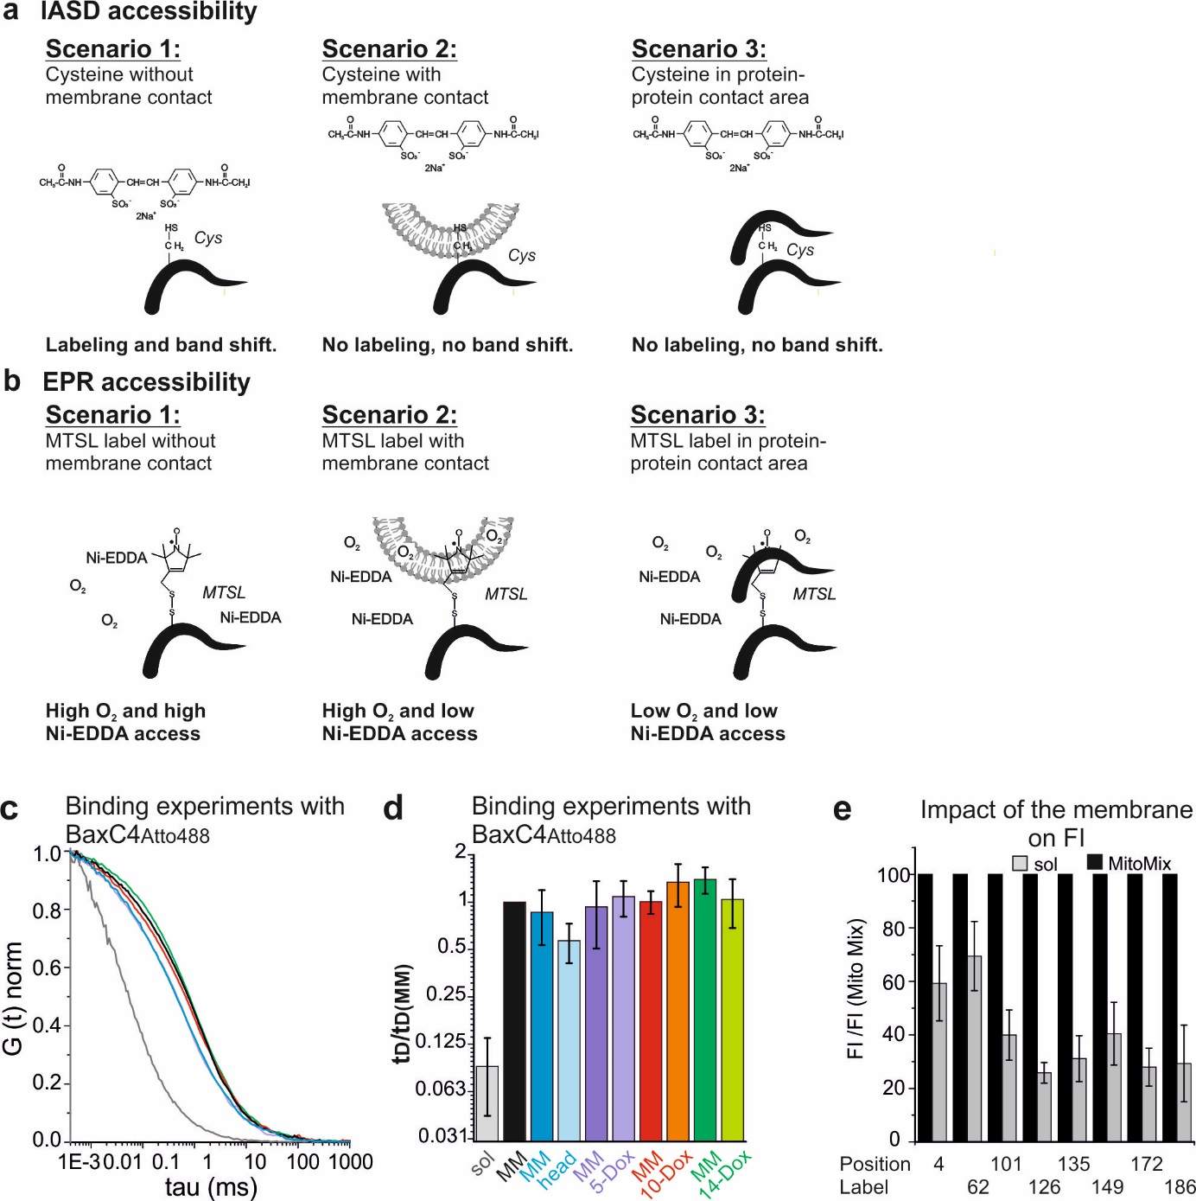
Supplementary Fig. 1 related to Figs. 3 and 4: IASD and EPR accessibility setup and control experiments for the NBD setup.
a-b IASD and EPR accessibility data expected in three different scenarios. c Exemplary FCS curves of Bax_{C4Atto488} in absence of lipids (grey), or after 60 min incubation at 37°C with cBid and liposomes mimicking the MOM in absence (black) or presence of lipids with attached doxyl groups (color code as shown in Figure 3b). d Summary of the diffusion times obtained via FCS experiments of Bax_{C4Atto488} before or after incubation with cBid the different liposomes (liposomes mimicking the MOM are indicated as MOM mix or MM; mean and standard deviation; n: 3-6; color code as in Fig. 3b). e Representation of the impact of membrane insertion (into liposomes mimicking the mitochondrial composition – MitoMix -) on the fluorescence intensity of the eight tested NDB-labeled Bax mutants.

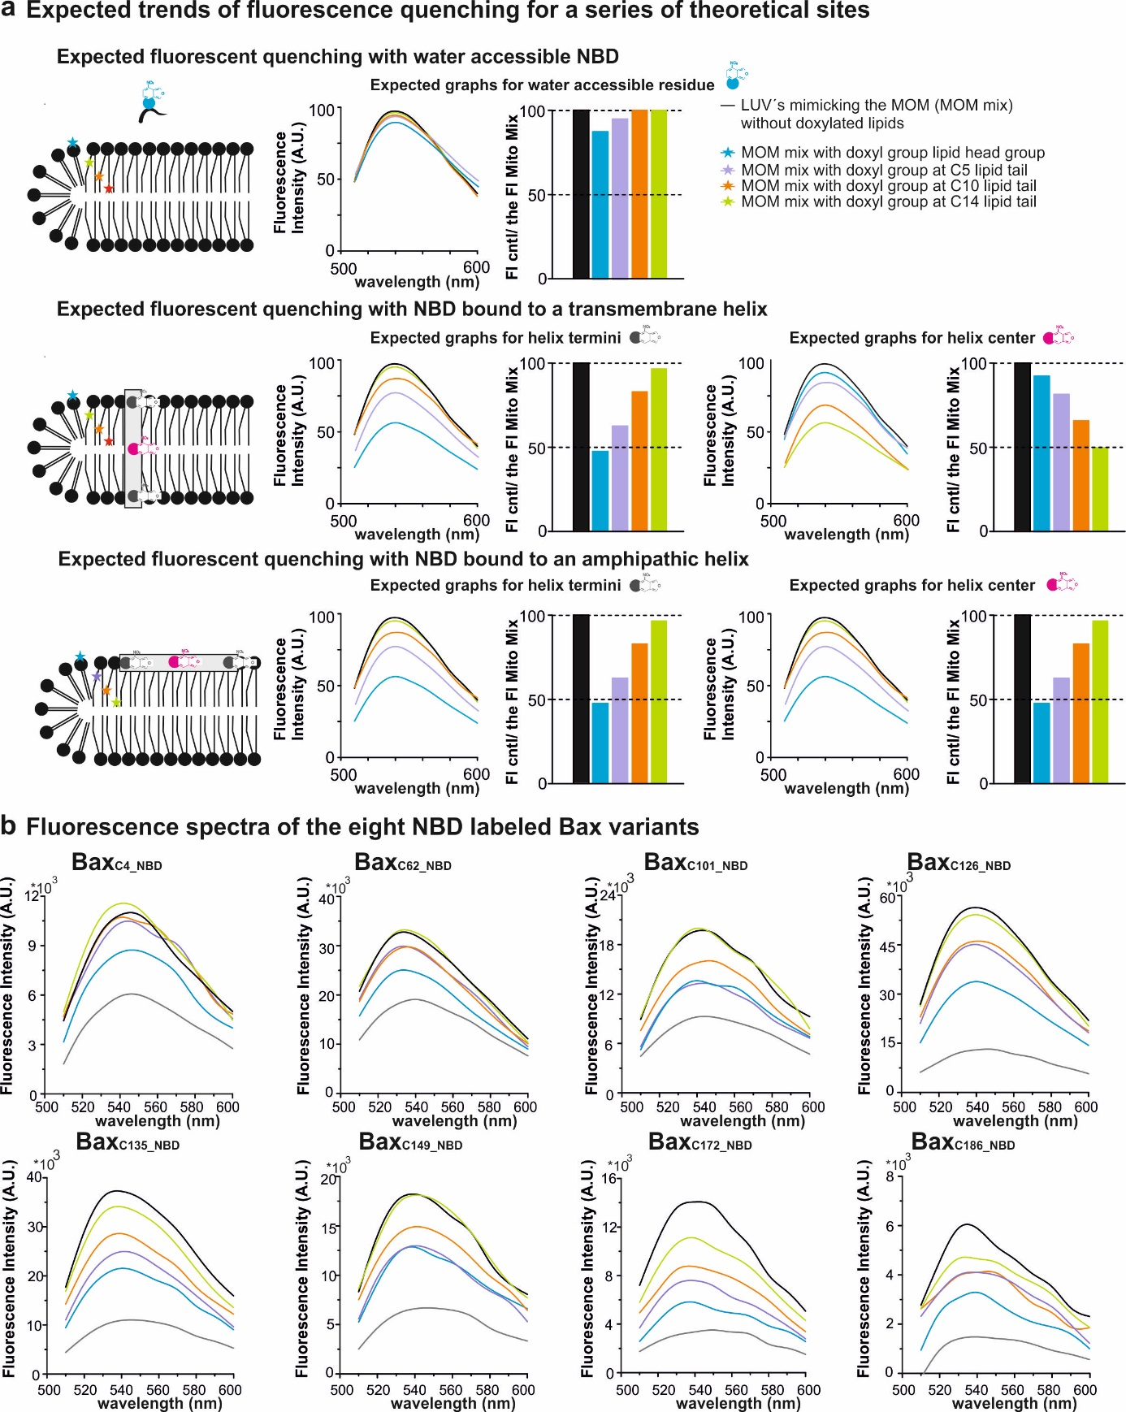
Supplementary Fig. 2 related to Fig. 4: Fluorescence quenching experiments to probe Bax topology. a Expected fluorescence spectra and bar diagrams for water accessible NBD, and NBD attached at the center or the end of transmembrane or amphipathic helices. The position of the doxyl group within the PC derivate is indicated by a colored star. b Fluorescence spectra of the eight Bax variants investigated. For each mutant, data are shown on the soluble protein (grey) and after 60 min incubation at 37°C with cBid and liposomes mimicking the MOM (black) or liposomes mimicking the MOM containing 10% of doxylated lipids (color code as in a; excitation at 478 nm; emission at 541 nm).
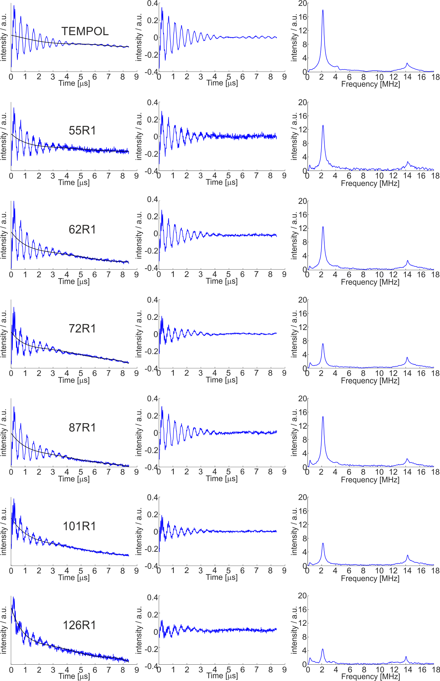
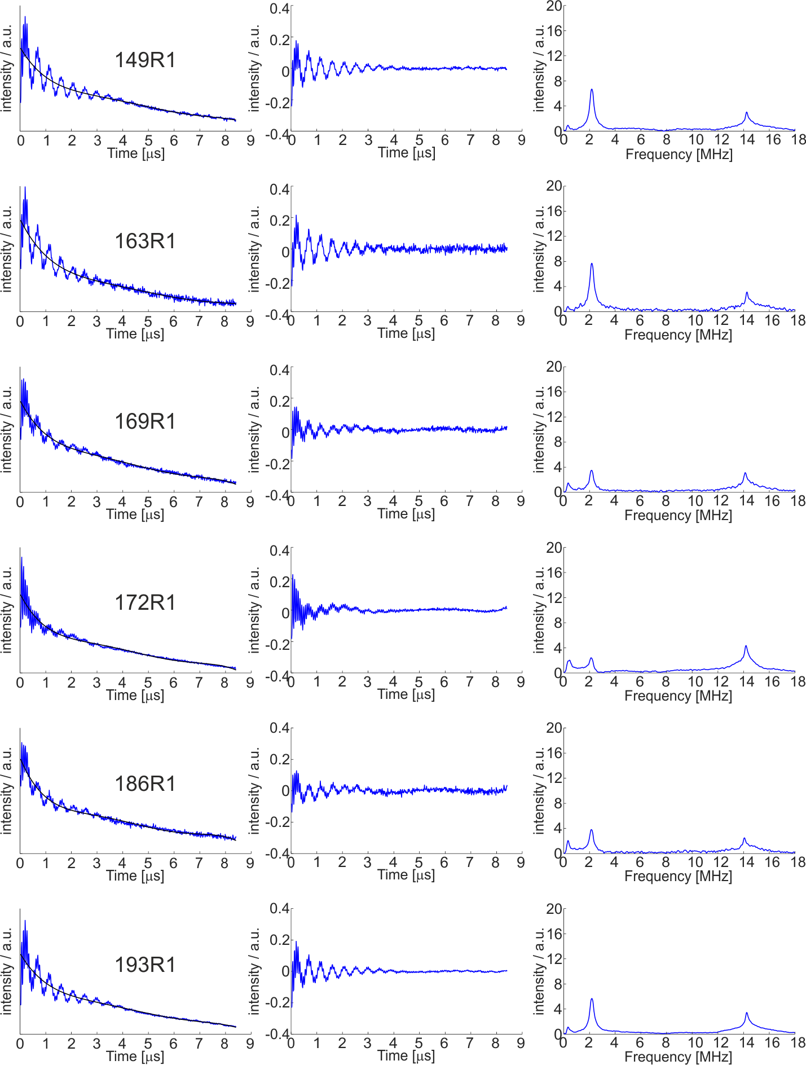
Supplementary Figure 3 related to Figure 4. ESEEM raw data. Raw data, background-corrected and Fourier transformed traces for the spin labeled Bax mutants and the control sample (100 μM TEMPOL), all containing 10% v/v deuterated glycerol.

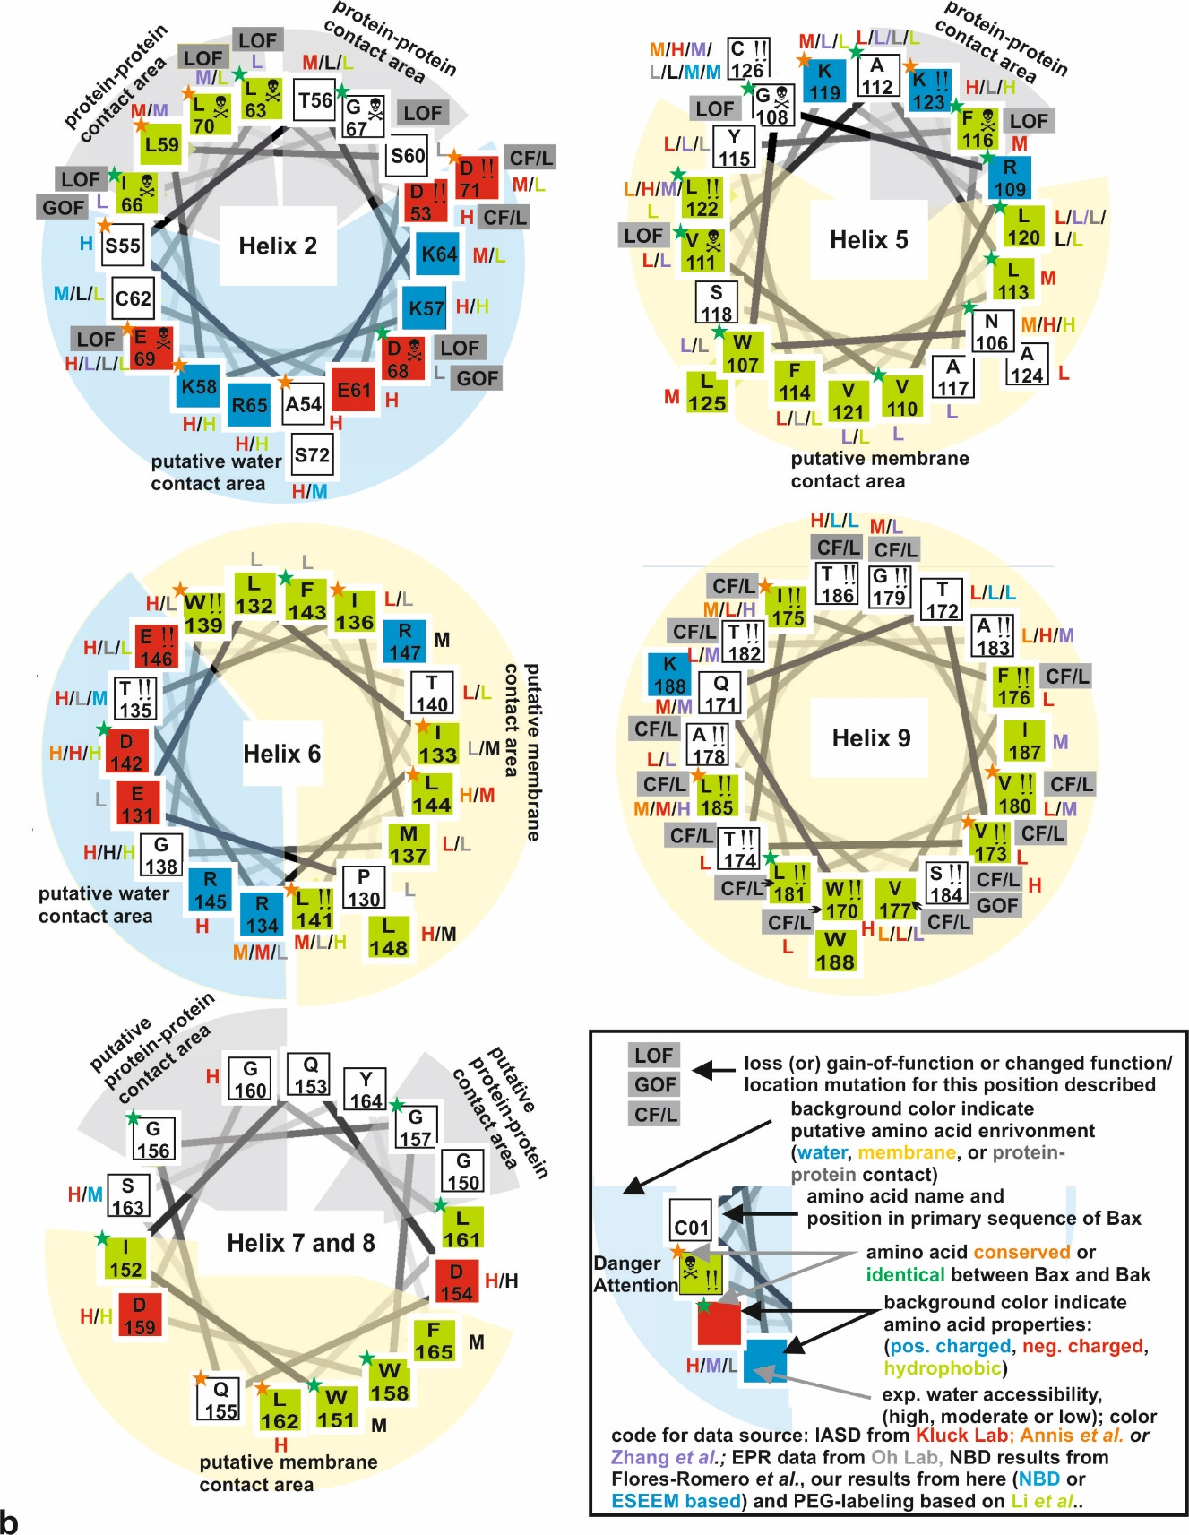
Supplementary Fig. 4 related to Fig. 5A: Summary on Bax/Bak topology data using helix wheel projections. a Helix wheel representation of helices 2 and 5-9 of Bax with information about: i) amino acid hydrophobicity, ii) conservation between Bax and Bak, iii) loss- (or gain-) of-function mutations or mutations with changed function/localization, iv) water accessibility data based on the available data. Water accessibility is classified into high (H), moderate (M) and low (L) and the data of different groups are distinguished by the color code: orange data from Annis et al.¹; red: from Kluck`s lab^{8, 13, 14}; lila: from Zhang et al.¹⁵, grey: from Oh´s lab^{30, 31}, black: from Flores-Romero et al.³², green: from Li et al.³³ and blue new set of data presented here). Non-congruent accessibility data (both H and L present) and mutants with described CF/L (change in function or localization) are highlighted with the symbol ‘!!’ (attention). Those accessibility data should not be considered, and attention should be payed if mutational studies are planned. Interestingly, for position 126 seven data sets exist, in line with M/L accessibility. However, one set shows H accessibility. Amino acids with known mutation-induced loss of function are highlighted by the skull symbol (danger, avoid mutational studies). Identical (green stars) or conserved amino acids (orange stars) between Bax and Bak should be preferentially not be considered for mutational studies. Moreover, known or suggested protein-protein, protein-water or protein- membrane interfaces are highlighted in the figure. For more information see the legend in the inset.

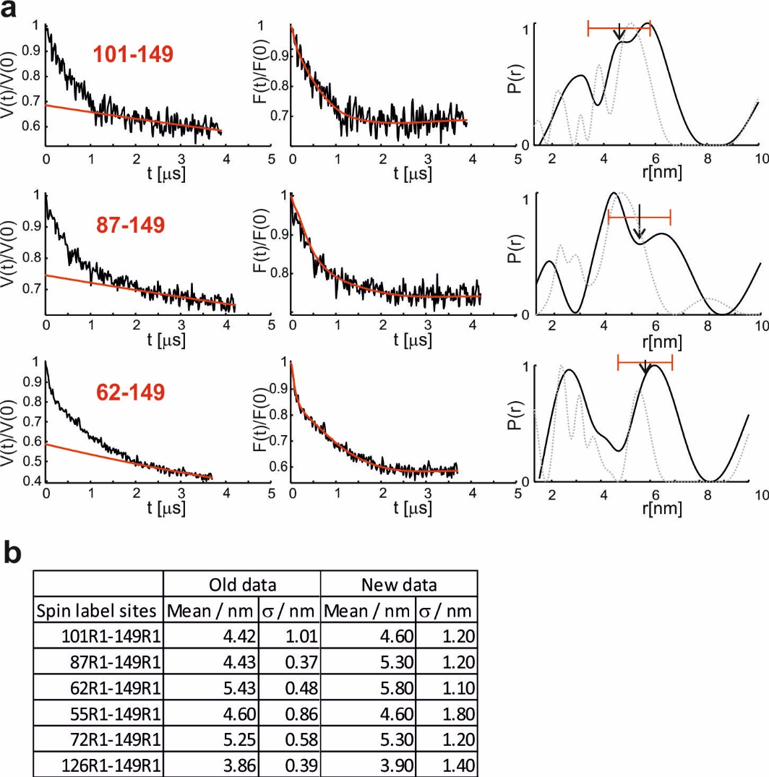
Supplementary Fig. 5 related to Fig. 6. DEER data to localize the localization of helix 6. a DEER measurements to localize position 149. The three double mutants were already studied in ²⁵. Here we show new measurements using an optimized Q-band setup using Gaussian pulses to increase the reliability of longer distances. All distance distributions for the 149 core-latch double mutants were calculated by Tikhonov regularization with an alpha parameter of 10000. The new DEER data is in black with the background and fittings in red. The original distance distributions from ²⁵ are shown in dotted grey. For the pair 62-149 residual intra-dimer distances (asterisk, ²⁵) are excluded from the multilateration process. b Summary of the mean and standard deviations used for the multilateration process to localize position 149 used in ²⁵ (Old data) and here (New data).

Supplementary Table 1: Summary of the published accessibility data on Bax and Bak mutants. The two most left columns present the primary sequence of human Bax alpha and Bak alpha with identical amino acids highlighted in green and highly conserved ones in orange. The third column indicates the position or helices or BH domains in respect to Bax. All other columns present published data. Content and references are given in the upper row. Data presenting Bax are shown in black while data presenting Bak in red.
aa Bax | aa  Bak  Orange very  conserved  Green identical | Secondary structure with respect to Bax | IASD on Bax  Andrews lab ¹  % water accessibility  in cell extracts.  Data classification: high -H-  (80-100%), medium -M-  (40-70%),  low -L-  (0-30%) | IASD on Bax and Bak  Kluck lab ^{7, 8, 13, 14}  % water accessibility  in cell extracts.  Data classification: high -H-  (80-100%), medium -M-  (40-70%),  Low -L-  (0-30%) | IASD on Bak  Weber et al ³⁴  % water accessibility  in cell extracts.  Data classification: high -H-  (80-100%), medium -M-  (40-70%),  Low -L-  (0-30%) | IASD on Bax  Zhang et al ¹⁵  % water accessibility  in pur. protein in isolated mitochondria.  Data classification: high -H-  (80-100%), medium -M-  (40-70%),  Low -L-  (0-30%) | EPR Accessibility on BakΔC  Oh lab ^{30, 31, 35}  Recombinantly produced proteins in  soluble (sol)  and membrane-embedded (me) form.  Water soluble position named “W”,  positions in protein contact areas “P”  and position within the  membrane “M”  (ns: data not shown).  In parenthesis data classification in high, medium or low (H, M, L) water accessibility. | Point mutation in Bax and Bak  that induce a LOF (loss of function),  GOF (gain of function) or RF  (reduced functionality) phenotype.  References are given for each mutant.
1 M | 1M | NT
- | 2A
2 D | 3S | NT
3 G | 4G | NT |  | G4C 100 (H)
4 S | 5Q | NT
5 G | 6G | NT
6 E | 7P | NT
7 Q | 8G | NT
8 P | 9P | NT
- | 10P | NT
- | 11R | NT
- | 12Q | NT
9 R | 13E | NT
10 G | 14C | NT |  | C14C 100 (H)
11 G | 15G | NT
12 G | 16E | NT
13 P | 17P | NT |  |  |  |  |  | P13V Not corr. folded ^{2, 36}
14 T | 18A | NT
- | 19L | NT |  | L19C 100 (H)
- | 20P | NT
- | 21S | NT
- | 22A | NT
15 S | 23S | NT |  | S23C 80 (H)
16 S | 24E | Helix 1
17 E | 25E | Helix 1 |  | E25C 100 (H)
18 Q | 26Q | Helix 1 |  | Q26C 100 (H)
19 I | 27V | Helix 1
20M | 28A | Helix 1 |  | A 28C 100 (H)
21 K | 29Q | Helix 1
22 T | 30D | Helix 1 |  |  |  |  | D30CR1; sol: W; me: W (H)
23 G | 31T | Helix 1
24 A | 32E | Helix 1
25 L | 33E | Helix 1
26 L | 34V | Helix 1 |  | V34C 80 (H) |  |  |  | L26G LOF ^{2, 36}
27 L | 35F | Helix 1
28 Q | 36R | Helix 1
29 G | 37S | Helix 1 |  | S37C 80 (H)
30 F | 38Y | Helix 1
31 I | 39V | Helix 1 |  | V39C 100 (H)
- | 40F |  |  | F40C 100 (H)
- | 41Y |  |  | Y41C 100 (H)
- | 42R |  |  | R42C 60 (M)
- | 43H
- | 44Q |  |  | Q44C 100 (H)
- | 45Q |  |  | Q45C 100 (H)
- | 46E |  |  | E46C 100 (H)
32 Q | 47Q | Helix 1 |  | Q47C 100 (H)
33 D | 48E | Helix 1 |  | E48C 100 (H)
34 R | 49A | Helix 1 |  | A49C 80 (H)
35 A | 50E | Helix 1 |  | E50C 100 (H)
36 G | 51G | Loop 1/2 |  | G51C 80 (H)
37 R | 52V | Loop 1/2 |  | V52C 100 (H)
38M | 53A | Loop 1/2 |  | A53C 80 (H)
39 G | 54A | Loop 1/2 |  | A54C 80 (H)
40 G | 55P | Loop 1/2 | G40C 90 (H) | P55C 100 (H) |  |  | P55CR1; sol: P; me: W (H)
41 E | 56A | Loop 1/2
42 A | 57D | Loop 1/2 |  | D57C 80 (H)
43 P | 58P | Loop 1/2 |  | P58C 100 (H)
44 E | 59E | Loop 1/2 |  | E59C 40 (M)
45 L | 60M | Loop 1/2 |  | M60C 60 (M)
46 A | 61V | Loop 1/2 |  | V61C 80 (H)
47 L | 62T | Loop 1/2 |  | T62C 80 (H)
48 D | 63L | Loop 1/2
49 P | 64P | Loop 1/2
50 V | 65L | Loop 1/2
51 P | 66Q | Loop 1/2 |  | Q66C 100 (H)
52 Q | 67P | Loop 1/2
53 D | 68S | Loop 1/2 |  | S68C 100 (H)
54 A | 69S | Helix 2 |  | S69C 100 (H)
55 S | 70T | Helix 2
56 T | 71M | Helix 2 |  | M71C 70 (M)
57 K | 72G | Helix 2 |  | G72C 100 (H)
58 K | 73Q | Helix 2 |  | Q73C 100 (H)
59 L | 74V | Helix 2 |  | V74C 60 (M) |  | L59C 50 (M)
60 S | 75G | Helix 2 |  |  |  |  | G75CR1; sol: W; me:P (L)
61 E | 76R | Helix 2 |  | R76C 100 (H)
62 C | 77Q | Helix 2
63 L | 78L | Helix 2 |  |  |  | L63C 10 (L) |  | L63E LOF ³⁷  L78A LOF ³⁴  L78P LOF ⁶
64 K | 79A | Helix 2 |  | A79C 40 (M) |  |  |  | K64A- changed fold ^{2, 36}
65 R | 80I | Helix 2 |  | I80C 100 (H)
66 I | 81I | Helix 2 |  |  |  | I66C 10 (L) |  | I66A changed fold, GOF ³  I81K LOF ⁶
67 G | 82G | Helix 2 |  |  |  |  |  | G67R LOF ³⁷
68 D | 83D | Helix 2 |  |  |  |  | D83CR1; sol: W; me: P (L) | D68A changed fold, GOF ³  D83G LOF ⁶
69 E | 84D | Helix 2 |  | D84C 100 (H) |  | E69C 10 (L) | D84CR1; sol: P; me: P (L) | D84G LOF ⁶
70 L | 85I | Helix 2 |  |  |  | L70C 50 (M) |  | L70A changed fold, GOF ³  I85T LOF ⁶
71 D | 86N | Helix 2 |  | N86C 60 (M) |  |  |  | D71A changed fold, GOF ³
72 S | 87R | Helix 2 |  | R87C 100 (H)
 | 88R |  |  | R88C 80 (H)
 | 89Y
73 N | 90D | Loop 2/3
74 M | 91S | Helix 3 |  | S91C 100 (H)
75 E | 92E | Helix 3 |  |  |  |  |  | E92G LOF ⁶
76 L | 93F | Helix 3 |  |  |  | L76C 90 (H) |  | F92S LOF ⁶
77 Q | 94Q | Helix 3
78 R | 95T | Helix 3 |  | T95C 100 (H)
79 M | 96M | Helix 3 |  |  |  | M79C 80 (H)
80 I | 97L | Helix 3
81 A | 98Q | Helix 3 |  | Q98C 100 (H)
82 A | 99H | Helix 3 |  | H99C 100 (H) |  |  | H99CR1; sol: W; me: W (H)
83 V | 100L | Loop 3/4 |  |  |  |  |  | L100P LOF ⁶
84 D | 101Q | Loop 3/4
 | 102P
 | 103T
85 T | 104a | Loop 3/4 |  | A104C 100 (H)
86 D | 105E | Loop 3/4 |  | E105C 80 (H)
87 S | 106N | Loop 3/4 |  | N106C 80 (H) |  |  | N106CR1; sol: W; me: M (L)
88 P | 107A | Helix 4 |  | A107C 20 (L) |  |  | A107CR1; sol: W; me: W (H)
89 R | 108Y | Helix 4 |  | Y108C 100 (H)
90 E | 109E | Helix 4
91 V | 110Y | Helix 4 |  | F110C 100 (H)
92 F | 111F | Helix 4 |  |  |  | F92C 50 (M)
93 F | 112T | Helix 4 |  |  |  | F93C 60 (M)
94 R | 113K | Helix 4
95 V | 114I | Helix 4
96 A | 115A | Helix 4 |  |  |  |  |  | F115S LOF ⁶
97 A | 116T | Helix 4
98 D | 117S | Helix 4 |  | S117C 100 (H) |  |  | S117R1; sol: ns; me: M (L)
99 M | 118L | Helix 4 |  |  |  |  |  | L118P LOF ⁶
100 F | 119F | Loop 4/5 |  | F119C 70 (M) |  | F100C 60 (M)
101 S | 120E | Loop 4/5 |  | E120C 100 (H)
102 D | 121S | Loop 4/5 |  | S121C 80 (H)
103 G | 122G | Loop 4/5 |  | G122C 100 (H) |  |  | G122R1; sol: W; me: W (H)
104 N | - | Loop 4/5
105 F | 123I | Loop 4/5 |  | I123C 70 (M)
106 N | 124N | Loop 4/5 | N106C 40 (M) | N124C 100 (H)  N106C/S184L 80 (H) | N124 C 100 (H)
107 W | 125W | Helix 5 |  |  |  | W107C 30 (L) | W125CR1; sol: W; me: M (L)
108 G | 126G | Helix 5 |  |  |  |  |  | G108R LOF ³⁷  G126S LOF ⁶
109 R | 127R | Helix 5
110 V | 128V | Helix 5 |  |  |  | V110C 30 (L)
111 V | 129V | Helix 5 |  | V129C 30 (L)  V111C/S184L 20 (L) |  | V111C 10 (L) |  | V129E LOF ⁶
112 A | 130A | Helix 5 |  | a130C 50 (M)  a112C/S184L 30 (L) |  | A112C 20 (L) | A130CR1; sol: W; me: M/P (L)
113 L | 131A | Helix 5 |  | l131c 40 (M)
114 F | 132L | Helix 5 |  | L132C 20 (L) |  |  | L132CR1; sol: P; me: P (L)
115 Y | 133G | Helix 5 |  | G133C 10 (L)  Y115C/S184L 30 (L) |  | Y115C 20 (L) | G133CR1; sol: W; me: M (L)
116 F | 134F | Helix 5 |  | F134C LOF 70 (M)  F116C/S184L 30 (L) |  |  | F134CR1; sol: P; me: ns | F134L/S LOF ⁶
117 A | 135G | Helix 5 |  |  |  | A117C 10 (L)
118 S | 136Y | Helix 5
119 K | 137R | Helix 5 |  | R137C 40 (M)  k119C/S184L 20 (L) | R 137C 100 (H) | K119C 10 (L)
120 L | 138L | Helix 5 |  | L120c/ s184V 10 (L) |  | L120C 20 (L) | L138CR1; sol: P; me: M (L)
121 V | 139A | Helix 5 |  |  |  | V121C 10 (L)
122 L | 140L | Helix 5 | L122C 10 (L) | L140C 80 (H)  L122c/s184V 80 (H) |  | L122c 60 (M)
123 K | 141H | Helix 5 |  | H141C 100 (H)  K123c/ s184V 80 (H) |  |  | H141CR1; sol: W; me: M (L)
124 A | 142V | Helix 5 |  | v142C 20 (L)  a124c/ s184V 50 (M)
125 L | 143L/Y | Helix 5 |  | L143C 40 (M)  L125c/ s184V 50 (M)
126 C | 144Q | Helix 5 | C126 40 (M) | Q144c 80 (H)  C126/s184V 80 (H) |  | C126 50 (M) | Q144CR1; sol: ns; me: M (L)
127 T | 145H | Loop 5/6 | T127C 80 (H) | H145c 80 (H) |  |  | H145CR1; sol: ns; me: M (L)
128 K | 146G | Loop 5/6 |  |  |  |  | G146CR1; sol: W; me: M (L)
129 V | 147L | Loop 5/6 | V129C 20 (L) |  |  |  | L147CR1 sol: ns; me: M (L)
130 P | 148T | Helix 6 |  |  |  |  | T148CR1; sol: ns; me: M (L)
131 E | 149G | Helix 6 |  |  |  |  | G149CR1; sol: ns; me: M (L)
132 L | 150F | Helix 6 |  |  |  |  | F150CR1; sol: ns; me: P (L)
133 I | 151L | Helix 6 |  |  |  |  | L151CR1; sol: ns; me: M (L)
134 R | 152G | Helix 6 | R134C 40 (M) | R134c/ s184V 70 (M) |  |  | G152CR1; sol: ns; me: M (L)
135 T | 153Q | Helix 6 |  | t135c/ s184V 80 (M) |  |  | Q153CR1; sol: ns; me: M (L)
136 I | 154V | Helix 6 |  | V154C 30 (L)  i136c/ s184V 30 (L) | V154 c 80 (H) |  | V154CR1; sol: M; me: M (L)
137 M | 155T | Helix 6 |  |  |  |  | T155CR1; sol: ns; me: M (L)
138 G | 156R | Helix 6 |  | R156C 100 (H)  g138c/ s184V 90 (H) | r156c 100 (H)
139 W | 157F | Helix 6 |  | F157C 100 (H) |  |  | F157CR1; sol: ns; me: M (L)
140 T | 158V | Helix 6 |  | V158V 20 (L)
141 L | 159V | Helix 6 |  | V159V 70 (M) |  |  | V159CR1; sol: ns; me: M (L)
142 D | 160D | Helix 6 | D142C 100 (H) | D160 100 (H)  d142c/ s184V 100 (H)
143 F | 161F | Helix 6 |  |  |  |  | F161CR1; sol: ns; me: M (L)
144 L | 162M | Helix 6 | L144C 90 (H) | m162C 70 (M)  l144c/ s184V 30 (L)
145 R | 163L | Helix 6 |  | L163C 100 (H)
146 E | 164H | Helix 6 |  | h164C 100 (H) |  |  | H164CR1; sol: W; me: M (L)
147 R | 165H | Helix 6
148 L | 166C | Loop 6/7 |  | C166 100 (H) | C166 100 (H)
149 L | 167I | Helix 7
150 G | 168A | Helix 7
 | 169R
151 W | 170W | Helix 7
152 I | 171I | Helix 7
153 Q | 172A | Helix 7
154 D | 173Q | Helix 7 |  | Q173C 100 (H)
155 Q | 174R | Helix 7
156 G | 175G | Helix 7
157 G | 176G | Loop 7/8
158 W | 177W | Helix 8
159 D | 178V | Helix 8 |  | V178C 100 (H)
160 G | 179A | Helix 8 |  | A179C 100 (H)
161 L | 180A | Helix 8
162 L | 181L | Helix 8 |  | L181C 100 (H)
163 S | 182N | Helix 8 |  | N182C 100 (H)
164 Y | 183L | Helix 8
165 F | 184G | Helix 8
166 G | 185N | Loop 8/9
167 T | 186G | Loop 8/9 |  | G186 c 70 (M)
168 P | 187P | Loop 8/9 |  | p187c 80 (H) |  |  |  | P168A RF ³⁸
169 T | 188I | Loop 8/9 |  | i188c 80 (H)
170 W | 189L | Helix 9 |  | L189c 80 (H) |  |  |  | L189C partially soluble Bak ¹⁴
171 Q | 190N | Helix 9 |  | N190c 50 (M) |  | Q171C 50 (M) |  | N190C partially soluble Bak ¹⁴
172 T | 191V | Helix 9 |  | v191c 20 (L)
173 V | 192L | Helix 9 |  | L192c 30 (L) |  |  |  | N192C partially soluble Bak ¹⁴
174 T | 193V | Helix 9 |  | V193c 20 (L) |  |  |  | V193C partially soluble Bak ¹⁴
175 I | 194V | Helix 9 | I175C 50 (M) | V194c 30 (L) |  | I175C 80 (H) |  | V194C partially soluble Bak ¹⁴
176 F | 195L | Helix 9 |  | I195c 20 (L) | L195C 0 |  |  | L195C partially soluble Bak ¹⁴
177 V | 196G | Helix 9 | V177C 0 (L) | G196c 20 (L) |  | V177C 30 (L) |  | G196C partially soluble Bak ¹⁴
178 A | 197V | Helix 9 |  | V197c 20 (L) |  | A178C 30 (L) |  | V197C partially soluble Bak ¹⁴
179 G | 198V | Helix 9 |  | V198c 40 (M) |  | G179C 10 (L) |  | G179I RF and reduced dimer-  Dimer contacts ¹⁵  V198C partially soluble Bak ¹⁴
180 V | 199L | Helix 9 |  | l199c 30 (L) |  | V180C 50 (M) |  | L199C partially soluble Bak ¹⁴
181 L | 200L | Helix 9 |  | L200c 20 (L) |  |  |  | L200C partially soluble Bak ¹⁴
182 T | 201G | Helix 9 |  | g201c 20 (L) |  | T182C 70 (M) |  | T182I RF and reduced dimer-  Dimer contacts ¹⁵
183 A | 202Q | Helix 9 | A183C 0 (L) | q202c 100 (H) |  | A183C 50 (M)
184 S | 203F | Helix 9 |  | f203c 100 (H) |  |  |  | S184V GOF ³⁷  S184A GOF ³⁸  S184K,E,D RF RF ³⁸  F203C partially soluble Bak ¹⁴
185 L | 204V | Helix 9 | L185C 40 (M) | v204c 70 (M) |  | L185C 80 (H) |  | V204C partially soluble Bak ¹⁴
186 T | 205V | Helix 9 |  | v205c 100 (H) |  |  |  | V205C partially soluble Bak ¹⁴
187 I | 206R | Helix 9 |  |  |  | I187C 70 (M)
188 W | 207R | Helix 9
189 K | 208F | Helix 9
190 K | 209F | CT
191 M | 210K | CT
192 G | 211S | CT

Supplementary Table 2: Summary of the accessibility data on Bax and Bak mutants based on Flores-Romero et.al. ³² and Li et al.³³. The two most left columns present the primary sequence of human Bax alpha and Bak alpha with identical amino acids highlighted in green and highly conserved ones in orange. The third column from the left indicated the position or helices or BH domains with respect to Bax. The next three columns present data on the amount of lipid or water contact certain amino acids have based on Flores-Romero et.al. ³² work on Bax, while and the right column present data of Li et al.³³ on Bak.
aa Bax | aa Bak  Orange very conserved  Green identical | Secondary structure with respect to Bax | Lipid accessibility  (high, medium and low) based on Flores-Romero et al ³² | Water accessibility (high, medium and low) based on Flores-Romero et al ³² | Sum of water accessibility based on the other two columns.  Data classification:  high -H-  medium -M-  low -L-  Cases in which both lipid and water accessibility are high or one of them is medium,  Are considered as medium -M- | Accessibility to PEG (5 kd) Labeling  Data classification:  high -H-  medium -M-  low -L-
1 M | 1M | NT
- | 2A
2 D | 3S | NT
3 G | 4G | NT |  |  |  | G4C H
4 S | 5Q | NT
5 G | 6G | NT
6 E | 7P | NT
7 Q | 8G | NT
8 P | 9P | NT
- | 10P | NT
- | 11R | NT
- | 12Q | NT
9 R | 13E | NT
10 G | 14C | NT |  |  |  | C14C H
11 G | 15G | NT
12 G | 16E | NT
13 P | 17P | NT
14 T | 18A | NT
- | 19L | NT
- | 20P | NT
- | 21S | NT
- | 22A | NT
15 S | 23S | NT |  |  |  | S23C H
16 S | 24E | Helix 1
17 E | 25E | Helix 1
18 Q | 26Q | Helix 1
19 I | 27V | Helix 1
20M | 28A | Helix 1
21 K | 29Q | Helix 1
22 T | 30D | Helix 1
23 G | 31T | Helix 1
24 A | 32E | Helix 1
25 L | 33E | Helix 1
26 L | 34V | Helix 1
27 L | 35F | Helix 1
28 Q | 36R | Helix 1 |  |  |  | R36C H
29 G | 37S | Helix 1
30 F | 38Y | Helix 1
31 I | 39V | Helix 1
- | 40F
- | 41Y |  |  |  |  | Y41C L
- | 42R
- | 43H
- | 44Q
- | 45Q
- | 46E
32 Q | 47Q | Helix 1
33 D | 48E | Helix 1
34 R | 49A | Helix 1
35 A | 50E | Helix 1
36 G | 51G | Loop 1/2
37 R | 52V | Loop 1/2 |  |  |  | V52C H
38M | 53A | Loop 1/2
39 G | 54A | Loop 1/2
40 G | 55P | Loop 1/2
41 E | 56A | Loop 1/2
42 A | 57D | Loop 1/2 |  |  |  | D57C H
43 P | 58P | Loop 1/2
44 E | 59E | Loop 1/2
45 L | 60M | Loop 1/2 |  |  |  | M60C H
46 A | 61V | Loop 1/2
47 L | 62T | Loop 1/2
48 D | 63L | Loop 1/2
49 P | 64P | Loop 1/2
50 V | 65L | Loop 1/2
51 P | 66Q | Loop 1/2
52 Q | 67P | Loop 1/2
53 D | 68S | Loop 1/2
54 A | 69S | Helix 2
55 S | 70T | Helix 2
56 T | 71M | Helix 2 | T56C low | T56C low | T56C (L) | Inactiv: 20% L  Activ: 80% H
57 K | 72G | Helix 2 |  |  |  | G72C H
58 K | 73Q | Helix 2 |  |  |  | Q73C H
59 L | 74V | Helix 2
60 S | 75G | Helix 2
61 E | 76R | Helix 2
62 C | 77Q | Helix 2 | C62 low | C62 low | C62 (L) | Q77C L
63 L | 78L | Helix 2
64 K | 79A | Helix 2 |  |  |  | A79C L
65 R | 80I | Helix 2 |  |  |  | I80C H
66 I | 81I | Helix 2
67 G | 82G | Helix 2
68 D | 83D | Helix 2
69 E | 84D | Helix 2 |  |  |  | D84C L
70 L | 85I | Helix 2 |  |  |  | I85C L
71 D | 86N | Helix 2 |  |  |  | I85C L
72 S | 87R | Helix 2
 | 88R |  |  |  |  | R88C H
 | 89Y |  |  |  |  | Y89C H-M  Y89C active: L
73 N | 90D | Loop 2/3
74 M | 91S | Helix 3 | M74C low | M74C high | M74C (H)
75 E | 92E | Helix 3 |  |  |  | E92C H
76 L | 93F | Helix 3
77 Q | 94Q | Helix 3
78 R | 95T | Helix 3
79 M | 96M | Helix 3
80 I | 97L | Helix 3
81 A | 98Q | Helix 3
82 A | 99H | Helix 3 |  |  |  | H99C H
83 V | 100L | Loop 3/4
84 D | 101Q | Loop 3/4
 | 102P
 | 103T
85 T | 104a | Loop 3/4
86 D | 105E | Loop 3/4
87 S | 106N | Loop 3/4
88 P | 107A | Helix 4
89 R | 108Y | Helix 4 | R89C high | R89C medium | R89C (M)
90 E | 109E | Helix 4
91 V | 110Y | Helix 4 |  |  |  | Y110C H
92 F | 111F | Helix 4
93 F | 112T | Helix 4
94 R | 113K | Helix 4 | R94C low | R94C low | R94C (L) | K113C H
95 V | 114I | Helix 4
96 A | 115A | Helix 4
97 A | 116T | Helix 4
98 D | 117S | Helix 4 |  |  |  | S117C H
99 M | 118L | Helix 4
100 F | 119F | Loop 4/5 | F100C high | F100C low | F100C (L)
101 S | 120E | Loop 4/5
102 D | 121S | Loop 4/5
103 G | 122G | Loop 4/5
104 N | - | Loop 4/5
105 F | 123I | Loop 4/5 | F105C high | F105C low | F105C (L) | I123C L
106 N | 124N | Loop 4/5 |  |  |  | N124C H
107 W | 125W | Helix 5
108 G | 126G | Helix 5
109 R | 127R | Helix 5
110 V | 128V | Helix 5
111 V | 129V | Helix 5
112 A | 130A | Helix 5 |  |  |  | A130C L  Activ: H
113 L | 131A | Helix 5
114 F | 132L | Helix 5 |  |  |  | L132C L
115 Y | 133G | Helix 5
116 F | 134F | Helix 5
117 A | 135G | Helix 5
118 S | 136Y | Helix 5
119 K | 137R | Helix 5 |  |  |  | R137C L
120 L | 138L | Helix 5 | L120C high | L120C low | L120C (L) | L138C L
121 V | 139A | Helix 5 |  |  |  | A139C L
122 L | 140L | Helix 5 |  |  |  | L140C L
123 K | 141H | Helix 5 |  |  |  | H141C H
124 A | 142V | Helix 5
125 L | 143L/Y | Helix 5
126 C | 144Q | Helix 5 | C126 high | C126 low | C126 (L)
127 T | 145H | Loop 5/6 |  |  |  | H145C H
128 K | 146G | Loop 5/6
129 V | 147L | Loop 5/6
130 P | 148T | Helix 6
131 E | 149G | Helix 6
132 L | 150F | Helix 6
133 I | 151L | Helix 6 | I133C medium | I133C medium | I133C (M)
134 R | 152G | Helix 6
135 T | 153Q | Helix 6
136 I | 154V | Helix 6
137 M | 155T | Helix 6
138 G | 156R | Helix 6 | G138C low | G138C high | G138C (H) | R156C H
139 W | 157F | Helix 6
140 T | 158V | Helix 6 |  |  |  | V158C L
141 L | 159V | Helix 6 |  |  |  | V159C H
142 D | 160D | Helix 6 |  |  |  | D160C H
143 F | 161F | Helix 6
144 L | 162M | Helix 6
145 R | 163L | Helix 6
146 E | 164H | Helix 6 |  |  |  | H164C H
147 R | 165H | Helix 6 | R147C medium | R147C high | R147C (M)
148 L | 166C | Loop 6/7 | L148C medium | L148C high | L148C (M) | Inactive ~ 50% M  Active ~ 80% H
149 L | 167I | Helix 7
150 G | 168A | Helix 7
 | 169R
151 W | 170W | Helix 7 | W151C medium | W151C medium | W151C (M)
152 I | 171I | Helix 7
153 Q | 172A | Helix 7
154 D | 173Q | Helix 7 | D154 low | D154 high | D154 (H)
155 Q | 174R | Helix 7
156 G | 175G | Helix 7
157 G | 176G | Loop 7/8
158 W | 177W | Helix 8
159 D | 178V | Helix 8 |  |  |  | V178C H
160 G | 179A | Helix 8
161 L | 180A | Helix 8
162 L | 181L | Helix 8
163 S | 182N | Helix 8
164 Y | 183L | Helix 8
165 F | 184G | Helix 8 | F165C medium | F165C medium | F165C (M)
166 G | 185N | Loop 8/9
167 T | 186G | Loop 8/9
168 P | 187P | Loop 8/9
169 T | 188I | Loop 8/9
170 W | 189L | Helix 9
171 Q | 190N | Helix 9
172 T | 191V | Helix 9
173 V | 192L | Helix 9
174 T | 193V | Helix 9
175 I | 194V | Helix 9
176 F | 195L | Helix 9
177 V | 196G | Helix 9
178 A | 197V | Helix 9
179 G | 198V | Helix 9
180 V | 199L | Helix 9
181 L | 200L | Helix 9
182 T | 201G | Helix 9
183 A | 202Q | Helix 9
184 S | 203F | Helix 9
185 L | 204V | Helix 9
186 T | 205V | Helix 9
187 I | 206R | Helix 9
188 W | 207R | Helix 9
189 K | 208F | Helix 9
190 K | 209F | CT
191 M | 210K | CT
192 G | 211S | CT

References:
1. Annis MG, Soucie EL, Dlugosz PJ, Cruz-Aguado JA, Penn LZ, Leber B, et al. Bax forms multispanning monomers that oligomerize to permeabilize membranes during apoptosis. EMBO J 2005, 24(12): 2096-2103.

2. Cartron PF, Arokium H, Oliver L, Meflah K, Manon S, Vallette FM. Distinct domains control the addressing and the insertion of Bax into mitochondria. J Biol Chem 2005, 280(11): 10587-10598.

3. Zhou H, Hou Q, Hansen JL, Hsu YT. Complete activation of Bax by a single site mutation. Oncogene 2007, 26(50): 7092-7102.

4. Valentijn AJ, Upton JP, Bates N, Gilmore AP. Bax targeting to mitochondria occurs via both tail anchor-dependent and -independent mechanisms. Cell Death Differ 2008, 15(8): 1243-1254.

5. Schinzel A, Kaufmann T, Schuler M, Martinalbo J, Grubb D, Borner C. Conformational control of Bax localization and apoptotic activity by Pro168. J Cell Biol 2004, 164(7): 1021-1032.

6. Dewson G, Kratina T, Sim HW, Puthalakath H, Adams JM, Colman PM, et al. To trigger apoptosis, Bak exposes its BH3 domain and homodimerizes via BH3:groove interactions. Mol Cell 2008, 30(3): 369-380.

7. Alsop AE, Fennell SC, Bartolo RC, Tan IK, Dewson G, Kluck RM. Dissociation of Bak alpha1 helix from the core and latch domains is required for apoptosis. Nat Commun 2015, 6: 6841.

8. Uren RT, O'Hely M, Iyer S, Bartolo R, Shi MX, Brouwer JM, et al. Disordered clusters of Bak dimers rupture mitochondria during apoptosis. Elife 2017, 6.

9. Ma S, Hockings C, Anwari K, Kratina T, Fennell S, Lazarou M, et al. Assembly of the Bak apoptotic pore: a critical role for the Bak protein alpha6 helix in the multimerization of homodimers during apoptosis. J Biol Chem 2013, 288(36): 26027-26038.

10. Ma SB, Nguyen TN, Tan I, Ninnis R, Iyer S, Stroud DA, et al. Bax targets mitochondria by distinct mechanisms before or during apoptotic cell death: a requirement for VDAC2 or Bak for efficient Bax apoptotic function. Cell Death Differ 2014, 21(12): 1925-1935.

11. Lazarou M, Stojanovski D, Frazier AE, Kotevski A, Dewson G, Craigen WJ, et al. Inhibition of Bak activation by VDAC2 is dependent on the Bak transmembrane anchor. J Biol Chem 2010, 285(47): 36876-36883.

12. Ross K, Rudel T, Kozjak-Pavlovic V. TOM-independent complex formation of Bax and Bak in mammalian mitochondria during TNFalpha-induced apoptosis. Cell Death Differ 2009, 16(5): 697-707.

13. Westphal D, Dewson G, Menard M, Frederick P, Iyer S, Bartolo R, et al. Apoptotic pore formation is associated with in-plane insertion of Bak or Bax central helices into the mitochondrial outer membrane. Proc Natl Acad Sci U S A 2014, 111(39): E4076-4085.

14. Iyer S, Bell F, Westphal D, Anwari K, Gulbis J, Smith BJ, et al. Bak apoptotic pores involve a flexible C-terminal region and juxtaposition of the C-terminal transmembrane domains. Cell Death Differ 2015, 22(10): 1665-1675.

15. Zhang Z, Subramaniam S, Kale J, Liao C, Huang B, Brahmbhatt H, et al. BH3-in-groove dimerization initiates and helix 9 dimerization expands Bax pore assembly in membranes. Embo j 2016, 35(2): 208-236.

16. Bordignon E. Site-directed spin labeling of membrane proteins. Topics in current chemistry 2012, 321: 121-157.

17. Klare JP. Site-directed spin labeling EPR spectroscopy in protein research. Biological chemistry 2013, 394(10): 1281-1300.

18. Bleicken S, Classen M, Padmavathi PV, Ishikawa T, Zeth K, Steinhoff HJ, et al. Molecular details of Bax activation, oligomerization, and membrane insertion. J Biol Chem 2010, 285(9): 6636-6647.

19. Ries J, Weidemann T, Schwille P. Fluorescence Correlation Spectroscopy. In: Egelman EH (ed). Comprehensive Biophysics. Elsevier: Amsterdam, 2012, pp 210-245.

20. Bleicken S, Wagner C, García-Sáez Ana J. Mechanistic Differences in the Membrane Activity of Bax and Bcl-xL Correlate with Their Opposing Roles in Apoptosis. Biophysical Journal 2013, 104(2): 421-431.

21. Bleicken S, Landeta O, Landajuela A, Basanez G, Garcia-Saez AJ. Proapoptotic Bax and Bak form stable protein-permeable pores of tunable size. J Biol Chem 2013, 288(46): 33241-33252.

22. Subburaj Y, Cosentino K, Axmann M, Pedrueza-Villalmanzo E, Hermann E, Bleicken S, et al. Bax monomers form dimer units in the membrane that further self-assemble into multiple oligomeric species. Nat Commun 2015, 6.

23. Bleicken S, Hofhaus G, Ugarte-Uribe B, Schroder R, Garcia-Saez AJ. cBid, Bax and Bcl-xL exhibit opposite membrane remodeling activities. Cell Death Dis 2016, 7: e2121.

24. Bleicken S, Garcia-Saez AJ, Conte E, Bordignon E. Dynamic interaction of cBid with detergents, liposomes and mitochondria. PLoS One 2012, 7(4): e35910.

25. Bleicken S, Jeschke G, Stegmueller C, Salvador-Gallego R, García-Sáez Ana J, Bordignon E. Structural Model of Active Bax at the Membrane. Molecular Cell 2014, 56(4): 496-505.

26. Lovell JF, Billen LP, Bindner S, Shamas-Din A, Fradin C, Leber B, et al. Membrane binding by tBid initiates an ordered series of events culminating in membrane permeabilization by Bax. Cell 2008, 135(6): 1074-1084.

27. Polyhach Y, Bordignon E, Tschaggelar R, Gandra S, Godt A, Jeschke G. High sensitivity and versatility of the DEER experiment on nitroxide radical pairs at Q-band frequencies. Phys Chem Chem Phys 2012, 14(30): 10762-10773.

28. Jeschke G, Chechik V, Ionita P, Godt A, Zimmermann H, Banham J, et al. DeerAnalysis2006—a comprehensive software package for analyzing pulsed ELDOR data. Appl Magn Reson 2006, 30(3-4): 473-498.

29. Segawa TF, Doppelbauer M, Garbuio L, Doll A, Polyhach YO, Jeschke G. Water accessibility in a membrane-inserting peptide comparing Overhauser DNP and pulse EPR methods. J Chem Phys 2016, 144(19): 194201.

30. Aluvila S, Mandal T, Hustedt E, Fajer P, Choe JY, Oh KJ. Organization of the Mitochondrial Apoptotic BAK Pore: Oligomerization of the BAK Homodimers. J Biol Chem 2013, 289(5): 2537-2551.

31. Mandal T, Shin S, Aluvila S, Chen HC, Grieve C, Choe JY, et al. Assembly of Bak homodimers into higher order homooligomers in the mitochondrial apoptotic pore. Scientific reports 2016, 6: 30763.

32. Flores-Romero H, Garcia-Porras M, Basanez G. Membrane insertion of the BAX core, but not latch domain, drives apoptotic pore formation. Scientific reports 2017, 7(1): 16259.

33. Li MX, Tan IKL, Ma SB, Hockings C, Kratina T, Dengler MA, et al. BAK α6 permits activation by BH3-only proteins and homooligomerization via the canonical hydrophobic groove. Proceedings of the National Academy of Sciences 2017, 114(29): 7629-7634.

34. Weber K, Harper N, Schwabe J, Cohen GM. BIM-mediated membrane insertion of the BAK pore domain is an essential requirement for apoptosis. Cell reports 2013, 5(2): 409-420.

35. Oh KJ, Singh P, Lee K, Foss K, Lee S, Park M, et al. Conformational Changes in BAK, a Pore-forming Proapoptotic Bcl-2 Family Member, upon Membrane Insertion and Direct Evidence for the Existence of BH3-BH3 Contact Interface in BAK Homo-oligomers. J Biol Chem 2010, 285(37): 28924-28937.

36. Cartron PF, Oliver L, Mayat E, Meflah K, Vallette FM. Impact of pH on Bax alpha conformation, oligomerisation and mitochondrial integration. FEBS Lett 2004, 578(1-2): 41-46.

37. Kim H, Tu H-C, Ren D, Takeuchi O, Jeffers JR, Zambetti GP, et al. Stepwise Activation of BAX and BAK by tBID, BIM, and PUMA Initiates Mitochondrial Apoptosis. Molecular Cell 2009, 36(3): 487-499.

38. Nechushtan A, Smith CL, Hsu Y-T, Youle RJ. Conformation of the Bax C-terminus regulates subcellular location and cell death. EMBO J 1999, 18(9): 2330-2341.

