SUPPLEMENTARY DATA

Supplementary Table 1. RNAseq and KEGG pathway analysis of differentially expressed genes in human dedifferentiated acinar cells and duct cells

Supplementary Table 2. RNAseq and KEGG pathway analysis of Mecom CRISPR KO in 266-6 cells

Supplementary Figure 1. MECOM expression in human PDAC. (a) RNA in situ hybridization for MECOM in human PDAC tissue (N=3). (b) Disease-free survival curve in PDAC patients with high and low MECOM expression (n=103). (c) Pathway analysis of genes correlated with MECOM in PDAC patients (N=103).

Supplementary Figure 2. CRISPR-mediated knockdown of Mecom in the partially differentiated mouse acinar cell line 266-6. Comparison of 3 different gRNAs designed to target mouse Mecom expression analyzed by qPCR. (mean ± SD; N=3)
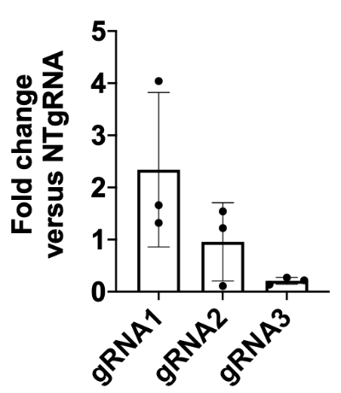

Supplementary Figure 3. Immunohistochemical staining and quantification of MECOM on ElaCreERT control and ElaCreERT;Mecom^{f/f} isolated acinar cells dedifferentiated in culture. Scale = 50M. (mean ± SD; N = 5; *p<0.05; two-way ANOVA with post-hoc Bonferroni correction)

Supplementary Figure 4. shRNA-mediated knockdown of MECOM in human exocrine cells dedifferentiating in culture: (a) Representative images and cluster diameter of MECOM shRNA-transduced and non-transduced control human exocrine cells at 24h, 4 days and 7 days after transduction. Scale = 400µM. (mean ± SD; N = 3; ***p<0.001; ****p<0.0001; paired two-tailed t-test). Each datapoint represents a separate cluster. (b) qPCR of MECOM expression at day of isolation and 4 and 7 days after transduction in control and shRNA-transduced cultures. (mean ± SD; N = 3; *p<0.05; one-way ANOVA with post-hoc Bonferroni correction).
Supplementary Figure 5. (a) Pancreata, (b) body weight and (c) pancreas/body weight of control and ElaCreERT;Mecom^{f/f} mice at 4 (D4) and 11 days (Day 11) after the start of caerulein administration. (mean ± SD; N=6).
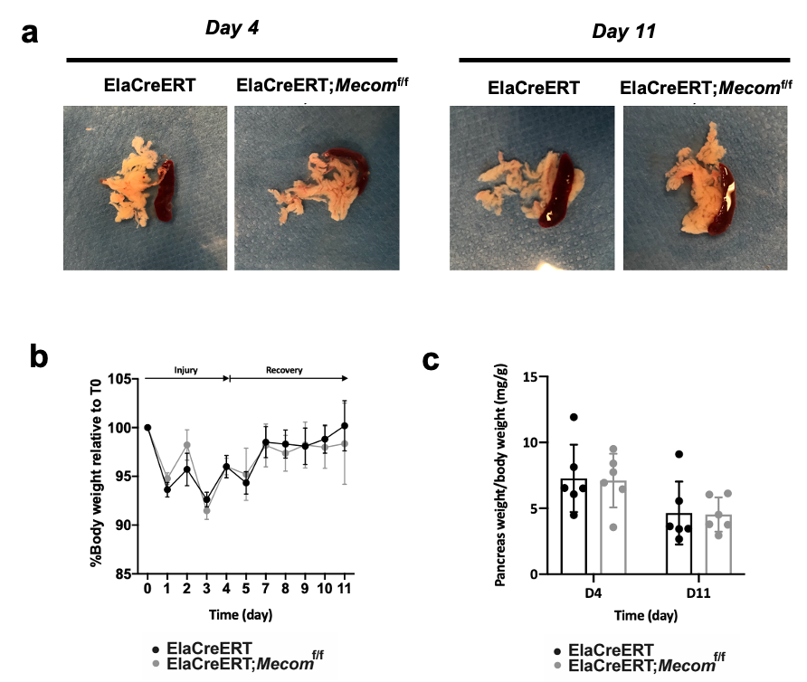

Supplementary Figure 6. F4/80 and CD19 staining and quantification. ElaCreERT and ElaCreERT;Mecom^{f/f} tissues sections after experimentally induced acute pancreatitis at the peak of inflammation (day 4) and after one week of recovery (day 11). Scale = 50µM. Mean ± SD; N = 6; ns = non-significant; two-way ANOVA with post-hoc Bonferroni correction). Lymph nodes are indicated with a white asterisk.

SUPPLEMENTARY MATERIALS AND METHODS

List of primers
mEvi1 exon 3 fw | GCTATGATCAGCACAACCTTGTTG
mEvi1 exon 3 rv | TGTCTGCGACTACTCGGTAGAATATC
mHprt fw | GGCCAGACTTTGTTGGATTTG
mHprt rv | TGCGCTCATCTTAGGCTTTGT
mSox9 fw | TCGGTGAAGAACGGACAAGC
mSox9 rv | TGAGATTGCCCAGAGTGCTCG
hEVI1 exon 3 fw | CGAAGACTATCCCCATGAAACTATG
hEVI1 exon 3 rv | TCACAGTCTTCGCAGCGATATT
hHPRT1 fw | GGCTCCGTTATGGCGACCC
hHPRT1 rv | TGTGATGGCCTCCCATCTCCTT
hSOX9 fw | GAGGAAGTCGGTGAAGAACG
hSOX9 rv | ATCGAAGGTCTCGATGTTGG
hGAPDH fw | TGCACCACCAACTGCTTAGC
hGAPDH rv | GGCATGGACTGTGGTCATGAG

