Supplementary Table 1. Sequences of sgRNAs used in this study.

Target gene | Target exon | sgRNA sequence 5’-3’
Mouse Bim (non-targeting negative control for human cells) | 3 | GCACAGGAGCTGCGGCGGAT
Mouse Trp53 | 5 | GAGCGCTGCTCCGATGGTGA
Mouse Bak | 1 | TCCATCTCGGGGTTGGCAG
Mouse Bax | 2 | CAGTTCATCTCCAATTCGC
Human BIM (non-targeting negative control for mouse cells) | 3 | GCCCAAGAGTTGCGGCGTAT
Human BAK | 5 | GGCCATGCTGGTAGACGTG
Human BAX | 4 | TCTGACGGCAACTTCAACTG

Supplementary Table 2. Antibodies used for western blotting.

Target | Clone | Dilution | Species raised in | Source
Primary antibodies
BAK | polyclonal | 1:2000 | Rabbit | Sigma #B5897
Mouse BAX | 5B7 | 1:2000 | Mouse | Sigma #B9054
Mouse TRP53 | CM5 | 1:2000 | Rabbit | Novocastra, #NCL-p53-CM5p
MCL-1 | 19C4-15 | 1:2000 | Rat | WEHI mAb Facility
BCL-2 | 7/BCL-2 | 1:2000 | Mouse | BD Biosciences #610539
BCL-XL | 9C9 | 1:1000 | Rat | WEHI mAb Facility
Mouse A1 | 6D6 | 1:100 | Rat | WEHI mAb Facility
PUMA | polyclonal | 1:500 | Rabbit | Prosci #3043
BIM | polyclonal | 1:1000 | Rabbit | Enzo Life Sciences,  #ADI-AAP-330-E
Human BAX | 21C10-23-8-38-P | 1:1000 | Rat | WEHI mAb Facility
HSP70 | N6 | 1:10000 | Mouse | Dr. R. Anderson,  Olivia Newton John  Cancer Centre,  Melbourne, Australia
β-ACTIN | AC-74 | 1:5000 | Mouse | Sigma #A2228
Secondary antibodies
Mouse IgG | N/A | 1:2000 | Goat | Southern Biotech,  #1010-05
Rat IgG | N/A | 1:5000 | Goat | Southern Biotech,  #3010-05
Rabbit IgG | N/A | 1:5000 | Goat | Southern Biotech,  #4010-05

Supplementary Table 3. Sequencing primers for the analysis of the mouse Bax promoter and exons.

Primer Pair | FWD sequence (5’-3’) | REV sequence (5’-3’)
1 | CTGCAGCGAGCGATGATGA | CCTAGTCCTCCGCCTCCC
2 | ACGTGACCGTGGTGCGCCG | CGCACGCGGATGTCCGCTCT
3 | ACCCCGAGAGCGGACATC | GCCTGGCTACTGCTTCTGAT
4 | GTTTGCTGTGGAGCTGGGAT | ATCTGTTCAGAGCTGGTGGG
5 | TTTCCTCCTCTCTCCCCCAG | CTGCTCCAAGGTCAGCTCAG
6 | GCTTGGTTCTCAACATTCTGCT | GAGACCCCTTGACGGACCC
7 | CATCTCACCCAGCGTCTGTT | TCTGTTCCCTGGTCCTCACA
8 | GCAAGGGCTTGAGATCACCT | ATAGCTAGGCCTGAGGGGTC
9 | CAGGGTGGCTGGGTGAGA | GGTTGACCAGAGTGCGTAGG
10 | TGGTATTGAAGTCACACCCATC | CCCATTCATCCCAGGAAAATGTC
11 | CCTTGGACTGTGTCTTTTCTTCAT | GAGCGGGTCCCTGATTGGA
12 | AGCCTCTCAATGCTGGGATG | ACGTGATCATCATCGCTCGC
13 | AGGTATGGACCATCACTCTGGT | AGATTCATGGTAGAGAGCACTAAGG
14 | CACAGGCATCTGCTTGCTTG | GATTGCTCCAATCTGGGGAG

Supplementary Figure 1

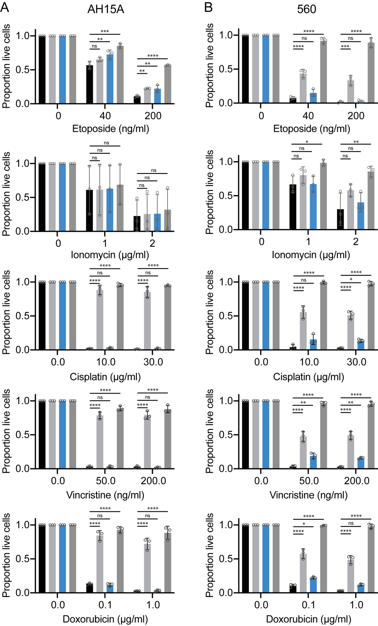

Supplementary Fig 1. Eµ-Myc lymphoma cells lacking BAX retain sensitivity to cytotoxic agents. Isogenic WT, Bak KO, Bax KO or Bak/Bax double KO AH15A and 560 mouse Eµ-Myc lymphoma cells treated with the cytotoxic drugs doxorubicin, vincristine, cisplatin, etoposide or ionomycin for 24 h. Live cells were identified as Annexin V/PI double negative by flow cytometry. All data are presented as mean ± S.D. for 3 independent experiments. One way ANOVA was used to measure statistical significance (**p<0.01, ***p<0.001, ****p<0.0001, ns=not significant).
Supplementary Figure 2

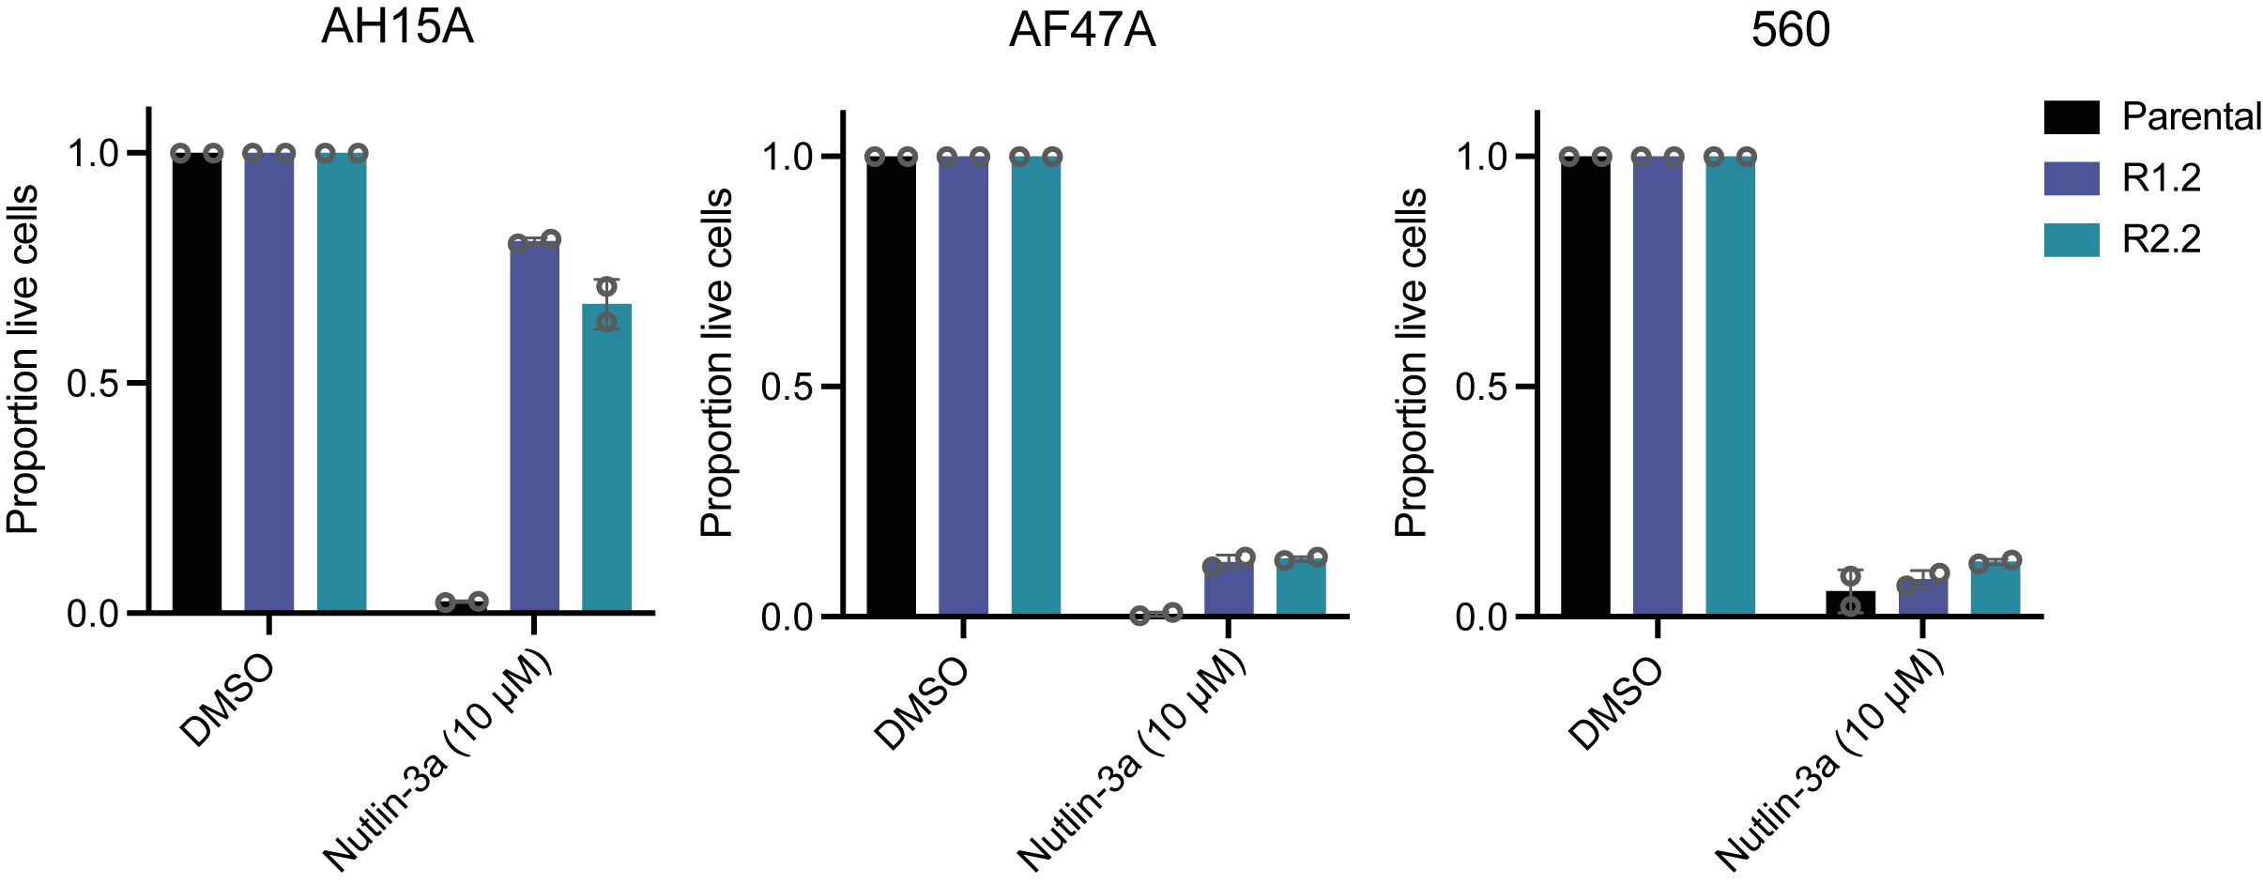

Supplementary Fig 2. Sensitivity of S63845-resistant cells to Nutlin-3a. Parental AH15A, AF47A and 560 cells and their derived S63845-resistant variants were treated with 10 µM Nutlin-3a for 24 h and live cells quantified by Annexin V/PI staining. All data are presented as mean ± S.D. for 2 independent experiments.

Supplementary Figure 3

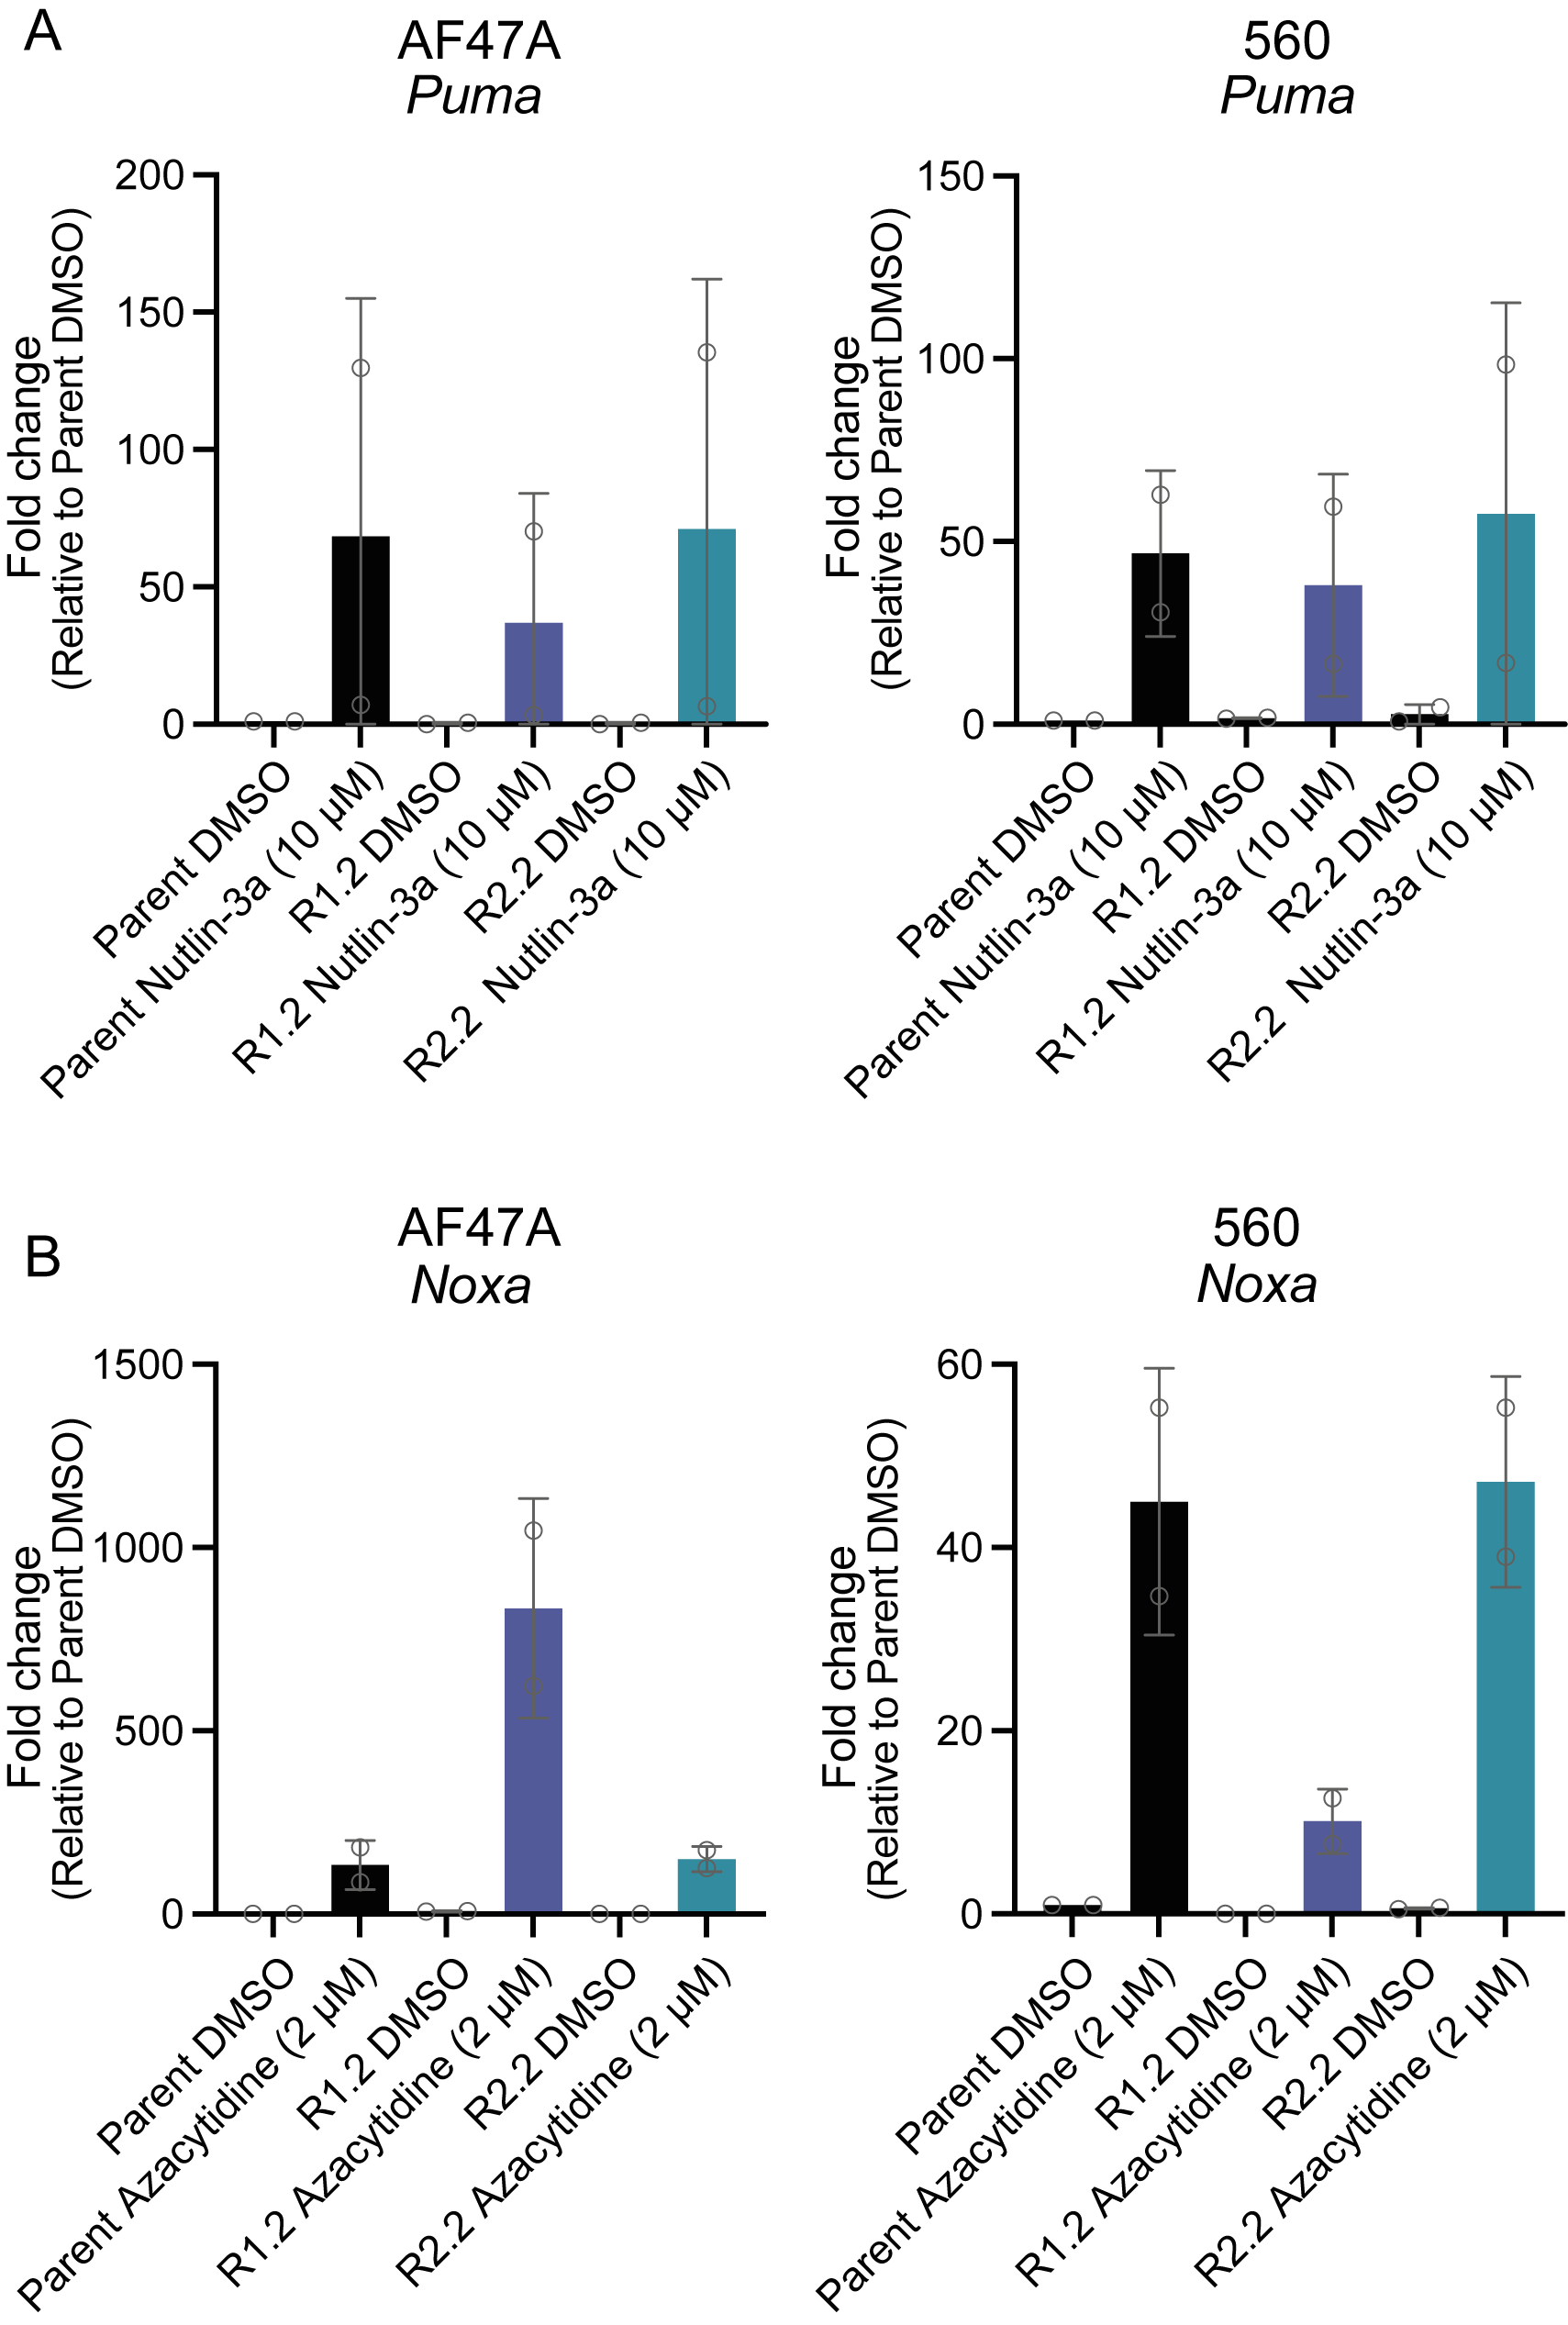

Supplementary Fig 3. qRT-PCR for Puma and Noxa to validate impact of Nutlin-3a and 5’azacytidine, respectively. (A) qRT-PCR of parental and drug resistant Eµ-Myc lymphoma cells treated with DMSO (vehicle, negative control) or the TRP53 activating drug Nutlin-3a for 24 h. Puma is a direct transcriptional target of TRP53. Data are shown normalised to the housekeeping gene Hmbs, and relative to the parental Eµ-Myc lymphoma cell line treated with DMSO (vehicle, negative control). (C) qRT-PCR of parental and drug resistant Eµ-Myc lymphoma cells treated for 24 h with DMSO or the hypomethylating agent 5’azacytidine (inhibitor of DNMT1). Noxa is transcriptionally regulated by DNMT1. Data are shown normalised to the housekeeping gene Hmbs, and relative to the parental cell line treated with DMSO. Data are presented as mean ± S.D. for 2 independent experiments.

