Supplementary Fig. 8
Supplementary Fig. 8 Original Western Blot shown in Figures 1-6. Each figure corresponds to the Western Blots in the indicated Figure number.

Supplementary Fig. 9
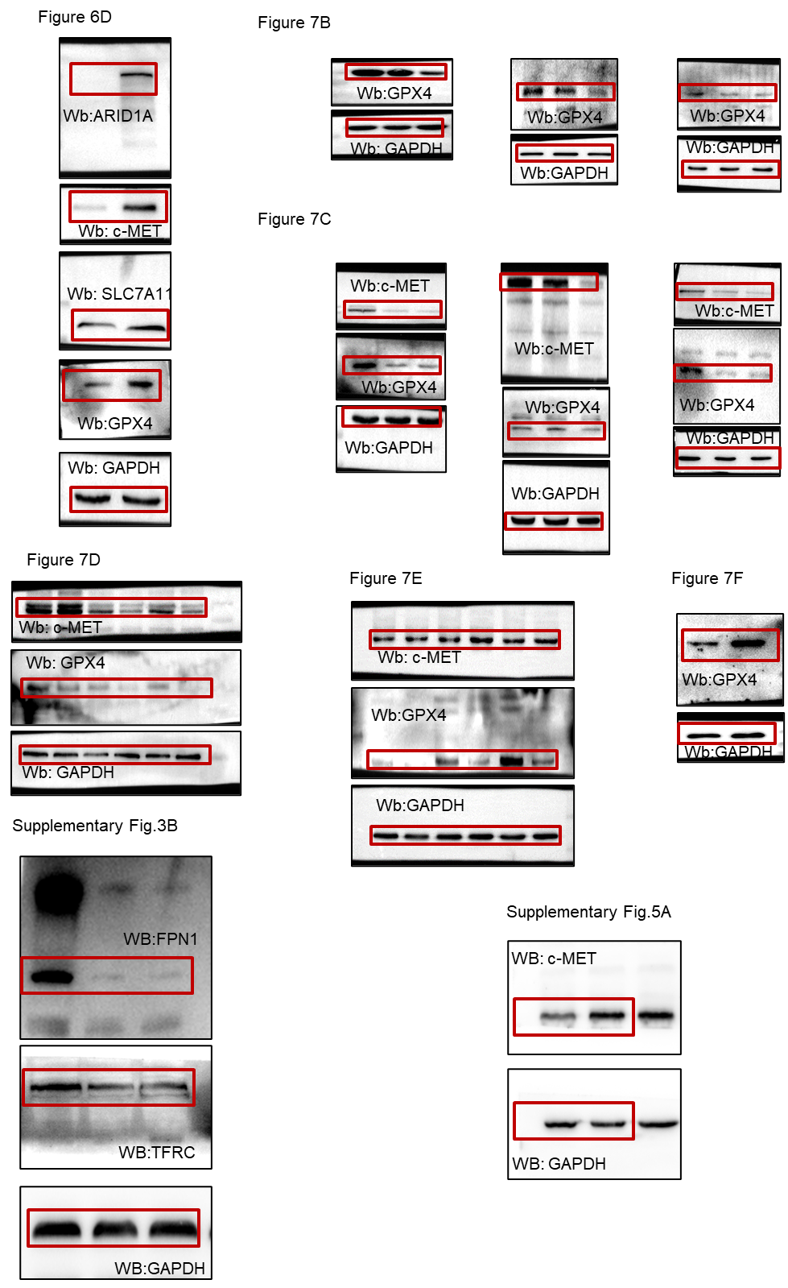
Supplementary Fig. 9 Original Western Blot shown in Figures 6-7, and supplementary Figures. Each figure corresponds to the Western Blots in the indicated Figure number.

