Supplementary Figures

USP2 promotes metabolic dysfunction-associated steatotic liver disease progression via stabilization of PPARγ

Supplementary figures file contains 4 figures.
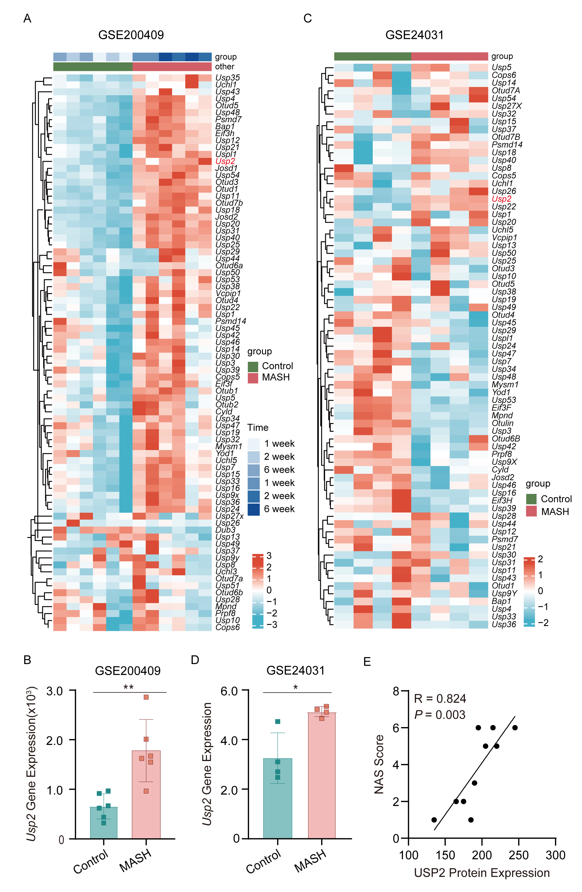

Figure S1. USP2 expression is increased in the pathogenesis of MASLD. (A-B) Usp2 expression in the livers of diet-induced MASH mice in GEO datasets (GSE200409) (n = 6). (C-D) Usp2 expression in the livers of Mice that showed a significant MASH high response to HFD in GEO datasets (GSE24031) (n = 4). (E) Correlation analysis of USP2 H-Score with NAS scores from clinical samples. R represents Pearson correlation coefficient (n = 10), p values were determined by linear regression analysis. Data were represented as the mean ± SEM. *p < 0.05 and **p < 0.01.
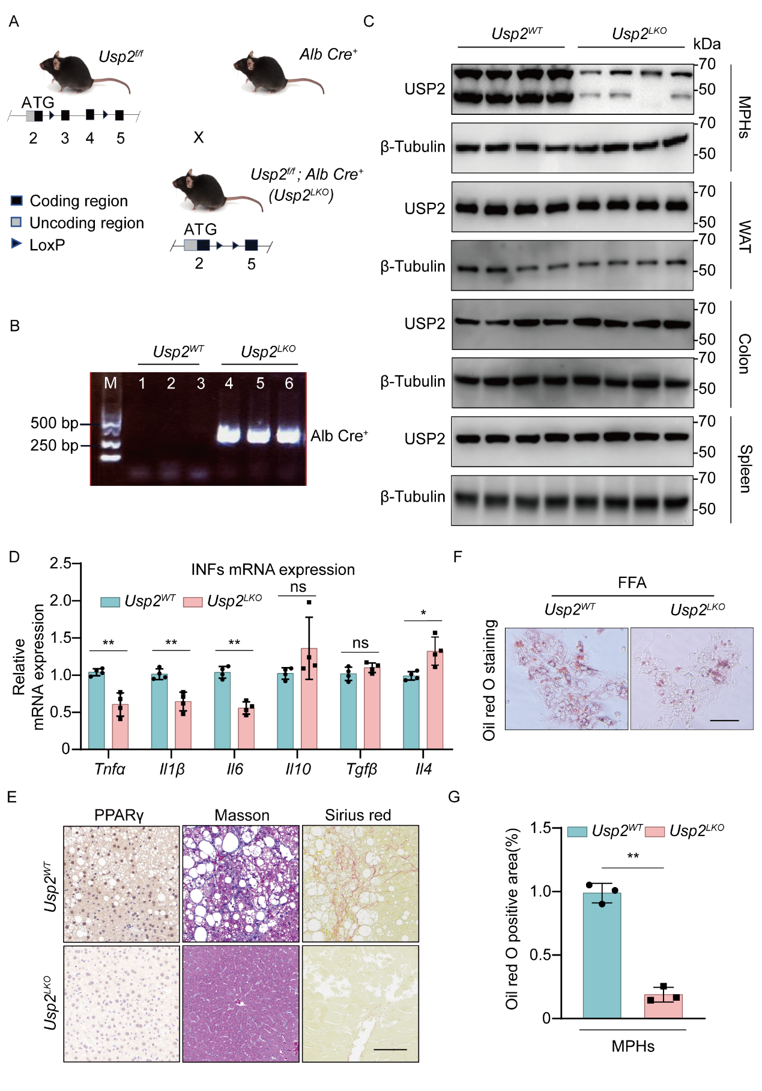

Figure S2. Construction of a liver-specific knockout mouse model of the Usp2 gene. (A) Diagrammatic representation of the constructed liver-specific knockout mice model. (B) Genotyping of Alb-cre using PCR. (C) Western blot analysis of mouse primary hepatocytes (MPHs), white adipose tissue (WAT), colon and spleen in Usp2^{LKO} mice and Usp2^{WT} mice. (D) RT-qPCR analysis of inflammatory factors (INFs) mRNA expression in liver tissues of Usp2^{LKO} or Usp2^{WT} mice fed with HFD (n = 4). (E) Slide sections of livers from the Usp2^{WT} and Usp2^{LKO} mice fed HFD. Liver sections were stained with IHC staining, Masson, and Sirius. (F) Representative images of Oil Red O staining experiments in MPHs from Usp2^{LKO} mice and Usp2^{WT} mice after treatment with 100 μM FFA for 6 h. (G) Normalization of Oil Red O staining from (F) Unpaired two-tailed Student’s t-test. The experiments were repeated three times (n = 3). Scale bar, 100 μm. Data were represented as mean ± SEM; ns = not significant; *p < 0.05 and **p < 0.01.

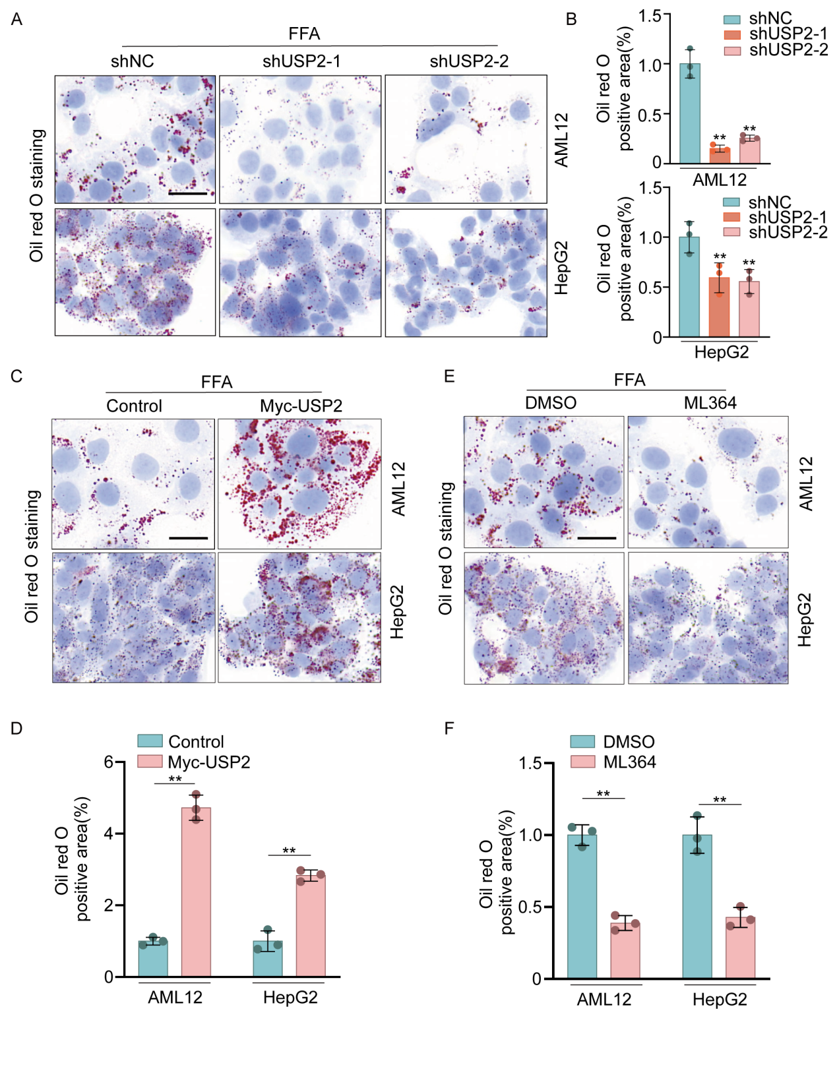

Figure S3. USP2 upregulates lipid accumulation. (A) Representative images of Oil Red O staining experiments in AML12 and HepG2 cells with USP2 knockdown after treatment with 100 μM FFA for 6 h. (B) Standardized results of Oil Red O staining from (A). (C) Representative images of Oil Red O staining experiments in AML12 and HepG2 cells overexpressing USP2 after 6 h of FFA treatment. (D) Standardized processing of Oil Red O staining from (C). (E) Representative images of Oil Red O staining experiments performed on AML12 cells and HepG2 cells treated with ML364 for 24 h and then treated with 100 μM FFA for 6 h. (F) Normalization of Oil Red O staining from (E). Scale bar, 25 μm. Data were represented as the mean ± SEM. **p < 0.01.
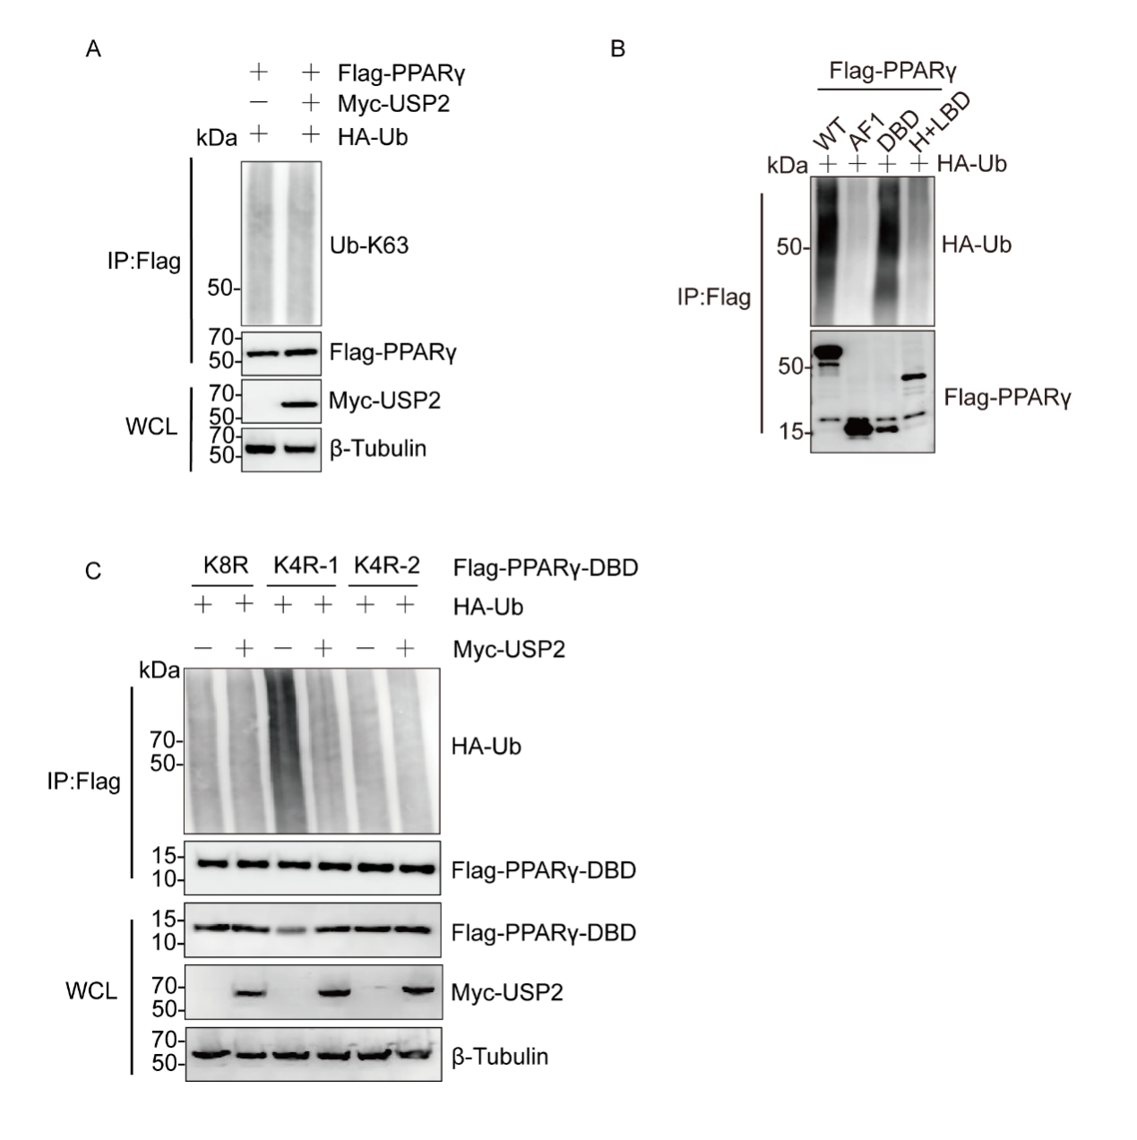
Figure S4. USP2 regulates the protein stability of PPARγ by deubiquitination. (A) The ubiquitinated Flag-PPARγ protein was subjected to in vitro deubiquitination assay using Myc-USP2, and the reaction mixes were analyzed by western blot. (B) Ubiquitination assay of FL (full length), AF1, DBD, and Hinge-LBD of PPARγ in HEK293T cells transfected with HA-Ub and treated with 10 μM MG132 for 6 h. (C) Ubiquitination assay of DBD domain of PPARγ in HEK293T cells cotransfected with HA-Ub, Myc-USP2, Flag-DBD-K8R, Flag-DBD-K4R-1, Flag-DBD-K4R-2, and treated with 10 μM MG132 for 6 h. K4R-1: K117/132/142/156R; K4R-2: K157/161/169/190R.

