List of contents for Supplemental Information
- Supplementary Figures
Supplementary Figure 1. Myoblast and C. elegans models for determination of the effects of adaptive UPR^{ER} signalling during early developmental stages.
Supplementary Figure 2. Effect of Tunicamycin treatment of myoblasts on myogenesis, mitochondrial and ER content and volume.
Supplementary Figure 3. Early-life induction of UPR^{ER} in C. elegans activates autophagy and promotes physiological adaptations.
Supplementary Figure 4. Early-life Tunicamycin treatment of C. elegans embryos or at L4 stage promotes opposite effects on lipid metabolism and lysosomal function.
Supplementary Figure 5. Early-life Tunicamycin treatment of C. elegans requires the PEK-1 arm of the UPRER for the beneficial adaptive response.
- Supplementary Tables
Supplementary Table 1: Multiple comparison lifespan analysis at 20°C of wild-type (WT), pek-1(ok275) (PEK), atfs-1(tm4525) (ATFS) and pek-1;atfs-1.
Supplementary Table 2: Multiple comparison Sodium Arsenite survival analysis at 20°C of wild-type (N2), pek-1(ok275) (PEK), atfs-1(tm4525) (ATFS) and pek-1;atfs-1.
Supplementary Table 3: Multiple comparison Paraquat survival analysis at 20°C of N2 wild-type (WT), pek-1(ok275) (PEK), atfs-1(tm4525) (ATFS) and pek-1;atfs-1 strains.
Supplementary Table 4: Multiple comparison lifespan analysis at 20°C of wild-type L4440 CNT, L4440 TM, RNAi lgg-1 CNT and RNAi lgg-1 TM.
Supplementary Table 5: Multiple comparison lifespan analysis at 20°C of wild-type L4440 CNT, L4440 TM, RNAi pdr-1 CNT and RNAi pdr-1 TM.
Supplementary Table 6: Multiple comparison lifespan analysis at 20°C of wild-type L4440 CNT, L4440 TM, RNAi lmp-1 CNT and RNAi lmp-1 TM.
Supplementary Table 7: Multiple comparison lifespan analysis at 20°C of wild-type CNT, NAC, TM and NAC+TM.
Supplementary Table 8: Key resources table.

- Uncropped Western blot membranes

Supplementary Figures

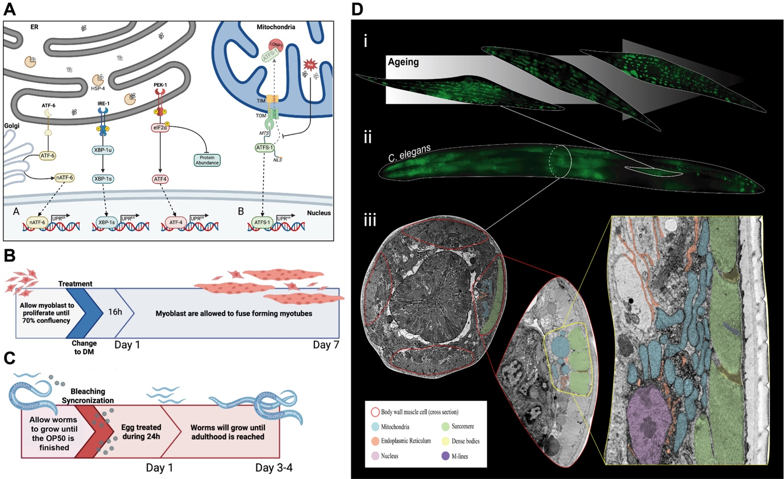

Suppl. Figure 1: Myoblast and C. elegans models for determination of the effects of adaptive UPR^{ER} signalling during early developmental stages.
A) Schematic diagram of the TM treatment protocol for C2C12 myoblasts.
B) Schematic diagram of the TM treatment protocol of C. elegans at embryo stage.
C) The UPR^{ER} and UPR^{mt} of C. elegans.
D) Organelle ultrastructure from the body wall muscle of C. elegans. (i) Muscle cell ageing visualised using a pmyo-3::mitoGFP translational fusion highlighting the mitochondrial network in body wall cells from a young day 2, 4 & 6 adult demonstrating mitochondrial network disorganisation. (ii) The organisation of body wall muscle cells in a mature hermaphrodite C. elegans (seen in a dorsal oblique view) was observed in a genetically modified worm expressing the Pmyo-3::mitoGFP reporter transgene. (iii) TEM cross-section images of body wall muscle cells. The first image shows the distribution of the four muscle quadrants (containing two rows of cells in each) from the pharynx area. The second image demonstrates a cross-section of the body wall cell, in which mitochondria, ER and Sarcomeres can be distinguished. High-resolution TEM section of the nucleus, mitochondria, ER and sarcomeres (with dense bodies and M-lines) in the body wall muscle cell.

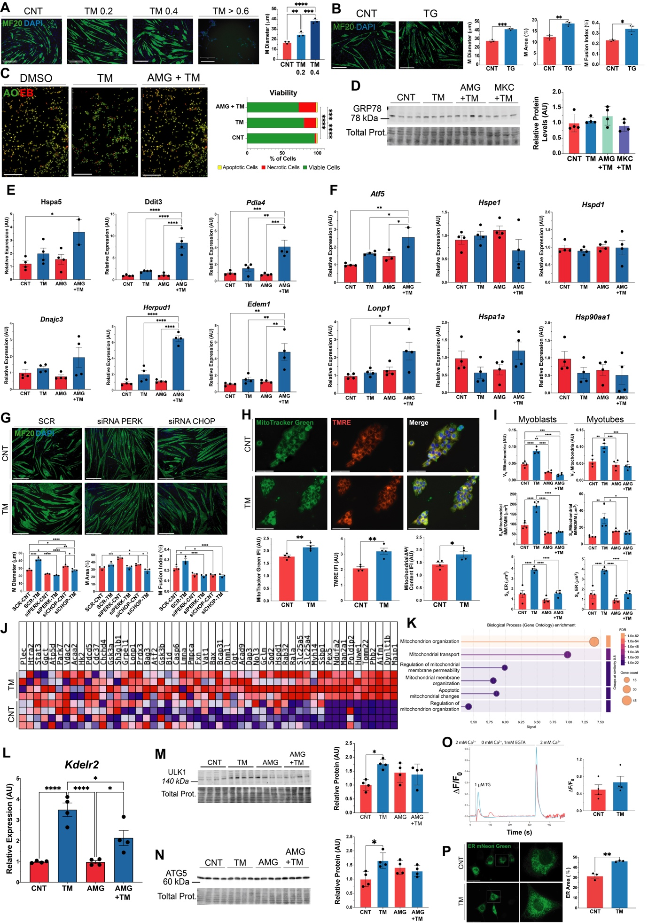

Suppl. Figure 2: Effect of TM treatment of myoblasts on myogenesis, mitochondrial and ER content and volume.
A) C2C12 myoblasts were exposed to TM 0.2, 0.4, 0.6, 0.8 and 1 μg/ml for 8h. Media was replaced with differentiation media and cells were allowed to differentiate for 7 days. MF20 immunostaining demonstrated that TM treatment improved the myogenic potential of the myoblast population compared to the control; this effect is lost when the concentration of TM exceeds the 0.4 μg/ml. ** p ≤ 0.01, *** p ≤ 0.001 & **** p ≤ 0.0001 One-way ANOVA.
B) C2C12 myoblasts were exposed to thapsigargin (TG) 10 nM for 8h. Media was replaced with differentiation media and cells were allowed to differentiate for 7 days. MF20 immunostaining demonstrated that TG treatment significantly increases myotube diameter, area and fusion index. * p ≤ 0.05, ** p ≤ 0.01 & *** p ≤ 0.001 Student’s t-test.
C) C2C12 myoblasts were exposed to TM 0.2μg/ml and AMG PERK44 (PERK inhibitor) 2μM for 8h. Media was replaced with differentiation media and cells were allowed to recover for 16h. Treatment with TM resulted in a significant increase in cell death compared to the control group; this effect is exacerbated with the inclusion of the PERK inhibitor. *** p ≤ 0.001 & **** p ≤ 0.0001 Chi-square.
D) Protein expression levels of GRP78 assessed by Western Blot, normalised against total protein (Ponceau staining). Each lane represents independent biological replicates, data represented as mean SEM. One-way ANOVA.
E) Gene expression levels of Hspa5, Dnajc3, Ddit3, Herpud1, Pdia4 and Edem1 were assessed in C2C12 myoblasts using ΔΔCT method by qPCR, and normalised against β2 microglobulin (B2M) housekeeper gene. * p ≤ 0.05 One-way ANOVA.
F) Gene expression levels of Atf5, Lonp1, Hspe1, Hspa1a, Hspd1 and Hsp90aa1 were assessed in C2C12 myoblasts using ΔΔCT method by qPCR, and normalised against β2 microglobulin (B2M) housekeeper gene. * p ≤ 0.05 One-way ANOVA.
G) C2C12 myoblasts were exposed to TM 0.2 μg/ml or, alongside Scr, siRNA for PERK or siRNA for CHOP during 8h. Media was replaced with differentiation media, and cells allowed to differentiate for 7 days. MF20 immunostaining demonstrated that the TM treatment increased the myogenic potential of the myoblast population compared to the control, but this effect is lost with the silencing of RNA for PERK and CHOP. * p ≤ 0.05, ** p ≤ 0.01, *** p ≤ 0.001 & **** p ≤ 0.0001 One-way ANOVA.
H) TM treatment resulted in a significant increase in MitoTracker green fluorescence intensity. TM treatment increased TMRE staining, indicating an increase in mitochondrial membrane potential. The TMRE:MitoTracker green ratio increased in the TM group,. Representative images; n=4. * p ≤ 0.05, ** p ≤ 0.01, *** p ≤ 0.001 & **** p ≤ 0.0001 Student’s t-test.
I) Mitochondria volume fraction (V_{V}), IMM/OMM ratio (S_{A}) and Surface area (S_{A}) of ER membrane and mitochondria calculated from TEM sections from a population of myoblasts and myotubes. * p ≤ 0.05, ** p ≤ 0.01, *** p ≤ 0.001 & **** p ≤ 0.0001 One-way ANOVA.
J) Heatmap from GSEA of mouse mitochondrial proteins significantly enriched in the upregulated proteins in the TM group compared to CNT.
K) GOBP enrichment dot plot from GSEA of mouse mitochondrial proteins significantly enriched in the upregulated proteins from the TM group compared to CNT.
L) Gene expression levels of Kdelr2 were assessed using ΔΔCT method by qPCR, and normalised against β2 microglobulin (B2M) housekeeper gene. * p ≤ 0.05 One-way ANOVA.
M) Protein expression levels of ULK1 were assessed by Western Blot. Each lane represents independent biological replicates, data represented as mean SEM. * p ≤ 0.05 One-way ANOVA.
N) Protein expression levels of ATG5 were assessed by Western Blot, and normalised against total protein (Ponceau staining). Each lane represents independent biological replicates, data represented as mean SEM. * p ≤ 0.05 One-way ANOVA.
O) Amplitude values of [Ca²⁺]i increase show that the TM treated myoblasts exhibited a slightly augmented Store-Operated-Calcium-Entry (SOCE) compared to control. Student’s t-test.
P) The area fraction of the ER surface against the total area of the cells. Representative images; green: ER mNeon Green, blue: DAPI; n=3. Scale 275 μm. ** p ≤ 0.01 Student’s t-test.

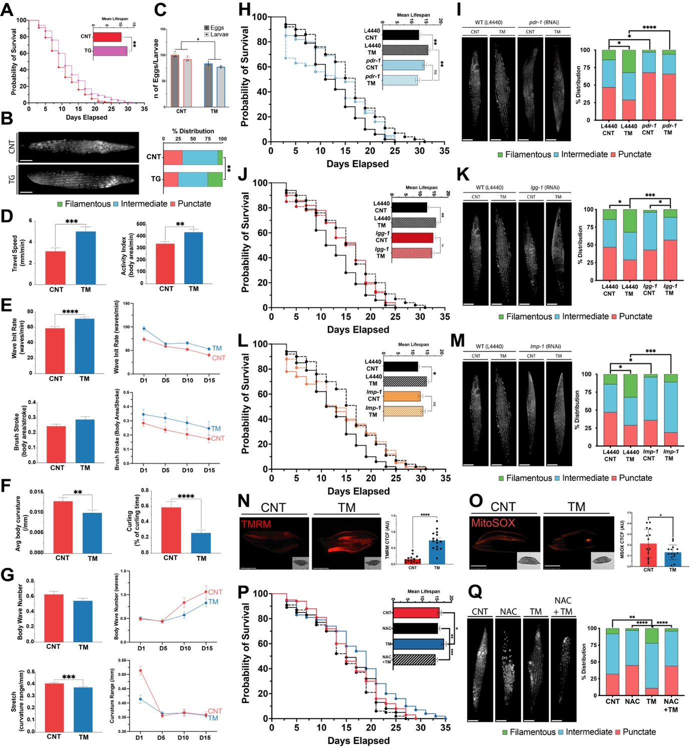

Suppl. Figure 3: Early-life induction of UPR^{ER} in C. elegans activates autophagy and promotes physiological adaptations.
A) Lifespan assay of TG treated N2 strain. Kaplan–Meier survival plots of two independent experiments initiated with 100 animals/group. Mean +/- SEM; **** p ≤ 0.0001 Log-rank (Mantel-Cox) test.
B) TG treated pmyo-3::mitogfp reporter strain for muscle mitochondrial morphology, classified as either filamentous, intermediate or punctate. 3 independent experiments were initiated with 15 animals/ condition. Scale 50μm. n=3 * p<0.05 Chi-square.
C) Number of laid embryos compared to number of viable larvae in N2 worms treated with TM. * p ≤ 0.05 One-way ANOVA.
D & E) CeleST physical fitness parameters that decrease with age; average fitness parameters of days 1, 5, 10, & 15. Mean +/- SEM; **** p ≤ 0.0001 Student’s t-test.
F & G) CeleST physical fitness parameters that increase with age; average fitness parameters of days 1, 5, 10, & 15. Mean +/- SEM; *** p ≤ 0.001 Student’s t-test.
H, J & L) Lifespan assay of TM treated N2 strain and RNAi for pdr-1, lgg-1 and lmp-1 genes. Kaplan–Meier survival plots of two independent experiments initiated with 100 animals/group. Mean +/- SEM; **** p ≤ 0.0001 Log-rank (Mantel-Cox) test.
I, K & M) TM treated pmyo-3::mitogfp reporter strain and RNAi for pdr-1, lgg-1 and lmp-1 genes. Representative images of reporter for muscle mitochondrial morphology, classified as either filamentous, intermediate or punctate. 3 independent experiments were initiated with 15 animals/ condition. Scale 50μm. n=3 * p<0.05 Chi-square.
N) N2 Wild-type worms incubated with TMRM dye, an indicator of mitochondrial membrane potential. Representative images of three independent experiments initiated with 15 animals/ strain; red: TMRM. Scale 275μm. Error bars SEM; * p ≤ 0.05 Student’s t-test.
O) N2 Wild-type worms incubated with MitoSOX dye, an indicator of mitochondrial ROS production. Representative images of three independent experiments initiated with 15 animals/ strain; red: MitoSOX. Scale 275μm. Error bars SEM; * p ≤ 0.05 Student’s t-test.
P) Lifespan assay of TM treated N2 strain and the antioxidant NAC. Kaplan–Meier survival plots of two independent experiments initiated with 100 animals/group. Mean +/- SEM; **** p ≤ 0.0001 Log-rank (Mantel-Cox) test.
Q) TM treated pmyo-3::mitogfp reporter strain and the antioxidant NAC. Representative images of the reporter for muscle mitochondrial morphology, classified as either filamentous, intermediate or punctate. 3 independent experiments were initiated with 15 animals/ condition. Scale 50μm. n=3 * p<0.05 Chi-square.

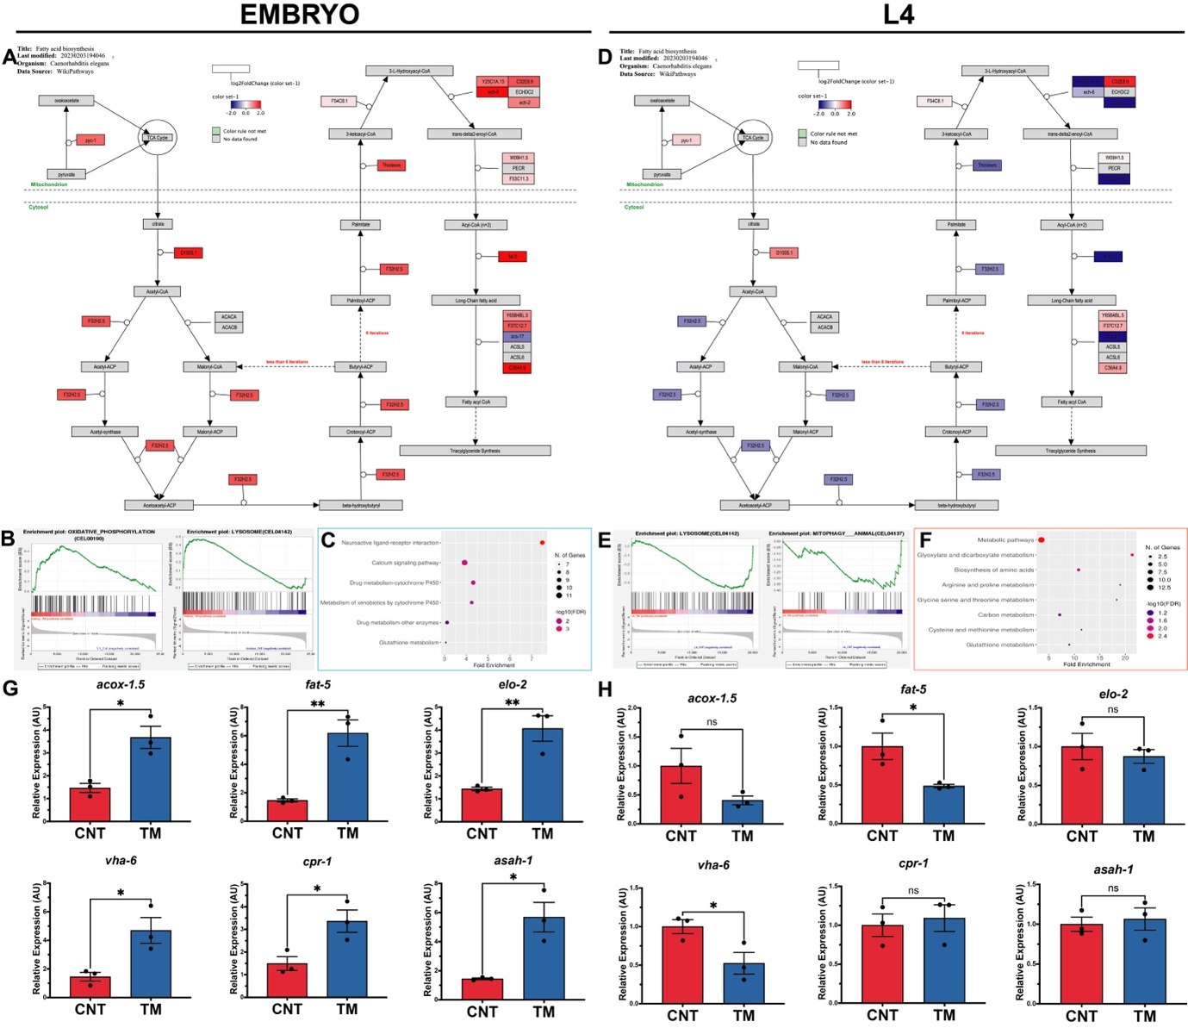

Suppl. Figure 4: Early-life TM treatment of C. elegans embryos or at L4 stage promotes opposite effects on lipid metabolism and lysosomal function.
A) PathVisio pathway analysis of EMBRYO DEGs revealed an upregulation of proteins involved in fatty acid biosynthesis in worms treated with TM.
B) GSEA pathways that are significantly enriched following treatment of embryos.
C) Dot plot of Shiny GO KEGG analysis of EMBRYO DEGs. Significantly downregulated pathways’ dotplot outlined in blue.
D) PathVisio pathway analysis of L4 DEGs revealed the downregulation of proteins involved in fatty acid biosynthesis in worms treated with TM.
E) GSEA pathways that are significantly enriched following treatment of L4 worms.
F) Dot plot of Shiny GO KEGG analysis of L4 DEGs. Significantly upregulated pathways’ dotplot outlined in red.
G & H) Gene expression levels of acox-1.5, elo-2, fat-5, vha-6, asah-1 and cpr-1 were assessed using ΔΔCT method by qPCR, and normalised against cdc-42 and pmp-3 housekeeper genes. * p ≤ 0.05 One-way ANOVA.

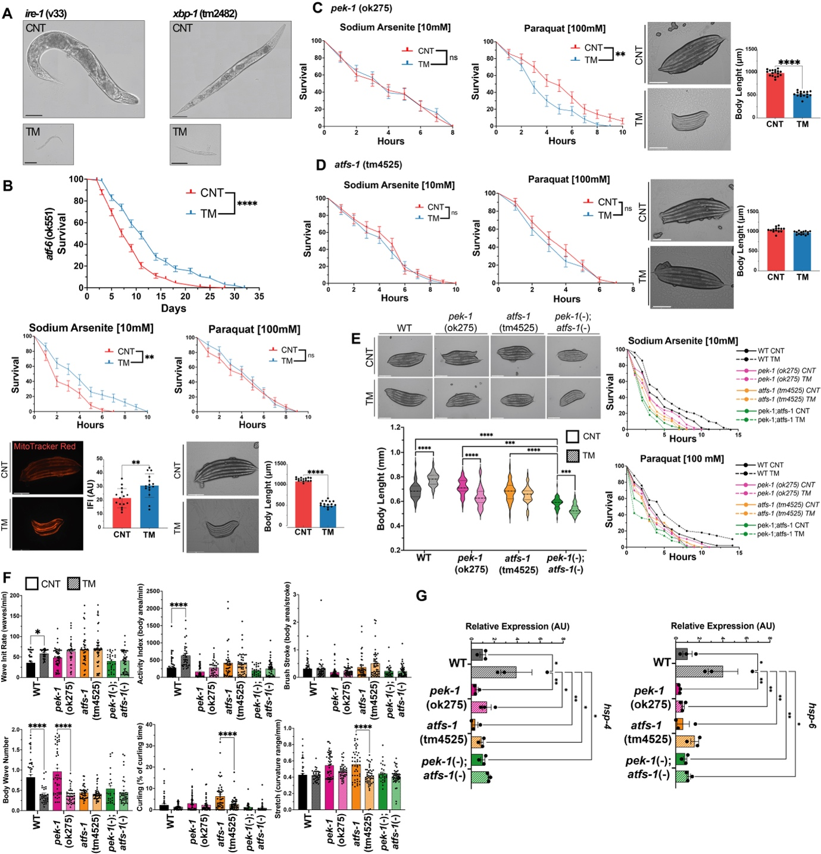

Suppl. Figure 5: Early-life TM treatment of C. elegans requires the PEK-1 arm of the UPR^{ER} for the beneficial adaptive response.
A) Representative transmitted light images of TM treated ire-1 (v33) worms and xbp-1(tm2482) worms.
B) TM treatment of atf-6 (ok551) increased lifespan at 20°C. Kaplan–Meier survival plots of two independent experiments initiated with 100 animals per group, Log-rank (Mantel-Cox) test, **** p ≤ 0.0001. Increased survival of TM-treated atf-6(ok551) in 10 mM Sodium Arsenite and no effect on survival in 100 mM Paraquat compared to control. Kaplan–Meier survival plots of two independent experiments initiated with 50 animals per group by Log-rank (Mantel-Cox) test, ** p ≤ 0.01. Representative MitoTracker Red staining of adult day 1 atf-6(ok551) worms treated with TM. Scale 275 μm. Mean +/- SEM; ** p ≤ 0.01 Student’s t-test. Representative transmitted light images of adult day 1 atf-6(ok551) mutant worms. Scale 275μm. Error bars SEM; ** p ≤ 0.01 Student’s t-test.
C) TM treatment of pek-1(ok275) did not affect survival in 10 mM Sodium Arsenite and decreased survival in 100 mM Paraquat compared to control. Kaplan–Meier survival plots of two independent experiments were initiated with 50 animals per group using log-rank (Mantel-Cox) test, ** p ≤ 0.01. Representative transmitted light images of adult day 1 pek-1(ok275) worms. Scale 275 μm. Mean +/- SEM; **** p ≤ 0.0001 Student’s t-test.
D) TM treatment of atfs-1(tm4525) had no effect on survival in 10 mM Sodium Arsenite and 100 mM Paraquat compared to controls. Kaplan–Meier survival plots of two independent experiments initiated with 50 animals per group by Log-rank (Mantel-Cox) test. Representative transmitted light images of adult day 1 atfs-1(tm4525) worms. Scale 275μm. Mean +/- SEM; Student’s t-test.
E) Body length of adult day 1 worms following TM treatment in N2, pek-1(ok275), atfs-1(tm4525) and pek-1;atfs-1 strains. Mean +/- SEM of 45 animals per assay. *** p ≤ 0.001 & **** p ≤ 0.0001 One-way ANOVA.
F) CeleST physical fitness parameters that change with age; average fitness parameters of day 1 TM-treated N2, pek-1, atfs-1, and pek-1;atfs-1 mutant strains. Data from three independent experiments initiated with at least 10 animals per condition. Scale 275μm. Mean +/- SEM; * p ≤ 0.05 & **** p ≤ 0.0001 One-way ANOVA.
G) Gene expression levels of hsp-4 and hsp-6 were assessed in N2, pek-1(ok275), atfs-1(tm4525) and pek-1;atfs-1 strains using ΔΔCT method by qPCR, and normalised against cdc-42 housekeeper gene. * p ≤ 0.05 One-way ANOVA.

Supplementary Tables
Suppl. Table 1: Multiple comparison lifespan analysis at 20°C of wild-type (WT), pek-1(ok275) (PEK), atfs-1(tm4525) (ATFS) and pek-1;atfs-1. Worms were treated with 1.25 μg/ml TM at EMBRYO stage during 24h, two independent experiments initiated with 100 animals per group.
Condition | χ² | p-value | Corrected p-value
WT_C vs. WT_T | 12.43 | 0.0004 | 0.003
WT_C vs. PEK_C | 8.14 | 0.0043 | 0.0304
WT_C vs. PEK_T | 25.41 | 4.60E-07 | 0.0000032
WT_C vs. ATFS_C | 3.75 | 0.0529 | 0.3706
WT_C vs. ATFS_T | 12.44 | 0.0004 | 0.0029
WT_C vs. PA_C | 22.09 | 0.0000026 | 0.000018
WT_C vs. PA_T | 55.52 | 0 | 0
WT_T vs. WT_C | 12.43 | 0.0004 | 0.003
WT_T vs. PEK_C | 34.68 | 3.90E-09 | 2.70E-08
WT_T vs. PEK_T | 62.85 | 0 | 0
WT_T vs. ATFS_C | 26.06 | 3.30E-07 | 0.0000023
WT_T vs. ATFS_T | 43.42 | 0 | 0
WT_T vs. PA_C | 57.75 | 0 | 0
WT_T vs. PA_T | 103.13 | 0 | 0
PEK_C vs. WT_C | 8.14 | 0.0043 | 0.0304
PEK_C vs. WT_T | 34.68 | 3.90E-09 | 2.70E-08
PEK_C vs. PEK_T | 5.49 | 0.0191 | 0.1336
PEK_C vs. ATFS_C | 0.73 | 0.3938 | 1
PEK_C vs. ATFS_T | 0.53 | 0.4661 | 1
PEK_C vs. PA_C | 3.83 | 0.0502 | 0.3516
PEK_C vs. PA_T | 22.54 | 0.0000021 | 0.000014
PEK_T vs. WT_C | 25.41 | 4.60E-07 | 0.0000032
PEK_T vs. WT_T | 62.85 | 0 | 0
PEK_T vs. PEK_C | 5.49 | 0.0191 | 0.1336
PEK_T vs. ATFS_C | 12.4 | 0.0004 | 0.003
PEK_T vs. ATFS_T | 4.15 | 0.0416 | 0.2911
PEK_T vs. PA_C | 0.3 | 0.5815 | 1
PEK_T vs. PA_T | 9.8 | 0.0017 | 0.0122
ATFS_C vs. WT_C | 3.75 | 0.0529 | 0.3706
ATFS_C vs. WT_T | 26.06 | 3.30E-07 | 0.0000023
ATFS_C vs. PEK_C | 0.73 | 0.3938 | 1
ATFS_C vs. PEK_T | 12.4 | 0.0004 | 0.003
ATFS_C vs. ATFS_T | 3.56 | 0.0592 | 0.4143
ATFS_C vs. PA_C | 9.51 | 0.002 | 0.0143
ATFS_C vs. PA_T | 35.32 | 2.80E-09 | 2.00E-08
ATFS_T vs. WT_C | 12.44 | 0.0004 | 0.0029
ATFS_T vs. WT_T | 43.42 | 0 | 0
ATFS_T vs. PEK_C | 0.53 | 0.4661 | 1
ATFS_T vs. PEK_T | 4.15 | 0.0416 | 0.2911
ATFS_T vs. ATFS_C | 3.56 | 0.0592 | 0.4143
ATFS_T vs. PA_C | 1.96 | 0.1612 | 1
ATFS_T vs. PA_T | 21.24 | 0.0000041 | 0.000028
PA_C vs. WT_C | 22.09 | 0.0000026 | 0.000018
PA_C vs. WT_T | 57.75 | 0 | 0
PA_C vs. PEK_C | 3.83 | 0.0502 | 0.3516
PA_C vs. PEK_T | 0.3 | 0.5815 | 1
PA_C vs. ATFS_C | 9.51 | 0.002 | 0.0143
PA_C vs. ATFS_T | 1.96 | 0.1612 | 1
PA_C vs. PA_T | 11.29 | 0.0008 | 0.0055
PA_T vs. WT_C | 55.52 | 0 | 0
PA_T vs. WT_T | 103.13 | 0 | 0
PA_T vs. PEK_C | 22.54 | 0.0000021 | 0.000014
PA_T vs. PEK_T | 9.8 | 0.0017 | 0.0122
PA_T vs. ATFS_C | 35.32 | 2.80E-09 | 2.00E-08
PA_T vs. ATFS_T | 21.24 | 0.0000041 | 0.000028
PA_T vs. PA_C | 11.29 | 0.0008 | 0.0055

Suppl. Table 2: Multiple comparison Sodium Arsenite survival analysis at 20°C of wild-type (N2), pek-1(ok275) (PEK), atfs-1(tm4525) (ATFS) and pek-1;atfs-1. Worms were treated with 1.25 μg/ml TM EMBRYO stage during 24h, two independent experiments initiated with 50 animals per group.

Condition | χ² | p-value | Corrected p-value
WT_C vs. WT_T | 4.48 | 0.0343 | 0.2402
WT_C vs. PEK_C | 1.59 | 0.2067 | 1
WT_C vs. PEK_T | 5.09 | 2.41E-02 | 0.1685
WT_C vs. ATFS_C | 6.57 | 0.0104 | 0.0727
WT_C vs. ATFS_T | 10.73 | 0.0011 | 0.0074
WT_C vs. PA_C | 14.43 | 0.0001 | 0.001
WT_C vs. PA_T | 21.66 | 0.0000032 | 0.000023
WT_T vs. WT_C | 4.48 | 0.0343 | 0.2402
WT_T vs. PEK_C | 8.27 | 4.00E-03 | 2.82E-02
WT_T vs. PEK_T | 13.18 | 0.0003 | 0.002
WT_T vs. ATFS_C | 15.31 | 1.00E-04 | 0.0006
WT_T vs. ATFS_T | 20.87 | 0.0000049 | 0.000034
WT_T vs. PA_C | 26.91 | 2.10E-07 | 0.0000015
WT_T vs. PA_T | 36.73 | 0 | 0
PEK_C vs. WT_C | 1.59 | 0.2067 | 1
PEK_C vs. WT_T | 8.27 | 4.00E-03 | 2.82E-02
PEK_C vs. PEK_T | 1.46 | 0.2267 | 1
PEK_C vs. ATFS_C | 2.77 | 0.0961 | 0.6726
PEK_C vs. ATFS_T | 6.2 | 0.0128 | 0.0897
PEK_C vs. PA_C | 8.27 | 0.004 | 0.0283
PEK_C vs. PA_T | 13.96 | 0.0002 | 0.0013
PEK_T vs. WT_C | 5.09 | 2.41E-02 | 0.1685
PEK_T vs. WT_T | 13.18 | 0.0003 | 0.002
PEK_T vs. PEK_C | 1.46 | 0.2267 | 1
PEK_T vs. ATFS_C | 0.27 | 0.6021 | 1
PEK_T vs. ATFS_T | 1.86 | 0.1721 | 1
PEK_T vs. PA_C | 3.23 | 0.0722 | 0.5057
PEK_T vs. PA_T | 8.5 | 0.0035 | 0.0248
ATFS_C vs. WT_C | 6.57 | 0.0104 | 0.0727
ATFS_C vs. WT_T | 15.31 | 1.00E-04 | 0.0006
ATFS_C vs. PEK_C | 2.77 | 0.0961 | 0.6726
ATFS_C vs. PEK_T | 0.27 | 0.6021 | 1
ATFS_C vs. ATFS_T | 1 | 0.3165 | 1
ATFS_C vs. PA_C | 2.3 | 0.1296 | 0.9072
ATFS_C vs. PA_T | 7.55 | 6.00E-03 | 4.20E-02
ATFS_T vs. WT_C | 10.73 | 0.0011 | 0.0074
ATFS_T vs. WT_T | 20.87 | 0.0000049 | 0.000034
ATFS_T vs. PEK_C | 6.2 | 0.0128 | 0.0897
ATFS_T vs. PEK_T | 1.86 | 0.1721 | 1
ATFS_T vs. ATFS_C | 1 | 0.3165 | 1
ATFS_T vs. PA_C | 0.32 | 0.5729 | 1
ATFS_T vs. PA_T | 3.26 | 0.0708 | 0.4957
PA_C vs. WT_C | 14.43 | 0.0001 | 0.001
PA_C vs. WT_T | 26.91 | 2.10E-07 | 0.0000015
PA_C vs. PEK_C | 8.27 | 0.004 | 0.0283
PA_C vs. PEK_T | 3.23 | 0.0722 | 0.5057
PA_C vs. ATFS_C | 2.3 | 0.1296 | 0.9072
PA_C vs. ATFS_T | 0.32 | 0.5729 | 1
PA_C vs. PA_T | 1.63 | 0.2014 | 1
PA_T vs. WT_C | 21.66 | 0.0000032 | 0.000023
PA_T vs. WT_T | 36.73 | 0 | 0
PA_T vs. PEK_C | 13.96 | 0.0002 | 0.0013
PA_T vs. PEK_T | 8.5 | 0.0035 | 0.0248
PA_T vs. ATFS_C | 7.55 | 6.00E-03 | 4.20E-02
PA_T vs. ATFS_T | 3.26 | 0.0708 | 0.4957
PA_T vs. PA_C | 1.63 | 0.2014 | 1

Suppl. Table 3: Multiple comparison Paraquat survival analysis at 20°C of N2 wild-type (WT), pek-1(ok275) (PEK), atfs-1(tm4525) (ATFS) and pek-1;atfs-1 strains. Worms were treated with 1.25 μg/ml TM EMBRYO stage during 24h, two independent experiments initiated with 50 animals per group.
Condition | χ² | p-value | Corrected p-value
WT_C vs. WT_T | 4.13 | 0.0422 | 0.2956
WT_C vs. PEK_C | 0.55 | 0.4593 | 1
WT_C vs. PEK_T | 3.58 | 5.84E-02 | 0.4088
WT_C vs. ATFS_C | 1.97 | 0.1606 | 1
WT_C vs. ATFS_T | 2.98 | 0.0846 | 0.5919
WT_C vs. PA_C | 5.34 | 0.0208 | 0.1456
WT_C vs. PA_T | 10.29 | 0.0013 | 0.0094
WT_T vs. WT_C | 4.13 | 0.0422 | 0.2956
WT_T vs. PEK_C | 7.14 | 7.50E-03 | 5.27E-02
WT_T vs. PEK_T | 11.47 | 0.0007 | 0.0049
WT_T vs. ATFS_C | 9.42 | 2.10E-03 | 0.015
WT_T vs. ATFS_T | 10.53 | 0.0012 | 0.0082
WT_T vs. PA_C | 13.53 | 0.0002 | 0.0016
WT_T vs. PA_T | 21.12 | 0.0000043 | 0.00003
PEK_C vs. WT_C | 0.55 | 0.4593 | 1
PEK_C vs. WT_T | 7.14 | 7.50E-03 | 5.27E-02
PEK_C vs. PEK_T | 1.72 | 0.1903 | 1
PEK_C vs. ATFS_C | 0.77 | 0.3815 | 1
PEK_C vs. ATFS_T | 1.47 | 0.2246 | 1
PEK_C vs. PA_C | 2.71 | 0.0999 | 0.699
PEK_C vs. PA_T | 6.92 | 0.0085 | 0.0595
PEK_T vs. WT_C | 3.58 | 5.84E-02 | 0.4088
PEK_T vs. WT_T | 11.47 | 0.0007 | 0.0049
PEK_T vs. PEK_C | 1.72 | 0.1903 | 1
PEK_T vs. ATFS_C | 0.37 | 0.5422 | 1
PEK_T vs. ATFS_T | 0.08 | 0.7726 | 1
PEK_T vs. PA_C | 0.22 | 0.6361 | 1
PEK_T vs. PA_T | 2.56 | 0.1095 | 0.7668
ATFS_C vs. WT_C | 1.97 | 0.1606 | 1
ATFS_C vs. WT_T | 9.42 | 2.10E-03 | 0.015
ATFS_C vs. PEK_C | 0.77 | 0.3815 | 1
ATFS_C vs. PEK_T | 0.37 | 0.5422 | 1
ATFS_C vs. ATFS_T | 0.1 | 0.754 | 1
ATFS_C vs. PA_C | 1.12 | 0.2905 | 1
ATFS_C vs. PA_T | 4.65 | 3.10E-02 | 2.17E-01
ATFS_T vs. WT_C | 2.98 | 0.0846 | 0.5919
ATFS_T vs. WT_T | 10.53 | 0.0012 | 0.0082
ATFS_T vs. PEK_C | 1.47 | 0.2246 | 1
ATFS_T vs. PEK_T | 0.08 | 0.7726 | 1
ATFS_T vs. ATFS_C | 0.1 | 0.754 | 1
ATFS_T vs. PA_C | 0.7 | 0.4024 | 1
ATFS_T vs. PA_T | 4.1 | 0.043 | 0.3008
PA_C vs. WT_C | 5.34 | 0.0208 | 0.1456
PA_C vs. WT_T | 13.53 | 0.0002 | 0.0016
PA_C vs. PEK_C | 2.71 | 0.0999 | 0.699
PA_C vs. PEK_T | 0.22 | 0.6361 | 1
PA_C vs. ATFS_C | 1.12 | 0.2905 | 1
PA_C vs. ATFS_T | 0.7 | 0.4024 | 1
PA_C vs. PA_T | 1.16 | 0.282 | 1
PA_T vs. WT_C | 10.29 | 0.0013 | 0.0094
PA_T vs. WT_T | 21.12 | 0.0000043 | 0.00003
PA_T vs. PEK_C | 6.92 | 0.0085 | 0.0595
PA_T vs. PEK_T | 2.56 | 0.1095 | 0.7668
PA_T vs. ATFS_C | 4.65 | 3.10E-02 | 2.17E-01
PA_T vs. ATFS_T | 4.1 | 0.043 | 0.3008
PA_T vs. PA_C | 1.16 | 0.282 | 1

Suppl. Table 4: Multiple comparison lifespan analysis at 20°C of wild-type L4440 CNT, L4440 TM, RNAi lgg-1 CNT and RNAi lgg-1 TM. Worms were treated with 1.25 μg/ml TM at EMBRYO stage during 24h, experiments were initiated with 100 animals per group.

Condition | χ² | p-value | Corrected p-value
L4440_CNT vs. L4440_TM | 15.25 | 1.00E-04 | 0.0003
L4440_CNT vs. lgg-1_CNT | 5.23 | 0.0222 | 0.0665
L4440_CNT vs. lgg-1_TM | 7.02 | 8.10E-03 | 2.42E-02
L4440_TM vs. L4440_CNT | 15.25 | 0.0001 | 0.0003
L4440_TM vs. lgg-1_CNT | 1.34 | 0.2471 | 0.7414
L4440_TM vs. lgg-1_TM | 2.45 | 1.18E-01 | 0.3534
lgg-1_CNT vs. L4440_CNT | 5.23 | 0.0222 | 0.0665
lgg-1_CNT vs. L4440_TM | 1.34 | 2.47E-01 | 0.7414
lgg-1_CNT vs. lgg-1_TM | 0.01 | 9.35E-01 | 1.00E+00
lgg-1_TM vs. L4440_CNT | 7.02 | 8.10E-03 | 2.42E-02
lgg-1_TM vs. L4440_TM | 2.45 | 1.18E-01 | 3.53E-01
lgg-1_TM vs. lgg-1_CNT | 0.01 | 0.9354 | 1

Suppl. Table 5: Multiple comparison lifespan analysis at 20°C of wild-type L4440 CNT, L4440 TM, RNAi pdr-1 CNT and RNAi pdr-1 TM. Worms were treated with 1.25 μg/ml TM at EMBRYO stage during 24h, experiments were initiated with 100 animals per group.

Condition | χ² | p-value | Corrected p-value
L4440_CNT vs. L4440_TM | 15.25 | 1.00E-04 | 0.0003
L4440_CNT vs. pdr-1_CNT | 7.62 | 0.0058 | 0.0173
L4440_CNT vs. pdr-1_TM | 1.33 | 2.49E-01 | 7.48E-01
L4440_TM vs. L4440_CNT | 15.25 | 0.0001 | 0.0003
L4440_TM vs. pdr-1_CNT | 2.11 | 0.1459 | 0.4377
L4440_TM vs. pdr-1_TM | 6.33 | 1.19E-02 | 0.0357
pdr-1_CNT vs. L4440_CNT | 7.62 | 0.0058 | 0.0173
pdr-1_CNT vs. L4440_TM | 2.11 | 1.46E-01 | 0.4377
pdr-1_CNT vs. pdr-1_TM | 1.11 | 2.91E-01 | 8.74E-01
pdr-1_TM vs. L4440_CNT | 1.33 | 2.49E-01 | 7.48E-01
pdr-1_TM vs. L4440_TM | 6.33 | 1.19E-02 | 3.57E-02
pdr-1_TM vs. pdr-1_CNT | 1.11 | 0.2912 | 0.8737

Suppl. Table 6: Multiple comparison lifespan analysis at 20°C of wild-type L4440 CNT, L4440 TM, RNAi lmp-1 CNT and RNAi lmp-1 TM. Worms were treated with 1.25 μg/ml TM at EMBRYO stage during 24h, experiments were initiated with 100 animals per group.

Condition | χ² | p-value | Corrected p-value
L4440_CNT vs. L4440_TM | 15.25 | 1.00E-04 | 0.0003
L4440_CNT vs. lmp-1_CNT | 5.45 | 0.0196 | 0.0587
L4440_CNT vs. lmp-1_TM | 8.68 | 3.20E-03 | 9.60E-03
L4440_TM vs. L4440_CNT | 15.25 | 0.0001 | 0.0003
L4440_TM vs. lmp-1_CNT | 1.1 | 0.2944 | 0.8831
L4440_TM vs. lmp-1_TM | 0.39 | 5.33E-01 | 1
lmp-1_CNT vs. L4440_CNT | 5.45 | 0.0196 | 0.0587
lmp-1_CNT vs. L4440_TM | 1.1 | 2.94E-01 | 0.8831
lmp-1_CNT vs. lmp-1_TM | 0.35 | 5.55E-01 | 1.00E+00
lmp-1_TM vs. L4440_CNT | 8.68 | 3.20E-03 | 9.60E-03
lmp-1_TM vs. L4440_TM | 0.39 | 5.33E-01 | 1.00E+00
lmp-1_TM vs. lmp-1_CNT | 0.35 | 0.5554 | 1

Suppl. Table 7: Multiple comparison lifespan analysis at 20°C of wild-type CNT, NAC, TM and NAC+TM. Worms were treated with 1.25 μg/ml TM at EMBRYO stage during 24h, experiments were initiated with 100 animals per group.

Condition | χ² | p-value | Corrected p-value
CNT vs. NAC | 0.08 | 7.81E-01 | 1.000
CNT vs. TM | 5.64 | 0.0176 | 0.053
CNT vs. NAC+TM | 3.2 | 7.34E-02 | 0.220
NAC vs. CNT | 0.08 | 0.7814 | 1.000
NAC vs. TM | 7.07 | 0.0078 | 0.024
NAC vs. NAC+TM | 2.45 | 1.18E-01 | 0.353
TM vs. CNT | 5.64 | 0.0176 | 0.053
TM vs. NAC | 7.07 | 7.80E-03 | 0.024
TM vs. NAC+TM | 14.83 | 1.00E-04 | 0.000
NAC+TM vs. CNT | 3.2 | 7.34E-02 | 0.220
NAC+TM vs. NAC | 2.45 | 1.18E-01 | 0.353
NAC+TM vs. TM | 14.83 | 0.0001 | 0.000

Suppl. Table 8: Key resources table.

REAGENT or RESOURCE | SOURCE | IDENTIFIER
Antibodies
mouse anti-CHOP | Cell Signaling Technology | 2895
mouse anti-MF20 | Developmental Studies Hybridoma Bank | MF 20
rabbit anti-ATF4 | Cell Signaling Technology | 11815
rabbit anti-eIF2α | Cell Signaling Technology | 5324
rabbit anti-phospo-eIF2α | Cell Signaling Technology | 3398
rabbit anti-MFN2 | Cell Signaling Technology | 9482
rabbit anti-TOM20 | Cell Signaling Technology | 42406
rabbit anti-GRP78 | Cell Signaling Technology | 3177
rabbit anti-ATG5 | Cell Signaling Technology | 12994
rabbit anti-P62 | Cell Signaling Technology | 5114
rabbit anti-LC3B | Cell Signaling Technology | 2775
rabbit anti-ULK1 | Cell Signaling Technology | 8054
Goat anti-Mouse IgG (H+L) Alexa FluorTM Plus 555 | Thermo Fisher Scientific | A32727
Goat anti-Rabbit IgG (H+L) Alexa FluorTM 546 | Thermo Fisher Scientific | A-11035
Bacterial and virus strains
E. coli: Strain OP50 | Caenorhabditis Genetics Center | OP50
TOP10 Competent Cells | Thermo Fisher | TOP10
Chemicals, peptides, and recombinant proteins
2-Propanol | Merck | I9516
25X dNTP Mix (100 mM) | Thermo Fisher | 4368814
3 PrimeG Gradient Thermal Cycler | Techne | 93945-09
4′,6-diamidino-2-phenylindole (DAPI) | Merck | 268298
Acetic acid | Sigma | A6283
Acrylamide | Sigma | A3699
Agar | Sigma | A1296
Agarose Ultrapure | Thermo Fisher | 16500
Ammonium Persulfate | Sigma | A3678
Beta-mercaptoethanol | Sigma | M7522
Bleach | Household
Bovine Serum Albumin BSA | Merck | A2153
Bradford Reagent | Bio-Rad | 5000006
Bromophenol blue | Sigma | 114391
BSA | Sigma | A3059
CaCl2 | Sigma | C1016
Cell culture flask, T-175 | Sarstedt | 833912
Cell culture flask, T-25 | Sarstedt | 833910
Cell culture flask, T-75 | Sarstedt | 833911
Cell culture plate, 12 well | Sarstedt | 833921
Cell culture plate, 24 well | Sarstedt | 833922
Cell culture plate, 6 well | Sarstedt | 833920
Cell culture plate, 96 well | Sarstedt | 833924
Cell scraper, sterile | Sarstedt | 833950
Chloroform | Sigma | C0549
Cholesterol | Sigma | C8667
DMEM | Sigma | D5796
EDTA | Sigma | ED2SS
EGTA | Sigma | E3889
Electric Pestle | VWR | SCERSP749540-0000
Ethanol | Sigma | E7023
Fast SYBR™ Green Master Mix | Applied | 4385617
FBS | Sigma | F7524
Fisher BioReagents™ EZ-Run™ Pre-stained Rec Protein Ladder | Fisher Bioreagents | BP36031
Glucose | Sigma | G7021
Glutaraldehyde | Sigma | G5882
Glycerol | Sigma | G6279
Glycine | Sigma | G8898
HEPES | Sigma | H3375
H₂O₂ | Sigma | H1009
Horse Serum | Thermo Fisher Scientific | 26050088
Hydromount | Scientific laboratory supplies | D2176
Isopropanol | Sigma | I9516
KCl | Sigma | P3911
K2HPO4 | Sigma | 3786
KH2PO4 | Sigma | P9791
Laminin | Merck | L2020
Lead Citrate | Leica Biosystems | S534/2
Lipofectamine 2000 Reagent | Thermo Fisher Scientific | 11668019
Lipofectamine 3000 Reagent | Thermo Fisher Scientific | L3000001
Methanol | Sigma | 34860
MgCl2 | Sigma | M8266
MgSO4 | Sigma | M7506
N,N,N′,N′-Tetramethylethylenediamine | Merck | T9281
Na2HPO4 | Sigma | S0876
NaAsO2 | Sigma | S7400
NaCl | Sigma | S9888
NaOH | Sigma | S5881
NEM | Sigma | E3876
Nitrocellulose Blotting membrane | GE Healthcare Life Sciences | 1060003
Nystatin | Sigma | N3503
OsO4 | Sigma | 201030
Paraformaldehyde | Thermo Fisher | 10131580
Paraquat | Sigma | 856177
PBS | Sigma | D8537
PCR plate half skirt, 96 well, transparent, Low-Profile | Sarstedt | 721981232
PCR single tube, 0.5 ml, Biosphere®plus | Sarstedt | 72735100
Penicillin/Streptomycin | Thermo Fisher Scientific | 15140122
Peptone | Sigma | 91249
Phosphatase Inhibitor | Merck | P0044
Ponceau S | Sigma | 141194
Protease Inhibitor Cocktail | Sigma | P8340
Protein Assay Dye Reagent Concentrate | Bio Rad | 5000006
Random Hexamers (50 µM) | Thermo Fisher | N8080127
REDTaq® ReadyMix™ PCR Reaction Mix | Merck | R2523
RiboLock RNase Inhibitor (40U/µL) | Thermo Fisher | EO0381
RNase free water | Sigma | W4502
SDS | Sigma | L3771
Sodium cacodylate trihydrate | Sigma | C0250
Sodium Dodecyl Sulfate | Merck | L3771
SuperScript™ II Reverse Transcriptase kit (includes 5X First- Strand Buffer and 0.1 M DTT) | Thermo Fisher | 18064014
SYBR Green | Qiagen | 339347
SYBR™ Safe DNA Gel Stain | Thermo Fisher | S33102
tBuOOH | Sigma | 654833
TEMED | Sigma | T9281
TritonTM X-100 | Sigma | T8787
Trizma® base | Sigma | T1503
Trizma® hydrochloride | Merck | T3253
TRIzol Reagent | Life Technologies | 15596018
TrypLE™ Express Enzyme | Thermo Fisher Scientific | 12604013
Tunicamycin | Sigma | T7765
Thapsigargin | Sigma | 586005
Tween 20 | Merck | P9416
Uranyl Acetate | Leica Biosystems | S534/1
Urea | Sigma | U5378
Critical commercial assays
Fluo-4, AM | Thermo Fisher Scientific | F14201
LysoSensor Green DND189 | Invitrogen | L7535
LysoTracker Red DND99 | Invitrogen | L7528
MitoTrackerTM Green FM | Thermo Fisher Scientific | M7514
MitoTrackerTM Red CMXRos | Thermo Fisher Scientific | M7512
MitoSOXTM Red | Thermo Fisher Scientific | M36008
Oil Red O | Sigma | O0625
PureYield™ Plasmid Miniprep System | Promega | A1223
TMRM | Thermo Fisher Scientific | T668
Deposited data
Original data | Original data | Original data
Proteomics data | Proteomics data | Proteomics data
RNA-seq data | RNA-seq data | RNA-seq data
Experimental models: Cell lines
C2C12 | ATCC | Cat # CRL-1772
Experimental models: Organisms/strains
C. elegans: wild type | Caenorhabditis Genetics Center | N2
C. elegans: zcIs4 [hsp-4::GFP] V | Dr Antonio Miranda Vizuete | SJ4005
C. elegans: zcIs13 [hsp-6p::GFP + lin-15 (+)] V | Dr Antonio Miranda Vizuete | SJ4100
C. elegans: zcIs14 [myo-3::GFP (mit)] | Caenorhabditis Genetics Center | SJ4103
C. elegans: zu476 [cox-4::eGFP::3xFLAG] I | Caenorhabditis Genetics Center | JJ2586
C. elegans: unc-119 (ed3);Ex[_{pmyo-3}TOMM-20::Rosella;unc-119 (+)] | Professor Nektarios Tavernarakis Crete, Greece | IR2539
C. elegans: pek-1 (ok275) X | Caenorhabditis Genetics Center | RB545
C. elegans: atf-6 (ok551) X | Caenorhabditis Genetics Center | RB772
C. elegans: ire-1 (v33) II | Caenorhabditis Genetics Center | RE666
C. elegans: xbp-1 (tm2482) III | NBRP Shigen | TM2482
C. elegans: atfs-1 (tm4525) V | Dr Antonio Miranda Vizuete | VZ591
C. elegans: pek-1 (ok275) X; atfs-1 (tm4525) V | Invertebrate Physiology Lab Galway | MCD10
C. elegans: pek-1 (ok275) X; zcIs14 [myo-3::GFP (mit)] | Invertebrate Physiology Lab Galway | MCD18
C. elegans: atfs-1 (tm4525) V; zcIs14 [myo-3::GFP (mit)] | Invertebrate Physiology Lab Galway | MCD19
C. elegans: pek-1 (ok275) X; atfs-1 (tm4525) V; zcIs14 [myo-3::GFP (mit)] | Invertebrate Physiology Lab Galway | MCD20
Oligonucleotides
F (Ms xbp1) tgtctattcggagtgggcct | Sigma | N/A
R (Ms xbp1) gaaccttgttgggaacgggag | Sigma | N/A
F (Ce xbp1u) ccgatccacctccatcaac | Sigma | N/A
R (Ce xbp1u) accgtctgctccttcctcaatg | Sigma | N/A
F (Ce xbp1s) tgcctttgaatcagcagtgg | Sigma | N/A
R (Ce xbp1s) accgtctgctccttcctcaatg | Sigma | N/A
OF (ok275) ctgagccatcgacaaactca | Sigma | N/A
IF (ok275) gcagaagagccacttaatgac | Sigma | N/A
OR (ok275) ccttggtaccattcaacgct | Sigma | N/A
OF (tm4525) cactgccaatgtgagtcatg | Sigma | N/A
IF (tm4525) ccgatcaatgaccagctgacc | Sigma | N/A
OR (tm4525) gtcggcaatgcgaaaaagat | Sigma | N/A
OF (v33) gtctcatcggcgaatagcct | Sigma | N/A
IF (v33) cgtctctgaatccaaagctctc | Sigma | N/A
OR (v33) ggctggagtacggttgacaaatg | Sigma | N/A
OF (tm2482) gccccatattcgctacactg | Sigma | N/A
IF (tm2482) gcaaagatcgaggatgtgatgc | Sigma | N/A
OR (tm2482) catgtggttgcatagaatcg | Sigma | N/A
OF (ok551) aatgaccaggaaatgtggga | Sigma | N/A
IF (ok551) gcaaacgaagaagtcggacc | Sigma | N/A
OR (ok551) aagtgtcaattggccagtcc | Sigma | N/A
OF (gk169) cgctcctcctaaacgttgtagtc | Sigma | N/A
IR (gk169) ggatattgaaacccaacggcaacg | Sigma | N/A
OR (gk169) ctagggatacgggggaaattag | Sigma | N/A
Recombinant DNA
mouse PERK siRNA | Ambion | 100418
mouse CHOP siRNA | Ambion | 288791
mouse PRDX1 siRNA | Life Technologies | 4390824
mouse PRDX2 siRNA | Life Technologies | 4390824
pCLBW cox8 EGFP mCherry | Addgene | 78520
ER (KDEL)-mNeonGreen | Addgene | 137804
Software and algorithms
Prism 9 | GraphPad Software | RRID:SCR_002798
ImageJ | NIH | RRID:SCR_003070
Seahorse Wave | Agilent Technologies | RRID:SCR_014526
Image Studio Lite | Image Studio Lite | RRID:SCR_013715
CeleST | Christophe Restif et al., 2014 | N/A
Other
EVOS M7000 Imaging System | Thermo Fisher | AMF7000
Nanodrop 2000 | Thermo Fisher | N/A
Odyssey® Fc Imaging System | LI-COR Biosciences | OFC-1025
omniPAGE Mini Vertical Protein Electrophoresis System | Cleaver Scientific | VS10
Owl™ EasyCast™ B2 Mini Gel Electrophoresis Systems | Thermo Fisher | B2
PowerEase™ 90W Power Supply (115 VAC) | Fisher Scientific | PS0090
Seesaw-Rocker Large 230V | Stuart | 51900-32
Sense Beta Plus Microplate Reader | Hidex | 425-311
StepOnePlus™ Real-Time PCR System | Applied Biosystems | 4376600
Transfer Pipette | Sarstedt | 861171

Uncropped Western blot membranes:

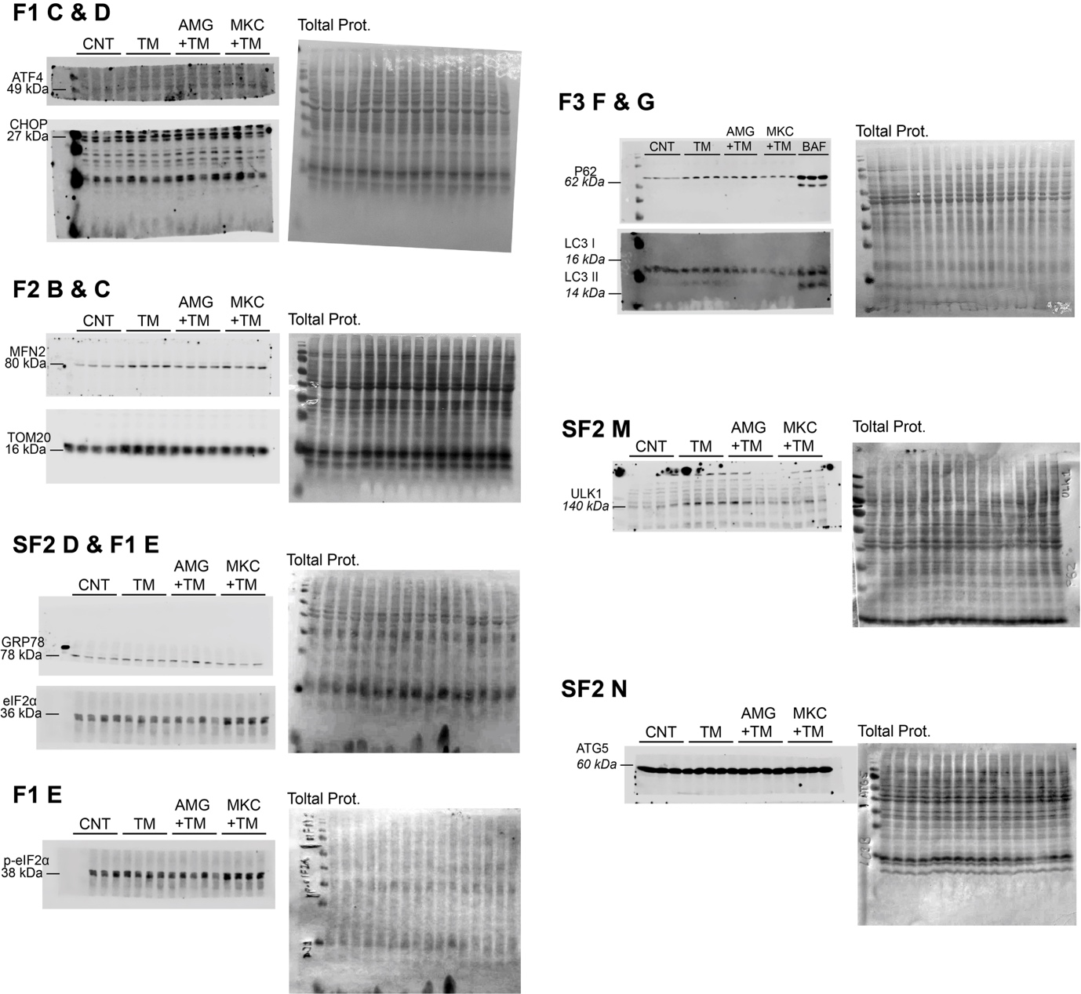

Uncropped Western blots. Uncropped membranes of the Western blot analysis shown in Figure 1, 2, 3 & Suppl. Figure 2.

